Supplementary figure
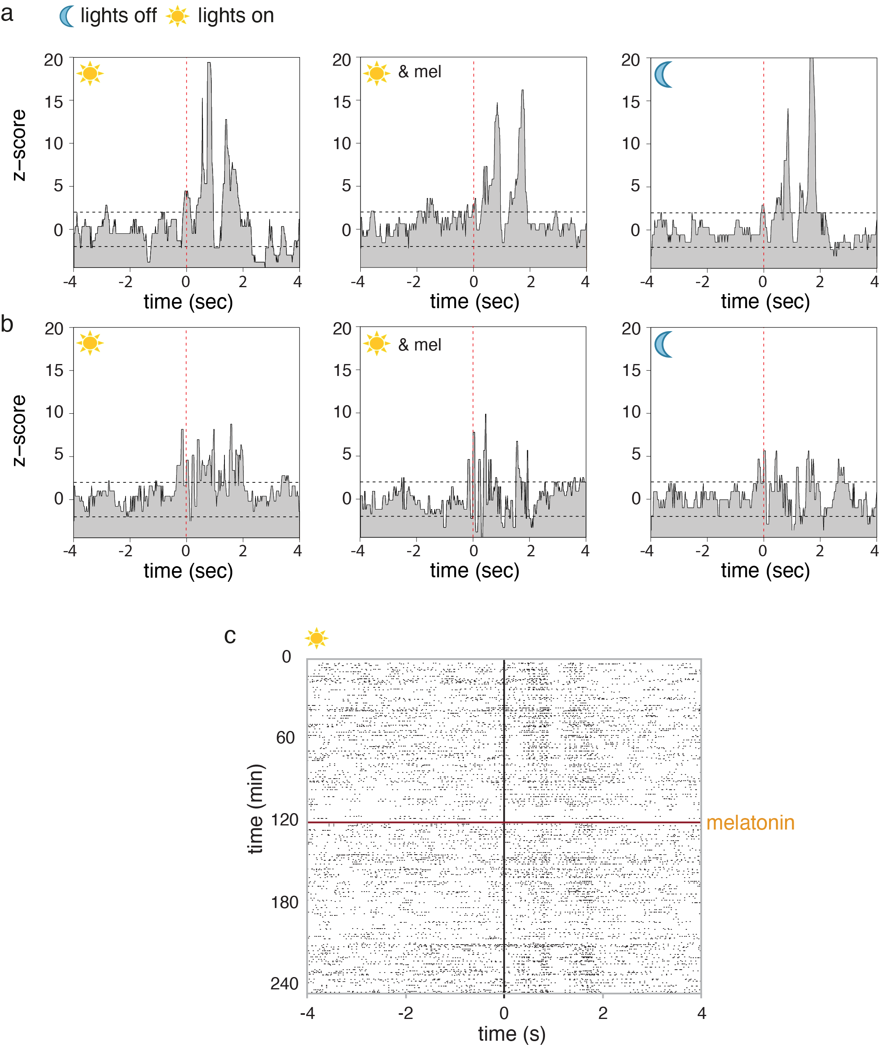
Figure S1: Melatonin does not affect the responsiveness of Field L neurons to playback of birds own song. Single Field L neurons of both bird a and bird b showed a significant increase in firing to playback of BOS in all three conditions, during the day, after melatonin treatment during the day, and during the night. First playback syllable aligned to zero, 10 millisecond bins, 95% confidence interval indicated by dotted lines. Based on the standard deviation of -4 to -3 sec from the stimulus onset, Z-scores during stimulus presentation are significantly different from average firing in all three conditions. c shows the reaction of a single Field L neuron to playback of BOS during 2 hours before and 2 hours after melatonin treatment (playback syllable aligned to 0).

