The following supplement accompanies the article
Respiration rates and inferred mass-specific field metabolic rates decline with body size among five sympatric cetaceans
Maria Glarou, Fredrik Christiansen, Takashi Iwata, Charla Jean Basran, Silva Naomi Sophie Ruppert, Dido Sotiropoulou, Maria Refsgaard Iversen, Tomonari Akamatsu, Joseph Schnitzler, Ursula Siebert, Marianne Helene Rasmussen
*Corresponding author: maria_glarou@outlook.com
Journal of Comparative Physiology B

Table S1. Summary of data sources, sample sizes, and data overlap for each species in the study (RR = respiration rate; n_{RR} = sample size for respiration rate data; n_{morph} = sample size for morphometric data sources; Data overlap = respiration rate and morphometric data were available for the same individuals).
Species | Respiration rates (RR) | n_{RR} | Morphometric data | n_{morph} | Data overlap
P. phocoena | Biologging tags ª | 13 | Direct measurements during tagging ª / UAV photogrammetry | 13 / 50 * | Y
L. albirostris | UAV focal follows | 103 | UAV photogrammetry | 294 | Y
B. acutorostrata | Land-based theodolite tracking ^{b} | 226 | Catch data ^{b} / UAV photogrammetry | 191 / 30 | N
M. novaeangliae | UAV focal follows / biologging tags | 8 / 8 | UAV photogrammetry | 282 | N
B. musculus | Biologging tags | 4 | UAV photogrammetry | 29 | N
ª Rojano-Donãte et al. (2018); ^{b} Christiansen et al. (2014); * Note: When multiple data sources were combined, sample sizes are separated with a forward slash symbol (“/”) for each data source.

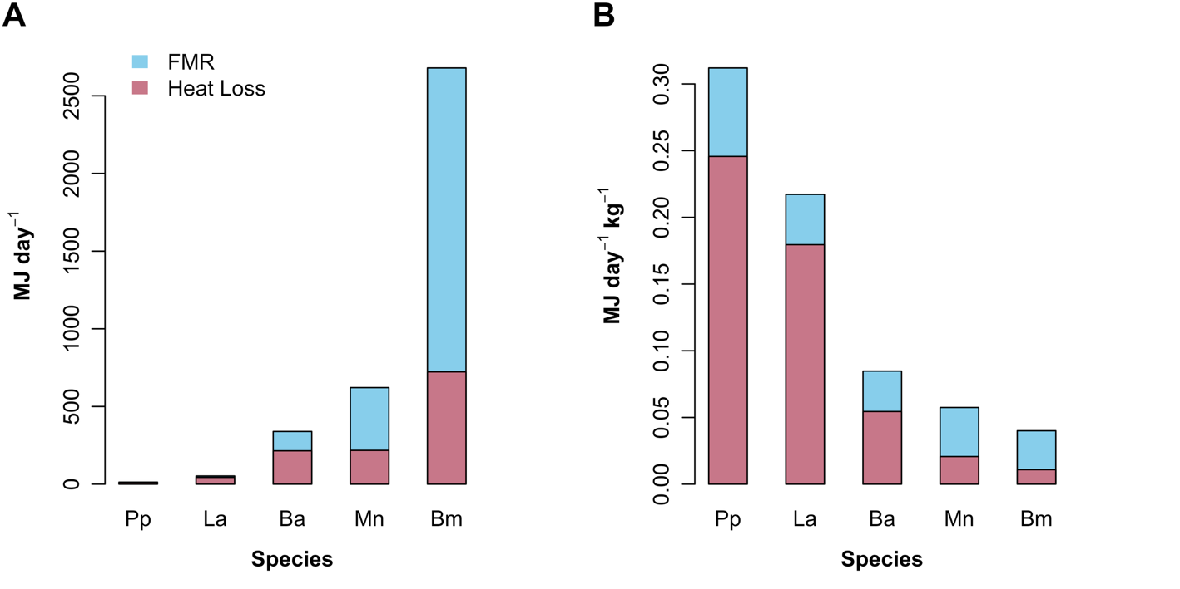
Figure S1. Partitioning of (A) total and (B) mass-specific field metabolic rate (FMR_{day}) into heat loss (dark pink; adjusted values from Glarou et al. 2025) and the remaining daily energy expenditure (light blue) across five sympatric cetaceans. The heat loss has been re-estimated for the white-beaked dolphins, using the thermal conductivity value of harbour porpoise blubber (k = 0.1 W m^{-1 o}C⁻¹).

