Evidence of earthquake seasonality in the Azores Triple Junction

Ana L. Lordi^{1,2}, Maria C. Neves^{1, 2}, Susana Custódio^{1,3}, Stéphanie Dumont^{1,4}
¹Instituto Dom Luiz, University of Lisbon, Lisbon, Portugal.
²University of the Algarve, Faro, Portugal.
³University of Lisbon, Lisbon, Portugal.
⁴University of Beira Interior, Covilhã, Portugal.

Corresponding author: Ana L. Lordi (analauralordi@gmail.com)

Supplementary Material

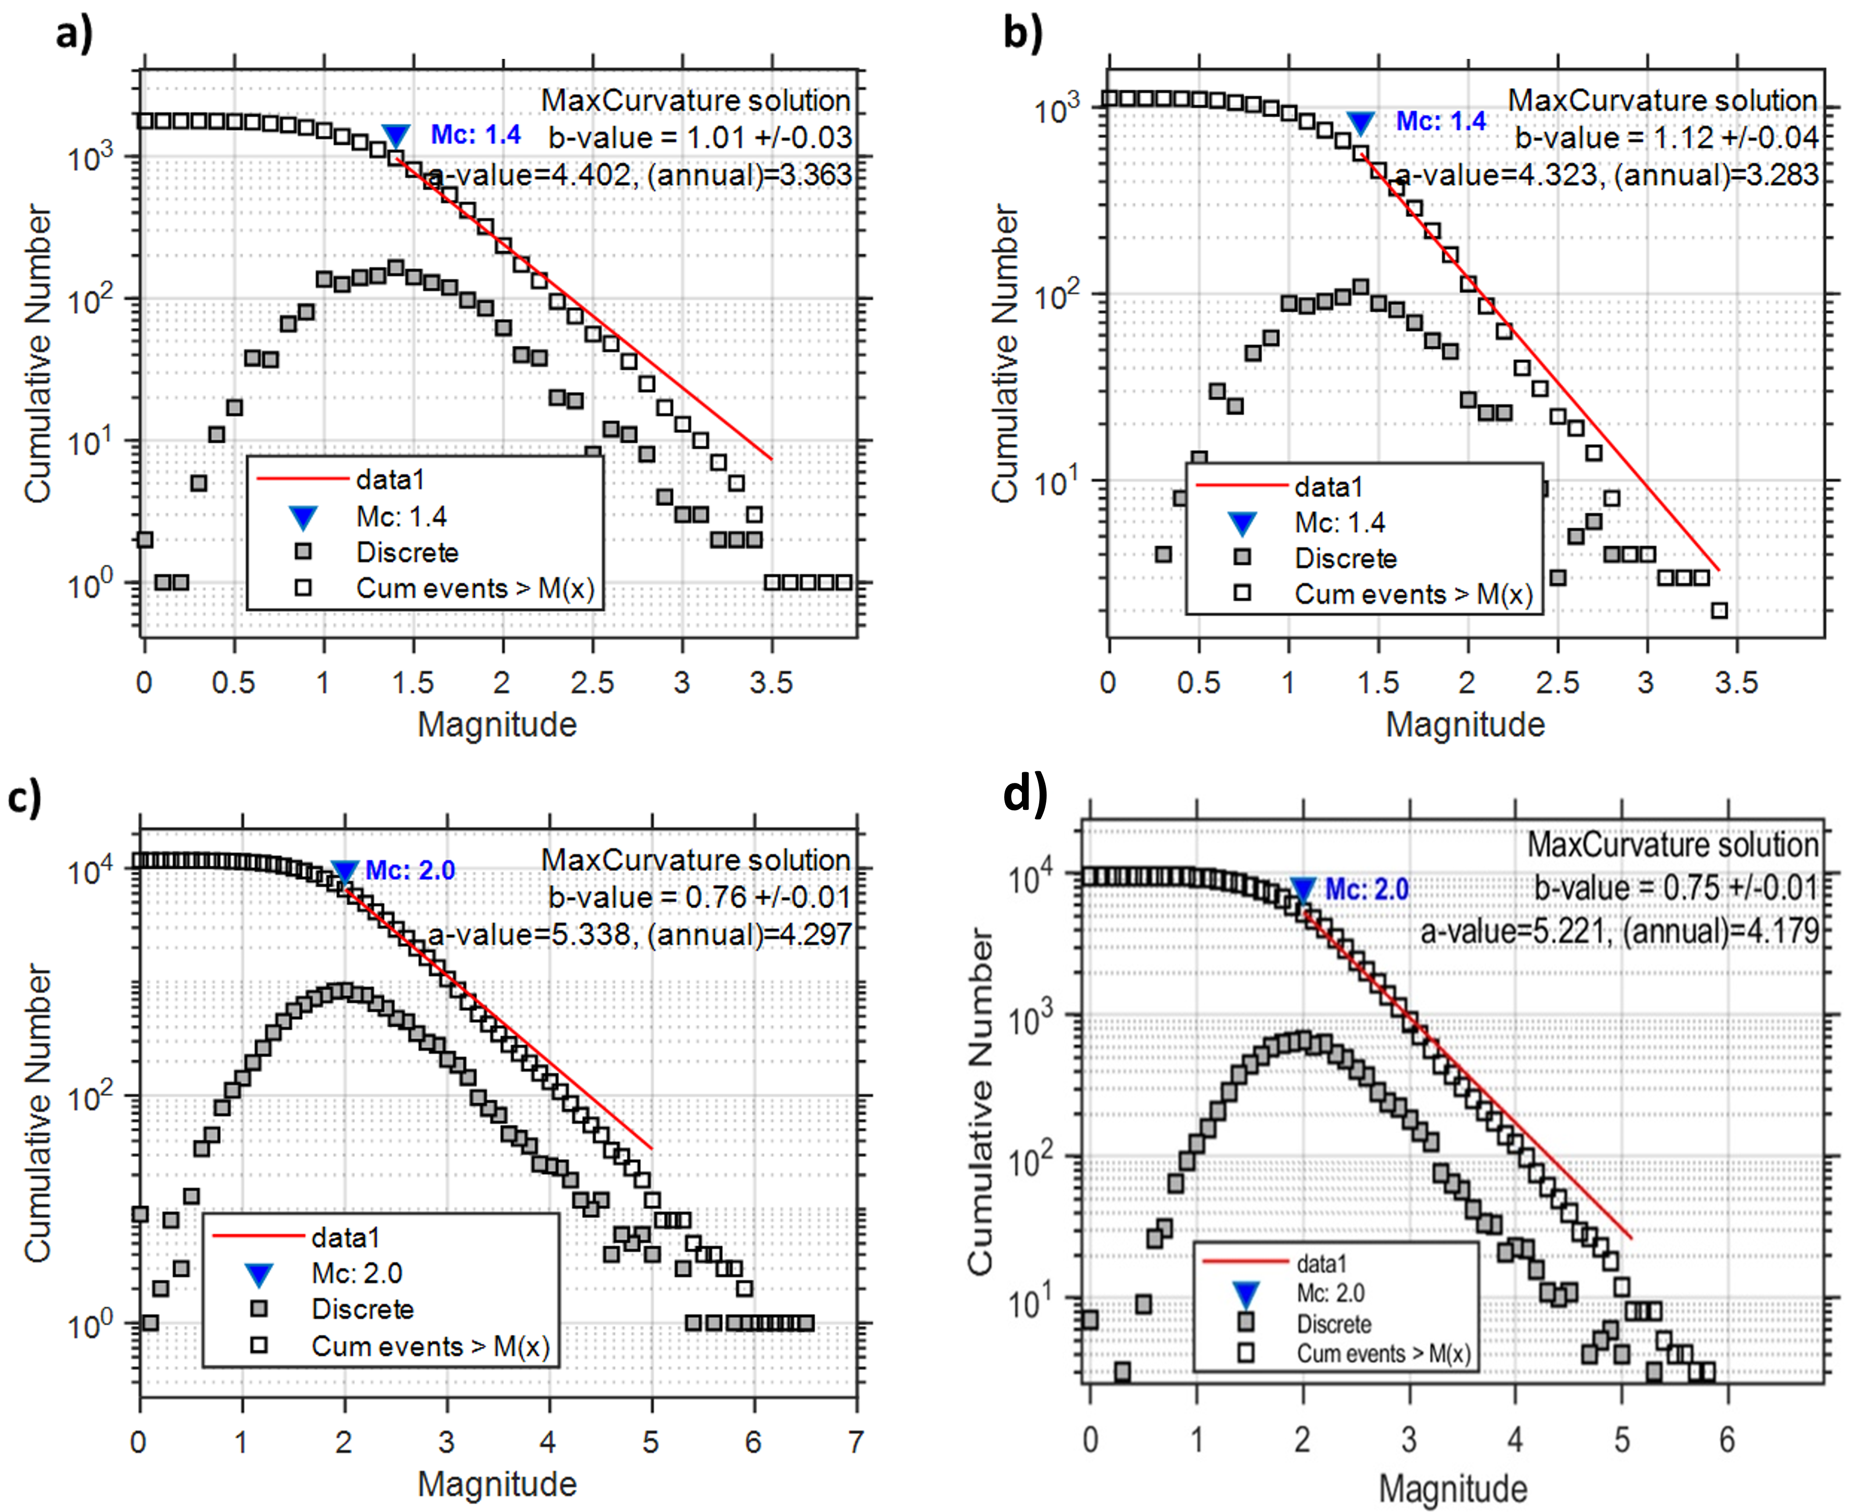
Fig. 1. Gutenberg-Richter magnitude-frequency distribution for (a) full and (b) declustered islands catalogue, and (c) full and (d) declustered oceanic catalogue

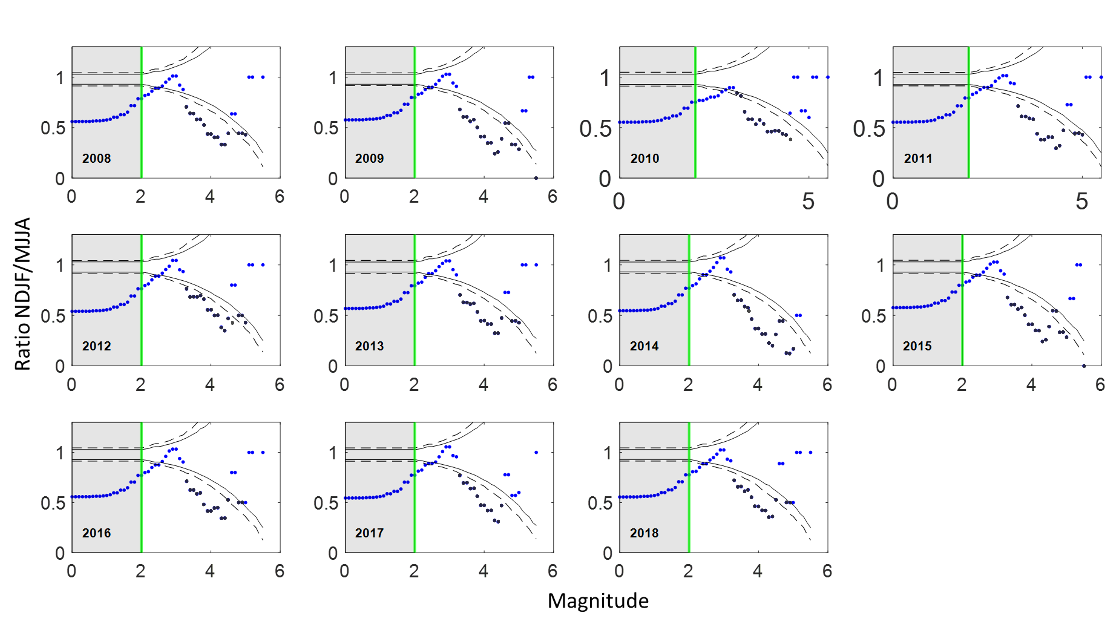 Fig. 2. Results of the complete Jack-Knife analysis for the declustered Azores ocean catalogue. Solid and dashed lines represent the 95% and 99% confidence limits estimated independently for each test. The number in the lower left corner of each panel indicates the year of data removed from January 2008 to December 2018 overall time period.

Fig. 3. Results of the complete Jack-Knife analysis for the full Azores islands catalogue. Solid and dashed lines represent the 95% and 99% confidence limits estimated independently for each test. The number in the lower left corner of each panel indicates the year of data removed from January 2008 to December 2018 overall time period. Note that no seasonality is identified in the islands events when removing the year 2018 (last panel), which is the year influencing the seasonality in the other panels due to a seismic crisis.

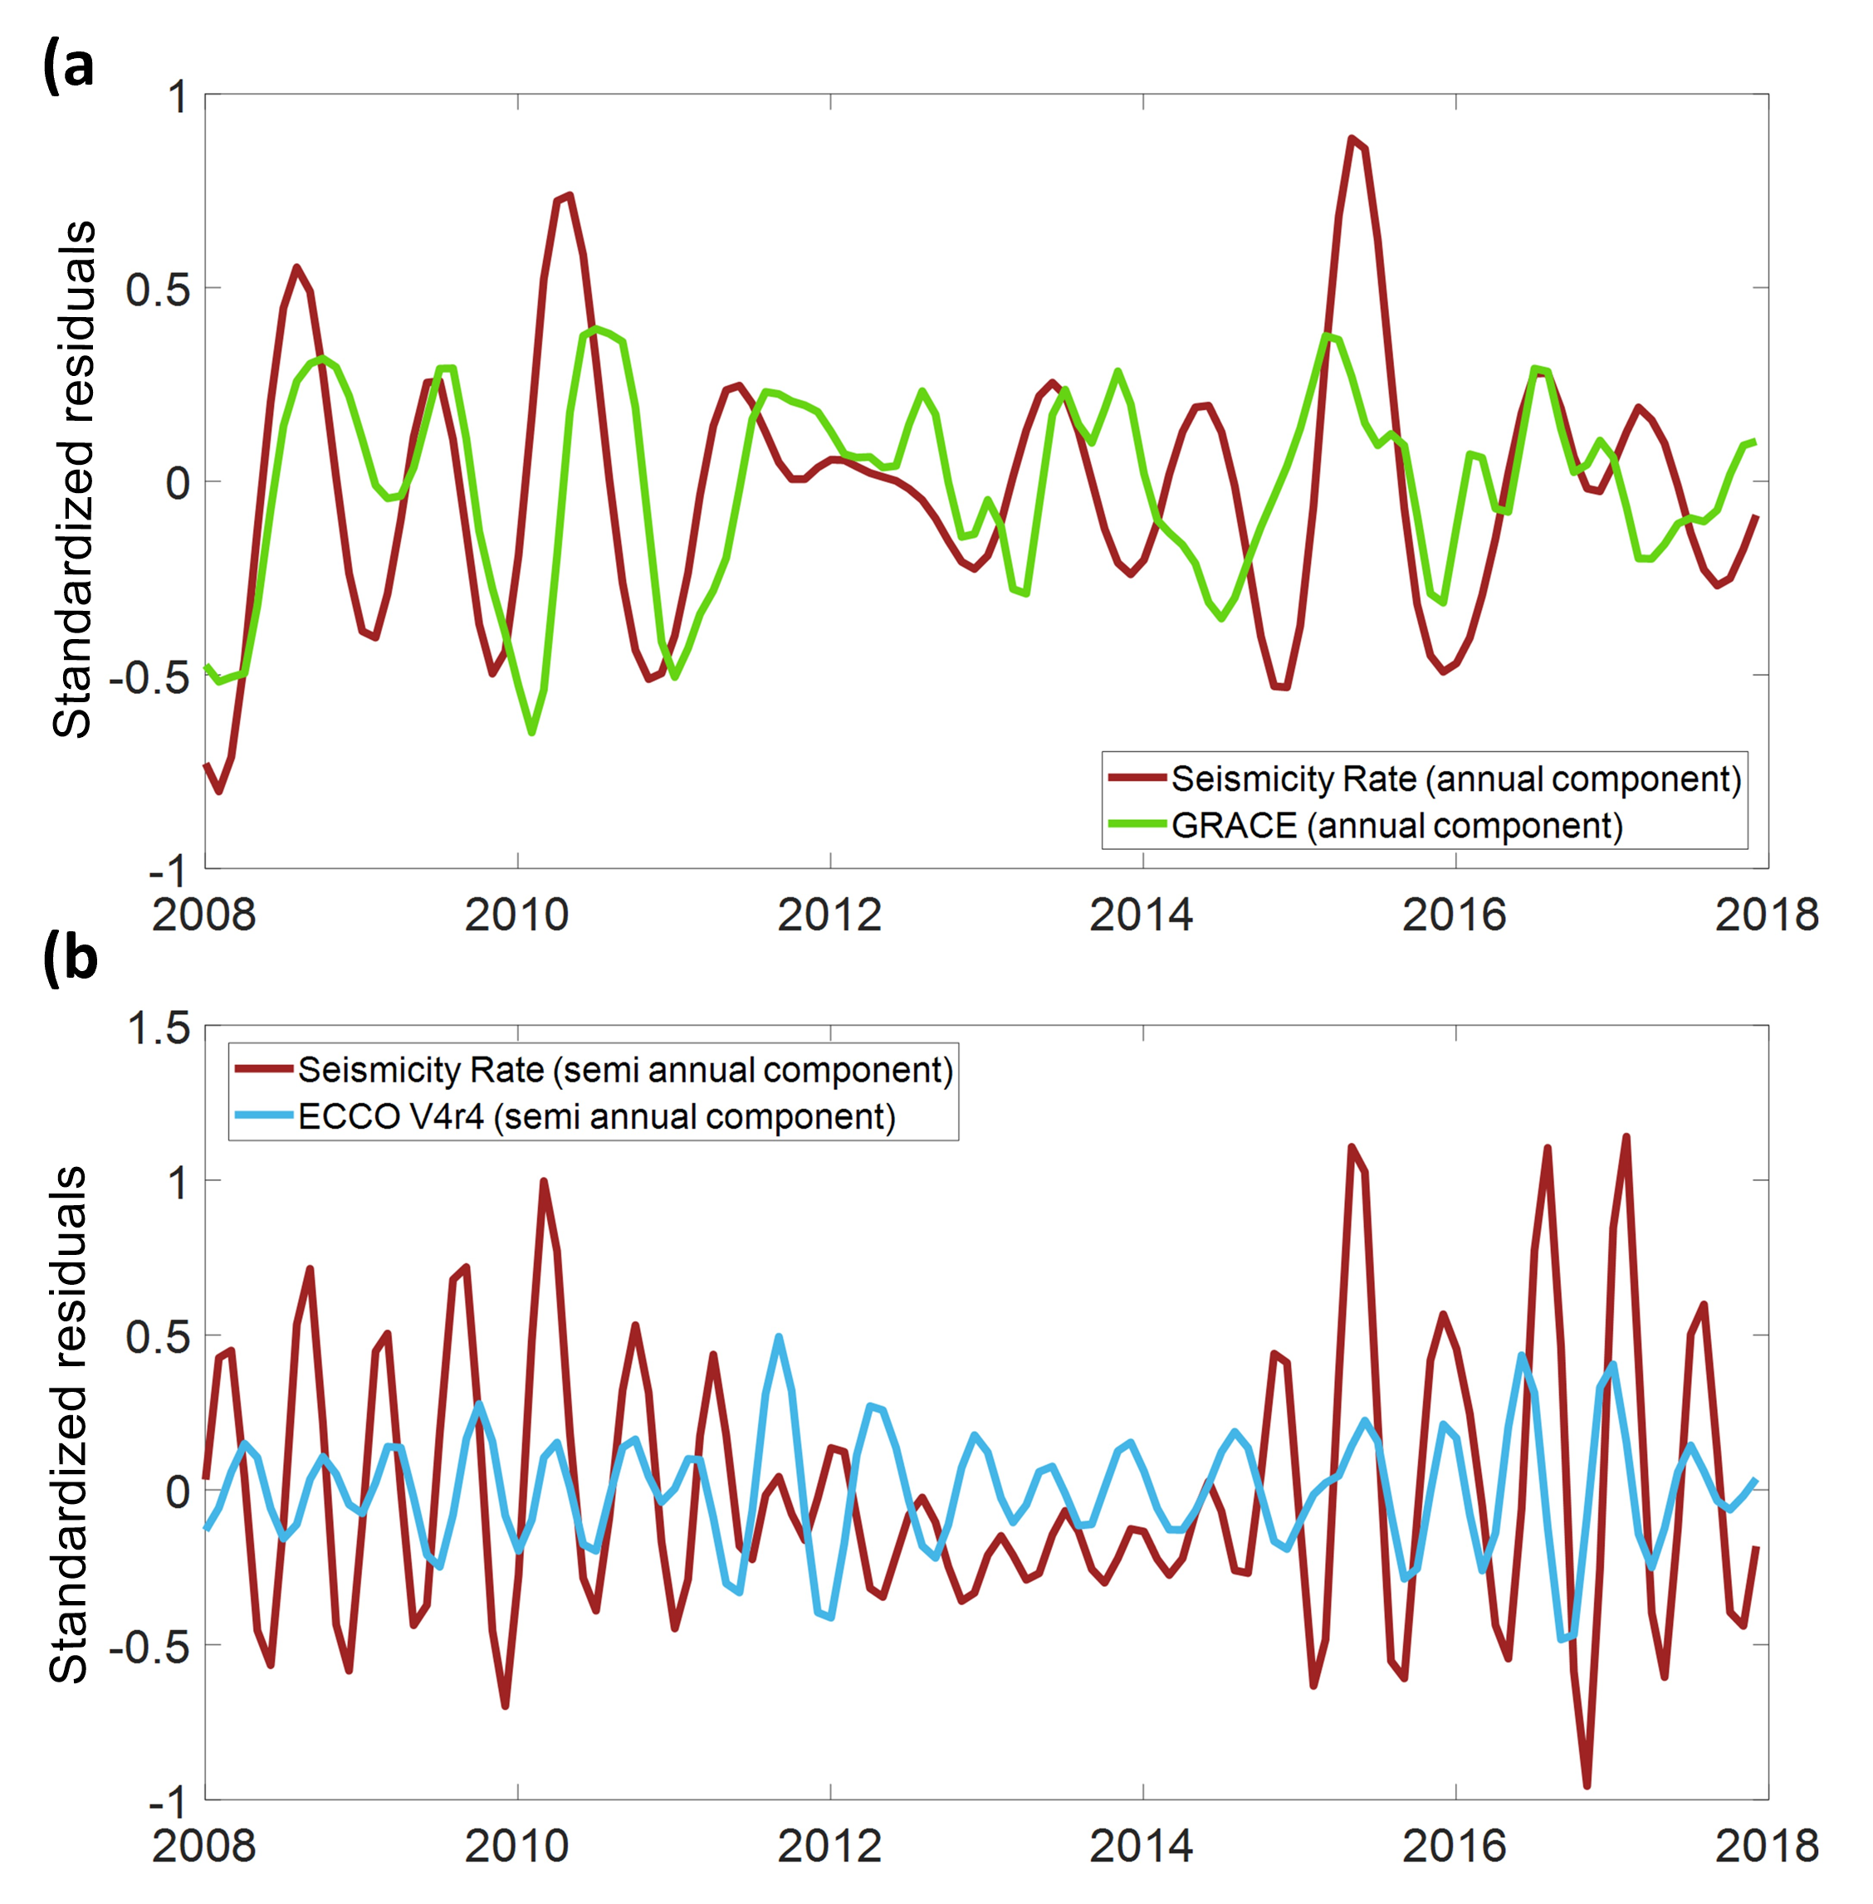
Fig. 4. Comparison between the (a) annual components of the seismicity rate and GRACE extracted by Singular Spectrum Analysis performed using the Hydroclimate software (Dickinson et al. 2014) , and (b) semi-annual components of the seismicity rate and OBP from ECCO V4r4 model. The y-axis represents the standardized residuals (departure from trend normalized by the standard deviation). GRACE and OBP time series show good correlations with the Azores seismicity rate although the relationships are not stationary and involve transient couplings and time varying lags.

