Nitrogen isotope enrichment predicts growth response of Pinus radiata in New Zealand to nitrogen fertiliser addition

Journal name: Biology and Fertility of Soils
Authors: Loretta G Garrett¹, Yue Lin¹, Amanda L Matson¹, Brian D Strahm²
Affiliation: ¹ Scion, Private Bag 3020, Rotorua 3046, New Zealand; ² Virginia Tech, 310C Cheatham Hall, Blacksburg, VA 24061.

Methods

Study sites
Table S1: Site soil classification, elevation, slope, mean annual temperature (MAT), mean annual rainfall, tree age at time of fertiliser addition, the single N fertiliser addition amount, and for the sub-set of sites included in the Random Forest model the soil and foliage properties (mean, minimum, and maximum).
Trial ID | New Zealand Soil classification¹ | Elevation (m a.s.l) | Slope (degrees) | MAT (◦C)² | Mean annual rainfall (mm)² | Tree age (years) at time of N fertiliser addition | Single N fertiliser addition (kg N ha⁻¹) | Soil and foliage properties | Mean | Min. | Max.
AK976/1 | Sandy Raw Soils | 30 | 2 | 16.4 | 1138 | 4 | 150 | N/A
AK976/2 | Mottled Albic Ulitc Soils | 75 | 10 | 15.1 | 1460 | 4 | 150 | N/A
RO1083/1 | Welded Impeded Pumice Soils | 610 | 0 | 10.6 | 1272 | 7 | 200 | N/A
RO1083/2 | Welded Impeded Pumice Soils | 671 | 0 | 10.3 | 1472 | 7 | 200 | N/A
RO1818 | Immature Orthic Pumice Soils | 427 | 0 | 11.4 | 1244 | 16 | 200 | N/A
RO1889 | Welded Impeded Pumice Soils | 640 | 5 | 10.3 | 1485 | 5 | 150 | N/A
FR467/1 | Mottled Oxidic Granular Soils | 260 | 10 | 14.1 | 1965 | 17 | 200 | Soil Total C (g kg⁻¹) | 105.6 | 88.8 | 123.9
 |  |  |  |  |  |  |  | Soil Total N (g kg⁻¹) | 7.9 | 6.6 | 9.7
 |  |  |  |  |  |  |  | Soil C/N ratio | 14 | 13 | 15
 |  |  |  |  |  |  |  | Soil pH | 4.8 | 4.5 | 5.0
 |  |  |  |  |  |  |  | Soil δ¹⁵N (‰) | 6.8 | 6.1 | 7.3
 |  |  |  |  |  |  |  | Foliage Total C (g kg⁻¹) | 528.3 | 523.0 | 538.0
 |  |  |  |  |  |  |  | Foliage Total N (g kg⁻¹) | 17.0 | 16.0 | 18.1
 |  |  |  |  |  |  |  | Foliage C/N ratio | 31 | 30 | 33
 |  |  |  |  |  |  |  | Foliage Total P (g kg⁻¹) | 1.1 | 1.1 | 1.3
 |  |  |  |  |  |  |  | Foliage δ¹⁵N (‰) | 3.2 | 2.1 | 4.5
 |  |  |  |  |  |  |  | Enrichment factor (¹⁵N_{foliage} – δ¹⁵N_{soil}) (‰) | -4.1 | -7.3 | -2.1
FR467/2 | Sandy Perch-gley Ultic Soils | 50 | 10 | 15.1 | 1295 | 22 | 200 | Soil Total C (g kg⁻¹) | 30.6 | 23.3 | 40.1
 |  |  |  |  |  |  |  | Soil Total N (g kg⁻¹) | 1.1 | 0.8 | 1.5
 |  |  |  |  |  |  |  | Soil C/N ratio | 29 | 27 | 33
 |  |  |  |  |  |  |  | Soil pH | 4.3 | 3.9 | 5.4
 |  |  |  |  |  |  |  | Soil δ¹⁵N (‰) | 6.0 | 3.9 | 7.9
 |  |  |  |  |  |  |  | Foliage Total C (g kg⁻¹) | 519.7 | 514.0 | 523.0
 |  |  |  |  |  |  |  | Foliage Total N (g kg⁻¹) | 13.6 | 12.2 | 14.4
 |  |  |  |  |  |  |  | Foliage C/N ratio | 38 | 36 | 42
 |  |  |  |  |  |  |  | Foliage Total P (g kg⁻¹) | 1.3 | 1.2 | 1.6
 |  |  |  |  |  |  |  | Foliage δ¹⁵N (‰) | -0.9 | -1.4 | -0.4
 |  |  |  |  |  |  |  | Enrichment factor (¹⁵N_{foliage} – δ¹⁵N_{soil}) (‰) | -6.9 | -8.4 | -5.1
FR467/3 | Acidic Firm Brown Soils / Acidic weathered Fluvial Recent Soils | 380 | 5 | 10.5 | 1559 | 16 | 200 | Soil Total C (g kg⁻¹) | 62.4 | 59.3 | 64.9
 |  |  |  |  |  |  |  | Soil Total N (g kg⁻¹) | 5.0 | 4.6 | 5.4
 |  |  |  |  |  |  |  | Soil C/N ratio | 12 | 12 | 14
 |  |  |  |  |  |  |  | Soil pH | 5.2 | 5.1 | 5.3
 |  |  |  |  |  |  |  | Soil δ¹⁵N (‰) | 3.5 | 2.8 | 3.8
 |  |  |  |  |  |  |  | Foliage Total C (g kg⁻¹) | 514.2 | 511.0 | 517.0
 |  |  |  |  |  |  |  | Foliage Total N (g kg⁻¹) | 16.2 | 15.1 | 16.8
 |  |  |  |  |  |  |  | Foliage C/N ratio | 32 | 31 | 34
 |  |  |  |  |  |  |  | Foliage Total P (g kg⁻¹) | 1.9 | 1.7 | 2.1
 |  |  |  |  |  |  |  | Foliage δ¹⁵N (‰) | -0.2 | -0.5 | -0.1
 |  |  |  |  |  |  |  | Enrichment factor (¹⁵N_{foliage} – δ¹⁵N_{soil}) (‰) | -3.7 | -3.9 | -3.4
FR467/4 | Acidic Orthic Brown Soils | 550 | 20 | 9.6 | 2239 | 15 | 200 | Soil Total C (g kg⁻¹) | 45.4 | 32.7 | 60.8
 |  |  |  |  |  |  |  | Soil Total N (g kg⁻¹) | 1.8 | 1.3 | 2.3
 |  |  |  |  |  |  |  | Soil C/N ratio | 26 | 23 | 28
 |  |  |  |  |  |  |  | Soil pH | 4.8 | 4.7 | 4.9
 |  |  |  |  |  |  |  | Soil δ¹⁵N (‰) | 4.0 | 3.5 | 4.5
 |  |  |  |  |  |  |  | Foliage Total C (g kg⁻¹) | 520.3 | 512.0 | 525.0
 |  |  |  |  |  |  |  | Foliage Total N (g kg⁻¹) | 13.4 | 11.8 | 15.0
 |  |  |  |  |  |  |  | Foliage C/N ratio | 39 | 35 | 44
 |  |  |  |  |  |  |  | Foliage Total P (g kg⁻¹) | 2.0 | 1.8 | 2.2
 |  |  |  |  |  |  |  | Foliage δ¹⁵N (‰) | -0.6 | -1.0 | -0.2
 |  |  |  |  |  |  |  | Enrichment factor (¹⁵N_{foliage} – δ¹⁵N_{soil}) (‰) | -4.6 | -5.5 | -3.9
FR467/5 | Immature Orthic Pumice Soils | 240 | 7 | 12.3 | 1312 | 15 | 200 | Soil Total C (g kg⁻¹) | 44.7 | 41.0 | 47.0
 |  |  |  |  |  |  |  | Soil Total N (g kg⁻¹) | 1.8 | 1.7 | 1.8
 |  |  |  |  |  |  |  | Soil C/N ratio | 25 | 22 | 27
 |  |  |  |  |  |  |  | Soil pH | 4.7 | 4.5 | 4.8
 |  |  |  |  |  |  |  | Soil δ¹⁵N (‰) | 2.4 | 2.0 | 2.8
 |  |  |  |  |  |  |  | Foliage Total C (g kg⁻¹) | 499.7 | 498.0 | 501.0
 |  |  |  |  |  |  |  | Foliage Total N (g kg⁻¹) | 12.7 | 11.0 | 14.0
 |  |  |  |  |  |  |  | Foliage C/N ratio | 40 | 36 | 45
 |  |  |  |  |  |  |  | Foliage Total P (g kg⁻¹) | 1.7 | 1.5 | 1.9
 |  |  |  |  |  |  |  | Foliage δ¹⁵N (‰) | -0.5 | -0.7 | -0.2
 |  |  |  |  |  |  |  | Enrichment factor (¹⁵N_{foliage} – δ¹⁵N_{soil}) (‰) | -2.9 | -3.2 | -2.4
FR561/1 | Welded Impeded Pumice Soils | 700 | 3 | 10.4 | 1365 | 14 | 207 | Soil Total C (g kg⁻¹) | 62.5 | 49.9 | 81.2
 |  |  |  |  |  |  |  | Soil Total N (g kg⁻¹) | 2.8 | 2.3 | 4.0
 |  |  |  |  |  |  |  | Soil C/N ratio | 22 | 20 | 25
 |  |  |  |  |  |  |  | Soil pH | 4.8 | 4.6 | 4.9
 |  |  |  |  |  |  |  | Soil δ¹⁵N (‰) | 1.7 | 0.8 | 2.6
 |  |  |  |  |  |  |  | Foliage Total C (g kg⁻¹) | 511.8 | 501.3 | 515.8
 |  |  |  |  |  |  |  | Foliage Total N (g kg⁻¹) | 13.9 | 13.4 | 14.5
 |  |  |  |  |  |  |  | Foliage C/N ratio | 37 | 36 | 39
 |  |  |  |  |  |  |  | Foliage Total P (g kg⁻¹) | 1.7 | 1.5 | 1.9
 |  |  |  |  |  |  |  | Foliage δ¹⁵N (‰) | -2.0 | -2.3 | -1.4
 |  |  |  |  |  |  |  | Enrichment factor (¹⁵N_{foliage} – δ¹⁵N_{soil}) (‰) | -2.7 | -4.8 | -0.8
FR561/2 | Acidic Orthic Brown Soils | 157 | 22 | 14.4 | 1769 | 14 | 207 | Soil Total C (g kg⁻¹) | 57.7 | 33.0 | 74.7
 |  |  |  |  |  |  |  | Soil Total N (g kg⁻¹) | 3.0 | 1.6 | 4.3
 |  |  |  |  |  |  |  | Soil C/N ratio | 20 | 18 | 24
 |  |  |  |  |  |  |  | Soil pH | 5.4 | 4.5 | 5.8
 |  |  |  |  |  |  |  | Soil δ¹⁵N (‰) | 5.5 | 4.7 | 6.1
 |  |  |  |  |  |  |  | Foliage Total C (g kg⁻¹) | 505.6 | 499.4 | 512.6
 |  |  |  |  |  |  |  | Foliage Total N (g kg⁻¹) | 13.1 | 12.2 | 14.0
 |  |  |  |  |  |  |  | Foliage C/N ratio | 39 | 36 | 41
 |  |  |  |  |  |  |  | Foliage Total P (g kg⁻¹) | 1.0 | 0.8 | 1.2
 |  |  |  |  |  |  |  | Foliage δ¹⁵N (‰) | 1.2 | 0.1 | 2.6
 |  |  |  |  |  |  |  | Enrichment factor (¹⁵N_{foliage} – δ¹⁵N_{soil}) (‰) | -5.0 | -5.9 | -3.4
FR561/4 | Silt-mantled Perch-gley Podzols | 41 | 0 | 11.7 | 3159 | 11 | 207 | Soil Total C (g kg⁻¹) | 48.3 | 29.8 | 73.1
 |  |  |  |  |  |  |  | Soil Total N (g kg⁻¹) | 1.8 | 1.2 | 3.1
 |  |  |  |  |  |  |  | Soil C/N ratio | 27 | 23 | 30
 |  |  |  |  |  |  |  | Soil pH | 4.3 | 3.9 | 4.5
 |  |  |  |  |  |  |  | Soil δ¹⁵N (‰) | 3.8 | 2.5 | 5.0
 |  |  |  |  |  |  |  | Foliage Total C (g kg⁻¹) | 509.5 | 508.4 | 512.3
 |  |  |  |  |  |  |  | Foliage Total N (g kg⁻¹) | 12.5 | 10.6 | 14.6
 |  |  |  |  |  |  |  | Foliage C/N ratio | 41 | 35 | 48
 |  |  |  |  |  |  |  | Foliage Total P (g kg⁻¹) | 1.4 | 1.3 | 1.5
 |  |  |  |  |  |  |  | Foliage δ¹⁵N (‰) | -0.9 | -1.4 | -0.1
 |  |  |  |  |  |  |  | Enrichment factor (¹⁵N_{foliage} – δ¹⁵N_{soil}) (‰) | -4.3 | -6.4 | -2.5
FR561/5 | Acidic Orthic Brown Soils | 440 | 7 | 8.4 | 866 | 11 | 207 | Soil Total C (g kg⁻¹) | 62.8 | 38.6 | 80.4
 |  |  |  |  |  |  |  | Soil Total N (g kg⁻¹) | 3.5 | 1.8 | 5.2
 |  |  |  |  |  |  |  | Soil C/N ratio | 18 | 14 | 24
 |  |  |  |  |  |  |  | Soil pH | 4.4 | 3.9 | 5.1
 |  |  |  |  |  |  |  | Soil δ¹⁵N (‰) | 3.3 | 2.2 | 4.5
 |  |  |  |  |  |  |  | Foliage Total C (g kg⁻¹) | 502.4 | 498.6 | 504.4
 |  |  |  |  |  |  |  | Foliage Total N (g kg⁻¹) | 14.5 | 13.8 | 15.6
 |  |  |  |  |  |  |  | Foliage C/N ratio | 35 | 32 | 37
 |  |  |  |  |  |  |  | Foliage Total P (g kg⁻¹) | 2.4 | 2.1 | 2.8
 |  |  |  |  |  |  |  | Foliage δ¹⁵N (‰) | -0.2 | -0.7 | 0.7
 |  |  |  |  |  |  |  | Enrichment factor (¹⁵N_{foliage} – δ¹⁵N_{soil}) (‰) | -3.4 | -3.8 | -2.4
FR561/7 | Podzolic Orthic Pumice Soils | 581 | 7 | 11.4 | 1527 | 9 | 207 | Soil Total C (g kg⁻¹) | 70.7 | 32.9 | 101.6
 |  |  |  |  |  |  |  | Soil Total N (g kg⁻¹) | 3.5 | 1.5 | 5.0
 |  |  |  |  |  |  |  | Soil C/N ratio | 20 | 19 | 22
 |  |  |  |  |  |  |  | Soil pH | 5.1 | 5.0 | 5.4
 |  |  |  |  |  |  |  | Soil δ¹⁵N (‰) | 1.9 | 1.5 | 2.3
 |  |  |  |  |  |  |  | Foliage Total C (g kg⁻¹) | 505.2 | 503.7 | 506.5
 |  |  |  |  |  |  |  | Foliage Total N (g kg⁻¹) | 14.5 | 13.5 | 15.8
 |  |  |  |  |  |  |  | Foliage C/N ratio | 35 | 32 | 37
 |  |  |  |  |  |  |  | Foliage Total P (g kg⁻¹) | 1.2 | 1.1 | 1.5
 |  |  |  |  |  |  |  | Foliage δ¹⁵N (‰) | -2.1 | -2.6 | -1.5
 |  |  |  |  |  |  |  | Enrichment factor (¹⁵N_{foliage} – δ¹⁵N_{soil}) (‰) | -3.0 | -4.5 | -1.8
RO1843 | Welded Impeded Pumice Soils | 579 | 0 | 11.0 | 1335 | 15 | 200 | Soil Total C (g kg⁻¹) | 60.3 | 54.8 | 65.7
 |  |  |  |  |  |  |  | Soil Total N (g kg⁻¹) | 2.7 | 2.5 | 2.8
 |  |  |  |  |  |  |  | Soil C/N ratio | 23 | 22 | 24
 |  |  |  |  |  |  |  | Soil pH | 4.4 | 4.3 | 4.5
 |  |  |  |  |  |  |  | Soil δ¹⁵N (‰) | 3.1 | 2.7 | 3.4
 |  |  |  |  |  |  |  | Foliage Total C (g kg⁻¹) | 504.5 | 504.0 | 505.0
 |  |  |  |  |  |  |  | Foliage Total N (g kg⁻¹) | 13.4 | 13.0 | 13.7
 |  |  |  |  |  |  |  | Foliage C/N ratio | 38 | 37 | 39
 |  |  |  |  |  |  |  | Foliage Total P (g kg⁻¹) | 2.3 | 2.2 | 2.4
 |  |  |  |  |  |  |  | Foliage δ¹⁵N (‰) | 1.1 | 1.0 | 1.1
 |  |  |  |  |  |  |  | Enrichment factor (¹⁵N_{foliage} – δ¹⁵N_{soil}) (‰) | -2.0 | -2.4 | -1.6
WN 379 | Immature Orthic Pumice Soils | 421 | 6 | 12.2 | 1345 | 12 | 200 | Soil Total C (g kg⁻¹) | 82.8 | 80.5 | 86.8
 |  |  |  |  |  |  |  | Soil Total N (g kg⁻¹) | 6.1 | 6.0 | 6.3
 |  |  |  |  |  |  |  | Soil C/N ratio | 14 | 13 | 14
 |  |  |  |  |  |  |  | Soil pH | N/A | N/A | N/A
 |  |  |  |  |  |  |  | Soil δ¹⁵N (‰) | 2.3 | 2.1 | 2.6
 |  |  |  |  |  |  |  | Foliage Total C (g kg⁻¹) | 509.7 | 507.0 | 512.0
 |  |  |  |  |  |  |  | Foliage Total N (g kg⁻¹) | 17.5 | 17.1 | 17.8
 |  |  |  |  |  |  |  | Foliage C/N ratio | 29 | 29 | 30
 |  |  |  |  |  |  |  | Foliage Total P (g kg⁻¹) | 1.6 | 1.5 | 1.8
 |  |  |  |  |  |  |  | Foliage δ¹⁵N (‰) | 0.3 | -0.2 | 0.6
 |  |  |  |  |  |  |  | Enrichment factor (¹⁵N_{foliage} – δ¹⁵N_{soil}) (‰) | -2.0 | -2.3 | -1.6
¹ Data sourced from New Zealand's Fundamental Soil Layer (Wilde et al. 2000):
² Climate data sourced from National Institute of Water and Atmosphere virtual climate database normalise over a 30 year period (period 1980 – 2010) (Anon. 2022)

Data and statistical analysis

Predicting a growth response – additional detailed method
To deal with missing data, we also used a new non-parametric method called MissForest (Stekhoven and Bühlmann 2011) for data imputation. The MissForest method is based on RF algorithm and can cope with different types of variables, complex interactions, nonlinear relations and high dimensions simultaneously. We also compared MissForest with traditional methods of omitting missing data such as substituting with median or most abundant values. The MissForest method outperformed traditional methods in data completeness and model accuracy (data not shown).

To evaluate and select candidate predictor variables used in the RF model, we employed the Boruta algorithm (Kursa and Rudnicki 2010). The Boruta algorithm is a wrapper built around the RF algorithm, which provides a statistically grounded way for automatically selecting variables on a given dataset. According to Boruta evaluations, all the forty-eight candidate variables were significant for model improvement based on their importance (Figure S1) and were used in our RF model as predictor variables.

In the RF model, there are two important tuning parameters (Freeman et al. 2015), first is the tuning parameter, ntree, determines the total number of regression trees to grow. In our model, we used the default number of 500 regression trees. Second is the tuning parameter, mtry, determines the number of predictor variables randomly sampled as candidates at each split in a CART. The default value is the number of predictor variables divided by three. We used a grid search strategy and explored thirty-four levels of mtry for tuning (from 15 to 48) for our model. We found that the best performance occurred when mtry = 28 for the model. We used a 10-fold cross-validation to train and validate the RF model and repeated it three times. Cross-validation is a re-sampling procedure widely used in machine learning to train and evaluate the performance of models with limited data samples. To evaluate the overall performance of our RF model, we used the coefficient of determination (R²) which was calculated from the residual sum of squares and the total sum of squares. In addition, the root-mean-square error score (RMSE) was also used to evaluate the RF model’s performance. The importance of predictor variables were normalised by the maximum variable importance for the RF model to produce standardised measures of variable importance (Duncanson et al. 2015). In addition, for interpretation of model predictions, we plotted partial dependence plots to show the changes in the average PAI BA value of all sites predicted in the model in response to each predictor variable in the model under ceteris paribus conditions.
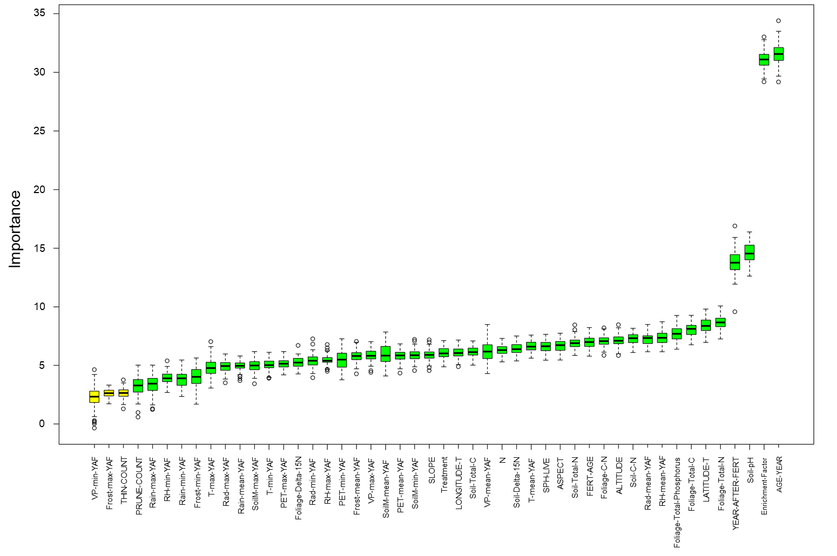
Figure S1. Predictor variable selection for the random forest model. Variable importance is evaluated by using Boruta algorithm (Kursa and Rudnicki, 2010). Variables with green colour are considered as significant important predictor variables at P < 0.01. Variables with yellow colour are considered as significant important predictor variables at P < 0.05. YAF stands for year after fertiliser addition.

Results
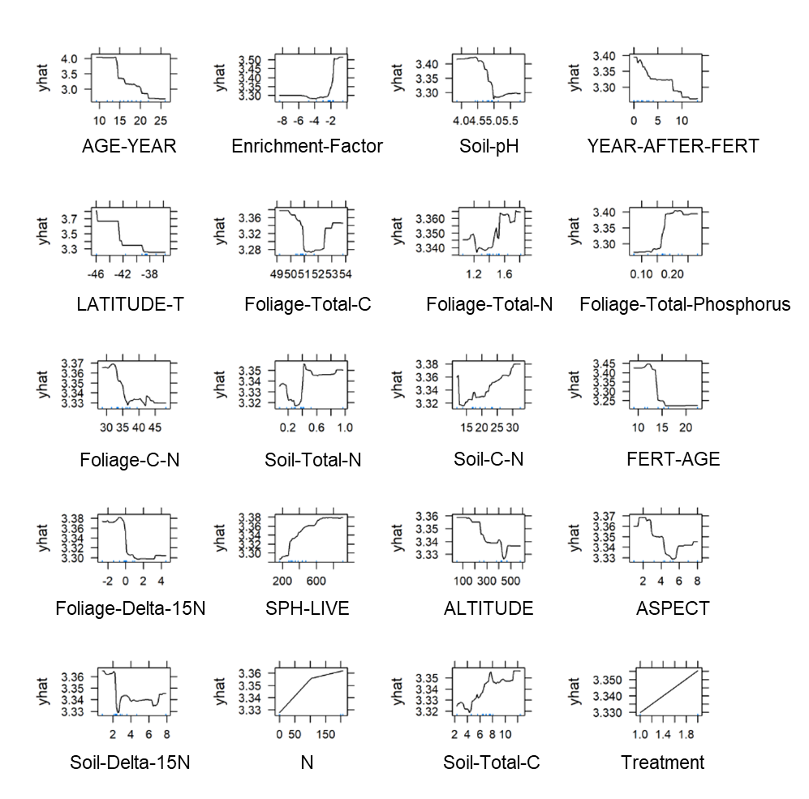
Figure S2: Partial dependence plots of important predictor variables from the Random Forests model for PAI BA (m² ha⁻¹ yr⁻¹). Each subplot shows the predicted value of PAI BA (yhat) depending on the values of the factor. In Treatment, 1 is no fertiliser addition and 2 is with fertiliser addition. Note that due to small data size the model may be sensitive to some plot data points and can cause noise peaks.

References
Anon. (2022) Virtual Climate Station. Retrieved June 2022, from <https://www.niwa.co.nz/climate/our-services/virtual-climate-stations>

Duncanson LI, Dubayah RO, Enquist BJ (2015) Assessing the general patterns of forest structure: quantifying tree and forest allometric scaling relationships in the United States. Glob Ecol Biogeogr 24: 1465-1475. 10.1111/geb.12371
Freeman EA, Moisen GG, Coulston JW, Wilson BT (2015) Random forests and stochastic gradient boosting for predicting tree canopy cover: comparing tuning processes and model performance. Can J For Res 46: 323-339. 10.1139/cjfr-2014-0562
Kursa MB, Rudnicki WR (2010) Feature Selection with the Boruta Package. J Stat Softw 36: 1 - 13. 10.18637/jss.v036.i11
Stekhoven DJ, Bühlmann P (2011) MissForest—non-parametric missing value imputation for mixed-type data. Bioinformatics 28: 112-118. 10.1093/bioinformatics/btr597
Wilde RH, Willoughby EJ, Hewitt AE (2000) Data manual for the national soils database spatial extension. Landcare Research, Palmerston North, New Zealand.

