- Supplementary Materials
- Bio-based solutions consisting of arbuscular mycorrhizal fungi (AMF) with contrasting life-history strategies differently affect health-promoting compounds in fruits of field-grown tomato by changing arbuscule occurrence and diversity of AMF in roots
Elisa Pellegrino^{1,a,*}, Myriam Arcidiacono^{1,a}, Alessandra Francini¹, Laura Ercoli¹
¹Crop Science Research Center, Scuola Superiore Sant'Anna, Pisa, Italy
*Corresponding author: Elisa Pellegrino elisa.pellegrino@santannapisa.it
ªThese authors contributed equally to this work

Table S1 Arbuscular mycorrhizal (AM) fungal species and family, isolate codes, donor, geographical origin and original inoculum supplier
AMF species | AMF family | CCS isolate codeª | Donor | INVAM isolate code^{b} | Geographic orgin | Original isolate supplier
Gigaspora gigantea | Gigasporaceae | MFGS05 | Giusto Giovannetti | PA125 | Pennsylvania | INVAM, Morgantown, West Virginia
Scutellospora pellucida | Gigasporaceae | MFGS12 | Giusto Giovannetti | MN408A | Minnesota | INVAM, Morgantown, West Virginia
Funneliformis mosseae | Glomeraceae | - | Joseph B. Morton | MD118 | Maryland | INVAM, Morgantown, West Virginia
Sclerocystis sinuosa | Glomeraceae | MFGS06 | Giusto Giovannetti | MD126 | Maryland | INVAM, Morgantown, West Virginia
ª CCS: Centro Colture Sperimentali, Quart (Aosta, Italia)
^{b} INVAM: The International Collection of (Vesicular) Arbuscular Mycorrhizal Fungi

Table S2 Mean values ± SE of total phenolic content (TPC), antioxidant activity (ORAC) and lycopene of fruits of plants of Solanum lycopersicum var. Pisanello and var. Rio Grande inoculated with four arbuscular mycorrhizal (AM) fungal species: Gigaspora gigantea (G.giga) and Scutellospora pellucida (S.pellu) belonging to the family Gigasporaceae (Giga), and Funneliformis mosseae (F.mos) and Sclerocystis sinuosa (S.sin) belonging to the family Glomeraceae (Glome). Samplings at BBCH 89: 22nd July and 1st August 2019 for var. Pisanello, 3rd August and 10th August 2020 for var. Rio Grande
 | var. Pisanelloª |  |  | var. Rio Grande
 | 1st harvest | 2nd harvest |  | 1st harvest | 2nd harvest
 | TPC
-M^{b} | 201.96 ± 4.7 | 99.60 ± 1.9 |  | 60.25 ± 0.2 | 107.15 ± 11
+M^{b} | 264.93 ± 5.3 | 144.61 ± 14 |  | 107.48 ± 2.9 | 144.58 ± 5.9
Giga^{c} | 263.81 ± 9.5 | 125.37 ± 5.4 |  | 112.94 ± 4.8 | 134.43 ± 7.9
Glome^{c} | 266.06 ± 5.8 | 163.85 ± 26 |  | 102.02 ± 1.0 | 154.74 ± 7.2
G.giga^{d} | 279.17 ± 14 | 135.73 ± 5.4 |  | 105.22 ± 2.6 | 146.89 ± 4.8
S.pellu^{d} | 248.44 ± 3.9 | 115.00 ± 3.4 |  | 120.65 ± 6.9 | 121.97 ± 12
F.mos^{d} | 270.79 ± 7.2 | 161.87 ± 23 |  | 102.15 ± 0.7 | 165.11 ± 12
S.sin^{d} | 261.33 ± 9.6 | 165.82 ± 52 |  | 101.89 ± 2.1 | 144.37 ± 1.9
 | ORAC
-M | 566.23 ± 4.2 | 521.09 ± 2.0 |  | 292.97 ± 14 | 242.96 ± 43
+M | 557.93 ± 4.2 | 598.06 ± 53 |  | 649.45 ± 58 | 359.63 ± 59
Giga | 554.47 ± 7.5 | 521.40 ± 2.4 |  | 811.14 ± 40 | 442.37 ± 103
Glome | 561.40 ± 4.2 | 674.72 ± 99 |  | 487.77 ± 51 | 276.90 ± 45
G.giga | 569.07 ± 2.2 | 524.16 ± 4.2 |  | 873.02 ± 57 | 671.35 ± 22
S.pellu | 539.86 ± 7.7 | 518.62 ± 2.0 |  | 749.25 ± 30 | 213.40 ± 13
F.mos | 556.54 ± 7.4 | 648.15 ± 136 |  | 494.96 ± 52 | 218.65 ± 30
S.sin | 566.25 ± 3.5 | 701.29 ± 2.0 |  | 480.57 ± 102 | 335.14 ± 76
 | Lycopene
-M | - | 141.67 ± 8.2 |  | - | 311.97 ± 82
+M | - | 628.69 ± 59 |  | - | 780.85 ± 89
Giga | - | 593.85 ± 71 |  | - | 864.77 ± 88
Glome | - | 663.53 ± 99 |  | - | 696.93 ± 155
G.giga | - | 740.60 ± 58 |  | - | 691.93 ± 66
S.pellu | - | 447.10 ± 17 |  | - | 1037.6 ± 67
F.mos | - | 512.80 ± 138 |  | - | 438.75 ± 3.2
S.sin | - | 814.27 ± 85 |  | - | 955.1 ± 230
ª BBCH 89 - Fully ripe: all fruits have typical fully ripe color
^{b} -M, mock inoculation (n=3); +M, AM fungal inoculation (n=12)
^{c} Giga (n=6); Glome (n=6)
^{d} G.giga (n=3); S.pellu (n=3); F.mos (n=3); S.sin (n=3)

Table S3 P-values of linear orthogonal contrasts on total phenolic content (TPC), antioxidant activity (ORAC) and lycopene of fruits of plants of Solanum lycopersicum var. Pisanello and var. Rio Grande inoculated with four arbuscular mycorrhizal (AM) fungal species: Gigaspora gigantea (G.giga) and Scutellospora pellucida (S.pellu) belonging to the family Gigasporaceae (Giga), and Funneliformis mosseae (F.mos) and Sclerocystis sinuosa (S.sin) belonging to the family Glomeraceae (Glome). Samplings at BBCH 89: 22nd July and 1st August 2019 for var. Pisanello, 3rd August and 10th August 2020 for var. Rio Grande
 | var. Pisanelloª |  |  | var. Rio Grande
 | 1st harvest | 2nd harvest |  | 1st harvest | 2nd harvest
 | TPC
-M vs +M^{b} | <0.001^{c} | 0.023 |  | <0.001 | 0.005
Giga vs Glome^{d} | 0.802 | 0.277 |  | 0.010 | 0.050
G.giga vs S.pellu^{e} | 0.032 | 0.034 |  | 0.010 | 0.085
F.mos vs S.sin^{e} | 0.462 | 0.897 |  | 0.959 | 0.142
 | ORAC
-M vs +M | 0.202 | 0.503 |  | <0.001 | 0.034
Giga vs Glome | 0.232 | 0.152 |  | <0.001 | 0.003
G.giga vs S.pellu | 0.236 | 0.712 |  | 0.169 | <0.001
F.mos vs S.sin | 0.004 | 0.969 |  | 0.866 | 0.082
 | Lycopene
-M vs +M | - | <0.001 |  | - | 0.005
Giga vs Glome | - | 0.390 |  | - | 0.183
G.giga vs S.pellu | - | 0.023 |  | - | 0.064
F.mos vs S.sin | - | 0.021 |  | - | 0.011
ª BBCH 89 - Fully ripe: all fruits have typical fully ripe color
^{b} -M, mock inoculation (n=3); +M, AM fungal inoculation (n=12)
^{c} In bold statistically significant values (P < 0.05)
^{d} Giga (n=6); Glome (n=6)
^{e} G.giga (n=3); S.pellu (n=3); F.mos (n=3); S.sin (n=3)

Table S4 Mean values ± SE of total phenolic content (TPC), antioxidant activity (ORAC) and lycopene of tomato sauce obtained from fruits of plants of Solanum lycopersicum var. Pisanello and var. Rio Grande inoculated with four arbuscular mycorrhizal (AM) fungal species: Gigaspora gigantea (G.giga) and Scutellospora pellucida (S.pellu) belonging to the family Gigasporaceae (Giga), and Funneliformis mosseae (F.mos) and Sclerocystis sinuosa (S.sin) belonging to the family Glomeraceae (Glome). Fruits used to produce the sauce were sampled at BBCH 89 (2nd harvest): 1st August 2019 for var. Pisanello, 10th August 2020 for var. Rio Grande
 | var. Pisanelloª | var. Rio Grande
 | TPC
-M^{b} | 11.91 ± 0.3 | 12.63 ± 0.1
+M^{b} | 11.35 ± 0.2 | 12.62 ± 0.2
Giga^{c} | 11.38 ± 0.1 | 13.11 ± 0.3
Glome^{c} | 11.48 ± 0.2 | 12.13 ± 0.6
G.giga^{d} | 11.44 ± 0.1 | 12.46 ± 0.2
S.pellu^{d} | 11.31 ± 0.1 | 13.75 ± 0.3
F.mos^{d} | 11.05 ± 0.1 | 12.60 ± 0.2
S.sin^{d} | 11.58 ± 0.2 | 11.67 ± 0.1
 | ORAC
-M ^{b} | 350.05 ± 3.1 | 346.45 ± 5.2
+M | 352.25 ± 4.6 | 340.06 ± 3.8
Giga | 354.20 ± 7.0 | 346.95 ± 6.6
Glome | 350.29 ± 6.5 | 333.17 ± 1.3
G.giga | 357.57 ± 10 | 358.58 ± 7.7
S.pellu | 350.84 ± 12 | 335.32 ± 5.1
F.mos | 337.3 ± 0.7 | 334.39 ± 1.0
S.sin | 363.3 ± 6.5 | 331.95 ± 2.6
 | Lycopene
-M ^{b} | 711.25 ± 40 | 412.30 ± 8.5
+M | 665.54 ± 30 | 372.69 ± 35
Giga | 723.03 ± 48 | 272.68 ± 23
Glome | 608.05 ± 15 | 472.70 ± 20
G.giga | 639.65 ± 12 | 311.50 ± 29
S.pellu | 806.40 ± 66 | 233.85 ± 18
F.mos | 620.05 ± 24 | 472.60 ± 44
S.sin | 596.05 ± 21 | 472.80 ± 10
ª BBCH 89 - Fully ripe: all fruits have typical fully ripe color
^{b} -M, mock inoculation (n=3); +M, AM fungal inoculation (n=12)
^{c} Giga (n=6); Glome (n=6)
^{d} G.giga (n=3); S.pellu (n=3); F.mos (n=3); S.sin (n=3)

Table S5 P-values of linear orthogonal contrasts on total phenolic content (TPC), antioxidant activity (ORAC) and lycopene of tomato sauce obtained from fruits of plants of Solanum lycopersicum var. Pisanello and var. Rio Grande inoculated with four arbuscular mycorrhizal (AM) fungal species: Gigaspora gigantea (G.giga) and Scutellospora pellucida (S.pellu) belonging to the family Gigasporaceae (Giga), and Funneliformis mosseae (F.mos) and Sclerocystis sinuosa (S.sin) belonging to the family Glomeraceae (Glome). Fruits used to produce the sauce were sampled at BBCH 89 (2nd harvest): 1st August 2019 for var. Pisanello, 10th August 2020 for var. Rio Grande
 | var. Pisanelloª | var. Rio Grande
 | TPC
-M vs +M ^{b} | 0.177 ^{c} | 0.959
Giga vs Glome^{d} | 0.721 | <0.001
G.giga vs S.pellu^{e} | 0.050 | 0.004
F.mos vs S.sin^{e} | 0.609 | <0.001
 | ORAC
-M vs +M | 0.800 | 0.271
Giga vs Glome | 0.617 | 0.018
G.giga vs S.pellu | 0.544 | 0.007
F.mos vs S.sin | 0.036 | 0.732
 | Lycopene
-M vs +M | 0.303 | 0.214
Giga vs Glome | 0.012 | <0.001
G.giga vs S.pellu | 0.011 | 0.996
F.mos vs S.sin | 0.662 | 0.067
ª BBCH 89 - Fully ripe: all fruits have typical fully ripe color
^{b} -M, mock inoculation (n=3); +M, AM fungal inoculation (n=12)
^{c} In bold statistically significant values (P < 0.05)
^{d} Giga (n=6); Glome (n=6)
^{e} G.giga (n=3); S.pellu (n=3); F.mos (n=3); S.sin (n=3)

Table S6 P-values of t-test between total phenolic content (TPC), antioxidant activity (ORAC) and lycopene in fruits and in sauce of tomato (Solanum lycopersicum L.) var. Pisanello and var. Rio Grande (i.e., effect of transformation process). Arbuscular mycorrhizal (AM) fungal treatment (five levels) was used as covariate in the analysis. Fruits and sauce were obtained from plants of var. Pisanello and var. Rio Grande inoculated with four AM fungal species
 | var. Pisanello^{a,b} | var. Rio Grande
TPC | < 0.001^{c} | < 0.001
ORAC | < 0.001 | 0.920
Lycopene | 0.066 | 0.003
ª Fruits were sampled at BBCH 89 (2nd harvest): 1st August 2019 for var. Pisanello, 10th August 2020 for var. Rio Grande. BBCH 89 (fully ripe: all fruits have typical fully ripe color). The sauce was produced from the same fruits
^{b} Plants were mock inoculated (control) or inoculated by the following AM fungal species: Gigaspora gigantea and Scutellospora pellucida belonging to the family Gigasporaceae; Funneliformis mosseae and Sclerocystis sinuosa belonging to the family Glomeraceae
^{c} In bold statistically significant values (P < 0.05), (n=15)

Table S7 P-values of linear orthogonal contrasts on the richness (S), Shannon index (H') and Simpson index (λ) of arbuscular mycorrhizal (AM) fungal phylotype found within the roots of Solanum lycopersicum var. Pisanello and var. Rio Grande. Plants were inoculated with four AM fungal species: Gigaspora gigantea (G.giga) and Scutellospora pellucida (S.pellu) belonging to the family Gigasporaceae (Giga), and Funneliformis mosseae (F.mos) and Sclerocystis sinuosa (S.sin) belonging to the family Glomeraceae (Glome). Roots were sampled at BBCH 89 (2nd harvest): 1st August 2019 for var. Pisanello, 10th August 2020 for var. Rio Grande
 | var. Pisanelloª | var. Rio Grande
 | S
-M vs +M^{b} | 0.007^{c} | 0.010
Giga vs Glome^{d} | 0.002 | 0.001
G.giga vs S.pellu^{e} | 0.038 | -
F.mos vs S.sin^{e} | 0.001 | 0.008
 | H'
-M vs +M | 0.001 | < 0.001
Giga vs Glome | <0.001 | < 0.001
G.giga vs S.pellu | <0.001 | < 0.001
F.mos vs S.sin | 0.335 | 0.002
 | λ
-M vs +M | < 0.001 | < 0.001
Giga vs Glome | < 0.001 | < 0.001
G.giga vs S.pellu | < 0.001 | < 0.001
F.mos vs S.sin | 0.006 | < 0.001
ª BBCH 89 - Fully ripe: all fruits have typical fully ripe color
^{b} -M, mock inoculation (control=3); +M, AM fungal inoculation (n=12)
^{c} In bold statistically significant values (P < 0.05)
^{d} Giga (n=6); Glome (n=6)
^{e} G.giga (n=3); S.pellu (n=3); F.mos (n=3); S.sin (n=3)

Table S8 Mean values ± SE of the richness (S), Shannon index (H') and Simpson index (λ) of arbuscular mycorrhizal fungal (AMF) phylotype found within the roots of Solanum lycopersicum var. Pisanello and var. Rio Grande. Plants were inoculated with four arbuscular mycorrhizal (AM) fungal species: Gigaspora gigantea (G.giga) and Scutellospora pellucida (S.pellu) belonging to the family Gigasporaceae (Giga), and Funneliformis mosseae (F.mos) and Sclerocystis sinuosa (S.sin) belonging to the family Glomeraceae (Glome). Roots were sampled at BBCH 89 (2nd harvest): 1st August 2019 for var. Pisanello, 10th August 2020 for var. Rio Grande
 | var. Pisanelloª | var. Rio Grande
 | S
-M^{b} | 6.0 ± 0.3 | 7.0 ± 0.0
+M^{b} | 5.0 ± 0.4 | 6.0 ± 0.9
Giga^{c} | 4.0 ± 0.4 | 4.0 ± 0.2
Glome^{c} | 6.0 ± 0.7 | 9.0 ± 0.8
G.giga^{d} | 3.0 ± 0.3 | 3.0 ± 0.0
S.pellu^{d} | 5.0 ± 0.3 | 4.0 ± 0.0
F.mos^{d} | 7.0 ± 1.0 | 11.0 ± 0.0
S.sin^{d} | 4.0 ± 0.3 | 7.0 ± 0.0
 | H'
-M^{b} | 0.71 ± 0.01 | 0.84 ± 0.00
+M | 0.62 ± 0.03 | 0.73 ± 0.06
Giga | 0.52 ± 0.03 | 0.54 ± 0.03
Glome | 0.72 ± 0.01 | 0.92 ± 0.04
G.giga | 0.46 ± 0.00 | 0.48 ± 0.00
S.pellu | 0.58 ± 0.01 | 0.60 ± 0.00
F.mos | 0.74 ± 0.01 | 1.02 ± 0.01
S.sin | 0.69 ± 0.00 | 0.83 ± 0.00
 | λ
-M^{b} | 0.79 ± 0.01 | 0.90 ± 0.00
+M | 0.74 ± 0.02 | 0.85 ± 0.02
Giga | 0.69 ± 0.02 | 0.77 ± 0.02
Glome | 0.80 ± 0.01 | 0.92 ± 0.01
G.giga | 0.65 ± 0.01 | 0.73 ± 0.00
S.pellu | 0.74 ± 0.01 | 0.81 ± 0.00
F.mos | 0.79 ± 0.01 | 0.94 ± 0.00
S.sin | 0.80 ± 0.00 | 0.90 ± 0.00
ª BBCH 89 - Fully ripe: all fruits have typical fully ripe color
^{b} -M, mock inoculation (n=3); +M, AM fungal inoculation (n=15)
^{c} Giga (n=6); Glome (n=6)
^{d} G.giga (n=3); S.pellu (n=3); F.mos (n=3); S.sin (n=3)

Table S9 Rho and P-values of BEST analysis using the BioEnv methods (Clark et al. 2008) on the Euclidean resemblance matrix of the square-root transformed and standardized quality parameters of fruits of Solanum lycopersicum L. var. Pisanello and Rio Grande with square-root transformed colonization traits and with arbuscular mycorrhizal (AM) fungal community structure. Akaike's information criterion (AICc), P and explained variation out of total variation (%) of the best descriptor/s obtained by Distance-based linear method (DistLM) analysis on the quality parameter matrix with AM fungal colonization traits and with AM fungal community structure. Plants were inoculated with four AM fungal species and mock inoculated. The quality parameters were: total phenolic content, antioxidant activity (ORAC) and lycopene of fruits. The colonization traits data were: AM fungal root colonization and root length containing arbuscules and vesicles. Roots for colonization and AM fungal community assessment and tomato fruits were sampled at BBCH 89
 | BESTª
 | var. Pisanello^{b} |  |  |  |  |  |  | var. Rio Grande
 | Rho |  | P |  |  |  |  | Rho |  | P
AM fungal colonization traits | 0.343 |  | 0.043 ^{c} |  |  |  |  | 0.256 |  | 0.050
AM fungal community structure | - ^{d} |  | - |  |  |  |  | 0.735 |  | 0.001
 | DistLM
 | Variable | AICc | P | % explained variation out of total variation |  | Total variation |  | Variable | AICc | P | % explained variation out of total variation | Total variation
AM fungal colonization traits | Arbuscules | 96.06 | 0.013 |  | 31.2 | 31.2 |  | Arbuscules | 97.93 | 0.006 | 25.97 | 31.2
AM fungal community structure | - | - | - | - |  | - |  | Archaespora sp. | 95.16 | 0.001 | 38.5 | 43.71
AM fungal community structure | - | - | - | - |  | - |  | Rhizophagus sp. | 87.08 | 0.002 | 32.5 | 75.6
AM fungal community structure | - | - | - | - |  | - |  | Rhizophagus fasciculatus | 85.07 | 0.022 | 9.3 | 80.3
ª BioEnv methods based on all combinations, Spearman rank and 999 permutations; DistLM using a stepwise selection and Akaike's information criterion (AICc) applied to measure the significance and the variance explained by the best descriptor/s
^{b} BBCH 89 - Fully ripe: all fruits have typical fully ripe color
^{c} Statical analyses based on 15 replicates
^{d} When rho value of the RELATE analysis was non significant, BEST and DistLM analyses were not performed

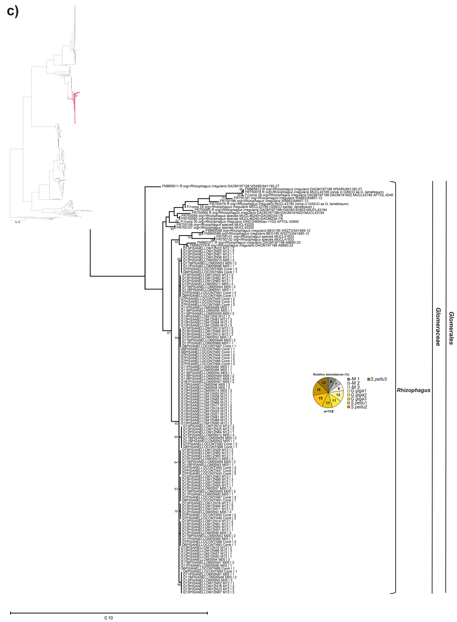

Fig. S1 Maximum Likelihood (ML) tree of sequences of arbuscular mycorrhizal fungi (AMF; Glomeromycota) retrieved at 2nd harvest within the roots of tomato (Solanum lycopersicum L.) var. Pisanello inoculated with AMF at nursery and mock inoculated (control, -M). Inocula were: Gigaspora gigantea (G.giga) and Scutellospora pellucida (S.pellu) belonging to Gigasporaceae, and Funneliformis mosseae (F.mos) and Sclerocystis sinuosa (S.sin) belonging to Glomeraceae. The ML tree is based on sequences obtained from the amplification of part of the SSU, the complete ITS region, and ca. 0.8 kb of the LSU rRNA gene (ca. 1500-bp-long fragment) (Krüger et al. 2009). Fragments were amplified using the primer pair SSUmAf–LSUmAr and then the SSUmCf and LSUmBr as nested primers. The tree is composed by 765 newly generated sequences belonging to 11 phylotypes, plus 161 reference sequences from NCBI. Bootstrap values (based on 1 000 replicates) are shown at the nodes. The Tamura-Nei model was used in the analysis (Tamura and Nei 1993). The scale bar indicates substitutions per site. Portions of the ML tree are shown (a-g). Pie charts represent the percentage of clones of each phylotype in the three replicates of each treatment. The sequences of Paraglomus occultum IA702 was used as outgroup. The newly generated sequences are black coloured, while the reference sequences from NCBI are red coloured. The newly generated sequences are named as follows (e.g. MD126.II.3.Q11Pis13): MD126 refers to the AM fungal isolate (see Table S1); II refers to the second harvest; 3 refers to the number of replicate plot; Q11 refers the number of the plate of the Sanger Run; Pis refers to variety Pisanello; 13 refers to the number of the clones within the specific AM fungal treatment and replicate plot. Evolutionary analyses were conducted in MEGA 11 (Stecher et al. 2020; Tamura et al. 2021). All representative newly generated sequences were deposited in the NCBI Sequence Read (SRA) database as SUB13362899.

Fig. S2 Maximum Likelihood (ML) tree of sequences of AMF (Glomeromycota) retrieved at transplanting within the roots of tomato (Solanum lycopersicum L.) var. Rio Grande inoculated with AMF at nursery and mock inoculated (control, -M). Inocula were: Gigaspora gigantea (G.giga) and Scutellospora pellucida (S.pellu) belonging to Gigasporaceae, and Funneliformis mosseae (F.mos) and Sclerocystis sinuosa (S.sin) belonging to Glomeraceae. The ML tree is based on sequences obtained from the amplification of part of the SSU, the complete ITS region, and ca. 0.8 kb of the LSU rRNA gene (ca. 1500-bp-long fragment) (Krüger et al. 2009). Fragments were amplified using the primer pair SSUmAf–LSUmAr and then the SSUmCf and LSUmBr as nested primers. The tree is composed by 211 newly generated sequences belonging to four phylotypes, plus 158 reference sequences from NCBI. Bootstrap values (based on 1 000 replicates) are shown at the nodes. The Tamura-Nei model was used in the analysis (Tamura and Nei 1993). The scale bar indicates substitutions per site. Portions of the ML tree are shown (a-c). Pie charts represent the percentage of clones of each phylotype in the three replicates of each treatment. The sequences of Paraglomus occultum IA702 was used as outgroup. The newly generated sequences are black coloured, while the reference sequences from NCBI are red coloured. The newly generated sequences are named as follows (e.g. MD118.3.Q14RG69): MD118 refers to the AM fungal isolate (see Table S1); 3 refers to the number of replicate plot; Q14 refers the number of the plate of the Sanger Run; RG refers to variety Rio Grande; 69 refers to the number of the clones within the specific AM fungal treatment and replicate plot. Evolutionary analyses were conducted in MEGA 11 (Stecher et al. 2020; Tamura et al. 2021). All representative newly generated sequences were deposited in the NCBI Sequence Read (SRA) database as SUB13324118 and numbers of accession are OQ975049-OQ975259.

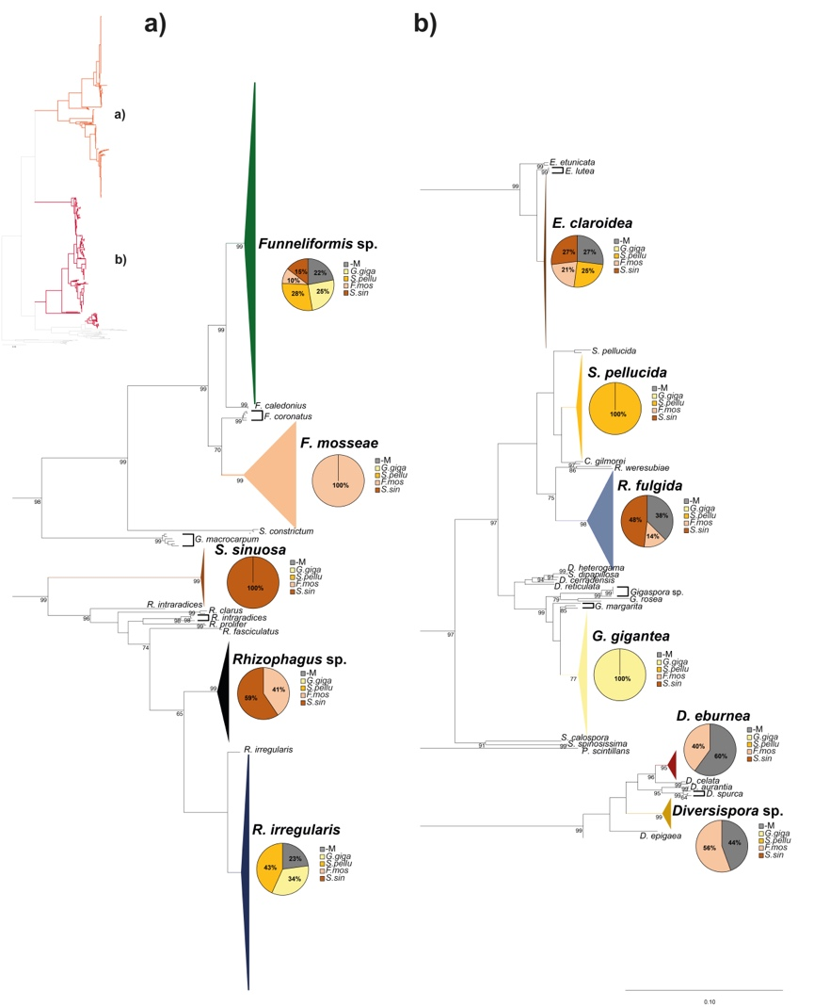

Fig. S3 Collapsed Maximum Likelihood (ML) tree of sequences of AMF (Glomeromycota) retrieved at transplanting within the roots of tomato (Solanum lycopersicum L.) var. Rio Grande inoculated with AMF at nursery and mock inoculated (control, -M). Inocula were: Gigaspora gigantea (G.giga) and Scutellospora pellucida (S.pellu) belonging to Gigasporaceae, and Funneliformis mosseae (F.mos) and Sclerocystis sinuosa (S.sin) belonging to Glomeraceae. The ML tree is based on sequences obtained from the amplification of part of the SSU, the complete ITS region, and ca. 0.8 kb of the LSU rRNA gene (ca. 1500-bp-long fragment) (Krüger et al. 2009). Fragments were amplified using the primer pair SSUmAf–LSUmAr and then the SSUmCf and LSUmBr as nested primers. The tree is composed by 211 newly generated sequences belonging to four phylotypes, plus 158 reference sequences from NCBI (see Fig. S2 for the whole ML tree including the accession numbers of the newly generated and reference AM fungal sequences). Bootstrap values (based on 1 000 replicates) are shown at the nodes. The Tamura-Nei model was used in the analysis (Tamura and Nei 1993). The scale bar indicates substitutions per site. Portions of the ML tree are shown (a) and (b). Collapsed phylotypes are shown by coloured branches and triangles. Pie charts represent the relative abundances of each phylotypes (calculated as number of clones in each treatment divided by total number of clones of the phylotype and multiplied by 100). The sequences of Paraglomus occultum IA702 was used as outgroup. The newly generated sequences are highlighted in boldface, see collapsed branches. Evolutionary analyses were conducted in MEGA 11 (Stecher et al. 2020; Tamura et al. 2021).

Fig. S4 Maximum Likelihood (ML) tree of sequences of AMF (Glomeromycota) retrieved at 2nd harvest within the roots of tomato (Solanum lycopersicum L.) var. Rio Grande inoculated with AMF at nursery and mock inoculated (control, -M). Inocula were: Gigaspora gigantea (G.giga) and Scutellospora pellucida (S.pellu) belonging to Gigasporaceae, and Funneliformis mosseae (F.mos) and Sclerocystis sinuosa (S.sin) belonging to Glomeraceae. The ML tree is based on sequences obtained from the amplification of part of the SSU, the complete ITS region, and ca. 0.8 kb of the LSU rRNA gene (ca. 1500-bp-long fragment) (Krüger et al. 2009). Fragments were amplified using the primer pair SSUmAf–LSUmAr and then the SSUmCf and LSUmBr as nested primers. The tree is composed by 788 newly generated sequences belonging to 15 phylotypes, plus 162 reference sequences from NCBI. Bootstrap values (based on 1 000 replicates) are shown at the nodes. The Tamura-Nei model was used in the analysis (Tamura and Nei 1993). The scale bar indicates substitutions per site. Portions of the ML tree are shown (a-g). Pie charts represent the percentage of clones of each phylotype in the three replicates of each treatment. The sequences of Paraglomus occultum IA702 was used as outgroup. The newly generated sequences are black coloured, while the reference sequences from NCBI are red coloured. The newly generated sequences are named as follows (e.g. MD126.II.1.Q17RG31): MD126 refers to the AM fungal isolate (see Table S1); II refers to the second harvest; 1 refers to the number of replicate plot; Q17 refers the number of the plate of the Sanger Run; RG refers to variety Rio Grande; 31 refers to the number of the clones within the specific AM fungal treatment and replicate plot. Evolutionary analyses were conducted in MEGA 11 (Stecher et al. 2020; Tamura et al. 2021). All representative newly generated sequences were deposited in the NCBI Sequence Read (SRA) database as SUB13375274.

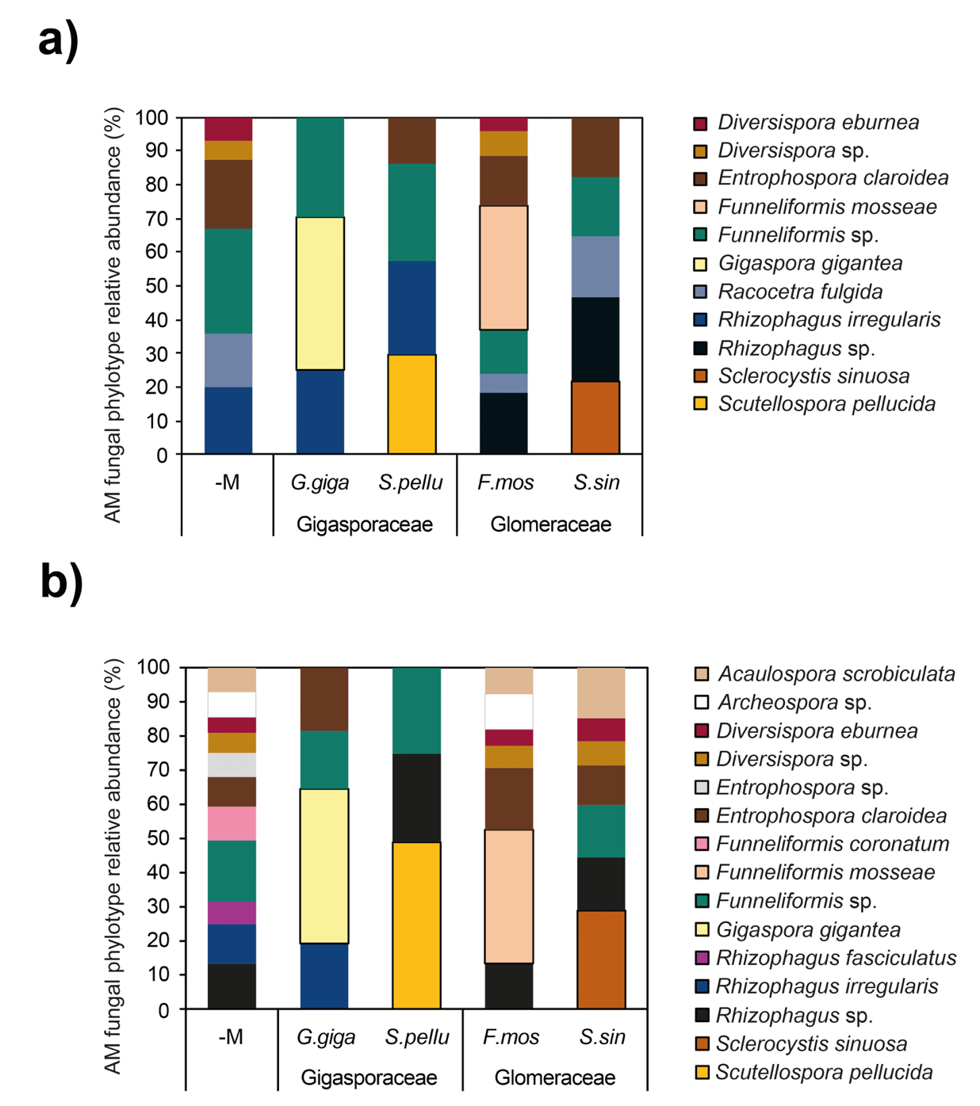

Fig. S5 Effect of AM fungal inoculation on the relative abundance of AMF phylotypes in roots of tomato (Solanum lycopersicum L.) var. Pisanello (a) and var. Rio Grande (b). Plants were inoculated with at nursery and mock inoculated (control, -M). Inocula were: Gigaspora gigantea (G.giga) and Scutellospora pellucida (S.pellu) belonging to Gigasporaceae, and Funneliformis mosseae (F.mos) and Sclerocystis sinuosa (S.sin) belonging to Glomeraceae.

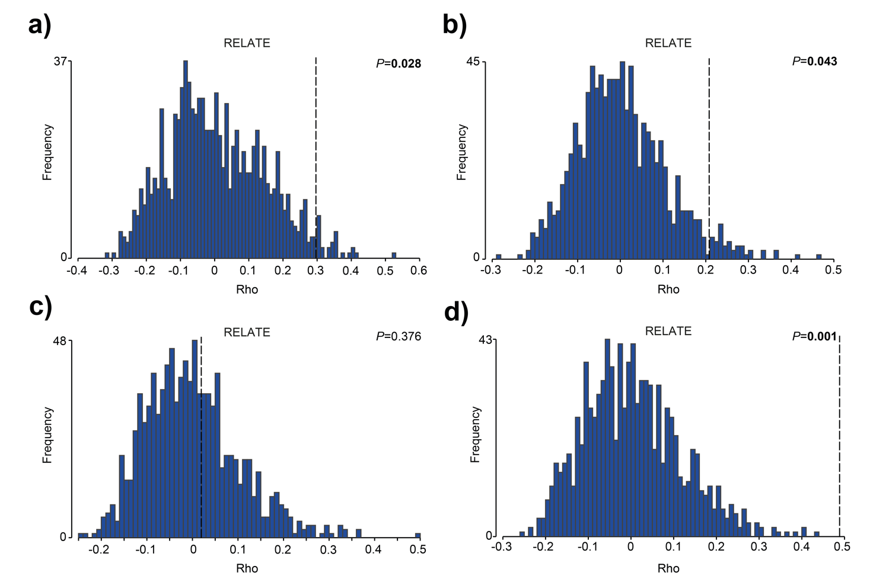
Fig. S6 RELATE analysis based on Spearman rank and 999 permutations for testing the significance of the relationship between the two matrices: the matrix of AM fungal colonisation traits and fruits quality parameters in var. Pisanello (a) and var. Rio Grande (b); the matrix of AMF community structure and fruits quality parameters in var. Pisanello (c) and var. Rio Grande (d) (ρ = 1 perfect relationship) (Clarke and Warwick 2001). Significant P values are highlighted boldface. The analysis was carried out using PRIMER 7 and PERMANOVA + software (Anderson et al. 2008; Clarke and Gorley 2015).

References
Anderson MJ, Gorley RN, Clarke RK (2008) Permanova+ for Primer: guide to Software and Statistical Methods. Plymouth: PRIMER-E
Clarke KR, Gorley RN (2015) Getting Started with PRIMER v7. Plymouth: PRIMER-E
Clarke KR, Warwick R (2001) Change in marine communities: an approach to statistical analysis and interpretation. Plymouth: PRIMER-E
Krüger M, Stockinger H, Krüger C, Schüßler A (2009) DNA‐based species level detection of Glomeromycota: one PCR primer set for all arbuscular mycorrhizal fungi. New Phytol 183:212-223
Stecher G, Tamura K., Kumar S (2020). Molecular Evolutionary Genetics Analysis (MEGA) for macOS. Mol Biol Evol 37:1237-1239
Tamura K, Nei M (1993) Estimation of the number of nucleotide substitutions in the control region of mitochondrial DNA in humans and chimpanzees. Mol Biol Evol 10:512-526
Tamura K, Stecher G, Kumar S (2021) MEGA 11: Molecular Evolutionary Genetics Analysis Version 11. Mol Biol Evol 38:3022–3027

