Supplementary files
Table S1. Treatment means and standard deviation in brackets of the soil physiochemical variables at 0-10 cm depth.
Date Treatment¹ pH EC² TOC Nt C/N CEC Bs
_______________________________________________________________________________________________________________________________________________________________
May 2018 A 6.3 (0.1) 0.8 (0.1) 27.4 (2.8) 1.8 (0.3) 15.2 (0.8) 26.4 (2.3) 23.2 (2.2)
B 6.1 (0.3) 1.0 (0.1) 29.0 (2.6) 2.0 (0.2) 14.4 (0.9) 25.8 (3.7) 21.4 (4.8)
C 6.3 (0.2) 0.8 (0.1) 28.5 (4.7) 2.1 (0.4) 13.8 (0.5) 26.4 (2.9) 23.3 (2.9)
D 6.1 (0.1) 1.0 (0.1) 27.6 (5.8) 2.2 (0.5) 12.8 (0.8) 24.4 (3.2) 19.8 (3.4)
Oct 2018 A 6.3 (0.1) 0.9 (0.2) 26.9 (3.3) 1.8 (0.2) 14.6 (1.0) 25.8 (3.8) 22.2 (4.1)
B 6.2 (0.2) 1.0 (0.1) 31.1 (3.4) 2.3 (0.2) 13.8 (0.6) 24.0 (3.1) 20.9 (3.3)
C 6.1 (0.2) 1.6 (0.1) 28.1 (4.8) 2.0 (0.4) 14.3 (0.2) 25.2 (1.9) 20.7 (2.7)
D 6.0 (0.3) 1.5 (0.3) 26.8 (4.9) 1.9 (0.4) 13.9 (0.6) 26.0 (3.9) 19.5 (3.5)
Oct 2019 A 6.3 (0.1) 0.6 (0.0) 26.8 (3.7) 2.2 (0.3) 12.4 (1.1) 21.6 (2.0) 19.9 (2.4)
B 6.2 (0.1) 0.7 (0.1) 29.1 (3.0) 2.5 (0.2) 11.8 (0.4) 18.5 (2.7) 17.3 (3.5)
C 6.1 (0.1) 0.9 (0.1) 28.2 (3.4) 2.3 (0.3) 12.4 (0.9) 20.8 (2.3) 18.5 (2.2)
D 6.2 (0.1) 0.8 (0.1) 30.2 (8.0) 2.6 (0.7) 11.8 (0.6) 22.0 (1.2) 20.1 (1.7)
Oct 2020 A 6.3 (0.1) 0.7 (0.0) 25.9 (2.5) 1.6 (0.3) 16.8 (2.5) 22.0 (2.0) 19.1 (1.7)
B 6.2 (0.3) 0.8 (0.1) 28.1 (3.8) 2.0 (0.3) 14.4 (1.0) 21.2 (3.3) 17.7 (3.5)
C 6.2 (0.2) 0.8 (0.0) 29.4 (4.9) 2.0 (0.4) 14.7 (0.8) 22.8 (1.9) 19.1 (1.1)
D 6.2 (0.1) 0.8 (0.1) 24.9 (3.4) 1.8 (0.4) 14.3 (1.4) 22.8 (3.5) 19.2 (3.0)
________________________________________________________________________________________________________________________________________________________________
EC, Electrical Conductivity [dS/m]; TOC, Total Organic C [g/kg]; Nt, total N [g/kg]; C/N, Ratio C and N; CEC, Cation Exchange Capacity [cmol/kg]; Bs, sum of base cations [cmol/kg]
¹Treatments (A and C) were conventionally tilled (CT; moldboard ploughing to a depth of 20 cm) and treatments (B and D) were no-till (NT) treatments for 10 years until May 2018. Thereafter all treatments started with barley and the division between CT and NT continued but A was diversified with a cover crop in Oct 2018, B continued as a monoculture and treatments C and D received a rotation in Oct 2019.
²The estimated means of the CT treatment (A, C) differed significantly (p = 0.034) from the NT treatment (B, D) in May 2018.

Table S2. Differentially abundant fungal OTUs according to paired comparisons by ANCOM-BC analysis. Log2FoldChange (lfc) value below 2 and above -2 are used as threshold levels for differential abundance with significance p<0.05. If there was more than one OTU representing the same taxa, only the highest or lowest lfc are shown.
Comparison OTU lfc Phylum Class Order Family Genus Function
______________________________________________________________________________________________________________________________________________________________________________________________________________________
May 18 AC OTU_12 -5.1 unknown unknown unknown unknown unknown
(CT) OTU_1067 -4.2 Basidiomycota Geminibasidiomycetes Geminibasidiales Geminibasidiaceae Geminibasidium SAP
OTU_21 -3.9 Ascomycota Leotiomycetes unknown unknown unknown
OTU_1046 -3.6 Mortierellomycota Mortierellomycetes Mortierellales Mortierellaceae Mortierella SAP
OTU_93 -3.0 Ascomycota unknown unknown unknown unknown
OTU_1072 -2.6 Ascomycota Leotiomycetes Helotiales unknown unknown
OTU_139 -2.5 unknown unknown unknown unknown unknown
May 18 BD OTU_45 2.5 Ascomycota Leotiomycetes Helotiales Helotiaceae unknown
(NT) OTU_86 3.0 Glomeromycota Glomeromycetes Glomerales Glomeraceae unknown SYM
OTU_1057 3.3 Ascomycota Pezizomycetes Pezizales Pezizaceae Peziza SAP-SYM
OTU_64 3.4 Ascomycota Pezizomycetes Pezizales Pyronemataceae unknown
______________________________________________________________________________________________________________________________________________________________________________________________________________________
Oct 19 AB OTU_51 -3.5 Basidiomycota Agaricomycetes Agaricales unknown unknown
(barley) OTU_1069 -3.4 Ascomycota Leotiomycetes Helotiales Helotiaceae unknown
OTU_88 -2.7 Ascomycota Leotiomycetes Helotiales unknown unknown
OTU_58 -2.5 unknown unknown unknown unknown unknown
Oct 19 CD OTU_155 2.7 Ascomycota Leotiomycetes Helotiales unknown unknown
(rapeseed) OTU_114 3.1 Ascomycota Leotiomycetes Helotiales Helotiaceae Pseudohelotium
OTU_40 3.4 Ascomycota Eurotiomycetes Chaetothyriales unknown unknown
OTU_1133 3.5 Basidiomycota Agaricomycetes Sebacinales Serendipitaceae unknown SYM
OTU_1059 3.9 Glomeromycota Paraglomeromycetes Paraglomerales unknown unknown SYM
OTU_1062 4.1 Olpidiomycota Olpidiomycetes Olpidiales Olpidiaceae Olpidium PAT
OTU_59 4.5 Blastocladiomycota unknown unknown unknown unknown
OTU_74 4.6 Basidiomycota Tremellomycetes Filobasidiales Filobasidiaceae Naganishia SAP
OTU_17 5.6 Ascomycota unknown unknown unknown unknown
OTU_1054 5.6 Basidiomycota Agaricomycetes Thelephorales Thelephoraceae Amaurodon SYM
______________________________________________________________________________________________________________________________________________________________________________________________________________________

Table S3. Differentially abundant bacterial OTUs according to paired comparisons by ANCOM-BC analysis. Log2FoldChange (lfc) value below 2 and above -2 are used as threshold levels for differential abundance with significance p<0.0001. If there was more than one OTU representing the same taxa, only the highest or lowest lfc are shown.
Comparison OTU lfc Phylum Class Order Family Genus
______________________________________________________________________________________________________________________________________________________________________________________________________________________May 18 AC OTU_1807 -3.0 Actinobacteria Actinobacteria Propionibacteriales Nocardioidaceae Nocardioides
(CT) OTU_1038 -2.8 Acidobacteria Thermoanaerobaculia Thermoanaerobaculales Thermoanaerobaculaceae unknown
OTU_2849 -2.5 Bacteroidetes Bacteroidia Chitinophagales Chitinophagaceae Flavisolibacter
May 18 BD OTU_8307 2.6 Rokubacteria NC10 Rokubacteriales unknown unknown
(NT) OTU_3890 3.1 Chloroflexi Ktedonobacteria Ktedonobacterales Ktedonobacteraceae unknown
OTU_36 3.3 Acidobacteria Acidobacteriia Acidobacteriales Koribacteraceae Can Koribacter
OTU_1157 3.4 Actinobacteria Acidimicrobiia unknown unknown unknown
OTU_5778 3.5 Proteobacteria Alphaproteobacteria Elsterales unknown unknown
OTU_7913 3.5 Proteobacteria Gammaproteobacteria Diplorickettsiales Diplorickettsiaceae Aquicella
OTU_5814 3.6 Proteobacteria Alphaproteobacteria Micropepsales Micropepsaceae unknown
OTU_3270 3.7 Chloroflexi AD3 unknown unknown unknown
OTU_6480 4.5 Proteobacteria Deltaproteobacteria Desulfuromonadales Geobacteraceae Geobacter
______________________________________________________________________________________________________________________________________________________________________________________________________________________
Oct 19 AB - - - - - - -
(barley)
Oct 19 CD - - - - - - -
(rapeseed)
______________________________________________________________________________________________________________________________________________________________________________________________________________________

Table S4. The estimated means of fixed effects for the fungal (ITS) or bacterial (16S) alpha-diversity measures HillQ0 (species richness), HillQ1 and HillQ2. Comparisons denoted with the different letter differed statistically significantly from each other (p<0.10). The letters from a to c are used for row-wise comparisons and the letters from u to v for column-wise comparisons, respectively. The values in the parentheses are the lower and upper limits of 95% confidence intervals of the estimates.
Response variable | Treatment | May 2018 | Oct 2018 | Oct 2019 | Oct 2020
ITSHillQ0 | A | 250^{ab} [214, 285] | 223^{a,u} [191, 256] | 244^{ab} [198, 290] | 282^{b} [229, 335]
ITSHillQ0 | B | 209ª [175, 243] | 221^{a,u} [188, 254] | 283^{b} [237, 329] | 281^{b} [228, 334]
ITSHillQ0 | C | 249 [216, 283] | 241^{uv} [209, 274] | 289 [243, 334] | 279 [225, 332]
ITSHillQ0 | D | 216ª [182, 250] | 270^{b,v} [237, 302] | 304^{b} [259, 350] | 295^{b} [242, 348]
ITSHillQ1 | A | 12.7^{ab} [8.1, 19.8] | 11.9ª [7.6, 18.5] | 13.6^{ab} [8.7, 21.1] | 14.8^{b} [9.5, 23.0]
ITSHillQ1 | B | 12.3ª [7.9, 19.2] | 9.0^{b} [5.8, 14.1] | 12.2ª [7.9, 19.0] | 11.6ª [7.5, 18.1]
ITSHillQ1 | C | 12.1ª [7.8, 18.9] | 12.1ª [7.8, 18.7] | 14.7^{ab} [9.5, 22.9] | 15.2^{b} [9.8, 23.7]
ITSHillQ1 | D | 10.0ª [6.4, 15.5] | 14.1^{b} [9.1, 21.9] | 16.0^{b} [10.3, 24.9] | 14.9^{b} [9.6, 23.1]
ITSHillQ2 | A | 5.9 [3.8, 8.1] | 5.3 [3.3, 7.4] | 5.8 [3.8, 7.9] | 6.5 [4.5, 8.6]
ITSHillQ2 | B | 6.2ª [4.2, 8.3] | 4.1^{b} [2.0, 6.2] | 5.6ª [3.5, 7.6] | 5.2^{ab} [3.1, 7.2]
ITSHillQ2 | C | 5.2^{ab} [3.2, 7.3] | 4.8ª [2.7, 6.8] | 6.0^{ab} [4.0, 8.1] | 6.6^{b} [4.6, 8.7]
ITSHillQ2 | D | 4.2ª [2.1, 6.2] | 6.0^{b} [3.9, 8.0] | 6.4^{b} [4.3, 8.4] | 5.3^{ab} [3.3, 7.4]
16SHillQ0 | A | 750 [474, 1026] | 642^{u} [503, 780] | 842 [614, 1070] | 927 [571, 1282]
16SHillQ0 | B | 769ª [493, 1045] | 806^{a,v} [668, 944] | 612ª [384, 840] | 1296^{b} [940, 1651]
16SHillQ0 | C | 866^{ab} [590, 1143] | 668^{a,uv} [530, 806] | 694ª [465, 922] | 1266^{b} [910, 1622]
16SHillQ0 | D | 716ª [440, 992] | 717^{a,uv} [579, 885] | 768^{ab} [540, 997] | 1247^{b} [892, 1603]
16SHillQ1 | A | 474 [310, 638] | 416 [332, 499] | 544 [397, 691] | 548 [350, 746]
16SHillQ1 | B | 470ª [306, 634] | 511ª [428, 594] | 393ª [247, 540] | 835^{b} [637, 1033]
16SHillQ1 | C | 552^{ab} [388, 716] | 438ª [355, 521] | 448ª [301, 595] | 812^{b} [614, 1010]
16SHillQ1 | D | 440ª [276, 604] | 461ª [377, 544] | 493ª [346, 639] | 798^{b} [600, 996]
16SHillQ2 | A | 272 [165, 380] | 244 [0, 493] | 330 [229, 431] | 312^{u} [196, 428]
16SHillQ2 | B | 262ª [154, 369] | 302ª [54, 551] | 224ª [123, 325] | 505^{b,v} [389, 621]
16SHillQ2 | C | 313ª [206, 421] | 255ª [6, 504] | 261ª [159, 362] | 491^{b,uv} [375, 607]
16SHillQ2 | D | 252ª [145, 360] | 269ª [20, 518] | 283ª [182, 384] | 484^{b,uv} [368, 600]

Table S5. The estimated means of fixed effects for relative proportion of fungal guilds SYM, SAP, PAT, qPCR of genes involved in the N cycle (amoA, narG and nirK), and potential nitrification (PN). Comparisons denoted with the different letter differed statistically significantly from each other (p<0.10). The letters from a to c are used for row-wise comparisons and the letters from u to x for column-wise comparisons, respectively. The values in the parentheses are the lower and upper limits of 95% confidence intervals of the estimates.
Response variable | Treatmentª | May 2018 | Oct 2018 | Oct 2019 | Oct 2020
SYM | A | 0.011 [0.006, 0.021] | 0.019 [0.011, 0.032] | 0.016^{uv} [0.009, 0.027] | 0.015^{uv} [0.009, 0.026]
SYM | B | 0.008 [0.005, 0.014] | 0.011 [0.006, 0.020] | 0.013^{u} [0.008, 0.022] | 0.015^{u} [0.009, 0.025]
SYM | C | 0.010ª [0.006, 0.017] | 0.012ª [0.007, 0.019] | 0.032^{b,v} [0.019, 0.054] | 0.034^{b,v} [0.020, 0.057]
SYM | D | 0.011ª [0.006, 0.018] | 0.014^{ab} [0.008, 0.024] | 0.024^{b,uv} [0.014, 0.040] | 0.018^{ab,uv} [0.011, 0.031]
SAP | A | 0.026 [0.000, 0.093] | 0.018^{u} [0.007, 0.029] | 0.021 [0.010, 0.031] | 0.021 [0.008, 0.033]
SAP | B | 0.095ª [0.038, 0.152] | 0.015^{b,u} [0.004, 0.026] | 0.024^{b} [0.014, 0.035] | 0.018^{b} [0.005, 0.030]
SAP | C | 0.022 [0.000, 0.079] | 0.021^{a,uv} [0.010, 0.032] | 0.018^{b} [0.008, 0.029] | 0.021 [0.008, 0.033]
SAP | D | 0.019^{ab} [0.000, 0.076] | 0.038^{a,v} [0.027, 0.049] | 0.032^{ab} [0.021, 0.042] | 0.025^{b} [0.012, 0.037]
PAT | A | 0.0003ª [0.0002, 0.0007] | 0.0004^{a,uv} [0.0002, 0.0007] | 0.0014^{b,u} [0.0008, 0.0025] | 0.0004^{ab,uv} [0.0003, 0.0008]
PAT | B | 0.0004 [0.0002, 0.0007] | 0.0003^{v} [0.0002, 0.0006] | 0.0005^{x} [0.0003, 0.0009] | 0.0004^{v} [0.0002, 0.0007]
PAT | C | 0.0006ª [0.0004, 0.0011] | 0.0004^{a,uv} [0.0002, 0.0007] | 0.0064^{b,v} [0.0037, 0.0110] | 0.0008^{a,uv} [0.0005, 0.0014]
PAT | D | 0.0004ª [0.0003, 0.0008] | 0.0009^{ab,u} [0.0005, 0.0016] | 0.0071^{c,v} [0.0041, 0.0122] | 0.0014^{b,u} [0.0008, 0.0025]
amoA (values × 10⁸) | A | 0.84 [0.61, 1.15] | 0.83^{u} [0.61, 1.14] | 1.01^{uv} [0.73, 1.38] | 0.77 [0.56, 1.06]
amoA (values × 10⁸) | B | 1.06^{ab} [0.77, 1.46] | 0.80^{a,u} [0.58, 1.10] | 1.21^{b,u} [0.88, 1.67] | 0.99^{ab} [0.72, 1.36]
amoA (values × 10⁸) | C | 0.75 [0.55, 1.03] | 0.79^{u} [0.58, 1.09] | 0.68^{v} [0.50, 0.94] | 0.83 [0.61, 1.14]
amoA (values × 10⁸) | D | 0.79ª [0.57, 1.08] | 1.51^{b,v} [1.10, 2.08] | 1.67^{b,u} [1.22, 2.29] | 0.80ª [0.58, 1.09]
narG (values × 10⁸) | A | 1.95 [1.35, 2.56] | 1.74^{uv} [1.09, 2.39] | 1.48 [0.69, 2.28] | 1.48 [-, -]
narG (values × 10⁸) | B | 1.80ª [1.24, 2.36] | 1.41^{ab,v} [0.77, 2.05] | 1.80^{ab} [1.08, 2.51] | 1.24^{b} [-, -]
narG (values × 10⁸) | C | 1.29ª [0.51, 2.07] | 1.98^{b,uv} [1.27, 2.69] | 1.53^{ab} [0.88, 2.17] | 1.46^{ab} [0.07, 2.84]
narG (values × 10⁸) | D | 1.76^{ab} [1.14, 2.38] | 2.37^{a,u} [1.62, 3.11] | 1.89^{ab} [1.29, 2.49] | 1.47^{b} [0.93, 2.01]
nirK (values × 10⁸) | A | 0.85^{a,u} [0.65, 1.13] | 0.85ª [0.65, 1.13] | 1.86^{b,u} [1.40, 2.45] | 1.19^{a,u} [0.90, 1.58]
nirK (values × 10⁸) | B | 0.55^{a,v} [0.42, 0.73] | 0.66ª [0.50, 0.87] | 2.28^{b,x} [1.73, 3.02] | 1.11^{c,u} [0.84, 1.46]
nirK (values × 10⁸) | C | 0.60^{a,uv} [0.45, 0.79] | 0.80ª [0.60, 1.05] | 0.55^{a,v} [0.42, 0.73] | 1.61^{b,uv} [1.22, 2.13]
nirK (values × 10⁸) | D | 0.52^{a,v} [0.39, 0.68] | 0.78^{b} [0.59, 1.03] | 0.61^{a,uv} [0.46, 0.81] | 1.99^{c,v} [1.51, 2.63]
PN | A | 168^{ab} [112, 224] | 131^{a,u} [74, 187] | 184^{ab,u} [128, 240] | 224^{b,u} [168, 281]
PN | B | 163ª [107, 219] | 199^{ab,u} [143, 255] | 255^{b,u} [199, 311] | 202^{ab,u} [146, 258]
PN | C | 175^{ab} [119, 231] | 129^{a,uv} [73, 185] | 222^{bc,u} [165, 278] | 276^{c,u} [220, 332]
PN | D | 180ª [124, 236] | 240^{a,v} [183, 296] | 342^{b,v} [285, 398] | 379^{b,v} [323, 436]
ªSee Table 1 for explanations

Table S6. Differences between tillage and non-tillage in May 2018. Bonferroni-level is now calculated 0.05 divided by the number of comparisons (=15). Thus, a significant p-value should be under that.
Variable | Effect | Label | Difference | t Value | P value | Bonferroni level | Decision
ITS_HillQ0 | Treatment*Time | CT vs NT, time 1 | 28.97 | 2.34 | 0.045 | 0.003 | Significant
ITS_HillQ1 | Treatment*Time | CT vs NT, time 1 | -0.07 | -0.33 | 0.749 | 0.003 | No significance
ITS_HillQ2 | Treatment*Time | CT vs NT, time 1 | -1.11 | -0.98 | 0.340 | 0.003 | No significance
16S_HillQ0 | Treatment*Time | CT vs NT, time 1 | 7.51 | 0.05 | 0.960 | 0.003 | No significance
16S_HillQ1 | Treatment*Time | CT vs NT, time 1 | 18.53 | 0.21 | 0.837 | 0.003 | No significance
16S_HillQ2 | Treatment*Time | CT vs NT, time 1 | 17.07 | 0.3 | 0.763 | 0.003 | No significance
SYM | Treatment*Time | CT vs NT, time 1 | 0.25 | 0.9 | 0.376 | 0.003 | No significance
SAP | Treatment*Time | CT vs NT, time 1 | -0.07 | -2.35 | 0.037 | 0.003 | No significance
PAT | Treatment*Time | CT vs NT, time 1 | 0.22 | 0.73 | 0.469 | 0.003 | No significance
PN | Treatment*Time | CT vs NT, time 1 | 10.98 | 0.38 | 0.708 | 0.003 | No significance
amoA | Treatment*Time | CT vs NT, time 1 | -0.31 | -1.72 | 0.095 | 0.003 | No significance
narG | Treatment*Time | CT vs NT, time 1 | -1.4E+07 | -0.46 | 0.648 | 0.003 | No significance
nirK | Treatment*Time | CT vs NT, time 1 | 0.13 | 0.88 | 0.383 | 0.003 | No significance

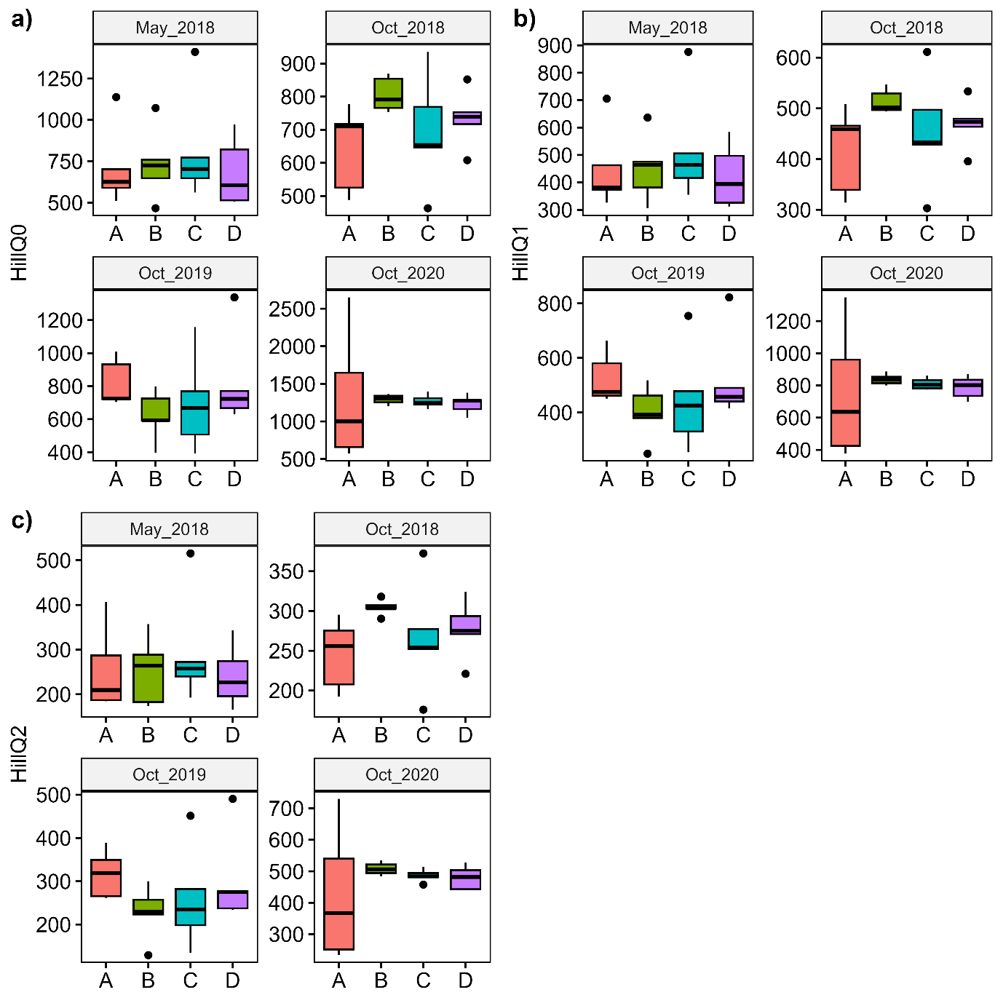
Figure S1. Boxplots representing the alpha diversity measures as Hills numbers a) Q0, b) Q1 and c) Q2 for fungal ITS data in different treatments (A, B, C, D) and sampling times (May 2018, October 2018, October 2019, October 2020).

Figure S2. Boxplots representing the alpha diversity measures as Hills numbers a) Q0, b) Q1 and c) Q2 for bacterial 16S rRNA data in different treatments (A, B, C, D) and sampling times (May 2018, October 2018, October 2019, October 2020)

