Supplementary Material

Table S1. Dominant microbial taxa identified in both inbred and hybrid rhizospheres under low and high N treatments. Statistical differences among various categories were evaluated using ANOVA following post-hoc Tukey HSD (only p values are shown). LN: Low-N, HN: High-N.

Comparison | Pseudomonas | Ralstonia | Ca._Udaeobacter | Nitrososphaeraceae
Inbred:HN compared to Hybrid:HN | <0.05 | <0.05 | 0.6 | 0.52
Hybrid:LN compared to Hybrid:HN | <0.05 | 1 | <0.05 | <0.05
Inbred:LN compared to Hybrid:HN | <0.05 | <0.05 | <0.05 | <0.05
Hybrid:LN compared to Inbred:HN | <0.05 | <0.05 | <0.05 | <0.05
Inbred:LN compared to Inbred:HN | <0.05 | <0.05 | <0.05 | <0.05
Inbred:LN compared to Hybrid:LN | <0.05 | <0.05 | 0.55 | <0.05

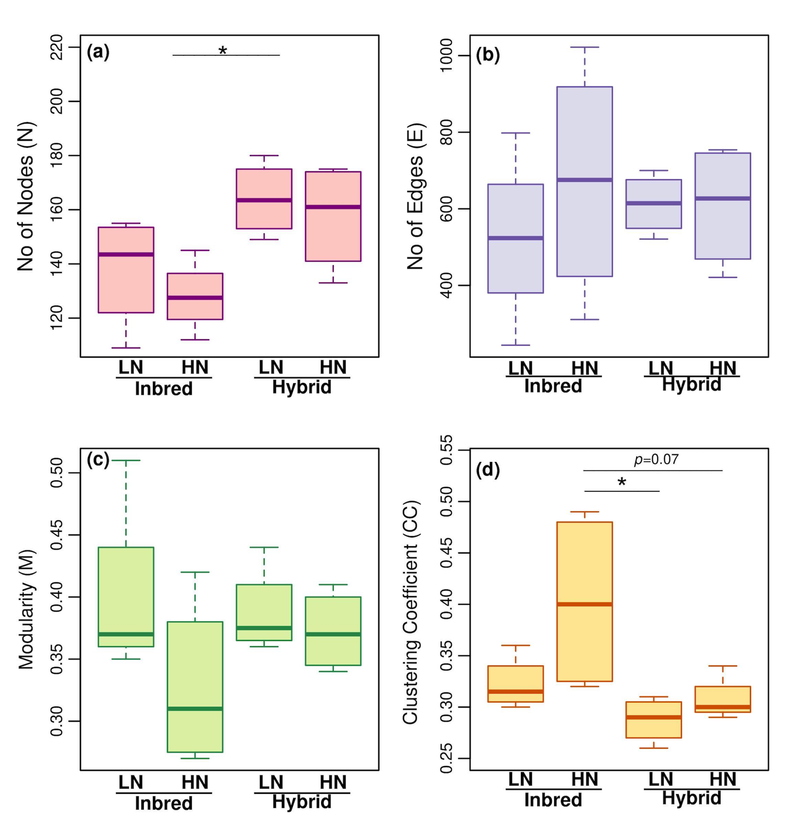
Figure S1: Changes in microbial network topological properties across plant groups and N treatments. Boxplots illustrate topological properties of microbial networks associated with subgroups of stiff stalk (SS) maize inbred lines and their hybrid rhizospheres under low- and high-N treatments. Network topological properties include (a) no of nodes (N), (b) network connectivity (total number of links, E), (c) modularity (M), and (d) clustering coefficient (the extent to which nodes are clustered, CC). Note: Microbial networks representing weak and nonsignificant interactions with a |correlation| < 0.3 and p > 0.05 were excluded from the analysis. * p<0.05 and ** p<0.01.

