Supplementary material 1 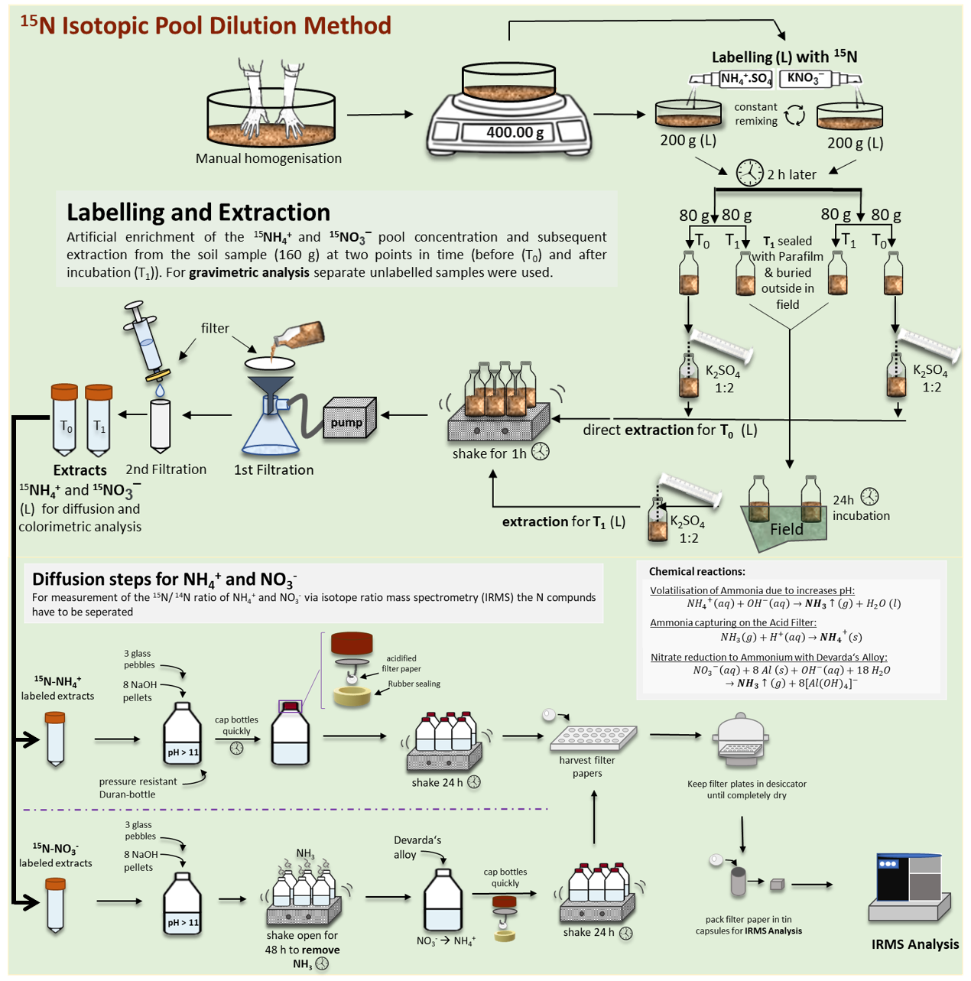
Fig. S1 Methodology used in the ¹⁵N pool dilution technique for the current study which involves the application of ¹⁵N labelling to soil, subsequent incubation to facilitate N assimilation, followed by the collection of samples and extraction of N compounds with the help of potassium sulfate. The extracted solution was then transported from diffusion steps to separate N through acidified filters and evaluated by Isotope-ratio mass spectrometry (IRMS).

