Supplementary information for
Košnar J, Šmilauer P, Šmilaurová M (2025): Arbuscular and fine root-endophytic mycorrhizal fungi forage differently for nutrients in a seminatural temperate grassland. Biology and Fertility of Soils, DOI: 10.1007/s00374-025-01891-8

List of appendices
EA1 | Scheme of the experimental design | 2
EA2 | DNA analyses | 4
EA3 | Overview of G-AMF VTX and M-FRE OTU | 6
EA4 | Nutrient availability, root and hyphal ingrowth into patches, G-AMF and M-FRE colonisation of ingrown roots | 14
EA5 | Foraging speed and precision of G-AMF and M-FRE taxa | 23
EA6 | G-AMF and M-FRE communities in ingrown roots | 34
EA7 | Interaction of patch type and exposure time on M-FRE community composition | 38
EA8 | Spatial structuring of G-AMF and M-FRE communities and differences between original roots and original soil | 39
EA9 | Sensitivity analysis of M-FRE definition on α- and β-diversity and G-AMF / M-FRE ratio models | 42

EA1 – Scheme of the experimental design
Fig. EA1 shows the approximate outline of the experimental design. In the field, the individual blocks were not spread so regularly as shown here, as we had to adjust their location to the presence of plots from other experiments, so that they did not overlap.
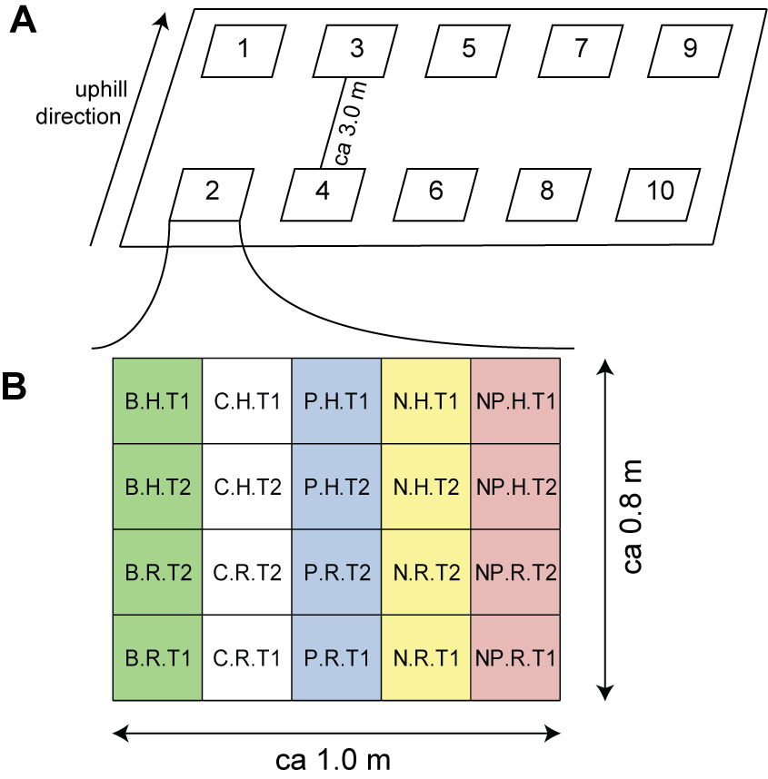
Fig. EA1 – Spatial arrangement of the experimental blocks at a mild hill slope (A) and exemplary arrangement of the plots within each block (B). The blocks were arranged in two rows and five columns, with the rows approximately three metres appart. Part B provides an example of the arrangement of experimental plots in a single block, with different blocks having different, randomised arrangement of the substrate types. Each plot had a single ingrowth patch (with a diameter of three centimetres) in its center. The individual types of substrate modification (adding biomass or inorganic N and/or P) were arranged within the columns, i.e. down the slope of the grassland, to minimise intermixing of experimental treatments due to water movement. Treatment codes encode the enrichment by the first letter (B biomass, C control, P phosphorus, N nitrogen, NP N+P), root access type (R roots and hyphae, H only hyphae), and exposure time (T1 6 weeks, T2 12 weeks). Patches for shorter exposure were arranged in the outer rows to minimise the disturbance during excavation for patches with longer exposure time.

EA2 – DNA analyses
G-AMF community amplification and sequencing
A 550-bp fragment of SSU rDNA was amplified by semi-nested PCR according to Dumbrell et al. (2011) except that PCR primer AML2 (Lee et al. 2008) was used as an AMF-specific primer. The first PCR amplification with the forward primer NS31 (Simon et al. 1992) and reverse primer AML2 was run in a reaction mixture containing 0.7 μL of template DNA, 0.2 mM of each dNTP, 0.4 μM of each primer (Integrated DNA Technologies, Coralville, Iowa, USA), 0.1 U Phusion High-Fidelity DNA Polymerase (New England Biolabs, Ipswich, Massachusetts, USA), 1× Phusion HF buffer, and sterile water to make up a final volume of 5 μL. Each sample was amplified in three independent replicates which were pooled for the next round of amplification (reaction volume of 15 μL). The thermal cycling program consisted of an initial denaturation of 30 s at 98°C; followed by 35 cycles of 10s at 98°C, 30s at 68°C, and 15s at 72°C; and a final extension of 5 min at 72°C.
The second PCR was identical to the first, except that 0.5 μL of the amplicon pool of the first PCR was used as a template, and the WANDA primer (Dumbrell et al. 2011) extended by sample-specific barcode sequences was used as a forward primer, and that the final reaction volume was increased to 10 μL. The barcode sequences were adopted from the Roche Extended Set of multiplex identifiers (MID) (454 Sequencing Technical Bulletin No. 005-2009; Roche, Basel, Switzerland). The thermal cycling conditions were the same as for the first PCR, except that the annealing temperature was set to 60°C and mostly only 10 cycles were used (but 20 or 25 cycles were used for three poorly amplifying root samples). Each sample was amplified in three independent replicates with a final reaction volume of 30 μL. The resulting products of the second PCR were pooled and purified using NucleoSpin Gel and PCR Clean-up kit (Macherey Nagel, Düren, Germany). The individual MID-barcoded samples were pooled and further purified using Agencourt AMPure XP beads (Beckman Coulter Brea, California, USA). The resulting PCR amplicon pool was subjected to Illumina paired-end 2 × 300 bp sequencing performed at the Institute of Applied Biotechnologies (Prague, Czech Republic).
M-FRE community amplification and sequencing and calculation of the G-AMF / M-FRE ratio
A 280-bp fragment of SSU rDNA was amplified using a single-step PCR with the primers pair AMV4.5NF and AMDGR (Saito et al. 2005). The PCR was performed in a reaction mixture containing 1 μL of template DNA, 0.2 mM of each dNTP, 0.3 μM of each primer (Integrated DNA Technologies, Coralville, Iowa, USA), 0.5 U Taq Polymerase (Top-Bio, Prague, Czech Republic) in the manufacturer´s reaction buffer, and sterile water to make up a final volume of 10 μL. The thermal cycling program consisted of an initial denaturation of 3 min at 95°C; followed by 40 cycles of 30 s at 95°C, 30 s at 55°C, and 30 s at 72°C; and a final extension of 10 min at 72°C. Both forward and reverse rimers were fused with a sample-specific barcode sequence to allow identification of individual samples. A set of 12 forward and 16 reverse barcoded primers providing up to 192 possible unique dual combinations was used. The barcode sequences were adopted from Roche’s Extended Set of MIDs (454 Sequencing Technical Bulletin No. 005-2009; Roche, Basel, Switzerland). Each sample was amplified in three independent technical PCR replicates with a final reaction volume of 30 μL. The resulting PCR products were pooled and purified using the NucleoSpin Gel and PCR Clean-up kit (Macherey Nagel, Düren, Germany). Individual barcode-tagged samples were pooled in equimolar concentrations and the pool was further purified using Agencourt AMPure XP beads (Beckman Coulter Brea, California, USA). The paired-end 2 × 250 bp Illumina sequencing was performed at the SEQme company (Dobříš, Czech Republic).

EA3 – Overview of G-AMF VTX and M-FRE OTU
The quality-filtered 18S rDNA sequence dataset amplified with the NS31 and AML2 primers yielded 103 G-AMF virtual taxa (VTX, Table EA1), represented by 233,293 reads. Richest in VTX was family Glomeraceae (69 VTX, representing 81.3% of reads), followed by the families Claroideoglomeraceae (9 VTX, 10.5% of reads), Acaulosporaceae (9 VTX, 2.0% of reads), Diversisporaceae (5 VTX, 0.1% of reads), Paraglomeraceae (4 VTX, 3.4% of reads), Archaeosporaceae (4 VTX, 2.6% of reads), Gigasporaceae (2 VTX, <0.1% of reads), and Ambisporaceae (1 VTX, <0.01% of reads). The most frequent G-AMF morphospecies was Rhizophagus irregularis (represented by three VTX t113, t114, and t115) with substantially higher frequencies in samples from the ingrowth patches with root access (Fig. EA2).
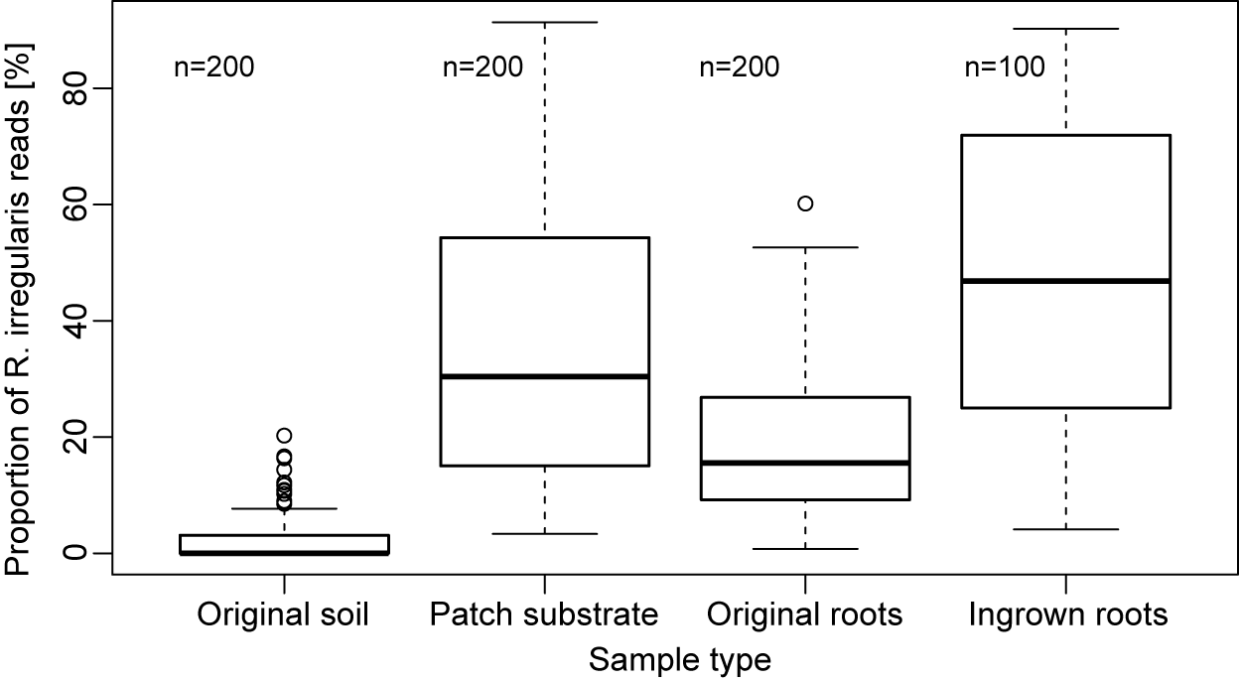
Fig. EA2 – Proportion of Rhizophagus irregularis sequences in the original rhizosphere soil, patch substrate (across all patch types), original roots separated from the original soil at the patch installation time, and roots ingrown into patches after 6 or 12 weeks of exposure in the grassland. The thick horizontal lines indicate medians, the boxes span from the lower to the upper quartile, whiskers reach to extreme data points within median ± 1.5× interquartile range, and empty circles represent outliers. The proportion of R. irregularis reads differs among the four sample types at p < 0.001 (based on a likelihood-ratio test) and also individual pair-wise differences are significant at p < 0.001.
The quality filtered 18S rDNA sequence dataset amplified with the PCR primers AMV4.5NF and AMDGR yielded 14 OTU of the order Endogonales (Table EA2), represented by 195,187 reads. Eight of those OTU are affiliated to sequences previously recognised as M-FRE plant symbionts (mostly by Bidartondo et al. 2011, but also Orchard et al. 2017). The most abundant OTU (Otu004, representing 65.4% of reads) includes sequences identified as OTU0 in Orchard et al. 2017 (where it was also found as the most abundant OTU with 44.6% of reads) and as 8388 OTU in Bidartondo et al. (2011). The second most abundant OTU (Otu012, 26.1% of reads) has no known M-FRE sequence and thus seems to represent novel M-FRE OTU. All remaining OTU were represented by less than 3% of all reads.
G-AMF VTXs were mostly shared among all sample types, i.e. original roots and soil taken at patch installation, the differentially nutrient-enriched zeolite-based substrate in the ingrowth patches, and the roots that had grown into the root access patches. Most of unique VTXs for a particular sample type were observed in the original soil (Fig. EA3).
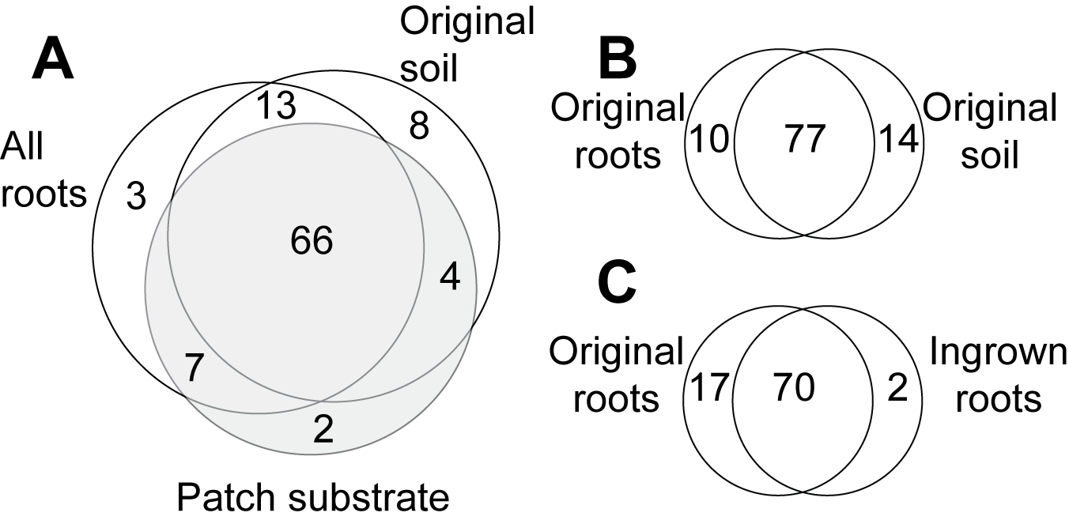
Fig. EA3 – Number of G-AMF VTX shared and unique to different sample types. A: Comparison of all G-AMF communities in original or ingrown roots with original soil and patch substrate; B: Comparison of all G-AMF communities in the original roots and rhizosphere soil; C: Comparison of all G-AMF communities in original roots and roots grown into the patches with root access. n=200 for original soil, original roots, and patch substrate, n=300 for “all roots”, n=100 for ingrown roots.
Most M-FRE OTU were shared among all sample types (Fig. EA4).

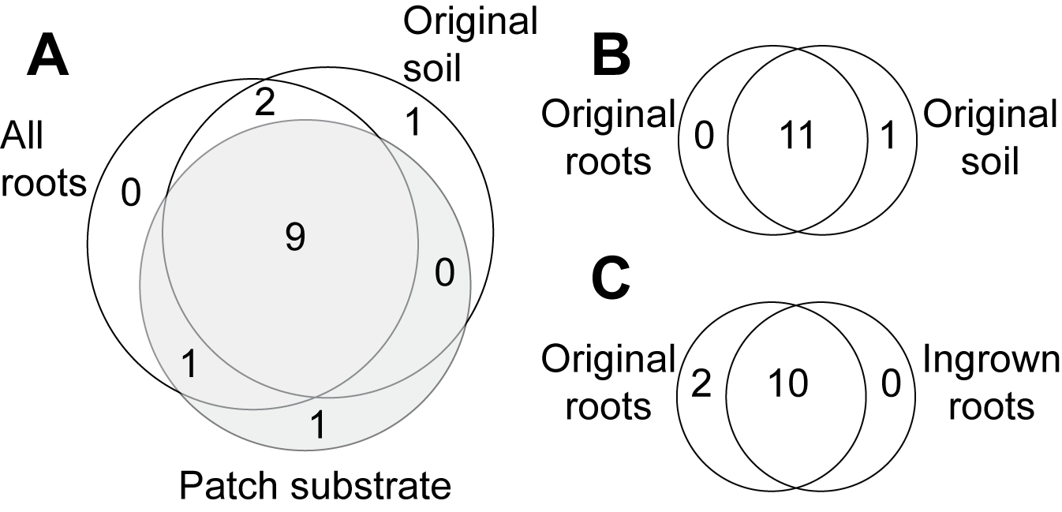
Fig. EA4 – Number of M-FRE OTU shared and unique among different sample types. A: Comparison of M-FRE communities in original or ingrown roots and original soil and patch substrate; B: Comparison of M-FRE communities in original roots and soil; C: Comparison of M-FRE communities in original roots and ingrown roots. n=200 for original soil, original roots, and patch substrate, n=300 for “all roots”, n=100 for ingrown roots.

Table EA1 – List of virtual taxa (VTX) of G-AMF identified in the 18S rDNA sequence dataset obtained with the PCR primers NS31 and AML2. The first column (VTX code) shows the VTX identifiers of the MaarjAM database (except first two entries, which represent novel virtual taxa), the second column shows the identifiers used in this paper, Family assigns VTX to G-AMF family, Genbank accession no. shows the identifier of the reference sequence in Genbank, RelAbund (relative abundance) shows the percentage of sequence reads representing the VTX among all G-AMF reads (700) of all community samples. Cultivation indicates whether any reference of a cultivated strain is recorded in the MaarjAM database. Morphospecies mentions information from the MaarjAM database.
VTX code | Code paper | Family | Genbank accession no. | RelAbund [%] | Cultivation | Morphospecies
CL004 | t004 | Glomeraceae | PQ433016 | 1.10 | no
CL006 | t006 | Glomeraceae | PQ433017 | 0.13 | no
VTX00005 | t005 | Archaeosporaceae | PQ433018 | 0.15 | no
VTX00008 | t008 | Archaeosporaceae | PQ433019 | 0.01 | no
VTX00010 | t010 | Acaulosporaceae | PQ433020 | 0.01 | no
VTX00013 | t013 | Acaulosporaceae | PQ433021 | 0.01 | no
VTX00015 | t015 | Acaulosporaceae | PQ433022 | 0.05 | no
VTX00023 | t023 | Acaulosporaceae | PQ433023 | 0.16 | yes | A. laevis
VTX00028 | t028 | Acaulosporaceae | PQ433024 | 0.01 | yes | A. longula, A. rugosa
VTX00030 | t030 | Acaulosporaceae | PQ433025 | 0.99 | yes | A. scrobiculata
VTX00049 | t049 | Gigasporaceae | PQ433026 | 0.01 | yes | Scutellospora dipurpurescens, S. calospora
VTX00052 | t052 | Gigasporaceae | PQ433027 | 0.05 | yes | Scutellospora calospora, S. aurigloba
VTX00054 | t054 | Diversisporaceae | PQ433028 | 0.03 | yes | D. celata, D. aurantia, Entrophospora nevadensis
VTX00055 | t055 | Claroideoglomeraceae | PQ433029 | 0.03 | no
VTX00056 | t056 | Claroideoglomeraceae | PQ433030 | 0.25 | no
VTX00057 | t057 | Claroideoglomeraceae | PQ433031 | 3.90 | no
VTX00060 | t060 | Diversisporaceae | PQ433032 | <0.01 | yes | D. celata, D. eburnea, D. aurantia
VTX00061 | t061 | Diversisporaceae | PQ433033 | 0.01 | yes | D. epigaea, D. spurca, Glomus versiforme
VTX00062 | t062 | Diversisporaceae | PQ433034 | 0.01 | no
VTX00064 | t064 | Glomeraceae | PQ433035 | 0.13 | yes | G. constrictum
VTX00072 | t072 | Glomeraceae | PQ433036 | 2.96 | no
VTX00074 | t074 | Glomeraceae | PQ433037 | 5.37 | yes
VTX00078 | t078 | Glomeraceae | PQ433038 | 1.55 | no
VTX00096 | t096 | Glomeraceae | PQ433039 | 0.50 | no
VTX00108 | t108 | Glomeraceae | PQ433040 | 5.47 | no
VTX00113 | t113 | Glomeraceae | PQ433041 | 15.44 | yes | Rhizophagus irregularis
VTX00114 | t114 | Glomeraceae | PQ433042 | 0.83 | yes | Rhizophagus irregularis
VTX00115 | t115 | Glomeraceae | PQ433043 | 6.91 | yes | Rhizophagus irregularis
VTX00117 | t117 | Glomeraceae | PQ433044 | 0.47 | no
VTX00118 | t118 | Glomeraceae | PQ433045 | 0.11 | no
VTX00123 | t123 | Glomeraceae | PQ433046 | <0.01 | no
VTX00125 | t125 | Glomeraceae | PQ433047 | 0.08 | no
VTX00129 | t129 | Glomeraceae | PQ433048 | 0.50 | no
VTX00135 | t135 | Glomeraceae | PQ433049 | 0.08 | no
VTX00140 | t140 | Glomeraceae | PQ433050 | <0.01 | no
VTX00143 | t143 | Glomeraceae | PQ433051 | 0.60 | no
VTX00148 | t148 | Glomeraceae | PQ433052 | 0.01 | no
VTX00149 | t149 | Glomeraceae | PQ433053 | 6.89 | no
VTX00153 | t153 | Glomeraceae | PQ433054 | 1.33 | no
VTX00154 | t154 | Glomeraceae | PQ433055 | 0.01 | no
VTX00155 | t155 | Glomeraceae | PQ433056 | 0.02 | no | G. iranicum ?
VTX00159 | t159 | Glomeraceae | PQ433057 | 0.01 | no
VTX00160 | t160 | Glomeraceae | PQ433058 | 0.01 | no
VTX00163 | t163 | Glomeraceae | PQ433059 | 3.14 | no
VTX00166 | t166 | Glomeraceae | PQ433060 | 3.45 | no
VTX00167 | t167 | Glomeraceae | PQ433061 | 0.01 | no
VTX00172 | t172 | Glomeraceae | PQ433062 | <0.01 | no
VTX00184 | t184 | Glomeraceae | PQ433063 | 0.03 | no
VTX00186 | t186 | Glomeraceae | PQ433064 | 0.14 | no
VTX00187 | t187 | Glomeraceae | PQ433065 | <0.01 | no
VTX00191 | t191 | Glomeraceae | PQ433066 | 1.41 | no
VTX00193 | t193 | Claroideoglomeraceae | PQ433067 | 4.91 | yes | C.claroideum & C. lamellosum & C.luteum
VTX00194 | t194 | Glomeraceae | PQ433068 | 0.63 | no
VTX00196 | t196 | Glomeraceae | PQ433069 | 0.02 | no
VTX00199 | t199 | Glomeraceae | PQ433070 | 1.07 | yes | G. hoi
VTX00202 | t202 | Glomeraceae | PQ433071 | 0.73 | no
VTX00212 | t212 | Glomeraceae | PQ433072 | 2.52 | no
VTX00213 | t213 | Glomeraceae | PQ433073 | 0.01 | no
VTX00216 | t216 | Glomeraceae | PQ433074 | 0.04 | no
VTX00219 | t219 | Glomeraceae | PQ433075 | 7.97 | no
VTX00222 | t222 | Glomeraceae | PQ433076 | 0.03 | no | G. indicum ?
VTX00223 | t223 | Glomeraceae | PQ433077 | <0.01 | no
VTX00225 | t225 | Claroideoglomeraceae | PQ433078 | 1.88 | no
VTX00228 | t228 | Acaulosporaceae | PQ433079 | 0.30 | no
VTX00231 | t231 | Acaulosporaceae | PQ433080 | 0.35 | yes
VTX00233 | t233 | Glomeraceae | PQ433081 | 0.85 | no
VTX00234 | t234 | Glomeraceae | PQ433082 | 0.04 | no
VTX00237 | t237 | Claroideoglomeraceae | PQ433083 | <0.01 | no
VTX00239 | t239 | Paraglomeraceae | PQ433084 | 0.04 | yes | P. brasilianum
VTX00245 | t245 | Archaeosporaceae | PQ433085 | 2.21 | yes | A.trappei, A.schenckii
VTX00247 | t247 | Glomeraceae | PQ433086 | 1.12 | no
VTX00256 | t256 | Glomeraceae | PQ433087 | 1.20 | no
VTX00276 | t276 | Claroideoglomeraceae | PQ433088 | 0.11 | no
VTX00281 | t281 | Paraglomeraceae | PQ433089 | 1.70 | yes | P. laccatum
VTX00283 | t283 | Ambisporaceae | PQ433090 | 0.00 | yes | A. fennica, A. granatensis, A. gerdemannii
VTX00305 | t305 | Glomeraceae | PQ433091 | 0.29 | no
VTX00312 | t312 | Glomeraceae | PQ433092 | 0.01 | no
VTX00315 | t315 | Glomeraceae | PQ433093 | 0.19 | no
VTX00324 | t324 | Glomeraceae | PQ433094 | 0.01 | no
VTX00325 | t325 | Glomeraceae | PQ433095 | 0.35 | no | Rhizophagus sp.
VTX00326 | t326 | Glomeraceae | PQ433096 | 0.04 | no
VTX00327 | t327 | Glomeraceae | PQ433097 | 0.01 | no
VTX00334 | t334 | Glomeraceae | PQ433098 | <0.01 | no
VTX00337 | t337 | Paraglomeraceae | PQ433099 | 1.05 | no
VTX00340 | t340 | Claroideoglomeraceae | PQ433100 | 0.07 | no
VTX00342 | t342 | Glomeraceae | PQ433101 | 0.07 | no
VTX00344 | t344 | Glomeraceae | PQ433102 | 0.43 | no
VTX00345 | t345 | Glomeraceae | PQ433103 | 0.03 | no
VTX00349 | t349 | Paraglomeraceae | PQ433104 | 0.10 | no
VTX00366 | t366 | Glomeraceae | PQ433105 | 0.36 | no
VTX00371 | t371 | Glomeraceae | PQ433106 | 0.30 | no
VTX00372 | t372 | Glomeraceae | PQ433107 | <0.01 | no
VTX00373 | t373 | Glomeraceae | PQ433108 | 0.01 | no
VTX00379 | t379 | Acaulosporaceae | PQ433109 | 0.07 | no
VTX00380 | t380 | Diversisporaceae | PQ433110 | 0.07 | no
VTX00386 | t386 | Glomeraceae | PQ433111 | 0.17 | no
VTX00402 | t402 | Claroideoglomeraceae | PQ433112 | 0.02 | no
VTX00411 | t411 | Glomeraceae | PQ433113 | 0.05 | no
VTX00417 | t417 | Glomeraceae | PQ433114 | 1.25 | no
VTX00420 | t420 | Glomeraceae | PQ433115 | <0.01 | no
VTX00431 | t431 | Glomeraceae | PQ433116 | 2.89 | no
VTX00440 | t440 | Glomeraceae | PQ433117 | <0.01 | no
VTX00456 | t456 | Archaeosporaceae | PQ433118 | <0.01 | no

Table EA2 – List of operational taxonomic units (OTU) of M-FRE identified in the 18S rDNA sequence dataset obtained with the PCR primer pair AMV4.5NF and AMDGR. The first column shows the identifiers used in this paper. Family/Genus column provides the taxonomic affiliation according to Tedersoo et al. 2024 (the most abundant sequence type of each OTU was compared to the Endogonomycetes SSU sequences deposited in Eukaryome v1.8 – accessed 3/10/2024; n.a. indicates the absence of classification at these taxonomic levels. Genbank accession no. provides the identifier of the reference sequence of the most abundant sequence of each detected OTU. The Source lists publications that provided DNA sequences of Endogonales in this OTU. RelAbund (relative abundance) column shows the percentage of total OTU reads out of the entire M-FRE dataset of 700 samples, and Occurrence column shows the number of samples, in which the OTU occurred of a total of 700.
OTU code | Family/Genus | Genbank code | Source | RelAbund [%] | Occurrence
CL0004 | Densosporales_fam13 / gen01 | PQ432555 | this study | 1.707 | 161
CL0015 | Planticonsortiaceae/ n.a. | PQ432556 | this study | 2.251 | 347
CL0036 | Planticonsortiaceae/ n.a. | PQ432557 | this study | 0.221 | 47
Otu004 | Planticonsortiaceae/ Planticonsortium | PQ432584 | Bidartondo et al 2011, Orchard et al 2017 | 65.394 | 700
Otu007 | Densosporales_fam13/ gen01 | PQ432585 | Bidartondo et al 2011 | 0.001 | 1
Otu011 | n.a. /  n.a. | PQ432586 | Bidartondo et al 2011 | 0.002 | 1
Otu012 | Planticonsortiaceae/ n.a. | PQ432587 | Quast et al 2013 | 26.096 | 643
Otu013 | n.a./  n.a. | PQ432588 | Bidartondo et al 2011 | 0.215 | 30
Otu016 | Planticonsortiaceae/ Planticonsortium | PQ432589 | Bidartondo et al 2011 | 1.740 | 208
Otu017 | Planticonsortiaceae/ Planticonsortium | PQ432590 | Orchard et al 2017 | 1.690 | 353
Otu026 | Endogonaceae/ Endogone | PQ432591 | Orchard et al 2017 | 0.004 | 5
Otu033 | Planticonsortiaceae/ n.a. | PQ432592 | Quast et al 2013 | 0.009 | 9
Otu036 | Endogonaceae/  n.a. | PQ432593 | Orchard et al 2017 | 0.003 | 3
Otu069 | Planticonsortiaceae/ n.a. | PQ432594 | Quast et al 2013 | 0.669 | 102

Figure EA5 shows taxon accumulation curves for sequencing data of G-AMF and M-FRE, estimated separately for the main types of analysed samples.

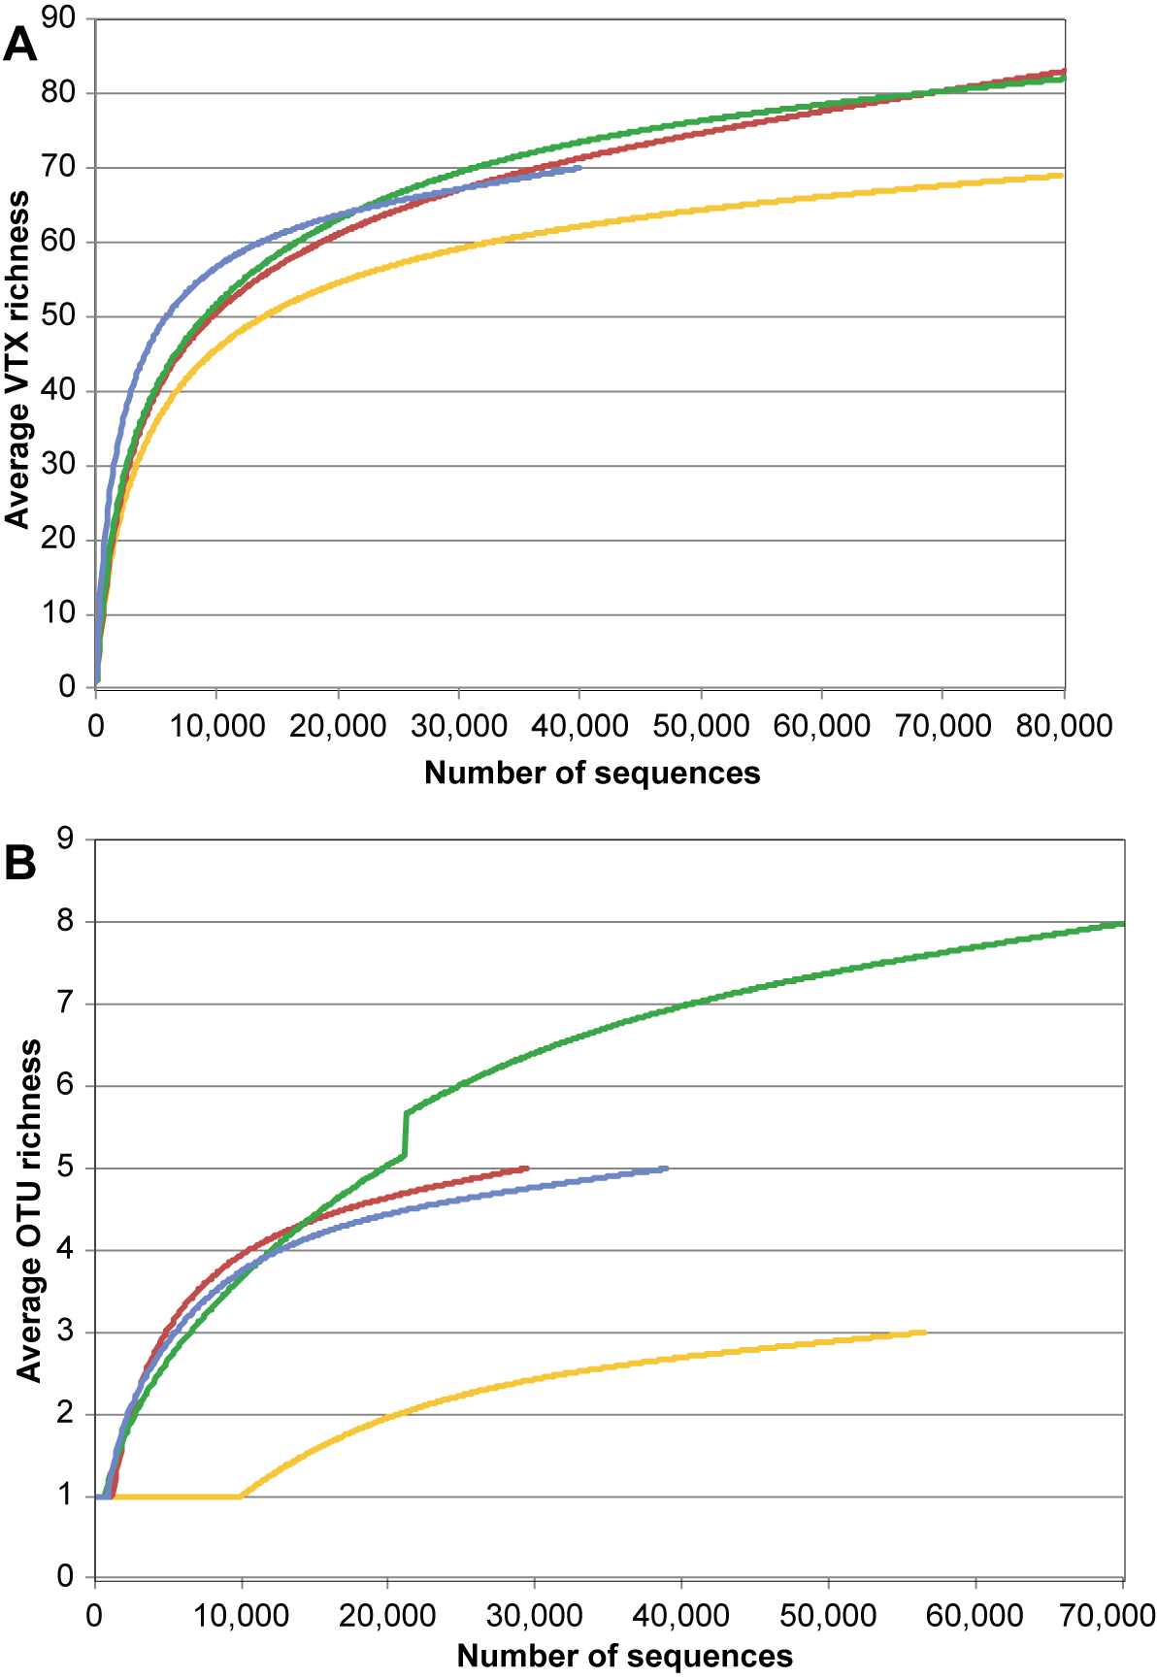
Figure EA5 – Accumulation curves displaying the change in G-AMF VTX (A) and M-FRE OTU (B) richness with the number of considered DNA sequences. Curves represent the major types of analysed substrate: orange – original soil, red – original roots, green – patch substrate, blue – ingrown roots.

EA4 – Nutrient availability, root and hyphal ingrowth into patches, G-AMF and M-FRE colonisation of ingrown roots

1 - Key abiotic properties of patch substrates and soil
The chemical fertility of the substrate filled into the ingrowth patches was determined 6 weeks after patch placement and compared to soil state at the same time. Average values and associated standard errors for the field soil and all different patch types are provided in Table EA3. The experimental manipulation of patches had mostly expected consequences (Table EA4). N-enriched patches showed elevated concentration of nitrate and ammonium and a somewhat lower pH. P-enrichment only increased the available orthophosphate, and there was no additional change when N and P were added together.

Table EA3 – Key physicochemical parameters of the fertility of the field soil (0-10 cm depth) and sand&zeolite-based substrate filled into control (C), nitrogen (N), phosphorus (P), N+P, and biomass (B) amended ingrowth patches. The analyses were made six weeks after patch exposure to the field conditions. Mean ± SE of n=4 are shown.
 | pH | Moisture  [%, w/w] | N (NH₄⁺)  [mg . kg⁻¹] | N (NO₃⁻)  [mg . kg⁻¹] | P (PO₄³⁻)  [mg . kg⁻¹]
Soil | 5.32 ± 0.09 | 33.8 ± 1.0 | 7.2 ± 1.5 | 0.29 ± 0.089 | 4.9 ± 0.2
C patches | 5.82 ± 0.07 | 13.0 ± 0.6 | 3.9 ± 0.3 | 0.01 ± 0.004 | 7.3 ± 0.9
N patches | 5.61 ± 0.10 | 12.2 ± 0.3 | 49.0 ± 14.5 | 0.24 ± 0.082 | 8.3 ± 0.5
P patches | 5.93 ± 0.03 | 13.1 ± 0.3 | 4.5 ± 0.7 | 0.04 ± 0.018 | 17.4 ± 1.6
NP patches | 5.51 ± 0.13 | 12.4 ± 0.2 | 47.0 ± 14.0 | 0.71 ± 0.363 | 15.2 ± 2.1
B patches | 5.62 ± 0.10 | 13.5 ± 1.4 | 67.1 ± 15.6 | 2.23 ± 1.213 | 18.8 ± 3.2

The presence of ingrown roots, depending on the type of enclosing sheet, inevitably changed the extent of leaching and nutrient uptake from the patches and reduced the concentration of the mobile nitrate (Table EA4).
Table EA4 – Effects of sole and combined N and P additions and of root access (H for hyphae only, R+H for root and hyphae) on the physicochemical properties of the substrate in the patches six weeks after exposure to field conditions. Significant effects (p < 0.05) are shown in bold. ▼ decline, ▲ increase with nutrient addition or with root access.
Exp. factor  Parameter | N  df = (1, 11)  F statistic, p-value | P  df = (1, 11)  F statistic, p-value | N : P  df = (1, 11)  F statistic,  p-value | Root access  (H vs R+H)  df = (1, 17)  F statistic, p-value
pH | 11.1, 0.007  (+N ▼ by 6%) | <0.1, n.s. | 1.18, n.s. | 6.36, 0.022  (R+H ▼ by 4%)
Moisture | 3.49, n.s. | 0.14, n.s. | 0.05, n.s. | 0.08, n.s.
N-NH₄⁺ | 92.9, < 0.001  (+N ▲ 9.9 fold) | 0.02, n.s. | 0.07, n.s. | 1.05, n.s.
N-NO₃⁻ | 11.4, 0.006  (+N ▲ 15.7 fold) | 1.38, n.s. | 0.03, n.s. | 6.65, 0.020  (R+H ▼ by 91%)
P-PO₄³⁻ | <0.1, n.s. | 49.0, < 0.001  (+P ▲ 2.1 fold) | 2.34, n.s. | 0.29, n.s.

Biomass addition to the patch substrate did not change the pH and moisture, compared to the surrounding soil and combined N+P addition. The concentrations of NH₄⁺ and NO₃⁻ of the biomass-amended patch substrate did not differ from that to which N (t₁₄=-1.20, n.s., and t₁₄=-1.55, n.s., respectively) or N+P (t₁₄=-1.28, n.s., and t₁₄=-0.88, n.s., respectively) were added. The biomass-amended patches had significantly higher concentrations of NH₄⁺ and NO₃⁻ compared to the no-addition control patches (t₁₄=-8.21, p<0.001, and t₁₄=-3.91, p=0.005, respectively) as well as to P-enriched patches (t₁₄=-7.91, p<0.001, and t₁₄=-3.01, p=0.030, respectively). The concentration of orthophosphate in the substrate of the biomass-amended patches was higher than in the control patches (t₁₄=-5.14, p<0.001) and in the N-enriched patches (t₁₄=-4.26, p=0.003), but did not differ from that in the N+P-enriched patches (t₁₄=-1.09, n.s.) or P patches (t₁₄=-0.19, n.s.).
All patches had a higher pH than the field soil, although the difference was only significant for the control patches (t₁₄=3.79, p=0.006) and P-enriched patches (t₁₄=4.59, p=0.001). Soil moisture was 20–22 % lower in all patches than in the surrounding field soil, probably due to the open top of all ingrowth patches and because of the lower organic matter content. The NH₄⁺ concentration was significantly higher in the biomass-amended patches (t₁₄=6.4, p<0.001), as well as the N-enriched (t₁₄=5.23, p<0.001) and NP-enriched patches (t₁₄=5.15, p<0.001) than the field soil. The control and P-enriched patches had non-significantly lower NH₄⁺ concentration (t₁₄=-1.60, n.s., and t₁₄=-1.31, n.s., respectively) compared with the soil. The NO₃⁻ concentration in the patches did not differ significantly from that in the field soil, irrespectively of the amendment, except for the control patches, in which it was lower (t₁₄=-3.25, p=0.019). The concentration of orthophosphate was higher in all patches than in the field soil, but the difference was not significant for the control patches (t₁₄=2.22, n.s.); the PO₄³⁻ concentration was highest in the biomass-amended patches (t₁₄=7.82, p<0.001), followed by the P-enriched patches (t₁₄=7.61, p<0.001) and NP-enriched patches (t₁₄=6.64, p<0.001); the difference from soil was not so high for the N-enriched patches (t₁₄=3.18, p=0.022).

2 - Hyphal length densities in patch substrate and soil
The hyphal length densities were estimated in additional patches and cores taken from the surrounding soil. The measurements were made 6 and 12 weeks after patch installation. Fig. EA6 summarises the hyphal length densities for all patch substrate types and the field soil averaged for the two exposure times.

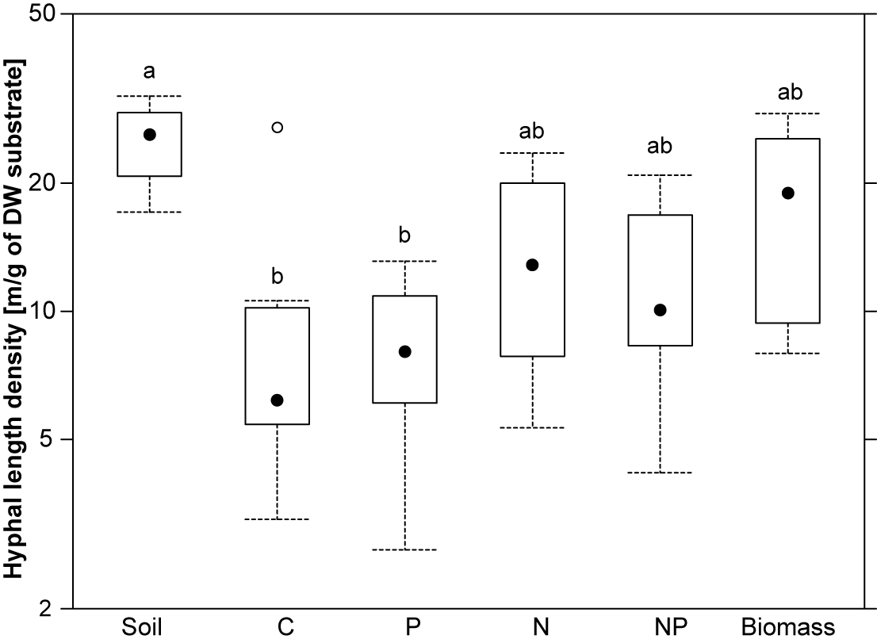
Fig. EA6 – Hyphal length densities in the field soil and the substrate in the ingrowth patches to which either nothing (control: C), inorganic P, N, N+P, or biomass was added (F_{5,37}=4.38, p=0.003, data from both sampling times, soil samples n=4, patches n=8 each). Black filled circles show the median values, boxes span from the lower to the upper quartile, whiskers reach to extreme data points within median ± 1.5× interquartile range, and empty circles represent outliers. Letters a and b show the results of a multiple mean comparisons test, based on a two-way ANOVA with patch type and blocks as predictors (groups sharing a letter are not significantly different from each other). The log-scaling of the y-axis showing the hyphal length density reflects the transformation used for statistical testing.
The hyphal length density increased by 52% after addition of N (F_{1,26}=8.83, p=0.007), but neither P addition (F_{1,26}=0.23, n.s.) nor the N:P interaction (F_{1,26}=0.23, n.s.) showed any significant effects. Hyphal length density was highest in the biomass-amended patches, but only so compared to the control (t₃₃=-4.07, p=0.001) and P-only-enriched patches (t₃₃=-4.08, p<0.001), but not so compared to the N- or N+P-enriched patches. Compared to field soil, only the control and P-only-enriched patches showed significantly lower hyphal length densities at p < 0.05 (Fig. EA6).
The hyphal length density in the ingrowth patches increased by 2.1-fold from 6 to 12 weeks of exposure to the field conditions (F_{1,37}=25.67, p<0.001). Ingrowing roots, however, did not affect the hyphal length density in the patches (F_{1,36}=1.07, n.s.).

3 - Length of ingrown roots
Only patches enclosed with sheet of 3 mm mesh size allowed roots to grow in. The root lengths were recorded after 6 and 12 weeks of patch exposure and had also been recorded in cores of field soil taken at the same times. Fig. EA7 shows the root lengths in the field soil and substrate of all patch types with the data of the two exposure times pooled.
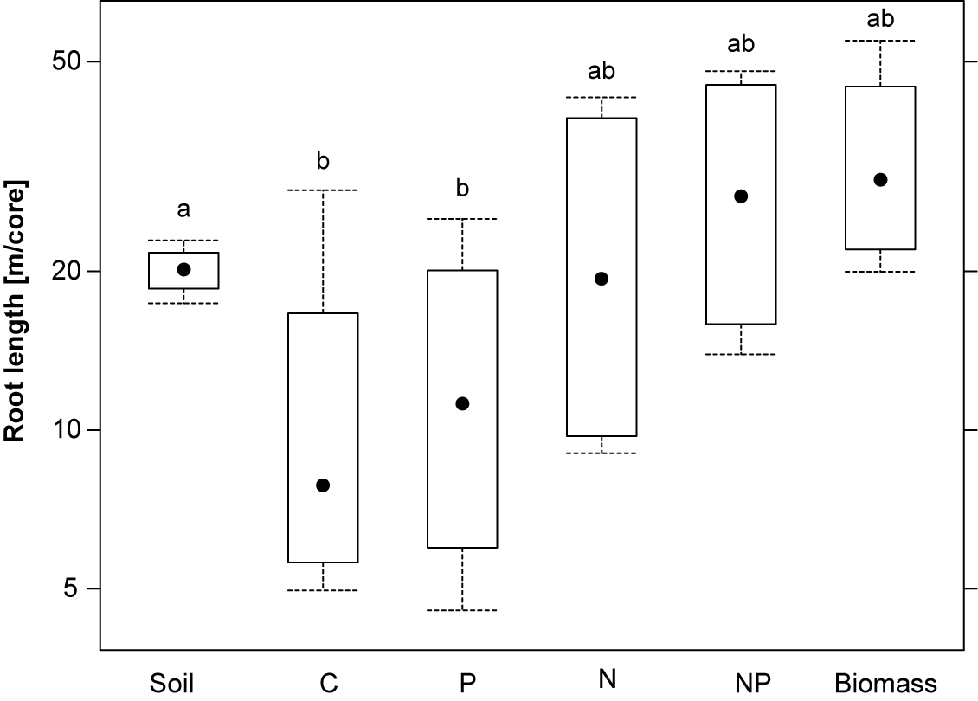
Fig. EA7 - Root lengths in soil cores and substrate in control, P-, N-, N+P-, and plant biomass-amended patches (F_{5,16}=6.85, p=0.001). The black dots show median values, the boxes span from the lower to the upper quartile, and whiskers reach to extreme data points within median ± 1.5× interquartile range. Letters a and b show the results of a multiple mean comparison test, based on a two-way ANOVA with patch type and blocks as predictors (means sharing a letter are not significantly different from each other). The log-scaling of the y-axis showing the root length reflects the transformation used in the statistical analyses.
The length of the plant roots in the ingrowth patches increased 2.2 fold with N addition (F_{1,10}=26.40, p<0.001), but neither the effect of P addition (F_{1,10}=2.03, n.s.), nor the N:P interaction (F_{1,10}=0.38, n.s.) wase significant.
The plant biomass-amended patches with attracted more roots than any other patch type, but this difference was only significant for the no-addition control (t₁₃=-3.80, p=0.008) and P-only addition (t₁₃=-3.39, p=0.016) patches. The field soil contained similar root lengths as the N, N+P, and biomass-amended patches. Significantly lower root lengths were only found for the no-addition control (t₁₆=-4.09, p=0.004) and P-only addition (t₁₆=-3.67, p=0.008) patches. The root length increased on average 2.6-fold from 6 to 12 weeks of exposure in the field (F_{1,17}=11.47, p=0.004).

4 - Root colonisation by G-AMF and M-FRE
Root colonisation by mycorrhizal fungi (G-AMF and M-FRE) was examined in roots that had grown into the patches within 6 weeks of patch exposure. Fungal colonisation was also determined in the roots from soil cores taken in the immediately surrounding grassland vegetation at the same sampling time.

Total root colonisation by G-AMF
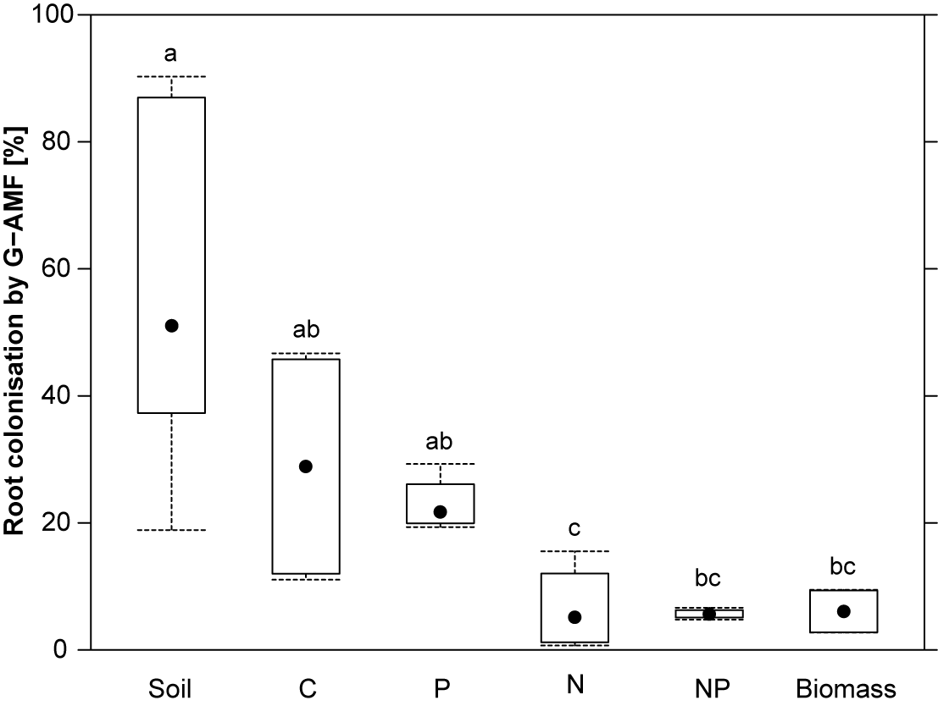
Fig. EA8 - Percentage root colonisation by G-AMF in the field soil and substrate of the experimental control (C), P, N, N+P, and plant biomass-enriched patches (F_{5,21}=11.9, p < 0.001). The black dots show median values, the boxes span from the lower to the upper quartile, and whiskers reach to extreme data points within median ± 1.5× interquartile range. Letters a, b and c show the results of a multiple mean comparison test, based on a two-way ANOVA with substrate type and block as predictors (mean values sharing a letter are not significantly different from each other).
Roots grown into patches enriched with inorganic N showed a 79% lower total colonisation by G-AMF than those grown into the no-addition control patches (F_{1,11}=23.25, p<0.001). Phosphorus addition did not affect the root colonisation by G-AMF (F_{1,11}=0.30, n.s.) nor was there a significant interaction between N and P addition (F_{1,11}=0.30, n.s.). Roots from the plant biomass-amended patches were less colonised by G-AMF than the roots from the P-only enriched patches (t₁₄=2.94, p=0.036) or those from the no-addition control patches (t₁₄=2.71, p=0.057). Overall, roots from any of the patches were less colonised by G-AMF than roots from the surrounding field soil, except for those from the control patches (t₂₁=-2.06, n.s.) and those from the P-only (t₂₁=-1.88, n.s.) patches (biomass: t₂₁=-5.79, p<0.001, N-only: t₂₁=-5.53, p<0.001, N+P: t₂₁=-4.87, p<0.001).

Relative frequency of G-AMF arbuscules
The relative frequency of G-AMF arbuscules (expressed as the percentage of colonised root length with observed arbuscules) remained unaffected by N addition (F_{1,11}=3.24, p=0.099), P addition (F_{1,11}<0.01, n.s.), or by the interaction of these two factors (F_{1,11}=0.73, n.s.). Also the biomass (B) addition to patches did not affect relative arbuscular frequency. Arbuscular root colonisation was, however, lower in the N-enriched patches than in field soil (t₂₁=-3.35, p=0.014). A similar (but not significant) trend was found for the remainder of patches.

Total root colonisation by M-FRE
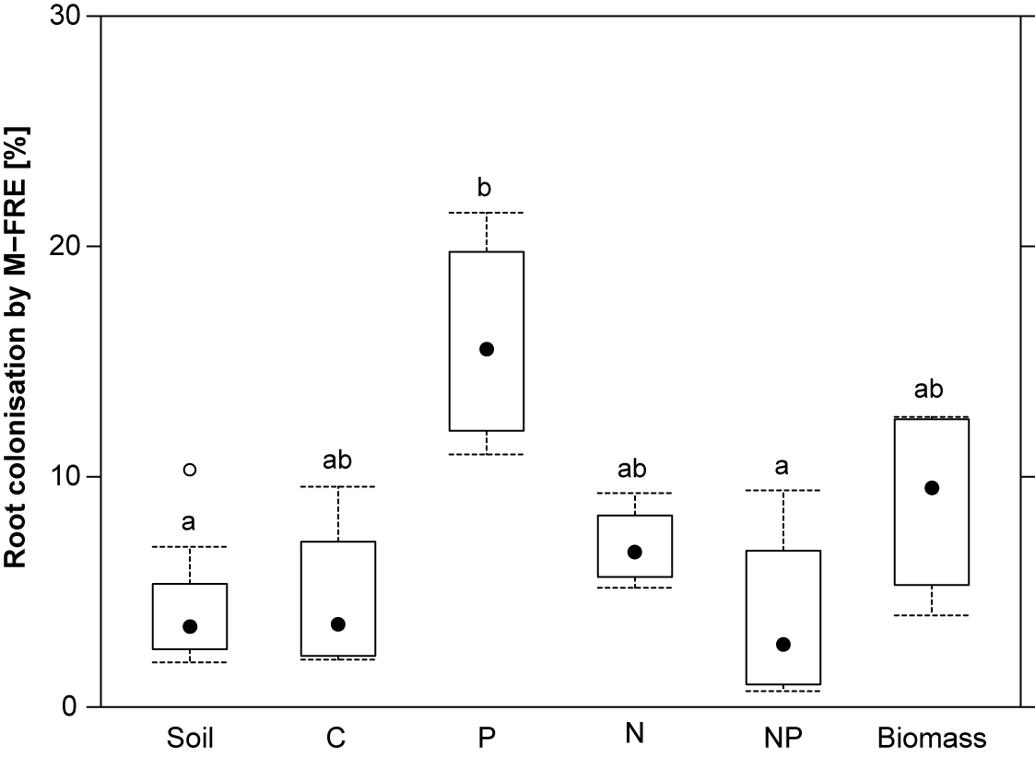
Fig. EA9 - Percentage of root length colonised by M-FRE of roots from field soil, control, P-, N-, N+P-enriched, and biomass-amended substrate of patches with root acess(F_{5,21}=4.64, p=0.005). The black dots show median values, the boxes span from the lower to the upper quartile, whiskers reach to extreme data points within median ± 1.5× interquartile range, and empty circles represent outliers. Letters a and b show the results of a multiple mean comparison test based on a two-way ANOVA with substrate type and blocks as predictors (groups sharing a letter are not significantly different from each other).
Root colonisation by M-FRE was neither affected by N addition (F_{1,11}=2.99, n.s.) nor P addition (F_{1,11}=0.47, n.s.), but there was a strong interaction effect by the two factors (F_{1,11}=13.07, p=0.004). This was because M-FRE root colonisation strongly increased with P addition, but only when no N was added. The lowest M-FRE root colonisation was recorded when both N and P were applied. When comparing the effects of all patch amendments to each other, M-FRE root colonisation differed only between the P-only and N+P addition treatments (t₁₁=-3.75, p=0.015). Root colonisation by M-FRE did not differ among the N-, P-, and N+P-enriched patches, and the patches to which plant biomass was added. Except for the P-only-enriched patches, in which the roots were colonised 4.1-fold more by M-FRE (t₂₁=3.61, p=0.008), the colonisation of roots from the patches by M-FRE was comparable to that of roots from surrounding field soil.

EA5 – Foraging speed and precision of G-AMF and M-FRE taxa

Methods

Foraging speed
We estimated the fungal foraging speed by comparing the proportion of sequence reads of a particular fungal taxon in a particular patch with its proportion in the original soil collected to install the patch, since any other reference would have confounded the foraging signal with spatial heterogeneity in fungal community structure. The underlying assumption of this procedure is however that the source propagules of the taxa that have been in the original soil were also present in the immediate surroundings of the patch installation place as well as that they were not harmed by soil coring during patch installation. Therefore we further assumed that in the long term, the composition of the fungal community in the patch would return to that at the time point of patch insertion. Our previous study (Šmilauer et al. 2020) relied on only one sampling time for ingrowth patches and the foraging speed was thus estimated based on the regression coefficient of the comparison of the proportional abundance (relative read number) in a sampled patch with the proportional abundance in the original soil. A positive regression coefficient meant that the taxon was more abundant in the patch, implying that it arrived earlier than other taxa. A negative regression coefficient, on the contrary, implied slow taxon arrival. In the present study with two exposure times (T1 - 6 weeks and T2 - 12 weeks) of the ingrowth patches, we assumed that after longer exposure (T2), the community composition would again be closer to the initial state of the community in the original soil (at patch installation, time T0) than it was the case after the shorter exposure time (T1). That this was indeed the case could be confirmed by RDA (Fig. EA10).
To estimate foraging speed as a single trait value for each taxon and ensure that the more quickly arriving taxa get larger positive values, the three time categories had to be converted into a single quantitative time variable, by assigning T0 the value of 1.0 and T1 the value of 0.0, which brings the time point T2 somewhere between 0.0 and 1.0. We used unconstrained principal components analysis (PCA) to estimate the average community composition of T2 between the averages (centroids) of T0 and T1, using the scores of the centroids of the three communities. In the case of G-AMF, the temporal position of T2 was estimated as 0.85, and for M-FRE as 0.87. These estimates maximise the linearity of the change of (average) taxon proportion with the (numeric) temporal values. The value of a regression coefficient representing the dependency of relative abundance of a taxon on time was estimated with a generalised linear mixed-effect model (GLMM), fitted with the glmer function in lme4 package (Bates et al. 2015), and used as the estimate of foraging speed for that taxon. We used three random effects representing experimental block identity, core/patch location identity and finally the identity of particular observation. The last random effect was used only to account for overdispersion in proportional data, as compared with the assumed binomial distribution. We have also estimated the standard error for the foraging speed and (adjusted) amount of explained variance, calculated with the r.squaredGLMM function of the MuMIn package (Bartoň 2023), as well as run a likelihood-ratio (χ²) test to confirm the significance of the proportional change with time.
To avoid conclusions based on poorly fitting data, we estimated foraging speed only for taxa that occurred in at least 5 soil and 5 zeolite samples or in 50 or more samples of either type (i.e. 25% of all 200 locations). This limited the number of G-AMF VTX to 48 and that of M-FRE OTU to 8. We adjusted the significance values due to presumed dependency among taxon occurrence and abundance, by transforming them to false discovery rates (Benjamini & Hochberg 1995).
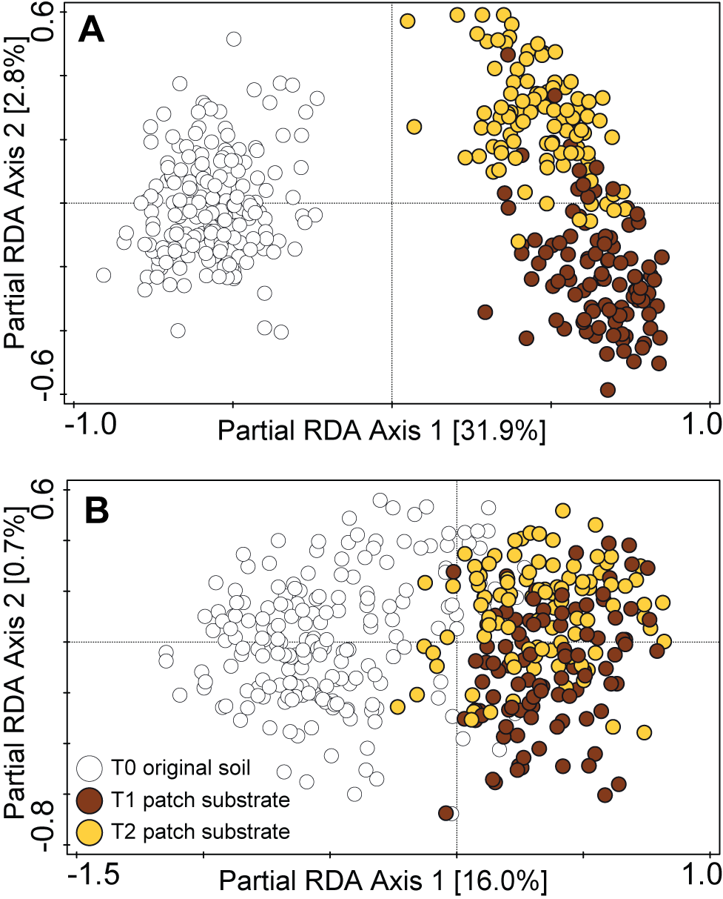
Fig. EA10 – Partial RDA plot summarising compositional differences of G-AMF (A) and M-FRE (B) communities in the original soil and zeolite and sand-based substrate of ingrowth patches collected at three different time points (T0: for original soil at patch installation, T1: patch substrate after six weeks of exposure, and T2: patch substrate after 12 weeks of exposure).

Foraging precision
The foraging precision of the fungal taxa was inferred from their change in relative abundance (i.e., taxa’s proportion of sequence reads per sample) between a particular type of nutrient-enriched patches and the corresponding control patch with the same exposure time and enclosing sheet type from the same experimental block. The procedure allowed us to determine the taxon-specific foraging precision for either N-, P-, N+P-enriched or plant biomass-amended patches. Generalised linear mixed-effect models (GLMM) assuming binomial distribution were used with two random effects – experimental block identity and observation identity (the latter to account for overdispersion), and fixed effects of patch type (one of N, P, N+P, B type versus control type), root access type (H or R+H), and exposure time (6 or 12 weeks). As for foraging speed, we also calculated the standard error of the estimated foraging precision, R²_{adj}, and carried out likelihood-ratio test to determine singificant differences.
The G-AMF VTX and M-FRE OTU were filtered for taxa that occurred in at least five control patches and at least five nutrient patches of a particular type and at least two complete pairs of compared patch types (i.e. a control patch together with and N, P, N+P or B patch, sharing the same block, exposure time as well as root access type). When a taxon passed this filtering for a single enrichment type, it was implicitly selected for estimating its foraging precision also for other enrichment types. This filtering retained 29 G-AMF VTX and 6 M-FRE OTU. Significances were transformed to false discovery rates (Benjamini & Hochberg 1995).

Results

Foraging speed of G-AMF and M-FRE
Fast foraging VTX were found in four G-AMF families (Acaulosporaceae, Archaeosporaceae, Claroideoglomeracae, and Glomeraceae) and slow foraging VTX in four families (Acaulosporaceae, Claroideoglomeraceae, Glomeraceae, and Paraglomeraceae) (Table EA5). The taxa from the Glomeraceae family seem to harbour comparable numbers of fast- and slow-foraging VTX. Among the fastest foragers were three VTX (t113, t114, and t115) of the Rhizophagus irregularis morphospecies (Table EA5). Another conspicuous pattern is the high frequency of VTX known to be cultivable, among those with a high foraging speed.

Table EA5 – Average foraging speed of selected G-AMF VTX. Positive values representing significantly faster patch colonisers than the average VTX are indicated by green background shading; significantly slower coloniser with red cell background shading. VTX not differing significantly in their foraging speed from the average foraging speed are shown with grey background shading. R²_{adj} is the amount of explained variation on a 0-1 scale. Two VTX highlighted with identifiers in red colour are novel phylotypes that are not yet present in the MaarjAM reference database. The three VTX codes with an asterisk (*) belong to the Rhizophagus irregularis morphospecies. VTX codes with a blue background represent morphospecies known from cultivation.
Family | VTX | Foraging speed | SE | p_{adj} | R²_{adj}
Acaulosporaceae | t030 | 2.37 | 0.35 | < 0.001 | 0.172
Acaulosporaceae | t228 | -3.24 | 1.20 | < 0.001 | 0.001
Acaulosporaceae | t231 | -5.64 | 1.32 | < 0.001 | 0.014
Archaeosporaceae | t245 | 4.18 | 0.26 | < 0.001 | 0.512
Archaeosporaceae | t005 | -2.09 | 1.23 | 0.062 | < 0.001
Claroideoglomeraceae | t193 | 3.18 | 0.15 | < 0.001 | 0.534
Claroideoglomeraceae | t057 | 1.59 | 0.14 | < 0.001 | 0.23
Claroideoglomeraceae | t340 | -0.88 | 0.98 | n.s. | < 0.001
Claroideoglomeraceae | t056 | -1.05 | 0.86 | n.s. | < 0.001
Claroideoglomeraceae | t225 | -4.63 | 0.23 | < 0.001 | 0.653
Glomeraceae | t386 | 5.11 | 0.79 | < 0.001 | 0.629
Glomeraceae | t114* | 4.85 | 0.32 | < 0.001 | 0.753
Glomeraceae | t344 | 4.61 | 0.35 | < 0.001 | 0.812
Glomeraceae | t113* | 4.43 | 0.17 | < 0.001 | 0.671
Glomeraceae | t115* | 4.30 | 0.17 | < 0.001 | 0.72
Glomeraceae | t199 | 3.81 | 0.36 | < 0.001 | 0.347
Glomeraceae | CL06 | 3.12 | 0.68 | < 0.001 | 0.187
Glomeraceae | t247 | 2.65 | 0.19 | < 0.001 | 0.507
Glomeraceae | t074 | 2.37 | 0.17 | < 0.001 | 0.305
Glomeraceae | t417 | 1.81 | 0.31 | < 0.001 | 0.112
Glomeraceae | t163 | 1.72 | 0.19 | < 0.001 | 0.166
Glomeraceae | t108 | 1.42 | 0.19 | < 0.001 | 0.124
Glomeraceae | t186 | 0.65 | 1.14 | n.s. | < 0.001
Glomeraceae | t219 | -0.11 | 0.17 | n.s. | 0.001
Glomeraceae | t325 | -0.27 | 0.93 | n.s. | < 0.001
Glomeraceae | t342 | -1.02 | 1.33 | n.s. | < 0.001
Glomeraceae | t366 | -1.15 | 0.57 | 0.045 | 0.01
Glomeraceae | t096 | -1.49 | 0.27 | < 0.001 | 0.109
Glomeraceae | t305 | -1.53 | 0.67 | 0.021 | 0.019
Glomeraceae | t143 | -1.83 | 0.38 | < 0.001 | 0.087
Glomeraceae | t166 | -2.40 | 0.18 | < 0.001 | 0.339
Glomeraceae | t129 | -2.52 | 1.03 | 0.005 | 0.001
Glomeraceae | t072 | -3.28 | 0.33 | < 0.001 | 0.225
Glomeraceae | t078 | -3.34 | 0.23 | < 0.001 | 0.527
Glomeraceae | t117 | -3.38 | 0.57 | < 0.001 | 0.147
Glomeraceae | t431 | -3.43 | 0.23 | < 0.001 | 0.514
Glomeraceae | t233 | -4.57 | 0.46 | < 0.001 | 0.172
Glomeraceae | t149 | -4.69 | 0.18 | < 0.001 | 0.735
Glomeraceae | CL04 | -4.94 | 0.36 | < 0.001 | 0.563
Glomeraceae | t256 | -5.17 | 0.36 | < 0.001 | 0.606
Glomeraceae | t194 | -5.48 | 0.68 | < 0.001 | 0.37
Glomeraceae | t212 | -5.56 | 0.28 | < 0.001 | 0.733
Glomeraceae | t191 | -5.68 | 0.40 | < 0.001 | 0.68
Glomeraceae | t202 | -5.84 | 0.61 | < 0.001 | 0.446
Glomeraceae | t153 | -6.52 | 0.49 | < 0.001 | 0.732
Paraglomeraceae | t349 | -2.47 | 0.64 | < 0.001 | 0.069
Paraglomeraceae | t337 | -2.80 | 0.23 | < 0.001 | 0.297
Paraglomeraceae | t281 | -3.27 | 0.18 | < 0.001 | 0.447

Among all M-FRE OTU, there were two significantly faster patch-colonising OTU and four significantly slower patch-colonising OTU, compared to the average colonisation speed (Table EA6).
Table EA6 – Average foraging speed of selected M-FRE OTU. Positive values indicate significantly faster patch colonisers and are shown with green background shading, negative values indicate significantly slower colonisers and are shown with red background shading. OTU whose foraging speed does not significantly differ from the average colonisation speed over all OTU have grey cell background shading. R²_{adj} represents the amount of explained variation on a 0-1 scale.
OTUs | Foraging speed | SE | p_{adj} | R²_{adj}
OTU016 | 1.78 | 0.39 | < 0.001 | 0.085
OTU012 | 1.77 | 0.15 | < 0.001 | 0.205
OTU017 | 0.24 | 0.23 | n.s. | 0.003
OTU004 | -0.69 | 0.14 | < 0.001 | 0.045
CL0036 | -1.55 | 1.19 | n.s. | < 0.001
CL0015 | -1.56 | 0.32 | < 0.001 | 0.085
OTU069 | -2.51 | 0.78 | < 0.001 | 0.024
CL004 | -4.56 | 0.47 | < 0.001 | 0.048

Foraging precision of G-AMF and M-FRE
There were just four G-AMF VTX that showed significant (α < 0.05 for adjusted p-values) differences in foraging precision for N+P-amended patches and two of those VTX belonged to the R. irregularis morphospecies that also targeted the biomass-amended patches (Table EA7). Only one of those VTX (t115) also showed significant foraging precision for N-amended and P-amended patches. A further Glomeraceae VTX (t247) showed significant foraging precision for biomass-amended patches. Two Claroideoglomeraceae and one Glomeraceae VTX avoided nutrient-enriched patches, possibly due to competitive exclusion.
No M-FRE OTUs showed any foraging precision (Table EA8), possibly because of high speed of ingrowth patch occupation.

Table EA7 – Foraging precision (FP) of selected G-AMF VTX towards nutrient-enriched patches compared to no-addition control patches. Significantly positive FP values are highlighted with green background shading and negative FP values with red background shading. Nutrient indifferent VTX are shown with grey background shading. R²_{adj} shows the amount of explained variation on a 0-1 scale. The VTX with a red identifier is a new taxon, not yet present in the MaarjAM reference database. VTX highlighted with an asterisk (*) belong to the Rhizophagus irregularis morphospecies and VTX with blue background shading represent morphospecies known to be cultivable.
 |  | NP |  |  |  | B |  |  |  | N |  |  |  | P
Family | VTX | FP  (NP) | SE | p_{adj} | R²_{adj} | FP(B) | SE | p_{adj} | R²_{adj} | FP  (N) | SE | p_{adj} | R²_{adj} | FP(P) | SE | p_{adj} | R²_{adj}
Acaulosporaceae | t030 | -0.38 | 0.44 | n.s. | 0.010 | -0.27 | 0.44 | n.s. | 0.005 | -0.44 | 0.50 | n.s. | 0.012 | 0.34 | 0.55 | n.s. | 0.006
Archaeosporaceae | t245 | -0.37 | 0.31 | n.s. | 0.018 | -0.60 | 0.32 | n.s. | 0.044 | -0.25 | 0.35 | n.s. | 0.007 | 0.03 | 0.29 | n.s. | < 0.001
Claroideoglomeraceae | t193 | -0.82 | 0.25 | 0.006 | 0.100 | -0.02 | 0.26 | n.s. | < 0.001 | -0.38 | 0.24 | n.s. | 0.023 | 0.27 | 0.25 | n.s. | 0.012
Claroideoglomeraceae | t057 | -0.88 | 0.24 | 0.002 | 0.137 | -0.52 | 0.25 | 0.049 | 0.051 | -0.86 | 0.26 | 0.003 | 0.123 | 0.25 | 0.24 | n.s. | 0.013
Claroideoglomeraceae | t225 | -1.08 | 1.60 | n.s. | 0.009 | -0.15 | 1.20 | n.s. | 0.002 | 0.44 | 1.24 | n.s. | 0.003 | 0.65 | 1.14 | n.s. | 0.009
Glomeraceae | t386 | 1.44 | 0.38 | <0.001 | 0.178 | 1.24 | 0.65 | n.s. | 0.070 | 0.95 | 0.73 | n.s. | 0.033 | 0.88 | 0.59 | n.s. | 0.036
Glomeraceae | t115* | 0.65 | 0.19 | 0.002 | 0.100 | 0.82 | 0.20 | <0.001 | 0.150 | 0.51 | 0.19 | 0.012 | 0.069 | 0.34 | 0.16 | 0.038 | 0.038
Glomeraceae | t113* | 0.52 | 0.21 | 0.035 | 0.052 | 0.50 | 0.21 | 0.035 | 0.058 | 0.13 | 0.20 | n.s. | 0.004 | 0.19 | 0.19 | n.s. | 0.009
Glomeraceae | t114* | 0.46 | 0.28 | n.s. | 0.033 | 0.65 | 0.29 | 0.083 | 0.070 | 0.17 | 0.31 | n.s. | 0.004 | 0.45 | 0.30 | n.s. | 0.028
Glomeraceae | t247 | 0.45 | 0.01 | 0.042 | 0.064 | 0.49 | 0.18 | 0.036 | 0.085 | 0.11 | 0.21 | n.s. | 0.004 | 0.07 | 0.16 | n.s. | 0.002
Glomeraceae | CL06 | 0.32 | 0.55 | n.s. | 0.006 | -0.04 | 0.60 | n.s. | < 0.001 | 0.23 | 0.01 | n.s. | 0.004 | -0.78 | 0.87 | n.s. | 0.017
Glomeraceae | t143 | 0.28 | 1.73 | n.s. | < 0.001 | 1.83 | 0.89 | n.s. | 0.001 | 1.89 | 1.02 | n.s. | 0.006 | 1.29 | 1.20 | n.s. | 0.009
Glomeraceae | t417 | 0.22 | 0.45 | n.s. | 0.006 | 0.13 | 0.55 | n.s. | 0.002 | -0.09 | 0.43 | n.s. | < 0.001 | 0.55 | 0.43 | n.s. | 0.019
Glomeraceae | t074 | 0.03 | 0.30 | n.s. | < 0.001 | -0.24 | 0.25 | n.s. | 0.010 | 0.16 | 0.29 | n.s. | 0.003 | -0.41 | 0.23 | n.s. | 0.033
Glomeraceae | t072 | 0.03 | 0.58 | n.s. | < 0.001 | -0.16 | 0.68 | n.s. | < 0.001 | 0.02 | 0.48 | n.s. | < 0.001 | 1.01 | 0.45 | 0.096 | 0.048
Glomeraceae | t078 | 0.00 | 0.92 | n.s. | < 0.001 | 0.14 | 1.05 | n.s. | < 0.001 | -0.70 | 1.47 | n.s. | 0.007 | 0.29 | 0.92 | n.s. | < 0.001
Glomeraceae | t163 | -0.04 | 0.25 | n.s. | < 0.001 | 0.03 | 0.02 | n.s. | < 0.001 | -0.10 | 0.27 | n.s. | 0.001 | 0.25 | 0.25 | n.s. | 0.008
Glomeraceae | t108 | -0.06 | 0.01 | n.s. | 0.001 | -0.09 | 0.01 | n.s. | 0.001 | -0.03 | 0.28 | n.s. | < 0.001 | 0.01 | 0.29 | n.s. | < 0.001
Glomeraceae | t344 | -0.10 | 0.20 | n.s. | 0.003 | 0.12 | 0.18 | n.s. | 0.006 | -0.27 | 0.23 | n.s. | 0.017 | 0.19 | 0.19 | n.s. | 0.015
Glomeraceae | t096 | -0.17 | 0.43 | n.s. | < 0.001 | 0.06 | 0.33 | n.s. | < 0.001 | -0.36 | 0.50 | n.s. | 0.005 | -1.05 | 0.50 | n.s. | 0.070
Glomeraceae | t149 | -0.23 | 0.60 | n.s. | 0.003 | -0.48 | 0.65 | n.s. | 0.011 | -1.31 | 0.02 | n.s. | 0.056 | -0.05 | 0.52 | n.s. | < 0.001
Glomeraceae | t324 | -0.24 | 0.68 | n.s. | < 0.001 | 1.65 | 1.52 | n.s. | 0.054 | -0.07 | 2.25 | n.s. | < 0.001 | -0.03 | 2.29 | n.s. | 0.769
Glomeraceae | t411 | -0.43 | 0.71 | n.s. | 0.007 | -1.36 | 0.77 | n.s. | 0.106 | -0.11 | 0.60 | n.s. | < 0.001 | -1.33 | 0.81 | n.s. | 0.095
Glomeraceae | t219 | -0.43 | 0.02 | n.s. | 0.010 | -0.53 | 0.27 | n.s. | 0.021 | -0.09 | 0.31 | n.s. | < 0.001 | -0.72 | 0.24 | 0.019 | 0.037
Glomeraceae | t166 | -0.62 | 0.01 | n.s. | 0.010 | -0.39 | 0.41 | n.s. | 0.009 | -0.32 | 0.42 | n.s. | 0.004 | -0.29 | 0.36 | n.s. | 0.007
Glomeraceae | t431 | -0.66 | 0.69 | n.s. | 0.010 | -0.96 | 0.48 | n.s. | 0.060 | -0.53 | 0.53 | n.s. | 0.013 | -0.69 | 0.67 | n.s. | 0.018
Glomeraceae | t199 | -0.80 | 0.44 | n.s. | 0.047 | -0.46 | 0.39 | n.s. | 0.020 | 0.03 | 0.01 | n.s. | < 0.001 | 0.08 | 0.33 | n.s. | < 0.001
Paraglomeraceae | t337 | -0.02 | 1.04 | n.s. | < 0.001 | 0.73 | 0.96 | n.s. | 0.011 | 0.52 | 0.83 | n.s. | 0.007 | 1.41 | 0.70 | n.s. | 0.077
Paraglomeraceae | t281 | -1.25 | 0.62 | n.s. | 0.072 | -0.27 | 0.58 | n.s. | 0.003 | -0.77 | 0.64 | n.s. | 0.023 | 0.13 | 0.54 | n.s. | 0.002

Table EA8 – Foraging precision (FP) of selected M-FRE OTU towards nutrient-enriched patches compared to no-addition control patches. There were no OTU significantly discriminating between nutrient-enriched and control patches. R²_{adj} shows the amount of explained variation on a 0-1 scale. The OTU highlighted with violet background shading represent those with at least one DNA sequence known from a plant host.
 | B |  |  |  | N |  |  |  | NP |  |  |  | P
OTU | FP (B) | SE | p_{adj} | R²_{adj} | FP (N) | SE | p_{adj} | R²_{adj} | FP (NP) | SE | p_{adj} | R²_{adj} | FP (P) | SE | p_{adj} | R²_{adj}
CL015 | 0.50 | 0.59 | n.s. | 0.010 | -1.11 | 0.83 | n.s. | 0.032 | -0.05 | 0.78 | n.s. | < 0.001 | 0.09 | 0.79 | n.s. | < 0.001
OTU004 | 0.09 | 0.29 | n.s. | 0.001 | -0.50 | 0.31 | n.s. | 0.027 | 0.19 | 0.31 | n.s. | 0.005 | 0.09 | 0.34 | n.s. | 0.001
OTU017 | 0.05 | 0.42 | n.s. | < 0.001 | -0.57 | 0.50 | n.s. | 0.021 | 0.38 | 0.39 | n.s. | 0.014 | 0.15 | 0.33 | n.s. | 0.001
OTU012 | 0.00 | 0.31 | n.s. | < 0.001 | 0.61 | 0.33 | n.s. | 0.035 | -0.08 | 0.33 | n.s. | 0.001 | -0.18 | 0.35 | n.s. | 0.003
OTU016 | -0.38 | 0.68 | n.s. | 0.004 | -1.38 | 0.65 | n.s. | 0.065 | -0.23 | 0.60 | n.s. | 0.002 | 0.43 | 0.59 | n.s. | 0.006
CL004 | -0.98 | 1.40 | n.s. | 0.010 | 0.12 | 1.24 | n.s. | < 0.001 | -1.56 | 1.73 | n.s. | 0.008 | -1.87 | 1.92 | n.s. | 0.003

Discussion
The foraging speed of plant roots is commonly defined as the first time a root appears in a nutrient-rich patch observed through a window. This is not a feasible approach for morphologically indistinguishable fungal hyphae and in a community context. We rather have to assume that there is a process of gradual patch occupation by different taxa from the time point of patch creation to that of sampling driven by patch quality and ultimately leading to a community composition similar (even in the proportion of individual taxa) to the original fungal community. But as the experimental substrate has a nature different from original soil, we cannot exclude the possibility that the community composition does not return to composition very similar to its original state.
Our way of estimating foraging precision is limited by the assumption that the fungal community would be very similar in original soil at the locations of the two compared patches (control and enriched one). We tried to setup our experiment so that the patches compared when estimating foraging precision would be physically close, by varying within each block the substrate type at smaller spatial scale than the exposure time or the type of patch enclosure sheet. Even so, background spatial variation in fungal community composition at the sub-metre scale is inevitable and that decreases the power of our tests for significant foraging precision. An experiment focusing on the estimation of foraging precision would need to replicate control patches in a close proximity of each type of patch enrichment, increasing the extent of the experiment, but also enhancing its informativeness. Another possible improvement, shared in its effect with the estimation of foraging speed, would be to quantify the fungal community in the soil surrounding the patch, at the time of the patch removal.

References
Bartoň K (2023) MuMIn: Multi-Model Inference. R package version 1.47.5, <https://CRAN.R-project.org/package=MuMIn>.
Bates D, Maechler M, Bolker B, Walker S (2015) Fitting linear mixed-effects models using lme4. J Stat Software 67: 1–48. doi:10.18637/jss.v067.i01.
Benjamini Y, Hochberg Y (1995) Controlling the false discovery rate: a practical and powerful approach to multiple testing. J Royal Stat Soc Series B 57: 289–300. doi:10.1111/j.2517-6161.1995.tb02031.x
Šmilauer P, Šmilauerová M, Kotilínek M, Košnar J (2020) Foraging speed and precision of arbuscular mycorrhizal fungi under field conditions: an experimental approach. Mol Ecol 29: 1574–1587. doi: 10.1111/mec.15425.

EA6 – G-AMF and M-FRE communities in ingrown roots
Inorganic N, P and N+P addition did not change the composition of the colonising G-AMF communities of ingrown roots. No patch type effect on G-AMF community composition was recorded when we included also the plant biomass-amended patches in the comparison (Table EA9). However, when the subsets of samples collected after 6 and 12 weeks of patch exposure were analysed separately, inorganic N addition (with or without inorganic P; F=3.1, p=0.003) and patch types (F=1.7, p=0.012) did significantly affect G-AMF communities occupying the patches after 12 weeks of patch exposure, but not those after 6 weeks of patch exposure. The effect of patch type mainly concerned a difference between the N- or N+P-enriched and biomass-amended, P-enriched and control patches (Fig. EA11). In M-FRE communities of ingrown roots, neither nutrient enrichment explained their compositional variation, nor different exposure times (Table EA9), suggesting indiscriminate and saturated root occupation by M-FRE.
The α-diversity of the G-AMF and M-FRE communities in ingrown roots was also little affected by nutrient enrichment of the patches. Only N+P addition reduced the G-AMF richness by 23%, compared to the N-enriched patches, across the two patch exposure times. When analysed separately for the two exposure times, the difference in G-AMF diversity was only found for 6 weeks exposure (F_{1,27}= 6.54, p=0.017) and not for 12 weeks (F_{1,27}=0.84, n.s.).
Nutrient enrichment of the patches did not affect the G-AMF / M-FRE ratio in the roots that had proliferated into the patches. The G-AMF / M-FRE ratio of the root colonising fungi increased, however, 2.7-times from 6 to 12-weeks of exposure to the field conditions.

Table EA9 – Effects of sole and combined N and P additions to patches, of the exposure time and of the exposure time:patch type interaction on the composition variation and a-diversity (Hill’s N2) of G-AMF and M-FRE communities in the roots that had grown into the patches. G-AMF VTX and M-FRE OTU columns present the results of RDA ordination analyses, with F representing the pseudo-F statistic, and p the Type I error probability estimated by data permutation. Columns with labels ending with N2 represent the diversity of the same communities and the G-AMF / M-FRE column was calculated based on DNA sequence read numbers. The a-diversity and G-AMF / M-FRE ratio were analysed with a linear mixed-effect models (LMM), yielding the F statistic with 1,66 DF for N addition, P addition, and their interaction effects, 4,85 DF for patch type (including also the biomass-amended patches), 1,85 for exposure time, and 4,81 for the patch type: exposure time interaction. R²_{adj}: adjusted explained variation [%], ▲ indicates a significant increase with exposure time. Significant effects are highlighted in boldface, VTX: virtual taxa, OTU: operational taxonomic units, n.s.: not significant.
 | G-AMF VTX |  | G-AMF VTX’ N2 |  | M-FRE OTU |  | M-FRE OTU N2 |  | G-AMF / M-FRE
Effect | R²_{adj} | F / p | R²_{adj} | F / p | R²_{adj} | F / p | R²_{adj} | F / p | R²_{adj} | F / p
N | 0.5 | 1.5  n.s. | 0.1 | 0.16  n.s. | 0.0 | 0.9  n.s. | 3.2 | 2.74  n.s. | 1.5 | 3.11  (0.082)
P | 0.0 | 0.7  n.s. | 2.8 | 2.85  (0.096) | 0.0 | 0.2  n.s. | 0.1 | 0.14  n.s. | 0.5 | 1.4  n.s.
N : P interaction | 0.2 | 1.2  n.s. | 5.5  low in N+P | 5.64  0.021 | 0.1 | 1.1  n.s. | 0.2 | 0.27  n.s. | 0.1 | 0.7  n.s.
Patch type | 1.0 | 1.3  (0.077) | 7.5 | 2.31  (0.064) | 0.0 | 0.60  n.s. | 3.8 | 1.02  n.s. | 2.1 | 1.7  n.s.
Exposure time | 2.4 | 3.7  < 0.001 | 0.4 | 0.55  n.s. | 0.0 | 1.0  n.s. | 1.7 | 1.80  n.s. | 43.1  171% ▲ T2 | 102.3  < 0.001
Patch type : exposure time | 1.3 | 1.4  0.038 | 5.6 | 1.93  n.s. | 0.0 | 0.8  n.s. | 5.6 | 1.62  n.s. | 0.1 | 0.44  n.s.

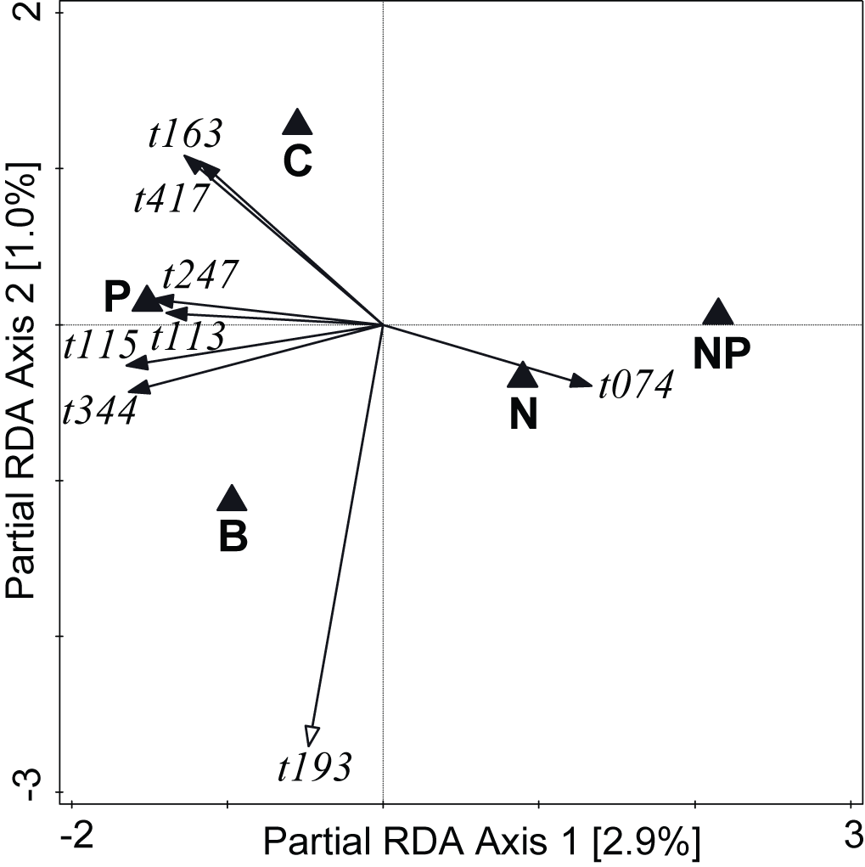
Fig. EA11 – Effects of nutrient enrichment of zeolite patches on the composition of the G-AMF communities in the roots that has grown into the patches, shown as an ordination diagram of partial RDA. The analysis used only data from the patches that had been exposed for 12 weeks to the field conditions. Only VTX strongly affected by the nutrient-enrichment are shown. Black filled arrow tips: VTX of Glomeraceae, open arrow tips: VTX of Claroideoglomeraceae. VTX t113 and t115 correspond to G-AMF morphospecies Rhizophagus irregularis.

EA7 – Interaction of patch type and exposure time on M-FRE community composition
The interaction between patch type (C, N, P, NP, and B patches) and exposure time was significant for the M-FRE community (F=2.3, p=0.008) explaining (R²_{adj}=)2.3% of the total community variation. However, the exposure time itself explained only very little of the total community variation (see Table 3), as resolved mainly by the second axis of the partial RDA biplot displaying the interaction and both main effects (Fig. EA12).
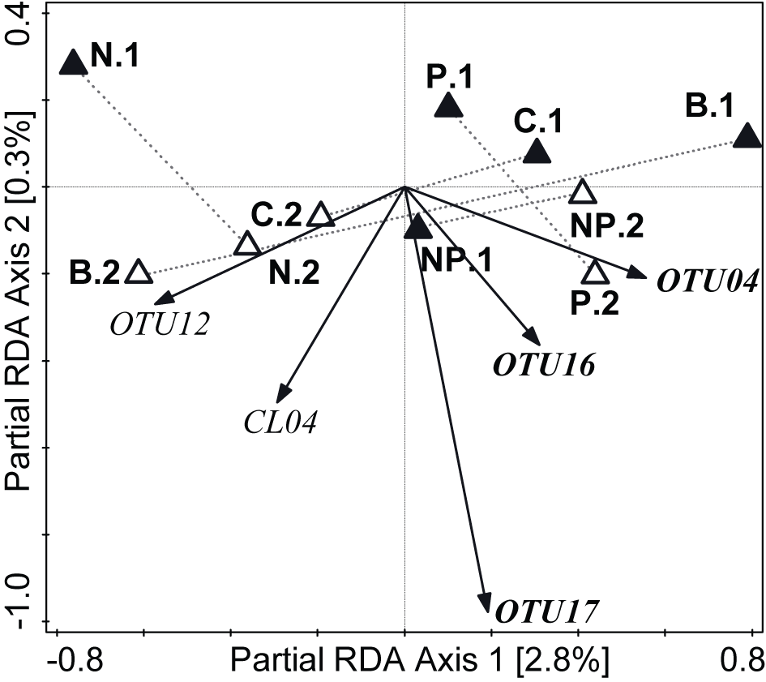
Fig. EA12 – Biplot of a partial RDA visualising the effects of patch type and exposure time and their interaction on the M-FRE community in the zeolite substrate. Triangles represent the centroids of individual patch types and exposure time (number after the dot: 1 for 6 weeks and 2 for 12 weeks) combinations, with the first sampling time shown as filled triangles and the second time as empty triangles. Five best-fitted M-FRE OTU are shown. OTU with labels in bold italics style include DNA sequences of M-FRE recovered from host plants (Orchard et al. 2017’ OTU0 and Bidartondo et al. 2011’ sequence 8388 for OTU04, Bidartondo et al. 2011’ sequence 8387 for OTU16, and Orchard et al. 2017’ OTU4 for OTU17).

EA8 – Spatial structuring of G-AMF and M-FRE communities and differences between original roots and original soil
Analyses presented here focus on the G-AMF and M-FRE communities in unmodified soil, using the roots and rhizosphere soil collected from cores taken at the time of patch installation (i.e., original roots and original soil).
The composition of G-AMF and M-FRE communities varied considerably (Table EA10, Fig. EA13) among the ten sampling blocks located in the rectangular grid of 5 x 2 blocks (Fig. EA1). The main spatial patterns are identical for the G-AMF and M-FRE communities (Fig. EA13). Both RDA resolved the effect of the shallow hill slope (first ordination axis), explained mostly by differences in soil moisture, and the perpendicular spatial direction representing columns of the block grid (second ordination axis).
N2 diversity of the G-AMF and M-FRE communities varied across the ten blocks, but this variation due to the factor block represented only a small part of the total variation (Table EA10). The G-AMF / M-FRE ratio varied considerably among the blocks and it was generally higher in the top row of blocks at the hill slope where the soil was drier.
The fungal communities differed considerably between the roots and soil (Table EA10). A particularly strong difference was found for G-AMF VTX, although the difference was also seen at the family level. Members of the Glomeraceae family dominated in the roots, while Paraglomeraceae, Claroideoglomeraceae and Archaeosporaceae predominated community in the surrounding soil. Differences in G-AMF diversity (N2) between roots and soil were greater than those among the study blocks. While for G-AMF the diversity was 13.5% higher in roots, for M-FRE it was 8.7% higher in soil.
The G-AMF / M-FRE ratio was 56.6% lower in soil than roots, explaining 35.6% of total variation.

Table EA10 – Effects of experimental block identity and sample type (roots vs. soil) on the composition of G-AMF and M-FRE communities, their α-diversity (Hill’s N2), and the G-AMF / M-FRE ratio. R²_{adj} represents the corrected amount of explained variation [%]. The test statistics of the multivariate tests are listed in the first three rows and those of the univariate tests in the last three rows. The block effect was checked by likelihood-ratio tests. Significant effects (p < 0.05) are shown in bold.
Factor | Spatial blocks |  | Roots vs. soil
Response variable(s) | R²_{adj} | Test statistic /  p-value | R²_{adj} | Test statistic /  p-value
G-AMF VTX community | 19.7 | F=11.9  p < 0.001 | 20.6 | F=102.0  p < 0.001
G-AMF family community | 9.4 | F=4.9  p < 0.001 | 1.8 | F=4.9  p < 0.001
M-FRE OTU community | 8.7 | F=5.2  p < 0.001 | 3.5 | F=15.1  p < 0.001
G-AMF α- diversity | 0.7 | χ²₁=19.8  p < 0.001 | 3.1  ▲ by 15.6% in roots | F_{1,199}=17.1  p < 0.001
M-FRE α- diversity | 0.1 | χ²₁=0.92  n.s. | 1.5  ▲ by 8.7% in soil | F_{1,199}=7.77  p = 0.006
G-AMF / M-FRE ratio | 11.6 | χ²₁=51.6  p < 0.001 | 35.6  ▲ 2.3 times in roots | F_{1,389}=269.2  p < 0.001

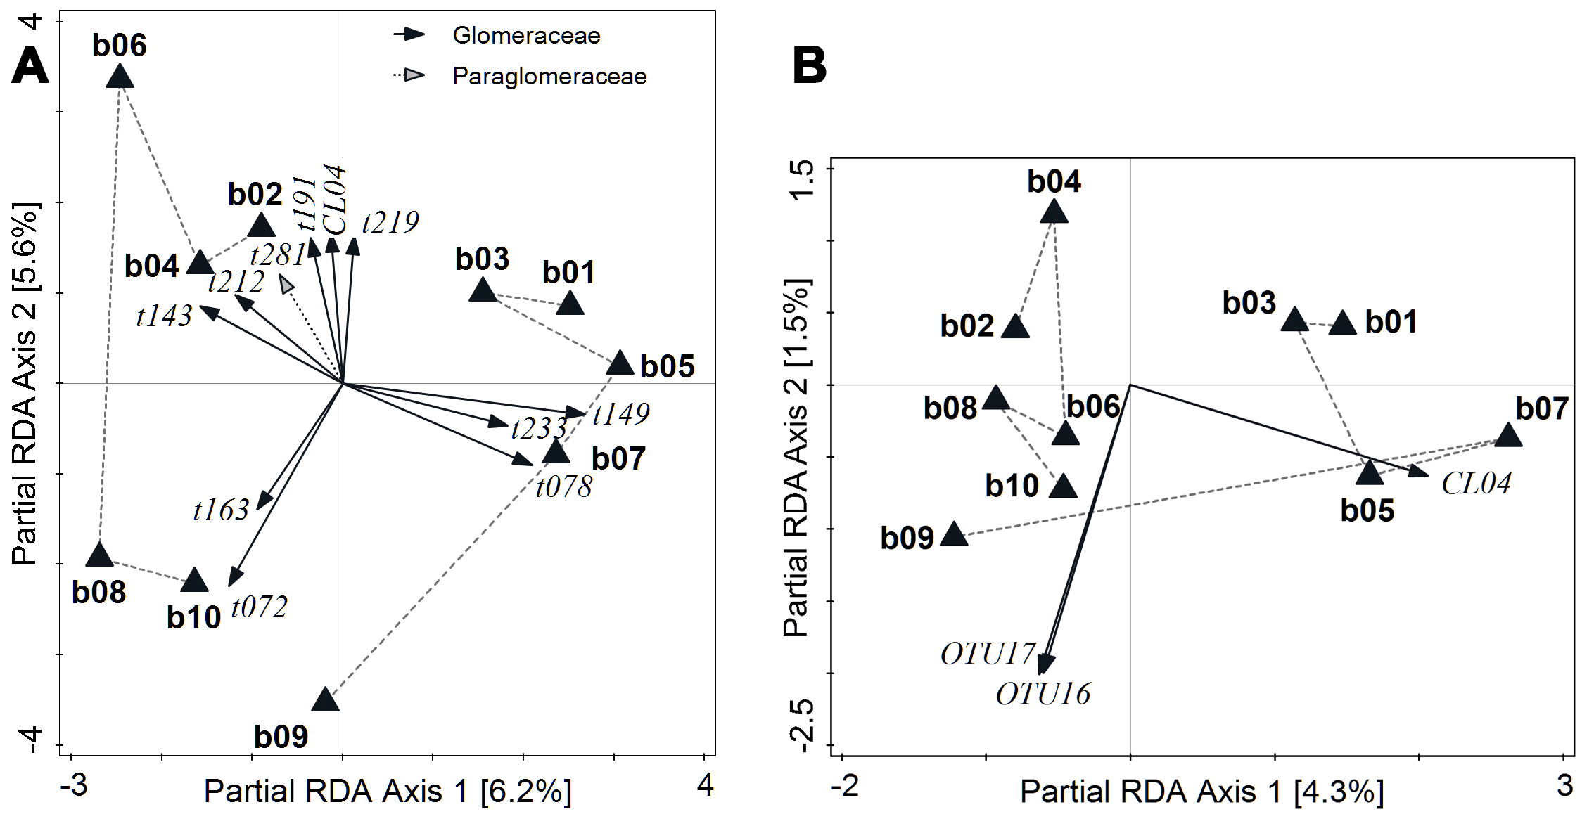
Fig. EA13 – Biplots of partial redundancy analyses (RDA) showing differences in composition of G-AMF (A) and M-FRE (B) communities among spatial blocks arranged in two rows along a shallow hill slope. The black triangles represent the centroids of the communities in each individual block. Blocks at the top of the slope (odd numbers) and those at the bottom (even numbers) are connected with a dashed polyline. VTX in A or OTU in B differing strongly in occurrence and abundance are shown with arrows. In part A, the affiliation of VTX to G-AMF families is indicated with either black or grey arrow heads.

EA9 – Sensitivity analysis of M-FRE definition on α- and β-diversity and G-AMF/M-FRE ratio models
Tables EA11 and EA12 contain the same analyses as Tables 1–4, but based only on OTU with a published DNA sequence from a plant host (M-FRE* dataset), representing the more conservative M-FRE definition. The more cautious M-FRE definition did not alter the message of Tables 1 and 2 about the effect of nutrient enrichment on the community composition or α-diversity (Table EA11). The weak effect of P addition on the G-AMF / M-FRE ratio for the M-FRE definition based on the affiliation to the Endogonales order is no longer significant with the M-FRE* definition (Table EA11), although the corresponding F statistic is still relatively large (2.21) compared with that of other factors.
Table EA11 – Effects of sole and combined inorganic N and P addition on M-FRE* community composition, α-diversity (Hill’s N2 index), and the G-AMF / M-FRE* ratio. Tests in the last row focus on patch types, including biomass addition. Data from weeks 6 and 12 are pooled. Changes due to the alternative M-FRE* definition are highlighted in red. R²_{adj} is the adjusted explained variation [%], F is the test statistic (with the DF for univariate tests) and p is the test significance.
 | M-FRE* OTUs community |  | M-FRE*  alpha diversity |  | G-AMF / M-FRE* ratio
Effect | R²_{adj} | F / p | R²_{adj} | F / p | R²_{adj} | F / p
N | 0.1 | F=1.2  n.s. | < 0.1 | F_{1,147}=0.09  n.s. | 0.7 | F_{1,147}=1.18  n.s.
P | <0.1 | F=1.0  n.s. | < 0.1 | F_{1,147}<0.01  n.s. | 1.4 | F_{1,147}=2.21  n.s.
N : P interaction | 0.0 | F=0.1  n.s. | < 0.1 | F_{1,147}=0.03  n.s. | 0.6 | F_{1,147}=0.96  n.s.
Patch type | <0.1 | F=0.6  n.s. | 0.3 | F_{4,186}=0.17  n.s. | 2.6 | F_{4,186}=1.31  n.s.

The more restrictive definition of M-FRE* led to a significant difference in community composition between the two patch exposure times (6 and 12 weeks) (Table EA12) with only two OTU showing higher abundances either after 6 weeks (OTU004) or 12 weeks (OTU017) of patch exposure in the field. The weak effect of the root presence and the interaction of substrate type with exposure time disappeared with the M-FRE* definition (Table EA12).
Table EA12 – Effects of exposure time, presence / absence of ingrown roots in patches, and the interactions of exposure time with patch type (including patches with biomass addition) and of exposure time with root presence/absence in patches on M-FRE* community composition, α-diversity (Hill’s N2 index), and the G-AMF / M-FRE* ratio. Changes due to the alternative M-FRE* definition are highlighted in red, showing a loss of significant effects, and in green, showing an appearance of significant effects. R²_{adj} represents the size of the adjusted explained variation [%], F is the test statistic with the associated degrees of freedom (for regression models), p is the test significance. Significant effects are highlighted in bold.
 | M-FRE* OTUs community |  | M-FRE*  α-diversity |  | G-AMF / M-FRE*  ratio
Effect | R²_{adj} | F / p | R²_{adj} | F / p | R²_{adj} | F / p
Exposure time | 3.6 | F=7.9  p=0.002 | 2.2  ▲T2 by 7.2% | F_{1,189}=4.94  p=0.028 | 23.0  ▲T2 by 75.3% | F_{1,181}=63.2  p<0.001
Patch type : exposure time | < 0.1 | F=0.6  n.s. | 1.0 | F_{4,181}=0.52  n.s. | 3.1 | F_{4,181}=2.46  p=0.047
Root presence / absence | < 0.1 | F=0.2  n.s. | 0.2 | F_{1,189}=0.44  n.s. | 0.1 | F_{1,99}=0.45  n.s.
Root presence/absence : exposure time | < 0.1 | F=0.8  n.s. | < 0.1 | F_{1,187}=0.04  n.s. | 0.1 | F_{1,98}=0.58  n.s.

The taxonomic diversity varied considerably among the original soil samples taken at the time of patch installation and the various types of ingrowth patches, depending on the M-FRE definitions. Whereas the relaxed EndogonaleanM-FRE definition yielded no significant difference, the more conservative M-FRE* definition yielded highly significant (p < 0.01) differences between all patch types and the original soil. The diversity of M-FRE* was significantly higher in the patches compared to the original soil. The M-FRE definition did not affect the G-AMF / M-FRE ratio analyses.

