Supplementary Information to article in Biology and Fertility of Soils

Title: Soil cropping selects for nutrient efficient but more costly indigenous mycorrhizal fungal communities
Authors: Paula A. Buil*, Jan Jansa, Martin Rozmoš, Michala Kotianová, Petra Bukovská, Gabriel Grilli, Nicolás Marro, Martina Janoušková
*Corresponding author, Institute of Botany, Czech Academy of Sciences, Zámek 1, 252 43 Průhonice, Czech Republic; e-mail: paula.buil@ibot.cas.cz

Content:
- Tables S1, S4, S5, S6
- Figures S1, S2, S3

Table S1: Location of the source sites for the experimental soils and inocula, their soil parameters.

Sites | Drahobuz | Drahobuz | Encovany | Encovany | Malíč | Malíč | Svařenice | Svařenice
 | Field | Grassland | Field | Grassland | Field | Grassland | Field | Grassland
 | 50.5271575N 14.3278672E | 50.5269444N 14.3283794E | 50.5321558N 14.2580742E | 50.5320708N 14.2575611E | 50.5403378N 14.0901225E | 50.5414769N 14.0846211E | 50.5024036N 14.3167103E | 50.5007061N 14.3151394E
 | Soils at the field sites
Clay (%) | 42.2 | 39.3 | 45.5 | 45.1 | 53.9 | 54.9 | 29.8 | 33.8
pH _{H20} | 7.9 | 7.9 | 7.9 | 8.0 | 7.9 | 8.1 | 7.8 | 8.0
C _{tot} (%) | 2.61 | 4.83 | 7.23 | 10.32 | 5.61 | 9.44 | 1.48 | 5.02
C _{org} (%) | 1.18 | 2.91 | 1.54 | 5.81 | 2.39 | 5.09 | 0.81 | 2.31
N _{tot} (%) | 0.20 | 0.23 | 0.25 | 0.50 | 0.31 | 0.50 | 0.13 | 0.24
P _{Olsen}  (mg kg⁻¹) | 36.87 | 7.39 | 29.71 | 19.68 | 35.07 | 11.25 | 22.72 | 7.16
P _{H20}  (mg kg⁻¹) | 3.70 | 0.72 | 0.81 | 4.95 | 2.76 | 1.37 | 2.15 | 0.99
Ca _{NH4OAc}  (mg kg⁻¹) | 3671 | 3900 | 6494 | 6056 | 6240 | 5390 | 3381 | 4210
K _{NH4OAc}  (mg kg⁻¹) | 344 | 213 | 371 | 876 | 733 | 387 | 234 | 204
Mg _{NH4OAc}  (mg kg⁻¹) | 60.6 | 56.9 | 80.2 | 241.6 | 143.9 | 157.9 | 49.8 | 51.3
CEC (mmol kg⁻¹) | 155 | 175 | 304 | 362 | 336 | 338 | 149 | 183
 | Cultivation substrates (1:1 mixtures of the soils with sand)
C _{tot} (%) | 0.72 | 1.46 | 4.78 | 5.78 | 2.14 | 3.81 | 1.05 | 1.96
N _{tot} (%) | 0.06 | 0.10 | 0.14 | 0.17 | 0.11 | 0.10 | 0.07 | 0.08
P _{H20}  (mg kg⁻¹) | 4.52 | 3.08 | 3.52 | 1.24 | 2.75 | 2.54 | 0.71 | 0.62

Particle size fractions (% of clay, silt and sand) were determined by pipette method according International Organization for Standardization (ISO, 2009) as mass of three particle size fractions (clay < 0.002 mm, silt 0.002–0.05 mm, sand 0.05–2.00 mm). Soil pH was measured in deionized H₂O (1:5 w/v sample/liquid ratio). Total nitrogen (N _{tot}) and carbon concentrations (C _{tot}) were determined on a Flash 2000 analyser (Thermo Scientific, USA). Organic C (C _{org}) was determined after digestion of carbonate C with HCl on a Flash 2000 analyser. Available P was measured after extraction from the soil samples according to (Olsen SR and Sommers LE 1982) and measured spectrophotometrically as phosphomolybdenum blue at 750 nm (Unicam UV-400) (P Olsen) or was determined spectrophotometrically in aqueous soil extracts (1:10 w/v sample/deionized water ratio) after shaking for 16 h and filtering through a 0.2-μm filter (CME, Carl Roth, Karlsruhe, Germany) using the malachite green method (Ohno and Zibilske 1991) (P _{H2O}). Available calcium (Ca _{NH4OAc}), magnesium (Mg _{NH4OAc}) and potassium (K _{NH4OAc}) levels were determined after extraction with ammonium acetate by atomic absorption spectroscopy (AAS, ContrAA 700, Analytik Jena). Cation exchange capacity (CEC) was determined after extraction with 0.1 M BaCl₂ by AAS (ContrAA 700).

Table S4: Effects of the experimental factors and their two-way interactions on plant performance according to redundancy analysis (RDA).
Factor / Interaction | pseudo-F | p-value | adjusted R²
Inoculation treatment | 22.0 | <0.002 | 23.4
Site | 14.4 | <0.002 | 22.4
Soil provenance | 4.1 | 0.006 | 2.2
Inoculum × Site | 8.6 | <0.002 | 25.7
Inoculum × Soil provenance | 0.9 | 0.520 | 0
Site × Soil provenance | 4.1 | <0.002 | 6.7
The parameters used to characterize plant performance were: shoot and root dry weights, N and P concentrations in shoots and roots, N and P contents in shoots and roots, the N:P ratio in shoots. To calculate the proportion explained by each factor, the other two factors were entered as covariates. For the calculation of the variation explained by the two-way interactions, the factors as well as the other two two-way interactions were entered as covariates.

Table S5: Effects of the experimental factors and their two-way interactions on the composition of arbuscular mycorrhizal fungal (AMF) communities according to redundancy analysis (RDA).
Factor / Interaction | pseudo-F | p-value | adjusted R²
Inoculum provenance | 11.9 | <0.002 | 10.7
Site | 2.9 | <0.002 | 5.8
Soil provenance | 0.8 | 0.694 | 0
Inoculum × Site | 4.2 | <0.002 | 10.2
Inoculum × Soil provenance | 1.0 | 0.498 | 0
Site × Soil provenance | 1.3 | 0.088 | 1.0
The community composition was based on 14 taxa of AMF (see Table 1). To calculate the proportion explained by each factor, the other two factors were entered as covariates. For the calculation of the variation explained by the two-way interactions, the factors as well as the other two two-way interactions were entered as covariates.
Table S6: Abundance of arbuscular mycorrhizal fungi in root zone soil and in the root-free compartment as copy numbers (CN) of ribosomal DNA, and effects of the experimental factors Soil provenance (Soil) and Inoculum provenance (Inoculum), and their interaction (lower part of the table).
Soil | Inoculum | Root zone soil (CN.mg-1 substrate) | Root-free compartment  (CN.mg-1 substrate)
Field | Field | 4214 (684) | 12210 (1467)
Field | Grassland | 4262 (695) | 12315 (1448)
Grassland | Field | 4562 (685) | 12127 (1423)
Grassland | Grassland | 4943 (743) | 12528 (1521)
 | df | X² (p-value)
Soil (A) | 1 | 0.962 (0.327) | 0.3327 (0.564)
Inoculum (B) | 1 | 0.013 (0.909) | 0.0365 (0.848)
A × B | 1 | 0.024 (0.877) | 4.147 (0.042)
Values in the upper part of the table are means (SEM) across all sites. The effects of the experimental factors (X² = Chi-square value) are given according to linear models fitted using generalised linear mixed (GLMM) method or generalised least squares (GLS) method to correct for heterogeneity of variances, which included Site and Harvest day as random variables. Significant effects of the factors are highlighted in bold, n.i. not included in the final model.

Fig. S1: Schema of the experimental design. Plants were grown in arable-field soil (brown pot) or in grassland soil (green pot), with arbuscular mycorrhizal fungi (AMF) from the arable-field (brown circle), the grassland (green circle) or without AMF (non-mycorrhizal controls, cross). This design was established for pairs of arable-field and grassland from four sites (Drahobuz, Encovany, Malíč and Svařenice). Created with BioRender.com.
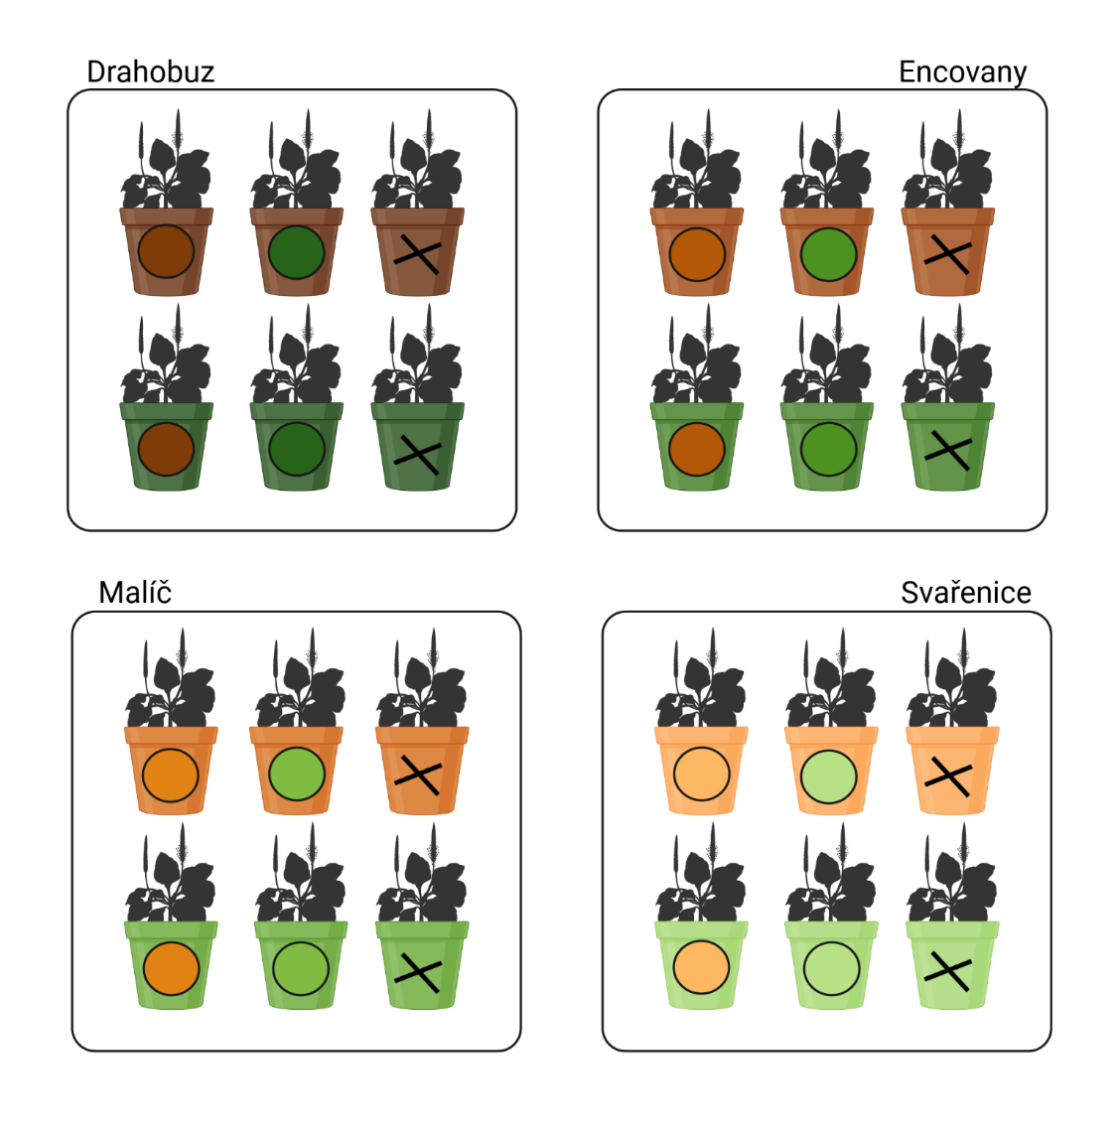
Fig. S2: Relative abundances of the three most abundant families and sum of low-abundance families of arbuscular mycorrhizal fungi within the established communities. The columns are means per combination of the treatments Site and Inoculum provenance, while Soil provenance, which did not significantly affect the AMF community composition, is neglected.

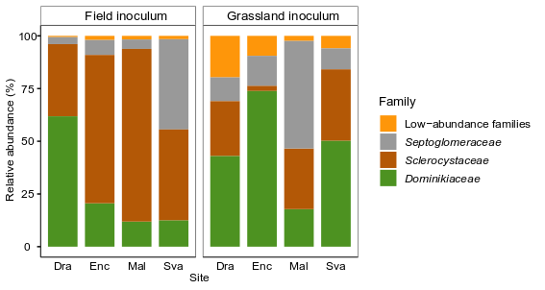

Fig. S3: Relationship of mycorrhizal growth response of shoots (Response SDW) with the shoot dry weight of non-mycorrhizal plants (SDW-NM) (a), and the N:P ratio in shoots of non-mycorrhizal plants (N:P-NM) (b). Green symbols show responses to grassland inocula, brown symbols to arable-field inocula, symbols are varied by sites (squares = Dra, circles = Enc, triangles = Mal, crosses = Sva).
a) | b)
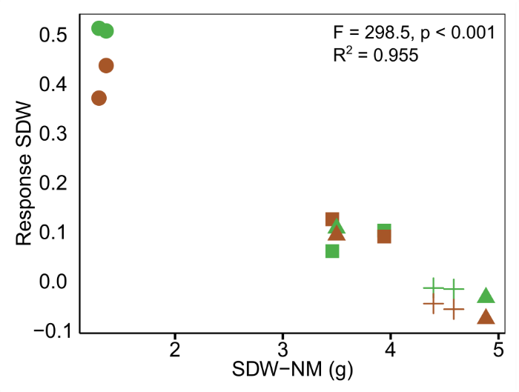 | 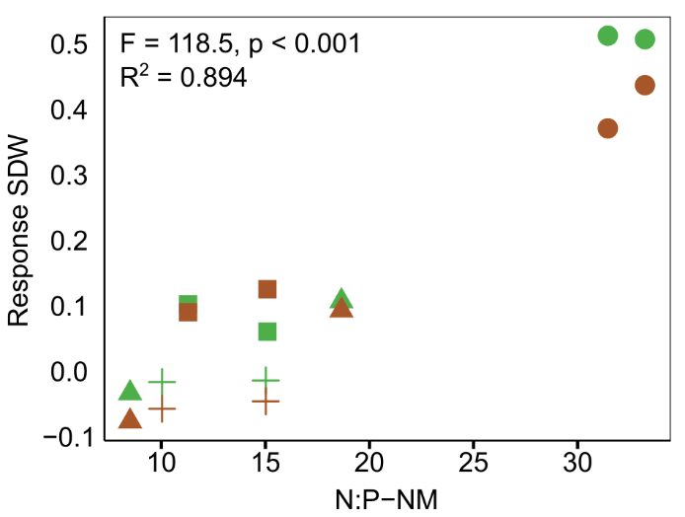

References to Supporting Information
International Organization for Standardization (2009) Soil quality — Determination of particle size distribution in mineral soil material — Method by sieving and sedimentation (ISO Standard No. 11277). Retrieved from https://www.iso.org/standard/54151.html
Ohno T, Zibilske LM (1991) Determination of low concentrations of phosphorus in soil extracts using malachite green. Soil Sci Soc Am J 55:892–895
Olsen SR, Sommers LE (1982) Phosphorus. In: Page A, Miller R, Keeney D (eds) Methods of soil analysis, part 2, Chemical and microbiological properties. American Society of Agronomy, Madison, pp 403–430

