Table S1. List of specific agricultural practices, dates and quantity of substances applied to each cropping system, during the experimental period of October 2021 – July 2022, at the DOK long-term field trial.
Cropping system | Agricultural practice/substance application | Date of application | Quantity applied
BIODYN | Composted manure application | 07.08.2021 | 10 t ha⁻¹
 | Horn manure (500P) application | 15.03.2022 | 96 g ha⁻¹
 | Horn silica (501) application | 05.05.2022 | 8 g ha⁻¹
 |  | 28.05.2022 | 8 g ha⁻¹
 | Slurry application | 16.03.2022 | 2.5 l ha⁻¹
 |  | 13.04.2022 | 4 l ha⁻¹
CONFYM | Stacked manure application | 07.10.2021 | 12 t ha⁻¹
 | Mineral fertilizer application | 16.03.2022 | 60 kg N ha⁻¹, 14 kg P ha⁻¹, 14 kg K ha⁻¹
 |  | 13.04.2022 | 30 kg N ha⁻¹
 |  | 17.05.2022 | 40 kg N ha⁻¹
 | Herbicide application (Othello ® Star; Bayer AG, Leverkusen, Deutschland) | 28.03.2022 | 1 l ha⁻¹
 | Plant growth regulators application (CCC 720 ®; Bayer AG) | 28.03.2022 | 0.5 l ha⁻¹
 | Plant growth regulators application (Moddus; Syngenta, Basel, Switzerland) | 11.04.2022 | 0.6 l ha⁻¹
 | Fungicide application (Aviator® Xproin; Bayer AG) | 18.05.2022 | 1.25 l ha⁻¹
CONMIN | Mineral fertilizer application | 07.10.2021 | 29 kg P ha ⁻¹, 75 kg K ha⁻¹
 |  | 16.03.2022 | 70 kg N ha⁻¹
 |  | 13.04.2022 | 40 kg N ha⁻¹
 |  | 17.05.2022 | 40 kg N ha⁻¹
 | Herbicide application (Othello ® Star; Bayer AG, Leverkusen, Deutschland) | 28.03.2022 | 1 l ha⁻¹
 | Plant growth regulators application (CCC 720 ®; Bayer AG) | 28.03.2022 | 0.5 l ha⁻¹
 | Fungicide application (Aviator® Xproin; Bayer AG) | 18.05.2022 | 1.25 l ha⁻¹
BIODYN = biodynamic cropping system; CONFYM = conventional cropping system; CONMIN = mineral cropping system

Table S2. Soil organic carbon (SOC) and total nitrogen (N) mean values per plant stage, with probability values of a mixed linear model using system as random variable, and an aligned rank transform ANOVA using plant stage as grouping term.
 | SOC | Total N
 | (mg g⁻¹ soil)
Plant stage
Stem elongation | 16.8 | 1.69
Flowering | 16.7 | 1.70
Ripening | 16.8 | 1.68
Probability values of mixed linear model
PS | NS | NS
WR | NS | NS
WR × PS | NS | NS
Probability values of aligned rank-transform ANOVA
CS | <0.01 | <0.01
CS × WR | NS | NS
CV (± %) | 14 | 16
WR = water regime; PS = plant stage; CS = cropping system; CV = mean coefficient of variation between replicate plots (n = 4), letters represent significant differences between the plant stages (P < 0.05, emmeans).

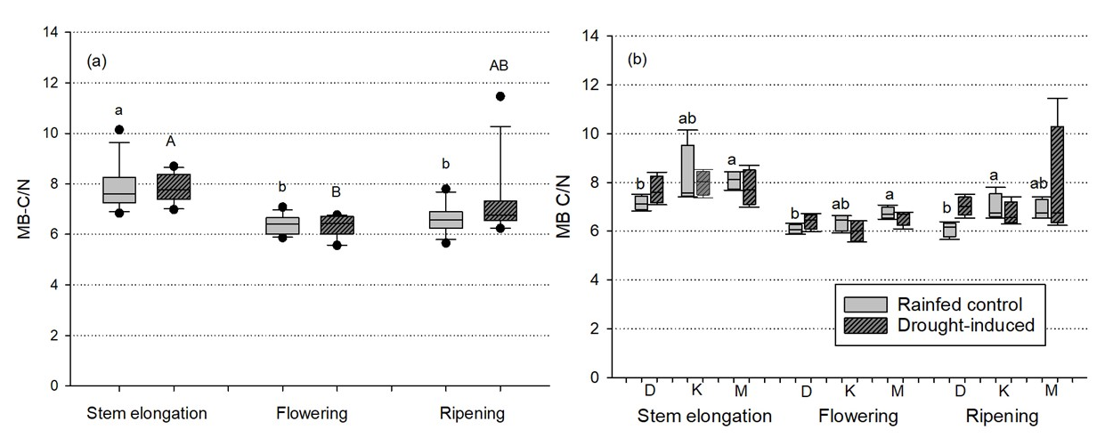
Fig. S1. Microbial biomass carbon to nitrogen ratio (MB C/N) shown for stem elongation, flowering, and ripening stages (a) comparing main effects of rainfed control and drought-induced, and (b) comparing the effects of biodynamic (BIODYN), mixed conventional (CONFYM) and mineral conventional (CONMIN) cropping systems under rainfed control and drought-induced; lowercase letters represent differences between groups in control plots and uppercase letters in roof plots (P < 0.05, Tukey HSD).

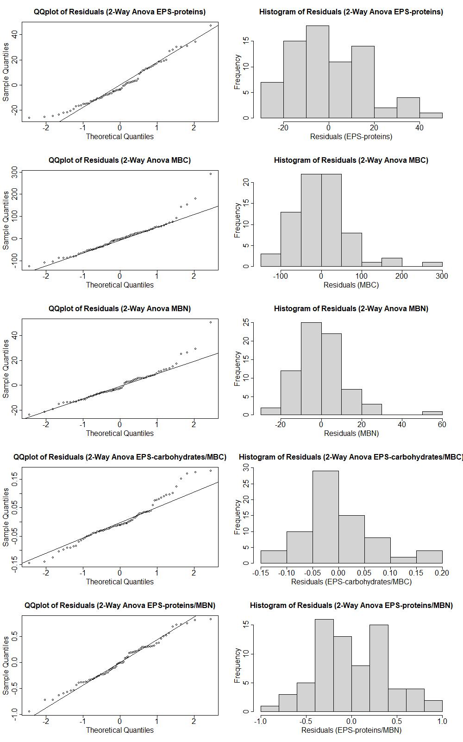
Fig. S2. Quantile-quantile plots and histograms of residuals from two-way ANOVAs before data transformation, on the variables Extracellular polymeric substances (EPS) proteins, microbial biomass carbon (MBC), microbial biomass nitrogen (MBN), EPS-carbohydrates/MBC and EPS-proteins/MBN, using cropping system and water regime as independent variables.

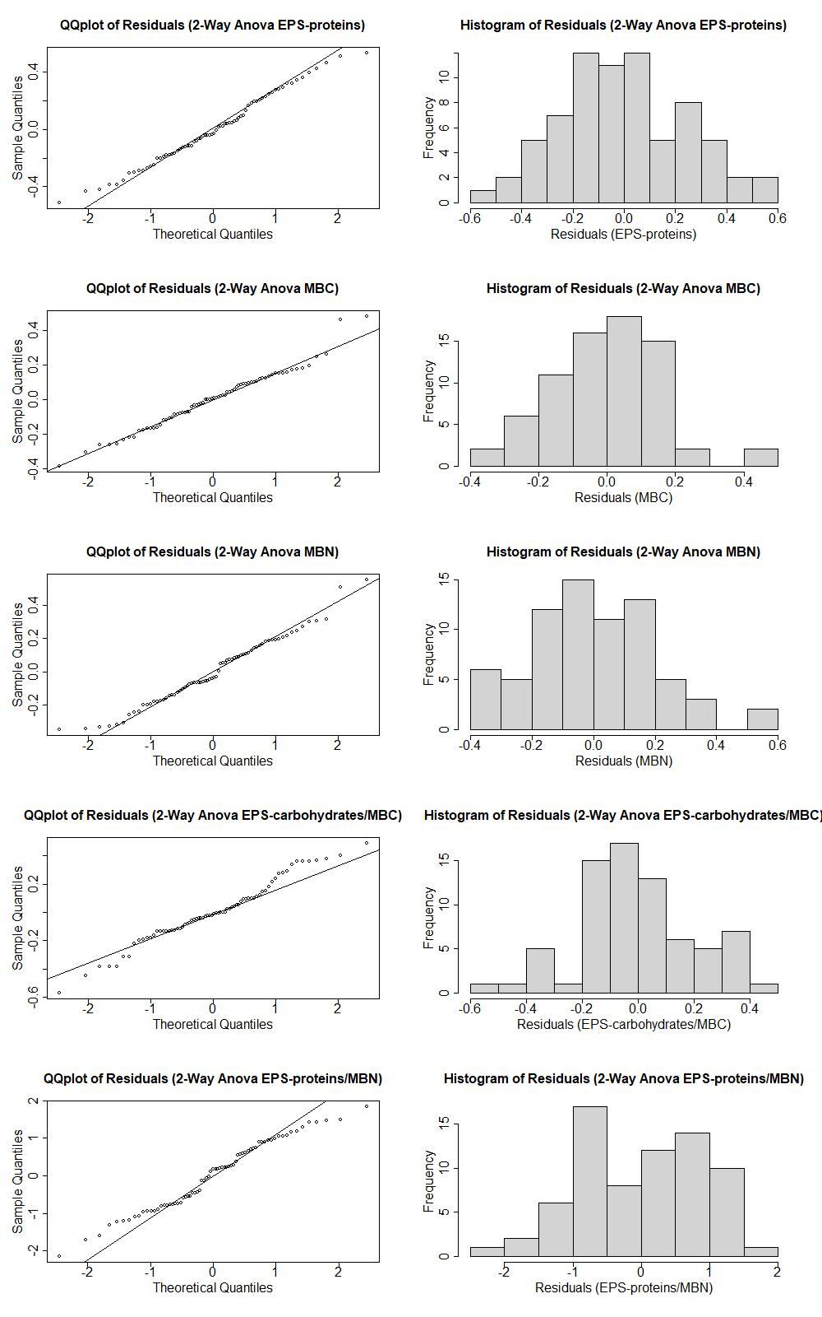
Fig. S3. Quantile-quantile plots and histograms of residuals from two-way ANOVAs after data transformation, on the variables Extracellular polymeric substances (EPS) proteins, microbial biomass carbon (MBC), microbial biomass nitrogen (MBN), EPS-carbohydrates/MBC and EPS-proteins/MBN, using cropping system and water regime as independent variables.

