Soil incorporation of crushed asphalt as a circular economy strategy for de-sealed soil reclamation: Case study in Prato, Italy
Giovanni Mastrolonardo^{1*}, Beatrice Fiore¹, Laura Giagnoni^{1,2}, Federico Selvi¹, Giovanni Argenti¹, Filippo Gallese³, Leonardo Verdi¹, Gregorio Fantoni¹, Bianca Rompato¹, Giacomo Certini¹
¹Dipartimento di Scienze e Tecnologie Agrarie, Alimentari, Ambientali e Forestali (DAGRI), Università di Firenze, P. le delle Cascine 18, 50144 Firenze, Italy
²Department Civil, Environmental, Architectural Engineering and Mathematics (DICATAM), University of Brescia, I-25123 Brescia, Italy
³Istituto di Bioeconomia - IBE, Consiglio Nazionale delle Ricerche - CNR, Via Madonna del Piano 10, 50019 Sesto Fiorentino, Firenze, Italy

Supplementary Information

SI 1. Description, classification and analysis of a soil profile opened in the study area
Station data
Location (Municipality and Province): Prato (PO), viale Pietro Nenni (43°52'26.0"N, 11°04'55.8"E)
Land use: Parking lot
Slope: Flat

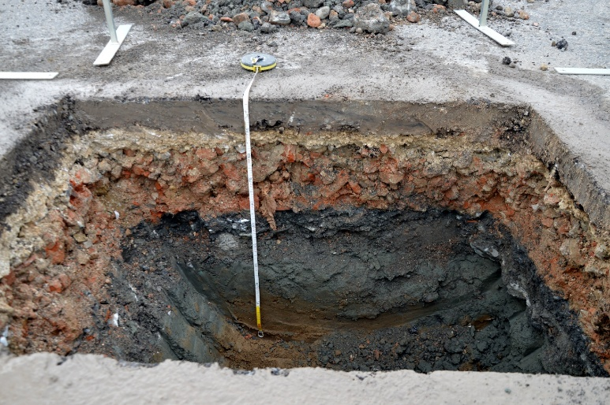
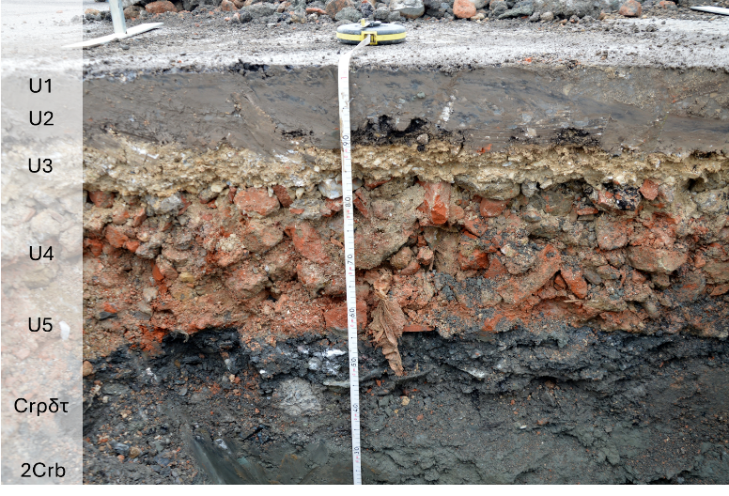

WRB Classification (ed. 2022):
Gleyic Ekranic Technosol (Siltic, Carbonic, Ochric) (IUSS Working Group WRB, 2022)
Horizons (according to WRB)

U1 | (0-9 cm) | Continuous layer of bituminous conglomerate, black road wear surface, fine grain size, waterproof.
U2 | (9-12 cm) | Binder layer made of larger-grained bituminous conglomerate, bituminous binder.
U3 | (12-17 cm) | Compacted calcareous gravel, with little fine earth (10-20%). Unstructured and non-pedogenized. Very strong effervescence with 10% HCl on both clasts and fines.
U4 | (17-35 cm) | Limestone rock fragments and bricks (the latter prevalent, maximum 10 cm in size) not cemented together but compacted, less than 10% of interstitial fine earth.
U5 | (35-52 cm) | Predominantly calcareous rock fragments (maximum 10 cm in size, no bricks), mixed with fine earth (20-30% of the total), apparently and at least partly belonging to the underlying horizon.
Crρδτ | (52-70 cm) | 5G 4/1 “dark greenish gray” (dry), stone-free, clay. Massive, very hard, plastic, slightly sticky. No roots, very low porosity, very fine, vesicular. pH 6-7. Sharp and linear lower boundary.
2Crb | (70-90+) | 10YR 5/2 “greyish brown” (dry), stone-free, clay. Massive, very hard, plastic, slightly sticky. No living roots, low porosity, very fine, vesicular and tubular (the latter with root remnants). pH 6-7.
Horizon/layer | c Sand  (>500 µm)  % | m Sand  (500-250 µm) % | f Sand  (250-50 µm)  % | c Silt  (50-20) µm  % | f Silt  (20-2) µm  % | Clay | Texture  class
U1-U2 | - | - | - | - |  | -
U4-U5 | 34 | 15 | 30 | 3 | 15 | 2 | Loamy sand
Crρδτ | 1 | 4 | 34 | 15 | 36 | 10 | Silt loam
2Crb | 1 | 5 | 32 | 5 | 45 | 12 | loam

Horizon/layer | pH | Carbonates  % | SOM  % | CEC  meq/100g | BD  g cm⁻³
U1-U2 | 7.8 | 22.3 | 8.8 | - | -
U4-U5 | 7.8 | 46.6 | 2.1 | - | -
Crρδτ | 6.9 | 0 | 3.5 | 9.21 | 1.8
2Crb | 7.5 | 0 | 3.3 | 11.49 | -

SI 2. List of plant species identified in the plots in May 2025
Species | Family
Agropyron repens | Poaceae
Artemisia vulgaris | Asteraceae
Arum italicum | Araceae
Aster squamatus | Asteraceae
Avena sterilis | Poaceae
Beta vulgaris | Chenopodiaceae
Bromus sterilis | Poaceae
Carex divulsa | Cyperaceae
Cerastium semidecandrum | Caryophyllaceae
Cichorium intybus | Asteraceae
Cirsium arvense | Asteraceae
Convolvulus arvensis | Convolvulaceae
Cynodon dactylon | Poaceae
Dactylis glomerata | Poaceae
Daucus carota | Apiaceae
Festuca sp. (rubra) | Poaceae
Galium aparine | Rubiaceae
Gaudinia fragilis | Poaceae
Geranium columbinum | Geraniaceae
Geranium dissectum | Geraniaceae
Hordeum murinum | Poaceae
Hypericum perforatum | Hypericaceae
Inula viscosa | Asteraceae
Lolium multiflorum | Poaceae
Lotus corniculatus | Fabaceae
Lotus tenuis | Fabaceae
Medicago lupulina | Fabaceae
Medicago polymorpha | Fabaceae
Oxalis corniculata | Oxalidaceae
Picris echioides | Asteraceae
Plantago lanceolata | Plantaginaceae
Poa annua | Poaceae
Poa trivialis | Poaceae
Potentilla reptans | Rosaceae
Ranunculus arvensis | Ranunculaceae
Ranunculus bulbosus | Ranunculaceae
Rumex crispus | Polygonaceae
Sonchus oleraceus | Asteraceae
Sorghum halepense | Poaceae
Trifolium repens | Fabaceae
Verbena officinalis | Verbenaceae
Veronica persica | Plantaginaceae
Vulpia ciliata | Poaceae

SI 3. Dynamic of soil gas fluxes measured over the study period. Values are expressed in kg/ha/day as means of replicates. The coloured ribbons represent the dispersion around the mean (Standard Error).

