Temporal variation in bacterial and fungal communities of the rhizosphere and roots of young avocado trees

MAU Zaman, Anish S. Shah, Treena I. Burgess, Kirsty L. Bayliss

Supplementary data

Table S1. Nutrient content of the commercial mineral feriliser and biostimulant applied to the avocado trees in the field.
Mineral nutrients | Liquid mineral fertiliser | Fish and kelp-based  biostimulant
Nitrogen (N) | 16.5 % w/v | 1.9 % w/v
Phosphorus (P) | - | 0.3 % w/v
Potassium (K) | 11.8 % w/v | 0.8 % w/v
Calcium (Ca) | - | 0.3 % w/v
Magnesium (Mg) | 0.87 % w/v | 0.15 % w/v
Sulphur (S) | 0.2 % w/v | 0.3 % w/v
Carbon (C) | - | 16.8 % w/v
Iron (Fe) | 1.01 % w/v | 0.02 % w/v
Manganese (Mn) | 574 ppm | 9 ppm
Zinc (Zn) | 339 ppm | 6 ppm
Copper (Cu) | 130 ppm | 5 ppm
Boron (B) | 47 ppm | -
Molybdenum (Mo) | 54 ppm | -

Table S2. Cumulative nutrient inputs per tree across the 12-month field trial.
Mineral nutrients | T1 | T2 | T3
 | Mineral, monthly | Biostimulant, monthly | Biostimulant, quarterly
Total volume per tree (mL) | 24 | 84 | 28
N (g) | 3.96 | 5.1 | 1.7
P (g) | - | 0.18 | 0.06
K (g) | 2.83 | 3.31 | 1.10
Ca (g) | - | 0.18 | 0.06
Mg (g) | 0.21 | 0.30 | 0.10
S (g) | 0.05 | 0.23 | 0.08
C (g) | - | 10.08 | 3.36
Fe (g) | 0.24 | 0.25 | 0.08
Mn (mg) | 13.78 | 14.32 | 4.77
Zn (mg) | 8.14 | 8.5 | 2.83
Cu (mg) | 3.12 | 3.42 | 1.14
B (mg) | 1.13 | 1.13 | 0.38
Mo (mg) | 1.30 | 1.30 | 0.43
Cumulative inputs were calculated from product concentrations in Table S1, multiplied by per-tree application volumes and frequencies. T1 was a mineral fertiliser formulated to match the mineral composition of the liquid nutrient fertiliser component of T2, without the biostimulant or organic fraction. T2 and T3 were mixed with a certified-organic fish-and-kelp liquid biostimulant (5 mL per dose), so their cumulative inputs exceed T1 and include carbon. T2 and T3 differed only in application frequency, giving a 3:1 cumulative-input ratio.
Table S3. Soil physicochemical properties of composite samples taken initially (July 2023), at the time of transplanting (June 2024) before treatment application, and at the end of the trial in June 2025 (T1 = mineral fertilizer, T2 = monthly biostimulant and T3 = quarterly biostimulant) at Whitby Falls farm.
Soil property | Initial | T1 |  |  | T2 |  |  | T3
Soil property | Initial | Initial | Final | Initial |  | Final | Initial |  | Final
Depth (cm) | 0-10 | 0-10 | 0-10 | 0-10 |  | 0-10 | 0-10 |  | 0-10
Gravel (%) | 35-40 | 30-35 | 35-40 | 25-30 |  | 45-50 | 30-35 |  | 45-50
Ammonium Nitrogen (mg/Kg) | 3 | 4 | 4 | 3 |  | 4 | 2 |  | 5
Nitrate Nitrogen (mg/Kg) | 4 | 18 | 11 | 21 |  | 8 | 22 |  | 4
Phosphorus Colwell (mg/Kg) | 140 | 140 | 183 | 184 |  | 217 | 186 |  | 183
Potassium Colwell (mg/Kg) | 59 | 109 | 201 | 130 |  | 259 | 162 |  | 134
Sulphur (mg/Kg) | 5.3 | 11.5 | 12.3 | 7.9 |  | 15.9 | 10.1 |  | 7
Organic Carbon (%) | 1.49 | 2.36 | 3.11 | 2.65 |  | 2.54 | 3.24 |  | 2.64
Conductivity (dS/m) | 0.042 | 0.067 | 0.11 | 0.07 |  | 0.14 | 0.076 |  | 0.096
pH (CaCl2) | 5.6 | 5.5 | 6.5 | 5.6 |  | 6.6 | 5.6 |  | 6.3
pH (H2O) | 6.3 | 6.4 | 7.7 | 6.3 |  | 7.6 | 6.5 |  | 7.5
DTPA Copper (mg/Kg) | 2.15 | 1.67 | 2.36 | 2.27 |  | 1.8 | 3.09 |  | 2.99
DTPA Iron (mg/Kg) | 37.3 | 34.1 | 28.3 | 39.6 |  | 27.5 | 42 |  | 30.4
DTPA Manganese (mg/Kg) | 2.79 | 1.48 | 5.92 | 1.97 |  | 3.56 | 2.05 |  | 3.51
DTPA Zinc (mg/Kg) | 4.71 | 2.97 | 17.15 | 4.74 |  | 13.06 | 5.25 |  | 13.92
Exc. Aluminium (meq/100g) | 0.034 | 0.03 | 0.026 | 0.02 |  | 0.029 | 0.033 |  | 0.028
Exc. Calcium (meq/100g) | 9.61 | 6.98 | 13.7 | 8.95 |  | 11.51 | 9.33 |  | 11.59
Exc. Magnesium (meq/100g) | 0.63 | 0.76 | 5.44 | 0.88 |  | 4.17 | 0.98 |  | 4.04
Exc. Potassium (meq/100g) | 0.14 | 0.26 | 0.56 | 0.32 |  | 0.76 | 0.38 |  | 0.24
Exc. Sodium (meq/100g) | 0.06 | 0.08 | 0.41 | 0.13 |  | 0.55 | 0.09 |  | 0.37
Boron (Hot CaCl2) (mg/Kg) | 0.38 | 0.44 | 1.07 | 0.5 |  | 1.07 | 0.59 |  | 1

Table S4. Mean avocado tree growth and leaf nutrient parameters (n = 8), for each of the three treatments (T1 = mineral fertilizer, T2 = monthly biostimulant, and T3 = quarterly biostimulant). Differences between treatments were assessed by one-way ANOVA with Tukey's HSD post-hoc comparisons, at p < 0.05. Superscript letters denote treatments that differed in Tukey's HSD comparisons, with boron higher under T2 than under T1 and T3.
 | Parameter | T1 | T2 | T3
Tree growth | Tree height (cm) | 134.125 | 118.625 | 123.875
Tree growth | Stem diameter (cm) | 2.738 | 2.138 | 2.388
Leaf nutrients | Boron (mg/Kg) * | 26.926 b | 33.533 a | 26.564 b
Leaf nutrients | Calcium (%) | 0.656 | 0.716 | 0.638
Leaf nutrients | Copper (mg/Kg) | 7.218 | 7.378 | 8.864
Leaf nutrients | Iron (mg/Kg) | 44.603 | 44.965 | 46.645
Leaf nutrients | Magnesium (%) | 0.369 | 0.396 | 0.340
Leaf nutrients | Manganese (mg/Kg) | 17.165 | 15.444 | 13.303
Leaf nutrients | Phosphorus (%) | 0.173 | 0.163 | 0.180
Leaf nutrients | Potassium (%) | 1.395 | 1.456 | 1.589
Leaf nutrients | Sodium (%) | 0.016 | 0.011 | 0.016
Leaf nutrients | Sulphur (%) | 0.186 | 0.180 | 0.190
Leaf nutrients | Total Nitrogen (%) | 1.918 | 1.930 | 1.963
Leaf nutrients | Zinc (mg/Kg) | 23.539 | 22.066 | 25.626

Table S5. Type III ANOVA results for bacterial (16S rRNA) alpha diversity in the rhizosphere and roots of young avocado trees. Two indices were modelled: Shannon's H′ and observed ASV richness. Diversity was calculated after rarefying samples within each compartment to the minimum read count (rhizosphere: 2,943 reads; root: 4,659 reads). Rhizosphere samples were collected at five timepoints - S0 (winter, pre-mulch baseline), S1 (spring), S2 (summer), S3 (autumn), and S4 (winter, one year after S0) - with n = 8 trees per treatment at each timepoint. Root samples were collected at S0 and S4. Treatments were T1 (monthly mineral fertiliser, control), T2 (monthly biostimulant), and T3 (quarterly biostimulant). The primary model included Treatment, Timepoint, and their interaction as fixed effects, with Tree as a random intercept; degrees of freedom were estimated using the Satterthwaite approximation. A baseline-adjusted sensitivity analysis on rhizosphere S1–S4 samples tested whether pre-existing baseline differences drove the rhizosphere results, with each tree's S0 value as a fixed-effect covariate. Significance of fixed-effect terms: * p < 0.05; ** p < 0.01; *** p < 0.001.
Compartment | Index | Model | Effect | F | p
Rhizosphere | Shannon | Primary | Treatment | 0.80 | 0.462
Rhizosphere | Shannon | Primary | Timepoint | 22.59 | < 0.001 ***
Rhizosphere | Shannon | Primary | Treatment × Timepoint | 4.71 | < 0.001 ***
Rhizosphere | Shannon | Baseline-adjusted | Treatment | 0.12 | 0.889
Rhizosphere | Shannon | Baseline-adjusted | Timepoint | 11.55 | < 0.001 ***
Rhizosphere | Shannon | Baseline-adjusted | S0 baseline | 0.03 | 0.858
Rhizosphere | Shannon | Baseline-adjusted | Treatment × Timepoint | 3.87 | 0.002 **
Rhizosphere | Richness | Primary | Treatment | 0.62 | 0.547
Rhizosphere | Richness | Primary | Timepoint | 18.82 | < 0.001 ***
Rhizosphere | Richness | Primary | Treatment × Timepoint | 6.86 | < 0.001 ***
Rhizosphere | Richness | Baseline-adjusted | Treatment | 0.26 | 0.772
Rhizosphere | Richness | Baseline-adjusted | Timepoint | 7.96 | < 0.001 ***
Rhizosphere | Richness | Baseline-adjusted | S0 baseline | 0.03 | 0.865
Rhizosphere | Richness | Baseline-adjusted | Treatment × Timepoint | 4.75 | < 0.001 ***
Root | Shannon | Primary | Treatment | 0.91 | 0.409
Root | Shannon | Primary | Timepoint | 11.22 | 0.002 **
Root | Shannon | Primary | Treatment × Timepoint | 0.05 | 0.955
Root | Richness | Primary | Treatment | 0.95 | 0.394
Root | Richness | Primary | Timepoint | 5.72 | 0.021 *
Root | Richness | Primary | Treatment × Timepoint | 0.06 | 0.943

Table S6. Type III ANOVA results for fungal (ITS) alpha diversity in the rhizosphere and roots of young avocado trees. Two indices were modelled: Shannon's H′ and observed ASV richness. Diversity was calculated after rarefying samples within each compartment to the minimum read count (rhizosphere: 3,570 reads; root: 4,322 reads). Sampling timepoints, treatments, model structure, and the baseline-adjusted sensitivity analysis are as in Table S6. Significance of fixed-effect terms: * p < 0.05; ** p < 0.01; *** p < 0.001.

Compartment | Index | Model | Effect | F | p
Rhizosphere | Shannon | Primary | Treatment | 0.41 | 0.670
Rhizosphere | Shannon | Primary | Timepoint | 0.80 | 0.530
Rhizosphere | Shannon | Primary | Treatment × Timepoint | 2.11 | 0.044 *
Rhizosphere | Shannon | Baseline-adjusted | Treatment | 0.17 | 0.844
Rhizosphere | Shannon | Baseline-adjusted | Timepoint | 0.95 | 0.421
Rhizosphere | Shannon | Baseline-adjusted | S0 baseline | 1.37 | 0.256
Rhizosphere | Shannon | Baseline-adjusted | Treatment × Timepoint | 1.95 | 0.086
Rhizosphere | Richness | Primary | Treatment | 0.29 | 0.751
Rhizosphere | Richness | Primary | Timepoint | 1.99 | 0.104
Rhizosphere | Richness | Primary | Treatment × Timepoint | 4.34 | < 0.001 ***
Rhizosphere | Richness | Baseline-adjusted | Treatment | 0.51 | 0.609
Rhizosphere | Richness | Baseline-adjusted | Timepoint | 2.64 | 0.057
Rhizosphere | Richness | Baseline-adjusted | S0 baseline | 0.03 | 0.864
Rhizosphere | Richness | Baseline-adjusted | Treatment × Timepoint | 3.07 | 0.011 *
Root | Shannon | Primary | Treatment | 1.66 | 0.216
Root | Shannon | Primary | Timepoint | 0.02 | 0.903
Root | Shannon | Primary | Treatment × Timepoint | 2.00 | 0.163
Root | Richness | Primary | Treatment | 1.56 | 0.234
Root | Richness | Primary | Timepoint | 19.57 | < 0.001 ***
Root | Richness | Primary | Treatment × Timepoint | 0.94 | 0.406

A
B
Fig S1: Principal Coordinate Analysis (PCoA) plot showing A). bacterial and B). fungal community composition in avocado rhizosphere soil (circles, n = 120) and root (triangles, n = 47) samples. Different colours indicate the treatments (T1 = mineral fertilizer, T2 = monthly biostimulant and T3 = quarterly biostimulant). The percentage of variation explained by PERMANOVA is shown in parentheses for each axis
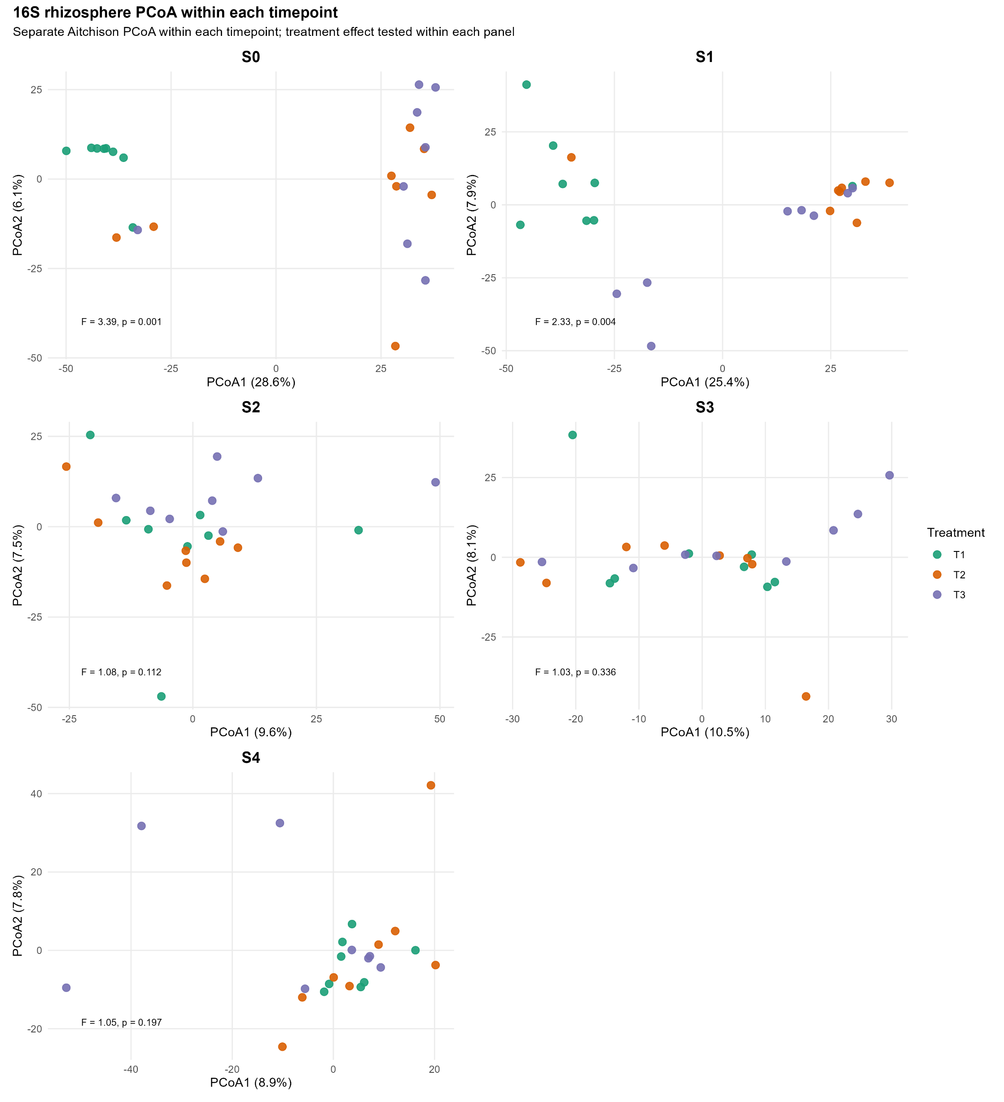
Figure S2. Principal coordinate analysis (PCoA) of bacterial rhizosphere communities across all sampling timepoints (S0–S4) based on Aitchison distance, calculated as the Euclidean distance between samples after centred log-ratio (CLR) transformation of read counts. T1 = monthly mineral fertiliser; T2 = monthly biostimulant; T3 = quarterly biostimulant. Points represent individual samples, point colour indicates treatment and point shape indicates sampling timepoint. Percentage values on each axis show the variation explained by that principal coordinate, calculated from the corresponding eigenvalue of the principal coordinates decomposition. PERMANOVA test statistics are reported in Table S8, and per-timepoint PERMANOVA results in Table S9.

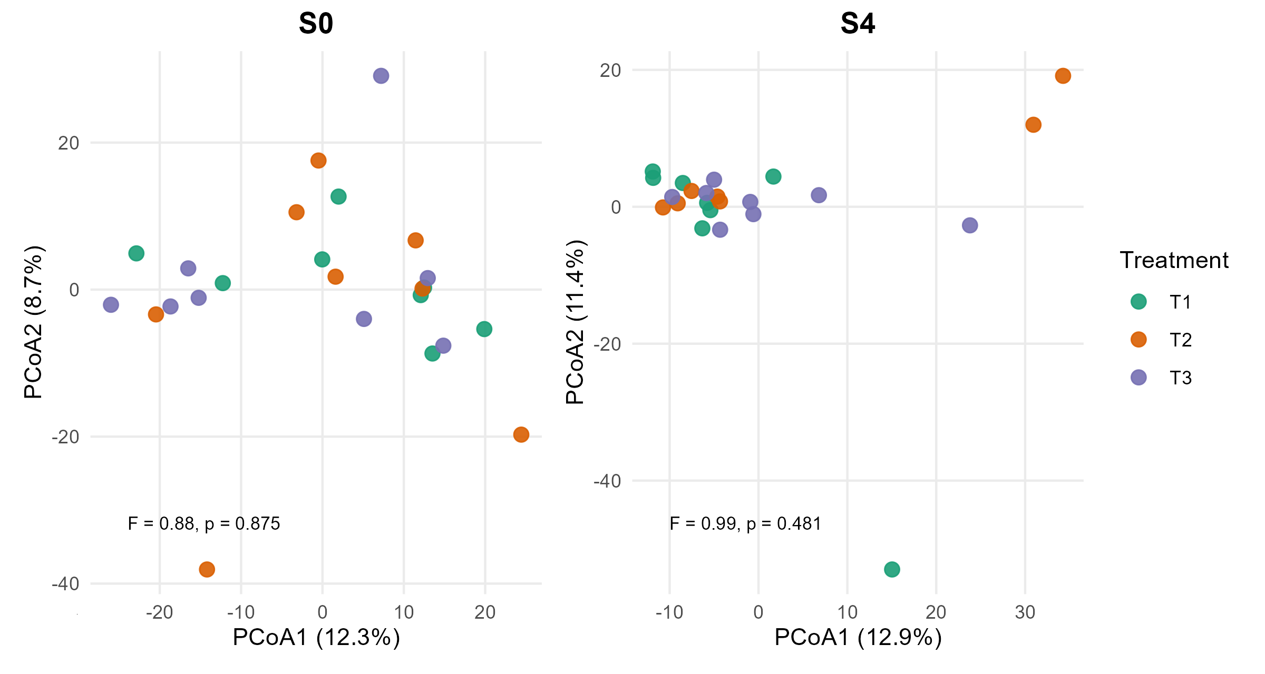
Figure S3. Principal coordinate analysis (PCoA) of bacterial root communities at S0 and S4 based on Aitchison distance, calculated as the Euclidean distance between samples after centred log-ratio (CLR) transformation of read counts. T1 = monthly mineral fertiliser; T2 = monthly biostimulant, T3 = quarterly biostimulant. Points represent individual samples, point colour indicates treatment and point shape indicates sampling timepoint. Percentage values on each axis show the variation explained by that principal coordinate, calculated from the corresponding eigenvalue of the principal coordinates decomposition.

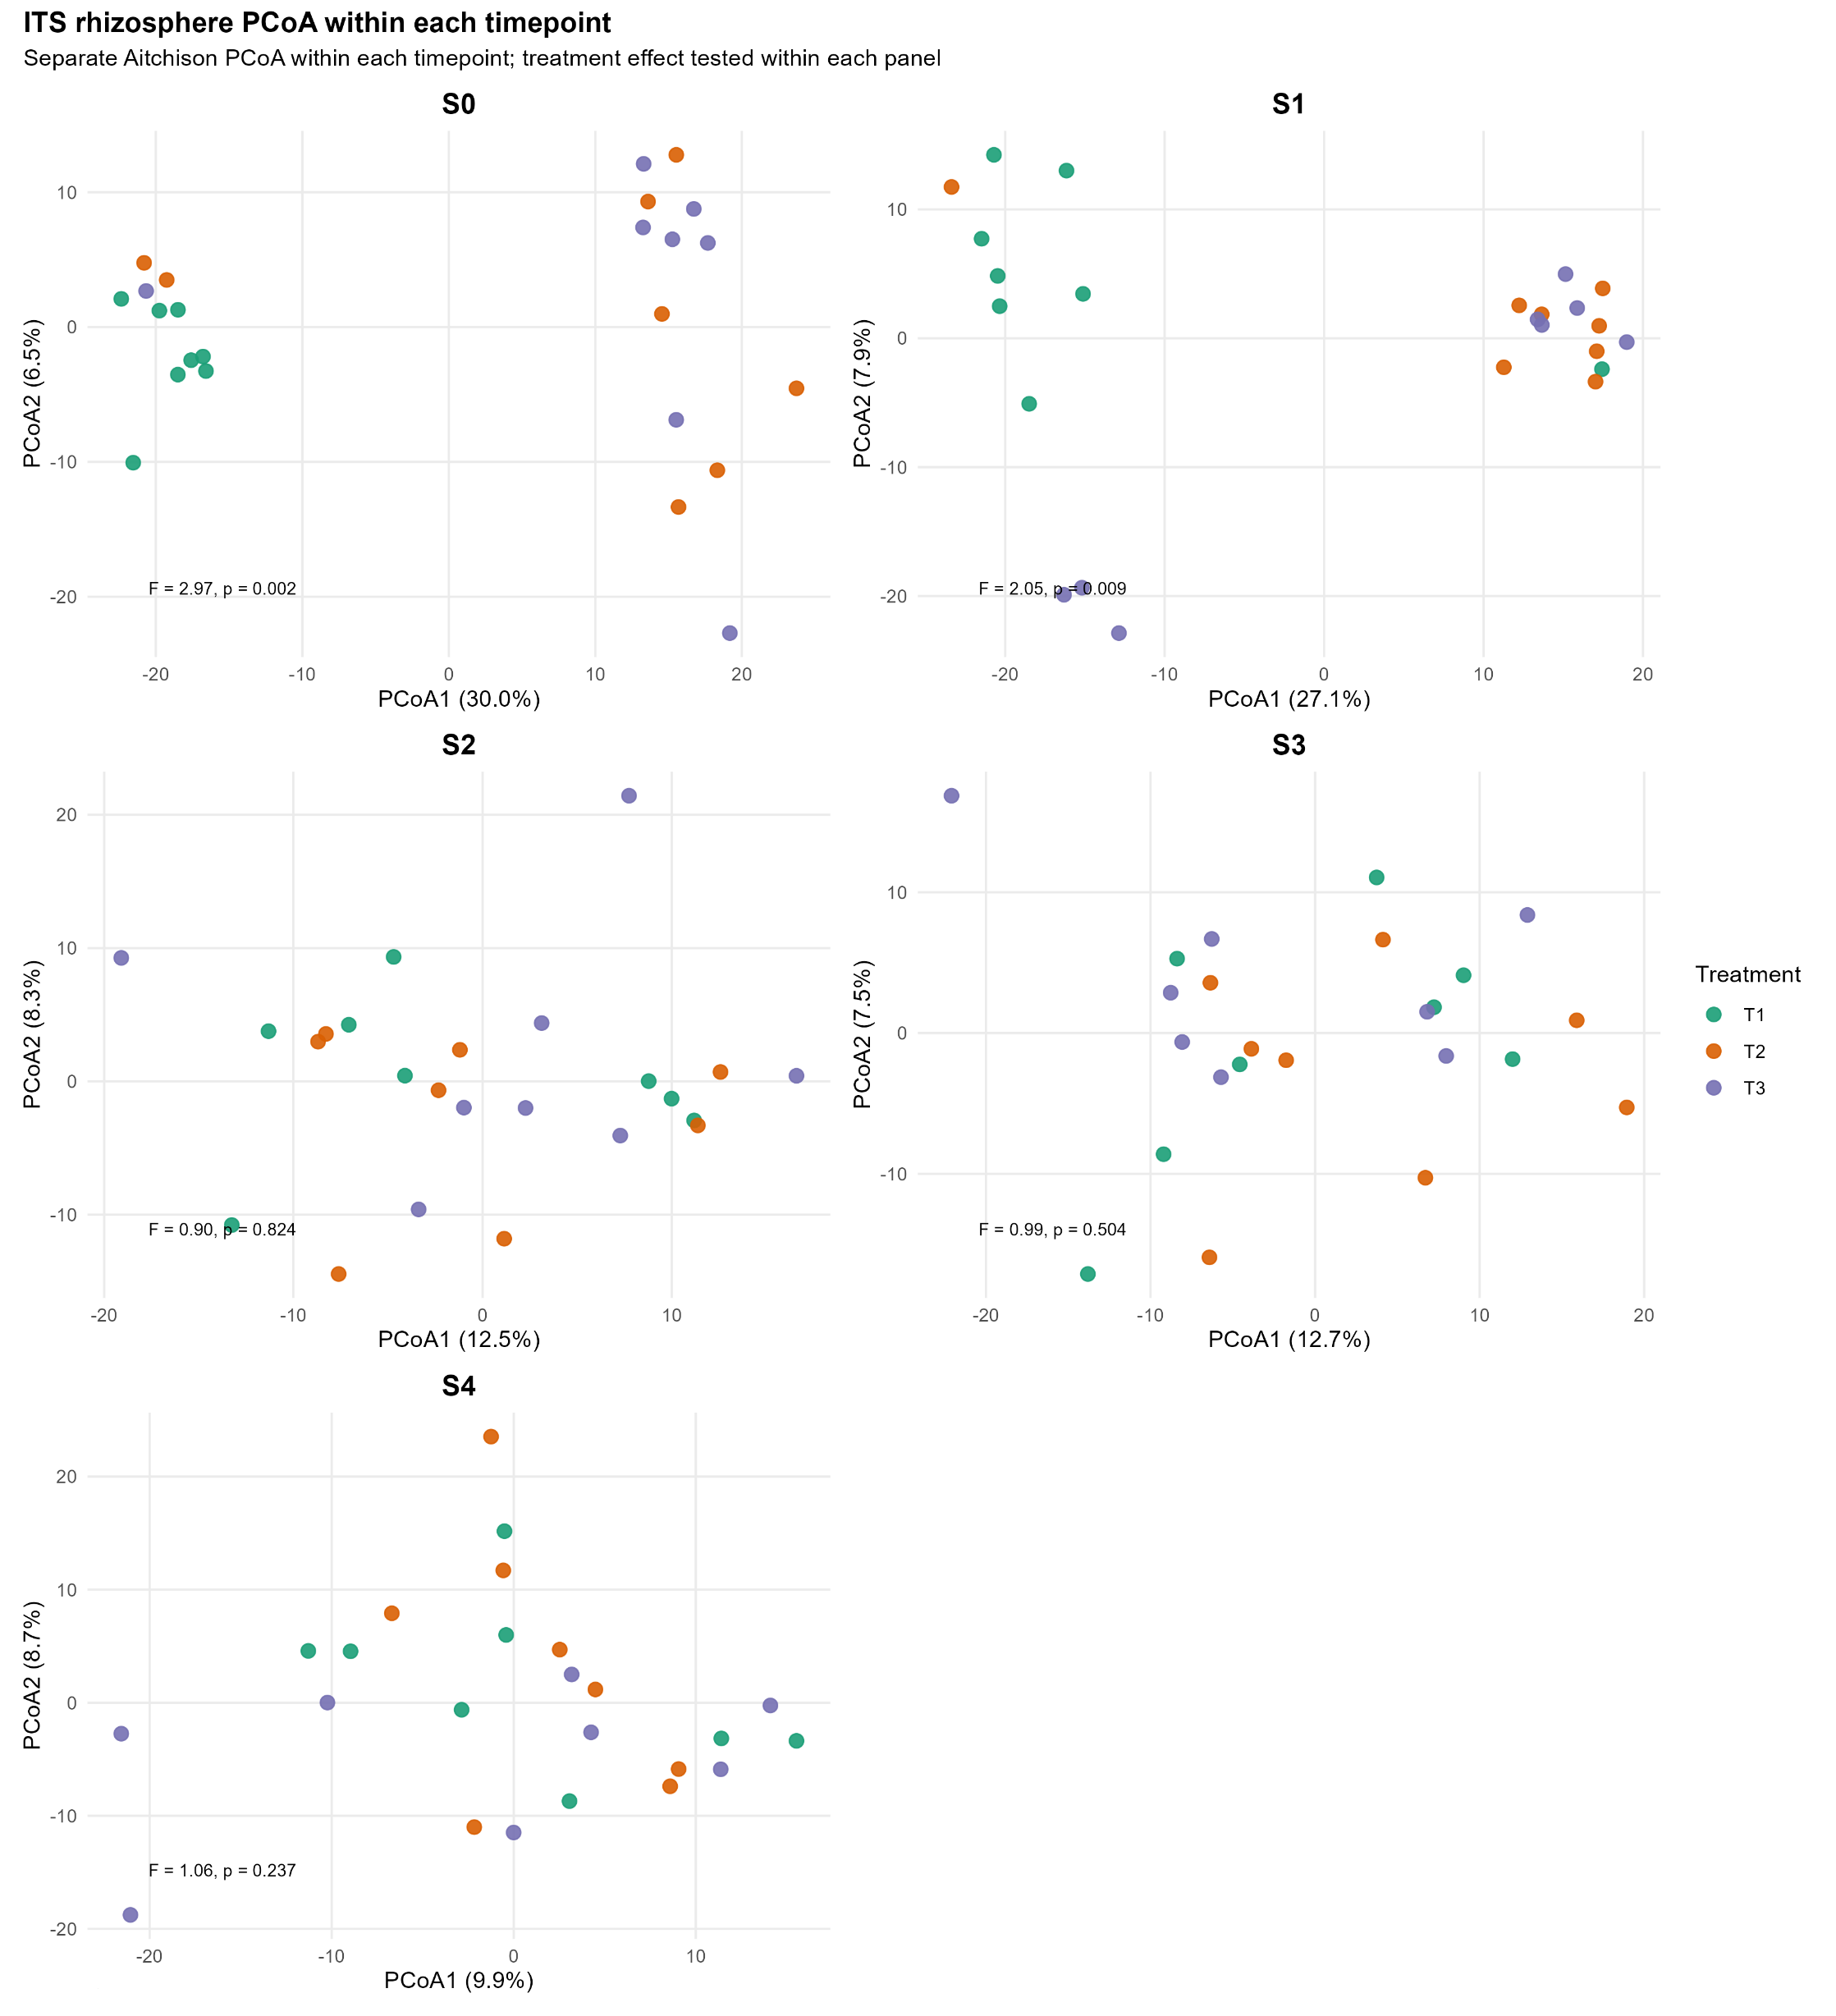

Figure S4. Principal coordinate analysis (PCoA) of Fungal rhizosphere communities across all sampling timepoints (S0–S4) based on Aitchison distance, calculated as the Euclidean distance between samples after centred log-ratio (CLR) transformation of read counts. T1 = monthly mineral fertiliser; T2 = monthly biostimulant, T3 = quarterly biostimulant. Points represent individual samples, point colour indicates treatment and point shape indicates sampling timepoint. Percentage values on each axis show the variation explained by that principal coordinate, calculated from the corresponding eigenvalue of the principal coordinates decomposition.
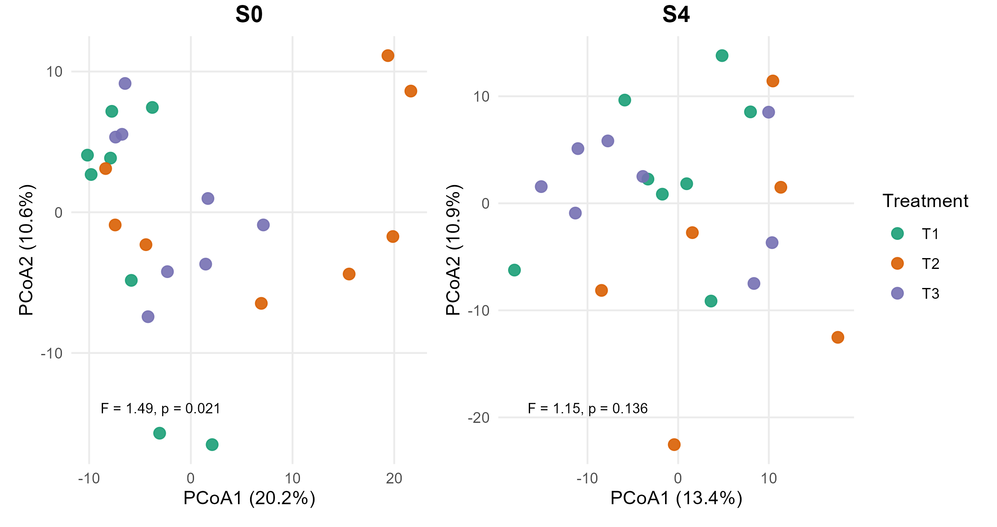

Figure S5. Principal coordinate analysis (PCoA) of fungal root communities at S0 and S4 based on Aitchison distance, calculated as the Euclidean distance between samples after centred log-ratio (CLR) transformation of read counts. T1 = monthly mineral fertiliser; T2 = monthly biostimulant, T3 = quarterly biostimulant. Points represent individual samples, point colour indicates treatment and point shape indicates sampling timepoint. Percentage values on each axis show the variation explained by that principal coordinate, calculated from the corresponding eigenvalue of the principal coordinates decomposition.

Table S7. PERMANOVA tests of bacterial (16S) and fungal (ITS) community composition based on Aitchison distances. Asterisks indicate significance: * p < 0.05; ** p < 0.01; *** p < 0.001.

Compartment / model | Term | df | R² | F | p
Rhizosphere - Bacteria (16S), primary (S0-S4) | Treatment | 2 | 0.019 | 1.28 | 0.001***
Rhizosphere - Bacteria (16S), primary (S0-S4) | Timepoint | 4 | 0.092 | 3.16 | 0.001***
Rhizosphere - Bacteria (16S), primary (S0-S4) | Treatment x Timepoint | 8 | 0.124 | 2.13 | 0.001***
Rhizosphere - Bacteria (16S), primary (S0-S4) | Residual | 105 | 0.765
Rhizosphere - Bacteria (16S), baseline-excluded (S1-S4) | Treatment | 2 | 0.028 | 1.49 | 0.001***
Rhizosphere - Bacteria (16S), baseline-excluded (S1-S4) | Timepoint | 3 | 0.097 | 3.41 | 0.001***
Rhizosphere - Bacteria (16S), baseline-excluded (S1-S4) | Treatment x Timepoint | 6 | 0.081 | 1.43 | 0.001***
Rhizosphere - Bacteria (16S), baseline-excluded (S1-S4) | Residual | 84 | 0.794
Rhizosphere - Fungi (ITS), primary (S0-S4) | Treatment | 2 | 0.015 | 1.05 | 0.001***
Rhizosphere - Fungi (ITS), primary (S0-S4) | Timepoint | 4 | 0.102 | 3.46 | 0.001***
Rhizosphere - Fungi (ITS), primary (S0-S4) | Treatment x Timepoint | 8 | 0.107 | 1.82 | 0.001***
Rhizosphere - Fungi (ITS), primary (S0-S4) | Residual | 105 | 0.775
Rhizosphere - Fungi (ITS), baseline-excluded (S1-S4) | Treatment | 2 | 0.027 | 1.41 | 0.001***
Rhizosphere - Fungi (ITS), baseline-excluded (S1-S4) | Timepoint | 3 | 0.110 | 3.90 | 0.001***
Rhizosphere - Fungi (ITS), baseline-excluded (S1-S4) | Treatment x Timepoint | 6 | 0.071 | 1.26 | 0.010**
Rhizosphere - Fungi (ITS), baseline-excluded (S1-S4) | Residual | 84 | 0.792
Root - Bacteria (16S), S0-S4 constrained model | Timepoint | 1 | 0.190 | 10.50 | 0.001***
Root - Bacteria (16S), S0-S4 constrained model | Treatment x Timepoint | 2 | 0.034 | 0.94 | 0.731
Root - Bacteria (16S), S0-S4 constrained model | Residual | 41 | 0.743
Root - Bacteria (16S), treatment-only sensitivity | Treatment | 2 | 0.033 | 0.75 | 0.987
Root - Bacteria (16S), treatment-only sensitivity | Residual | 44 | 0.967
Root - Fungi (ITS), S0-S4 constrained model | Timepoint | 1 | 0.270 | 16.65 | 0.001***
Root - Fungi (ITS), S0-S4 constrained model | Treatment x Timepoint | 2 | 0.042 | 1.31 | 0.346
Root - Fungi (ITS), S0-S4 constrained model | Residual | 40 | 0.648
Root - Fungi (ITS), treatment-only sensitivity | Treatment | 2 | 0.040 | 0.90 | 0.519
Root - Fungi (ITS), treatment-only sensitivity | Residual | 43 | 0.960

R² values are term-specific PERMANOVA variance components. Rhizosphere primary models include S0-S4; baseline-excluded models include S1-S4 only. For root samples, the constrained S0-S4 model is used to evaluate Timepoint and Treatment x Timepoint. Root Treatment is reported from an unrestricted treatment-only sensitivity test because Treatment does not vary within Tree_ID strata. Empty F and p cells correspond to residual rows.

Table S8. Per-timepoint PERMANOVA tests of bacterial (16S) and fungal (ITS) community composition based on Aitchison distances. Asterisks indicate significance: * p < 0.05; ** p < 0.01; *** p < 0.001.

Marker | Compartment | Timepoint | R2 | F | p | p_FDR
16S | Rhizosphere | S0 | 0.244 | 3.39 | 0.001 | 0.005**
16S | Rhizosphere | S1 | 0.182 | 2.33 | 0.004 | 0.010*
16S | Rhizosphere | S2 | 0.093 | 1.08 | 0.112 | 0.187
16S | Rhizosphere | S3 | 0.089 | 1.03 | 0.336 | 0.336
16S | Rhizosphere | S4 | 0.091 | 1.05 | 0.197 | 0.246
16S | Root | S0 | 0.078 | 0.88 | 0.875 | 0.875
16S | Root | S4 | 0.090 | 0.99 | 0.481 | 0.875
ITS | Rhizosphere | S0 | 0.221 | 2.97 | 0.002 | 0.010*
ITS | Rhizosphere | S1 | 0.164 | 2.05 | 0.009 | 0.022*
ITS | Rhizosphere | S2 | 0.079 | 0.90 | 0.824 | 0.824
ITS | Rhizosphere | S3 | 0.086 | 0.99 | 0.504 | 0.630
ITS | Rhizosphere | S4 | 0.092 | 1.06 | 0.237 | 0.395
ITS | Root | S0 | 0.125 | 1.49 | 0.021 | 0.042*
ITS | Root | S4 | 0.108 | 1.15 | 0.136 | 0.136

Table S9. ANCOM-BC2 significant taxa in the rhizosphere and root compartments under sensitivity-score filtering (diff_robust = TRUE) at q < 0.05.
Taxa with at least one significant ANCOM-BC2 coefficient (Treatment main effect, Timepoint main effect, or Treatment × Timepoint interaction) after applying the sensitivity-score filter are listed. Each row reports one significant coefficient; taxa with multiple significant coefficients appear in multiple rows. Reference levels are Treatment T1 (monthly mineral fertiliser) and Timepoint S0 (baseline at transplanting). Rhizosphere models included Timepoints S0-S4 with Tree_ID as a random intercept; root models included Timepoints S0 and S4 with fixed effects only. Coefficients are reported on the log scale. Genus names are italicised; family-, order-, and class-level entries indicate taxa retained at the next-highest taxonomic level under the genus-first fallback.

Taxon | Rank | Model term | Coefficient | Log-fold change | SE | q-value
Rhizosphere — Bacteria
Gaiellales | order | Treatment main effect | T3 vs T1 | -3.18 | 0.65 | 0.001
Acidobacteriales | order | Treatment main effect | T3 vs T1 | -3.26 | 0.69 | 0.005
Gemmatimonas | genus | Treatment main effect | T3 vs T1 | -2.01 | 0.51 | 0.049
Acidobacteriales | order | Timepoint main effect | S4 vs S0 | -4.41 | 0.66 | < 0.0001
Gemmataceae | family | Timepoint main effect | S2 vs S0 | -2.51 | 0.47 | 0.0002
Gemmatimonas | genus | Timepoint main effect | S4 vs S0 | -2.59 | 0.51 | 0.0007
Pseudarthrobacter | genus | Timepoint main effect | S2 vs S0 | 3.21 | 0.64 | 0.0008
Pseudarthrobacter | genus | Timepoint main effect | S3 vs S0 | 3.44 | 0.69 | 0.0009
Acidothermus | genus | Timepoint main effect | S4 vs S0 | -3.80 | 0.78 | 0.006
Pseudomonas | genus | Timepoint main effect | S3 vs S0 | 4.20 | 0.94 | 0.010
Elsterales | order | Timepoint main effect | S4 vs S0 | -2.59 | 0.62 | 0.028
Acidobacteriales | order | Timepoint main effect | S1 vs S0 | -3.01 | 0.72 | 0.041
Microscillaceae | family | Treatment × Timepoint | T3:S1 vs T1:S0 | -5.13 | 0.84 | < 0.0001
JG30-KF-AS9 | family | Treatment × Timepoint | T2:S1 vs T1:S0 | 5.78 | 0.78 | < 0.0001
Microvirga | genus | Treatment × Timepoint | T3:S1 vs T1:S0 | -4.94 | 0.76 | < 0.0001
CCD24 | order | Treatment × Timepoint | T3:S1 vs T1:S0 | -5.69 | 0.77 | < 0.0001
Gaiellales | order | Treatment × Timepoint | T2:S1 vs T1:S0 | 4.13 | 0.79 | 0.0005
Micropepsaceae | family | Treatment × Timepoint | T2:S1 vs T1:S0 | 3.71 | 0.72 | 0.0008
Acidobacteriales | order | Treatment × Timepoint | T2:S1 vs T1:S0 | 4.60 | 0.92 | 0.002
Pseudomonas | genus | Treatment × Timepoint | T3:S1 vs T1:S0 | -5.39 | 1.10 | 0.002
IS-44 | genus | Treatment × Timepoint | T3:S1 vs T1:S0 | -3.99 | 0.84 | 0.003
A4b | family | Treatment × Timepoint | T3:S1 vs T1:S0 | -4.22 | 0.92 | 0.006
Skermanella | genus | Treatment × Timepoint | T3:S1 vs T1:S0 | -3.40 | 0.74 | 0.007
Acidothermus | genus | Treatment × Timepoint | T2:S1 vs T1:S0 | 4.57 | 1.00 | 0.015
Anaerolineaceae | family | Treatment × Timepoint | T3:S1 vs T1:S0 | -3.64 | 0.88 | 0.034
Pullulanibacillus | genus | Treatment × Timepoint | T2:S1 vs T1:S0 | 3.11 | 0.68 | 0.048
Rhizosphere — Fungi
Mortierella | genus | Timepoint main effect | S4 vs S0 | -3.26 | 0.67 | 0.001
Talaromyces | genus | Timepoint main effect | S1 vs S0 | 5.17 | 1.29 | 0.034
Didymocrea | genus | Treatment × Timepoint | T2:S1 vs T1:S0 | -5.45 | 0.90 | < 0.0001
Talaromyces | genus | Treatment × Timepoint | T2:S1 vs T1:S0 | -9.48 | 1.56 | < 0.0001
Linnemannia | genus | Treatment × Timepoint | T3:S1 vs T1:S0 | -6.22 | 1.24 | 0.0006
Talaromyces | genus | Treatment × Timepoint | T3:S1 vs T1:S0 | -8.27 | 1.65 | 0.001
Didymocrea | genus | Treatment × Timepoint | T3:S1 vs T1:S0 | -3.49 | 0.89 | 0.032
Pyrenophora | genus | Treatment × Timepoint | T2:S1 vs T1:S0 | 4.44 | 1.10 | 0.049
Root — Bacteria
Pseudomonas | genus | Timepoint main effect | S4 vs S0 | 6.67 | 0.58 | < 0.0001
Unclassified Burkholderia | genus | Timepoint main effect | S4 vs S0 | -3.65 | 0.61 | 0.0003
Root — Fungi
Oehlia | genus | Timepoint main effect | S4 vs S0 | -4.43 | 0.63 | < 0.0001
Rhizophagus | genus | Timepoint main effect | S4 vs S0 | -3.53 | 0.52 | 0.0001
Calophoma | genus | Timepoint main effect | S4 vs S0 | -2.43 | 0.53 | 0.015
Knufia | genus | Timepoint main effect | S4 vs S0 | -1.89 | 0.47 | 0.034

Table S10. Changes in core rhizosphere taxa from the pre-mulch baseline (S0) to one month after mulch application (S1). Core taxa were assessed across treatments and kingdoms. Taxa were defined at the genus level where possible, and at the next available taxonomic rank when genus-level annotation was unavailable. Treatments were mineral fertiliser control (T1), monthly biostimulant, (T2), and quarterly biostimulant (T3).
Group | Kingdom | S0 core | S1 core | Retained | Lost | Gained
All treatments | Bacteria | 59 | 48 | 45 | 14 | 3
All treatments | Fungi | 19 | 21 | 17 | 2 | 4
T1 | Bacteria | 86 | 100 | 46 | 40 | 54
T1 | Fungi | 25 | 31 | 16 | 9 | 15
T2 | Bacteria | 73 | 69 | 40 | 33 | 29
T2 | Fungi | 25 | 26 | 17 | 8 | 9
T3 | Bacteria | 117 | 50 | 42 | 75 | 8
T3 | Fungi | 32 | 24 | 18 | 14 | 6

Table S11. Pre-sampling mean air temperature and cumulative rainfall used as climate constraints in the db-RDA, calculated over a 30-day window ending on each sampling date.

Timepoint | Sampling date | Window | Mean temperature (°C) | Cumulative rainfall (mm)
S0 | 14 Jun 2024 | 15 May–13 Jun 2024 | 13.80 | 153.4
S1 | 18 Sep 2024 | 19 Aug–17 Sep 2024 | 13.01 | 100.0
S2 | 11 Dec 2024 | 11 Nov–10 Dec 2024 | 19.30 | 13.6
S3 | 12 Mar 2025 | 10 Feb–11 Mar 2025 | 21.19 | 0.4
S4 | 11 Jun 2025 | 12 May–10 Jun 2025 | 11.82 | 52.0

Mean air temperature from DPIRD Jarrahdale station JA001 (32.335°S, 116.077°E; ~7.7 km east-southeast of the trial site); cumulative rainfall from Bureau of Meteorology Serpentine station 009039 (32.350°S, 116.010°E; ~6.5 km south of the trial site). Mean temperature is the time-weighted daily mean from sub-daily logging.

