Supplementary Materials:

Five millennia of paleotemperature from tree-rings in the Great Basin, USA

Climate Dynamics
Matthew W. Salzer^{1*}, Andrew G. Bunn², Nicholas E. Graham³, and Malcolm K. Hughes¹
¹Laboratory of Tree-Ring Research, University of Arizona, Tucson, AZ 85721, USA
²Department of Environmental Sciences, Western Washington University, Bellingham, WA 98225, USA
³ Hydrologic Research Center, 12780 High Bluff Drive, Suite 250, San Diego, CA 92130-2069, USA
*msalzer@ltrr.arizona.edu

A zero year is maintained on some of the figures for scaling and for computational purposes. Year zero actually represents year 1 BC.
Both Both GB3rwi and GB3raw chronologies were constructed from smoothed ring-width series with details on decadal to multi-centennial temperature variability in mind. The standardization process narrows the confidence intervals during the early millennia. While most of the decadal to centennial-scale variability recorded in GB3raw and in GB3rwi is similar, the GB3raw record contains additional very low-frequency information/noise not retained in GB3rwi. Without standardizing each series to a common mean, GB3raw may be influenced by non-climatic growth factors particular to individual or small groups of trees. Under such circumstances, GB3raw could possibly be biased by a set of fast/slow growing trees during a particular interval. Despite this limitation, GB3raw is potentially valuable for analyzing multi-centennial to millennial scale variability and for generating hypotheses regarding climate change at these timescales.

Fig. S1
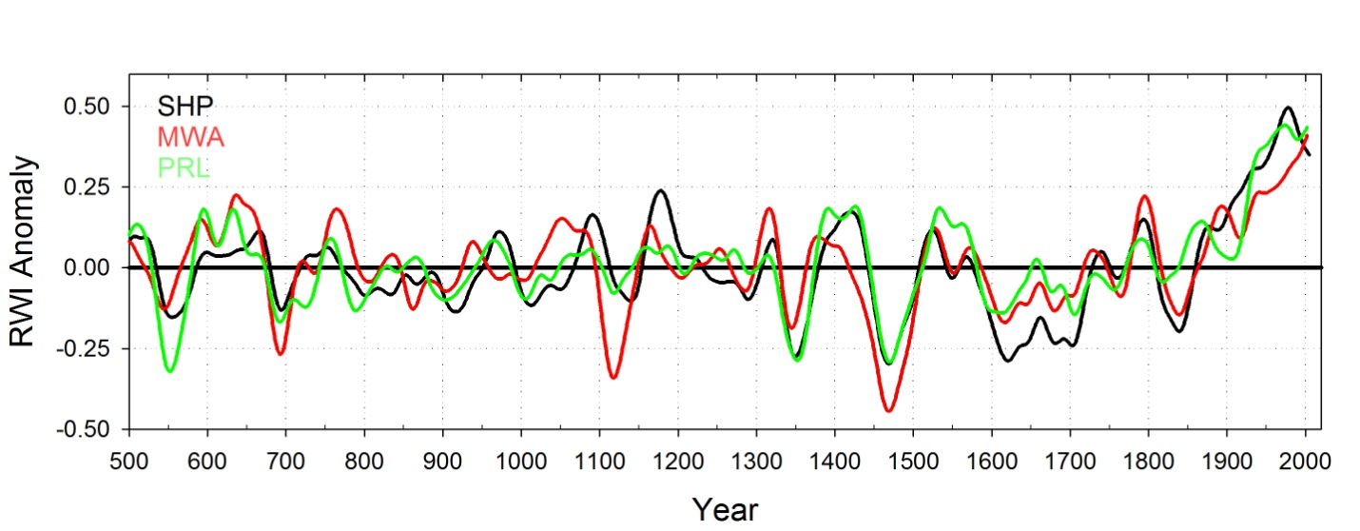
Fig. S1. Time series plot of three individual ring-width index anomaly site chronologies smoothed with 50-yr spline. Black is Sheep Mtn.; Red is Mt. Washington; Green is Pearl Peak. The strong covariance over the last 1.5 millennia between these records is justification for combining the samples from the three individual sites into the single GB3rwi regional chronology. These versions were created before the removal of some individual series as shown in Figs. S3-S5.
Fig. S2.
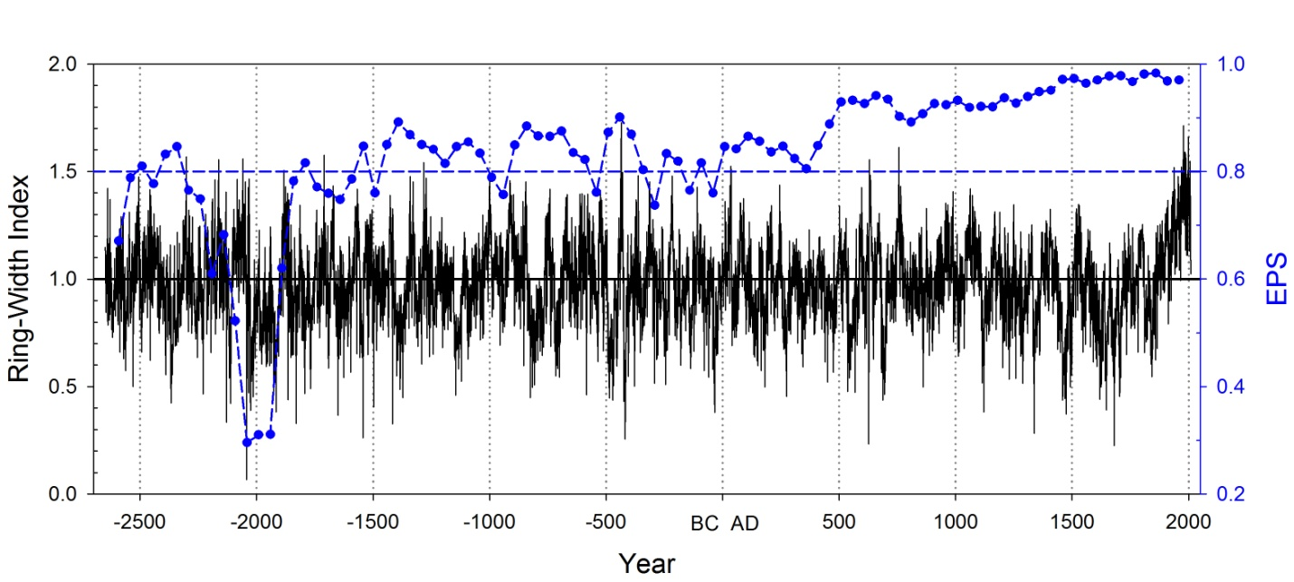
Fig. S2.Time-series plot of non-smoothed GB3rwi chronology (black) and running EPS statistic calculated on 100-year segments overlapped 50 years and plotted on the center year (blue). EPS tests whether the merged GB3rwi chronology suffers back in time from poor sample depth as seen around -2000 (4000 BC). For most of the length of the time series EPS remains near or above 0.8 (blue dashed line).
For Figures S3-S5 Elevation and time period for the treeline zone samples from the three sites used in the GB3rwi regional high elevation chronology. Each blue bar represents a dated and measured tree-ring series over that time interval at the shown elevation. Only series within the 100 m elevational band (between the black lines) were used for the regional GB3rwi chronology.

Fig. S3
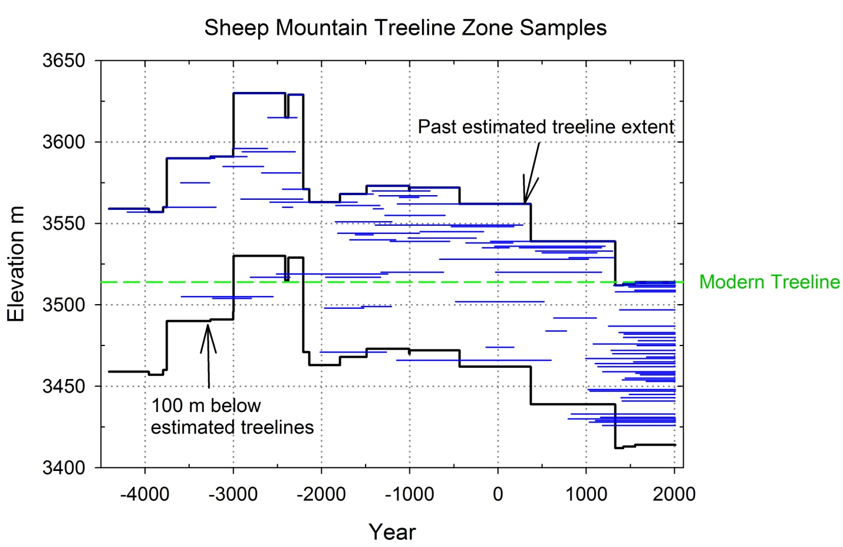
Fig. S3. Sheep Mountain Treeline Zone Samples
Fig. S4
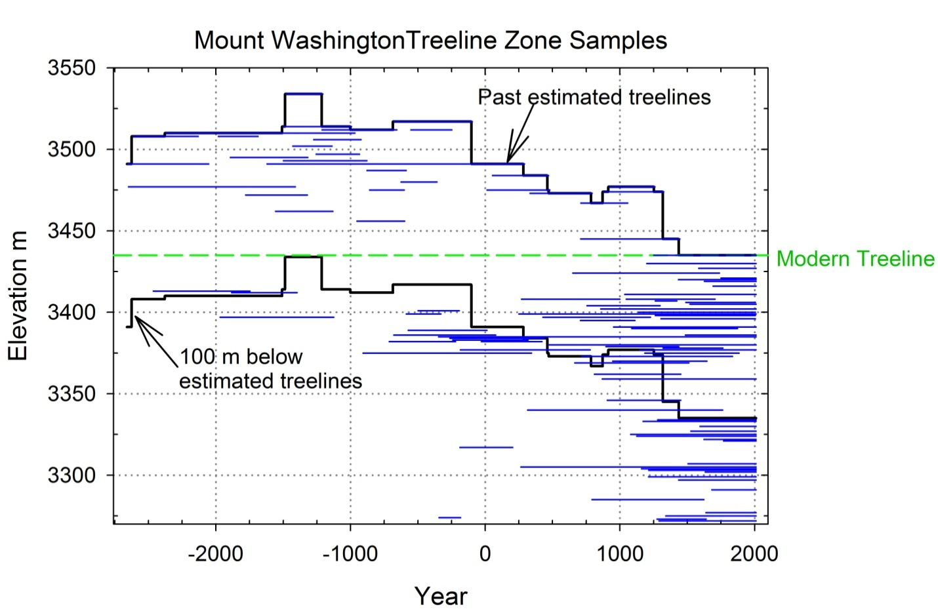
Fig. S4. Mount Washington Mountain Treeline Zone Samples
Fig. S5
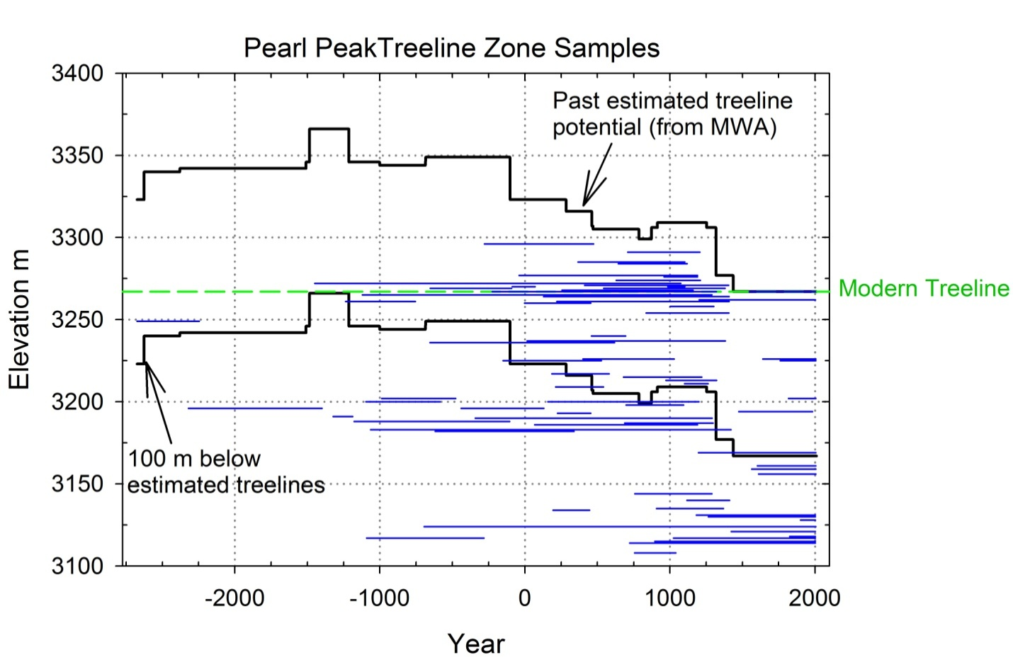
Fig S5. Pearl Peak Treeline Zone Samples.

