Supplemental Material for

ENSO-Driven Energy Budget Perturbations in Observations and CMIP Models

Michael Mayer^{1,*}, John T. Fasullo² and Kevin E. Trenberth², Leopold Haimberger¹

¹University of Vienna, Vienna, Austria

²National Center for Atmospheric Research, Boulder, Colorado

Corresponding author address:

Michael Mayer

Department of Meteorology and Geophysics

University of Vienna

Althanstrasse 14

1090 Vienna

Austria

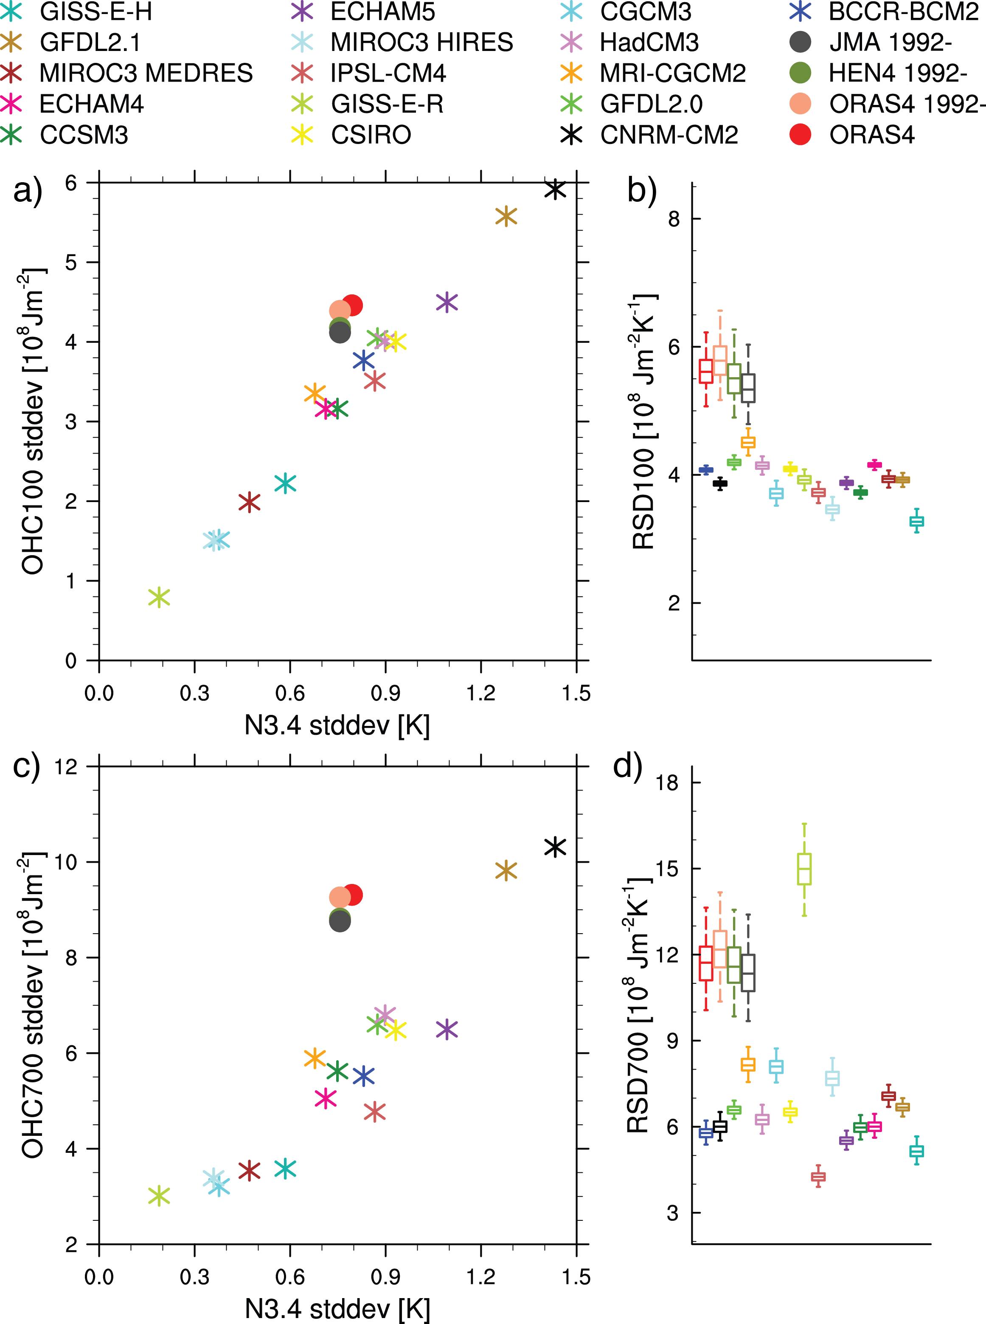

Fig. S1 Niño 3.4 index standard deviation versus the temporal standard deviations of a) OHC100 and c) OHC700 averaged over the N3.4 region from ORAS4 (1979-2013 and 1992-2013), HEN4 (1992-2013), JMA (1992-2012) and CMIP3 models;
Fraction of the standard deviations of b) OHC100 and d) OHC700 in the N3.4 region and N3.4 index standard deviations. Boxes mark the inner quartiles and whiskers mark the 2.5 and 97.5% percentiles, respectively; uncertainties are estimated with a block bootstrap method (length of the blocks is set to 6 months); Color code for b) and d) is the same as for a) and c)

a)
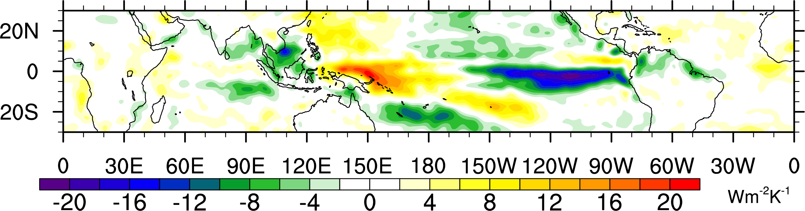
b)
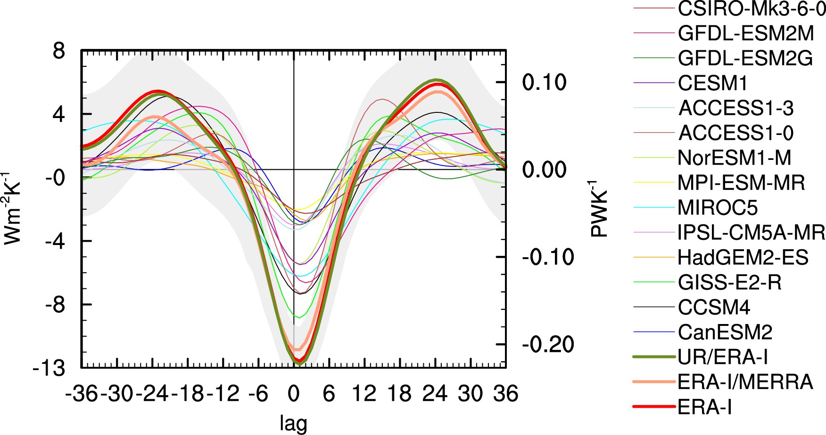

Fig. S2 a) Difference between the regression of F_{S} onto N3.4 from reanalyses and the CMIP5 multi-model mean. Note that the difference pattern qualitatively resembles the F_{S} response pattern, indicating that CMIP5 models generally underestimate the F_{S} response when compared to observations; b) F_{S} regression for the eastern Pacific ITCZ region (10S-10N, 155W-70W) as a function of lag. Note the large spread among the models.

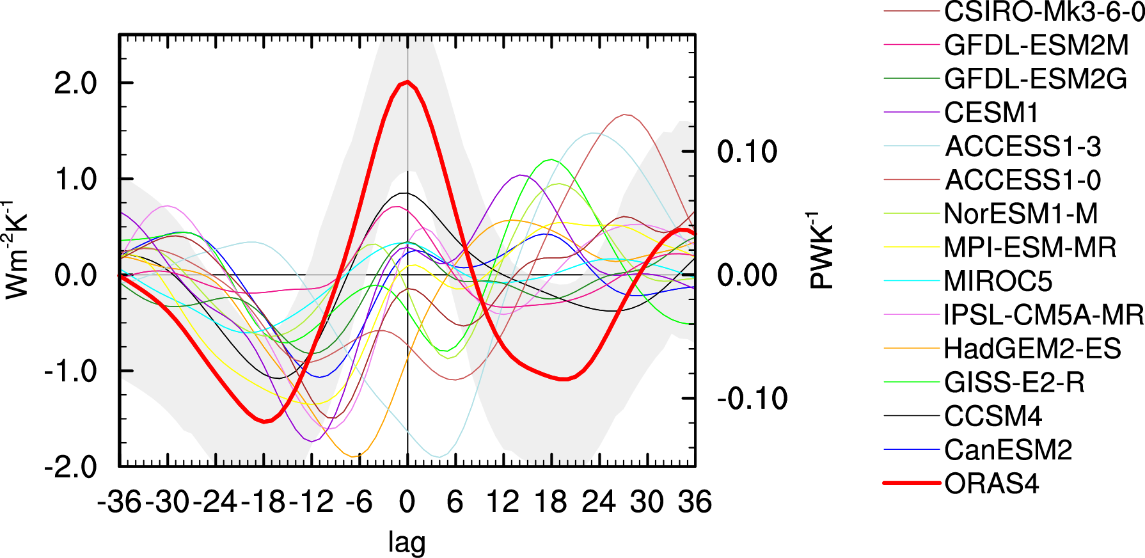

Fig. S3 DIVFO (full-depth) from ORAS4 and CMIP5 models regressed against N3.4 in the tropical Pacific (20S-20N)

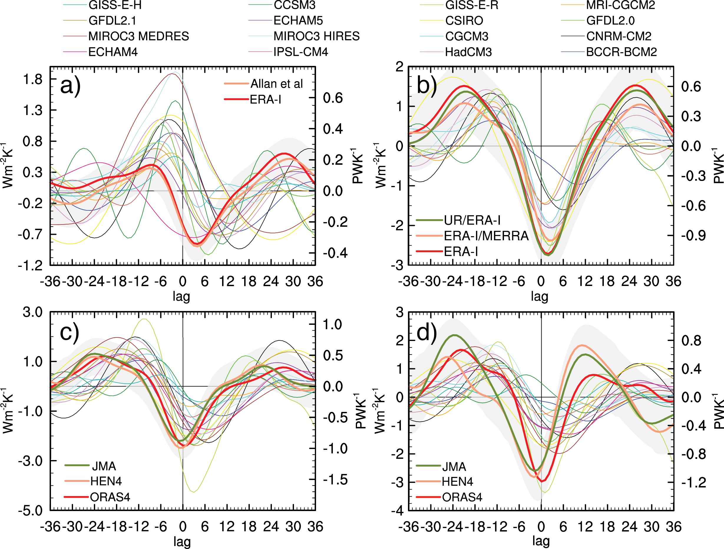

Fig. S4 Regression of a) Rad_{TOA}, b) F_{S}, c) OHCT(0-300m), and d) OHCT(0-700m) onto N3.4 averaged over tropical Pacific ocean (30S-30N) for CMIP3 models. The shading represents 95% confidence
intervals of the regression coefficients, computed from the residual sum of squares of the respective observational ensemble mean, taking autocorrelation into account

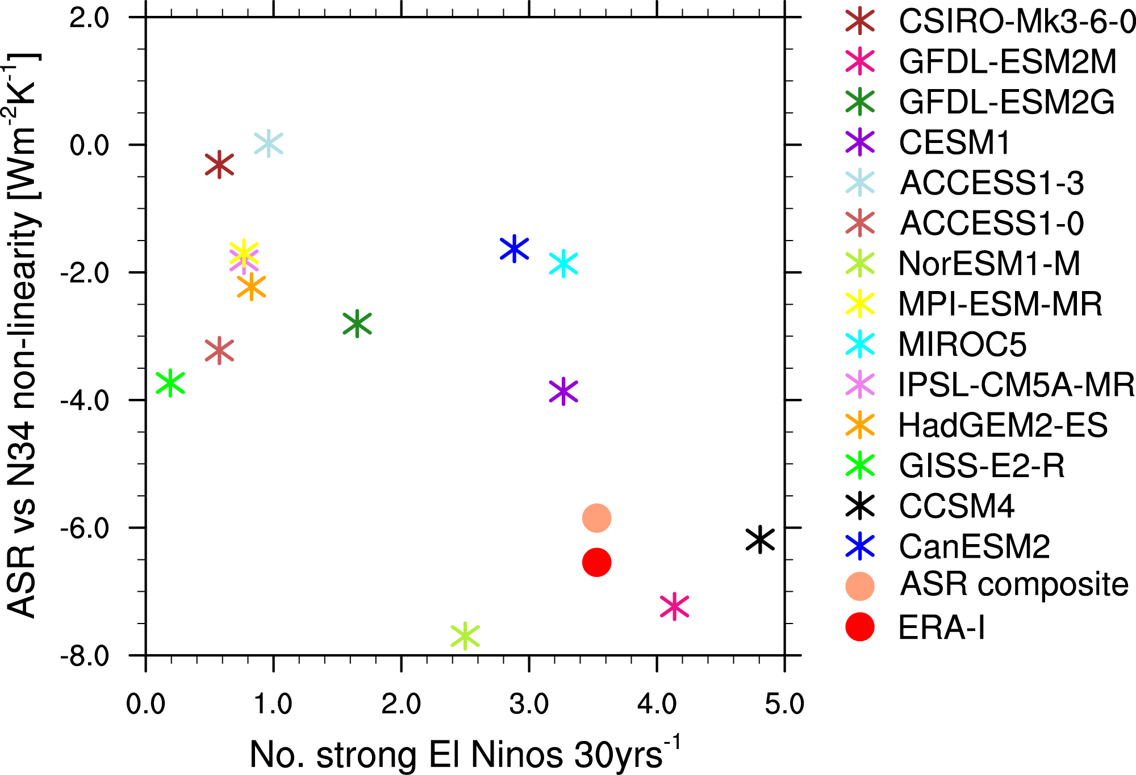

Fig. S5 Scatter plot of the non-linearity of the ASR response in the ITCZ region (measured by the difference of separate linear regressions for positive and negative N3.4 anomalies, respectively) and the number of strong El Niños (measured by the number of December N3.4 anomalies exceeding 2 standard deviations of the observed N3.4 standard deviation). The correlation coefficient of the scatter plot is -0.66.

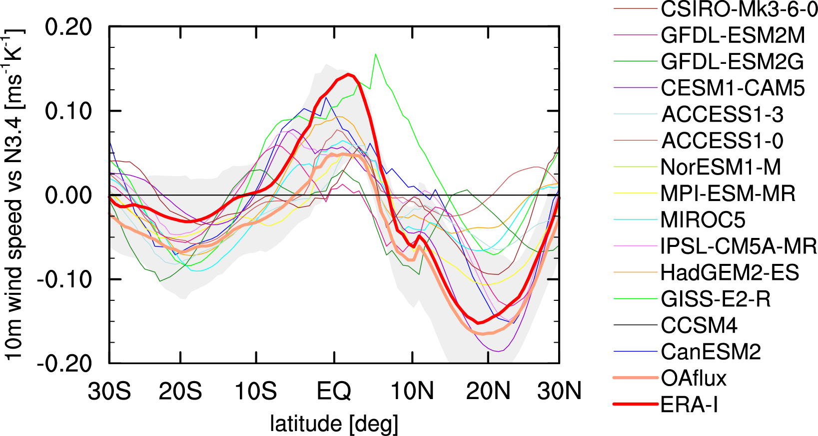

Fig. S6 Regression of near-surface (10m) wind from ERA-I, OAflux, and CMIP5 models onto N3.4 zonally averaged over Atlantic basin. Note that CCSM4 and NorESM-1 are missing as this variable has not been provided with these models

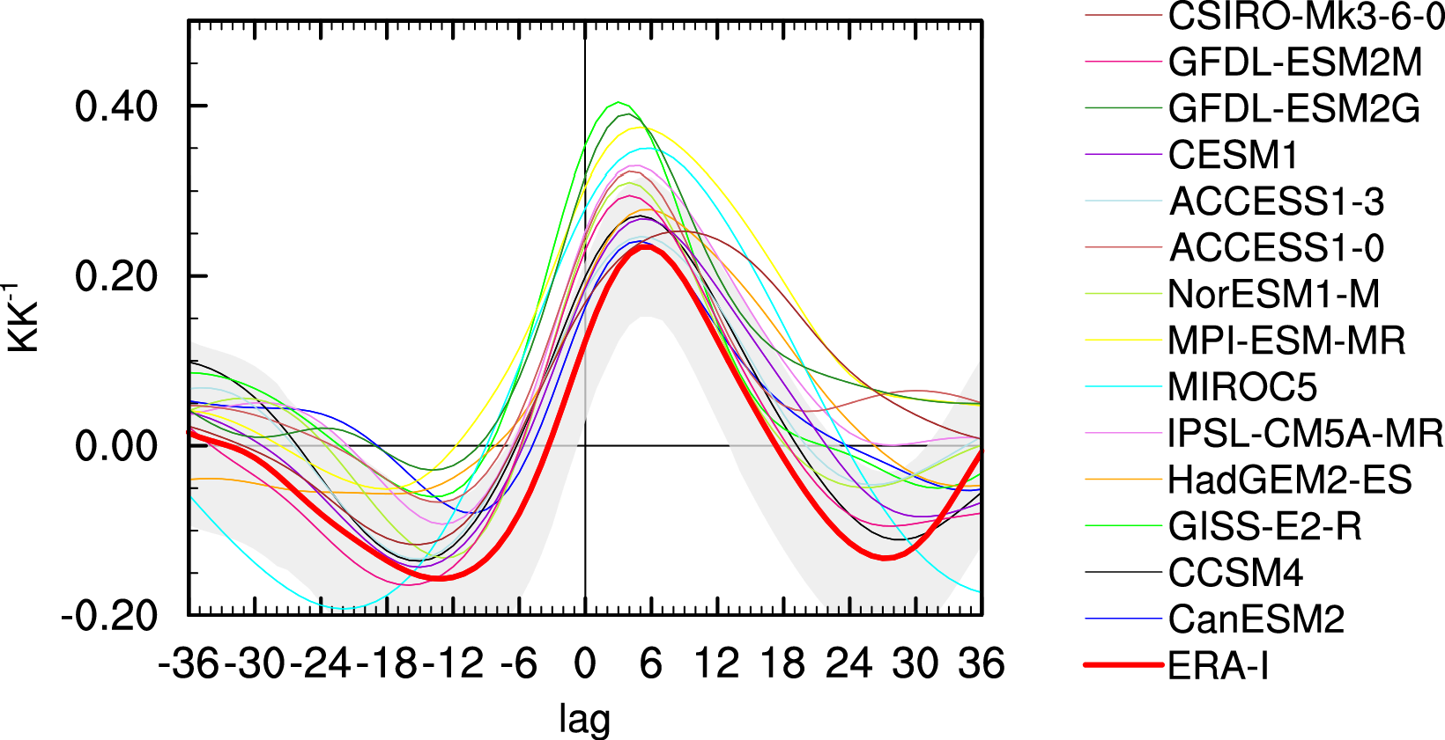

Fig. S7 Regression of temperatures at the 500hPa level onto N3.4 as a function of lag averaged over western Atlantic ITCZ region (10S-10N, west of 10W).

