Supplemental Figures

Figure S1.Time series over the 600 year pre-industrial control run of the annual mean global mean sea surface temperature (SST), net top of atmosphere flux (net TOA flux), and sea surface salinity (SSS). The bottom two plot shows a similar time series for the Arctic sea-ice area and the Atlantic meridional overturning circulation.

Figure S2. Ocean fraction mask used to calculate H_{OAt}.

Figure S3. Lag correlation plot for H_{A} and H_{O} as a function of latitude. Positive correlations show the ocean is leading the atmosphere. The shading represents regions where the significance exceeds 95% after accounting for autocorrelation in H_{A} and H_{O.}.

Figure S4. Time series and correlation of anomalies in H_{A} (blue) and H_{O} (red) at 673N where H_{O} is leading by one year.

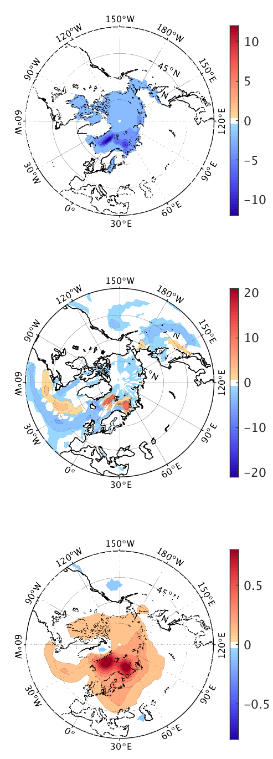
Figure S5. Maps of H_{O} regressed onto sea-ice concentration (top), surface flux (middle), and surface air temperature. Contour levels and units are 2 [%], 2 [Wm⁻²], and 0.1 [K] respectively, per standard deviation of H_{OA.} White regions are below the 95% significance level.

