Supplementary information:

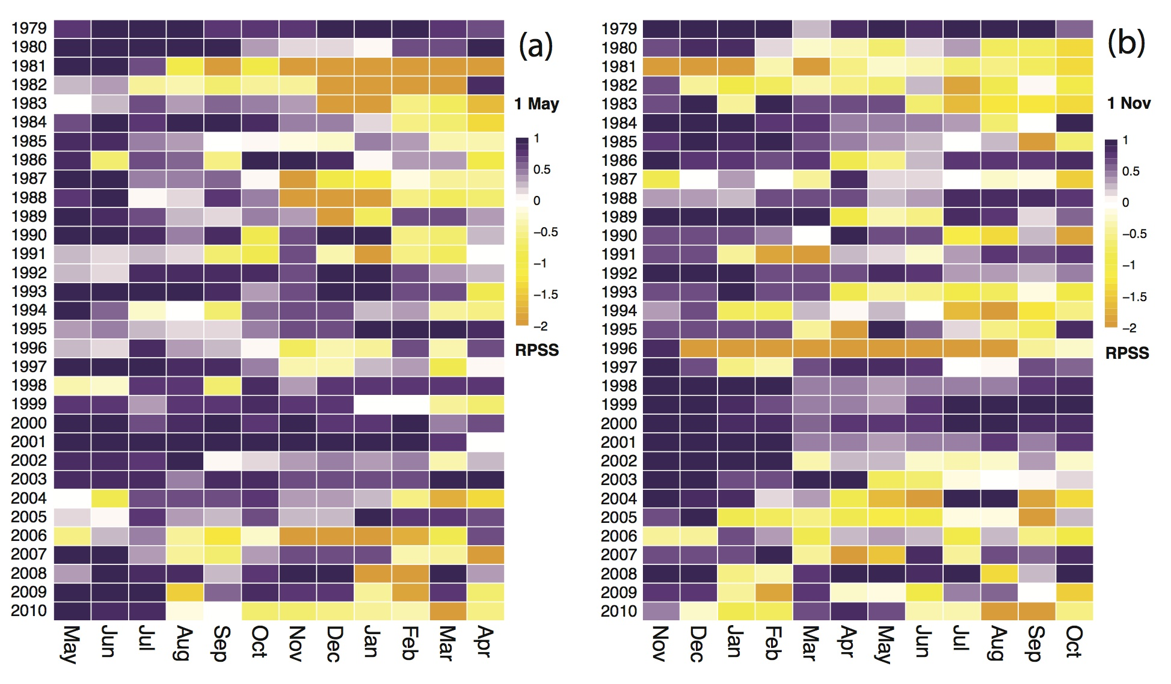

Fig. S1. RPSS of EC-Earth2.3 12-month 5-member ensemble predictions of the NH SIT modes - with respect to climatological forecast as the reference - for 1 May and 1 November start dates in the left and right panels, respectively, from 1979 to 2010.

