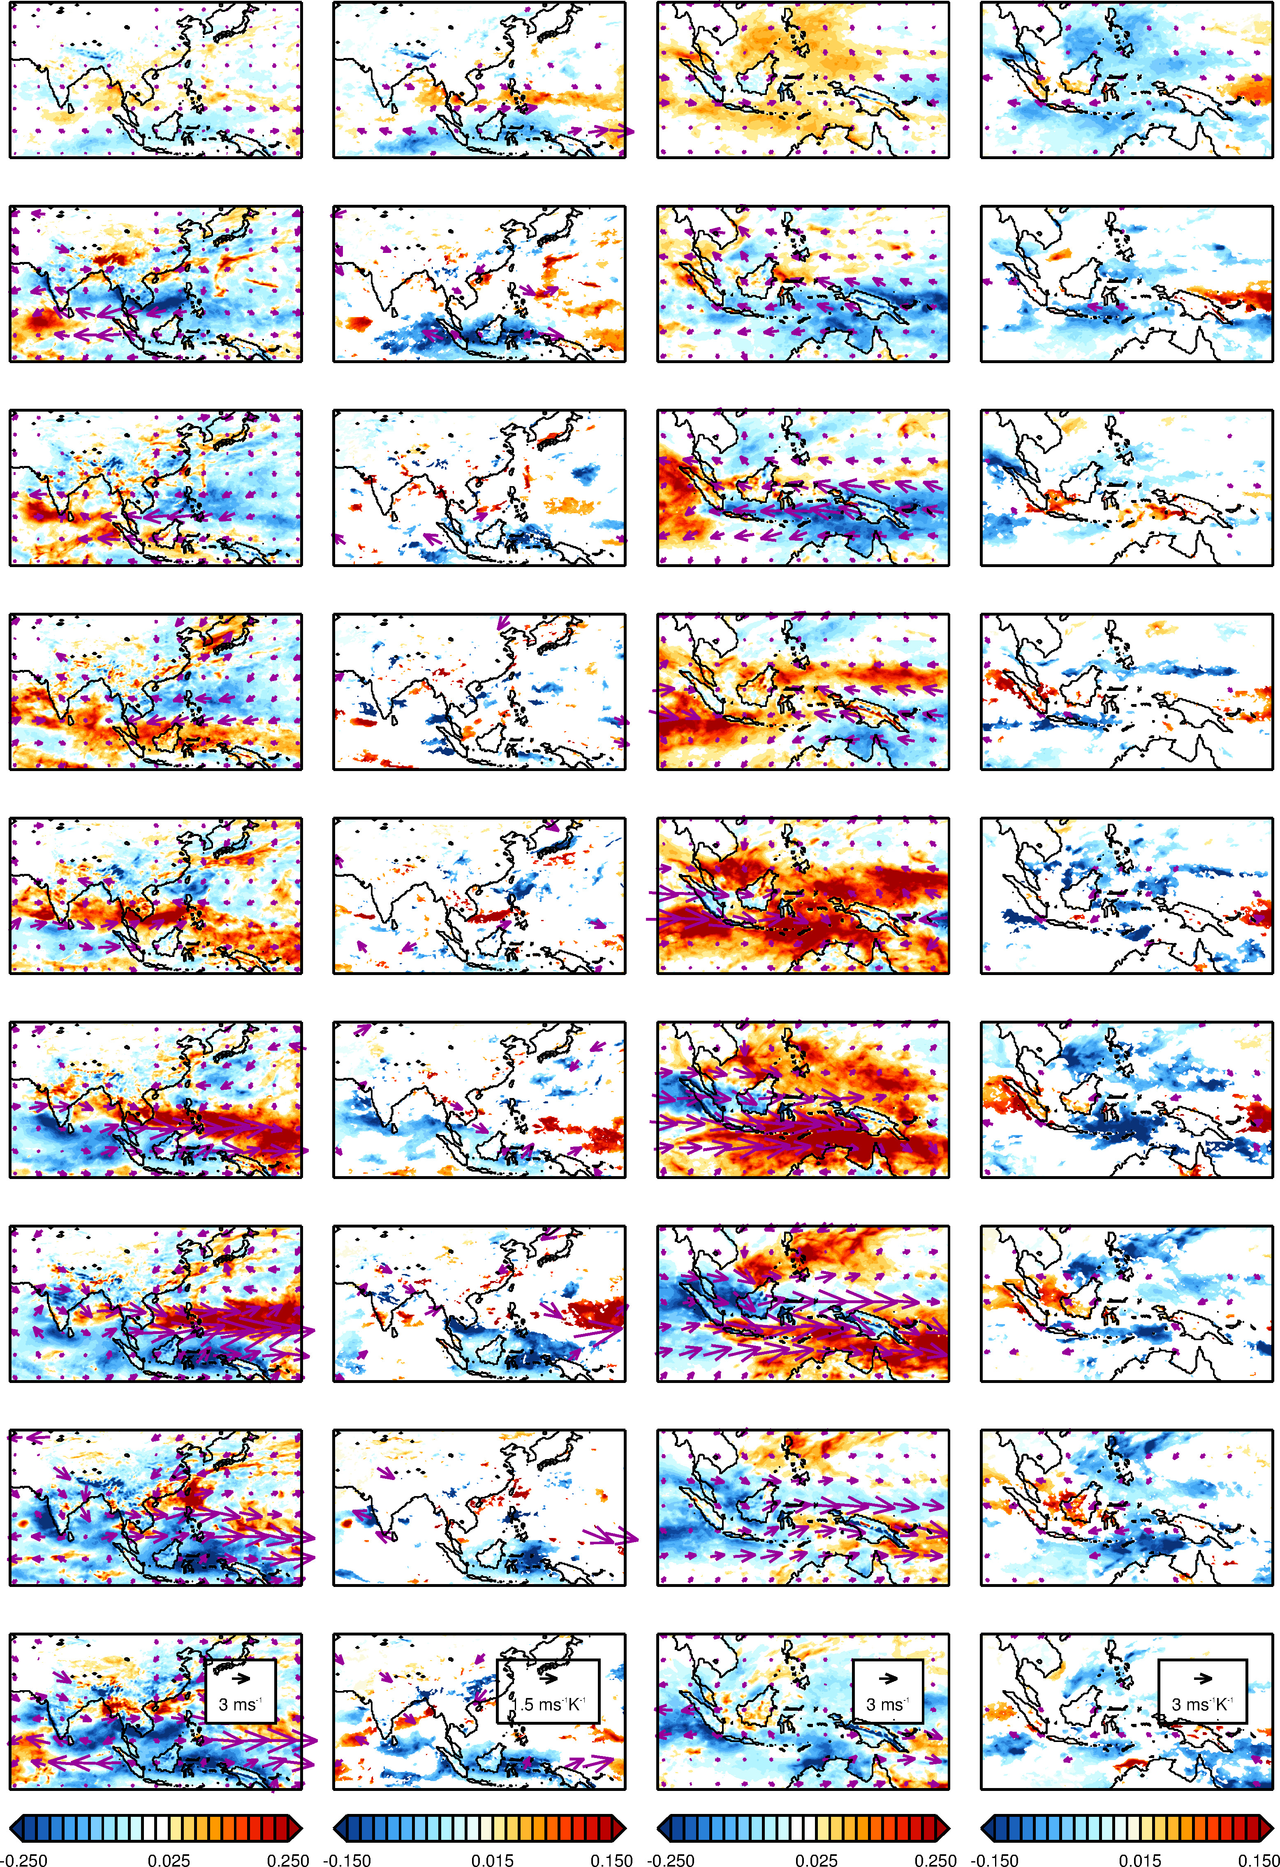
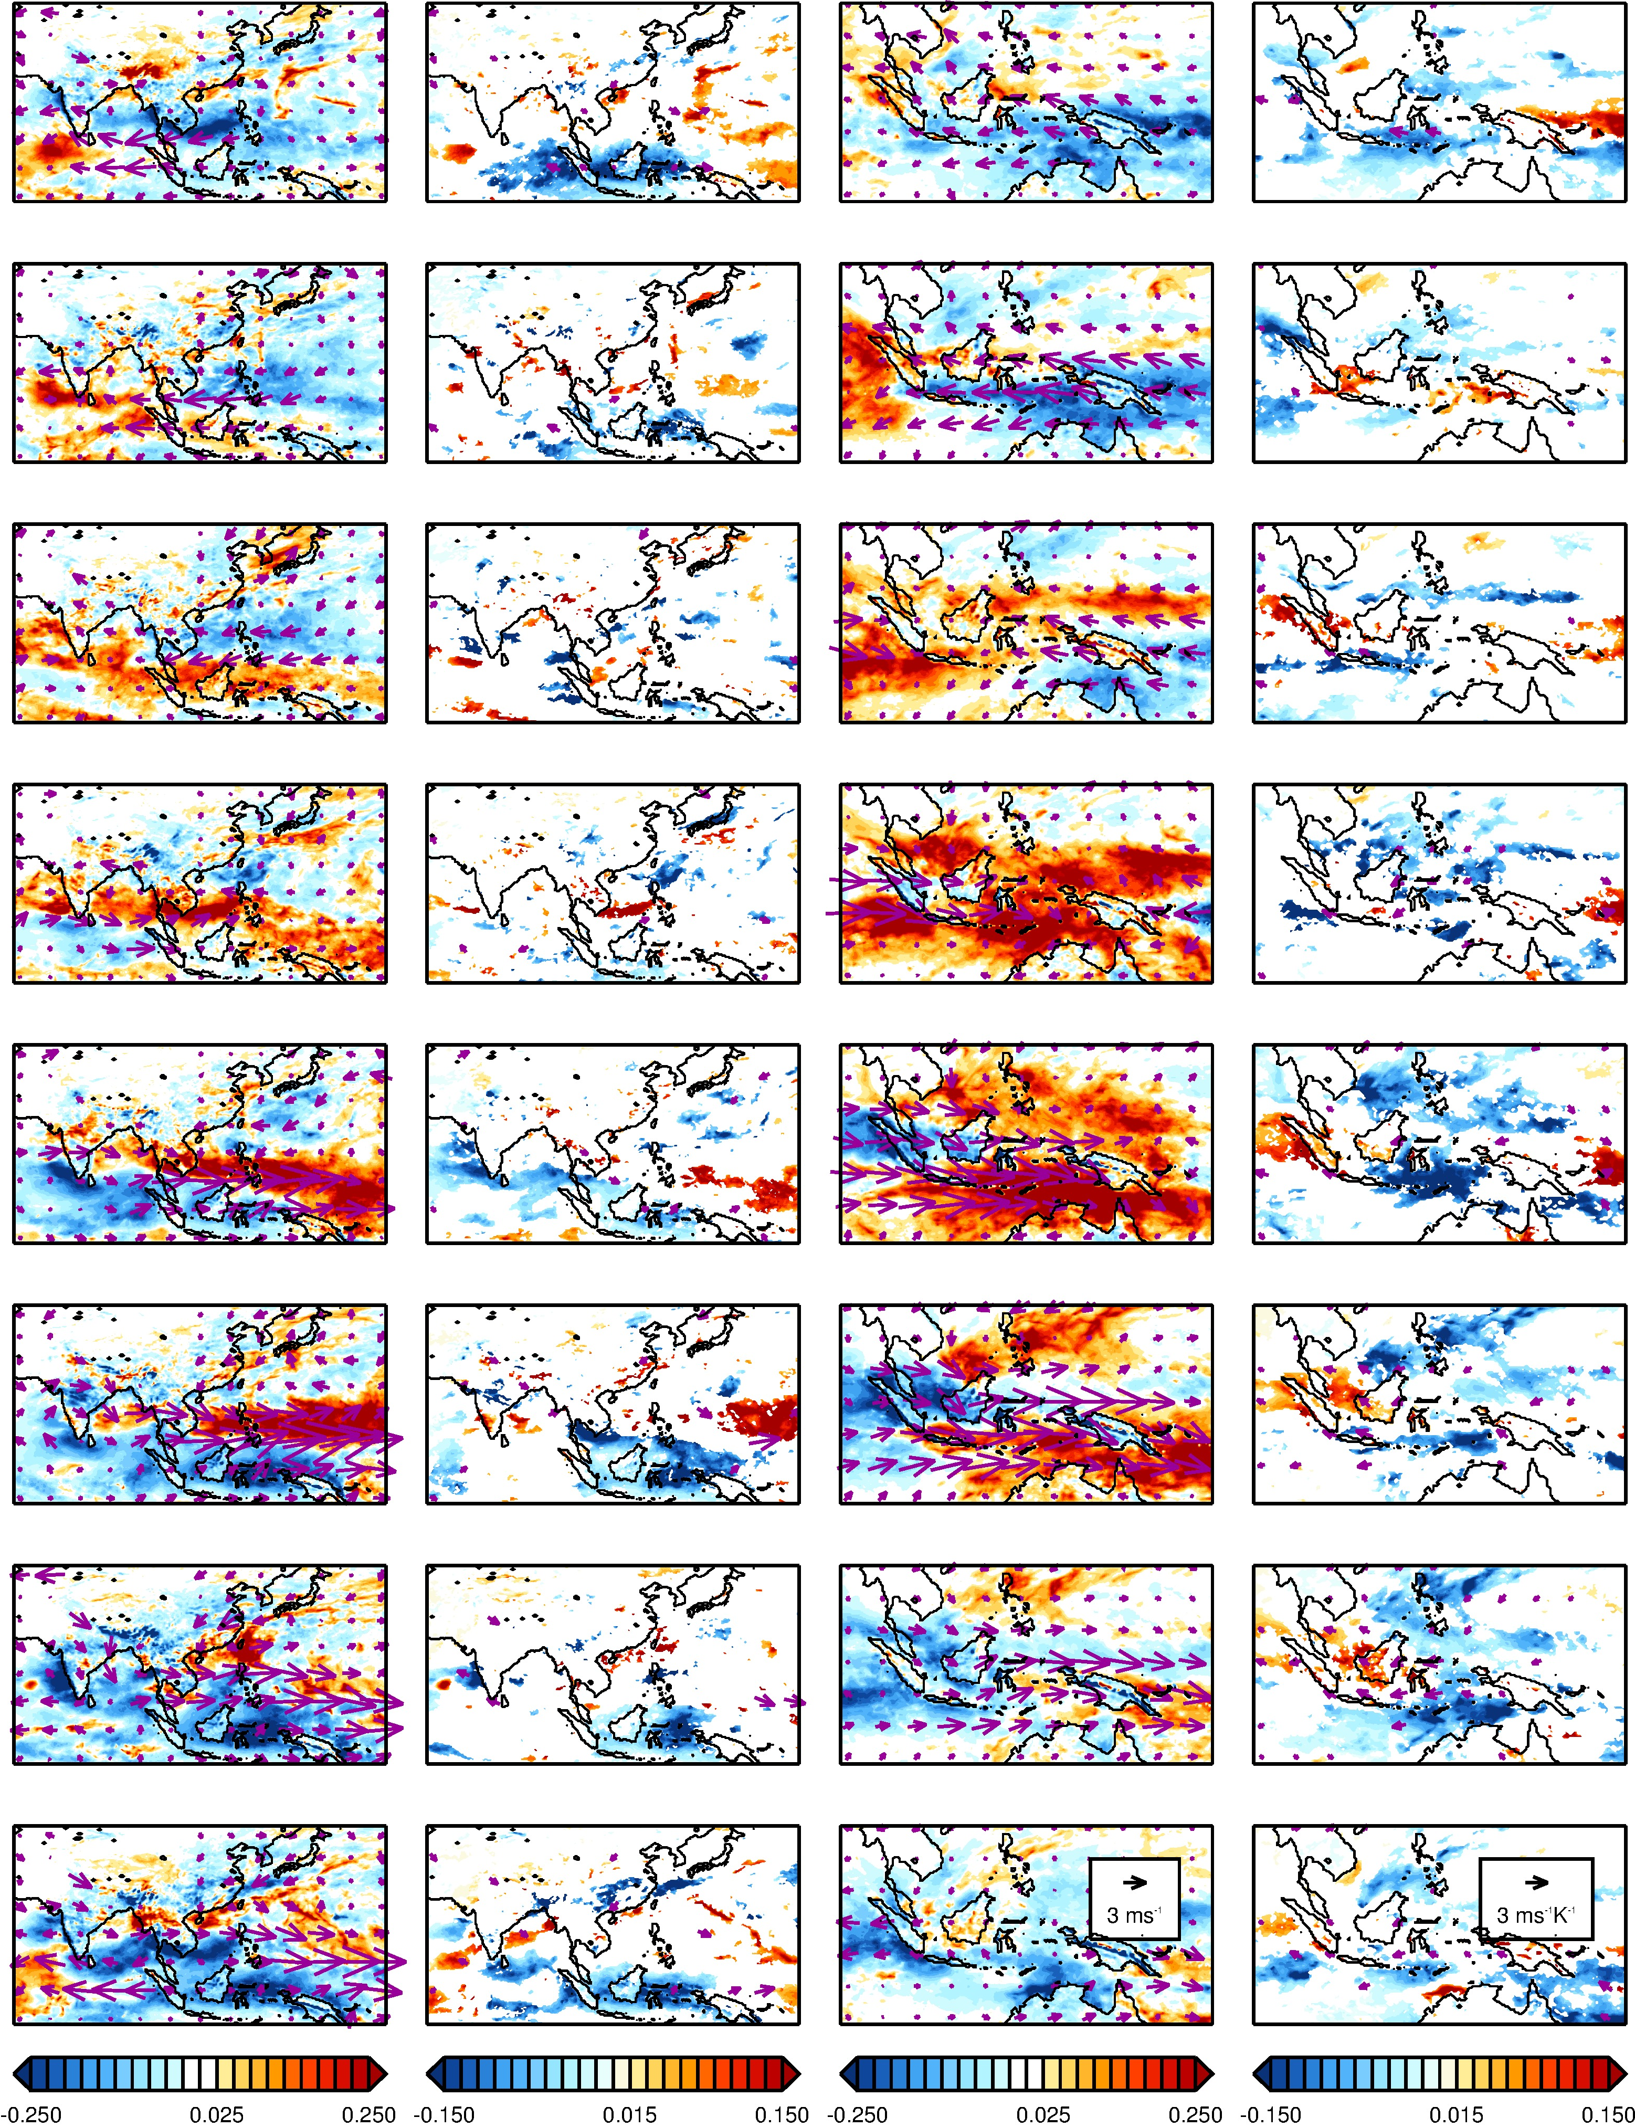
REGRESSION OF MJO (JJAS) AGAINST ENSO
Figure S11: Linear regression of precipitation rate and 850 hPa horizontal wind vector anomalies with respect to the daily climatology of the boreal summer (left) and winter (right) MJO with the conventional ENSO index. The left panel shows the regression intercept (mm h⁻¹ for the precipitation and m s⁻¹ for the winds) and the right panel shows the regression coefficient (mm h⁻¹ K⁻¹ for the precipitation and m s⁻¹ K⁻¹ for the winds; only those statistically significant at 95% level are plotted). The conventions are as in Figure S3.
P8
P7
P6
P5
P4
P3
P2
P1
WEAK MJO
REGRESSION COEFFICIENT
REGRESSION INTERCEPT
REGRESSION COEFFICIENT
REGRESSION INTERCEPT
REGRESSION OF MJO (DJFM) AGAINST ENSO
Regression Coefficient (mm h⁻¹ K⁻¹)
Regression Intercept (mm h⁻¹)

Regression Coefficient (mm h⁻¹ K⁻¹)
Regression Intercept (mm h⁻¹)

