DAILY MEAN PRECIPITATION RATE ANOMALY, $\hat{a}$
PRECIPITATION DIURNAL CYCLE
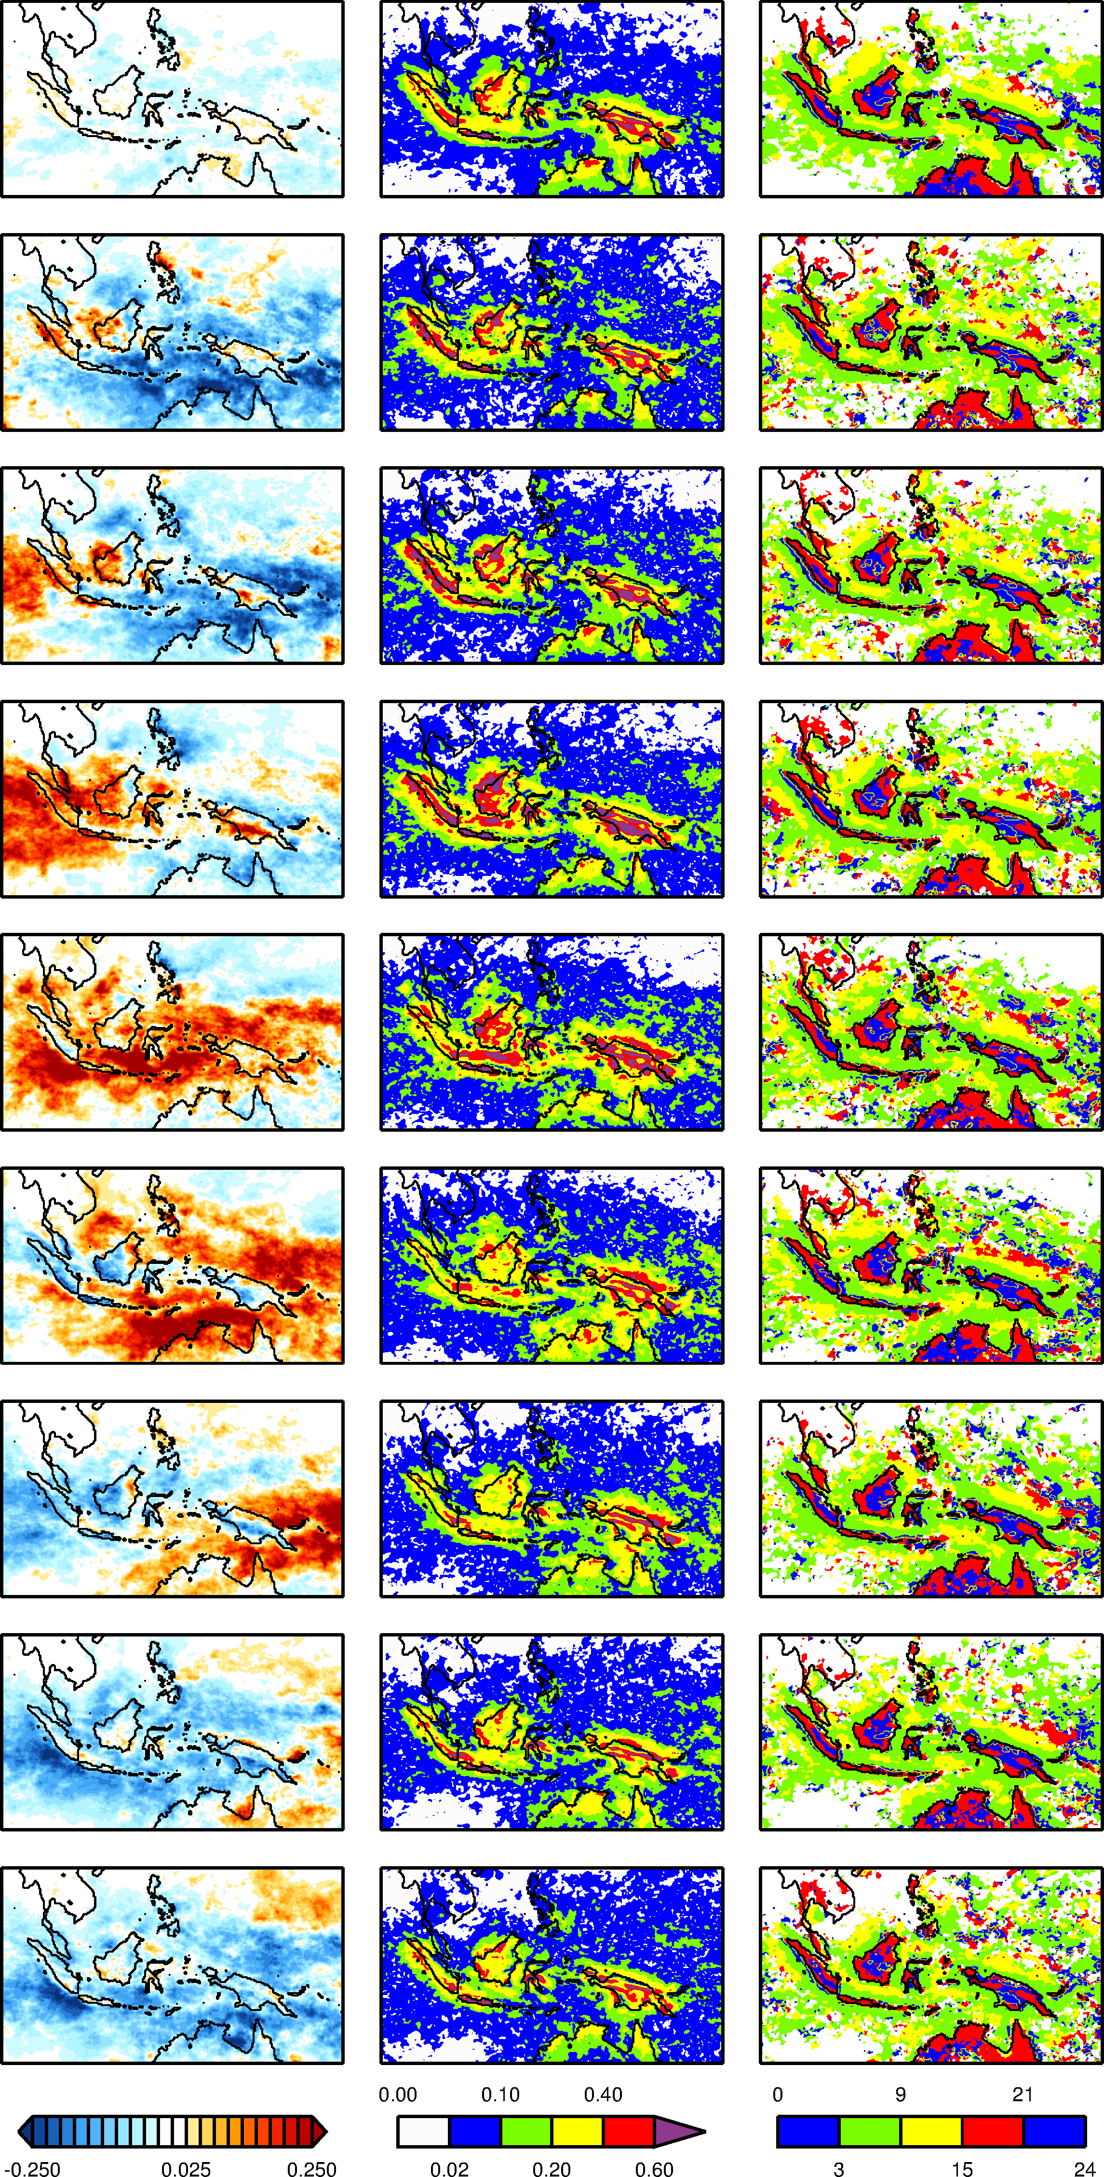
PHASE, $ϕ_{w}$
AMPLITUDE, $A_{w}$
WEAK MJO

PHASE LAG,
$$ϕ_{MJO}-ϕ_{w}$$

AMPLITUDE ENHANCEMENT, $A_{MJO}/A_{w}$

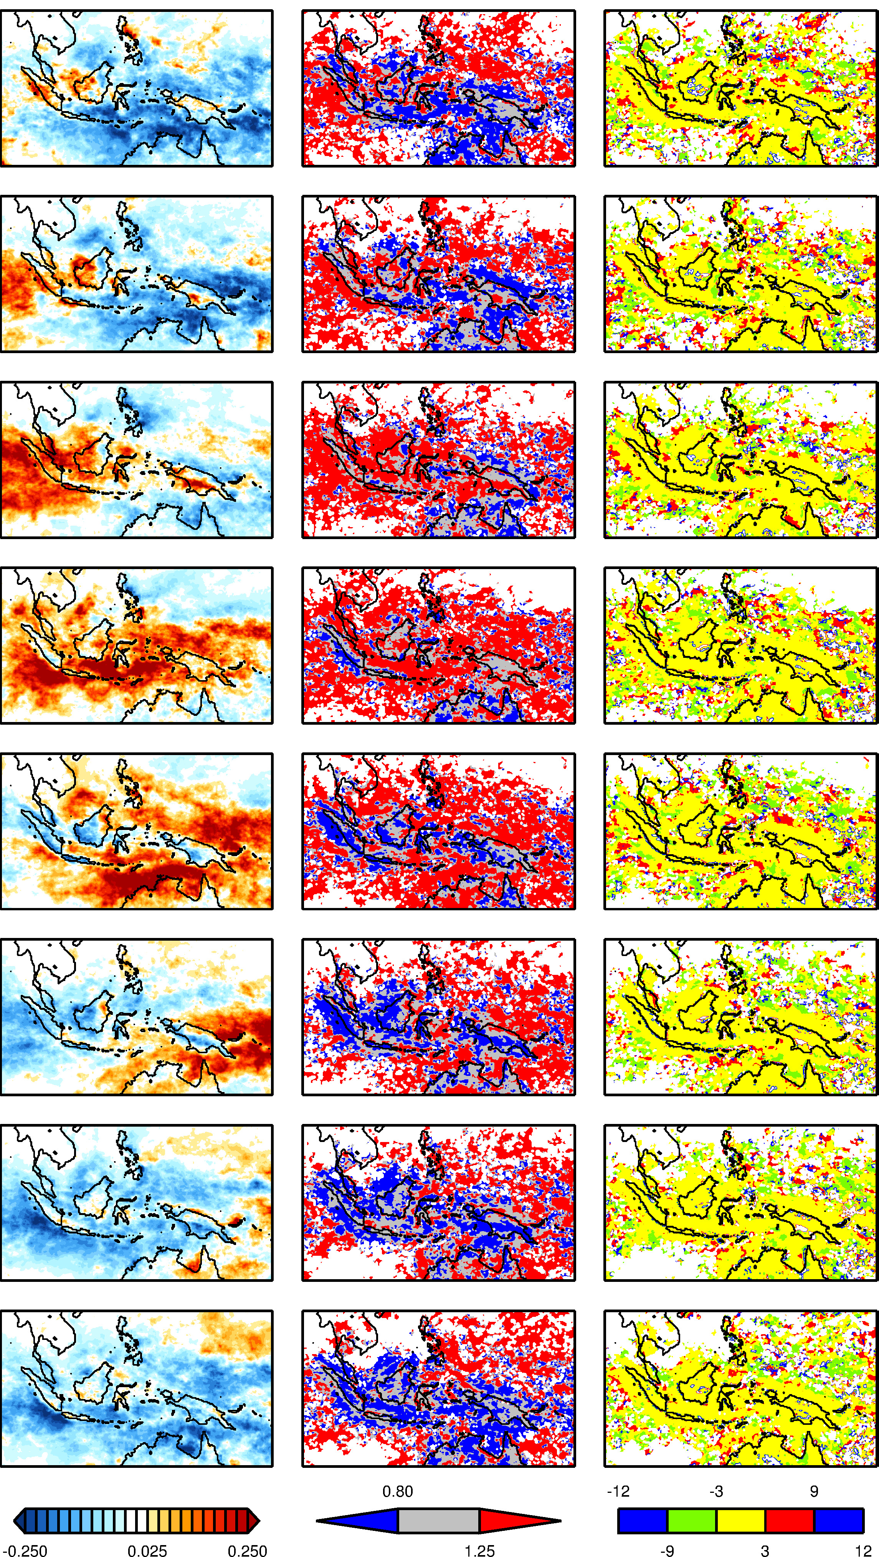
P1

P2

P3

P4

P5

P6

P7

P8

Figure S13: Intercept of the linear regression of the boreal winter TRMM 3B42 (1998-2015), daily mean precipitation rate anomaly (first column,$\hat{a}$; mm h⁻¹) and precipitation diurnal cycle (second and third columns) for the 8 MJO phases and weak MJO with respect to the conventional ENSO index. For weak MJO shown is the amplitude ($A_{w}$; mm h⁻¹) and phase ($ϕ_{w}$; peak hour in LST) with the latter masked out in regions in which the amplitude does not exceed 0.02 mm h⁻¹. For the MJO phases shown is the amplitude enhancement (${A_{MJO}}/{A_{w}}$; non-dimensional) and phase lag ($ϕ_{MJO}-ϕ_{w}$; hours). The conventions are as in Figure S3.

