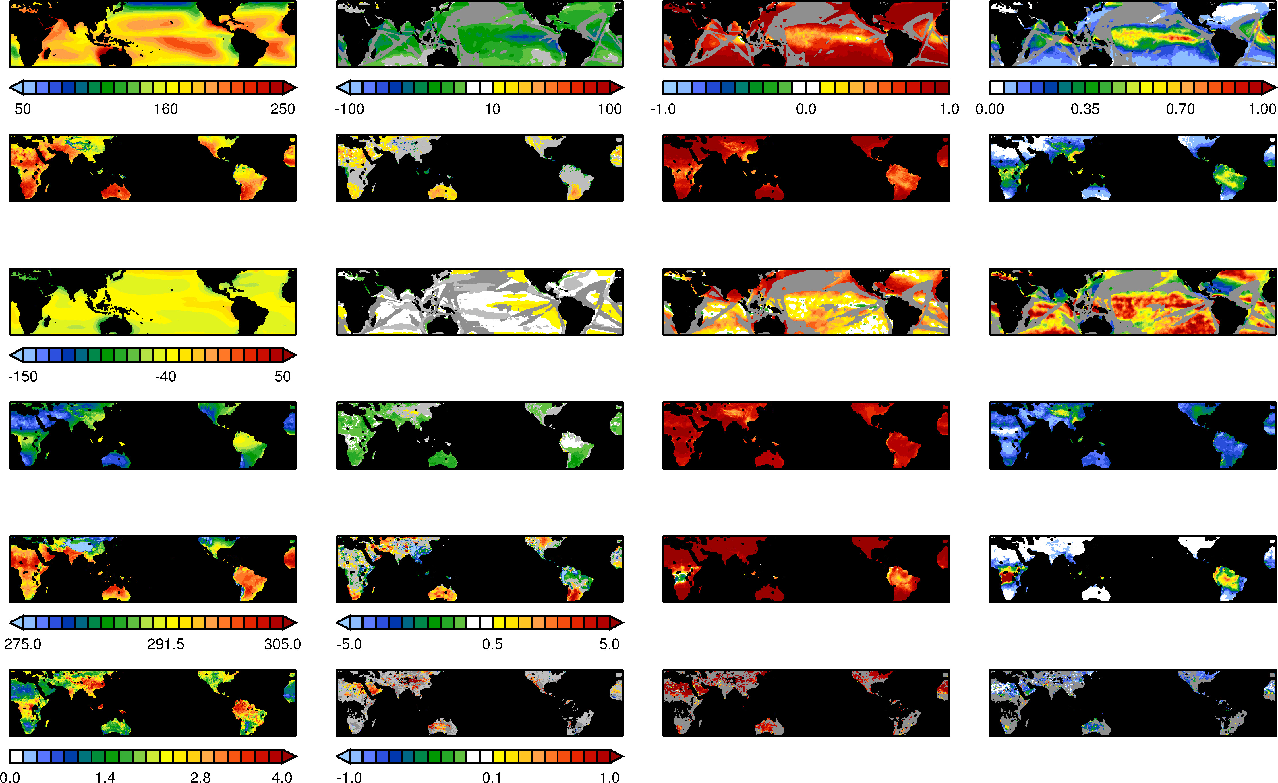
CORRELATION, ρ
NORMALIZED ERROR VARIANCE, α
BIAS (GREY SHADING IF |μ|≤ 0.5)
WRF MEAN
Surface Net SW radiation (W m⁻²)
Surface Net LW radiation (W m⁻²)

2-Meter Temperature (K)

Volumetric Soil Moisture (m³ m⁻³)

OCEAN
OCEAN
LAND
LAND

Figure S9: Verification diagnostics for the surface net short-wave and long-wave radiation fluxes (positive downwards, W m⁻²), 2-meter temperature (K) and volumetric soil moisture (m³ m⁻³). Left to right: WRF mean, bias (regions where |μ|≤0.5 are shaded in light grey), correlation (ρ) and normalized error variance (α). The diagnostics are computed using monthly data except for soil moisture and surface fluxes over land for which pentad data is used. In all diagnostics with respect to the NOCSv2 and ESA CCI soil moisture datasets regions where the uncertainty in the observations is large (see Appendix A.2 for more details) are masked out in dark grey. For the volumetric soil moisture regions where observational data is missing are masked out in black. The conventions are as in Figure S3.

