Assessing the climate change impact on the North African offshore surface wind and coastal low-level jet using coupled and uncoupled regional climate simulations

Pedro M.M. Soares, Daniela C.A. Lima, Álvaro Semedo, Rita M. Cardoso, William Cabos and Dmitry Sein

Electronic Supplementary Material
S1 Methods – Radiosonde Evaluation

Table S1. Missing values of the vertical wind and temperature profiles for the period 1980-2009 (available from Earth System Research Laboratory (ESRL) radiosonde database).
Local | Time UTC | Temp |  |  |  | Wind
 |  | 925 hPa | 850 hPa | 700 hPa | 500 hPa | 925 hPa | 850 hPa | 700 hPa | 500 hPa
Al Massira | 00 | 84.57% | 83.62% | 83.56% | 83.55% | 86.70% | 85.80% | 85.79% | 85.80%
Al Massira | 12 | 92.54% | 91.66% | 91.63% | 91.59% | 92.60% | 91.70% | 91.66% | 91.62%
Casa Blanca / ANFA | 12 | 98.62% | 98.39% | 96.39% | 98.35% | 98.64% | 98.44% | 98.44% | 98.42%
Dakar / Yoff | 00 | 67.78% | 66.77% | 66.86% | 66.84% | 68.96% | 67.82% | 67.61% | 67.67%
Dakar / Yoff | 12 | 70.19% | 69.14% | 69.13% | 69.19% | 71.52% | 70.17% | 69.88% | 69.81%
Nouadhibou | 12 | 91.56% | 88.63% | 87.34% | 84.87% | 94.62% | 93.11% | 93.22% | 91.35%
Praia | 00 | 99.90% | 99.90% | 99.90% | 99.90% | 99.90% | 99.90% | 99.90% | 99.90%
Praia | 12 | 99.90% | 99.90% | 99.90% | 99.90% | 99.90% | 99.90% | 99.90% | 99.90%
SalISL  Amilcar | 00 | 96.17% | 95.46% | 95.47% | 95.33% | 97.54% | 96.90% | 96.91% | 96.78%
SalISL  Amilcar | 12 | 96.17% | 95.46% | 95.47% | 95.33% | 97.54% | 96.90% | 96.91% | 96.78%
Santa Cruz Tenerife | 00 | 77.30% | 75.72% | 75.70% | 75.50% | 78.63% | 77.26% | 77.18% | 77.09%
Santa Cruz Tenerife | 12 | 76.73% | 75.02% | 74.94% | 74.77% | 78.06% | 76.57% | 76.40% | 76.28%

Table S2. Statistical errors of the vertical wind and temperature profiles when comparing the existing radiosondes (shown in FigureS1) and the nearest ROM model grid-point. Left refers to the uncoupled simulation and right to the coupled run.
Local | Time UTC | Bias |  | MAE |  | MAPE | RMSE
 |  | Wind (m/s) | T (ºC) | Wind (m/s) | T (ºC) | Wind (%) | Wind (m/s) | T (ºC)
Al Massira | 00 | 0.54  0.41 | -0.53  -0.71 | 2.32  2.32 | 2.11  2.12 | 30.27  30.29 | 3.45  3.45 | 2.77  2.72
Al Massira | 12 | 0.91  0.76 | 0.08  -0.09 | 2.74  2.67 | 2.75  2.75 | 37.67  36.80 | 4.01  3.98 | 3.73  3.68
Casa Blanca / ANFA | 12 | 1.24  1.19 | -0.80  -0.87 | 4.30  4.21 | 3.89  3.94 | 50.30  49.27 | 5.67  5.55 | 5.65  5.69
Dakar / Yoff | 00 | 0.30  -0.10 | -1.02  -1.95 | 1.44  1.40 | 1.43  2.15 | 18.15  17.67 | 1.93  1.92 | 1.92  2.45
Dakar / Yoff | 12 | 0.32  -0.04 | -0.87  -1.75 | 1.61  1.59 | 1.50  2.06 | 19.91  19.64 | 2.13  2.12 | 2.05  2.43
Nouadhibou | 12 | -0.28  -0.61 | 5.88  5.29 | 3.14  3.13 | 7.38  7.27 | 35.52  35.45 | 5.03  5.04 | 12.77  12.37
Praia | 00 | 0.07  -0.56 | -0.26  -1.28 | 4.48  4.10 | 1.24  1.71 | 51.18  46.87 | 5.65  5.20 | 1.74  2.12
Praia | 12 | 0.59  -0.42 | -0.29  -1.25 | 5.20  4.45 | 1.15  1.50 | 58.91  50.46 | 6.87  6.29 | 1.43  1.87
SalISL  Amilcar | 00 | 0.95  0.31 | 0.65  -0.19 | 3.07  2.83 | 2.84  3.04 | 38.50  35.47 | 5.79  5.62 | 7.04  6.90
SalISL  Amilcar | 12 | 0.58  0.14 | 0.18  -0.64 | 1.70  1.54 | 1.64  1.82 | 20.12  18.25 | 2.19  2.08 | 2.44  2.41
Santa Cruz Tenerife | 00 | 0.89  0.71 | 0.33  -0.10 | 2.18  2.06 | 1.64  1.68 | 25.83  24.43 | 2.65  2.55 | 2.21  2.15
Santa Cruz Tenerife | 12 | 0.92  0.70 | 0.46  0.03 | 2.02  1.91 | 1.66  1.69 | 25.07  23.73 | 2.47  2.35 | 2.29  2.19

Table S3. Statistical errors of the vertical wind and temperature profiles when comparing ERA-Interim and the nearest ROM model grid-point. Left refers to the uncoupled simulation and right to the coupled run. P1 and P2 are the two locations where maxima values of frequency of occurrence of the coastal jet arise.
Local | Time UTC | Bias |  | MAE |  | MAPE | RMSE
 |  | Wind (m/s) | T (ºC) | Wind (m/s) | T (ºC) | Wind (%) | Wind (m/s) | T (ºC)
P1 | 00 | 1.01  0.51 | -0.81  -1.54 | 1.29  1.07 | 1.06  1.66 | 18.82  15.59 | 2.78  1.81 | 1.81  3.50
P1 | 06 | 1.08  0.59 | -0.64  -1.30 | 1.35  1.11 | 1.09  1.54 | 19.18  15.80 | 2.93  1.96 | 1.92  3.17
P1 | 12 | 1.23  0.79 | -0.82  -1.51 | 1.45  1.19 | 1.12  1.61 | 21.45  17.55 | 3.34  2.26 | 2.03  3.43
P1 | 18 | 0.92  0.52 | -0.69  -1.46 | 1.32  1.19 | 1.01  1.56 | 20.24  18.28 | 3.05  2.28 | 1.70  3.24
P2 | 00 | 1.47  1.27 | -0.02  -0.41 | 1.64  1.49 | 1.17  1.17 | 20.98  19.01 | 1.95  1.81 | 1.48  1.46
P2 | 06 | 1.38  1.12 | 0.07  -0.30 | 1.59  1.37 | 1.25  1.22 | 20.72  17.91 | 1.89  1.66 | 1.60  1.52
P2 | 12 | 1.23  0.98 | 0.06  -0.31 | 1.47  1.27 | 1.27  1.23 | 19.86  17.10 | 1.76  1.54 | 1.54  1.54
P2 | 18 | 0.98  0.86 | 0.26  -0.13 | 1.25  1.16 | 1.26  1.22 | 16.85  15.76 | 1.52  1.43 | 1.63  1.54

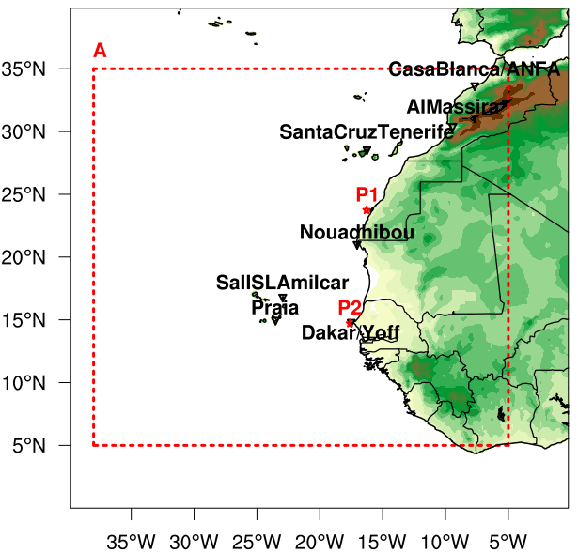
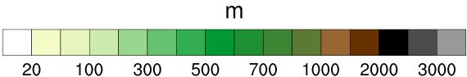
Figure S1. A zoom in the area of interest (A) from the ROM model domain (Fig. 1). Triangular pins mark the location of the radiosondes and P1 and P2 correspond to the points of maximum frequency of NACLLJ occurrence in the ROM coupled simulation during JJA and DJF.

Al Massira
Casa Blanca / ANFA
Dakar / Yoff
Nouadhibou
Praia
SalISL Amilcar
Santa Cruz Tenerife
Figure S2. Mean vertical wind and temperature profiles from the radiosondes (black solid line) and ROM uncoupled and coupled simulations (green and blue solid lines, respectively).

P1
 | 00h | 06h | 12h | 18h
Temperature
Wind
P2
 | 00h | 06h | 12h | 18h
Temperature
Wind
Figure S3. Mean vertical wind and temperature profiles from ERA-Interim (black solid line) and ROM uncoupled and coupled simulations (green and blue solid lines, respectively). P1 and P2 are shown in Figure S1 and correspond to the points of maximum frequency of NACLLJ occurrence in the ROM coupled simulation during JJA and DJF. ERA-Interim profiles refer to nearest the grid point.

