SUPPORTING INFORMATION FOR THE MANUSCRIPT
Circulation analogues and uncertainty in the time-evolution of extreme event probabilities: evidence from the 1947 Central European heatwave
Luke J Harrington¹, Friederike E L Otto¹, Tim Cowan^{2,3}, Gabriele C. Hegerl²
¹Environmental Change Institute, University of Oxford, South Parks Road, Oxford, OX1 3QY, UK
²School of Geosciences, University of Edinburgh, James Hutton Road, Edinburgh, EH9 3FE, UK
³University of Southern Queensland & The Bureau of Meteorology, 700 Collins St, Melbourne, 3008, Australia
Corresponding contact details: luke.harrington@ouce.ox.ac.uk
------------------------
Supplementary figures
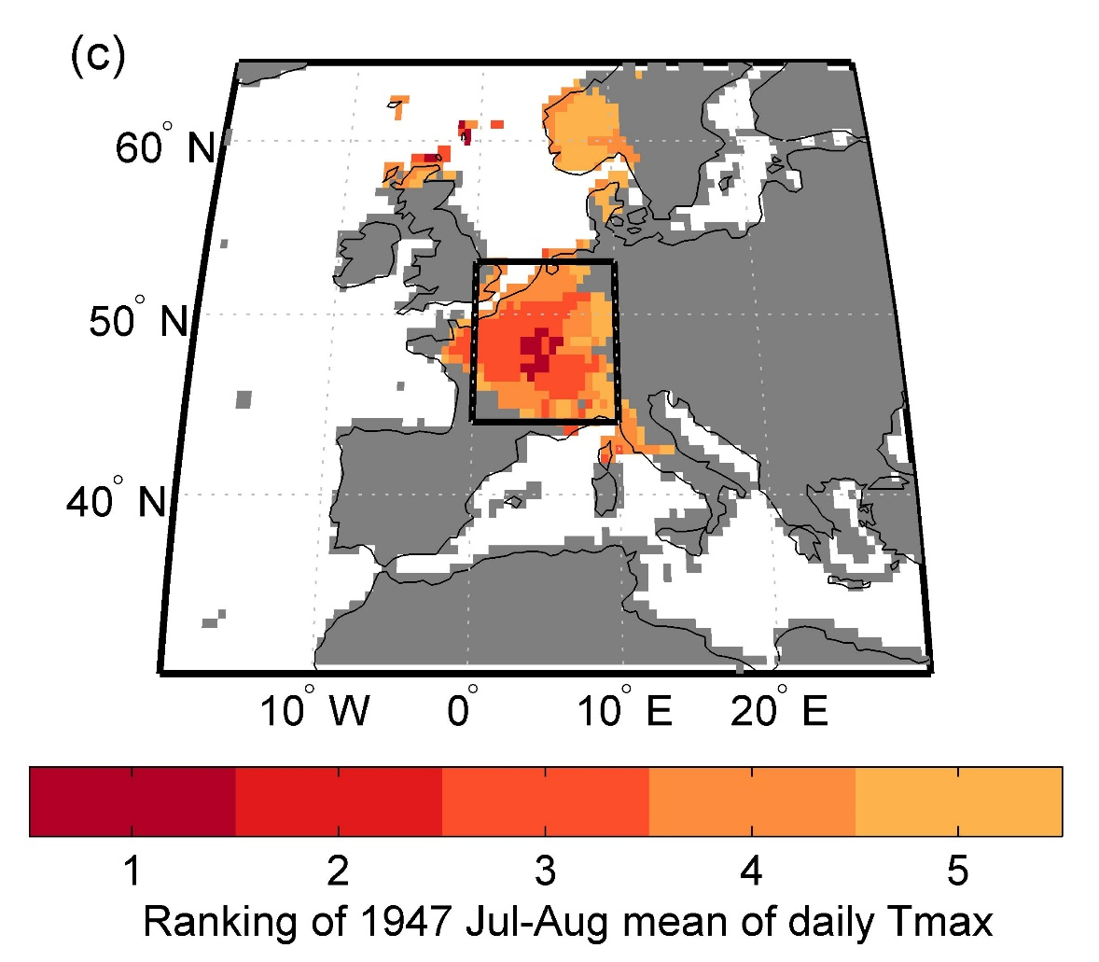
Figure S1 – Same as Figure 1c of the main manuscript, but this time considering all summers between 1901-2014, instead of just those summers between 1901 and 2000 only.
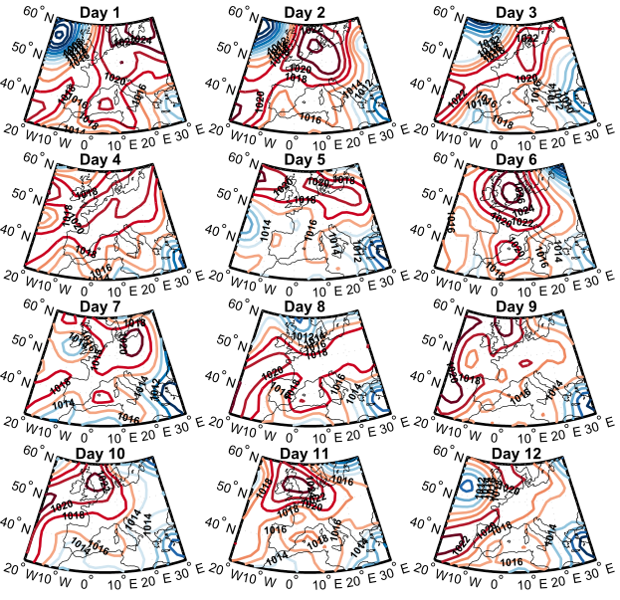
Figure S2 – Same as Figure 3 of the main article, but instead showing the top circulation analogues for each of the 12 days of the 1947 heatwave. These have been sampled from all years in the baseline 1901-2000 period, considering a 31-day window centred on each of the days of interest.
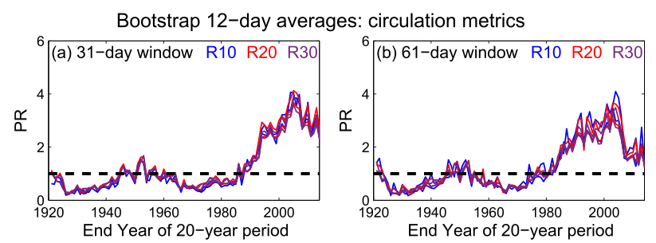
Figure S3 – Panel (a) is the same as Figure 7f of the main article, while panel (b) shows equivalent results, but when considering an even longer 61-day time window from which to select individual analogue days.

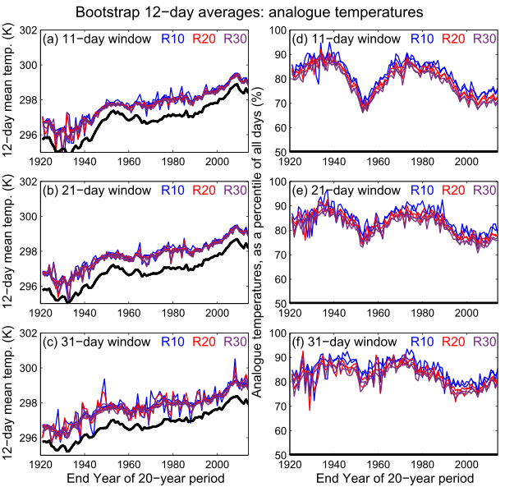
Figure S4 – Same as Figure 8 of the main article, but including variations in analogue temperatures as a function of different N-day time windows.

