Supplementary information (SI)

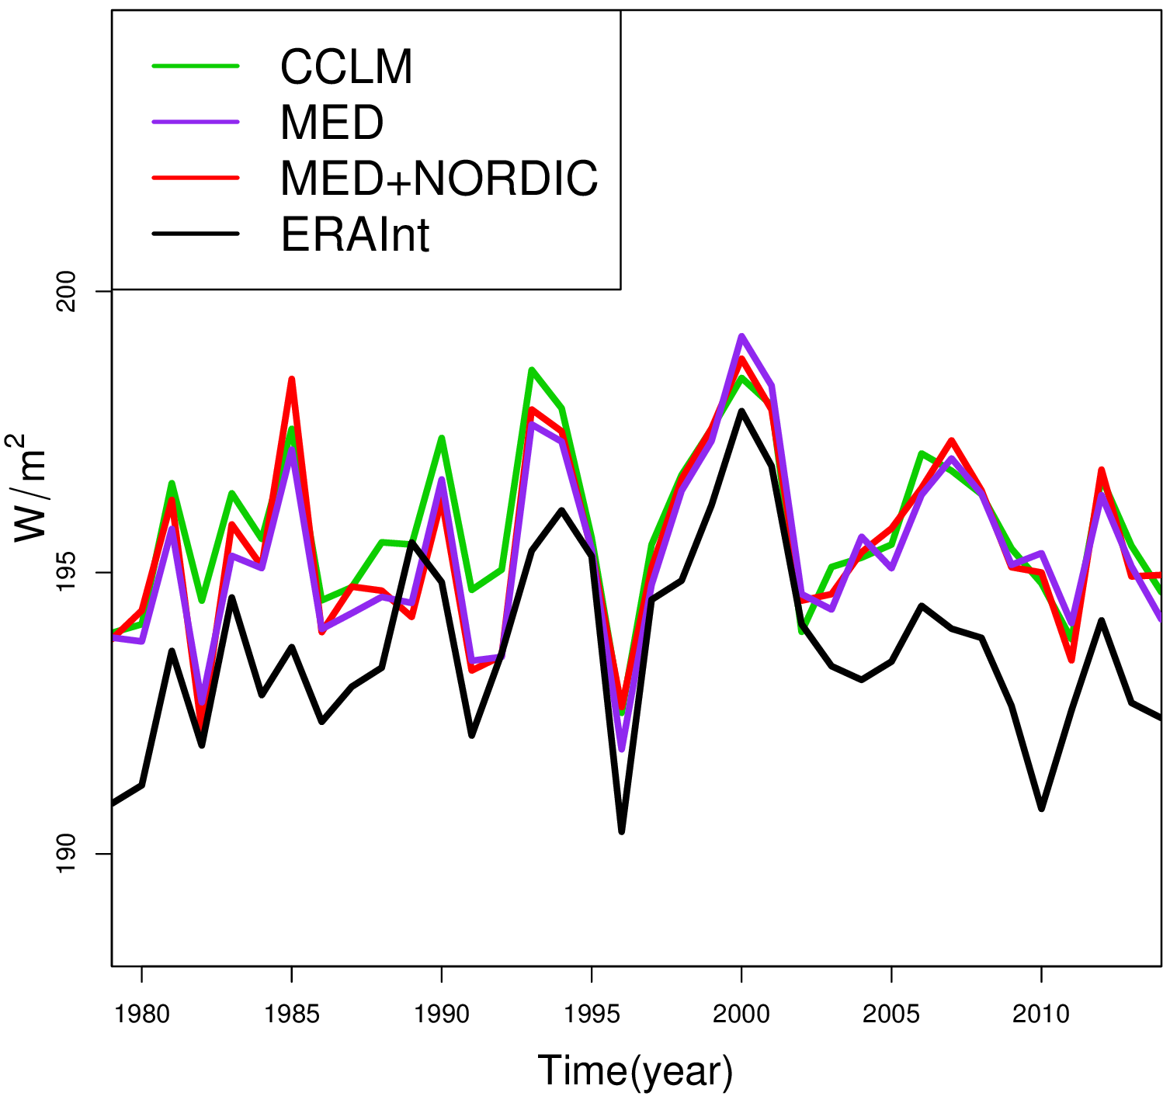

Fig. SI-1. Shortwave radiation (W/m²) for 1979-2014 from CCLM, MED, MED+NORDIC simulations and ERA-Interim data.

