Supplementary material S1

Validation of present day climate as simulated by the coupled atmosphere-ocean-sea ice model RCA4-NEMO

The main purpose with the coupled ocean-atmosphere-sea ice model is to downscale future climate change for the North Sea and Baltic Sea region. This implies that the model will be driven by a (possibly high) number of different global models. Due to their global nature these models cover present day climate dynamics only in a way where mean statistics and variability can be expected to be reproduced whereas real time comparison with observational data sets is not possible. From this follows that the fine-tuning of the model to atmospheric reanalysis data does not necessarily adds value to the purpose of climate change simulation where global climate model output is used to drive the regional model which is biased compared to reanalysis data. By contrast, bounding tuning parameters tightly according to present day conditions will influence the models' sensitivity against an altered climate and it is not known if tuning parameters that give best results for the present day climate work likewise well for a future, warmer climate.
Furthermore, a coupled ocean-atmosphere sea ice model has a higher degree of freedom compared to standalone models which are strongly constraint by prescribed boundary conditions from either the atmosphere or the ocean. Hence, for the purpose of downscaling climates different from today, we here primarily test the models ability to reproduce the observed mean climatic state, the seasonal cycle and its skills to represent interannual variability. The latter is important as it measures how the model responds to different forcing.

Therefore, for validation purposes the model was run in hindcast mode, i.e driven by the ERA40 atmospheric reanalysis data set at the lateral boundary of the RCA4 atmospheric model component. Temperature and salinity at the ocean models boundary represent a long term mean climatology (Janssen et al., 1999). Temperature and salinity at the latetral boundaries are subject to a flow relaxation scheme (Engedahl, 1995) that also calculates the normal baroclinic velocities on the open boundary. SSH at the lateral boundaries is taken from a 1960-2009 hindcast run with the regionally coupled ocean atmosphere model REMO-MPIOM (Sein et al., 2015, Sein et al., 2019) and is prescribed for the RCA4-NEMO ERA40 hindcast run. The hindcast run is used to validate mainly water temperature, and salinity, the general circulation, and water column stability.

North Sea
In a first step the modelled SST is compared to satellite data derived from the Federal Maritime and Hydrographic Agency (BSH) of Germany (Fig. 1a, https://www.bsh.de/DE/DATEN/Meerestemperaturen/Meeresoberflaechentemperaturen/meeresoberflaechentemperaturen_node.html). In general, the model reproduces the strong (6 to 7 K) gradients build up between colder waters originating from the North Atlantic and warmer waters in the southern coastal regions during summer. Along the inflow areas NE of Scotland and in the English Channel the modelled temperatures are colder compared to the satellite product. This reflects likely too cold prescribed temperatures at the models boundaries since the Janssen et al. (1999) climatology represents a long term average which includes many data from the period before 1990 and back to 1900 where the climate has presumably not warmed as it is the case in the most recent period. In the transition zone to the Baltic Sea, i.e. the Kattegat and Skagerrak region between Norway, Denmark, and Sweden the model is likewise colder but the small scale gradients are well reproduced: the higher SSTs along the Norwegian and Swedish coasts compared to the Danish coast as well as higher SSTs in the Kattegat. Contrary to summer, the large effective heat capacity of the North Atlantic provides warmer waters at the northern model boundary leading lower SSTs towards the southern coast compared to the northern boundary. In addition the entire North Sea is well mixed in winter which leads to an enhanced heat transfer from deeper layers to the surface in the North (e.g. Gröger et al., 2015) and to a rapid adaption to the cold winter atmosphere in the shallow near coastal areas in the south. As a result the NW - SE temperature gradients are opposed in winter compared to summer (Fig. 1). The Skaggerak constitutes a transition zone that is marked by warmer North Sea waters along the Danish coast and colder waters from the Baltic Sea along the Norwegian coast. As for summer, the Janssen climatology represents a bit tool cold boundary conditions leading to loo low temperatures in the English Channel and along the northern model boundary.

Table S1 summarizes the models ability to reproduce the general hydrographic gradients and the overall spatial pattern for each season averaged over the period 1990 to 2009.

 | COR | STD model | STD BSH | RMS
North Sea
Winter | 0.96 | 1.60 | 1.80 | 0.70
Spring | 0.93 | 1.21 | 1.10 | 0.74
Summer | 0.89 | 1.61 | 1.40 | 1.07
Autumn | 0.95 | 1.50 | 1.32 | 0.68
Baltic Sea
Winter | 0.94 | 1.46 | 0.92 | 0.33
Spring | 0.95 | 1.45 | 1.61 | 0.37
Summer | 0.90 | 1.42 | 1.39 | 0.91
Autumn | 0.97 | 1.54 | 1.55 | 0.61
Table 1: Spatial correlation (COR), standard deviations (STD, and root mean squared errors (RMS) between modelled and satellite derived SSTs for the North Sea and the Baltic Sea.

Modelled SSTs and satellite derived SSTs deviate between ~0.7 K and 1.1 K in the North Sea depending on the season as revealed by the root mean squared error (table 1). Variability as indicated by the models and satellites standard deviations (STD) are in good agreement. Likewise the correlations between the two data sets are high in all season which simply reflects the fact that the NW – SE large scale gradients are reproduced by the model.

As a test for the models ability to reflect interannual variability Fig. 1b shows the temporal correlation between the multi-year (1990-2009) satellite derived SST and modeled SST for the summer season and winter season. During winter highest correlation is derived in the shallow regions of southern North Sea which adapts rapidly to the atmospheric forcing. Lower correlation is seen in the northern North Sea which is expected because the models boundary condition reflects only the climatological mean seasonal cycle of the Janssen et al. (1999) climatology with no interannual variation. Only the region west of Norway shows high correlation near the northern boundary as this region is mark by outflow waters from further south and is relatively unaffected by Atlantic waters (and thus by the models lateral boundaries). During summer the cyclonic circulation in the North Sea weakens and the influence of Atlantic waters is generally decreased and a strong thermal stratification sets up giving rise to more local meteorological forcing. This is reflected in vast areas with correlation coefficients between 0.7 and 0.9. Only the region near the English coast and the English Channel show somewhat lower correlation.

Figure 1: a) Comparison between modelled (top) and a satellite based (bottom) multi-year (1990-2009) averaged SST from the Federal Maritime and Hydrographic Agency (BSH), Germany. b) Interannual (1990-2009) correlation between the two data sets for the the summer season (left) and winter season (right).
In the following, modeled water temperature and salinity is compared to 3D in situ observations. For this we employ the latest version of the KLIWAS North Sea climatology hydrographic data set (Bersch et al., 2013). In a first step we compare the seasonal cycle at 5 different stations and averaged over a 20 years period (1990-2009). We selected stations characteristic for open sea conditions in the deeper North Sea (Fladden Ground), the permanently stratified Norwegian Coastal Current (NCC), the German Bight (GB), the Southern Bight (SB), and the Skaggerak (SK, see Fig. 1 of the main article for the the positions of the stations).

At Fladden Ground a strong seasonal cycle is shown with a well mixed water column down to the bottom during the cold season (Fig. 2a). Thermal stratification develops during spring and predominates the situation during summer. This suppresses vertical mixing with cold deep waters and thus leads to highest temperatures near the surface in July and August. This is well reproduced by the model although the temperatures are a bit underestimated at the surface which was also indicated by the comparison with the satellite data from the BSH (see above). The strong thermal stratification promotes also weak vertical salinity gradients during summer since upward mixing of higher salinity deep waters weakens likewise at Fladden Ground. (Fig. 2b). Salt concentrations are too low during the winter months which can be explained by a too weak inflow from the North Atlantic.

Station NCC reflects the seasonal cycle along the Norwegian Coastal Current. Figure 2b shows that this station is permanently stratified as it is influenced by northward flowing fresher water originating from the Baltic and deeper waters from the Atlantic. The seasonal amplitude as shown by salinity as well as vertical gradients are well reproduced by the model whereas the summer salinity minimum Fig. 2b) appears somewhat delayed compared to observations. The seasonal cycle of temperature and thermal stratification is reproduced quite well in the model compared to observations (Fig. 2a) at station NCC. The seasonal temperature maximum at depth (50 m) occurs clearly later than the maximum near the surface. This is seen in both, the observations and the model. However, the model somewhat underestimates the temperature maximum at depth in late summer and autumn which could indicate too weak mixing in highly stratified regions like the NCC.

The shallow southern North Sea is analyzed at the stations Southern Bight and German Bight (Fig. 2). The former reflects the conditions in the southwestern North Sea influenced by the inflow of high salinity waters from the English Channel, while the latter reflects fresher conditions with a strong imprint of runoff from land in the southeastern North Sea (Fig. 2b). The Southern Bight is permanently mixed around the year and the seasonal cycle is characterized by to minima in spring and autumn (Fig. 2b). This dynamics is well reproduced by the model. However, especially during winter the modelled salinities are quite too low. As the inflow transports through the Straits of Dover (0.16 Sv) agree well with observations (e.g. 0.15 Sv, Otto et al. 1990; Thomas et al., 2005) part of the difference is probably due to inconsistencies between the lateral boundary climatology (Janssen et al., 1995) and the KLIWAS climatology that strongly translates into the models interior. Moreover, Pätsch et al. (2017) who compared 5 different models for the North Sea with observations concluded that all models have large biases in simulated SSTs and SSS in the vicinity of the coasts probably due to insufficiency in the boundary forcing (runoff, coarse meteorological forcing) and vertical resolution. With respect to temperature both the observed, and modelled data show a vertical homogenous water column and a strong seasonality with a temperature minimum in early February and maximum in August which is slightly overestimated in the model compared to the observation (Fig. 2a).
As in the Southern Bight no thermal stratification is seen in the German Bight throughout the year. This station exhibits the strongest seasonal amplitude of >15 K (Fig. 2a). This indicates a fast adaption time to the atmospheric temperature. The salinity reflects the presence of two water masses which build up a haline stratification (Fig. 2b, Becker et al., 1992): Saline Atlantic waters at depth and fresher waters from surrounding land. The seasonal cycle is stronger near the surface than in the deep which indicates that seasonally varying freshwater addition from runoff is responsible for seasonal variation at this station.

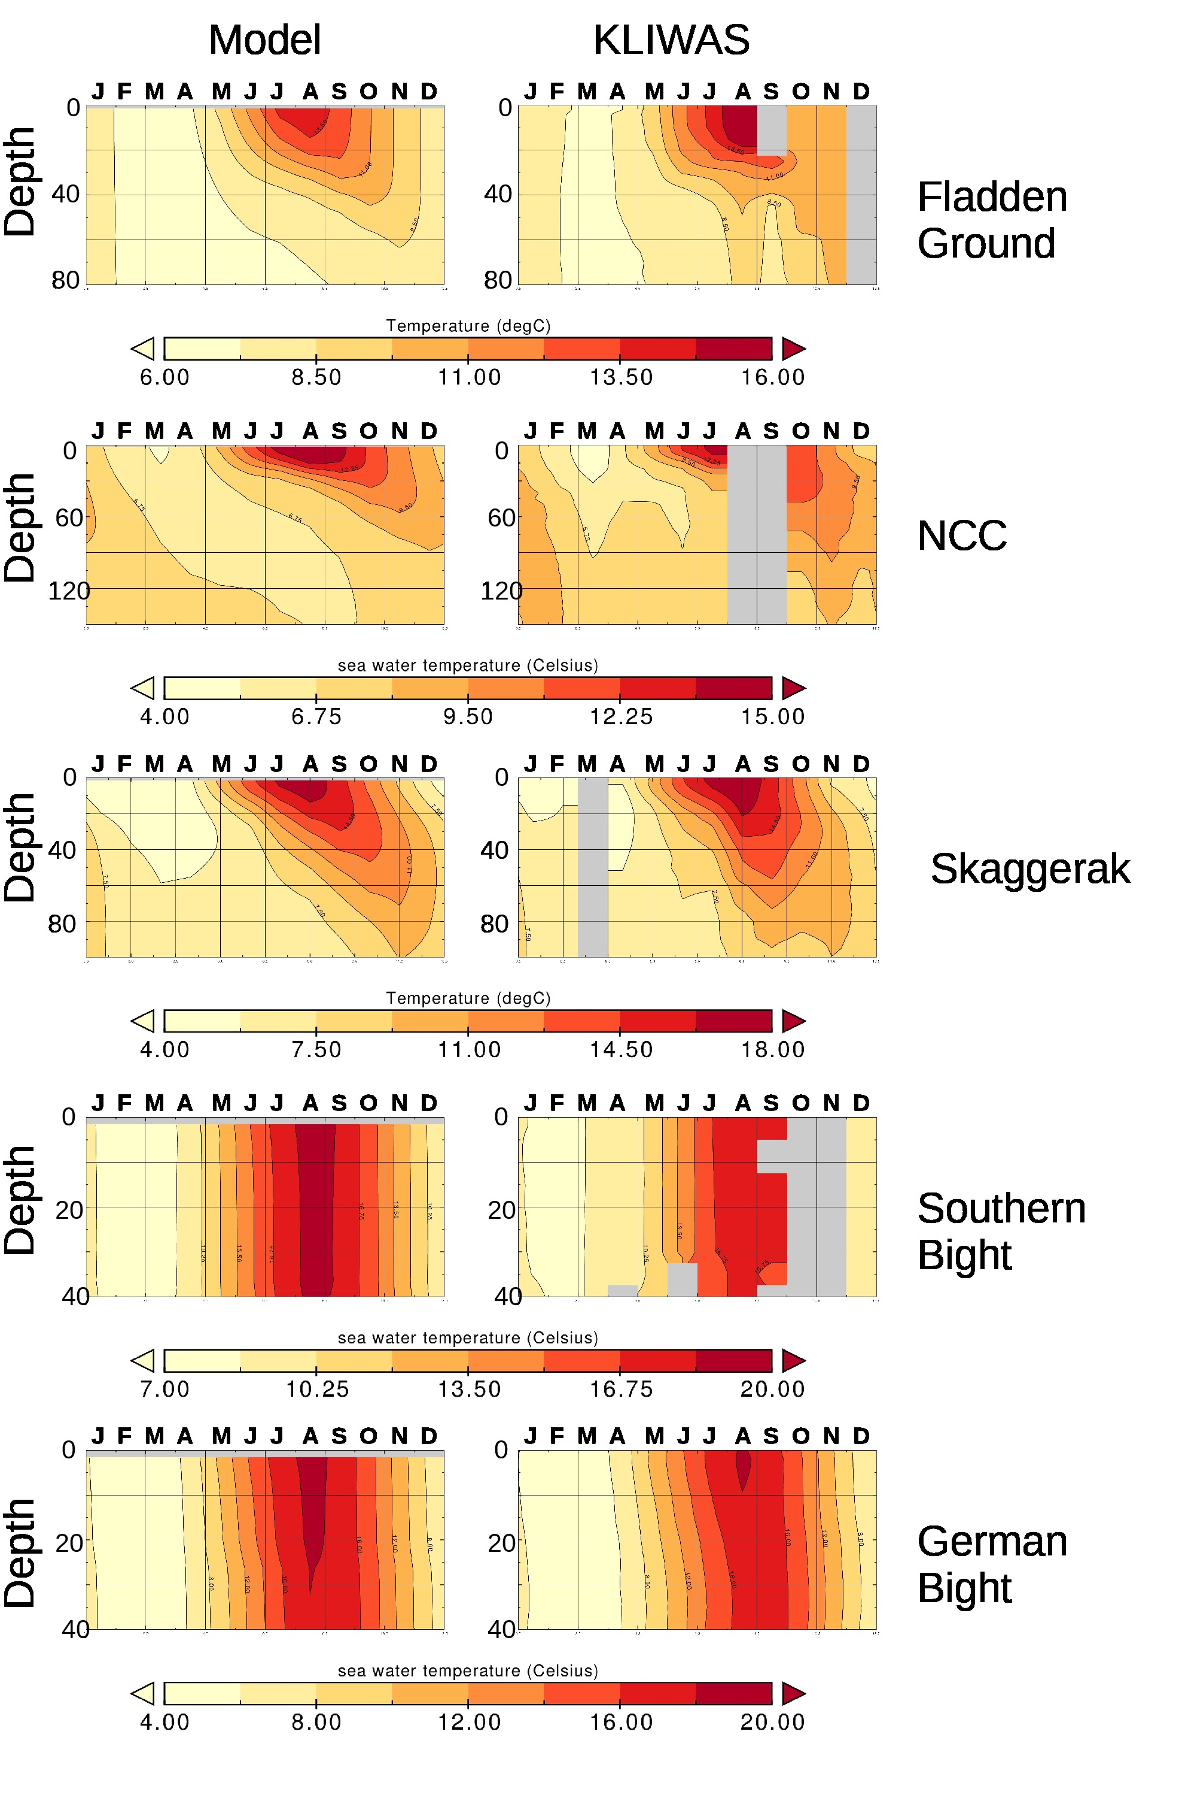Figure 2a:Seasonal cycle of water temperature as simulated (left hand) and from observations from the KLIWAS climatology (Bersch et al. (2013). Shown is a multi-year average over 1990-2009. Months where not sufficient data were available to calculate the seasonal cycle are left grey.
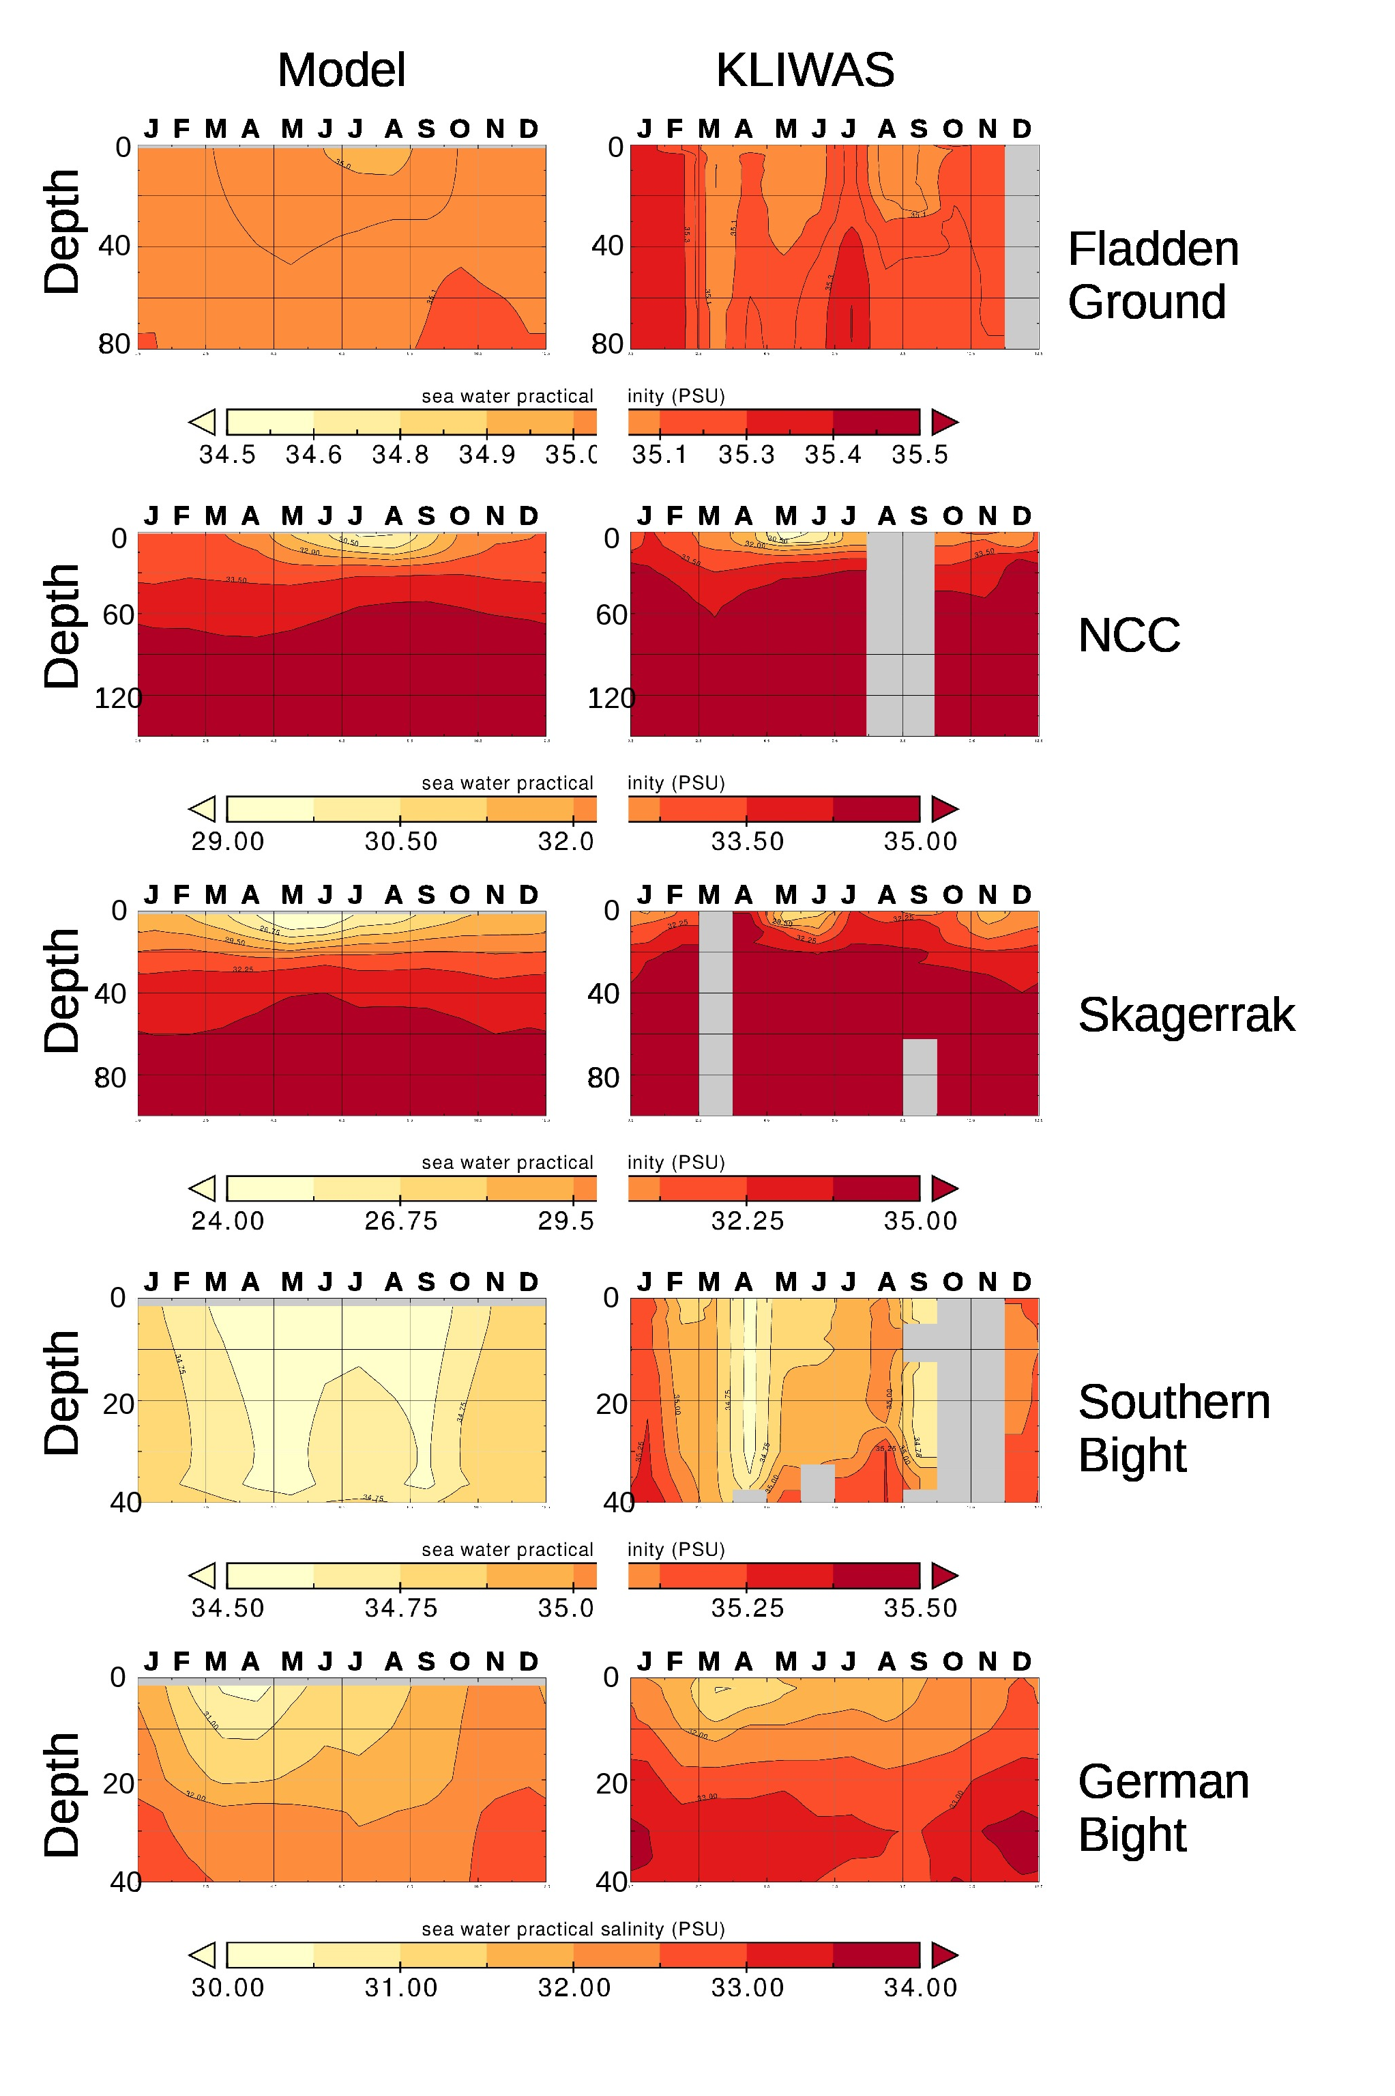Figure 2b:Seasonal cycle of water salinity as simulated (left hand) and from observations from the KLIWAS climatology (Bersch et al. (2013). Shown is a multi-year average over 1990-2009. Months where not sufficient data were available to calculate the seasonal cycle are left grey.

So far it was shown the model reproduces the seasonal dynamics in different hydrographic settings fairly well. For climate applications the models ability to reproduce interannual variability is essential because this measures the models skills to respond to large-scale atmospheric variations like for example the North Atlantic/Arctic Oscillation etc. In order to get a more quantitative measure of the modells skill to represent the climatological long term average and interannual variablity we follow earlier approaches and subdivide the North Sea in 1x1 degree boxes (e.g. Moll and Raddach, 2003; Grosse and Moll, 2011, Gröger et al., 2013, Hordoir et al., 2019). Furthermore, both observations and model data were interpolated at the same vertical standard levels. For each box the mean and standard deviation, and the root mean squared error were calculated. We here focus on January and July climatologies to represent winter and summer conditions which span almost the amplitude of the seasonal cycle and for which data are most abundant. The results are summarized in Fig. 3 and Table 2.

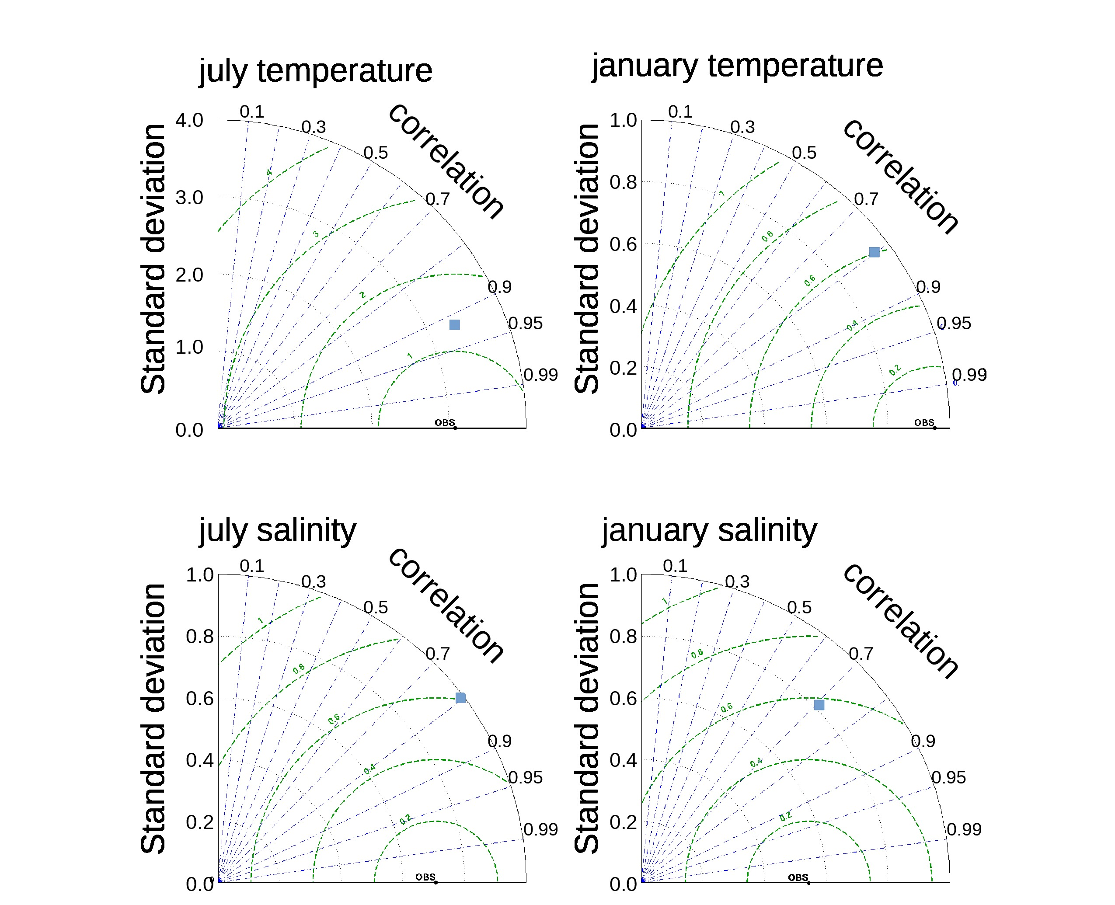Figure 3: Taylor diagram summarizing the models skill in reproducing interannual 3 D in situ observations between 1990-2011. Exact value of the Taylor statistics can be depicted from Table 2.
For summer the relatively high temperature bias (expressed as RMS, table 2) of 1.36 ºC points mainly to the northernmost North Sea which is influenced by the prescribed lateral boundary condition as well as to the near coastal regions where the model has problems to repruduce the seasonal maximum temperature (see above). Interannual spread (inferred from standard deviation) and variability (expressed by correlation coefficients) compare quite well with observations which is important for climate studies. The same is true for winter temperature where also the bias (0.60 K) is substantially lower compared to summer (1.36 K).
 | RMS | CORR | STD model | STD Kliwas. | N
Summer (July)
Temperature | 1.36 | 0.91 | 3.33 | 3.08 | 5847
Salinity | 0.60 | 0.80 | 0.99 | 0.71 | 5696
Winter (January)
Temperature | 0.60 | 0.79 | 0.93 | 0.95 | 6179
Salinity | 0.58 | 0.70 | 0.82 | 0.54 | 6084
Table 2: Comparison of water temperature and salinity depicted by root mean squared error (RMS), standard deviation, and correlation between the model and the KLIWAS data for the period 1990-2011 for the whole North Sea domain. N indicates the number of available observations for each parameters of which about 20% are from the first 5 m. The remaining part is roughly equally distributed at depths down to the ~150 m.

With respect to salinity the same general conclusions can be drawn as for temperature. Summer standard deviation is well reproduced between the model (0.99) and observation (0.71) while during winter interannual spread is a bit overestimated by the model (0.82 vs 0.54, table 1). Correlation coefficients are between 0.7 and 0.8 for salinity and indicate that the interannual variability is captured well.

Circulation and salinity
The long term mean surface circulation (Fig. 4a) shows the well known cyclonic circulation for the North Sea which is responsible for the large scale salinity gradients in this area. The western part of the northern North Sea is dominated by inflowing high salinity waters from the North Atlantic while the eastern part is dominated by fresher waters from the Baltic Sea. This builds up the steep east - west salinity gradients as shown in Fig. 4a. The exchange of water with the Atlantic is however substantially lower compared to other models. This is reflected in the barotropic stream function which yields a maximal value in the eastern northernmost North Sea of 0.6 Sv which is low compared to published values of ~0.9 – 1.2 Sv (e.g. Schrum et al., 2001, Hordoir et al., 2019, Pätsch et al., 2017). The weak circulation along the northern boundary is a consequence of the formulation of lateral boundary conditions where the barotropic transports are neglected at inflow is largely controlled by sea level variations as outlined in the main article (section 2.1). To demonstrate this, we performed a second hindcast (=HindBaro) run where the barotropic transports are accouned for at the northern boundary. This run yields a baratotropic streamfunction of 1.1. Sv which is in well agrement with observations and demonstrates that the internal solution of hydrodynamics is well in the model. This is also reflected in the water exchange across the Straight of Dover and with the Baltic sea which is well in both hindcasts: Inflow of water across the Strait of Dover is 0.13 (HindBaro) and 0.16 Sv and the inflow from the Baltic amounts to 0.020 and 0.021 Sv. However, due to the too weak circulation in the northern North Sea we decided to exclude the North Sea from the interpretation in this study and focus the main article on the Baltic Sea, Kattegat, and Skagerrak regions.

This leads to slightly reduced salinities along the flow path of Atlantic waters in the northern North Sea. Inflow through the Strait of Dover into the North Sea amounts to 0.16 Sv which in the range of observed values (Otto et al., 1990; Thomas et al., 2005).
The North Sea further receives fresher waters from Baltic Sea. The net transport amounts to 0.02 Sv which is in good range with published studies (e.g. 0.016 Sv, Thomas et al. 2005). These waters further flow along the Norwegian Coastal Current and leave the North Sea to the North Atlantic. The result of this general cyclonic circulation is the the strong E-W salinity gradient which is well reproduced by the model (Fig. 4a).

The transition to the Baltic Sea

The Skagerrak and Kattegat constitute the transition to the Baltic Sea. Figure 4c shows the general circulation and the corresponding salinity in this region. The predominant feature in the Skagerrak is a cyclonic circulation that is fed by southeastward flow along the Norwegian coast and northeastward flow along the Danish coast. The larger part of this water recirculates and mixes with fresher northwestward flowing waters from the Kattegat. This complex circulation pattern maintains salinity gradients of up to 9 g/kg within very small spatial scales (Fig. 4c). Fig. 2b reveals similar seasonal dynamics at the Skagerrak station and likewise strong vertical salinity gradients as described previously for the station in the NCC (Fig. 2b). The seasonal cycle weakens with depth and is strongest in the upper 10 m of the water column. A spring/early summer minimum in salinity during May-June is well reproduced by the model whereas the weak second minimum in November is absent in the model. Strongest vertical gradients during summer (Fig. 2b) occur slightly to deep in the model (20m) compared to the KLIWAS climatology (10 m). With respect to temperature the same characteristics are seen as for the NCC station and modelled data compare fairly well with the KLIWAS climatology (Fig. 2a).

The seasonal cycle in the Kattegat can be inferred from station Anholt (Fig. 5). The station shows a pronounced haline stratification with only weak seasonality (Fig. 5b). The salinity minimum is found at the end of April early May which can be seen in both the model and Shark data. Below ~20 m the model is clearly to fresh compared to the observations. The dynamics of the thermal stratification is reproduced very well (Fig. 5a). During spring the water column stabilizes more and more leading to a temperature maximum in early August. Below 20 m the model is slightly too warm while at the surface the models maximum temperature is a bit colder. This could indicate too much mixing in the the model

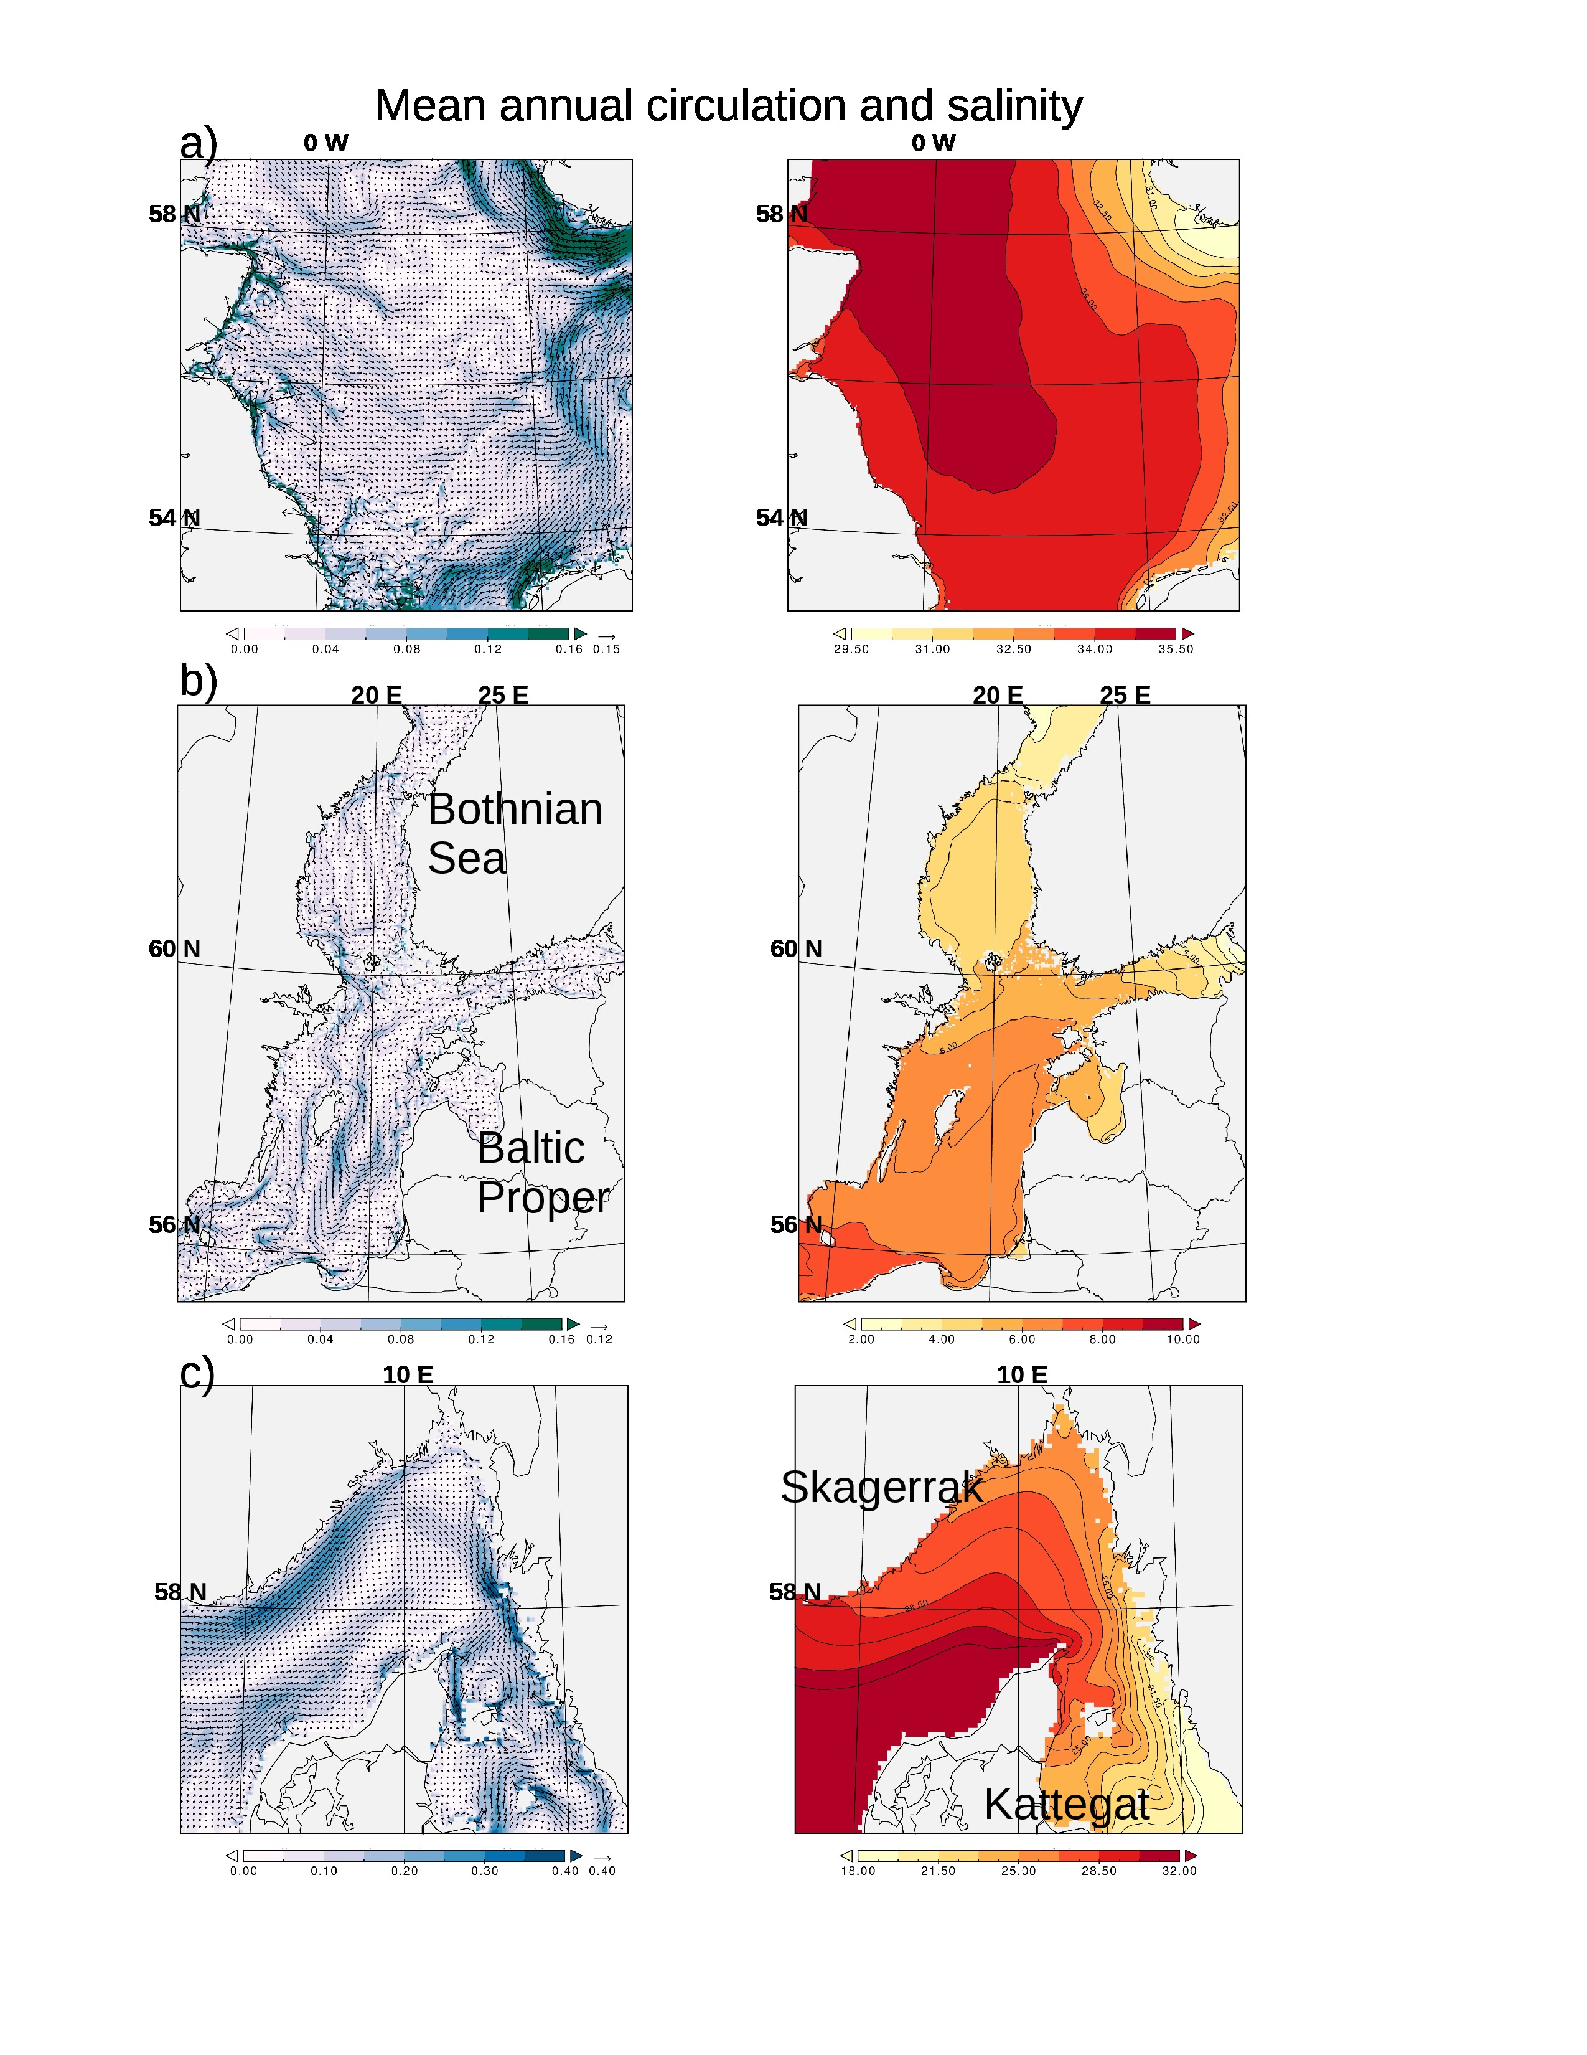Figure 4: Annual mean surface circulation (left, m/s) and salinity (g/kg, right) averaged over the years 1990 to 2011. c) North Sea, b) Baltic Sea, c) transition zone.

Baltic Sea

Figure 6a compares the modelled winter and summer SST with the satellite data from the BSH. Overall, during summer the model is colder compared to the satellite based estimate. In both data sets the warmest regions are shallow areas along the southern coast and small marginal bights like the eastern Gulf of Finland or the Bay of Riga. North of 60º SST above 15º C are virtually absent. Likewise in winter modelled SSTs are slightly colder than the satellite derived estimate. The general spatial pattern, however, agree well between the data sets. Generally, deviations are subtantially lower during the cold seasons winter and spring where the RMS is by far lower (winter=0.33 and spring=0.37, table 1) than during the warm seasons (summer=0.91 and autumn=0.61, table 1). The magnitude of spatial variability as expressed as standard deviation agrees likewise well (table 1). Only the for the winter season the observed standard deviation is by far lower than as revealed by the model (1.46 degree compared to 0.92). However, the low observed STD is likely caused by vast areas of missing data in the satellite derived data set in the Gulf of Bothian and Gulf of Finland (Fig. 6a) which limits spatial variability against very low SSTs.
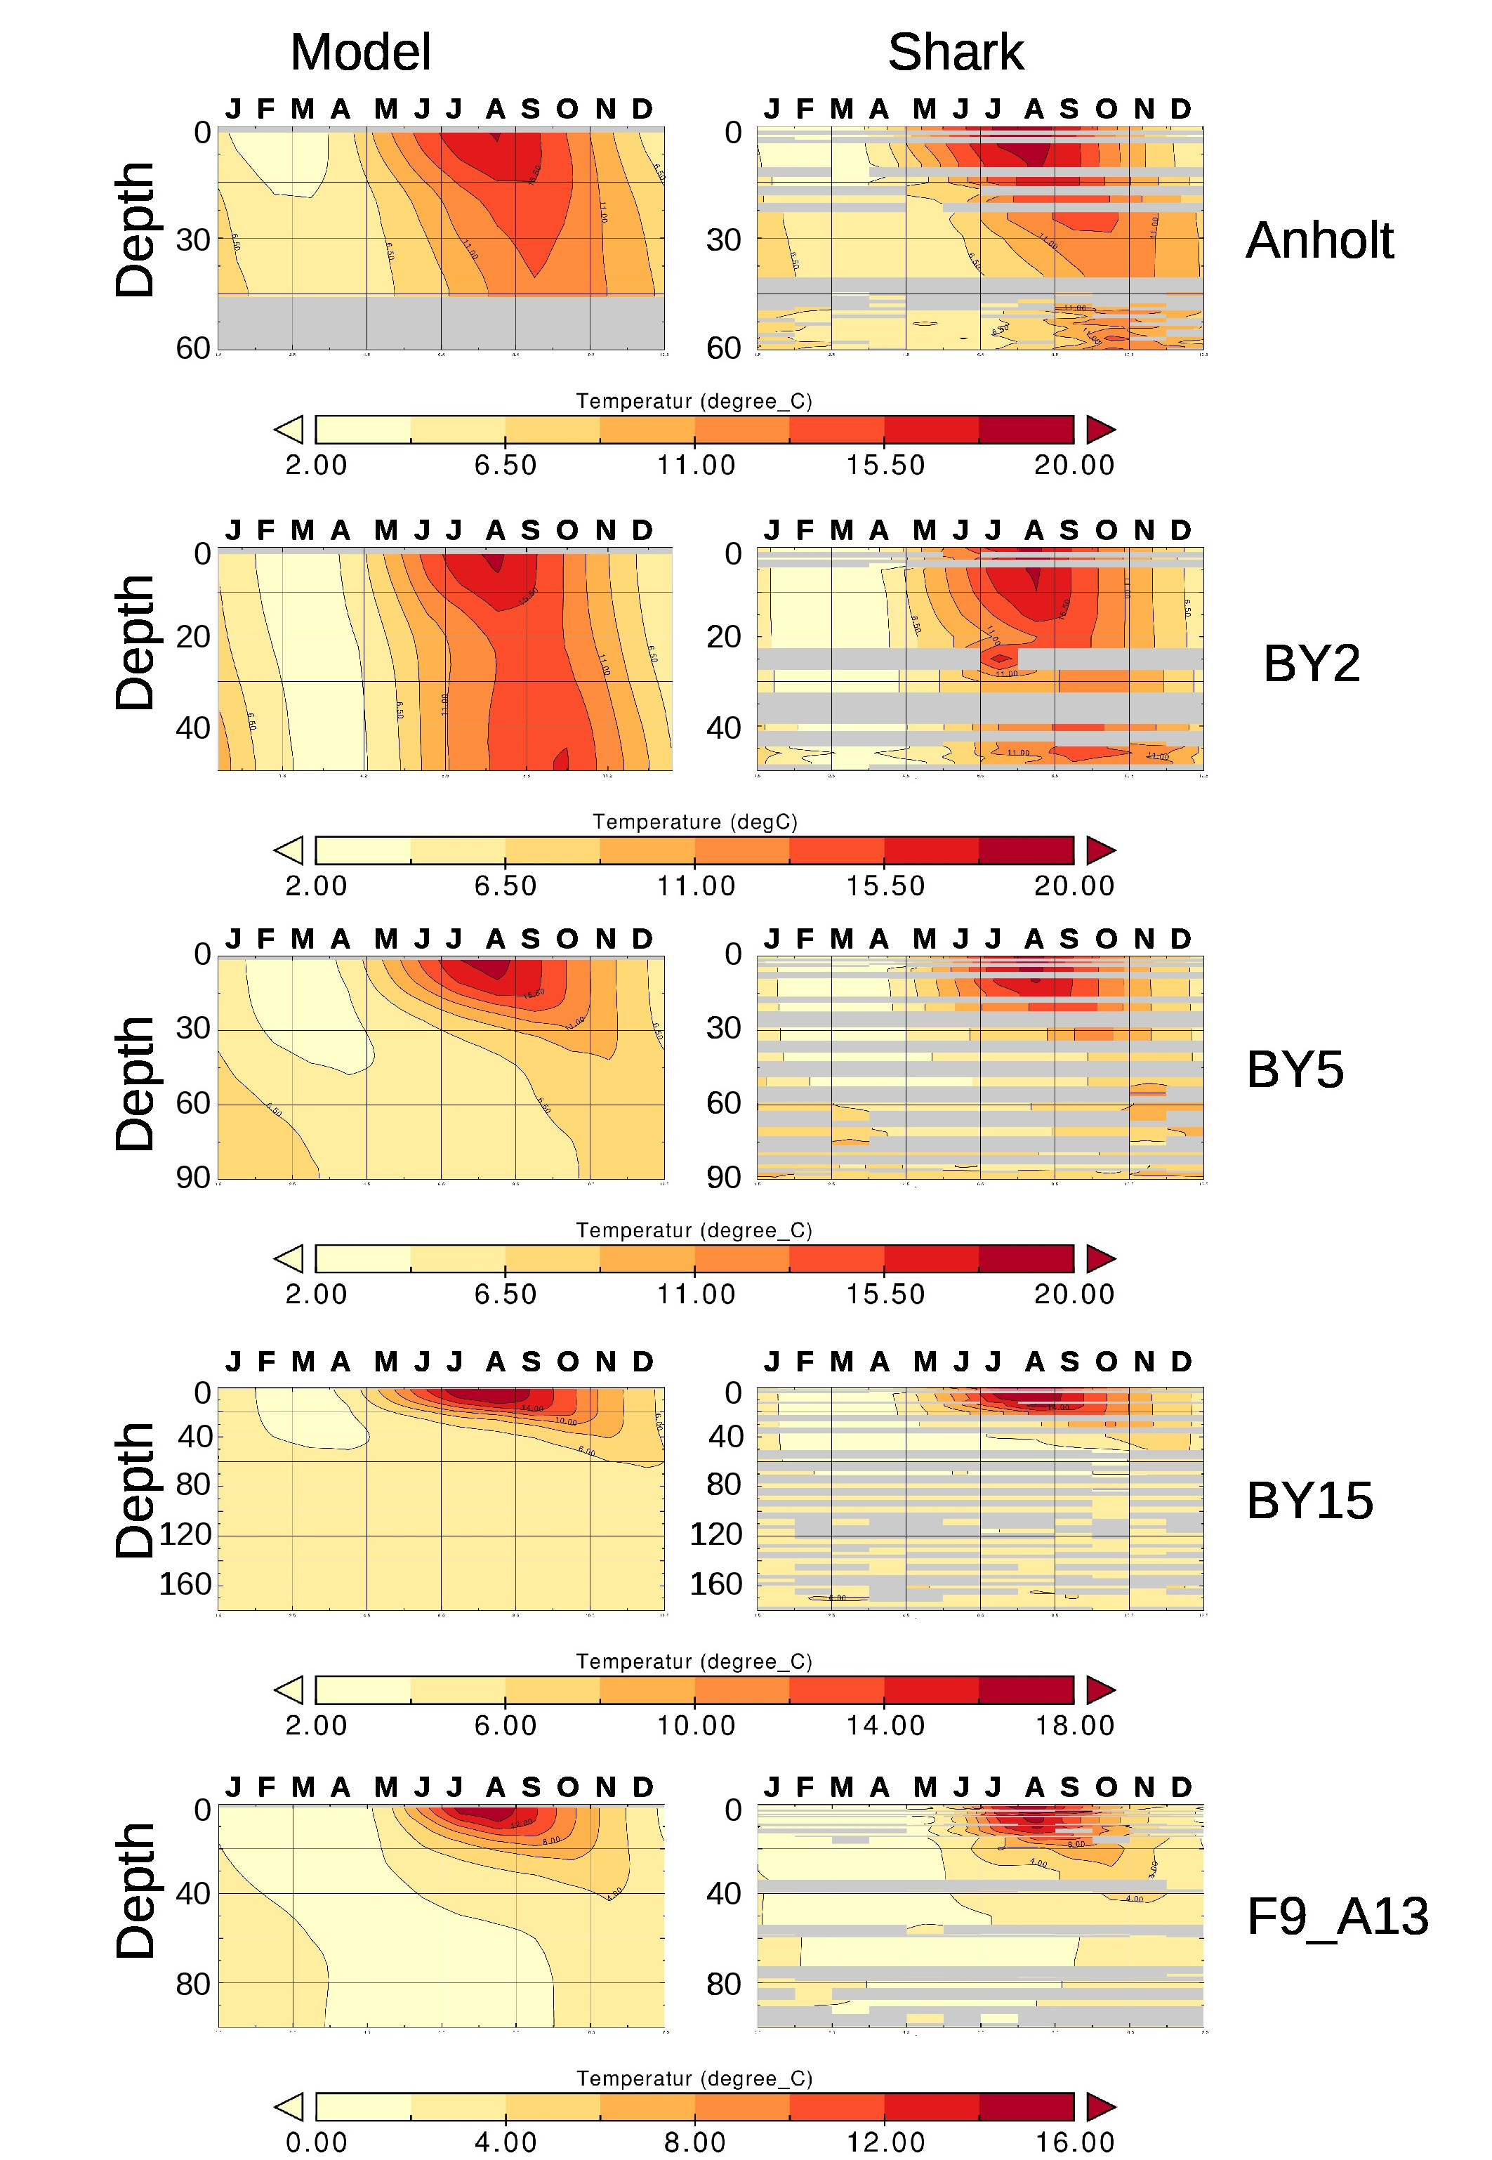Figure 5a: Seasonal cycle of water temperature as simulated (left hand) and from observations from the Shark climatology. Shown is a multi-year average over 1990-2009. Months where not sufficient data were available to calculate the seasonal cycle are left grey. For the position of the stations see Fig. 1 of the main article.

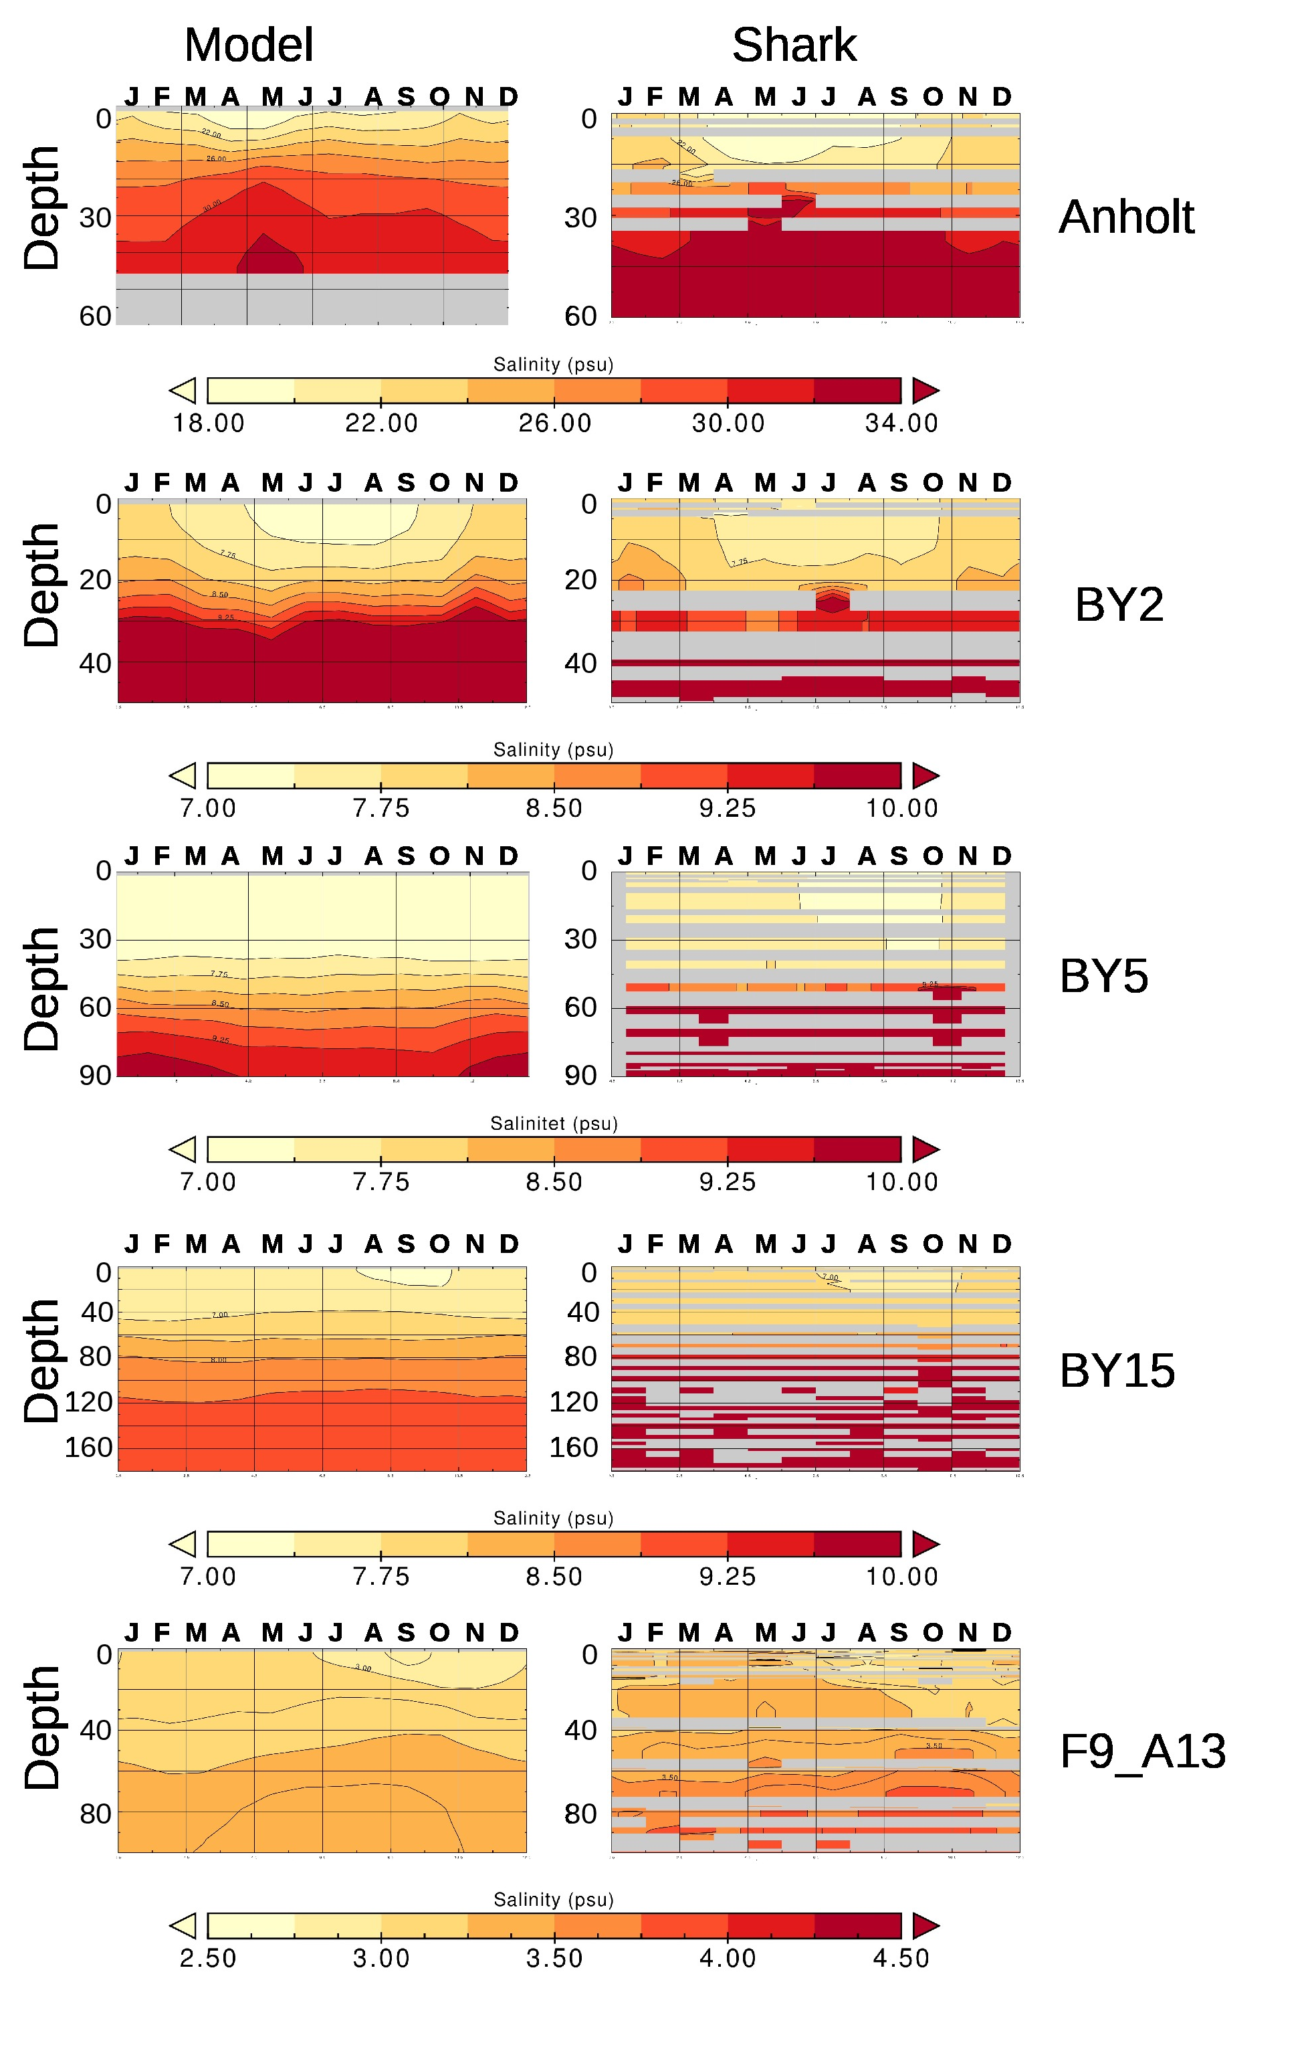Figure 5b: Seasonal cycle of water salinity as simulated (left hand) and from observations from the Shark climatology. Shown is a multi-year average over 1990-2009. Months where not sufficient data were available to calculate the seasonal cycle are left grey. For the position of the stations see Fig. 1 of the main article.
Figure 6b assesses the correlation through time with respect to interanual variability for the summer and winter season. Contrary to the North Sea, the strong halocline in the Baltic prevents this sea from getting mixed to the bottom in winter. This makes the Baltic sensitive to the local meteorological forcing also in more open environments. As a result, high correlation coefficients between the modelled and satellite SSTs are revealed for the whole Baltic (Fig. 6b). Also during summer correlations are higher than 0.6 for most open sea regions. Lower correlation is seen along the southern and eastern coasts.

In the following we use in situ data to analyze the long term mean seasonal cycle for temperature and salinity. For this we employ station data derived from the Svenskt HavsARKiv (SHARK, https://sharkweb.smhi.se/).
Figure 5a,b shows different stations along a path from southwest (Anholt) to the northeast of the Baltic Sea (F9_A13). Along this pathway both the model and the observational data reflect the freshening and cooling trend toward the northernmost station.
Station BY2 is located in the Arkona Basin (see Fig. 1 in the main article). BY2 is characterized by a haline stratification which in the near surface layers is marked by a weak seasonality that is slightly more pronounced in the model than in the observations. Below 30 m the model salinities are slightly too high and indicate a too strong influence of North Sea waters while in the upper layers modelled salinties are bit lower during the warm season. Station BY5 is located further east in the Bornholm Basin. In contrast to station BY2 further west, at BY5 salinities in the deeper layers are lower than the Shark data which could indicate that the eastward flow of deeper saline water is too weak in the model. Haline seasonality is very weak at BY5. The trend of too low deep salinity is seen also in the stations further east (BY15) and north (F9_A13, Fig. 5b). At station BY15 the halocline at around 80 m is weaker than in the observations which is probably the result of too weak inflow of saline bottom waters. Salinities in the northernmost station in the Bothnian Bay are lower in the second half of the year which is well reproduced by the model. In the model the minimum salinity is reached in the late summer when sea ice is absent.

Figure 5a displays the temperature seasonal cycle at the selected Baltic Sea stations. Stations Anholt (Kattegat) and BY2 (Arkona basin) reflect over most of the year homogenous temperature profiles. Only during June, July and August a weak thermal stratification develops. Further east at stations BY5 (Bornholm Basin) and BY15 (Baltic proper) the transition to fully pronounced thermal stratification during summer has been executed with a strong thermocline at around 20 m depth. At BY15 stratification already starts at the end of April / early May. The transition from calm summer conditions to the beginning storm season in autumn leaves its imprint in the vertical temperature structure: the temperature maximum at 30 m depth is clear delayed by two months compared to the maximum at the surface. This reflects strengthening wind induced mixing of warm thermocline waters with deeper layers in the beginning autumn. These processes can be well recognized in both the model and observational data. Also in the Bothnian Bay at station F9_A13 a thermal stratification develops in summer the same dynamics is recognized.

Figure 4b displays the models long term mean circulation in the Baltic Sea together with the surface salinity. Overall, the circulation shows a cyclonic pattern in the Baltic proper and further north in the Bothnian Sea. Compared to the North Sea, the Baltic Sea has a more homogenous salinity pattern and strongest gradients are located near topographic structures that divide the Baltic into different sub-basins (see also Fig. 1 in the main article). However, also in the Baltic Sea the general cyclonic circulation promotes weak west-east salinity gradients with fresher waters arriving from the North at the western boundary and more saline water flowing to the North at the eastern boundary (Fig. 4b). Inter-basinal water exchange like between the Baltic Proper and the Bothnian Sea is restricted by topographic barriers.

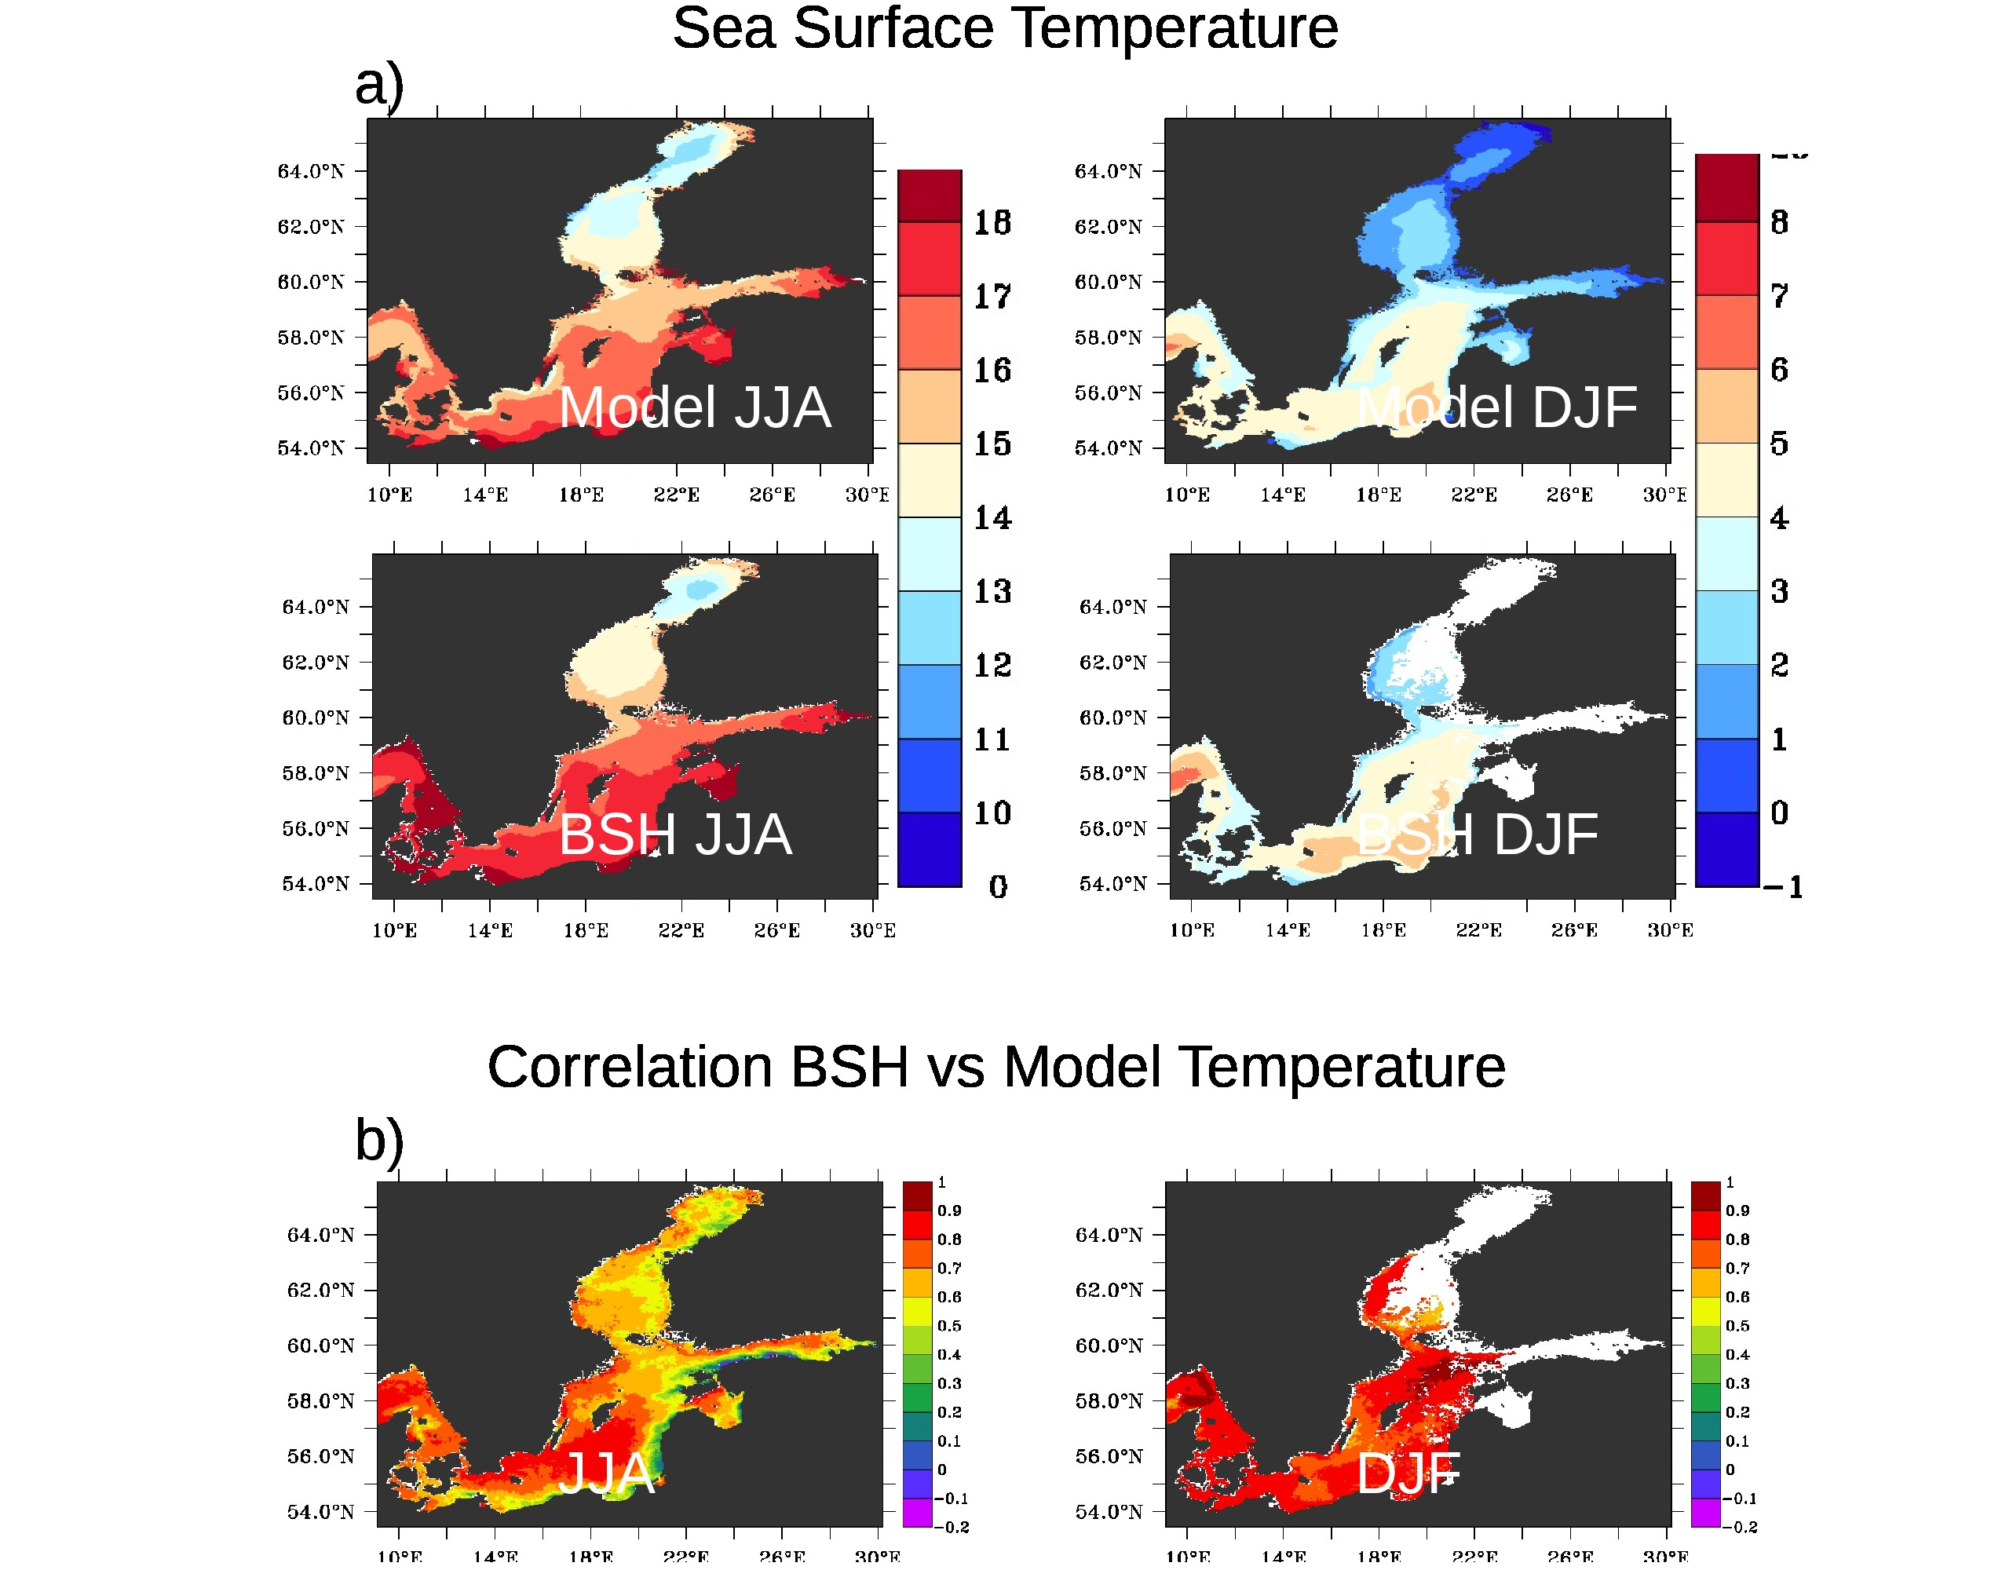Figure 6: ) a) Comparison between modelled (top) and a satellite based (bottom) multi-year (1990-2009) averaged SST from the Federal Maritime and Hydrographic Agency (BSH), Germany. b) Interannual (1990-2009) correlation between the two data sets for the the summer season (left) and winter season (right). Areas for which no satellite data is available are marked white.

Assessment of stratification by comparison with gridded data products from the World Ocean Atlas (WOA).
In order to assess the models ability to realistically simulate patterns of water column stability we employ 3D temperature and salinity data from the World Ocean Atlas (WOA, Concright et al., 2002). The WOA provides compiled data sets from different sources on a 3D grid with 1 degree resolution and interpolated on 33 vertical levels. In the following this data is used to assess the water column stability. Due to the coarse resolution of the data set it is certainly not optimal in use for regional seas. Therefore we do not calculate common diagnostic parameters like mixed layer depth or the exact depth of the pycnocline. We rather follow here an approach to calculate the potential energy anomaly (PEA, e.g. Simson and Bowers, 1981; Holt et al., 2012). This gives a bulk quantity of the energy necessary to homogenize the water column normalized by depth and is therefore independent of small scale features like the thermocline or the pycnocline.

Figure 7 compares the seasonal cycle of PEA between the model and the observational data. In the North Sea highest values are seen over the whole year along the NCC. In the WOA data set this region is not so extended as in the model. However, this may be related to the coarser resolution of the WOA data which may have biases in regions with steep topographical gradients. Most pronounced differences are displayed for the transitional seasons spring and autumn in the northern North Sea where the onset of seasonal stratification (spring) and onset of wind mixing (autumn) is delayed in comparison with WOA data. The southern North Sea is in both data sets well mixed all over the year. In the Baltic Sea the Baltic Proper exhibits highest values in all seasons but modelled PEA is in most regions slightly lower than in the WOA data set. The Bothnian Sea and Bothnian Bay are less stratified in the two data sets indicating more brackish conditions there without strong vertical density differences in this region. The seasonal cycle however compares well in most regions.

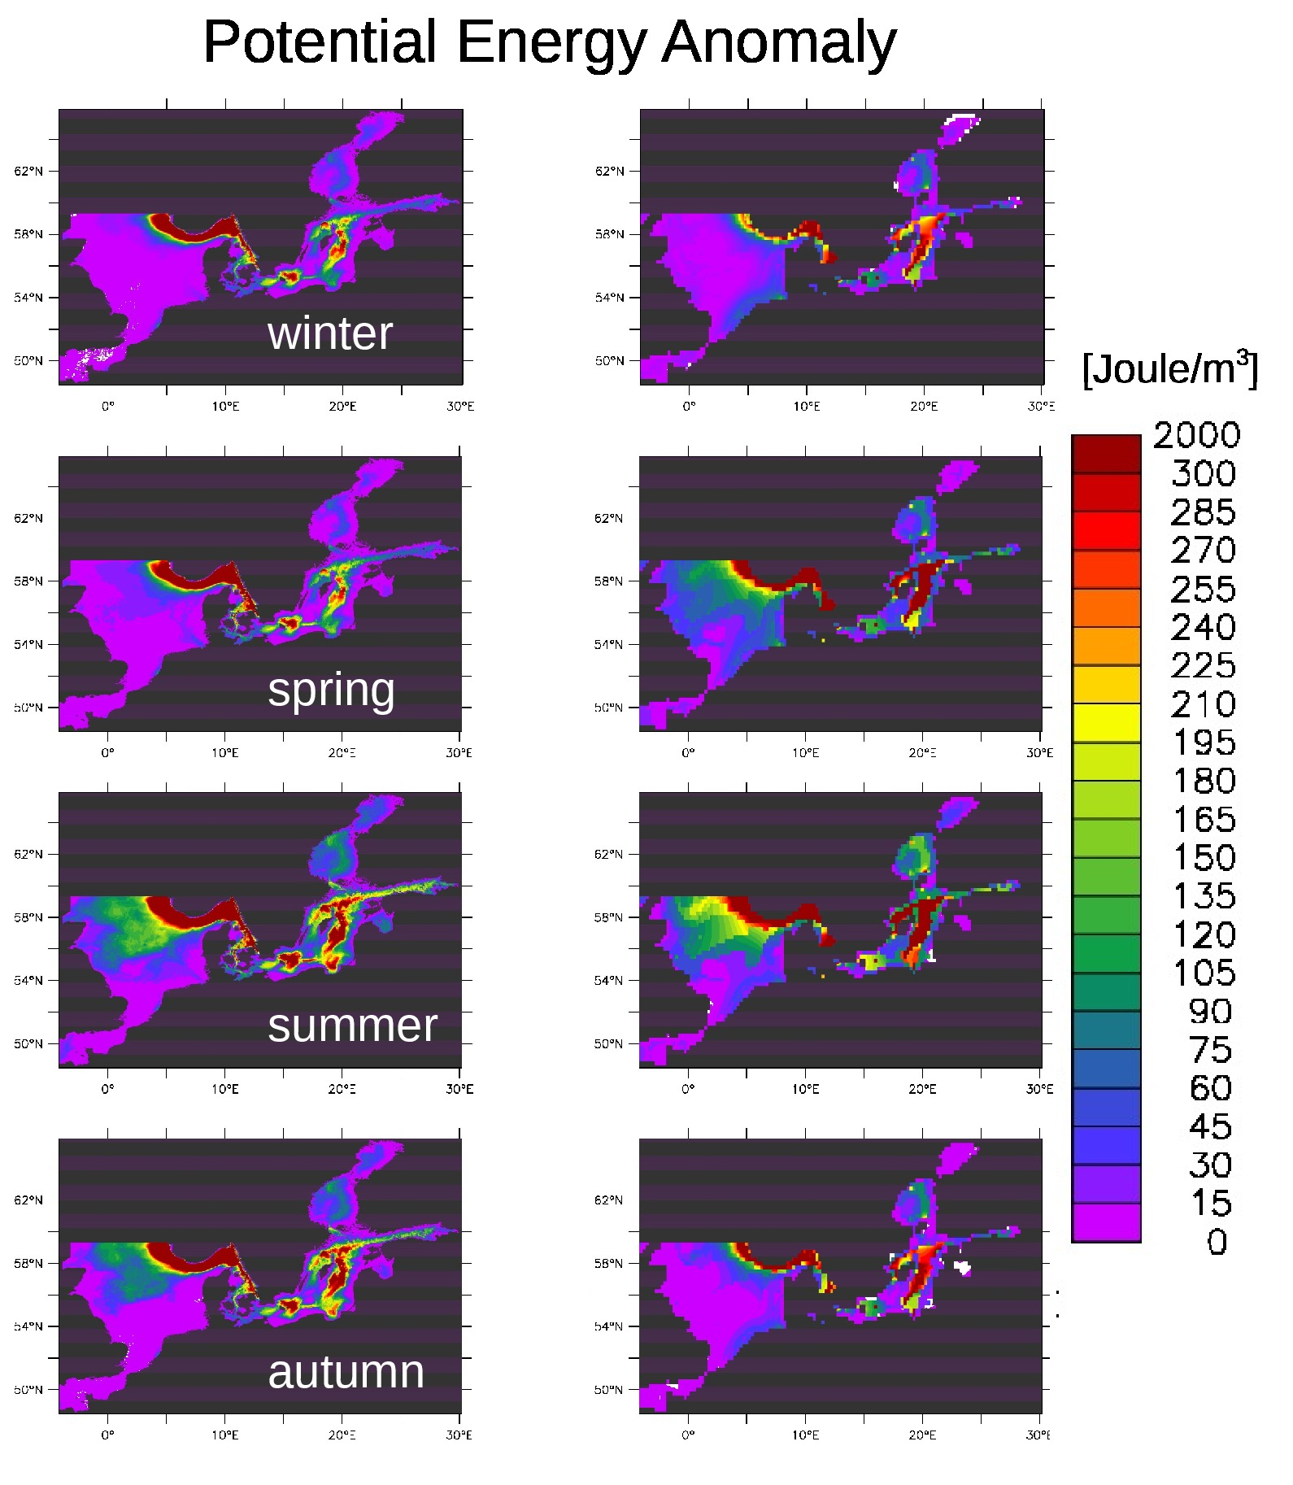Figure 7: Comparison of potential energy anomaly between model (left) and data from the World Ocean Atlas (right)

Sea ice
It is beyond the purpose of this paper to provide a detailed validation of sea ice in particular as the focus is mainly on summer hydrographic changes. However, in the Bothnian Sea and Gulf of Finland sea ice may play a significant role and leave a hydrographic imprint in the water column that may influence also summer water properties. Figure 8a and 8b show the maximal monthly mean sea ice fraction averaged over the periods 1970-1989 and 1990-2009. In Figure 9c we compare the total area covered by sea ice with satellite data from the Swedish Meteorological and Hydrological Institute (available under https://www.smhi.se/klimatdata/oceanografi/havsis). Unfortunately, the model ouput for sea ice fraction exists only as monthly mean data while the satellite data are calculated from a daily data basis. This is why in Figure 8 the model data are almost always lower than the satellite data. However, both data sets correlate very well (r=0.93) which indicates that interannual variability is covered quite well by the model. Furthermore, at around 1990 a shift to generally lower ice cover is seen. Also this is represented well in the model. Figures 9a and b indicate that the ice loss is primarily occurring in the open Bothnian Sea.
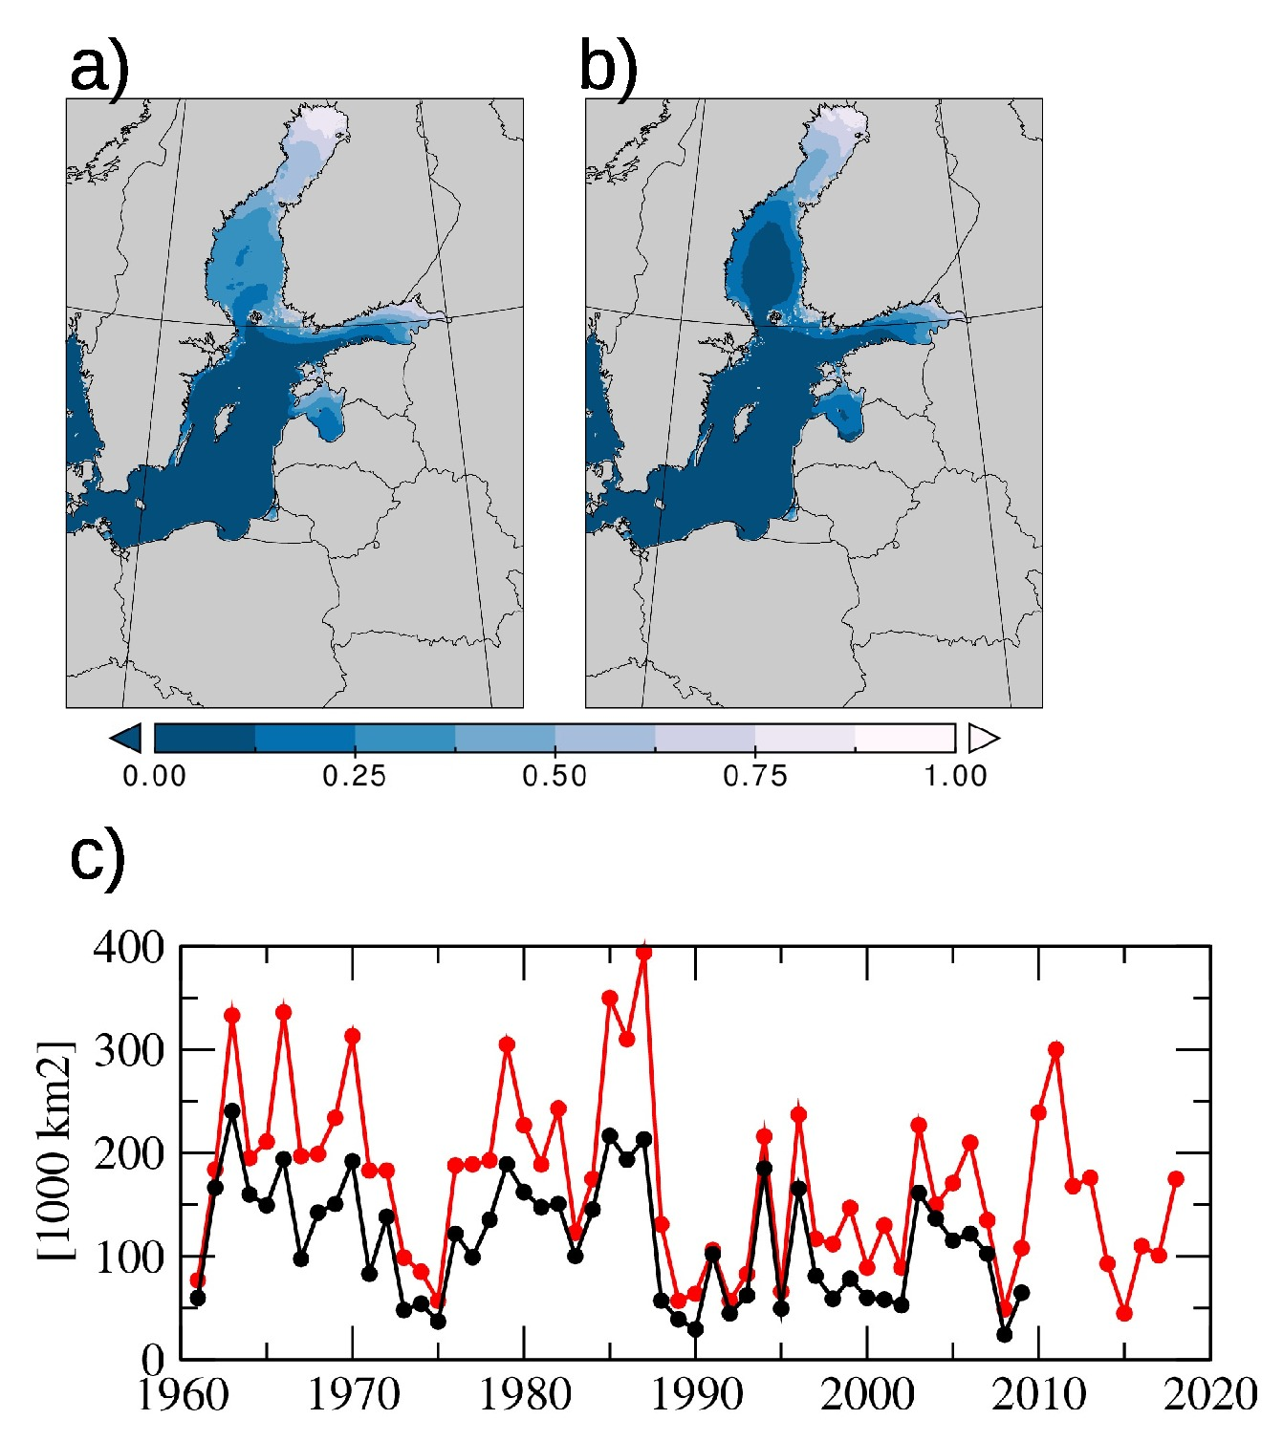Figure 8: a) Yearly monthly maximum grid cell area fraction covered by sea ice and averaged over the period 1970-1989. b) same as a) but averaged over the period 1990-2009). c) total area cover by sea ice where sea ice is denser that 15% per unit area. Red satellite data from the Swedish Meteorological and Hydrological Institute, black modelled. NOTE: satellite data are calculated from daily mean values while model data relate are calculated from monthly mean data. Therefore, model data reach in most cases not the level of the higher resolved satellite data.
References

Becker, G.A., Dick, S., and Dippner, J.W., 1992. Hydrography of the German Bight. Marine Ecology Progress series, 91, 9-18.

Bersch, Manfred; Gouretski, Viktor; Sadikni, Remon; Hinrichs, Iris; (2013): KLIWAS North Sea Climatology of Hydrographic Data (Version 1.0); World Data Center for Climate (WDCC). doi:10.1594/WDCC/KNSC_hyd_v1.0

Conkright, M.E., R. A. Locarnini, H.E. Garcia, T.D. O’Brien, T.P. Boyer, C. Stephens, J.I. Antonov,
2002: World Ocean Atlas 2001: Objective Analyses, Data Statistics, and Figures, CD-ROM Documentation. National Oceanographic Data Center, Silver Spring, MD, 17 pp.

Engedahl H (1995) Use of the flow relaxation scheme in a three-dimensional baroclinic ocean model with realistic topography. Tellus A 47(3):365–382, DOI 10.1034/j.1600-0870.1995.t01-2-00006.x

Gröger, M. , Maier-Reimer, E. , Mikolajewicz, U. , Moll, A. and Sein, D. (2013): NW European shelf under climate warming: implications for open ocean - shelf exchange, primary production, and carbon absorption , Biogeosciences, 10 (6), pp. 3767-3792 . doi: 10.5194/bg-10-3767-2013

Große, F. and Moll, A.: Validation tool for analyzing vertical profile data of one state variable (valpro1var) by comparison of merged observational data sets and their preparation – description and user guide, Technical Reports 01-2011, Institute of Oceanography, Hamburg, Germany, 83 pages, 2011

Holt, J.; Butenschön, M.; Wakelin, S.L.; Artioli, Y.; Allen, J.I.. 2012 Oceanic controls on the primary production of the northwest European continental shelf: model experiments under recent past conditions and a potential future scenario. Biogeosciences, 9 (1). 97-117.10.5194/bg-9-97-2012

Janssen F, Schrum C, Backhaus JO (1999) A Climatological Data Set of Temperature and Salinity for the Baltic Sea and the North Sea. Hydrographische Zeitschrift German Journal of Hydrography Supplement(9):245 pp

Moll, A. and Radach, G.: Review of three-dimensional ecological modelling related to the North Sea shelf system, part 1: models and their results (2003). Prog. Oceanogr., 57, 175–217, doi: 10.1016/s0079-6611(03)00067-3

Otto, L., Zimmerman, J., Furnes, G., Mork, M., Saetre, R., and Becker, G., 1990: Review of the physical oceanography of the North Sea, Neth. J. Sea Res., 26, 161–238, https://doi.org/10.1016/0077-7579(90)90091-T.

Pätsch, J., Burchard, H., Dieterich, C., Gräwe, U., Gröger, M., Mathis, M., Kapitza, H., Bersch, M., Moll, A., Pohlmann, T., Su, J., Ho-Hagemann, H. T., Schulz, A., Elizalde, A., and Eden, C.: An evaluation of the North Sea circulation in global and regional models relevant for ecosystem simulations, Ocean Model., 116, 70–95, 2017.

Simpson J. H. , Bowers D . Models of stratification and frontal movement in shelf seas. Deep-Sea Res. 1981; 28: 727–738.

Sein DV, Mikolajewicz U, Gröger M, Fast I, Cabos W, Pinto JG, Hagemann S, Semmler T, Jacob D (2015) Regionally coupled atmosphere - ocean - sea ice - marine biogeochemistry model ROM. Part I: Description and validation. Journal of Advances in Modeling Earth Systems 7(1):268–304, DOI 10.1002/2014MS000357

Sein, D.V., Gröger, M., Cabos, W., Alvarez, F., Hagemann, S., Pinto, J.G., Izquierdo, A., Koldunov, N.V.,Yu Dvornikov, A.Y., Limareva, N., Martinez, B., Jacob, D., 2019. Regionally coupled atmosphere - ocean - marine biogeochemistry model ROM: 2. Studying the climate change signal in the North Atlantic and Europe, ournal of Advances in Modeling Earth Systems, in revision.

Thomas, H., Bozec, Y., de Baar, H. J. W., Elkalay, K., Frankignoulle, M., Schiettecatte, L.-S., Kattner, G., and Borges, A. V.: The carbon budget of the North Sea, Biogeosciences, 2, 87–96, https://doi.org/10.5194/bg-2-87-2005, 2005.

