Supplementary Figure for

Observationally constrained projection of the reduced intensification of extreme climate events in Central Asia from 0.5 ℃ less global warming

Dongdong Peng ^{1, 2, 3}, Tianjun Zhou^{2, 3, 4}*, Lixia Zhang^{2, 4}, Wenxia Zhang², and Xiaolong Chen²
1 Institute of Tropical and Marine Meteorology, China Meteorological Administration, Guangzhou, China
2 LASG, Institute of Atmospheric Physics, Chinese Academy of Sciences, Beijing 100029, China
3 University of Chinese Academy of Sciences, Beijing 100049, China
4 CAS Center for Excellence in Tibetan Plateau Earth Sciences, Chinese Academy of Sciences (CAS), Beijing 100101, China.

Corresponding author:
Dr. Tianjun ZHOU
LASG, Institute of Atmospheric Physics, Chinese Academy of Sciences
Beijing 100029, China.
Phone: 86-10-8299-5279
Fax: 86-10-8299-5172
E-mail: zhoutj@lasg.iap.ac.cn
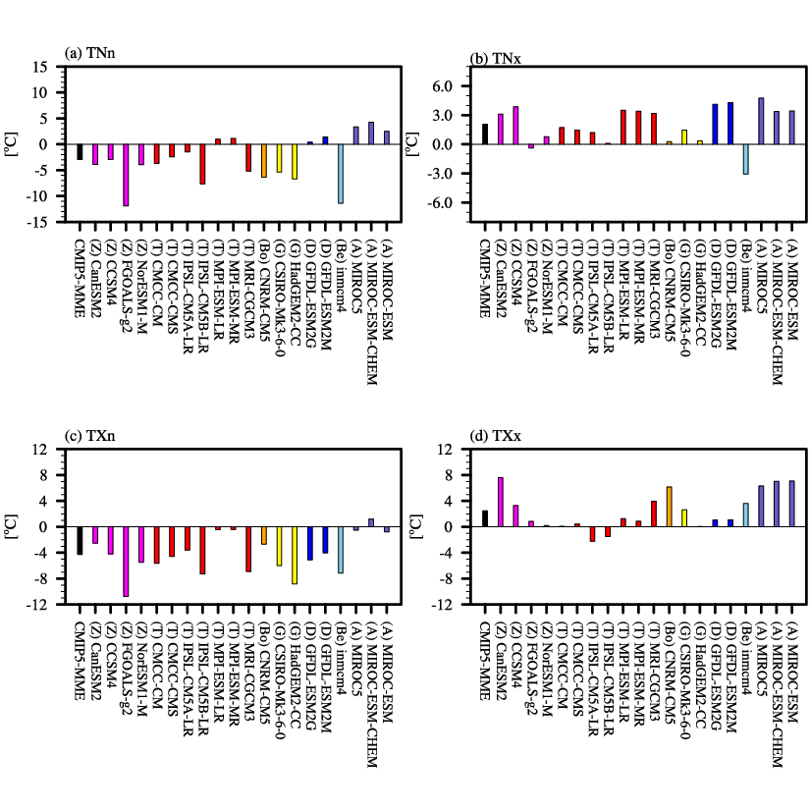
Figure S1. Regional averaged biases of extreme temperature indices (unit: ℃) over Central Asia for the CMIP5 models. (a) TNn; (b) TNx; (c) TXn; (d) TXx. “Z”, “T”, “Bo”, “G”, “D”, “Be”, and “A” in the parentheses denote the model-employed convective schemes utilized, as listed in Table 2.
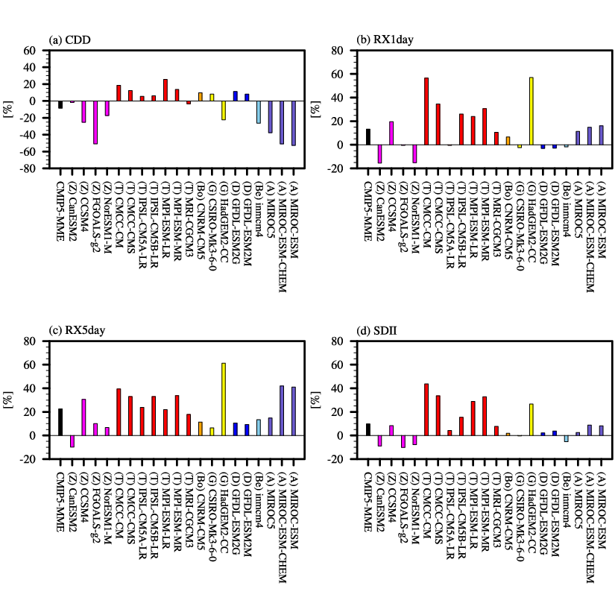
Figure S2. Same as Figure S1, but for the extreme precipitation indices (unit: %). (a) CDD; (b) RX1day; (c) RX5day; (d) SDII.

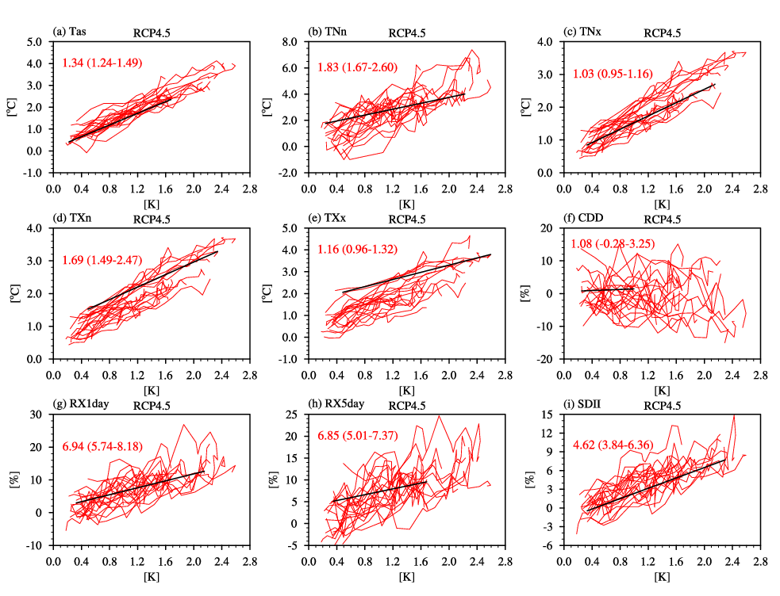
Figure S3. Responses of corrected extreme events averaged over Central Asia (vertical coordinates) to global near-surface air temperature changes (horizontal coordinates) under the RCP4.5 scenario. Projected changes are calculated over decadal periods starting in 2006, with an overlap of 5 years (i.e., 2006-2015, 2011-2020, up to 2081-2095). Each red line represents an individual model, and the black line denotes the linear fit of the median response. The red strings in the top left figure indicate the multimodel median scaling rates and the 25-75% uncertainties for the temperature (℃ K⁻¹) and precipitation (% K⁻¹) indices.
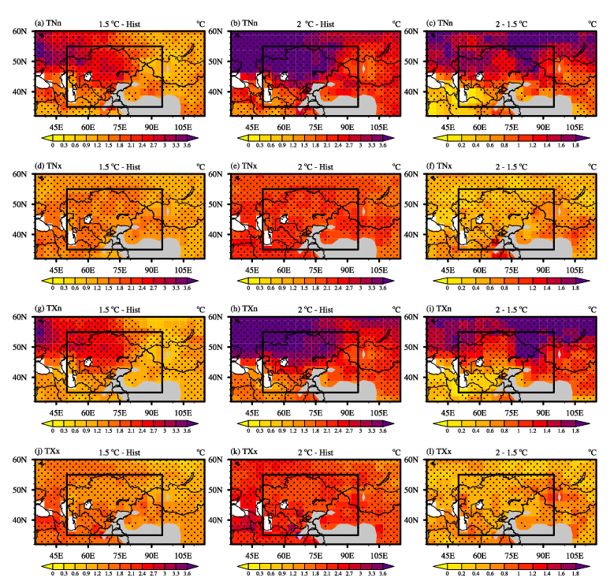
Figure S4. Spatial patterns for the changes in corrected extreme temperature indices (unit: ℃) in 1.5 and 2 ℃ warmer worlds from the CMIP5 MME under the RCP4.5 scenario (relative to the period 1986-2005). The left, middle, and right columns show the results in the 1.5 and 2 ℃ warmer worlds and the results due to an increase of 0.5 ℃, respectively. The rows, from top to bottom, denote TNn, TNx, TXn, and TXx. Dots indicate where more than 70% of the models agree on the sign of the changes (the same applies below).
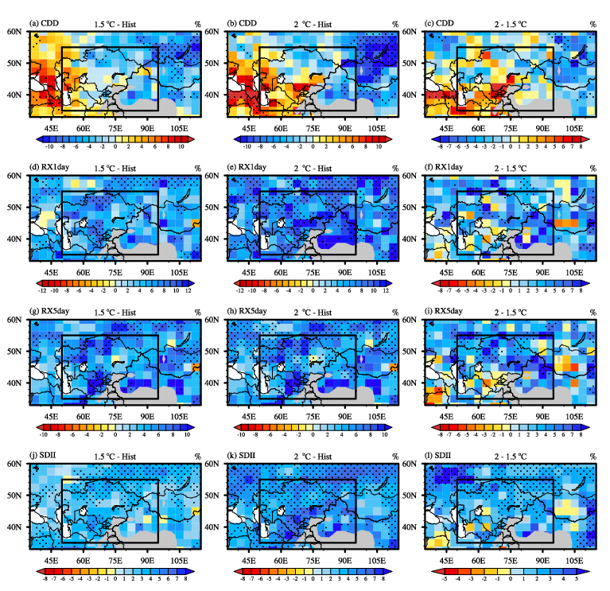
Figure S5. Spatial patterns for the changes in corrected extreme precipitation indices (unit: %) in 1.5 and 2 ℃ warmer worlds from the CMIP5 MME under the RCP4.5 scenario. The left, middle, and right columns show the results in 1.5 and 2 ℃ warmer worlds and the results due to an increase of 0.5 ℃, respectively. The rows, from top to bottom, denote CDD, RX1day, RX5day, and SDII.

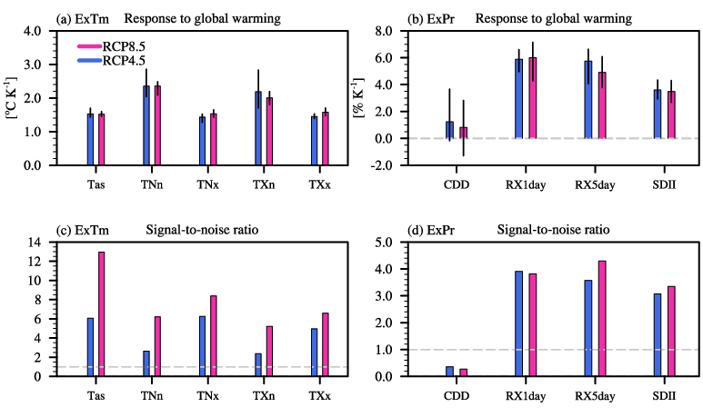
Figure S6. Response rates of the uncorrected extreme indices over Central Asia to the changes in global mean surface air temperature under the RCP4.5 (blue bars) and RCP8.5 (red bars) scenarios. (a) Temperature extreme indices (℃ K⁻¹). (b) Precipitation extreme indices (% K⁻¹). The multimodel ensemble medians and the 25-75% uncertainties are denoted by histograms and vertical black lines, respectively. (c) and (d) show the signal-to-noise ratios of the temperature and precipitation extremes, respectively.

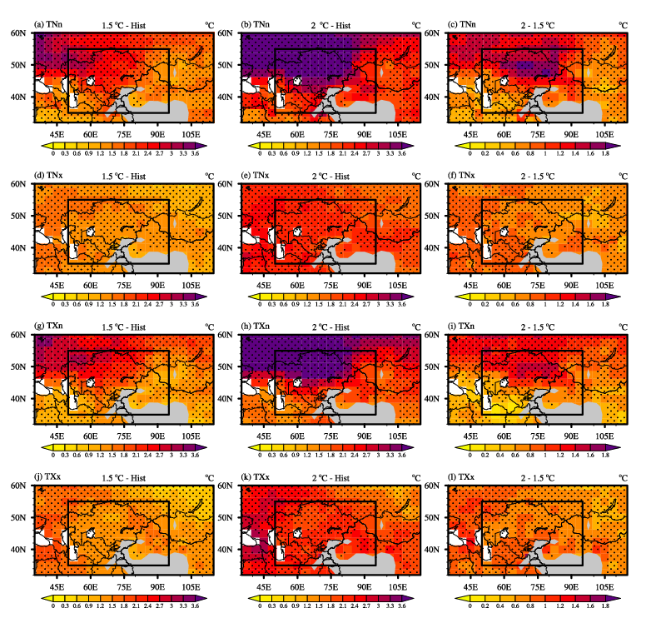
Figure S7. Spatial patterns for the changes in uncorrected extreme temperature indices (unit: ℃) in 1.5 and 2 ℃ warmer worlds from the CMIP5 MME under the RCP8.5 scenario (relative to the period 1986-2005). The left, middle, and right columns show the results in the 1.5 and 2 ℃ warmer worlds and the results due to an increase of 0.5 ℃, respectively. The rows, from top to bottom, denote TNn, TNx, TXn, and TXx. Dots indicate where more than 70% of the models agree on the sign of the changes (the same applies below).

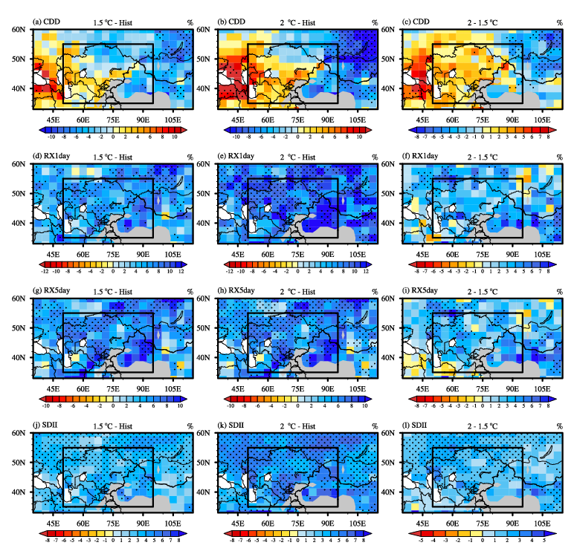
Figure S8. Spatial patterns for the changes in uncorrected extreme precipitation indices (unit: %) in 1.5 and 2 ℃ warmer worlds from the CMIP5 MME under the RCP8.5 scenario. The left, middle, and right columns show the results in 1.5 and 2 ℃ warmer worlds and the results due to an increase of 0.5 ℃, respectively. The rows, from top to bottom, denote CDD, RX1day, RX5day, and SDII.

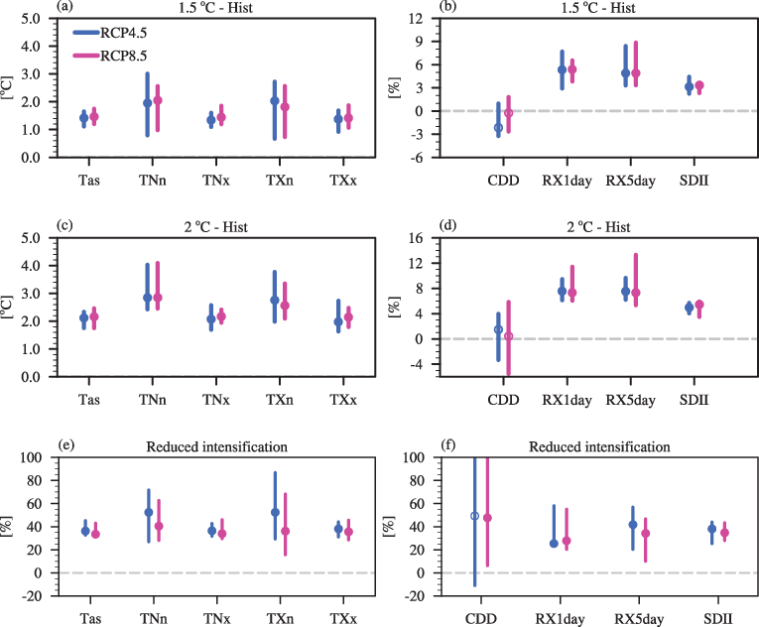
Figure S9. The changes in uncorrected extreme indices averaged over Central Asia in 1.5 and 2 ℃ warmer worlds under the RCP4.5 (blue bars) and RCP8.5 (red bars) scenarios. The left and right columns show the results for the extreme temperature (℃) and precipitation (%) indices. The top and middle rows indicate the results for 1.5 and 2 ℃ global warming, respectively. The bottom row indicates the avoided intensification from 0.5 ℃ less warming. The circles and bars indicate the multimodel medians and the 25-75% uncertainties, respectively. Solid (open) circles indicate that more (less) than 70% of the models agree on the sign of the changes.

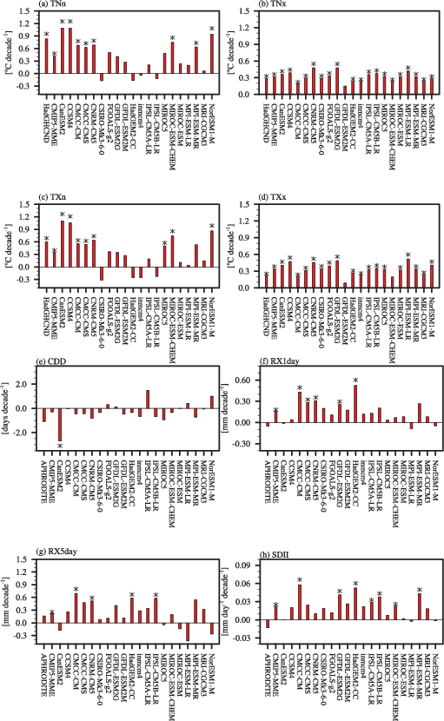
Figure S10. Trends of observed and model simulated extreme indices (uncorrected results) over Central Asia during 1961-2005. (a) TNn (℃ decade⁻¹); (b) TNx (℃ decade⁻¹); (c) TXn (℃ decade⁻¹); (d) TXx (℃ decade⁻¹); (e) CDD (days decade⁻¹); (f) RX1day (mm decade⁻¹); (g) RX5day (mm decade⁻¹); (h) SDII (mm day⁻¹ decade⁻¹). Stars indicate the trends are statistically significant at the 5% level (based on Student’s t-test).

