Supplemental Material for the article “Air-Sea interaction over the Gulf Stream in an ensemble of HighResMIP present climate simulations” by A. Bellucci et al.
This supplementary information contains 4 figures as referenced in the main manuscript. These figures provide a comparison of lead-lag SST (and SST tendency)-THF correlation (Fig. SM1-2) and covariance patterns (Fig. SM3-4) for the MPI-ESM model hierarchy.

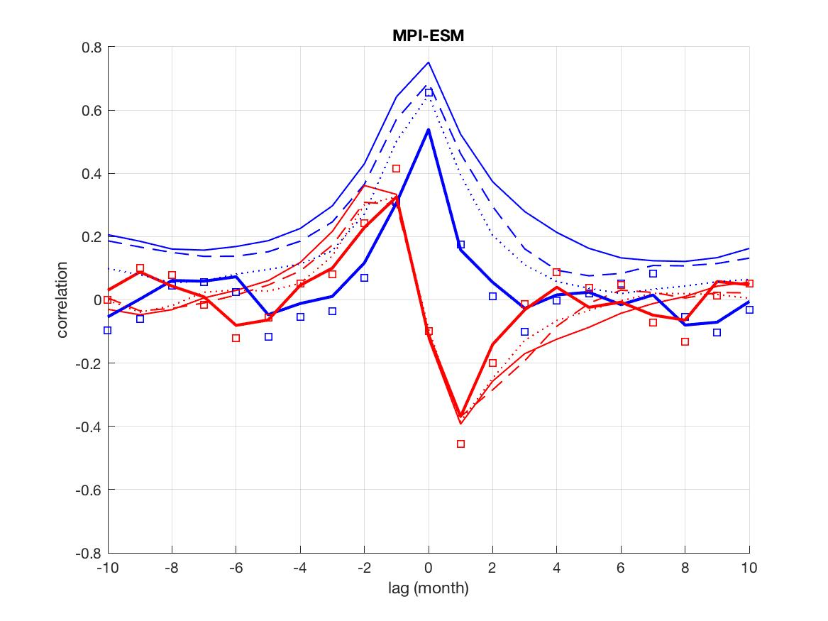
Fig. SM1. SST-THF (blue) and SST tendency-THF (red) correlation in the GS region, for HR (dashed), XR (solid thin) and ER (dotted) configurations of MPI-ESM models. SST/SST tendency leads (lags) THF for negative (positive) time-lags. Observational estimates based on J-OFURO3 dataset are also indicated with solid thick lines (1988-2013) and squares (2002-2013).

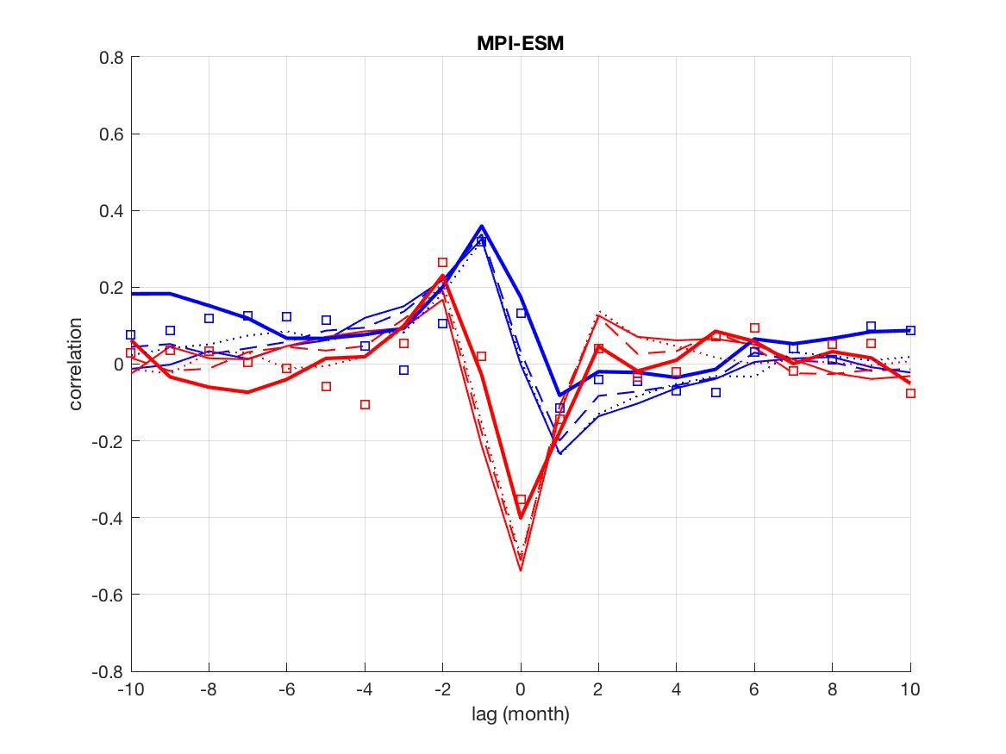
Fig. SM2: As Fig. SM1 but for the SG region.

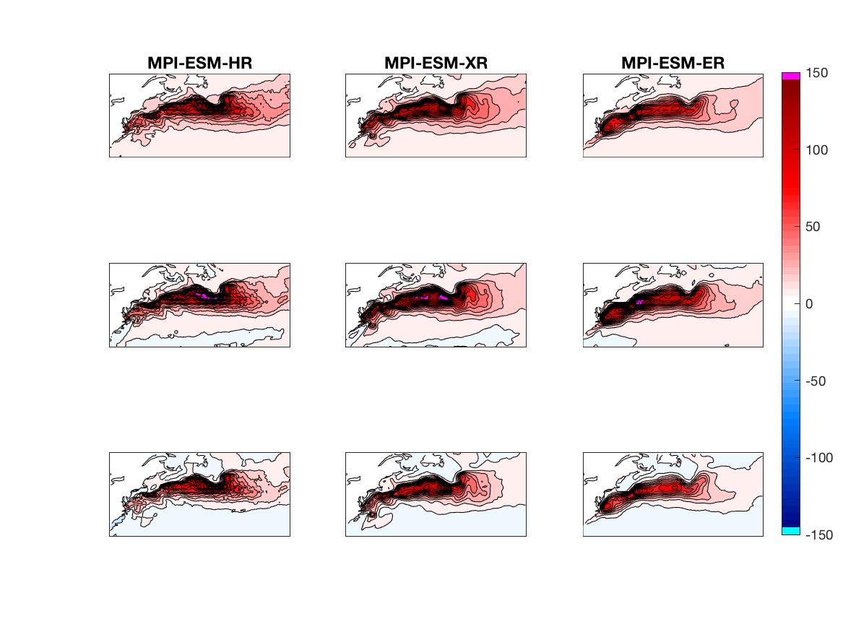
Fig. SM3: SST-THF covariance maps in the North Atlantic (ºC W m⁻²), computed for [-1, 0, +1]-month lag (top, mid, bottom row, respectively) for MPI-ESM models. SST leads THF for negative lags.

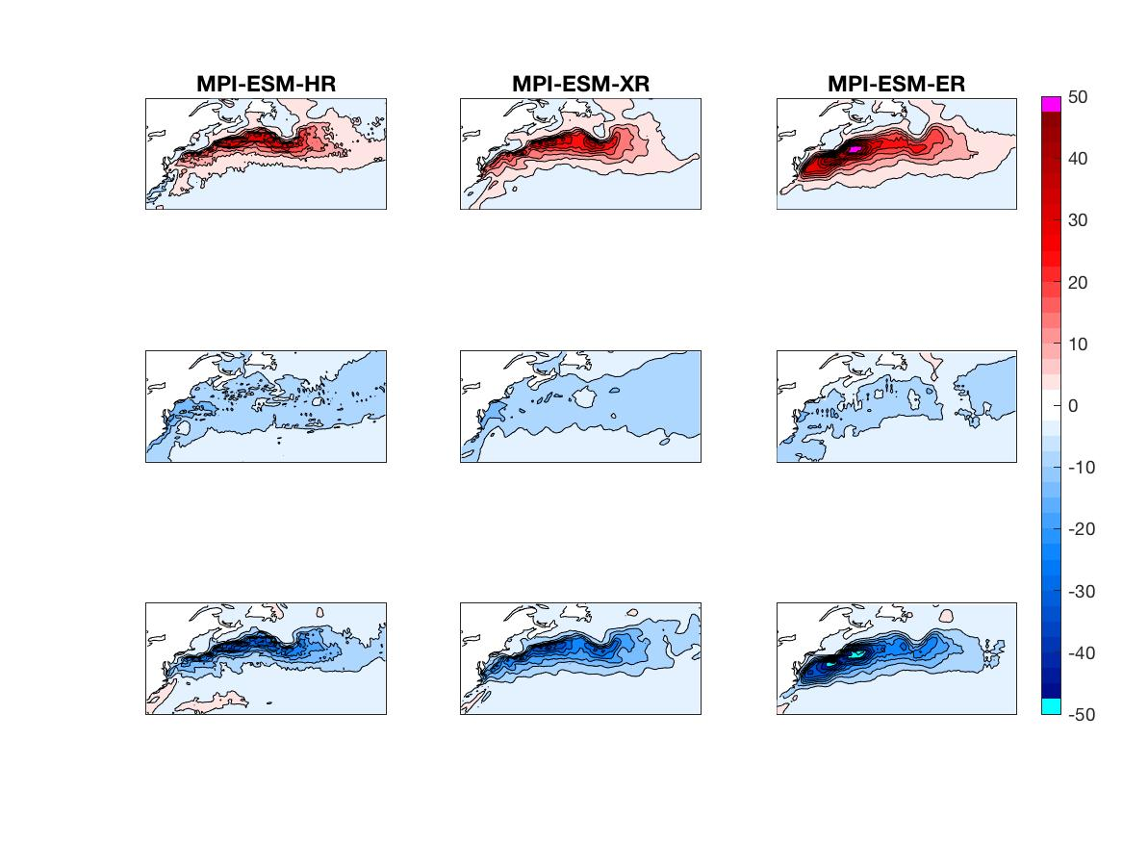
Fig. SM4: As Fig. SM3 but for SST tendency and THF (ºC W m⁻² month⁻¹). SST tendency leads THF for negative lags.

