Supplementary Material for “Interdecadal Weakening of the Cross-equatorial Flows over the Maritime Continent during the Boreal Summer in the mid-1990s: Drivers and physical processes”
By Xiaoxuan Zhao, Buwen Dong, Riyu Lu

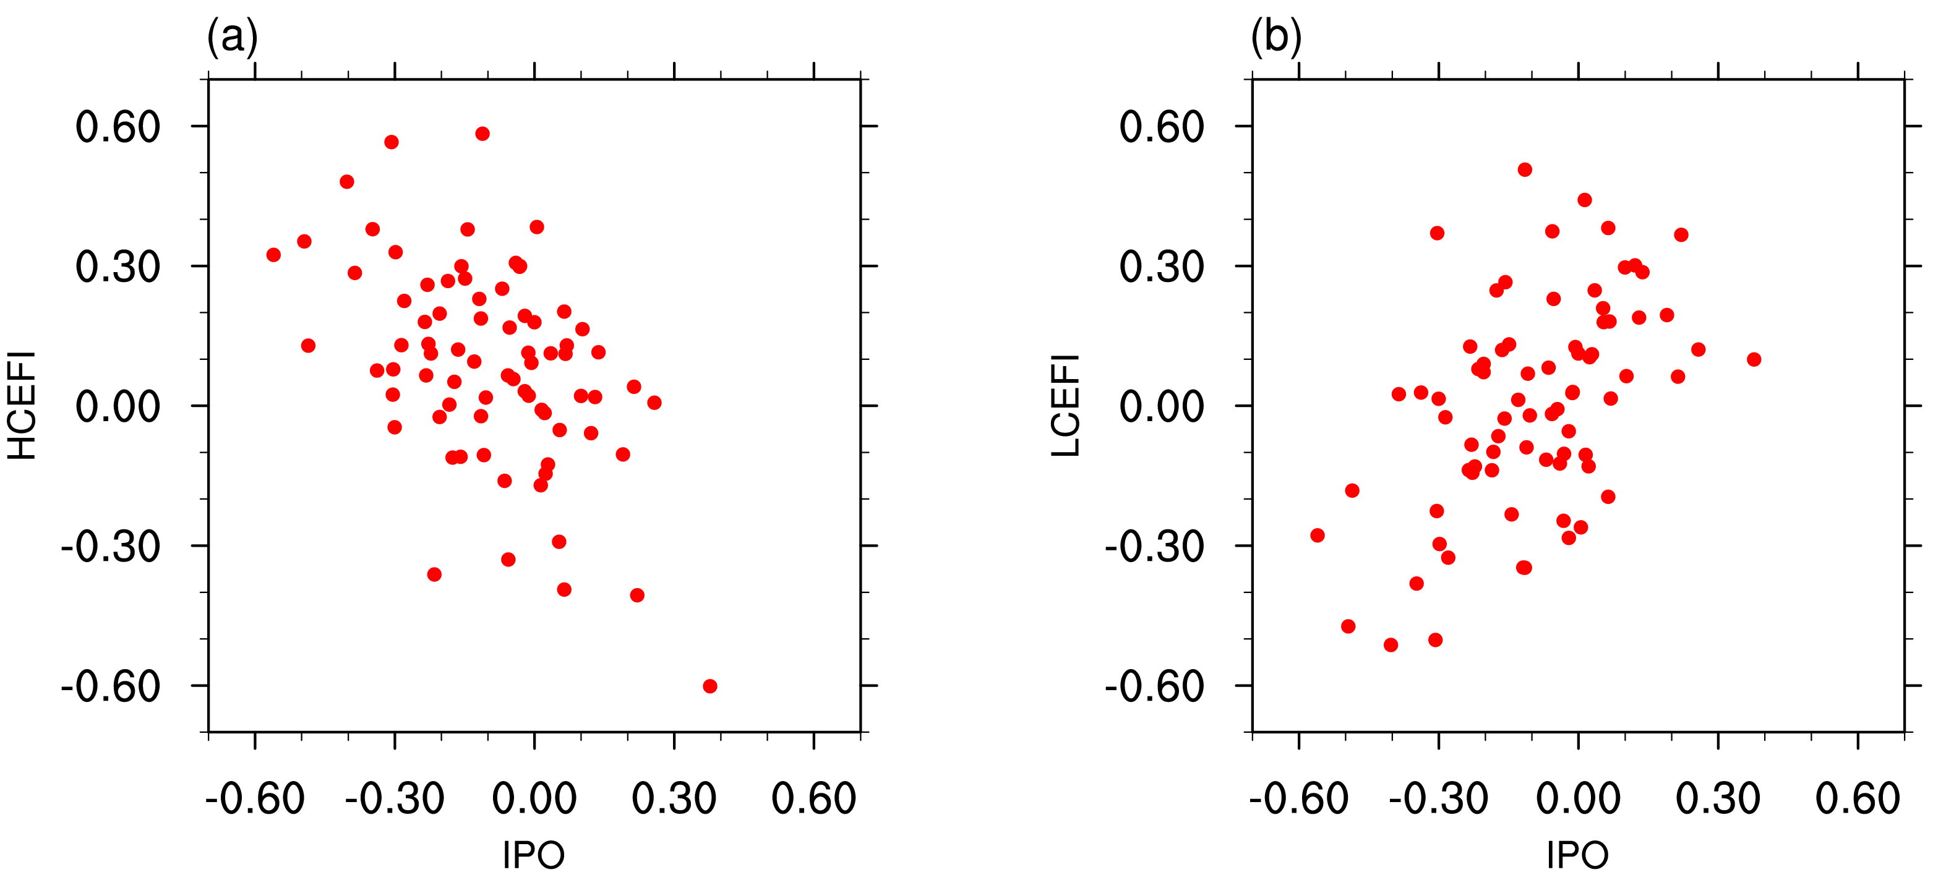
Fig. S1 Scatter plot of changes in CEF and IPO indexes between two periods 1995-2014 and 1975-1994 based on historical run in each member of 8 CMIP6 models (76 members in total). (a) HCEFI and IPO, (b) LCEFI and IPO.

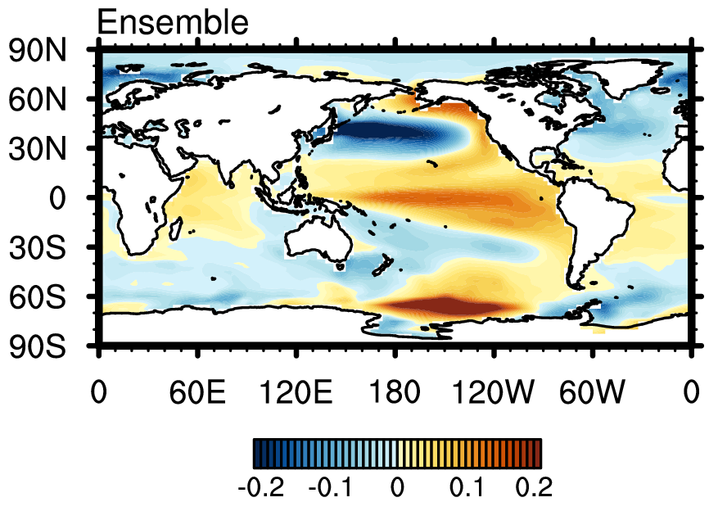
Fig. S2 Ensemble mean of the regression maps of SST on IPO index based on the piControl simulations in 8 CMIP6 models.
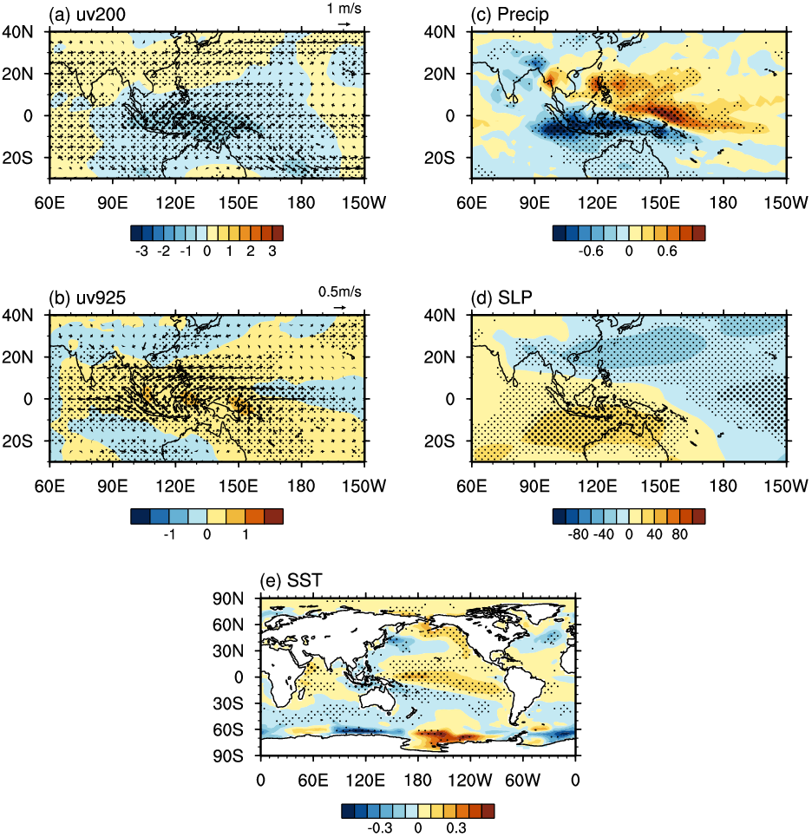
Fig. S3 Spatial patterns of changes between two 20 years in the multi-cases ensemble (MCE) mean of strengthening cases selected in piControl simulations according to LCEFI. (a) wind fields (m s⁻¹) at 200 hPa, (b) at 925 hPa, (c) precipitation (mm day⁻¹), (d) SLP (hPa), and (e) SST (℃, the global mean of SST is not subtracted). The Student’s t test is applied on u or v winds in (a–b). Consistency among cases are also considered, regions are dotted only if two conditions are both satisfied, i.e. changes are significant at the 95% confidence level and consistency is over 60%. Dots are larger in regions where consistency exceeds 90%.
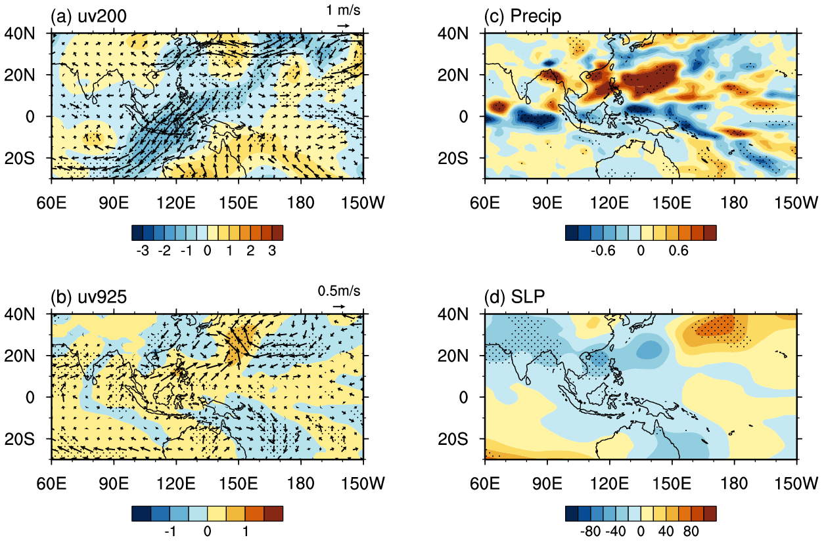
Fig. S4 Responses for (a) wind fields (m s⁻¹; uv: vector; v: shading) at 200 hPa, (b) 925 hPa, (c) precipitation (mm day⁻¹) and (d) SLP (hPa) in JJA to SST anomalies in WNP (EXP3 minus Control). The Student’s t test is applied on u or v winds in (a–b). Dots represent regions where responses are significant at the 90% confidence level.

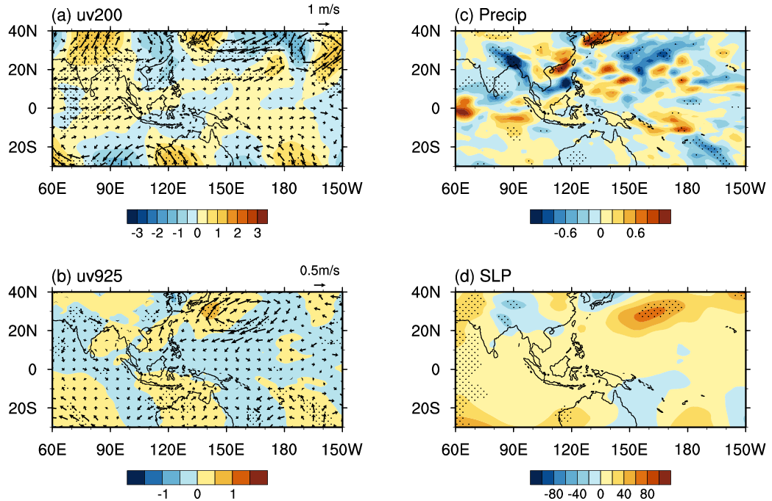
Fig. S5 Same as Fig. S4, but for responses to SST anomalies in IO (EXP2 minus Control).
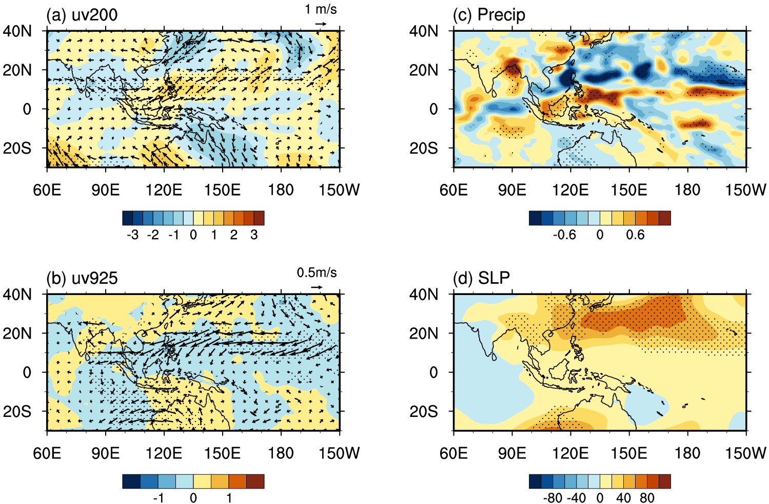
Fig. S6 Same as Fig. S4, but for responses to SST anomalies in SNP (EXP6 minus Control).

