Supplementary Materials for

Drivers of the decadal variability of the North Ionian Gyre upper layer circulation during 1910–2010: a regional modelling study

Appendix A. River discharge

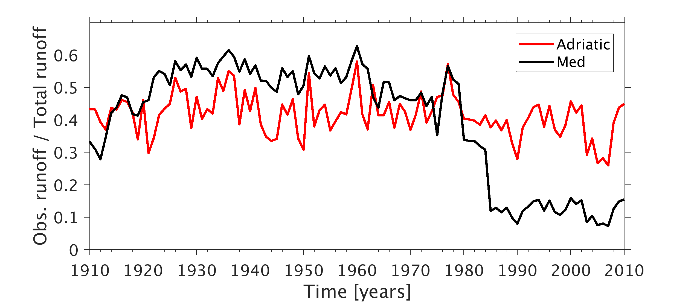
Fig.S1 Fraction of the river runoff that is based on direct observations (Med: Mediterranean Sea)

River | Period of observations | Basin
Po | 1901-2010 | Adriatic
Adige | 1922-1979 | Adriatic
Rhone | 1920-1979 | Western Med.
Ebro | 1913-1984 | Western Med.
Danube | 1921-1984 | Black Sea
Don | 1901-1984 | Black Sea
Kizil | 1976-1983 | Black Sea
Kuban | 1965-1984 | Black Sea
Cheliff | 1976-1978 | Western Med.
Ceyhan | 1970-1983 | Levantine Basin
Sakarya | 1976-1983 | Black Sea
Jucar | 1913-1984 | Western Med.
Nile | 1901-1984 | Levantine Basin
Rioni | 1965-1984 | Black Sea
Table S1 Information on rivers derived from the UNESCO RivDis database

Appendix B. Model reproduction of the general fields of the Mediterranean Sea

This section deals with the assessment of the ability of the model to simulate the general fields of the Mediterranean Sea. We compare the simulated temperature/salinity fields with MEDATLAS II climatology. Since the measurements that constitute the MEDATLAS II are mainly conducted in the 1980s and 1990s, we chose the average fields over the years 1980-1999 of the simulation to present the modeled climatology. In the model, SST and SSS refer to the temperature and salinity of the uppermost layer, which has a thickness of 8m plus sea level. For consistency, the observations have been linearly interpolated onto 4m depth, the center of the uppermost model level. Here we don’t discuss about the Black Sea.
With a few exceptions, the modeled temperature is close to observations with a typical error smaller than 1 ºC (Fig.S2). In general, the model shows an underestimation of the temperature in upper layers and overestimation in deeper parts. In winter (DJF) the model underestimates the SSTs in the Adriatic Sea, the Levantine Basin and the southern and eastern Ionian Sea, while in summer (JJA) in a wide range of the model domain including the Adriatic Sea, the Levantine Basin, the Algerian Basin, the eastern Tyrrhenian Sea and the Aegean Sea, the simulated SST shows a cold bias as compared with the observations (Fig.S2a,b). SST deviations in excess of 1 ºC are found in the northernmost of the Adriatic Sea and small regions south of Crete in winter and in areas south of Crete and east of Cyprus in summer. Higher temperature is produced around the Strait of Gibraltar, the Gulf of Lion and the western Ionian Sea in summer. As argued by Mikolajewicz et al. (2011), simulated SST bias larger than 1ºC are probably a consequence of either neglecting tides which would enhance vertical mixing (e.g. the Strait of Gibraltar) or unresolved small scale features in the atmospheric circulation by the atmospheric forcing (e.g. coastal areas).
The simulated annual mean temperatures of the intermediate water masses at the depth of 325m are characterized by opposite deviations in the western and eastern basins: generally 0.4 ºC higher in the west and 0.4 ºC lower in the east (mainly in the central Levantine Basin) than the observed climatology. At the deep layer of 1401m depth, the water masses are generally 0.4-0.8 ºC warmer then the observations in both basins (Fig.S2c,d).
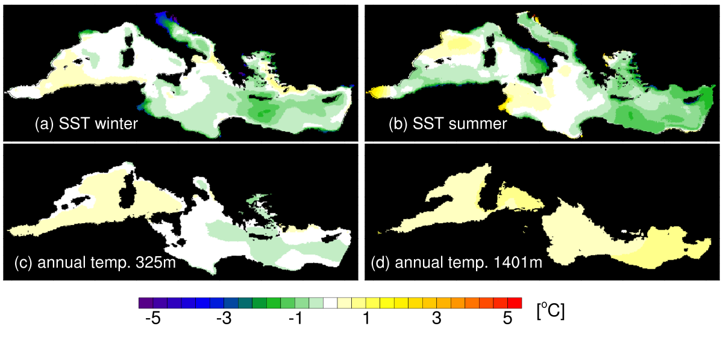
Fig.S2 Difference between simulated and climatological (MEDATLAS) potential temperatures in ºC. Winter (DJF) and summer (JJA) SST and annual mean temperatures at 325 m and 1401m depth. Contour interval is 0.4 ºC. White indicates deviations smaller than 0.2 ºC

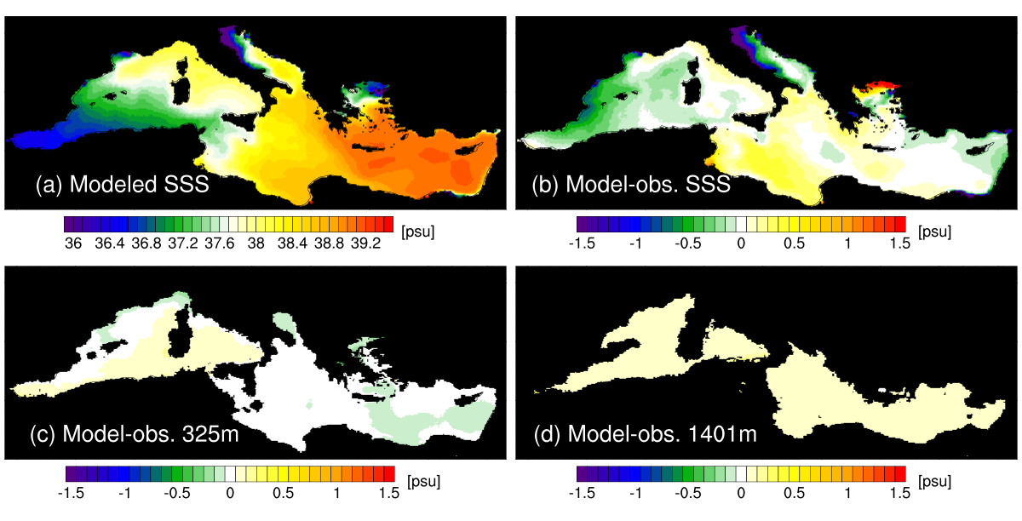

Fig.S3 (a) Modeled annual mean SSS. (b-d) Difference between simulated and climatological (MEDATLAS) annual mean SSS and salinity at 325 m and 1401m depth. Contour interval is 0.1 psu. White indicates deviations smaller than 0.05 psu

The simulated annual mean surface salinity as well as the deviations from the MEDATLAS climatology are displayed in Fig. S3. The simulated surface salinity shows a realistic general structure (Fig.S3a), which is related with a well reproduced circulation pattern shown in Fig.S4. Relative fresh water enters the Mediterranean Sea through the Strait of Gibraltar and spreads eastward along the Algerian coast into the eastern basin through the Strait of Sicily. Salty waters are generated in the Levantine Basin and spreads westward into the Ionian Sea. The outflow with low salinity from the Black Sea spreads into the Aegean Sea through the Bosporus Strait. The Adriatic Sea is characterized by salty waters in the southern and eastern parts due to the inflow from the Ionian Sea and fresh waters in the northern and western parts indicating the influence of the freshwater discharge from the Po River.
The model shows an underestimation of the SSS in the western Mediterranean, the Adriatic Sea and a small area in the east of the Levantine Basin with a deviation less than 1psu except for the Adriatic Sea, where the water is more than 1psu too fresh in the northern part. In the Ionian Sea and the Aegean Sea, the SSS is overestimated with a deviation no larger than 0.5psu except for the northernmost of the Aegean Sea (Fig.S3b), which is connected with the outflow of too salty waters from the Black Sea. At the intermediate depth, the simulated bias is much smaller than the surface (less than 0.15psu, see Fig.3c). The deep layer shows a typical model deviation of 0.15psu (Fig.S3d).
The simulated circulation pattern agrees quite well with the present-day observations (Pinadi and Masetti, 2000). The major near-surface circulation features are illustrated in Fig.S4 by the 1980-1999 mean currents at 27m. A strong Atlantic inflow in the western Mediterranean basin enters into the eastern basin through the Strait of Sicily, forming the Mid Ionian Jet which further propagates into the Levantine Basin. Three typical cyclonic gyres, which are closely associated with deep water formations, are well reproduced in the Gulf of Lion, the southern Adriatic Sea and the Rhodes gyre. Part of the Asia Minor current flows along the cost of Turkey northward into the Aegean Sea and returns together with the Black Sea outflow along the western Aegean Sea towards the south, and eventually along the Greek coast into the northern Ionian Sea or the Adriatic Sea.
Related to this general circulation, the model reproduces realistic water transport through the Strait of Gibraltar, giving an inflow of +0.79 Sv and an outflow of -0.74 Sv. The simulation is consistent with actual estimates from observations, which give values ranging between +0.72 and +1.01 Sv for the inflow and between -0.67 and -0.97 Sv for the outflow (Table S2). The simulated net transport of +0.049 Sv from the Atlantic into the Mediterranean perfectly balances the net water loss of 49,000 m³/s at the Mediterranean and Black Sea surface.
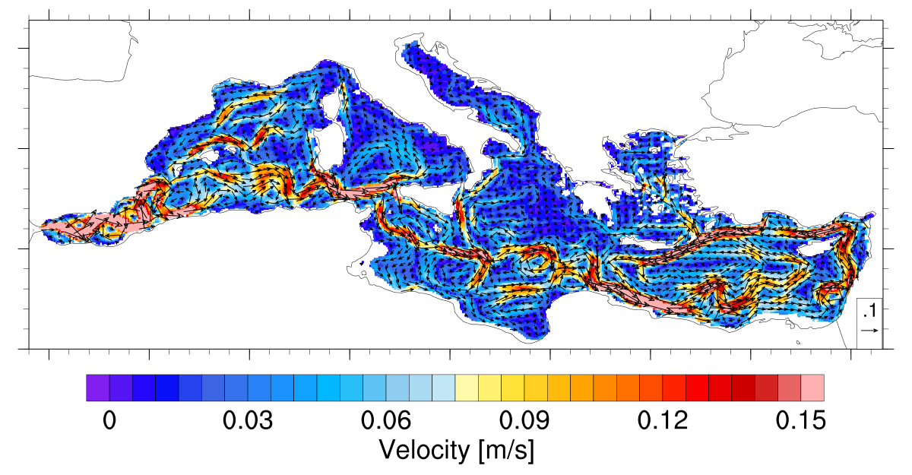
Fig.S4 Simulated currents over 1980-1999 at 27m depth. Colors indicate the flow speed in m/s, vectors with both direction and speed are plotted at every four model grids

Authors | Inflow (Sv) | Outflow (Sv)
Bryden [1994] | +0.72 ± 0.16 | −0.68 ± 0.15
Tsimplis and Bryden [2000] | +0.78 | −0.67
Candela [2001] | +1.01 | −0.97
Baschek et al. [2001] | +0.81 ± 0.07 | −0.76 ± 0.07
This work | +0.79 | -0.74
Table S2 Estimates of the Water Inflow and Outflow at the Strait of Gibraltar

Appendix C. Model reproduction of the Eastern Mediterranean Transient (EMT) event

The time evolution of the volume of dense water masses in the Aegean Sea (Aegean Dense Water, AeDW) and the associated annual formation rates during the period 1970 to 2010 depict clearly the development of the EMT (Fig.S5). The simulated AeDW, in good agreement with observations of Theocharis et al. (1999), becomes very dense ($≥$1029.2 kg m⁻³) after 1987 and slowly fills the Aegean Sea, indicating the starting of the EMT event. Zervakis et al. (2000) and Gertman et al. (2006) presented the same conclusion from a series of cruise measurements, giving the evidence that dense water formation started in the northern Aegean Sea in 1987. The modeling study of Beuvier et al. (2010) also showed a similar starting time. In 1993, both the dense water volume and the formation rates peak in our simulation. About 80% of the Aegean Sea is filled by waters denser than 29.2 kg m⁻³ (considering a total volume of the Aegean Sea of 8.7x10¹³ m³) which is comparable to the model study by Beuvier et al. (2010). The associated formation rates are the largest over the 40 years: 0.88 Sv for density 1029.2 kg m⁻³ and 0.65 Sv for 1029.3 kg m⁻³. Some deep convection also takes place around 1975 but is much weaker than that simulated by Beuvier et al. (2010), even though similar strong cold winter conditions are prescribed in both studies (Figure not shown). As argued by Josey (2003), surface flux anomalies are not the sole factor controlling the convective activities, given that a water column with strong stratification is more resistant to convection arising from surface flux anomalies. So far there is no clear evidence from historical hydrographic observations on episodes of deep water formation occurring in the Aegean Sea at this time (Roether et al. 1996; Theocharis et al. 1999). To get a firm conclusion about this time, a detailed analysis of new historical data would be required. Beside the 1975 period, strong deep formation happens in 1996 in our simulation, but is not reproduced in Beuvier et al. (2010), which would need further validations with observations as well.
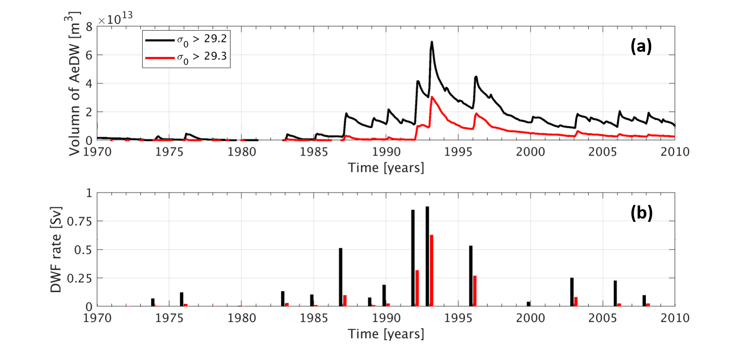
Fig.S5 (a) Monthly volume (in m³) of Aegean waters denser than 29.2 kg m⁻³ (black) and 29.3 kg m⁻³ (red). (b) Annual formation rate (in Sv) of dense water in the Aegean Sea for two thresholds: 29.2 kg m⁻³ (black) and 29.3 kg m⁻³ (red)

The dense waters gradually fill the Aegean Sea and finally exit the Aegean Sea through the Cretan Arc straits. This dense overflow water is mixed with resident waters in the Ionian Sea and the Levantine basin (Roether et al. 2007). The depth and salinity on the 29.16 kg m⁻³ isopycnal surface during and after the EMT demonstrate two pathways of the AeDW exiting the Aegean Sea (Fig.S6). The first one is through the Antikithira Strait and flowing northwestwards following the shelf slope in the eastern Ionian Sea. The overflow water turns in a cyclonic manner while sinking to a depth of 2400m in 1993 and 2600m in 1994. The second pathway is through the Kassos and Karpathos Strait (See Fig.1 in the main text). The dense overflow water propagates southwards, sinking down to similar depths as the first waters but in the Levantine Basin. From 1994 onward, the isopycnal surface shallows. The two overflow water masses continue to spread westwards and eastwards, occupying large parts of the northern Ionian Sea and the Levantine Basin in 2000.
Compared to observations, the simulated density of the Eastern Mediterranean Deep Water (EMDW) is slightly underestimated. We attribute this underestimation to the millennial scale spin-up. The density of the Levantine bottom water is underestimated by approximately 0.03 kg m⁻³ in the pre-EMT period, given a typical density of 29.17 kg m⁻³ in 1987 observed by the METEOR cruise M5/6 (Klein et al. 1999) and 29.14 kg m⁻³ by our study. As a consequence, mixing of the Aegean outflow water with the resident EMDW in the model results in a slightly lower density (29.16 kg m⁻³) compared to observations (29.18 kg m⁻³, Klein et al. 1999). Despite the deviations in absolute values, our model is able to describe the outflow and the spreading of the Aegean dense waters, such as the replacement of the previous bottom and deep waters in the Levantine Basin and the Ionian Sea, as well as the spreading of the AeDW over large parts of the deep domain in these two basins.
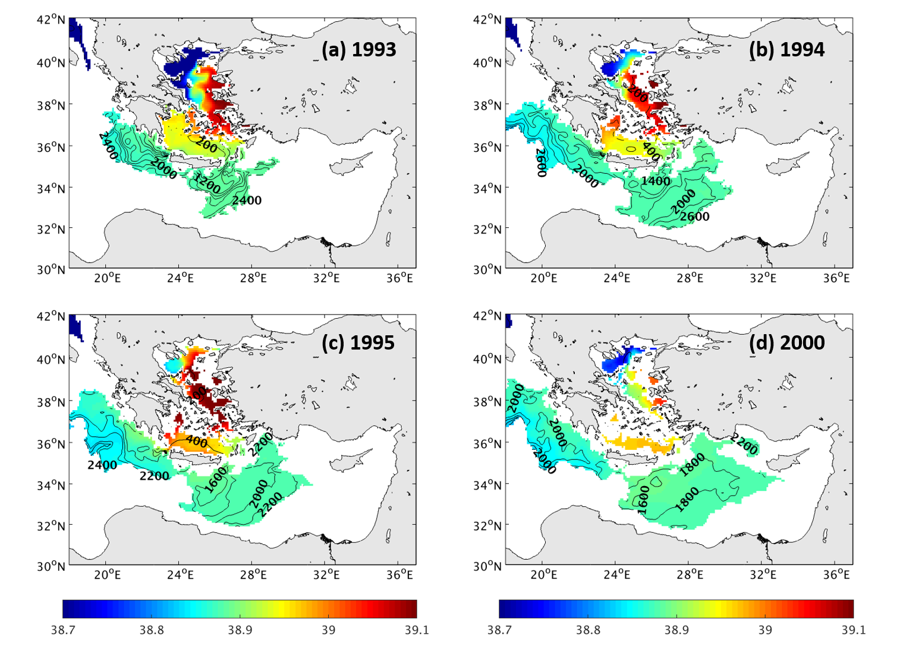Fig.S6 Annual mean salinity [psu] on the annual isopycnal surface $σ_{0}$=29.16 kg m⁻³ (colors) and depth of this surface (contour lines, interval of 200m) in (a) 1993, (b) 1994, (c) 1995 and (d) 2000

Appendix D. Standard deviation in density, temperature and salinity

In Fig.S7 we can find that the large standard deviation in density around 1920s is mostly due to the large standard deviation in temperature, while around the 1960s, the large standard deviation in density is mainly caused by the large standard deviation in salinity.
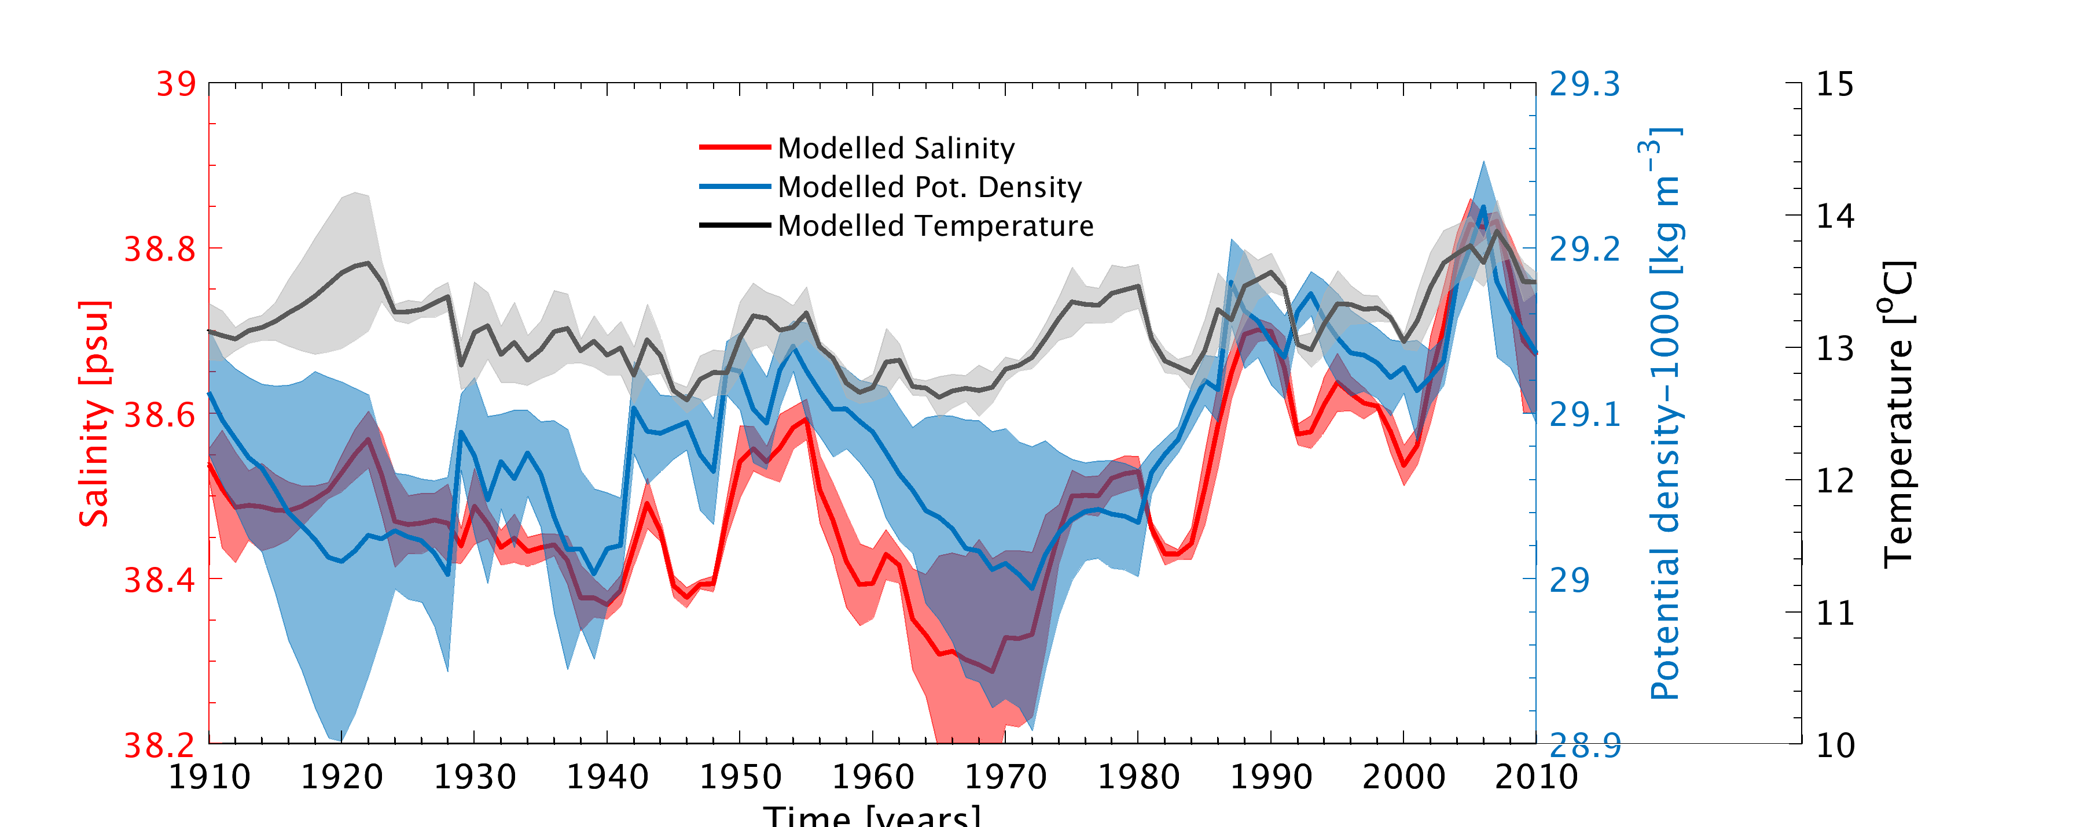
Fig.S7 Time series of annual mean temperature (black line), salinity (red line) and potential density (blue line) averaged over 206m-727m depth and over the Southern Adriatic Sea (black box in Fig.1 in the manuscript). Shaded areas denote the range of data variations within one standard deviation.

Appendix E. Simulated evolution of the NIG anticyclonic circulation

The annual mean current fields in Fig.S8 clearly show the evolution of the NIG anticyclonic circulation in CW in 1971-1976. The anticyclonic circulation starts to build up in 1972 and reaches its maximum in 1973. Since 1974, the anticyclone starts to withdraw, leaving space for the development of the cyclonic circulation.
Fig.S9 shows that in 1972, the dense AdDW flows out from the Adriatic through the western part of the Strait of Otranto (in March), and is spreading in deep depths southwestwards along the Sicily coast (in June and September). Clearly, dense water along the eastern coast of the Ionian Sea is not of the Adriatic origin but from the intrusion of Levantine intermediate water. In 1973, the dense water along the northwestern flank of the Ionian Sea is spreading eastwards, part of which reaches the Greek coast.

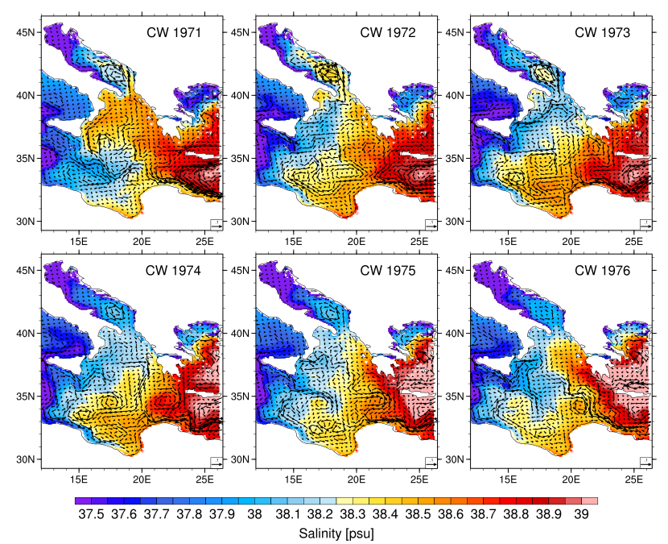
Fig.S8 Annual mean salinity and currents [m s⁻¹] averaged over the upper 124m depth in 1971-1976 for CW

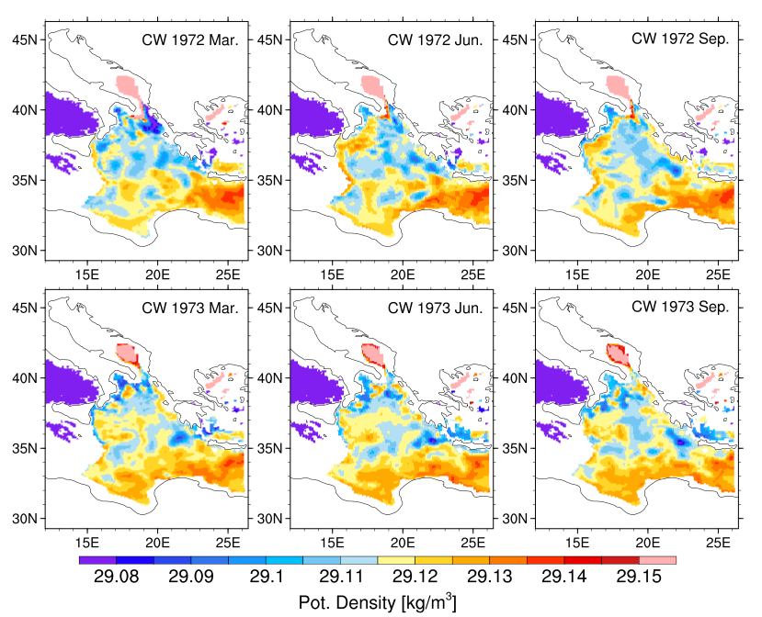
Fig.S9 Spatial distribution of the monthly mean potential density at the depth of 671m in different months in 1972 and 1973 for CW

Reference:

Baschek B, Send U, Lafuente JG, Candela J (2001) Transport estimates in the Strait of Gibraltar with a tidal inverse model. Journal of Geophysical Research: Oceans 106(C12):31033-31044
Beuvier J, Sevault F, Herrmann M, Kontoyiannis H, Ludwig W, Rixen M, Stanev E, Béranger K, Somot S (2010) Modeling the Mediterranean Sea interannual variability during 1961–2000: focus on the Eastern Mediterranean Transient. Journal of Geophysical Research: Oceans 115(C8)
Bryden HL, Candela J, Kinder TH (1994) Exchange through the Strait of Gibraltar. Progress in Oceanography 33(3):201-248
Candela J (2001) The Mediterranean water and the global circulation, in Observing and Modelling the Global Ocean, pp. 419–429, edited by G. Siedler, J. Church, and J. Gould, Academic, San Diego, Calif.
Gertman I, Pinardi N, Popov Y, Hecht A (2006) Aegean Sea water masses during the early stages of the Eastern Mediterranean climatic transient (1988–90). Journal of Physical Oceanography 36(9):1841-1859
Josey SA (2003) Changes in the heat and freshwater forcing of the eastern Mediterranean and their influence on deep water formation. Journal of Geophysical Research: Oceans 108(C7)
Klein B, Roether W, Manca BB, Bregant D, Beitzel V, Kovacevic V, Luchetta A (1999) The large deep water transient in the Eastern Mediterranean. Deep Sea Research Part I: Oceanographic Research Papers 46(3):371-414
Pinardi N, Masetti E (2000) Variability of the large scale general circulation of the Mediterranean Sea from observations and modelling: a review. Palaeogeography, Palaeoclimatology, Palaeoecology 158(3-4):153-173
Roether W, Klein B, Manca BB, Theocharis A, Kioroglou S (2007) Transient Eastern Mediterranean deep waters in response to the massive dense-water output of the Aegean Sea in the 1990s. Progress in Oceanography 74(4):540-571
Roether W, Manca BB, Klein B, Bregant D, Georgopoulos D, Beitzel V, Kovačević V, Luchetta A (1996) Recent changes in eastern Mediterranean deep waters. Science 271(5247):333-335
Theocharis A, Nittis K, Kontoyiannis H, Papageorgiou E, Balopoulos E (1999) Climatic changes in the Aegean Sea influence the Eastern Mediterranean thermohaline circulation (1986–1997). Geophysical Research Letters 26(11):1617-1620
Tsimplis MN, Bryden HL (2000) Estimation of the transports through the Strait of Gibraltar. Deep Sea Research Part I: Oceanographic Research Papers 47(12):2219-2242
Zervakis V, Georgopoulos D, Drakopoulos PG (2000) The role of the North Aegean in triggering the recent Eastern Mediterranean climatic changes. Journal of Geophysical Research: Oceans 105(C11):26103-26116

