Supplementary Material
A Bayesian approach to exploring the influence of climate variability modes on fire weather conditions and lightning-ignited wildfires
Bryson C. Batesª, Andrew J. Dowdy^{b∗}, Lachlan McCaw^{c}
ª CSIRO Oceans and Atmosphere and School of Agriculture and Environment, University of Western Australia, Perth, Western Australia, Australia
^{b} Bureau of Meteorology, Melbourne, Victoria, Australia
^{c} Department of Biodiversity, Conservation and Attractions, Manjimup, Western Australia, Australia

Journal: Climate Dynamics
Ms. No. CLDY-D-20-00729

E-mail address of corresponding author: Andrew.Dowdy@bom.gov.au

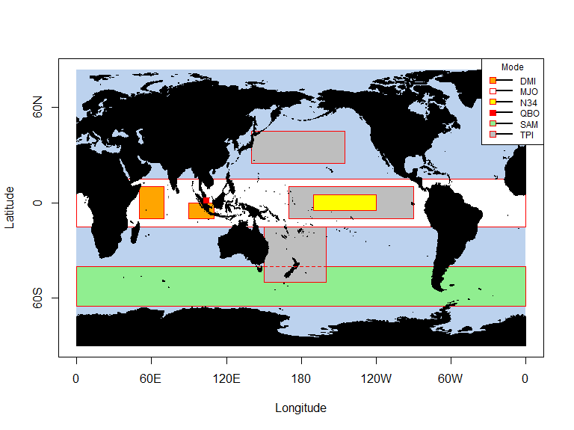

Figure S.1: Geography of large-scale, low frequency climate variability modes. DMI = dipole mode index, MJO = Madden-Julian Oscillation, N34 = Niño3.4 index, QBO = Quasi-Biennial Oscillation (over Singapore), SAM = Southern Annular Mode and TPI=tripole index.

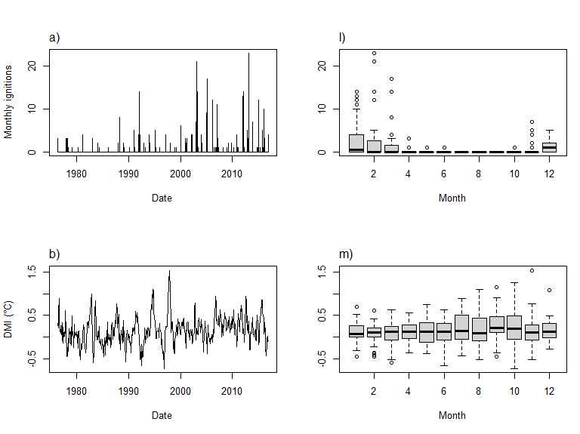
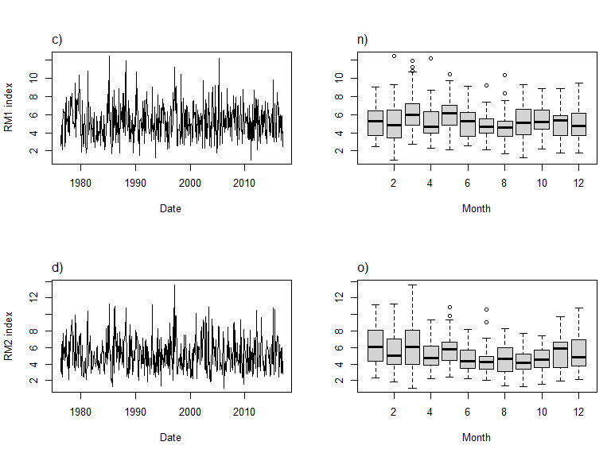
Figure S2: Continued.

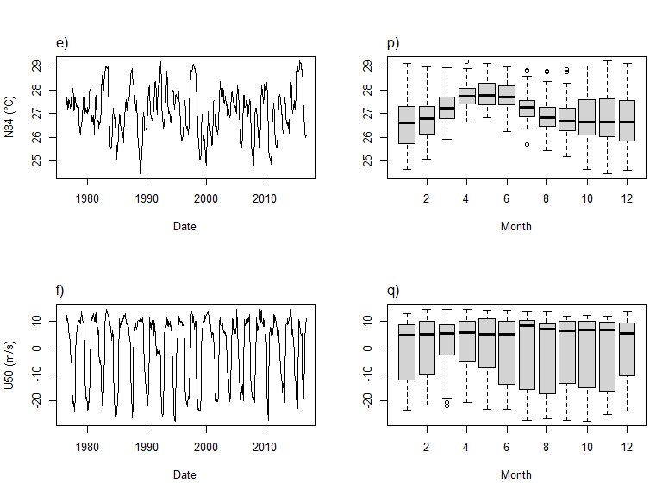
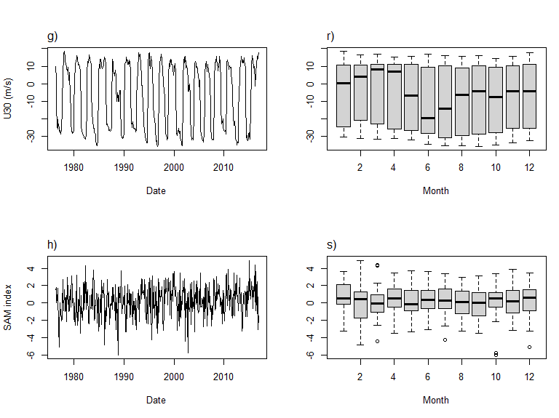
Figure S2: Continued.
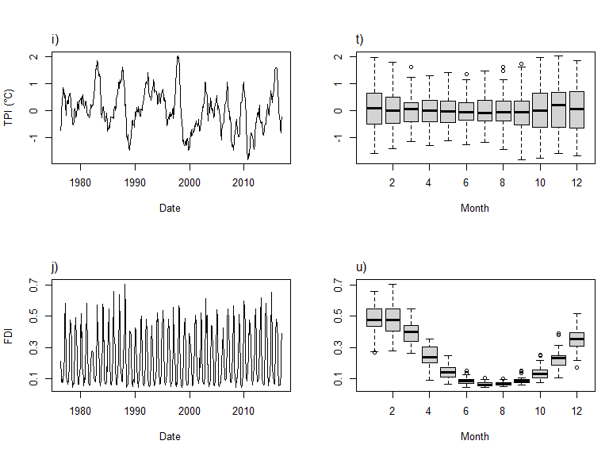
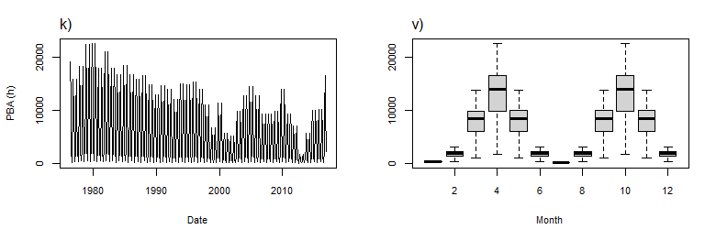
Figure S2: Time series plots for the data used in this study (a – k) and boxplots showing data distributions by month (l – v).

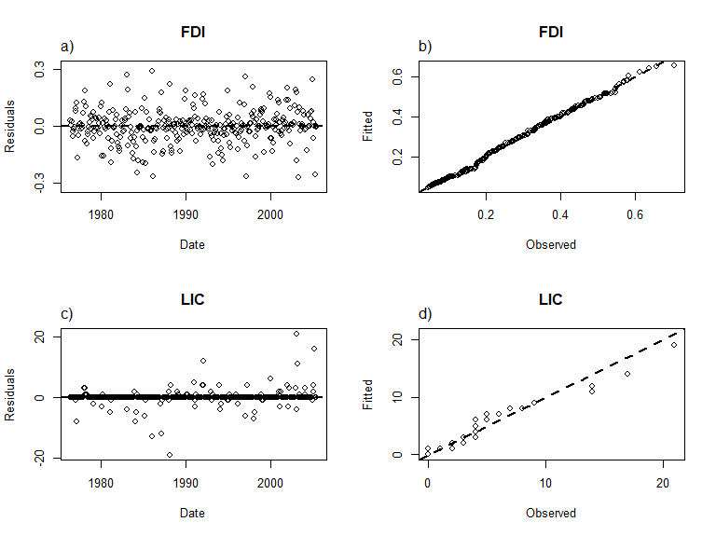
Figure S3: Diagnostic plots for assessing the quality of fit between the sDBN and the training set (f_{m} = 0.7). FDI = McArthur Mark V forest fire danger index, LIC = lightning ignition counts.

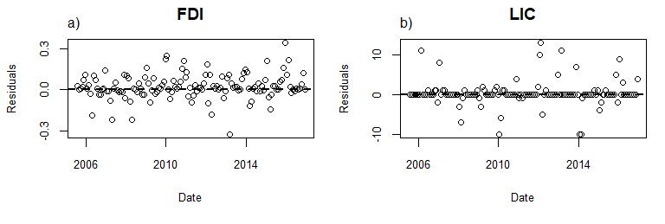
Figure S4: Diagnostic plots for assessing the performance of the sDBN during rolling origin evaluation. FDI = McArthur Mark V forest fire danger index, LIC = lightning ignition counts. The corresponding quantile-quantile plots of predicted versus observed series appear as Figs. 6a and 6b.

