(a) ‘High’ sea-ice + ‘early’ SST clim (EM)  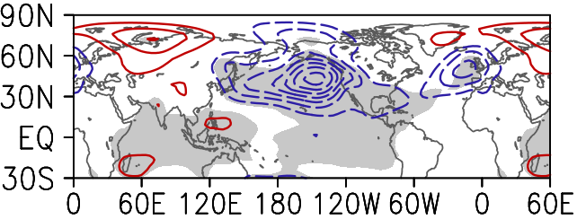 | (b) ‘Low’ sea-ice + ‘late’ SST clim (EM)  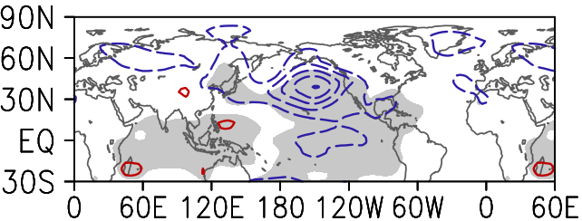
(c) ‘Low’ sea-ice + ‘early’ SST clim (EM)  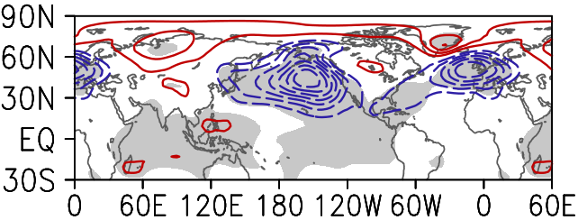 | (d) ‘High’ sea-ice + ‘late’ SST clim (EM)  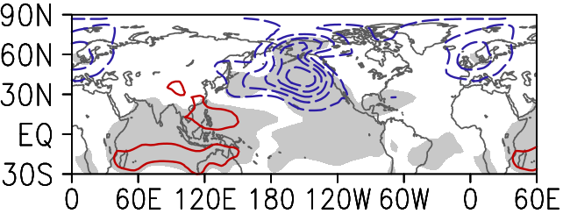

Supplementary Figure S4 ICTP AGCM simulated MSLP response to El Niño Modoki (EM) in conditions with: (a) ‘high’ sea-ice and ‘early’ SST climatology, (b) ‘low’ sea-ice and ‘late’ SST climatology, (c) ‘low’ sea-ice and ‘early’ SST climatology and (d) ‘high’ sea-ice and ‘late’ SST climatology. Contouring interval is 0.5 hPa. Statistically significant results (p < 5%) are shaded

