Hot and cold flavors of southern California’s Santa Ana winds:
Their causes, variability and trends

SUPPLEMENTARY FIGURES AND TABLES

ABSOLUTE HOTTEST AND COLDEST COASTAL TEMPERATURES ON RECORD
a) Top 10 hot days |  |  |  | b) Top 10 cold days
Date | Abs CTmax (˚C) | Abs CTmin (˚C) | R1D-SAWRI (m/s) | Date | Abs CTmax (˚C) | Abs CTmin (˚C) | R1D-SAWRI (m/s)
09/27/10 | 39.48 | 17.56 | 0 | 01/11/49* | 6.23 | -2.51 | 0
07/06/18 | 38.10 | 17.01 | 0 | 01/10/49 | 6.65 | -3.63 | 0
09/02/55 | 38.04 | 18.99 | 0 | 01/28/57 | 7.18 | -2.24 | 0
09/01/55 | 38.03 | 18.87 | 0 | 01/29/57* | 8.03 | 1.20 | 0
09/26/63 | 38.02 | 18.24 | 0 | 01/27/57 | 8.15 | -0.28 | 0
09/01/17 | 38.00 | 19.69 | 0 | 12/14/67 | 8.15 | -1.85 | 5.10
09/24/78 | 37.98 | 16.05 | 3.23 | 12/10/72* | 8.17 | -0.65 | 0
07/07/18 | 37.73 | 21.02 | 0 | 12/22/90 | 8.18 | -4.27 | 6.36
09/27/63 | 37.53 | 17.72 | 0 | 01/22/62* | 8.24 | 0.87 | 0
06/16/81 | 37.44 | 14.26 | 2.29 | 01/04/49 | 8.51 | -3.88 | 6.41
Table S1. Top 10 coastal hottest and coldest days according to absolute coastal Tmax (CTmax) from 1948 to 2018. The corresponding absolute coastal Tmin (CTmin) values are also shown for each category. SAW conditions for those days are identified using SAWRI derived from the hybrid downscaling (R1D-SAWRI). In the top 10 cold days section, asterisk mark dates immediately preceding SAW events.

HOTTEST AND COLDEST COASTAL TEMPERATURE ANOMALIES ON RECORD
a) Top 10 hot days |  |  |  | b) Top 10 cold days
Date | CTmax (˚C) | CTmin (˚C) | R1D-SAWRI (m/s) | Date | CTmax (˚C) | CTmin (˚C) | R1D-SAWRI (m/s)
04/06/89 | 17.08 | 7.03 | 0 | 01/11/49 | -11.11 | -6.47 | 0
04/07/89 | 15.64 | 6.58 | 0 | 01/10/49 | -10.69 | -7.58 | 0
04/05/89 | 15.43 | 5.57 | 3.64 | 01/28/57 | -10.27 | -6.47 | 0
04/20/09 | 14.53 | 4.98 | 0 | 12/10/72 | -10.26 | -5.35 | 0
05/15/14 | 14.39 | 6.41 | 0 | 12/14/67 | -10.08 | -6.38 | 5.10
03/26/88 | 14.08 | 5.00 | 0 | 12/22/90 | -9.63 | -8.48 | 6.36
04/27/04 | 13.83 | 5.05 | 0 | 11/17/64 | -9.60 | -3.01 | 5.23
09/27/10 | 13.45 | 5.71 | 0 | 12/09/72 | -9.50 | -6.68 | 0
10/24/17 | 13.33 | 9.63 | 7.32 | 01/29/57 | -9.44 | -3.06 | 0
05/03/04 | 13.31 | 5.17 | 0 | 12/21/90 | -9.31 | -4.91 | 0
Table S2. Top 10 coastal hottest and coldest days according to de-seasonalized coastal Tmax (CTmax) from 1948 to 2018. The corresponding de-seasonalized coastal Tmin (CTmin) values are also shown for each category. SAW conditions for those days are identified using SAWRI derived from the hybrid downscaling (R1D-SAWRI). In the top 10 cold days section, asterisks mark dates immediately preceding SAW days.

(a) SAW event duration | (b) SAW event minimum RH
Figure S1. Duration of SAW events (a), and minimum relative humidity (b) during SAW events. The extreme categories consider events when extreme SAW days have occurred.

a) 500mb height composites on hot SAW days
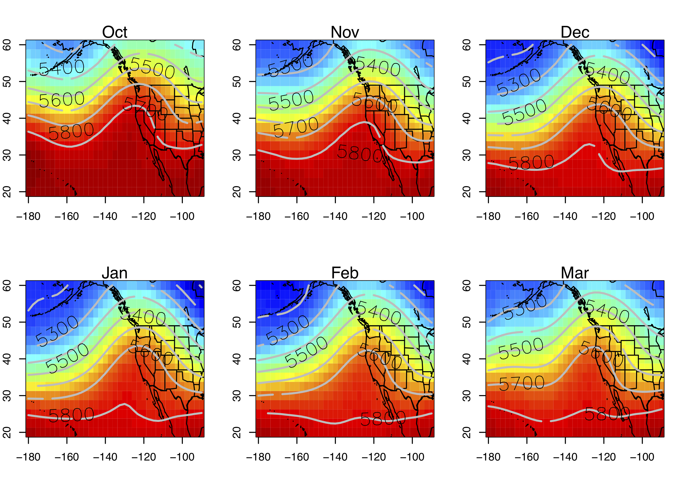

b) 500mb height composites on cold SAW days
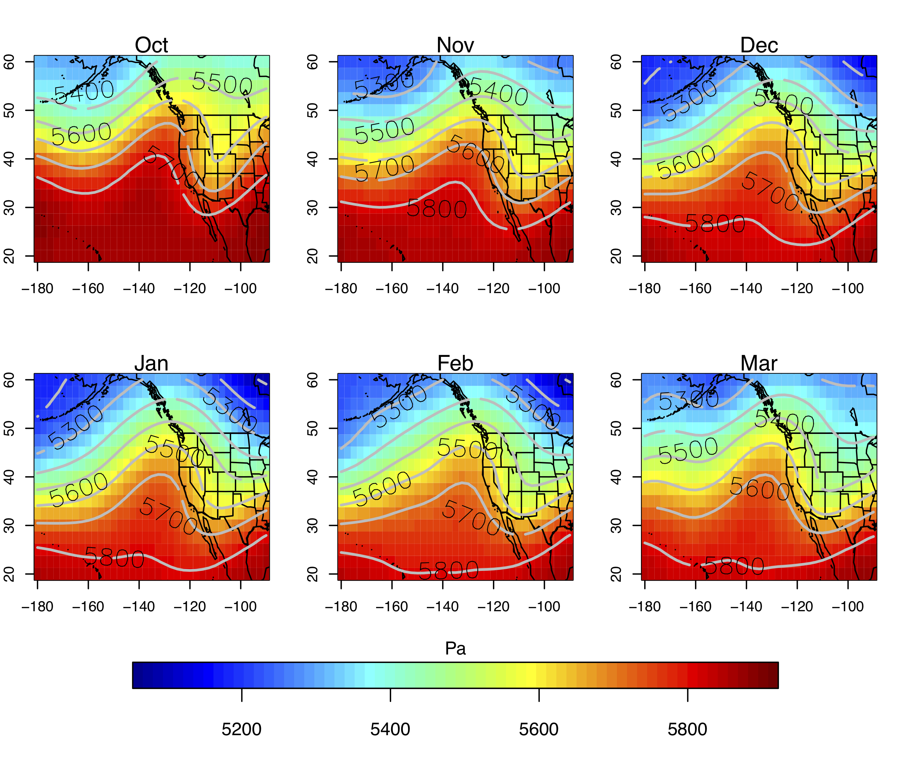

c) Hot-cold SAW 500mb height composites differences
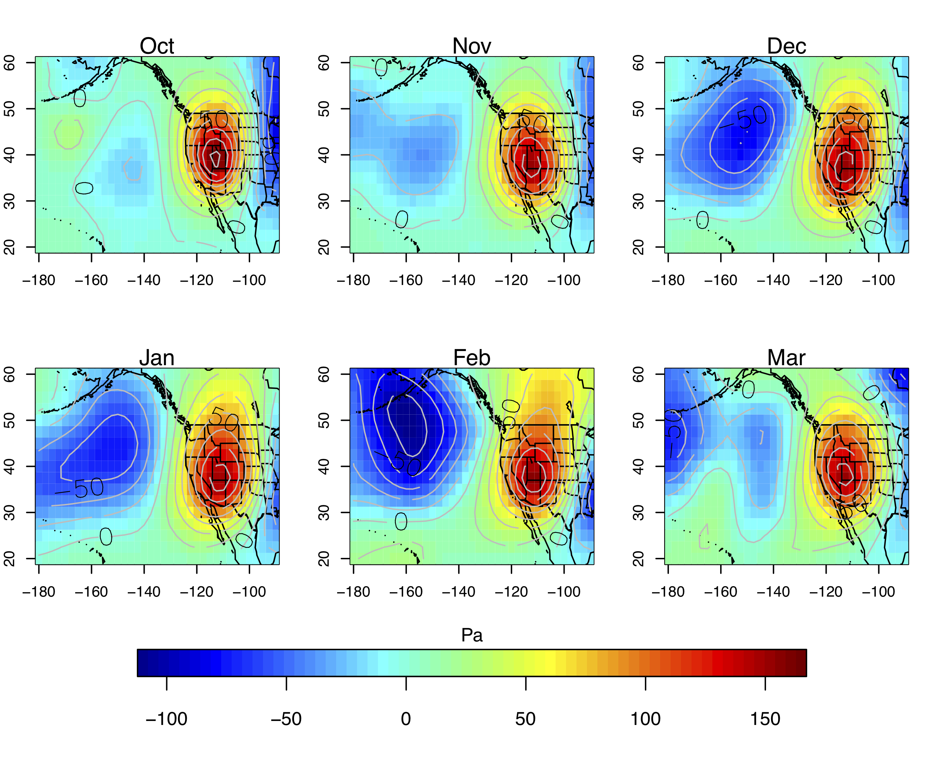
Figure S2. 500mb geopotential heights composited on hot and cold SAW days by months (panels a and b) hot-cold composites differences (panels c)

GB Tmax during SAW days | GB Tmin during SAW days
Figure S3. Great Basin Tmax (a) and Tmin (b) as a function of the pressure gradient force (PGF) directed into SoCal (see Figure S2)

(a) Hot SAW days | (b) Top 10% hottest SAW days
(c) Cold SAW days | (d) Top 10% coldest SAW days
(e) Difference cold-hot | (f) Difference top 10% cold-hot
Figure S4. Great Basin Tmax 15 days before and after SAW days. Thick black line marks the median, boxes lower and upper limit correspond to the 1st and 3rd quartiles, respectively, and whiskers extend to the farthest extreme values. Colored bars correspond to snow cover on SAW days (at x=0, around which compositing was done) for each category, panels (a)–(d). Panels (e) and (d) show the differences of cold minus hot SAW days and top 10% cold minus hot SAW days, respectively.

(a) Hot SAW days | (b) Top 10% hottest SAW days
(c) Cold SAW days | (d) Top 10% coldest SAW days
(e) Difference cold-hot | (f) Difference top 10% cold-hot
Figure S5. Great Basin Tmin 15 days before and after SAW days. Thick black line marks the median, boxes lower and upper limit correspond to the 1st and 3rd quartiles, respectively, and whiskers extend to the farthest extreme values. Colored bars correspond to snow cover on SAW days (at x=0, around which compositing was done) for each category, panels (a)–(d). Panels (e) and (d) show the differences of cold minus hot SAW days and top 10% cold minus hot SAW days, respectively.

a) Precipitation composites leading up to hot SAW days

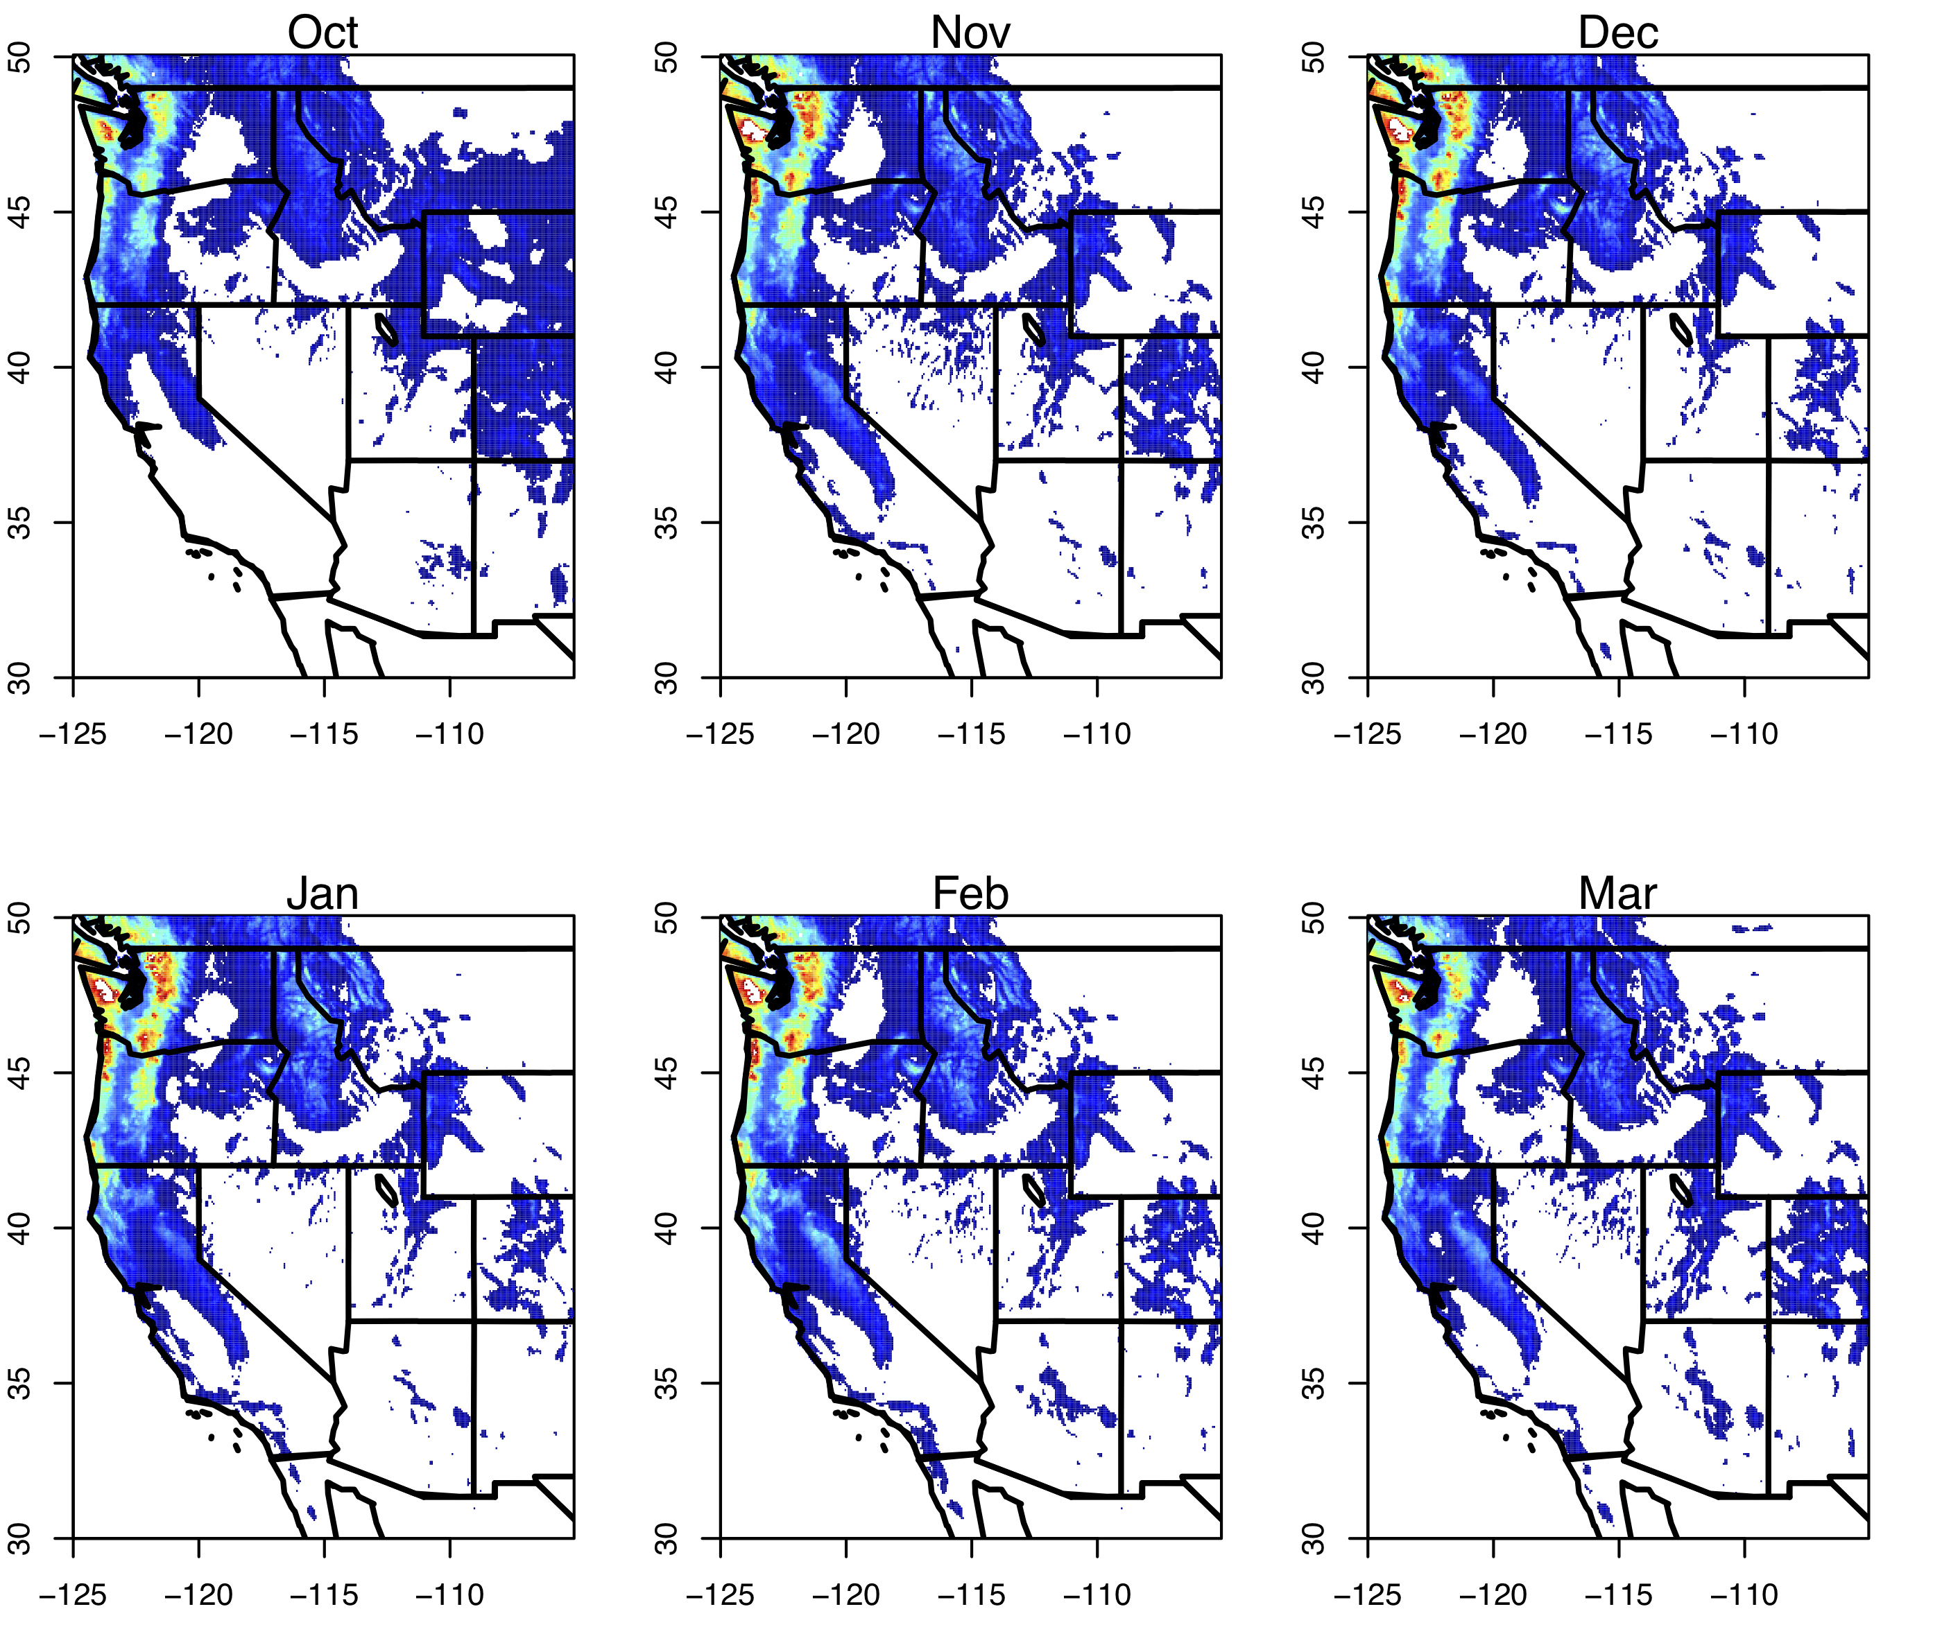

b) Precipitation composites leading up to cold SAW days

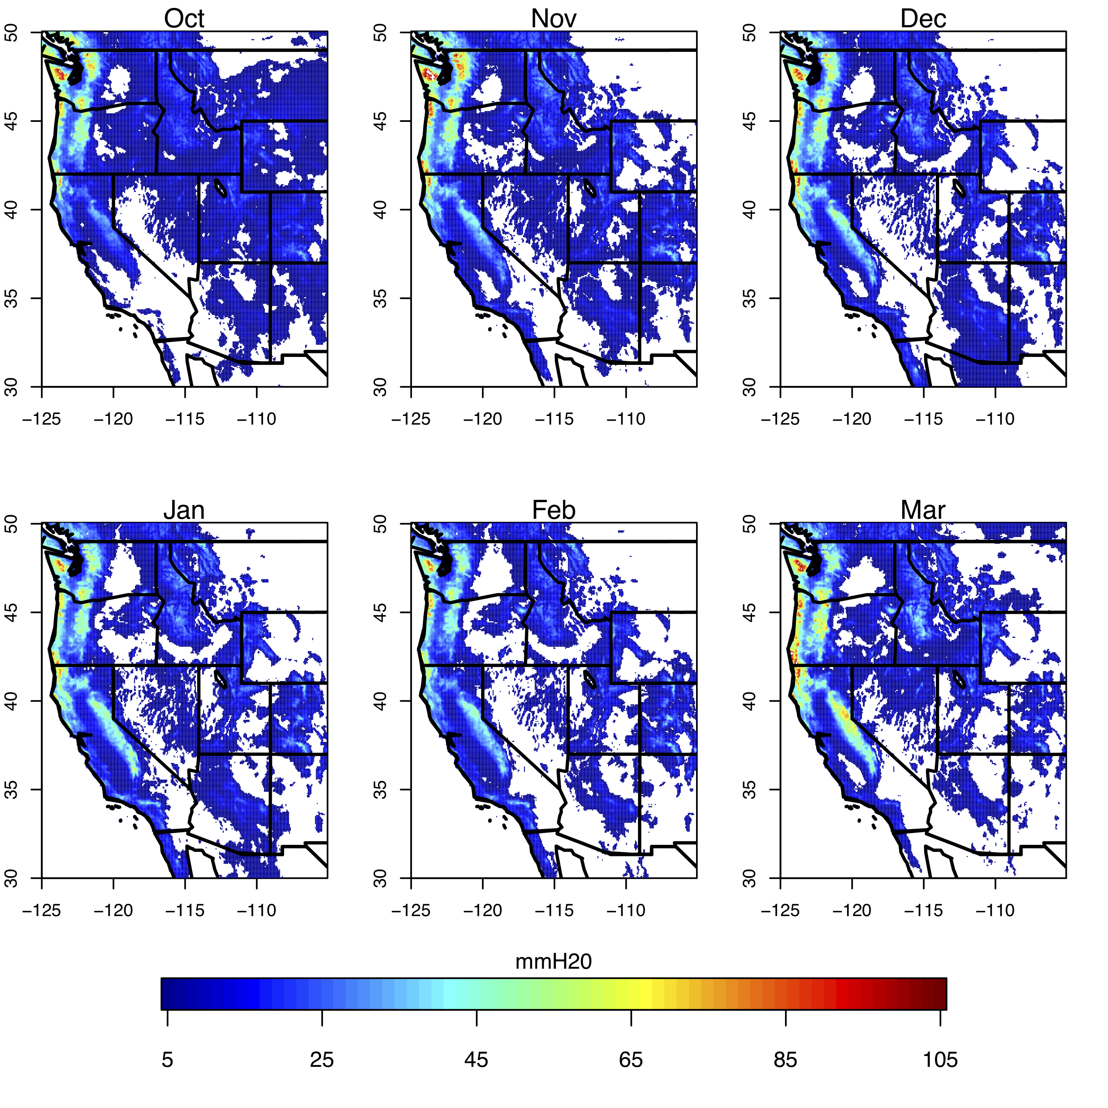
Figure S6. Precipitation composites by month accumulated over the five days leading up to hot (a) and cold (b) SAW days. Daily precipitation is from the Livneh et al. (2015) data set, which has been updated and spans 1950-2018.

October Tmax | November | December
January | February | March
Figure S7. Linear trends in °C Tmax by month over the Western U.S. fitted locally over 1948-2018. Data are gridded daily Tmax observations from Livneh et al. (2015).

