Supplementary Material

1. Interannual variability of sea ice removal
A heating term is added to the non-solar heat fluxes at the ocean surface, with the purpose to prevent new sea ice from forming. The amount of heat added depends on whether there is sea ice at each grid point at initialization, and so is not identical for all years and members. Figure S1 shows the interannual variability of sea ice concentration difference between the perturbed (ICEFREE) and unperturbed run (CTRL).
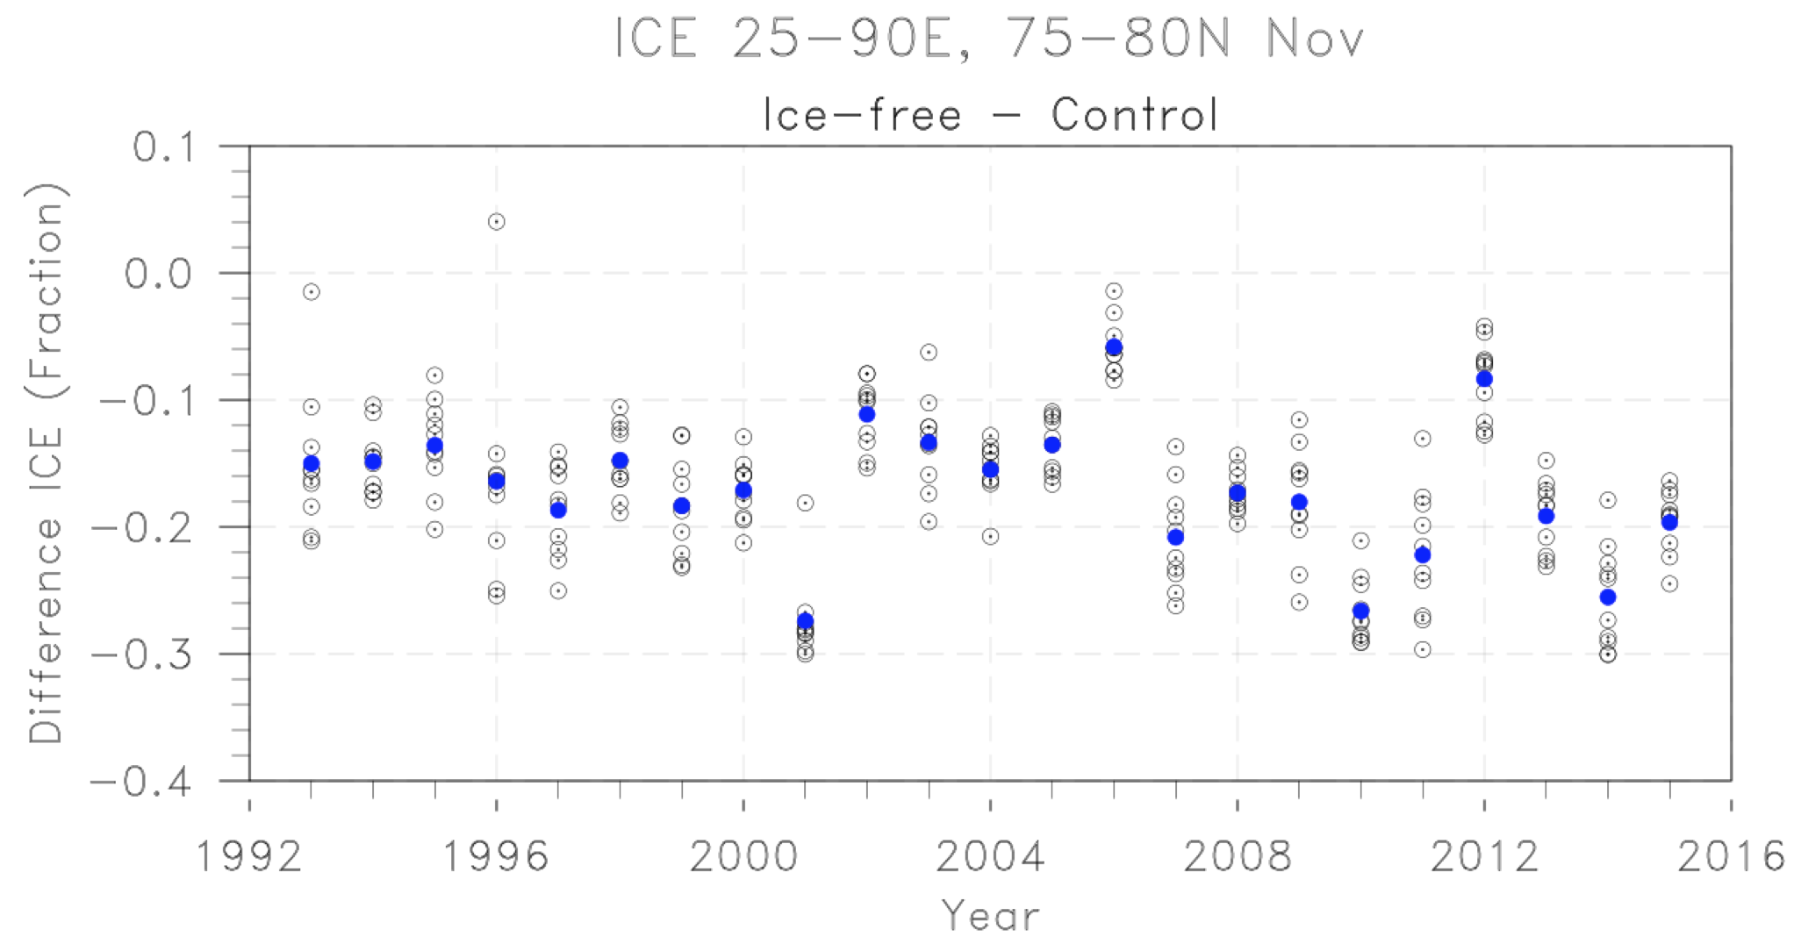

Fig. S1 Time series of relative sea ice removal in the BKS. Ensemble mean differences of November mean sea ice concentration averaged over the BKS (25-90E, 75-80N) between ICEFREE and CTRL (blue dots) and between single members in each year (grey circles).

2. Statistical significance

The statistical significance of the difference between the perturbed (ICE-FREE) and control (CTRL) simulation has been computed according to a test for differences of the mean for paired samples (Wilks, 2011). The following test statistic has been used:

$s =\frac{\underline{Δ} - {μ_{Δ}}_{}}{{(s_{Δ}^{2}/n)}^{1/2}}$

where $\underline{Δ}$ is the difference between the means of the two samples, $μ_{Δ}$is the corresponding population mean, here taken zero under the Null hypothesis, $s_{Δ}^{2}$ is the sample variance of the n differences between the two samples (n=23x10=230 for this study). The statistical significance has been evaluated at the 95% confidence interval.

3. January response to sea ice loss over the Euro-Atlantic sector

Fig. S2 depicts the low-level wind field, near-surface temperature and precipitation response to Barents-Kara Seas sea ice loss in the Euro-Atlantic sector during January.

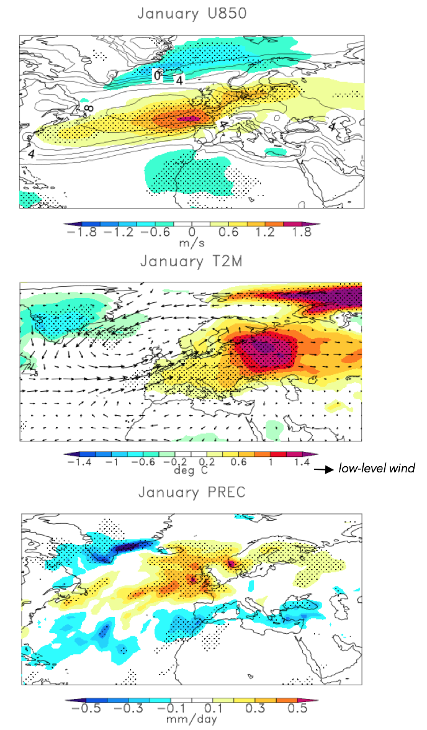
a)

b)

c)

Fig. S2 Euro-Atlantic circulation response during January. Anomalies in a) the zonal component of low-level winds (m s-1; colors), overlaid with climatology (contours; interval 4 ms-1), b) 2m-temperature overlaid with low-level wind vectors, (bottom) total (large scale + convective) precipitation anomaly (mm day-1). All fields are computed as the difference between ensemble means of ICEFREE and CTRL simulations (see main text for further description).

4 Excluding El Nino / La Nina years

1) Without El Nino (1998, 2003, 2005, 2007, 2010)

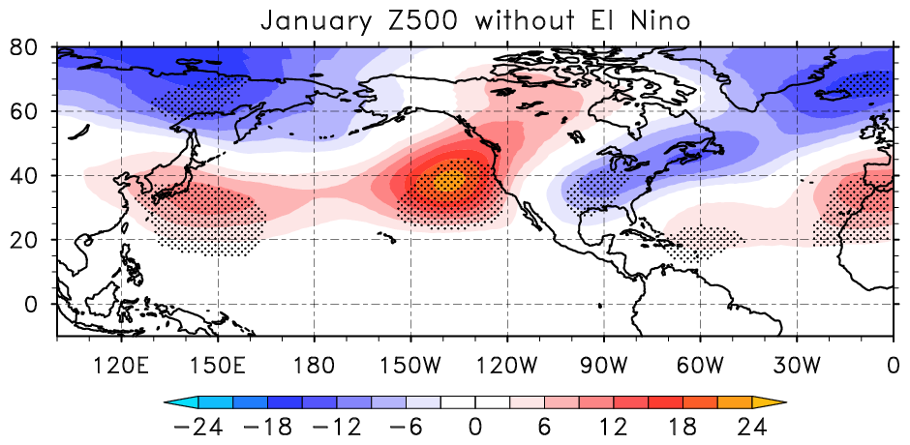
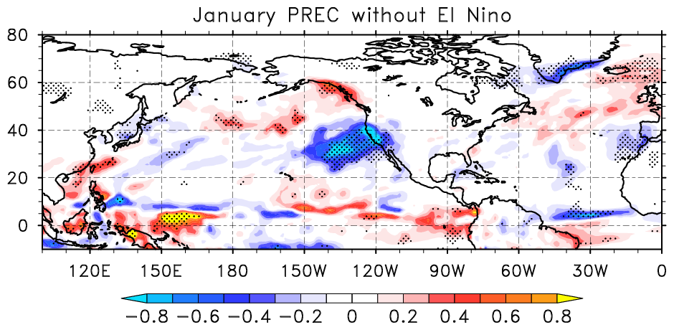
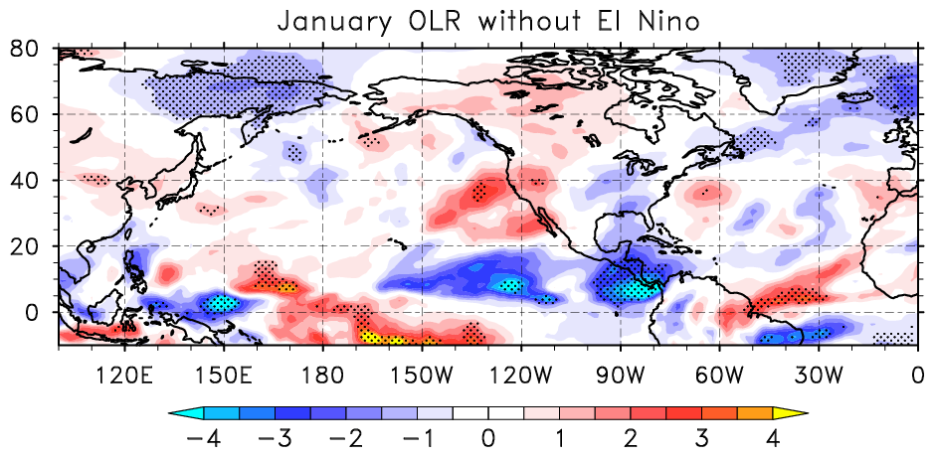

Fig. S3: Ensemble mean difference between ICEFREE and CTRL considering excluding years with a strong El Nino (1998, 2003, 2005, 2007, 2010) (top) Z500, (middle) total precipitation, and (bottom) outgoing longwave radiation (OLR).

2) Without La Nina (1999, 2000, 2001, 2008, 2011)

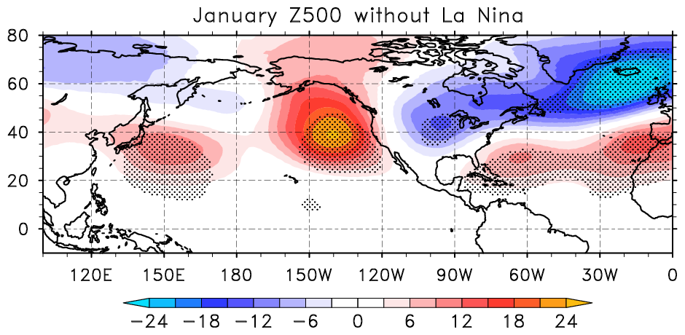
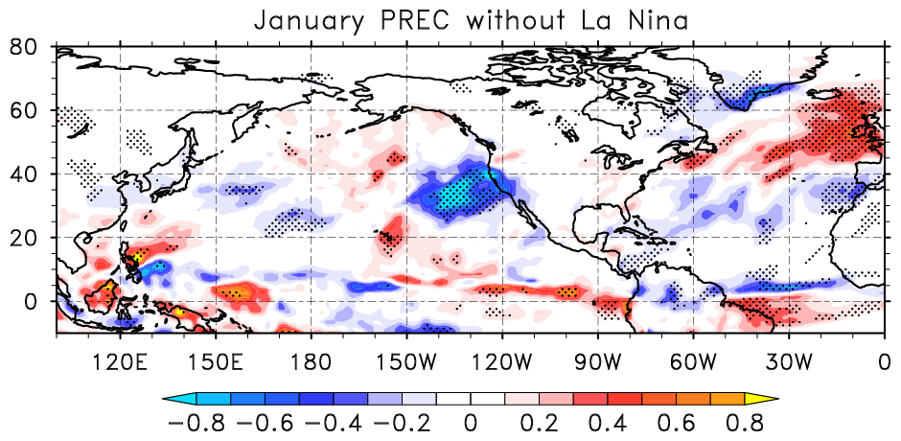
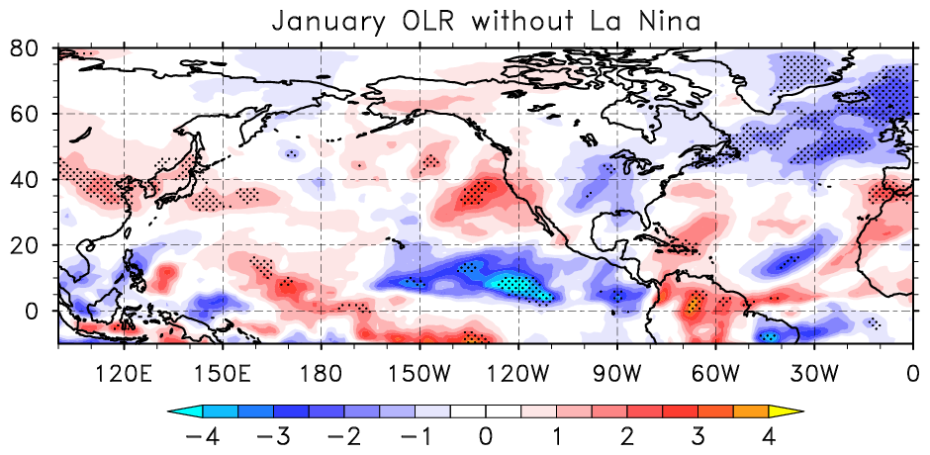

Fig. S4: Ensemble mean difference between ICEFREE and CTRL excluding years with a strong La Nina (1999, 2000, 2001, 2007, 2010) (top) Z500, (middle) total precipitation, and (bottom) outgoing longwave radiation (OLR).

5 Climate signals associated with Arctic sea ice reduction in reanalysis data (LOW-HIGH sea ice years)

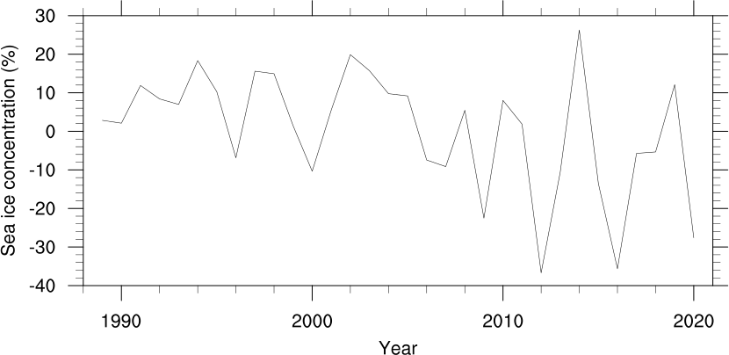

Fig. S5: Detrended sea ice concentration (%) index of the Barents-Kara Seas during the month November from the HadISST data set (Rayner et al., 2003). Low sea ice years are marked with blue dots (2000, 2009, 2012, 2016), high sea ice years are marked with red dots (1994, 1997, 2002, 2014).

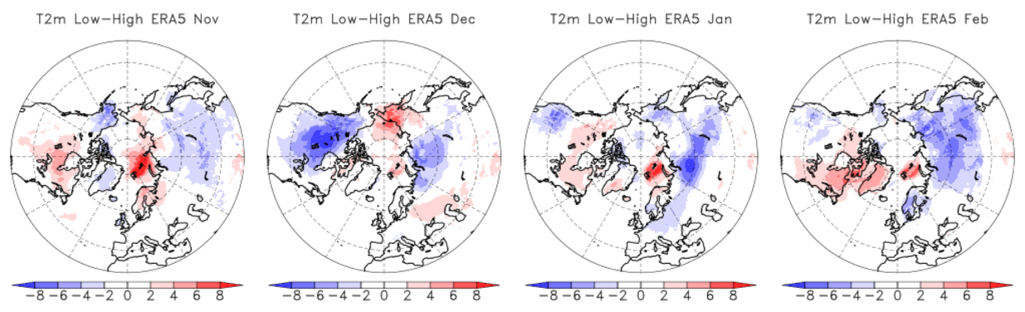
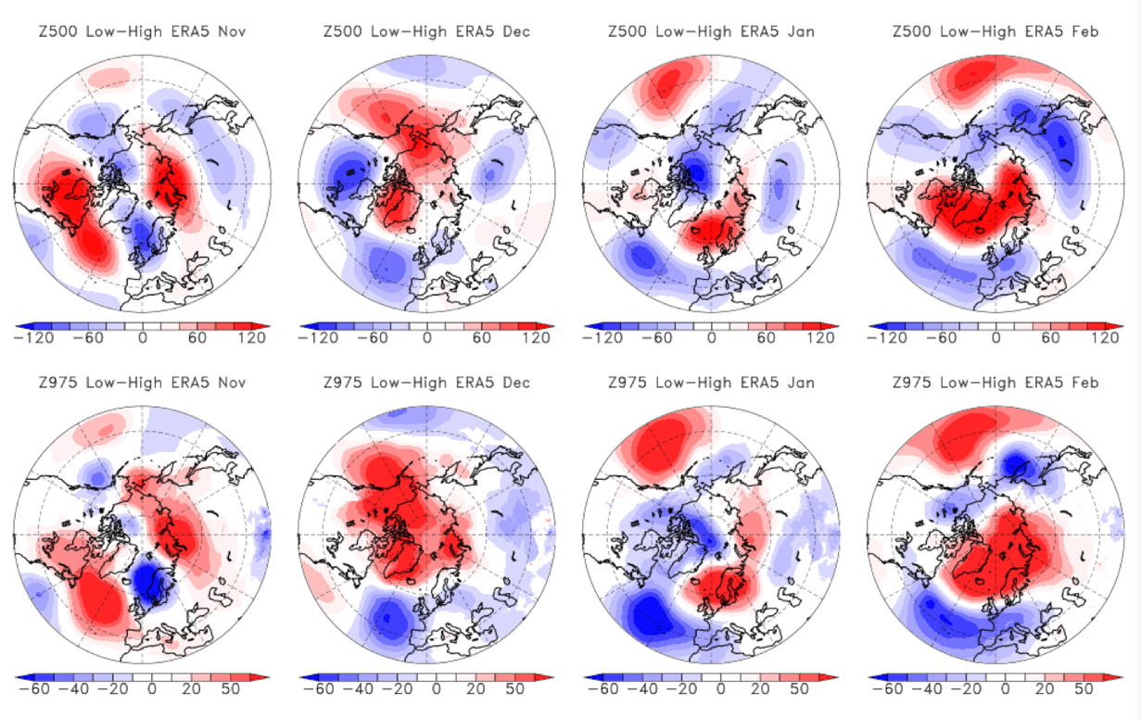

Fig. S6: Composite difference between LOW and HIGH sea ice years (consult Fig. S5) in top) near-surface temperature (°C), middle) Z500 (m), bottom) near-surface pressure (Z975(m)). Data are from the ERA5 data set (Copernicus Atmosphere Monitoring Service (CAMS) and Copernicus Climate Change Service (C3S) data, Hersbach et al., 2019).

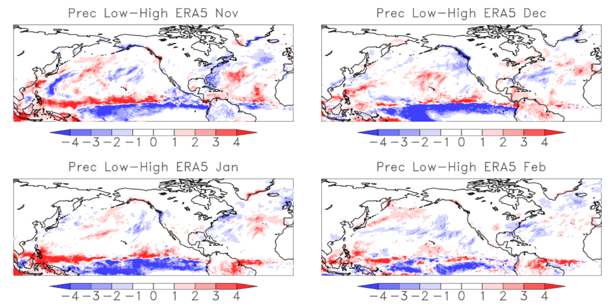

Fig. S7: Composite difference between LOW and HIGH sea ice years (see Fig. S5) in total precipitation (mm). Data stem from the ERA5 data set (Copernicus Atmosphere Monitoring Service (CAMS) and Copernicus Climate Change Service (C3S) data; Hersbach et al., 2019).

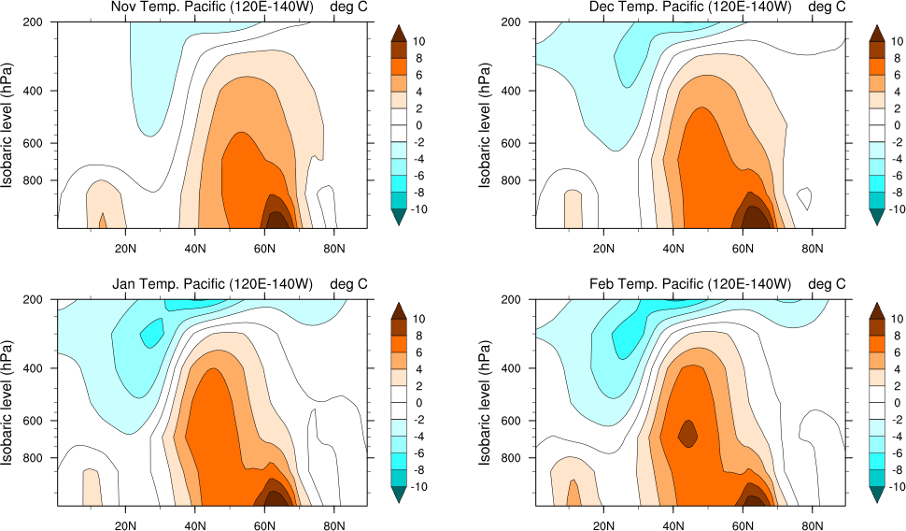

Fig. S8: Height-latitude sections of temperature anomalies in the Pacific sector (120°E-140°W) in ICEFREE minus CTRL.

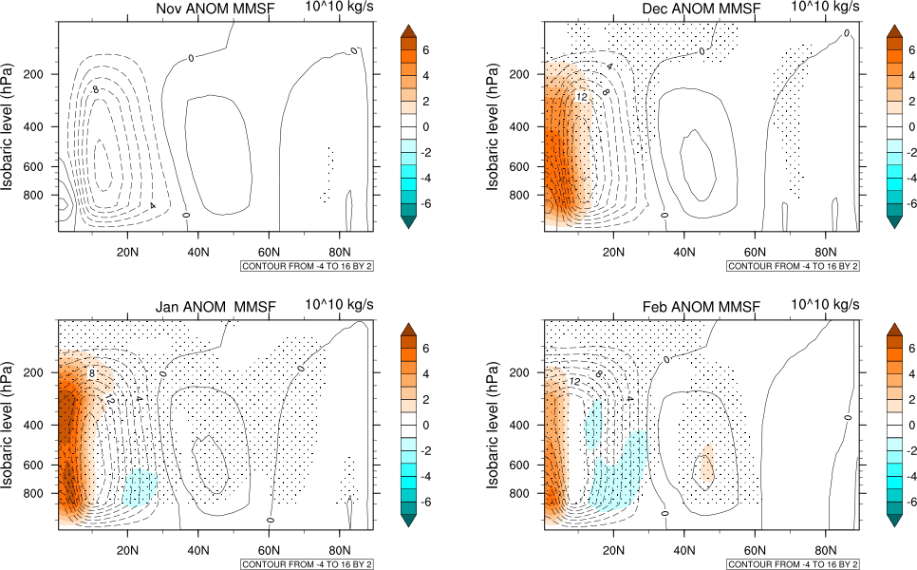

Fig. S9: Height-latitude sections of anomalies in the Pacific zonal mean (120°E-180°E) meridional mass stream function (Tg/s) in ICEFREE minus CTRL.

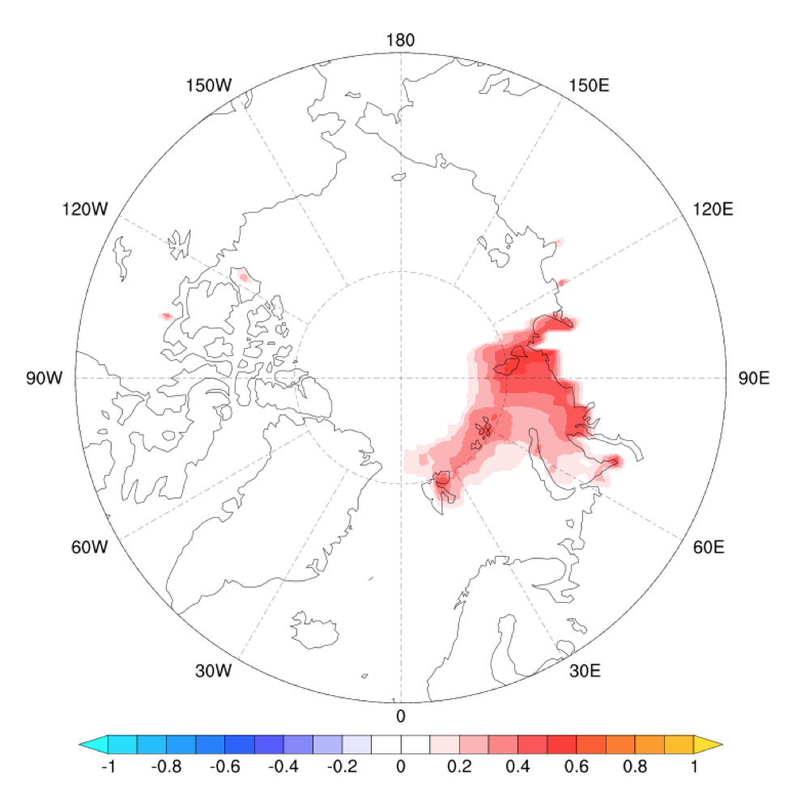

Fig. S.10: Ensemble mean difference of ICEFREE minus CTRL in SST anomalies during November (no statistical significance is shown).

References

Rayner, N. A.; Parker, D. E.; Horton, E. B.; Folland, C. K.; Alexander, L. V.; Rowell, D. P.; Kent, E. C.; Kaplan, A. (2003) Global analyses of sea surface temperature, sea ice, and night marine air temperature since the late nineteenth century J. Geophys. Res.Vol. 108, No. D14, 4407 10.1029/2002JD002670

Hersbach, H., Bell, B., Berrisford, P., Biavati, G., Horányi, A., Muñoz Sabater, J., Nicolas, J., Peubey, C., Radu, R., Rozum, I., Schepers, D., Simmons, A., Soci, C., Dee, D., Thépaut, J-N. (2019): ERA5 monthly averaged data on single levels from 1979 to present. Copernicus Climate Change Service (C3S) Climate Data Store (CDS). Assessed several times in February, 2021.

