Seasonal forecast skill of upper-ocean heat content in coupled high-resolution systems
Ronan McAdam¹, Simona Masina¹, Magdalena Balmaseda², Silvio Gualdi³, Retish Senan² and Michael Mayer^{2,4}.
¹ Ocean Modeling and Data Assimilation Division, Centro Euro-Mediterraneo sui Cambiamenti Climatici, Italy
² European Centre for Medium-Range Weather Forecasts, United Kingdom
³ Climate Simulations and Predictions Division, Centro Euro-Mediterraneo sui Cambiamenti Climatici, Italy
⁴ Department of Meteorology and Geophysics, University of Vienna, Vienna, Austria.
Corresponding author: Ronan McAdam (ronan.mcadam@cmcc.it) (ORCID 0000-0003-0883-9014)
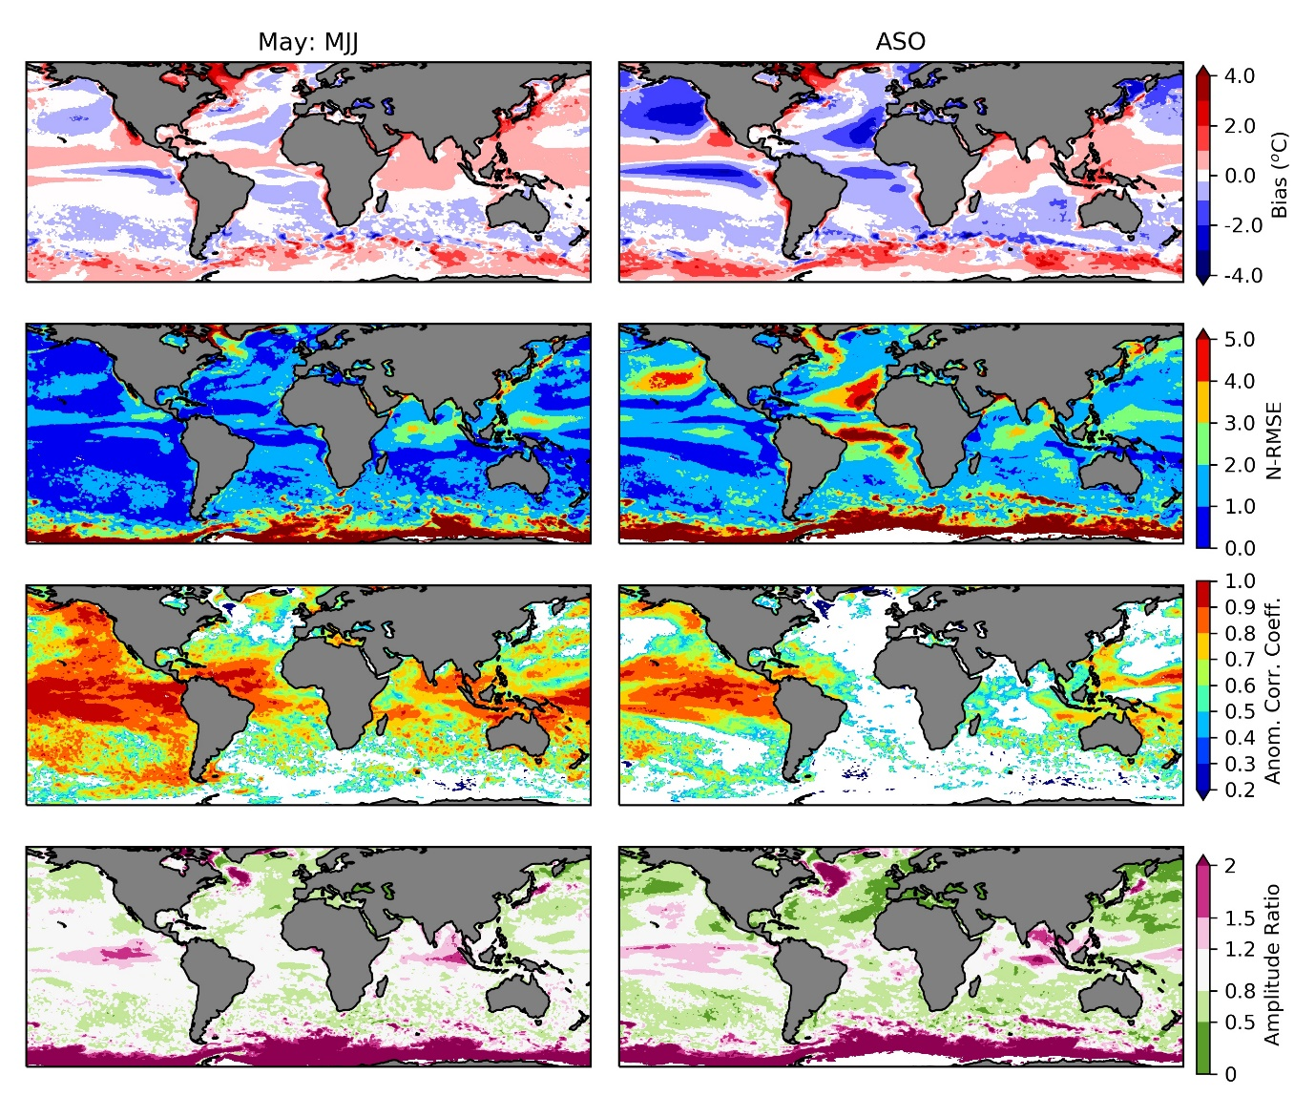
Supplementary Figure 1: Skill measure maps for CMCC-SPS3 re-forecasts of SST initialised in May: Bias, Normalised-RMSE, Anomaly Correlation Coefficient and Amplitude Ratio. Left column: First lead season (May-June-July). Right column: Second lead season (August-September-October). Bias values in the range [-0.25, 0.25] are shown in white. White regions in the correlation maps indicate where correlations are not statistically significant.

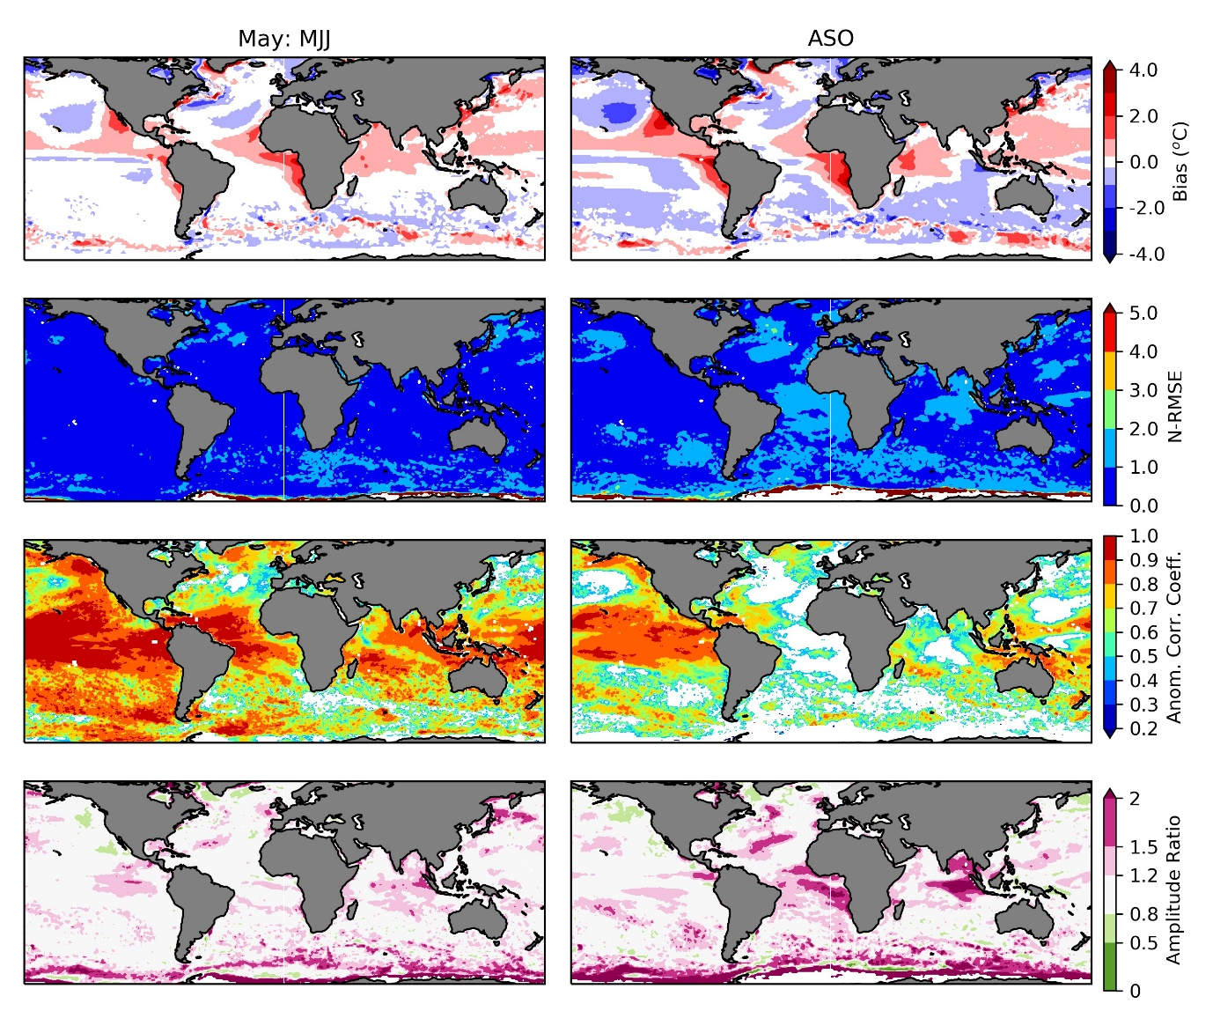
Supplementary Figure 2: Skill measure maps for ECMWF-SEAS5 re-forecasts of SST initialised in May: Bias, Normalised-RMSE, Anomaly Correlation Coefficient and Amplitude Ratio. Left column: First lead season (May-June-July). Right column: Second lead season (August-September-October). Bias values in the range [-0.25, 0.25] are shown in white. White regions in the correlation maps indicate where correlations are not statistically significant.

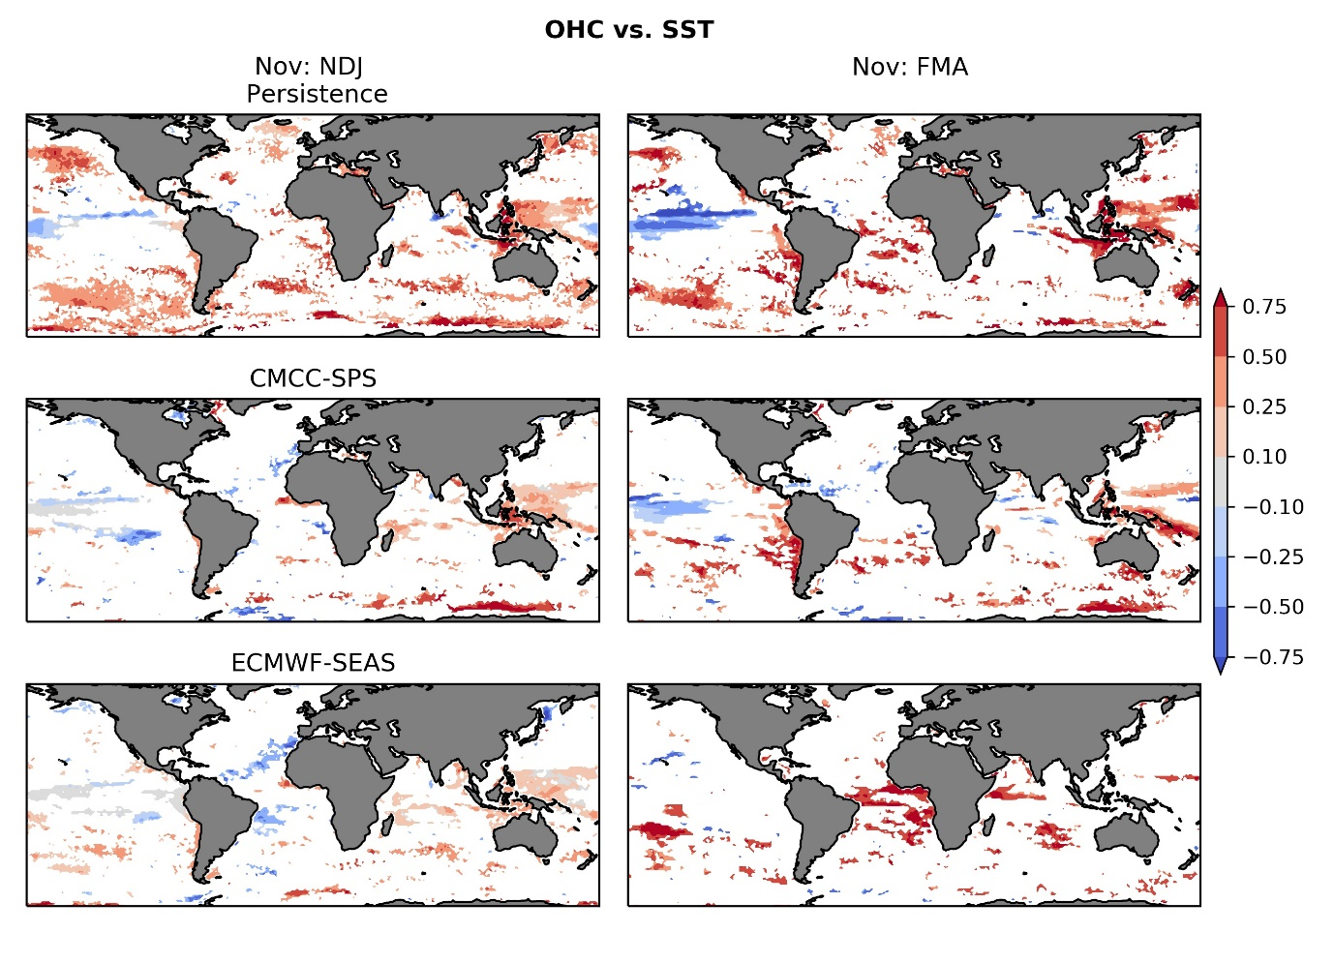
Supplementary Figure 3: Difference in anomaly correlation coefficients for OHC 0-300 m and SST for three different models: Persistence (top), CMCC-SPS3 (middle) and ECMWF-SEAS5 (bottom). Positive values show where OHC skill is greater than SST skill in the corresponding model. Re-forecasts and the persistence model are initialised in November, and the seasonal averages of Lead 0 and Lead 1 seasons are shown. White regions indicate where differences in correlations are not statistically significant.

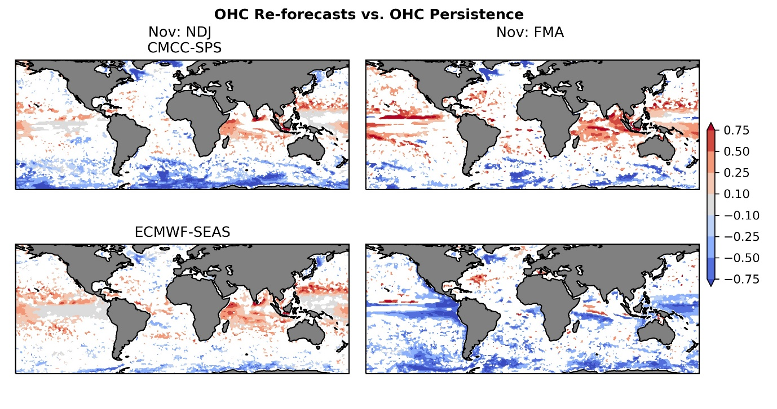
Supplementary Figure 4: Difference in anomaly correlation coefficients for OHC 0-300 m re-forecast and persistence models. Positive values show where OHC skill is greater in the forecast system than in the persistence model. Re-forecasts and the persistence model are initialised in November, and the seasonal averages of Lead 0 and Lead 1 seasons are shown. Top: CMCC-SPS3; Bottom: ECMWF-SEAS5. White regions indicate where differences in correlations are not statistically significant.

