SUPPLEMENTARY MATERIAL

a) 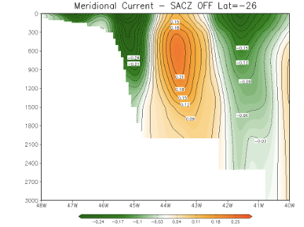
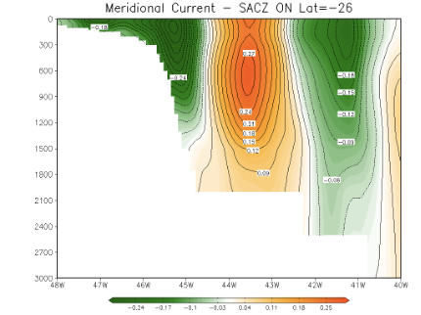
b)
c)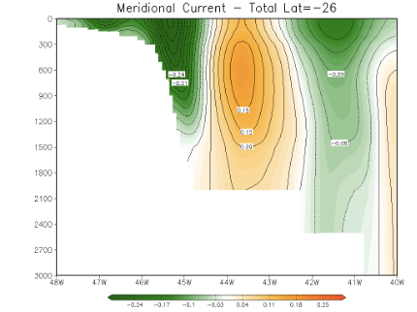
Figure S1 – Vertical section of meridional oceanic current at 26°S. a) Average for all cases of oceanic SACZ. b) Average for the 5 days prior to establishment of the oceanic SACZ. c) Average for the three months of simulations used in this study. For each panel the volume transport (VT) was calculated to be -11.15 Sv (a), -18.37 Sv (b) and -16.98 Sv (c). (1 Sv = 10⁶ m³.s⁻¹).

