Supplementary Figure

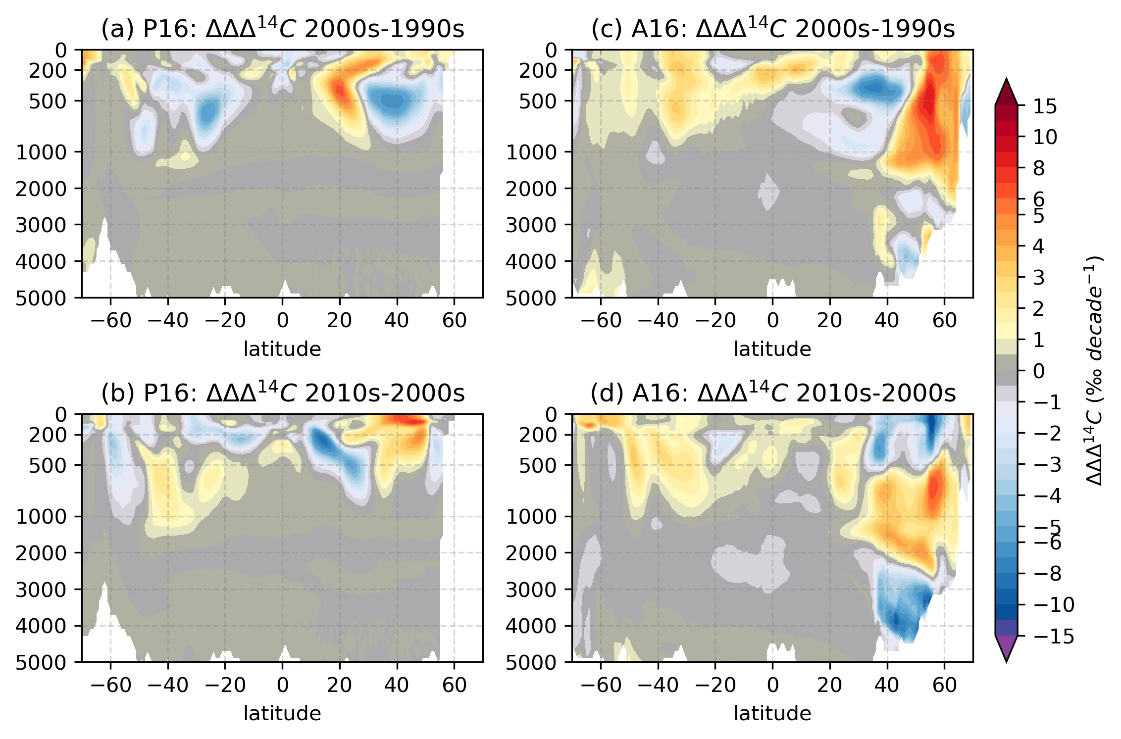
SFig. 1. The effect of variable forcing on changes in bomb-∆¹⁴C over decades along (a,b) P16 in the Pacific Ocean and (c,d) A16 in the Atlantic Ocean. Bomb-∆¹⁴C for the interannually varying atmospheric forcing simulation is calculated as the difference between Hist and Fix, and for the Neutral year forced (steady-state) it is Hist_NYF – Fix_NYF.

