Supplementary Table and Figures

Supplementary Table 1. Summary of different methods utilizing limited area models or regional climate models in studying TCs and climate change
Method | Brief description | References | Sample TC case studies
Direct dynamical downscaling method (Direct DDS) | Directly uses reanalysis data or simulation result from a GCM as the constraints for an RCM | Dickinson et al. (1989)
Surrogate climate change method (SCC) | A simple method for evaluating the regional climate response to thermodynamic changes i.e. temperature warming associated with increasing greenhouse gases due to global warming. Uses idealized or imposed SST change delta. | Sch är et al. (1996) | Shen et al. 2000; Radu et al. 2014; Lavender et al. 2018
Pseudo global warming method (PGW) | Evaluates regional climate responses to thermodynamic and dynamic changes in a large-scale atmospheric mean state (the climatology component) due to global climate change. Uses GCM with reanalysis data. | Kimura and Kitoh (2007) and Sato et al. (2007) | Lynn et al. 2009; Lackman 2015; Nakimura et al. 2016; Parker et al. 2018; Patricola and Wehner 2018; Gutmann et al. 2018; Mittal et al. 2019; Chen et al. 2020; Reddy et al. 2020
Mean bias correction method (MBC) | Generates regional climate with bias-corrected GCM outputs to eliminate biases in the climatology component. Uses bias-corrected GCM data. | Misra and Kanamitsu (2004); Holland et al. (2010) | Bruyere et al. 2014; Holland et al. 2010; Done et al. 2015
Adopted from Adachi and Tomita (2020)

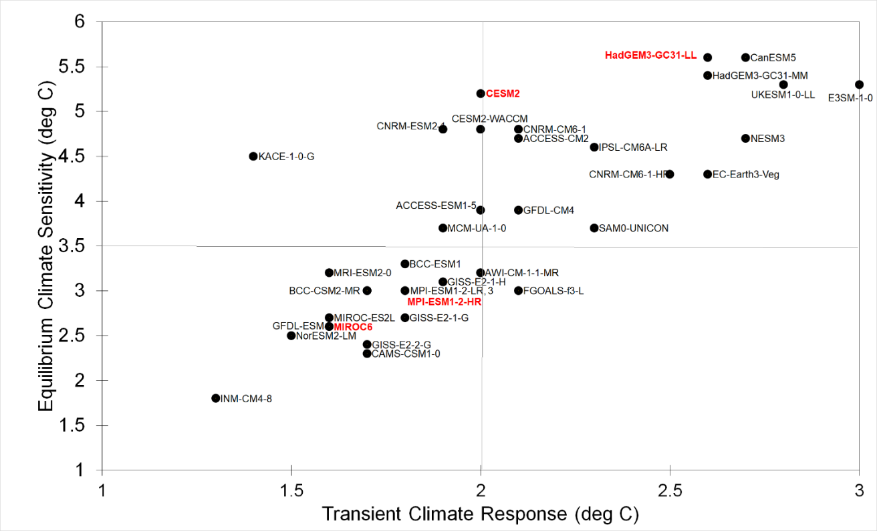
Supplementary Fig. 1 Selected CMIP6 GCMs (in red text font) and their corresponding ECS and TCR based on Meehl et al. 2020. Source of ECS and TCR data: https://advances.sciencemag.org/content/6/26/eaba1981/tab-Fig.s-data

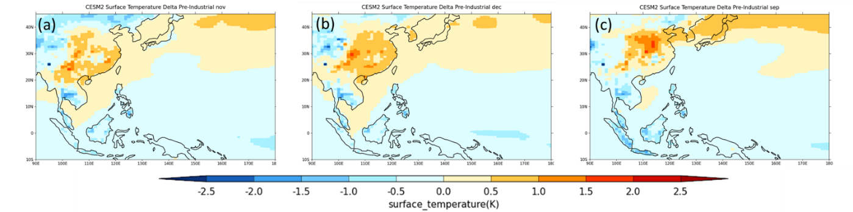

Supplementary Fig. 2 The November (a), December (b) and September (c) monthly mean surface temperature delta (°C) added the boundary and initial conditions of the control runs for Typhoons Mangkhut, Haiyan and Bopha, respectively, to create the pre-industrial climate scenario change from the CESM2 relative to the historical period (1970-1999).

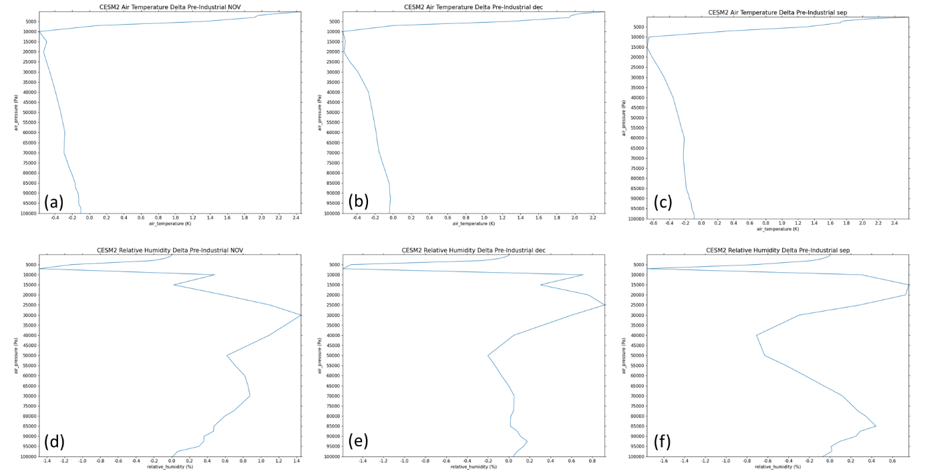

Supplementary Fig. 3 The November (a,d), December (b,e) and September (c,f) monthly mean air temperature (°C, top panel) and relative humidity (%, bottom panel) delta added the boundary and initial conditions of the control runs for Typhoons Mangkhut, Haiyan and Bopha, respectively, to create the pre-industrial climate scenario change from the CESM2 relative to the historical period (1970-1999).

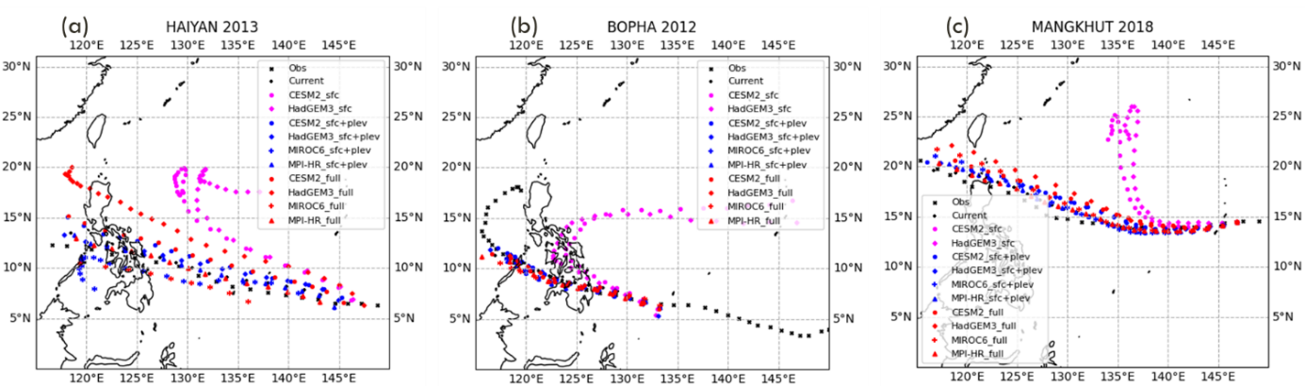
Supplementary Fig. 4 Observed (IBTrACS) and simulated tracks of the different TC cases - Typhoon Haiyan (a), Typhoon Bopha (b), and Typhoon Mangkhut with the surface level delta (SFC), surface and atmospheric level delta (SFC+PLEV) and surface and atmospheric level with relative humidity delta (FULL) experiments forced with deltas from different GCMs.

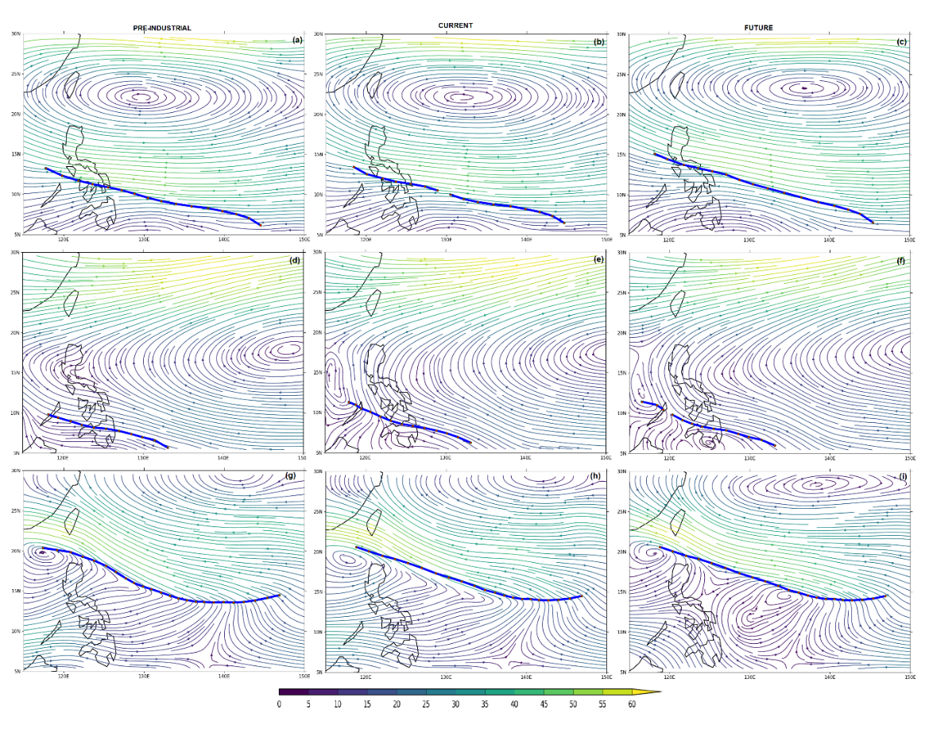
Supplementary Fig. 5 Simulated track (blue lines) and steering flow (streamlines, calculated as winds averaged between 500hPa & 700hPa) averaged over the entire period of the 5kmCU experiments for Typhoon Haiyan (a, b, c), Bopha (d, e, f), and Mangkhut (g, h, i) under pre-industrial (left), current (middle) and future (right) climate from the runs using deltas from CESM2. Minimal changes in the streamlines were observed.
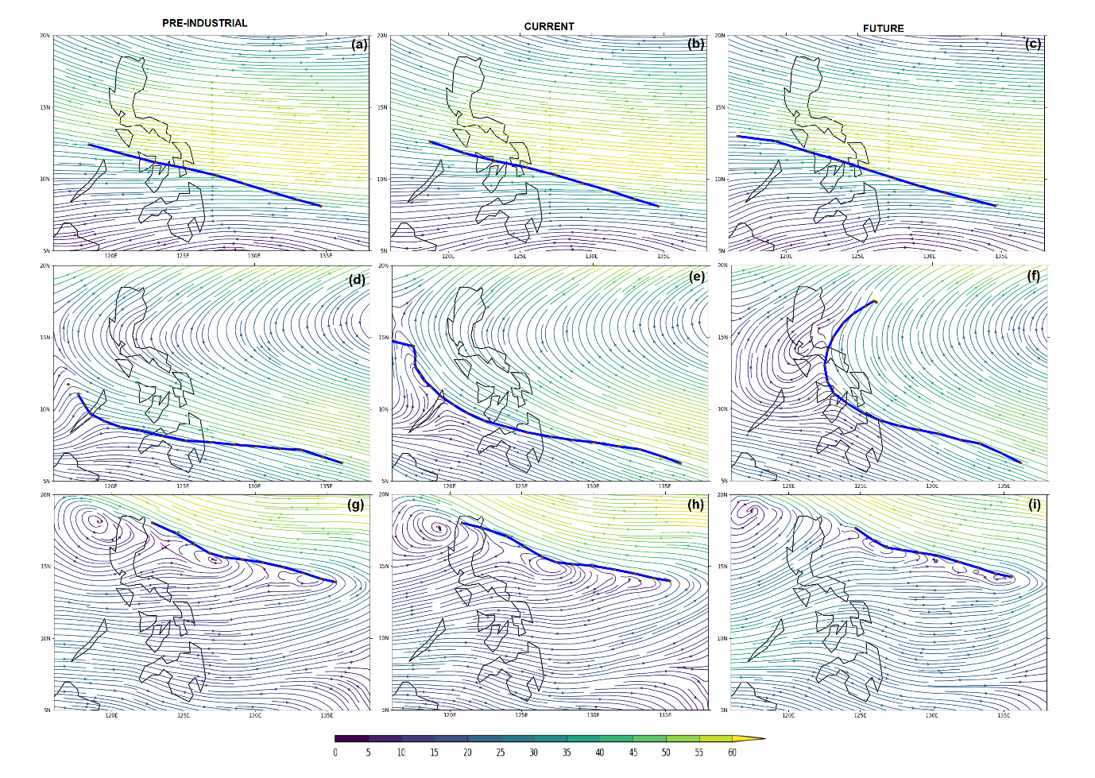
Supplementary Fig. 6 same as Supplementary Fig. 5 but for the 3kmNoCU experiments

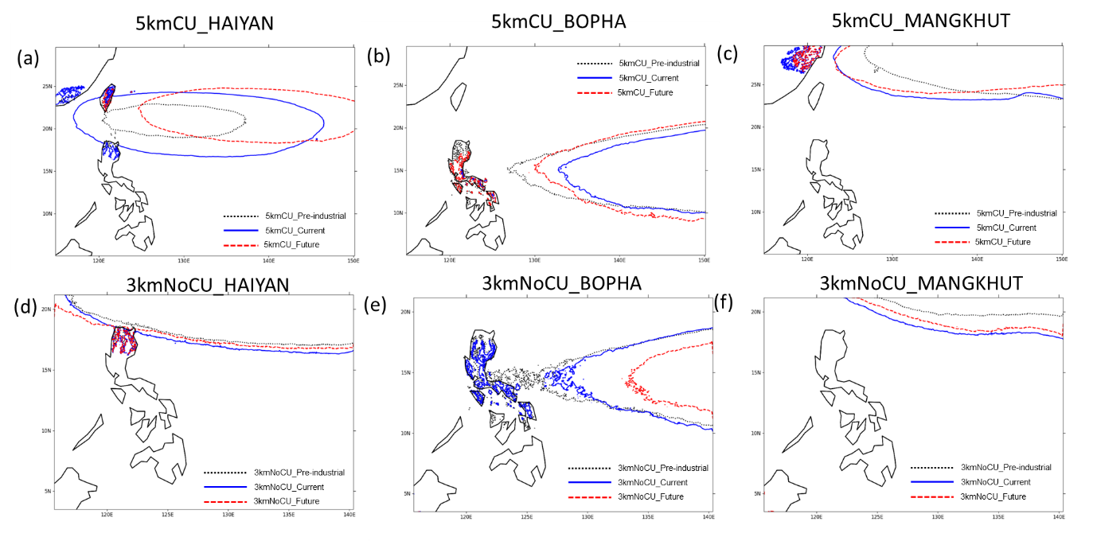
Supplementary Fig. 7 The contours representing the location of the Western North Pacific Sub-tropical High (5800 gpm Geopotential Height at 500hPa) for the 5kmCU (top panels) and 3kmNoCU (bottom panel) experiments under the pre-industrial (black dotted lines), current (blue lines), and future (red dashed lines) climate for Typhoon Haiyan, Bopha, and Mangkhut

