Selecting regional climate models based on their skill could give more credible precipitation projections over the complex Southeast Asia region
Phuong-Loan Nguyen^{1,2*}, Margot Bador³, Lisa V. Alexander^{1,2}, Todd P. Lane^{4,5}
¹Climate Change Research Centre, UNSW Sydney, Sydney, New South Wales, Australia
²ARC Centre of Excellence for Climate Extremes, UNSW Sydney, Sydney, New South Wales, Australia
³ CECI, Université de Toulouse, CERFACS/CNRS, Toulouse, France
⁴School of Geography, Earth and Atmospheric Sciences, The University of Melbourne, Melbourne, Victoria, Australia
⁵ARC Centre of Excellence for Climate Extremes, The University of Melbourne, Melbourne, Victoria, Australia

January 31, 2023

Supplementary Materials
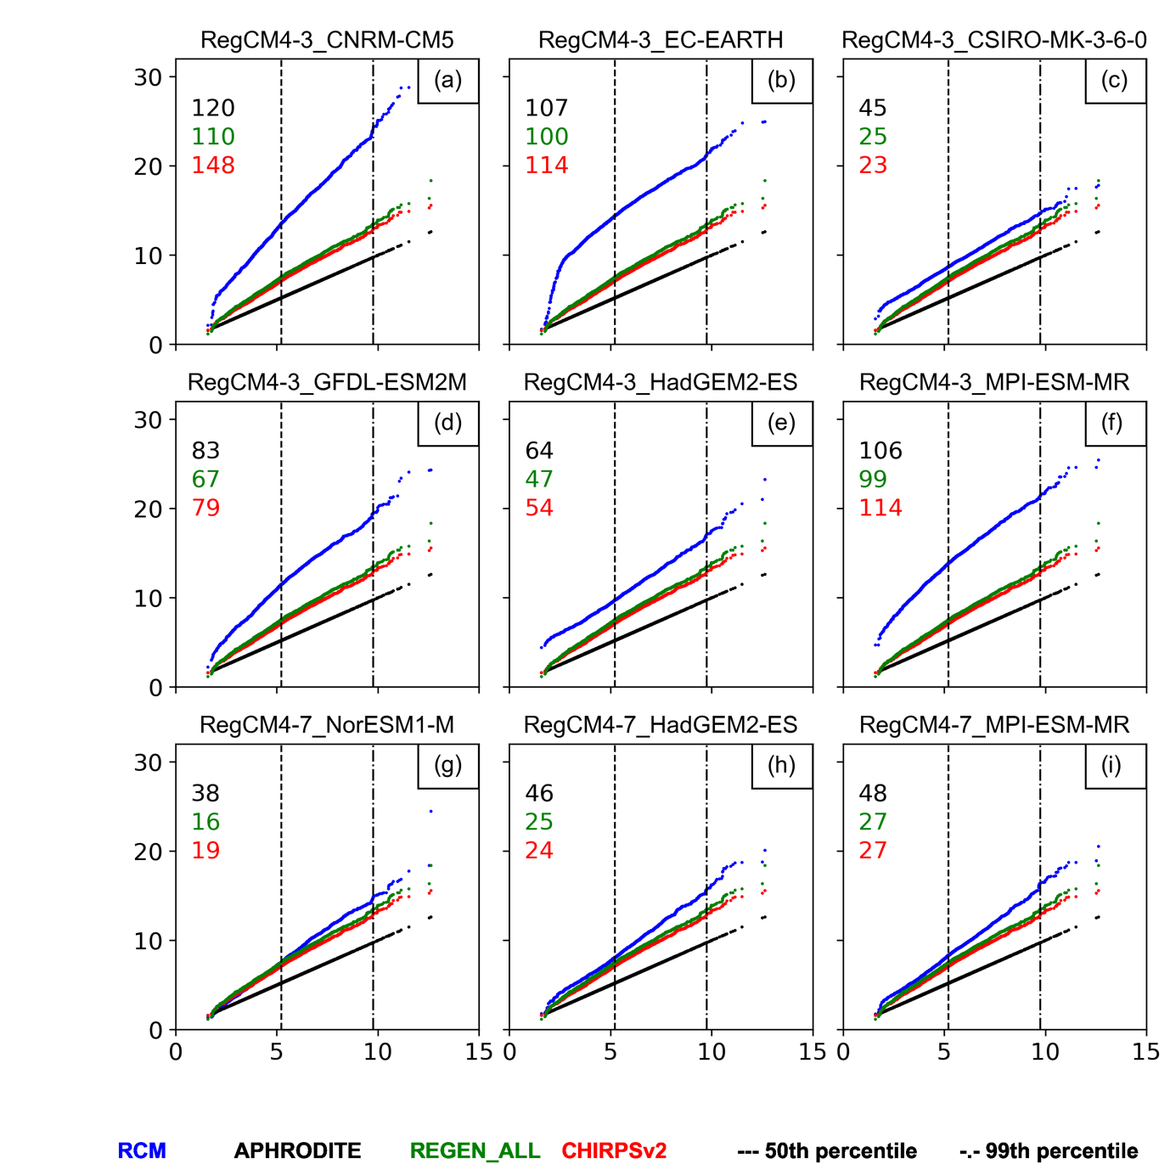
Figure s1. Quantile-quantile plots for daily regional-averaged precipitation (in mm day⁻¹) during the climatological period of (1982-1005) from RegCM simulations (blue), REGEN_ALL (green), CHIRPSv2 (red) against APHRODITE (black) for the boreal summer (JJAS). All simulations are on the coarsest forcing GCMs grid (i.e., NorESM1-M, ~240km). Inserted numbers indicate values of the area score metric (ASM) which measure the proximity between two distributions: RCMs and different observations (different colors).
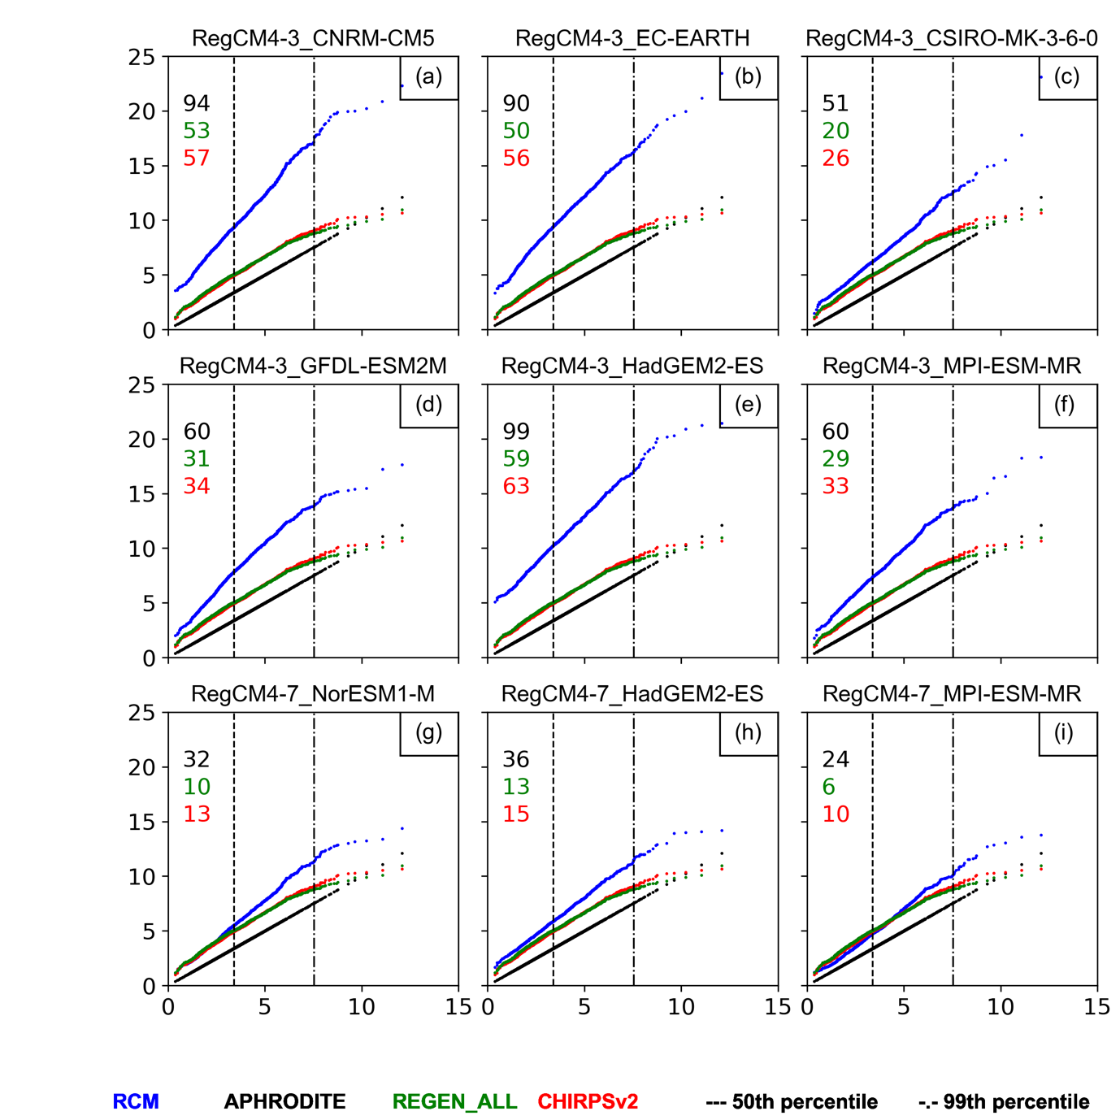
Figure s2. Same as Figure s1 but for boreal winter (December-January-February).

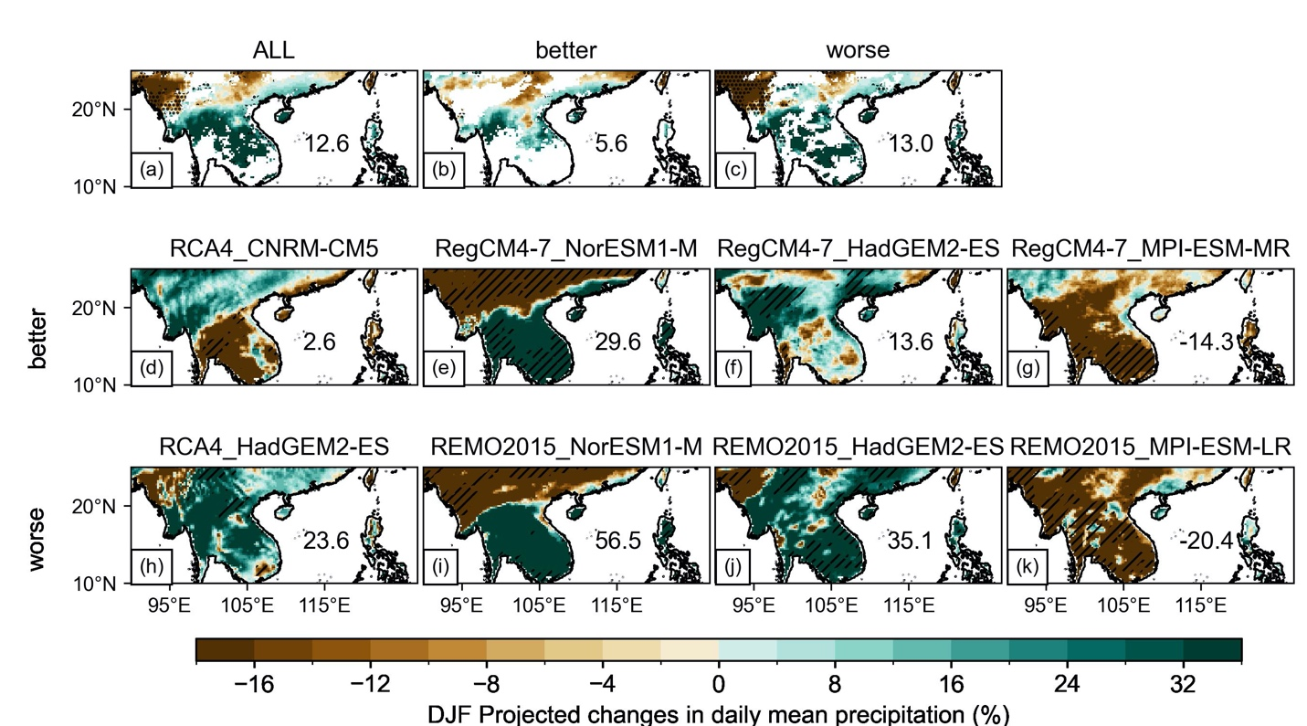
Figure s3. Changes in the seasonal mean of winter daily precipitation (relative to the Historical, %) between 2070-2099 (RCP8.5) and 1976-2005 historical for different ensemble models: ALL, ‘better’ and ‘worse’ (top-panels) and for individual simulation (panels underneath), zoomed in over northern parts of Southeast Asia (90$°$-127$°$E, 10$°$ -25$°$N). See section 2.3 to learn more on how significance is treated in the ensemble means. For the individual model, the hatching indicates significant changes at a 10% level of confidence according to the Mann-Whitney U test. The inserted number indicates the regionally-averaged precipitation changes over the land points of sub-region.

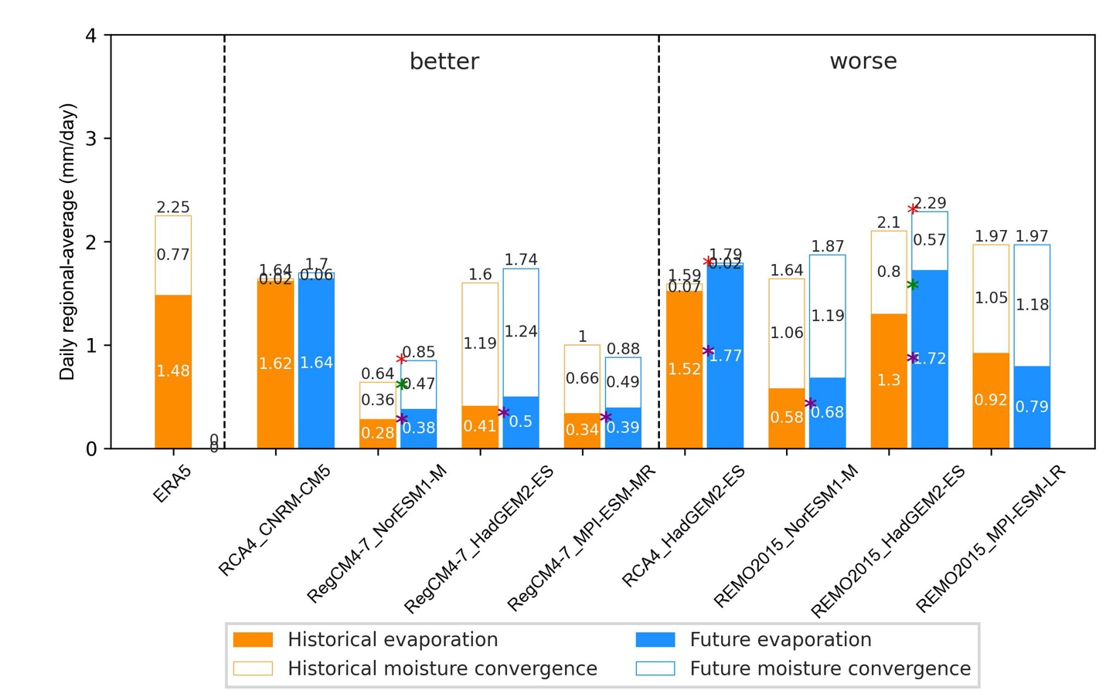
Figure s4. Comparison of winter (DJF) mean of daily regionally-averaged evaporation (color-filled) and moisture convergence (color) (land only, in mm/day) simulated by all RCMs’ simulation (Table 1) between the climatological period (1976-2005, orange) and the end of twenty-first century period (2070-2099; blue) over northern parts of Southeast Asia (90$°$-127$°$E, 10$°$N – 25$°$N). The red, purple, and green asterisks indicate the significant differences between the historical and future precipitation, evaporation, and moisture convergence respectively at a 10% level of significance according to Mann-Whitney U-test. The vertical dashed black lines mark the gaps between reanalysis, ‘better’, and ‘worse’ ensembles.
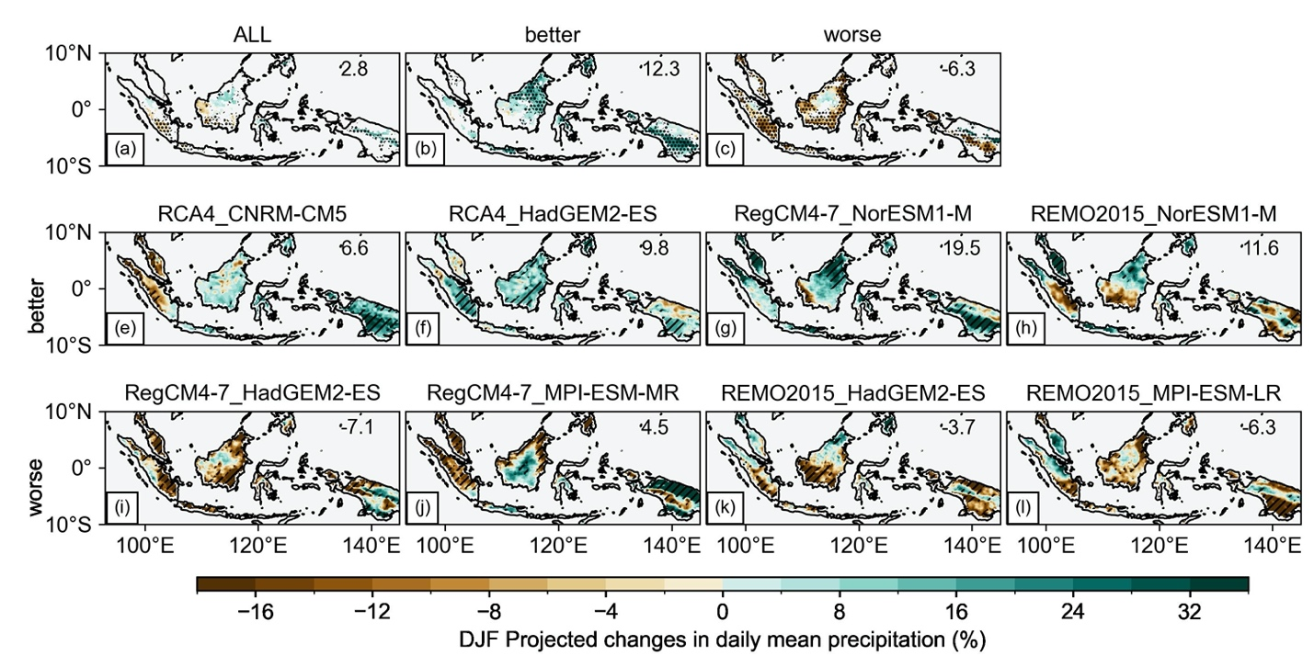
Figure s5. Same as Figure s3 but zoom in for changes in winter daily precipitation over the southern parts of SEA (e.g., Maritime Continent, Papua, and the southern Philippines) (93$°$-145$°$E, 10$°$S – 10$°$N).

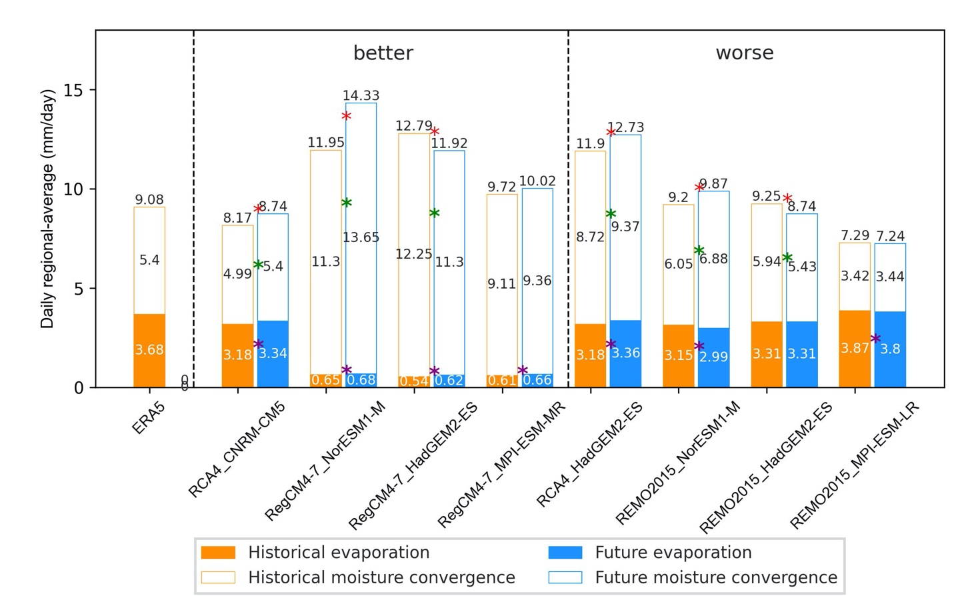
Figure s6. Same as Figure s4 but for over southern parts of Southeast Asia (e.g., Maritime Continent, Papua and southern Philippines) (93$°$-145$°$E, 10$°$S – 10$°$N).

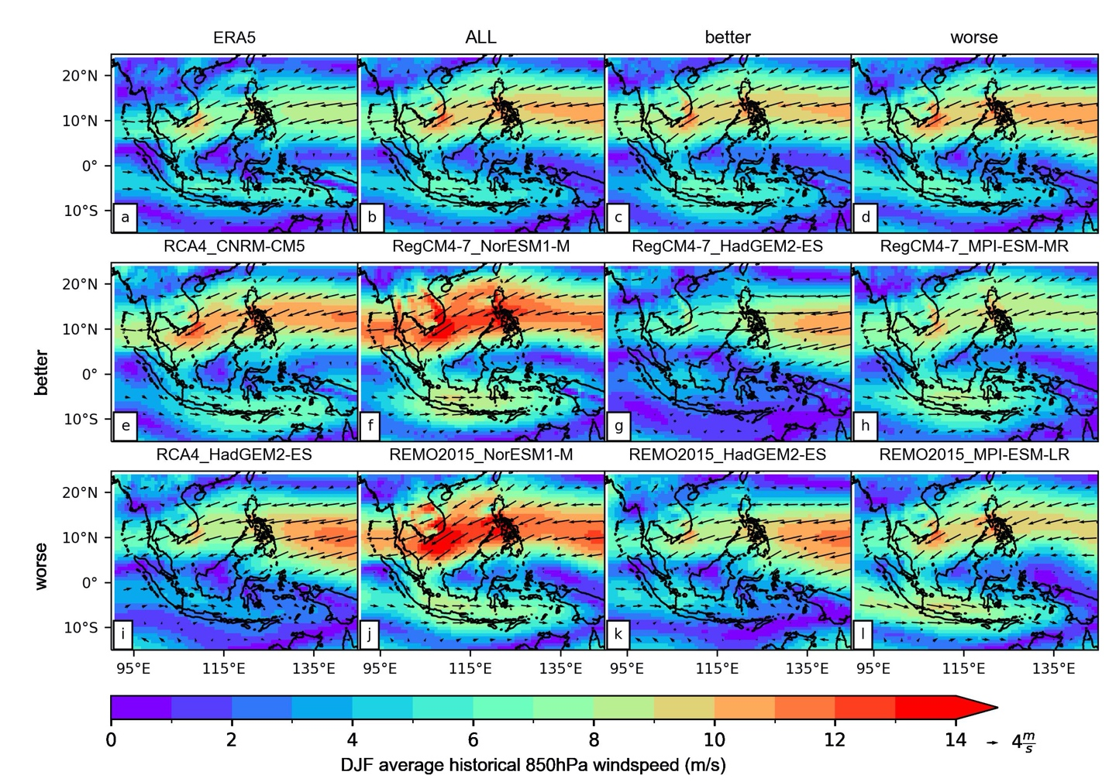
Figure s7. Spatial distribution of the observed climatological (1979-2005) low-level wind circulation during the summer (JJAS) (vector) in (a) the ERA5 reanalysis, the ALL, ‘better’, and ‘worse’ ensembles (b-d), and for all individual RCM simulations listed in Table 1. Shading indicates the magnitude of wind (in mm s⁻¹).
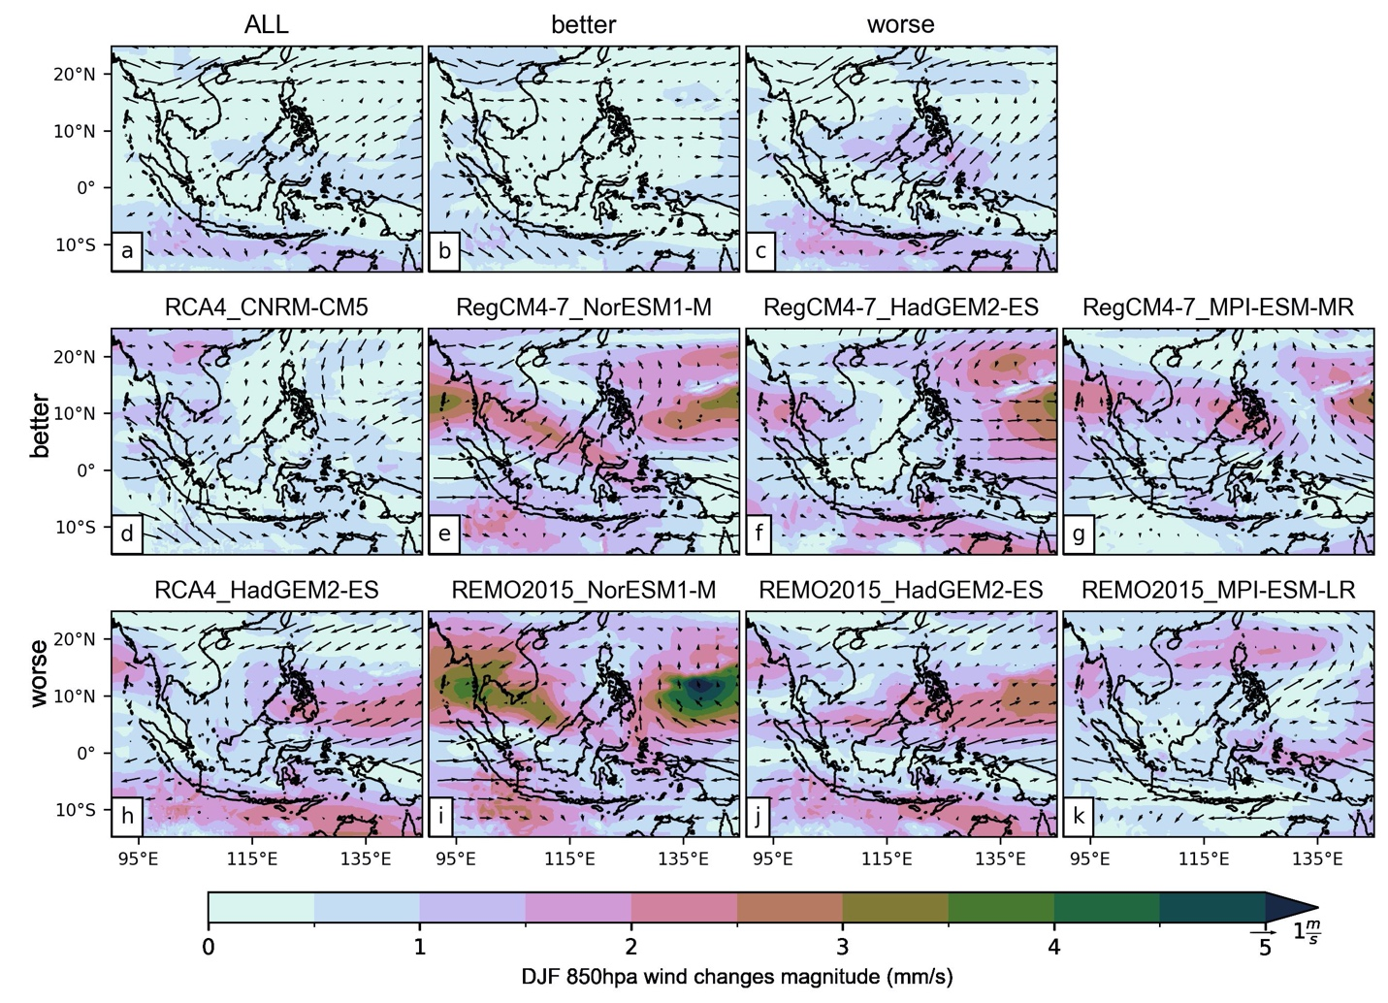
Figure s8. The projected changes in the low-level wind (850 hPa) for the late 21st century (2070-2099) over three model ensembles: ALL, ‘better’ and ‘worse’ (Table 1) (a-c) and for individual simulations (d-k, Table 1) are relative to the historical period (1976-2005) for the boreal winter (DJF). The shading indicates the magnitude of changes (in mm s⁻¹).
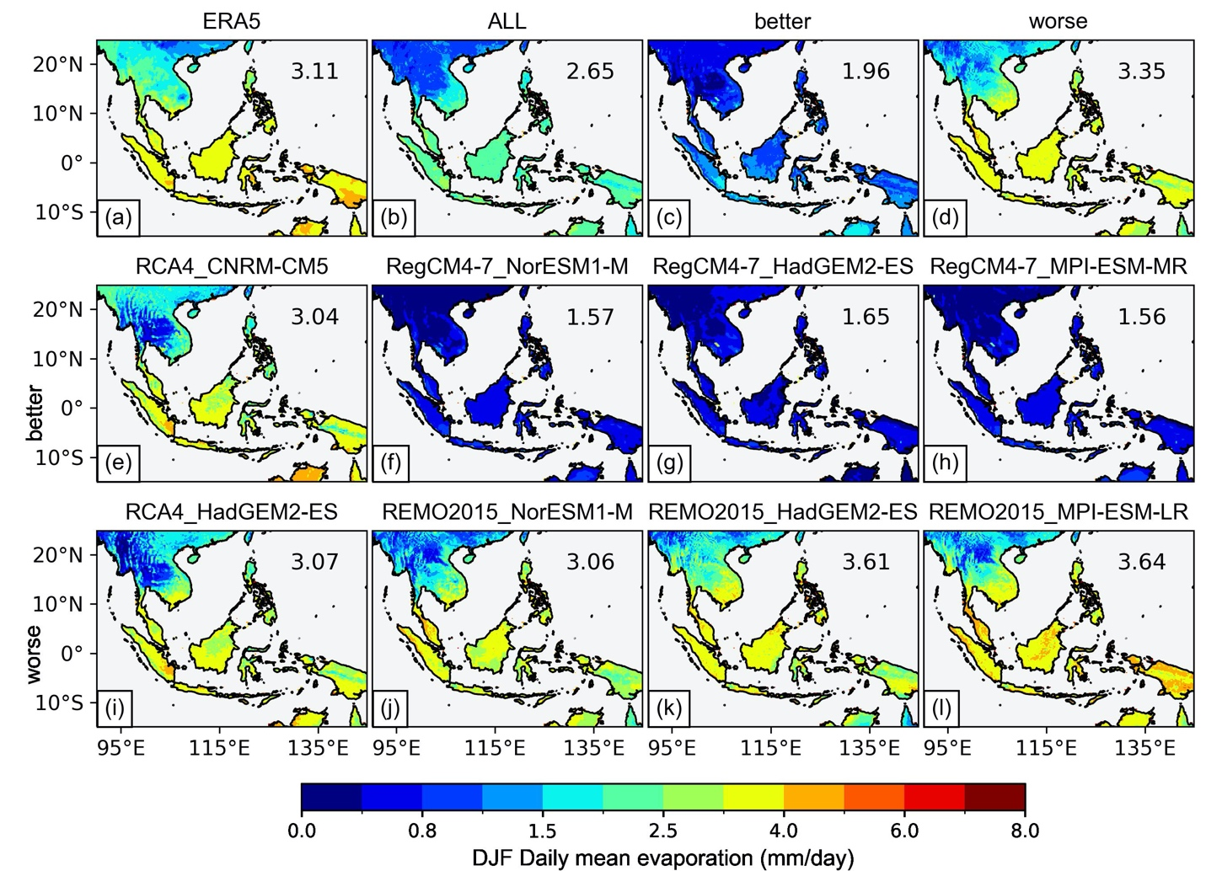
Figure s9. Spatial distribution of the observed climatological (1979-2005) evaporation (in mm/day) during the boreal winter (DJF) in the ERA5 reanalysis (a), the ALL, ‘better’ and ‘worse’ ensembles (b-d) and for all individual RCM simulations listed in Table 1.
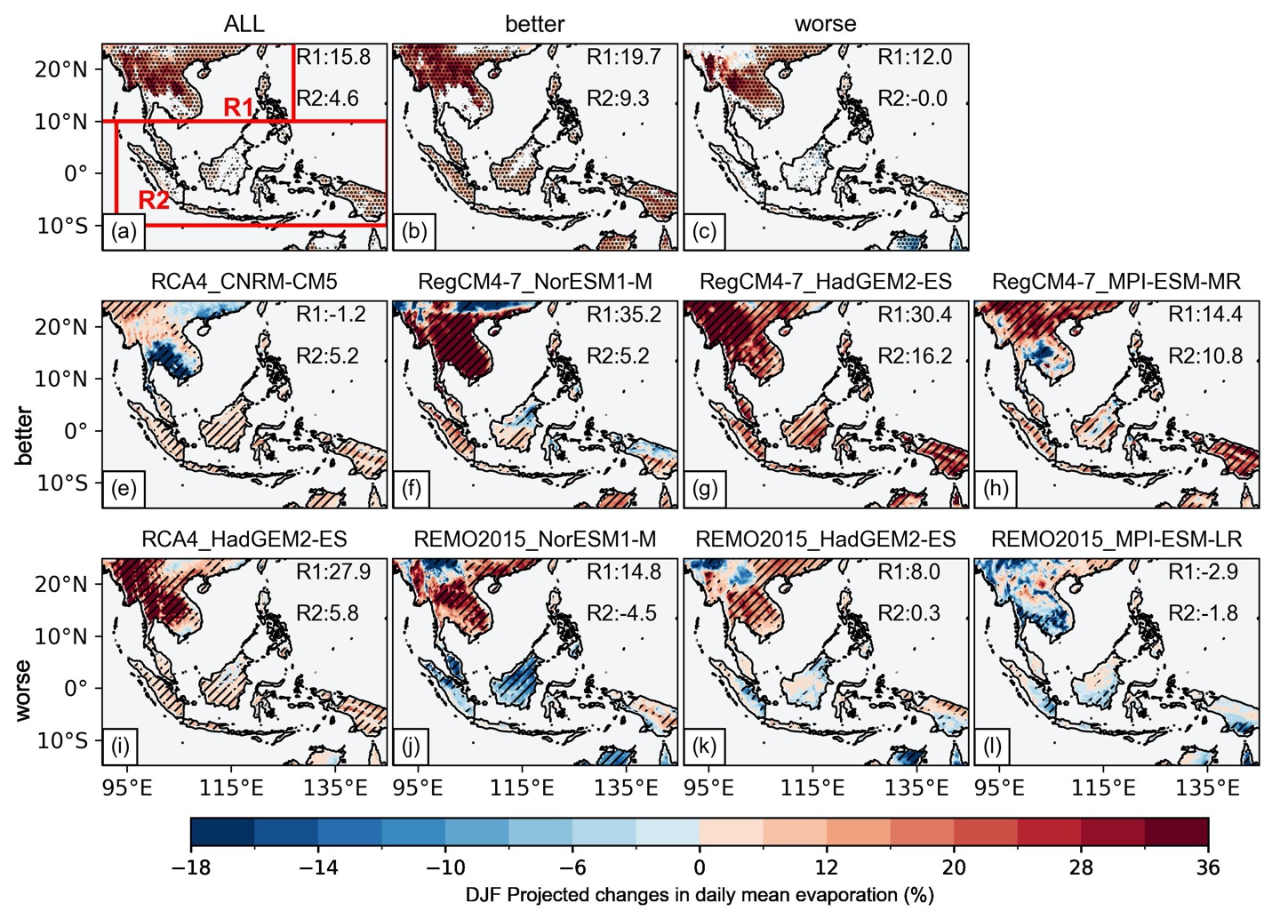
Figure s10. Changes in the mean of winter daily evaporation (relative to the Historical, %) between 2070-2099 (RCP8.5) and 1976-2005 historical for different ensemble models: ALL, ‘better’ and ‘worse’ (top-panels) and for individual simulation (panels underneath). For the individual model, the hatching indicates significant changes at a 10% level of confidence according to the Mann-Whitney U test. For ensemble mean of projections, statistically insignificant areas are shown in color, denoting that less haft of the models are significantly changed. In significant agreeing areas (stippled), at least half of RCMs are significant biases and at least 75% of the significant model agree on the direction of biases. Significant disagreement areas are shown in white. The inserted number indicates the regional-averaged evaporation changes over the land points of sub-region.
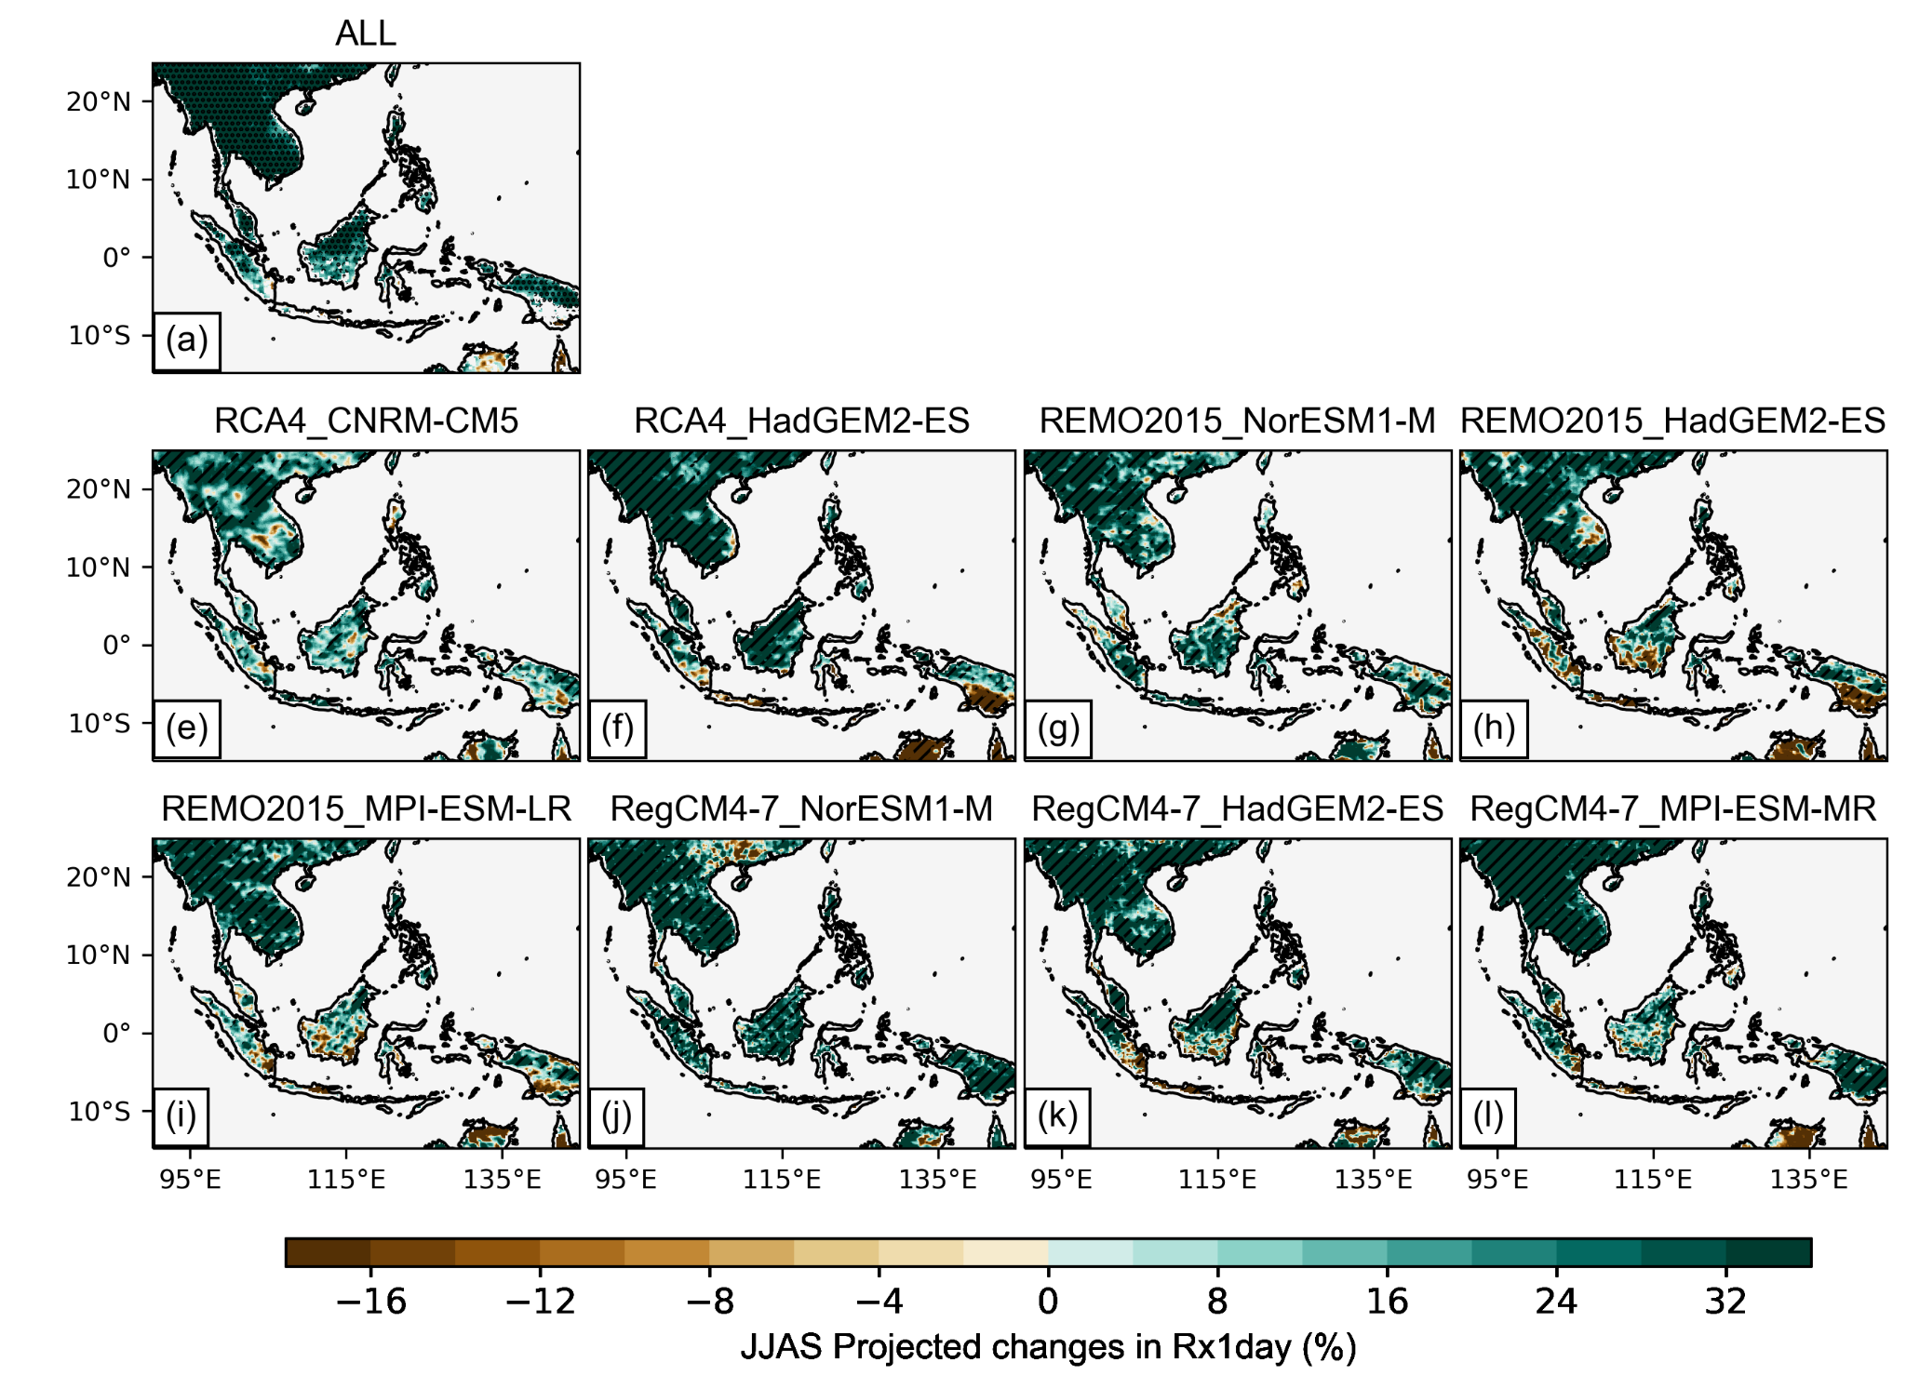
Figure s11. Changes in the mean of summer wettest day (Rx1day) (relative to the Historical, %) between 2070-2099 (RCP8.5) and 1976-2005 historical for ensemble mean (ALL) and individual simulation (panels underneath). For the individual model, the hatching indicates significant changes at a 10% level of confidence according to the Mann-Whitney U test. For ensemble mean of projections, statistically insignificant areas are shown in color, denoting that less haft of the models are significantly changed. In significant agreeing areas (stippled), at least half of RCMs are significant biases and at least 75% of the significant model agree on the direction of biases. Significant disagreement areas are shown in white.
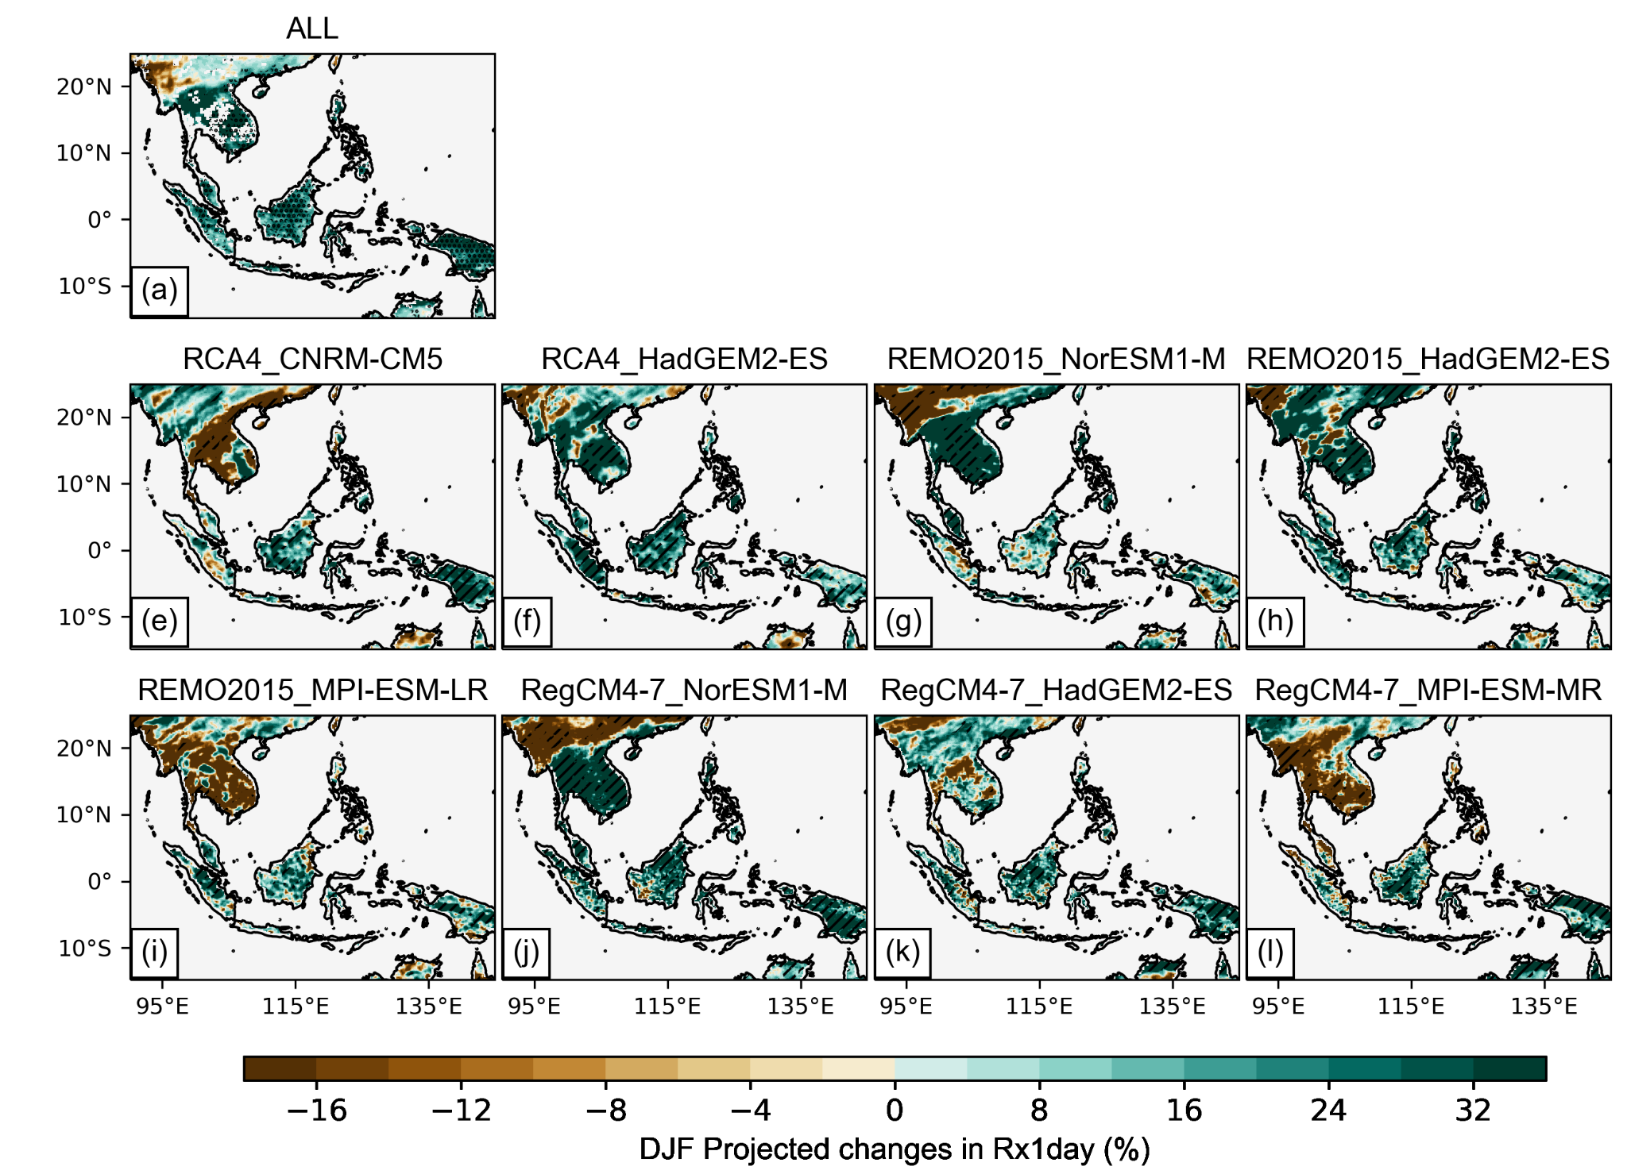
Figure s12. Same as Figure s11 but for the boreal winter (DJF).

Table s1. Ranking of RCM simulations for seasonal daily precipitation based on RMSE and ASM with ERA5 taken as reference. The skill metrics are calculated based on: the land points of SEA domain only at: 0.25-degree and 1-degree resolution. The green and yellow colors indicate the “better” and “worse” simulations respectively. See section 3.2 to learn more on how models are categorized.

 | 025-degree resolution |  |  |  | 1-degree resolution
Simulation | Summer |  | Winter |  | Summer |  | Winter
Simulation | RMSE | ASM | RMSE | ASM | RMSE | ASM | RMSE | ASM
RAC4_CNRM-CM5 | 1 | 3 | 1 | 1 | 2 | 3 | 1 | 1
RCA4_HadGEM2-ES | 2 | 1 | 3 | 5 | 3 | 1 | 2 | 3
REMO2015_NorESM1-M | 3 | 4 | 2 | 7 | 4 | 4 | 6 | 6
REMO2015_HadGEM2-ES | 8 | 7 | 8 | 8 | 8 | 7 | 7 | 7
REMO2015_MPI-ESM-MR | 6 | 8 | 5 | 6 | 6 | 6 | 8 | 8
RegCM4-7_NorESM1-M | 4 | 2 | 6 | 3 | 1 | 2 | 5 | 4
RegCM4-7_HadGEM2-ES | 7 | 6 | 7 | 4 | 7 | 8 | 3 | 2
RegCM4-7_MPI-ESM-MR | 5 | 5 | 4 | 2 | 5 | 5 | 3 | 5

