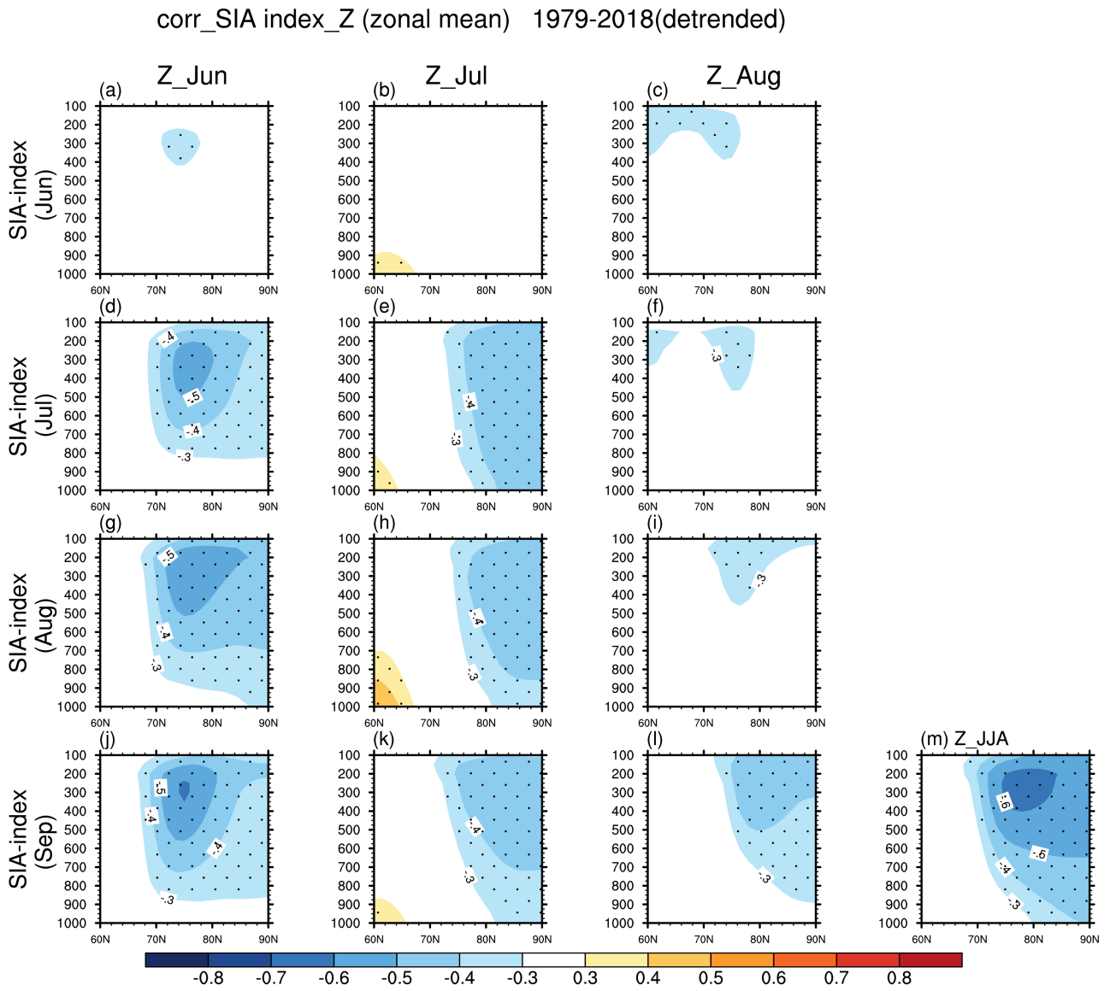
Supplementary Figure 1 Correlations of detrended NSIDC monthly SIA index from June to September (First to forth rows, respectively) with ERA5 detrended zonal mean geopotential height from June to August and their seasonal mean (First to forth columns, respectively) during the period of 1979-2019. Stippling indicates statistical significance at the 95% confidence level based on the two-tailed Student’s t-test.

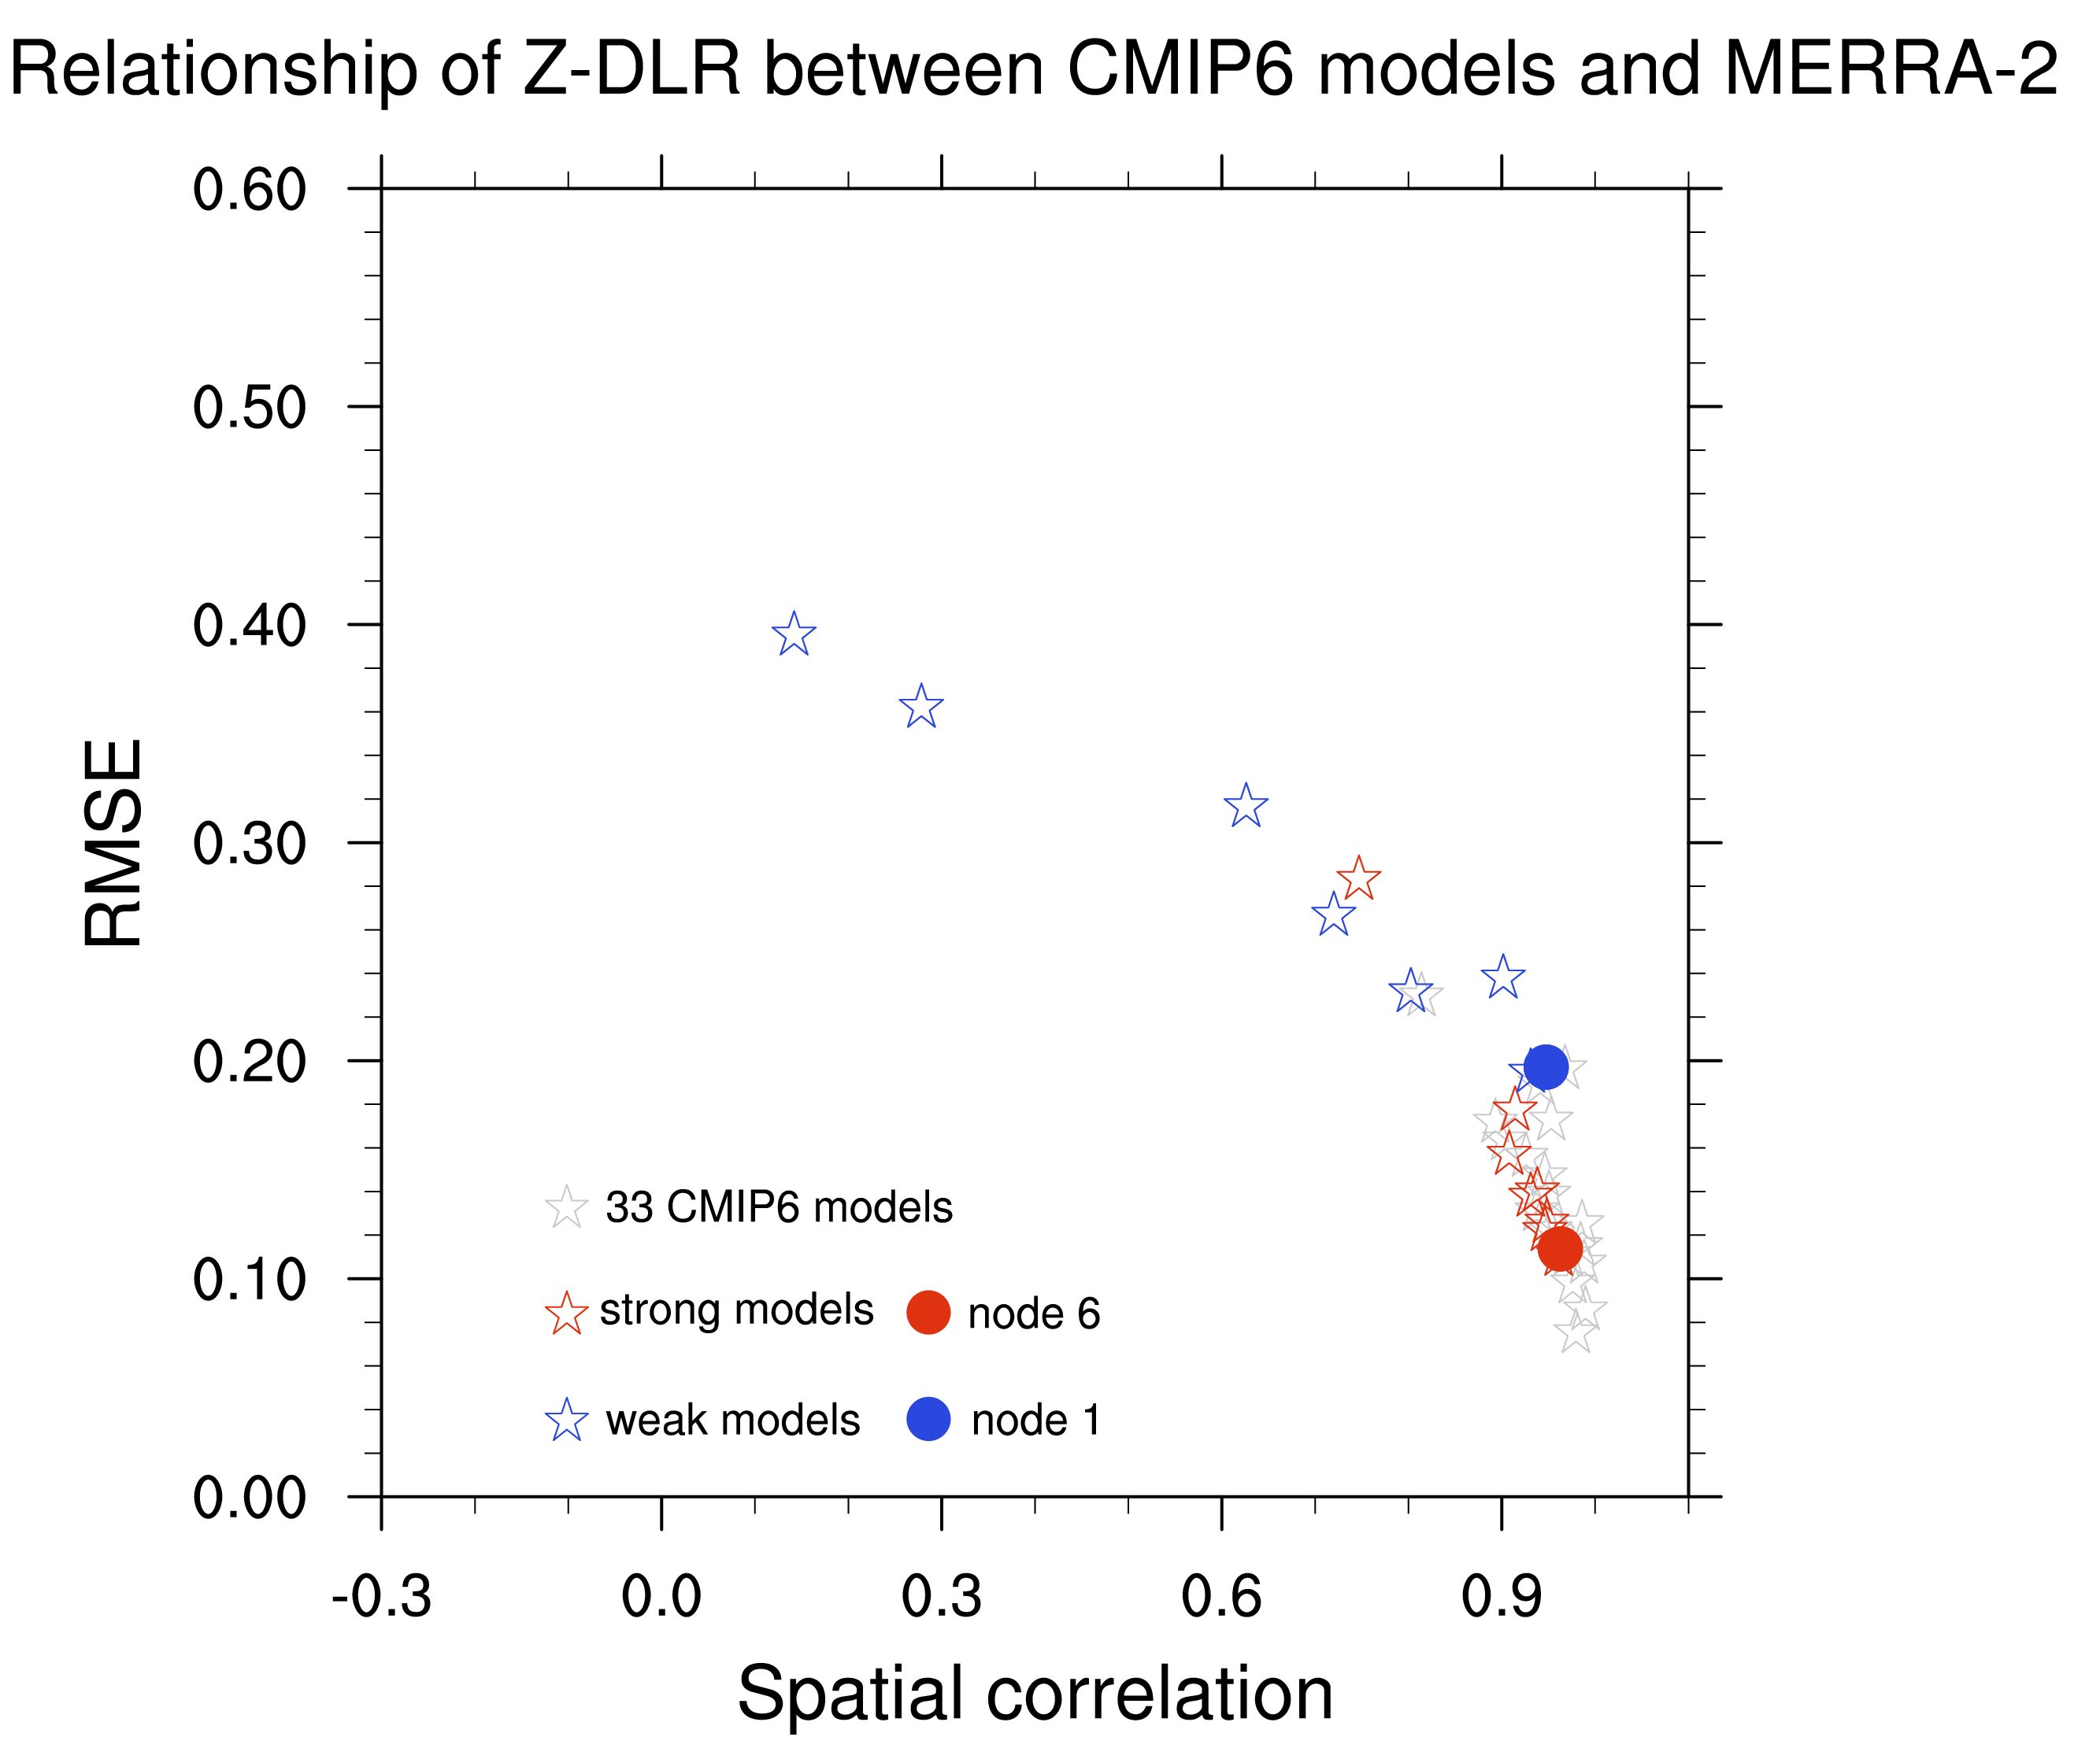
Supplementary Figure 2 Same as Fig. 3 but replace the ERA5 Z-DLR coupling pattern with the MERRA-2 counterpart of 1980-2019.

