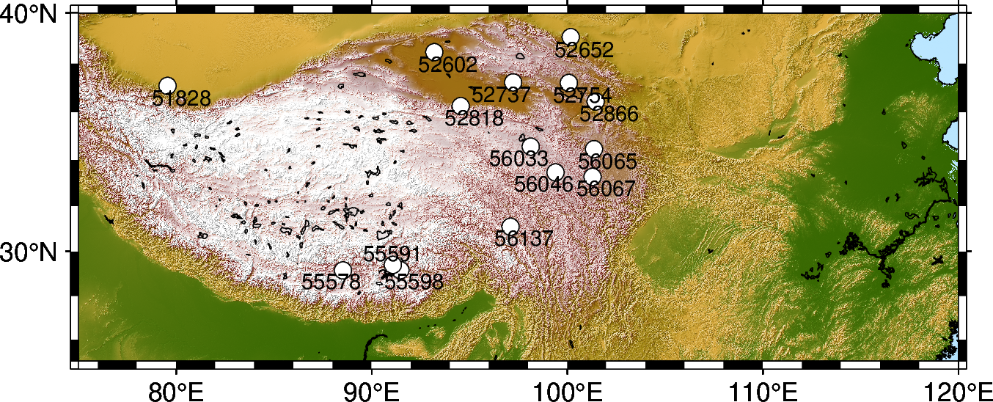

Figure S1. TP sites with soil temperature measurements.

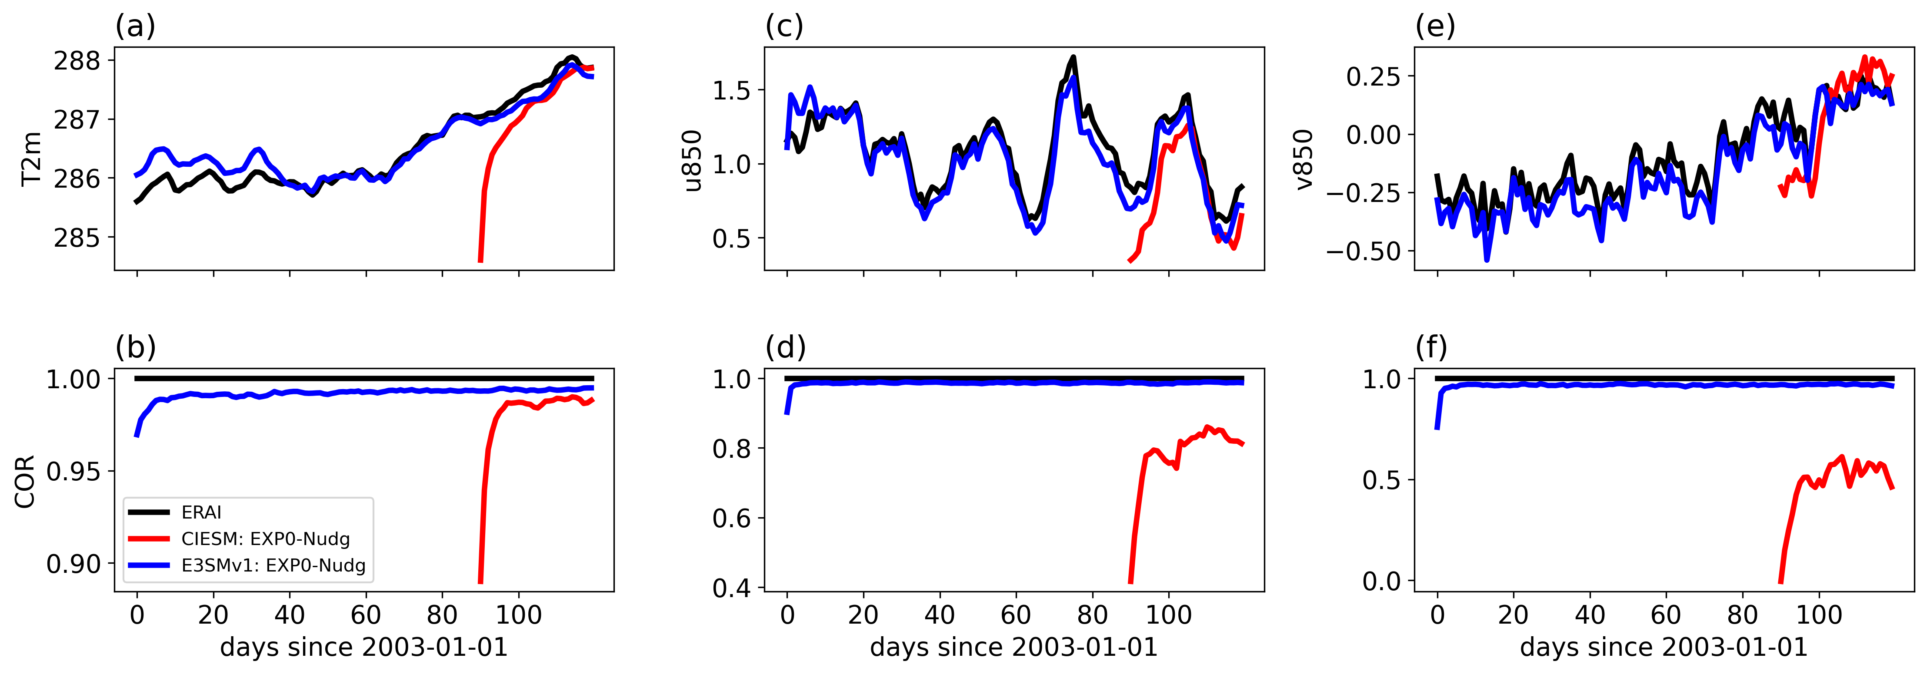
Figure S2. (a, c, e) The time-evolving global-mean values of T2m (K), u850 (m/s) and v850 (m/s) from ERAI (black), CIESM EXP0-Nudg (red) and E3SMv1 EXP0-Nudg (blue). Panels (b, d, f) show the time-evolving spatial correlations (COR) between CIESM EXP0-Nudg, E3SMv1 EXP0-Nudg and ERAI data for the three variables.
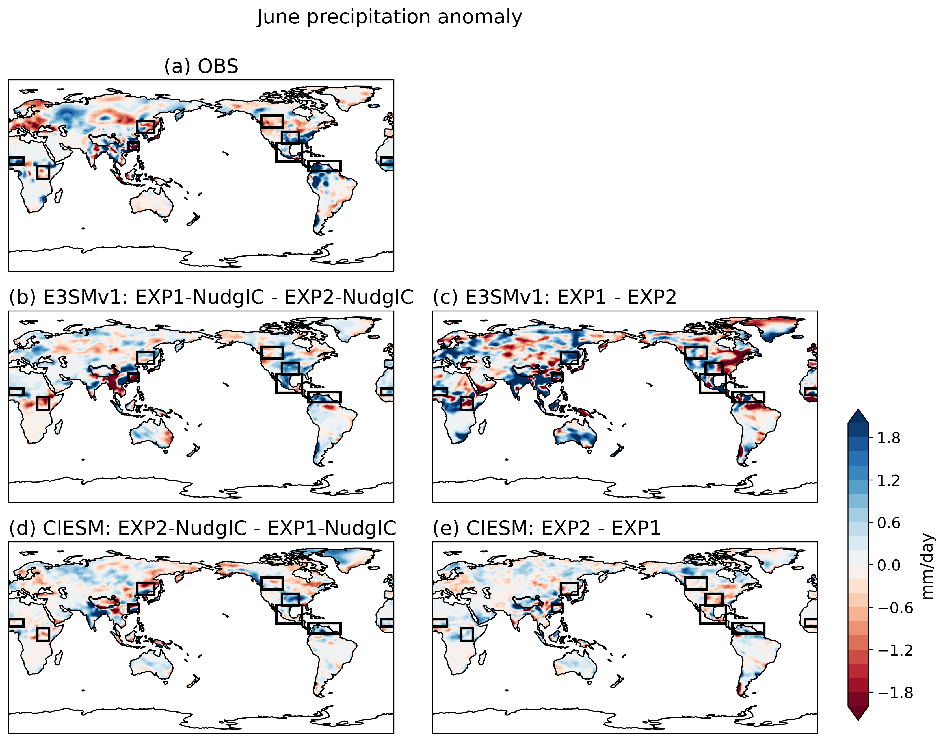

Figure S3. The June 2003 precipitation anomaly (mm/day) relative to the climatology from observation (a) and response with imposed land mask for E3SMv1 (b, c) and CIESM (d, e) with (b, d) and without (c, e) nudged ICs. The black boxes denote the eight hot spots.

Table S1. Observed/Simulated May 2003 T2m and June 2003 precipitation anomalies/differences due to LST/SUBT effects.

 | T2m (K) | Precipitation (mm/day)
 | TP above 4000 m | SYRB | NEast  Asia | East  Africa | Sahel | SGP | Central  America | NSouth  America | NW  US
OBS | -1.82 | -1.52 | -0.25 | -0.31 | 1.25 | 0.88 | 0.44 | 3.34 | -0.69
E3SMv1 with NudgIC | -0.78 | -2.51 | 0.17 | -0.87 | 0.28 | 1.01 | 0.34 | 0.83 | -0.20
E3SMv1 | -0.67 | -0.06 | 1.06 | -0.75 | 0.44 | 0.18 | 2.02 | -0.03 | 0.20
CIESM with NudgIC | -0.22 | 0.36 | 0.16 | -0.33 | 0.07 | 0.83 | 0.40 | 0.56 | 0.08
CIESM | -0.76 | -0.63 | -0.42 | 0.31 | 0.02 | -0.61 | -0.40 | -0.13 | -0.04

