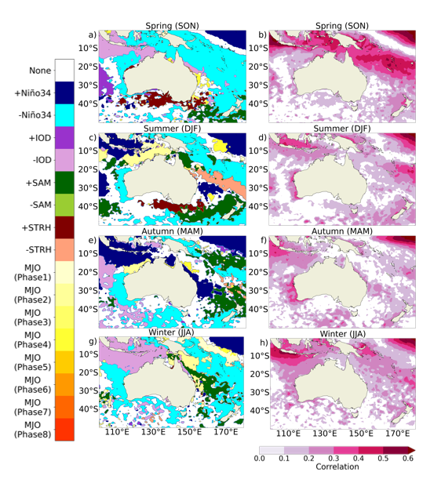
Supplementary Fig 1. As in Fig. 14 from the manuscript, with the SST anomalies lagged 1 week. The left column shows the driver with the highest correlation to positive SST anomalies, separated by season, with the right column showing the respective correlation between the index of the leading driver and SST anomalies. Only analysed drivers with a statistically significant correlation (p<0.05) are shown

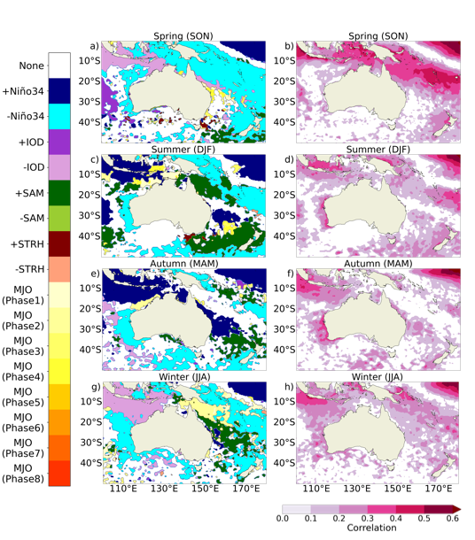
Supplementary Fig 2. As in Fig. 14 from the manuscript, with the SST anomalies lagged 2 weeks. The left column shows the driver with the highest correlation to positive SST anomalies, separated by season, with the right column showing the respective correlation between the index of the leading driver and SST anomalies. Only analysed drivers with a statistically significant correlation (p<0.05) are shown
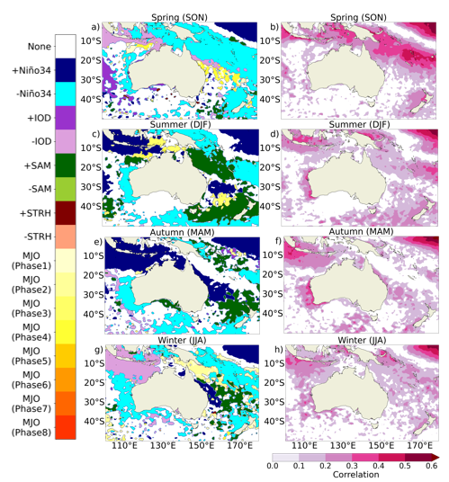
Supplementary Fig 3. As in Fig. 14 from the manuscript, with the SST anomalies lagged 3 weeks. The left column shows the driver with the highest correlation to positive SST anomalies, separated by season, with the right column showing the respective correlation between the index of the leading driver and SST anomalies. Only analysed drivers with a statistically significant correlation (p<0.05) are shown

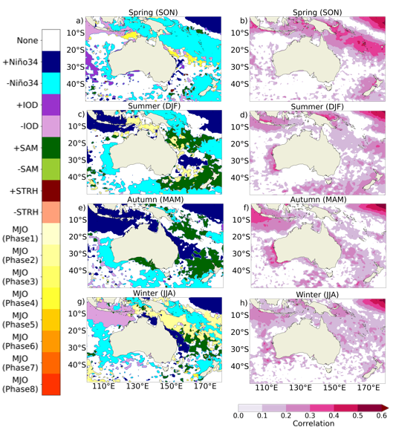
Supplementary Fig 4. As in Fig. 14 from the manuscript, with the SST anomalies lagged 4 weeks. The left column shows the driver with the highest correlation to positive SST anomalies, separated by season, with the right column showing the respective correlation between the index of the leading driver and SST anomalies. Only analysed drivers with a statistically significant correlation (p<0.05) are shown

