Figure S1. Contribution of individual physical processes from each region, along with their sum (rightmost column), to the annual δ¹⁸O_{p} response (units: permille). The four physical processes considered are changes in source composition (row1), rainout (row2), condensation (row3), and source location (row5). The sum of three processes (source composition + rainout + condensation) is shown in row 4. For the definition of source regions for individual maps (shown on the left hand side above each map) refer to Figure 7b in the main text.

Figure S2. As Figure S1, but for the contribution of four individual physical processes from each region, along with their sum (rightmost column), to the DJF δ18Op response (units: permille).

Figure S3. As Figure S1, but for the contribution of four individual physical processes from each region, along with their sum (rightmost column), to the JJA δ18Op response (units: permille).

Figure S4 Zonal average diabatic heating (10⁻⁶ K/s), derived using the highly simplified thermodynamic equation, to quantify the spatial distribution of the large-scale future of Hadley circulation (contours, 10¹⁰ kg/s), where diabatic heating (cooling) corresponds to upward (downward) motion of Hadley circulation.

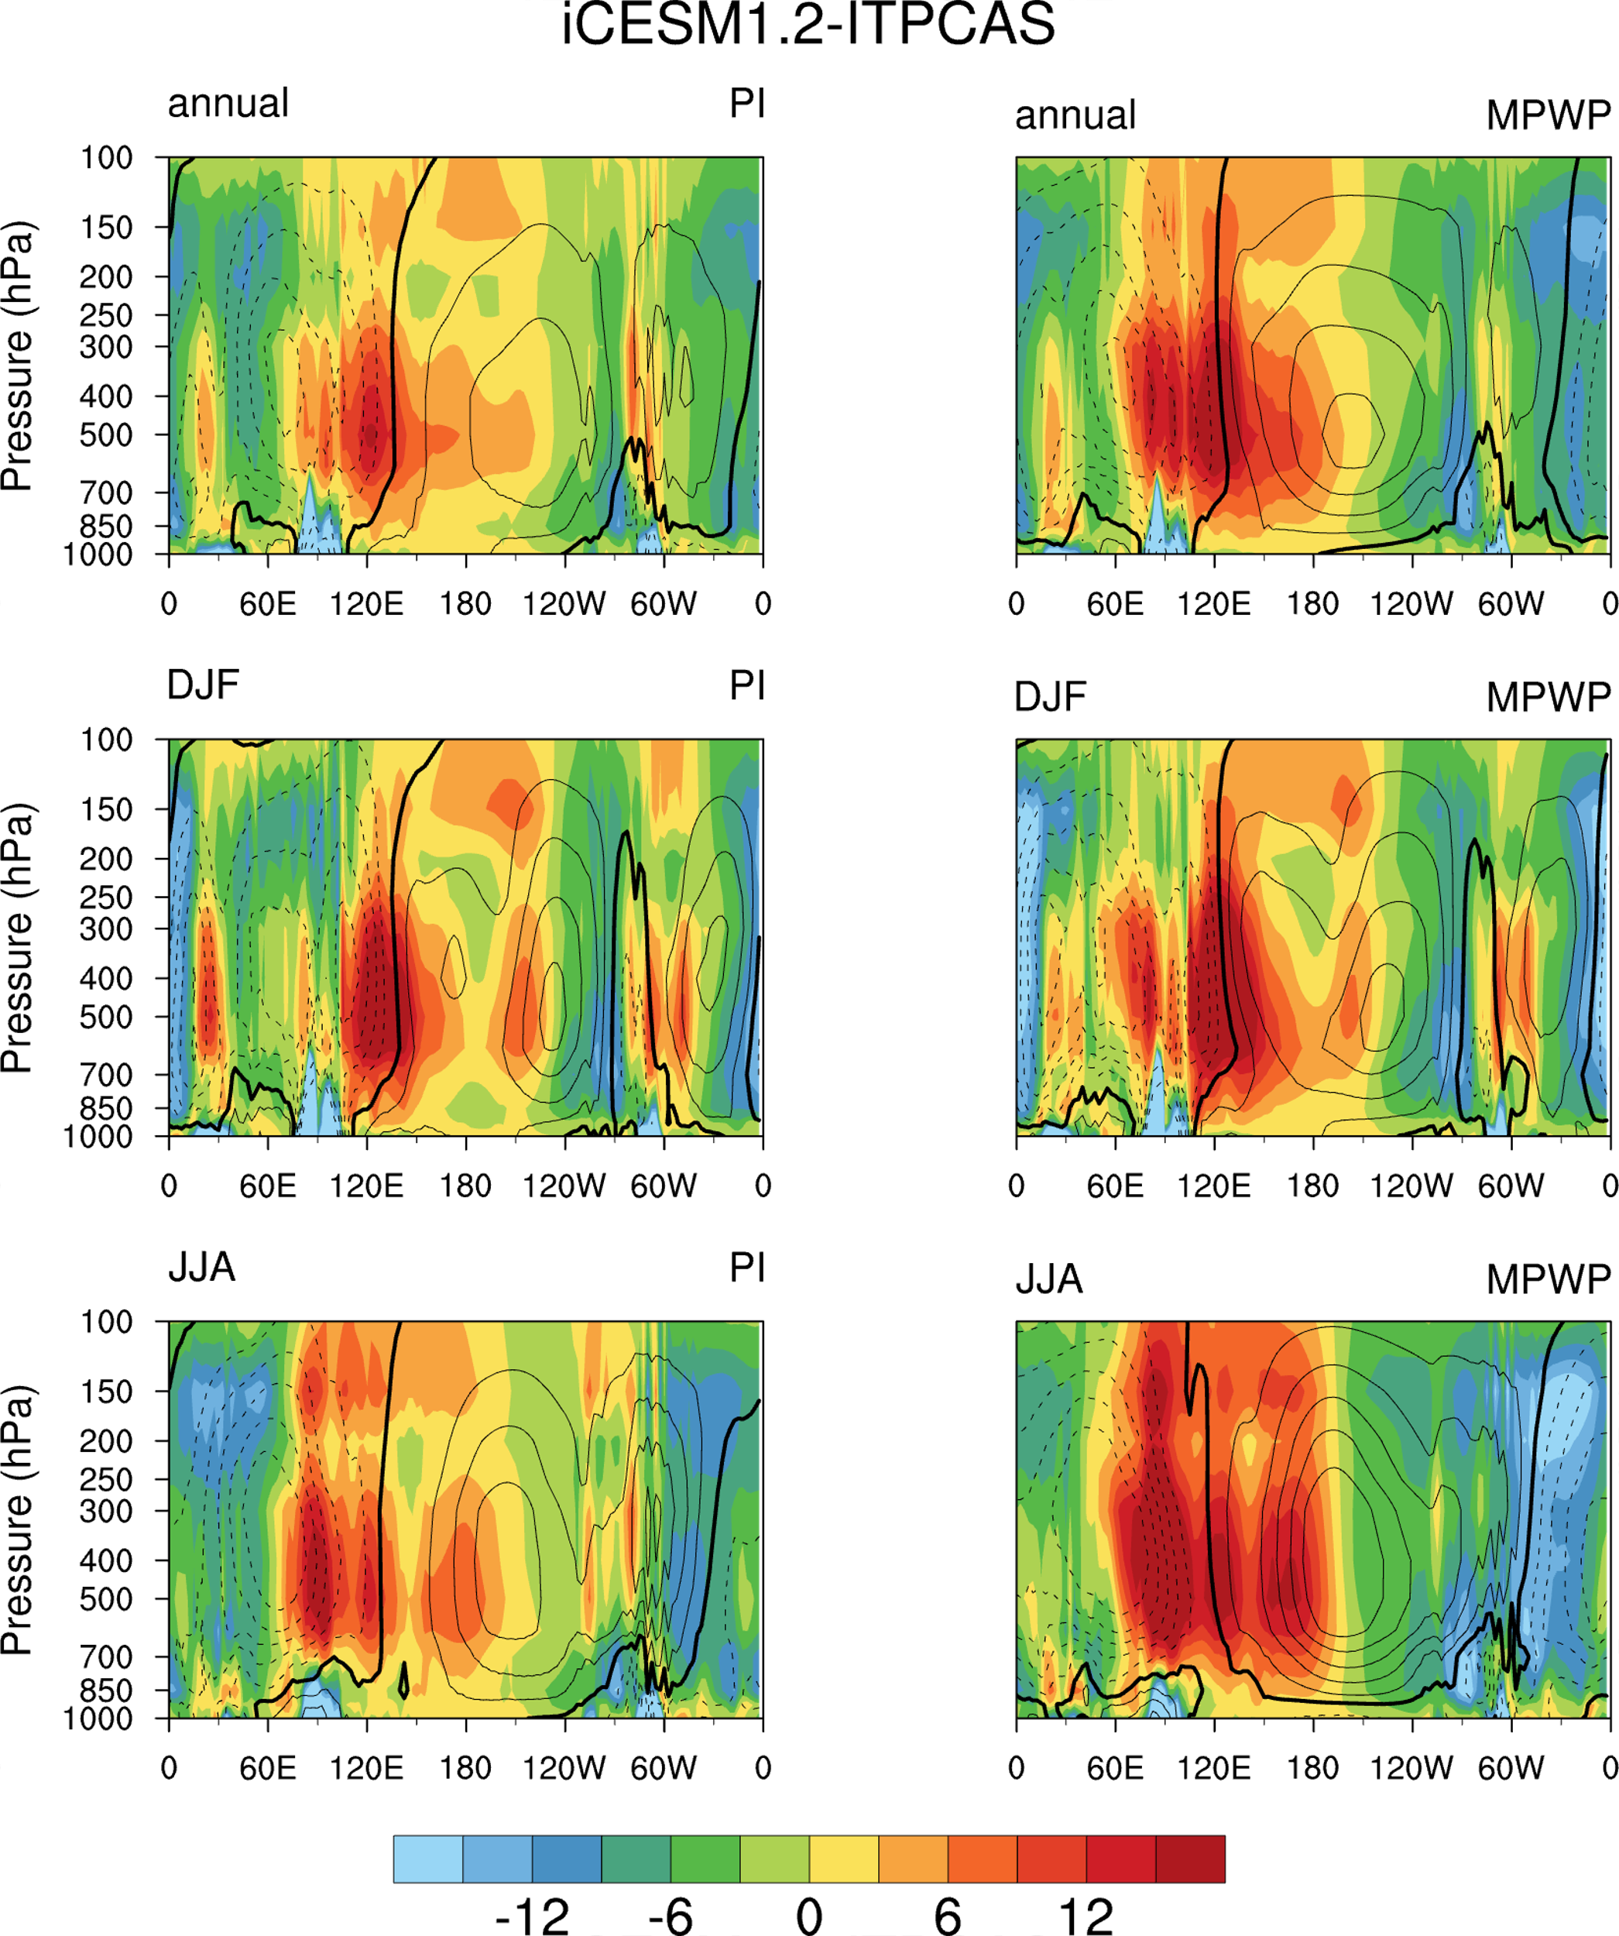
Figure S5 Tropical diabatic heating meridionally averaged over the latitude band [30S°–30$°$N] (10⁻⁶ K/s), derived using the highly simplified thermodynamic equation, to quantify the spatial distribution of the large-scale future of Walker circulation (contours, 10¹⁰ kg/s), where, diabatic heating (cooling) corresponds to upward (downward) motion of Walker circulation.

