Sub-seasonal prediction skill: Is the mean state a good model evaluation metric?

Jihun Ryu¹, Shih-Yu (Simon) Wang², Jee-Hoon Jeong³, and Jin-Ho Yoon^{1,*}

¹ School of Earth Sciences and Environmental Engineering, Gwangju Institute of Science and Technology, Gwangju, South Korea
²Department of Plants Soil and Climate, Utah State University, Logan, UT, USA
³Department of Oceanography, Chonnam National University, Gwangju, South Korea.

Corresponding author: Jin-Ho Yoon, (yjinho@gist.ac.kr)

Key words : Sub-seasonal to Seasonal(S2S), prediction skill, mean state, S2S project

Table S1. Temperature prediction skill evaluated index of Figure 6 (a) – (c). (a) – (c) are weather scale, (d) – (f) are Sub-seasonal scale. (a) and (d) are global, (b) and (e) are mid-latitude regions, and (c) and (f) are tropical regions.
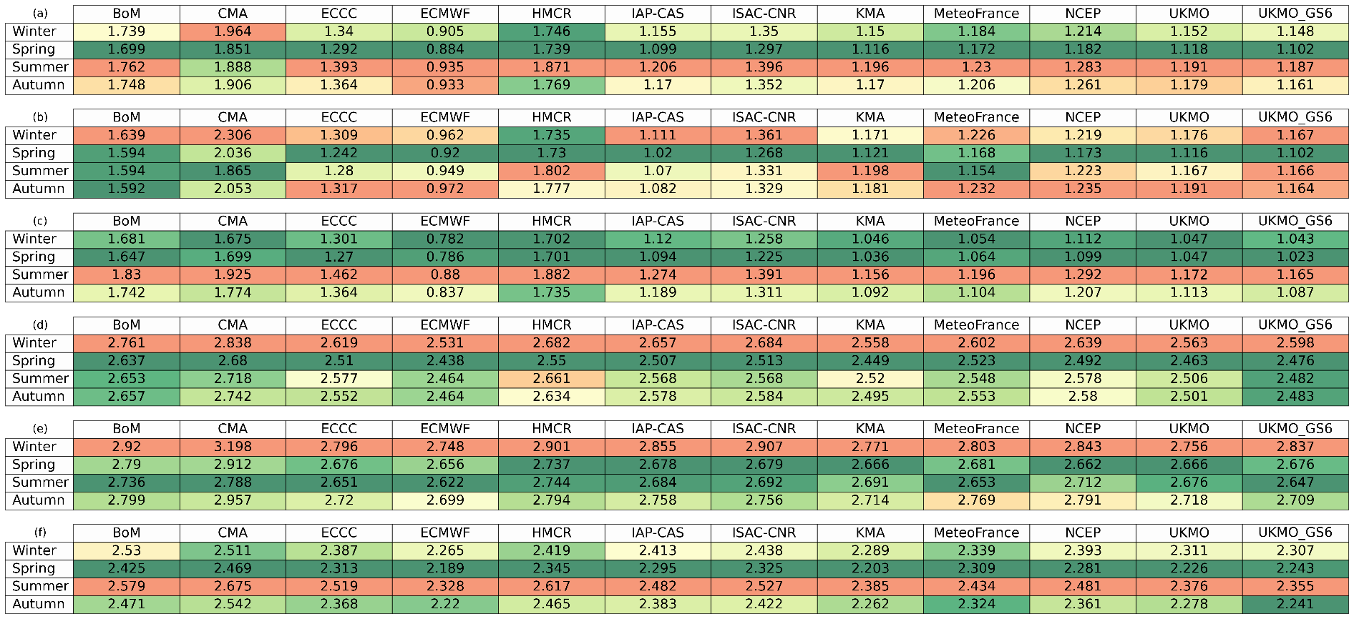

Table S2. Same as Table S1, but for the precipitation.
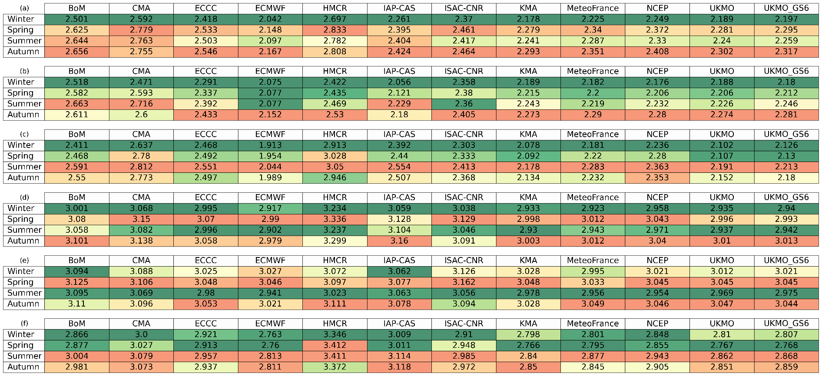

Table S3. Detail information on simple mean state performance metrics over a global scale.
Tempreature | Mean (± STD) | Number in  STD range | Minimum | Maximum
Anuual mean absoule error | 0.539 ± 0.310 | 9 | 0.209 | 1.165
Anuual mean pattern correlation | 0.962 ± 0.020 | 10 | 0.920 | 0.981
RMSE of climatology | 0.764 ± 0.357 | 9 | 0.373 | 1.484
Correlation of climatology | 0.996 ± 0.002 | 7 | 0.992 | 0.999
Precipitation | Mean (± STD) | Number in  STD range | Minimum | Maximum
Anuual mean absoule error | 0.417 ± 0.086 | 9 | 0.282 | 0.578
Anuual mean pattern correlation | 0.881 ± 0.055 | 9 | 0.745 | 0.938
RMSE of climatology | 0.534 ± 0.093 | 9 | 0.360 | 0.698
Correlation of climatology | 0.871 ± 0.073 | 10 | 0.684 | 0.926
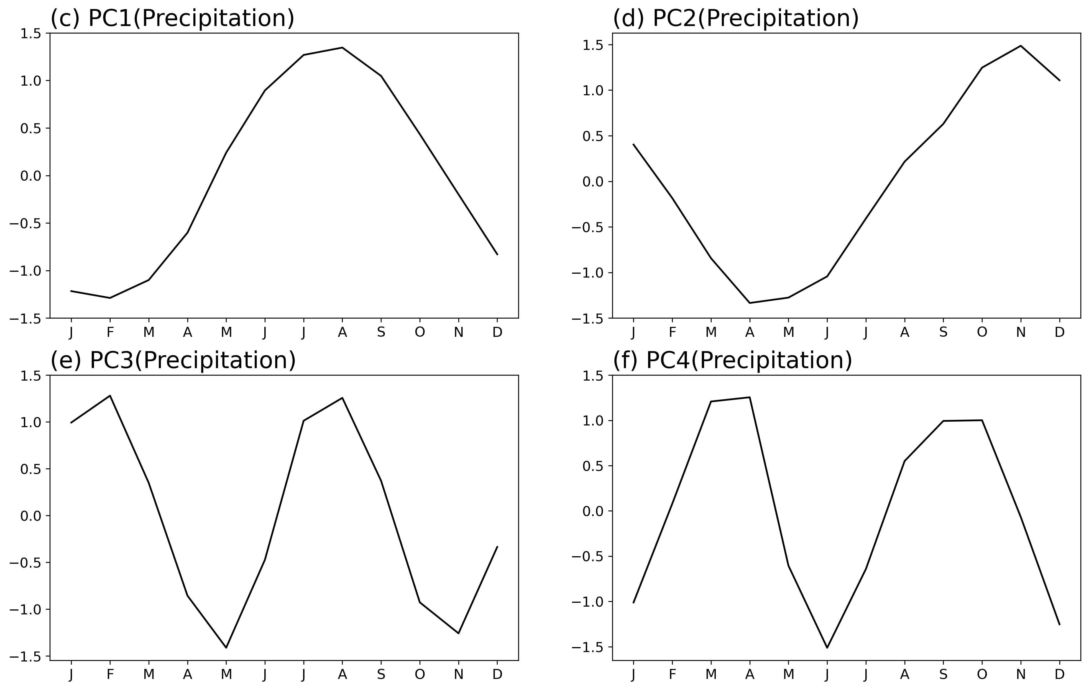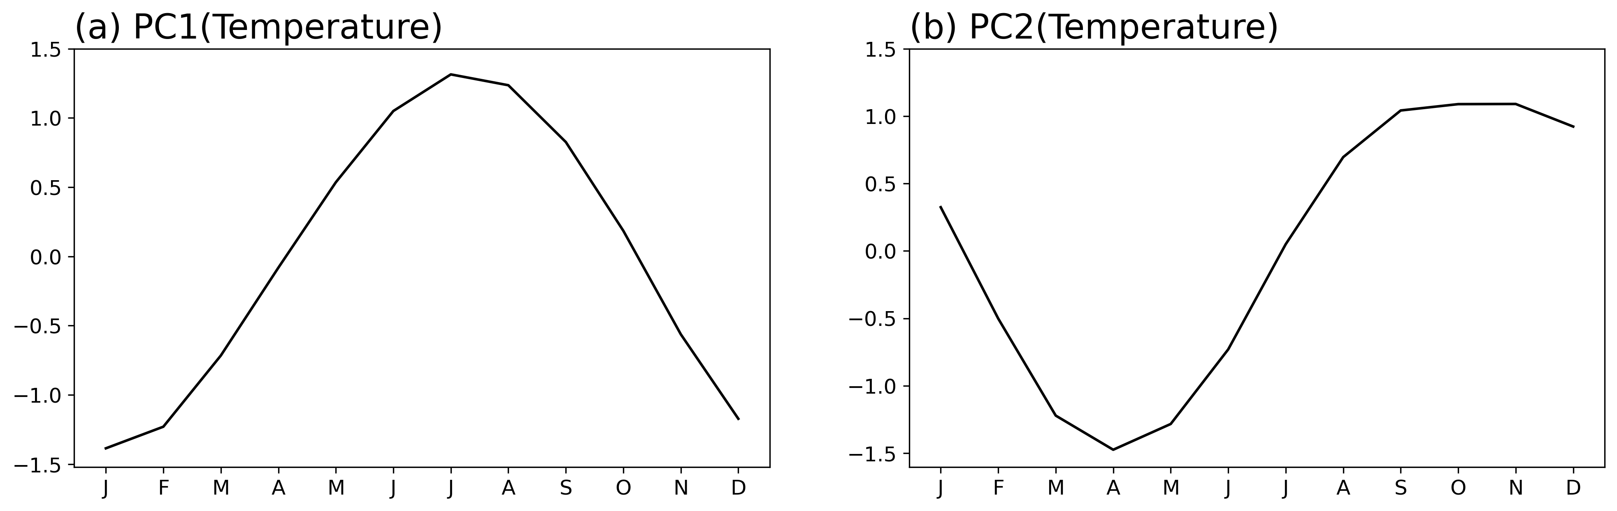

Figure S1. PC time series of each mode in global climatology by EOF analysis. (a) and (b) are the first and second modes of temperature, respectively, and (c) to (f) are the first to fourth modes of precipitation.

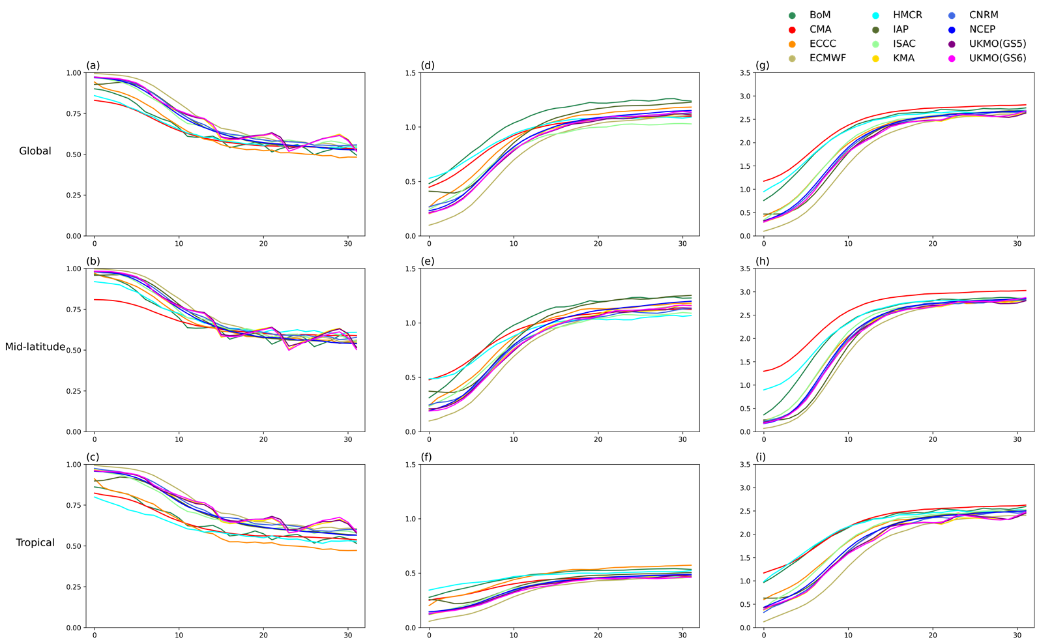

Figure S2. Prediction skill metrics of S2S models for 1-33 lead days. (a) – (c) show the correlation, (d) – (f) display RMSE, (g) – (h) represent the evaluated index. (a), (d), and (g) are global, (b), (e), and (h) are mid-latitude regions, and (c), (f), and (i) are tropical regions.

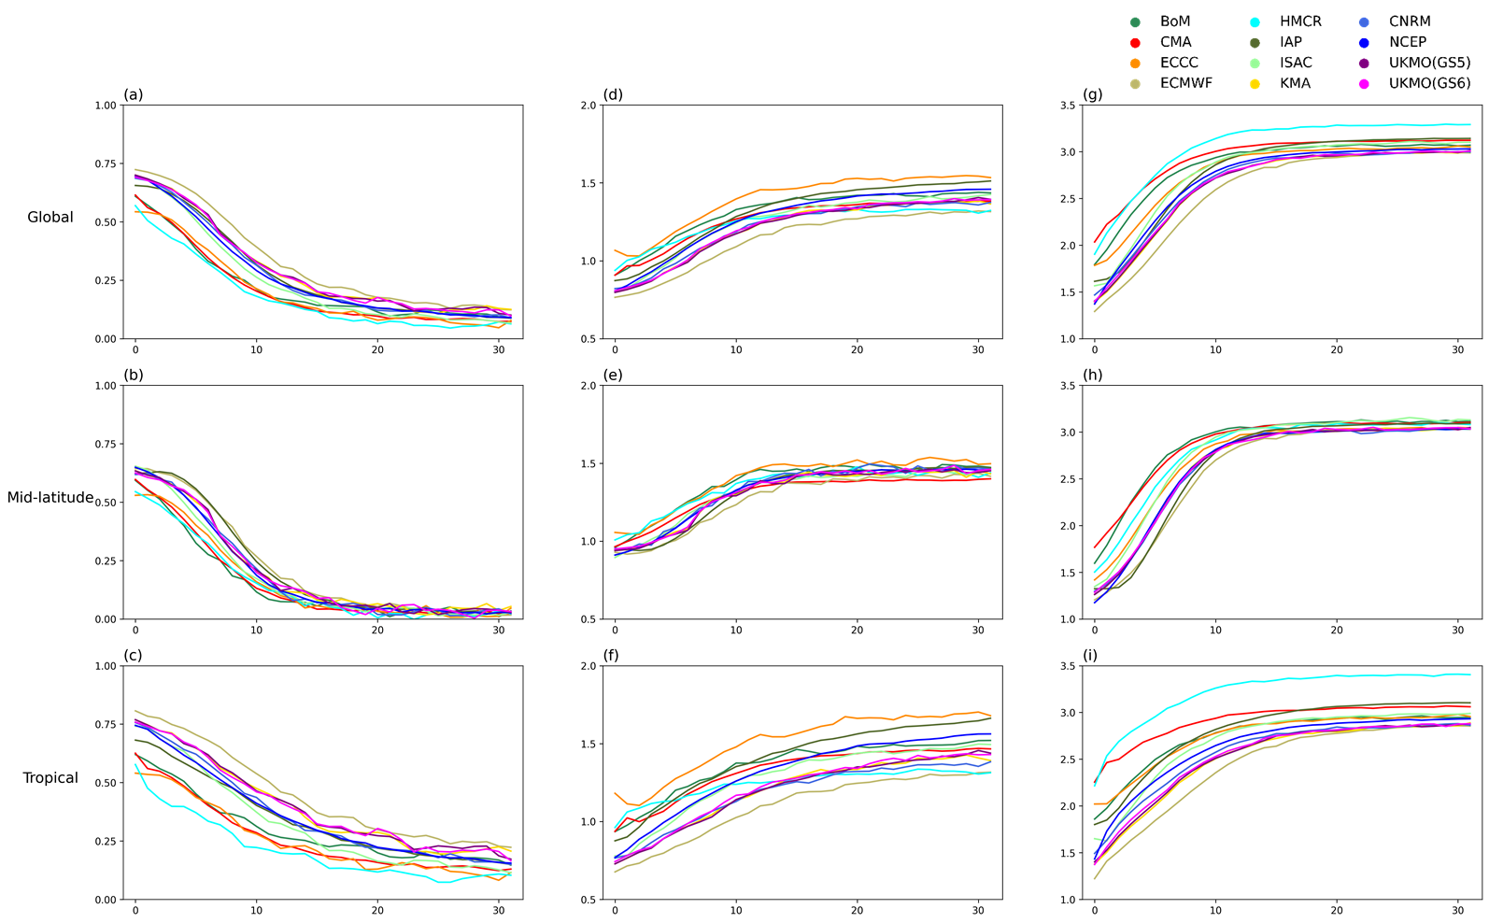

Figure S3. Same as Figure S2, but for the precipitation.

Figure S4. Relationship between mean state performance and prediction skill of each S2S model temperature. (a) – (l) are each S2S model.

Figure S5. Same as Figure S4, but for the precipitation.

