Supplementary Materials
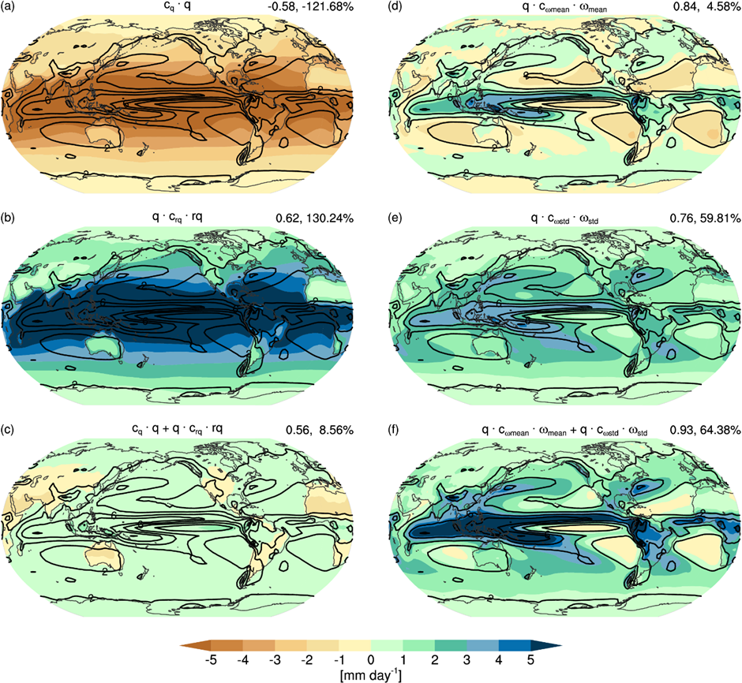
Figure S1: Same as in Fig. 3, but for CMIP5 multimodel mean.

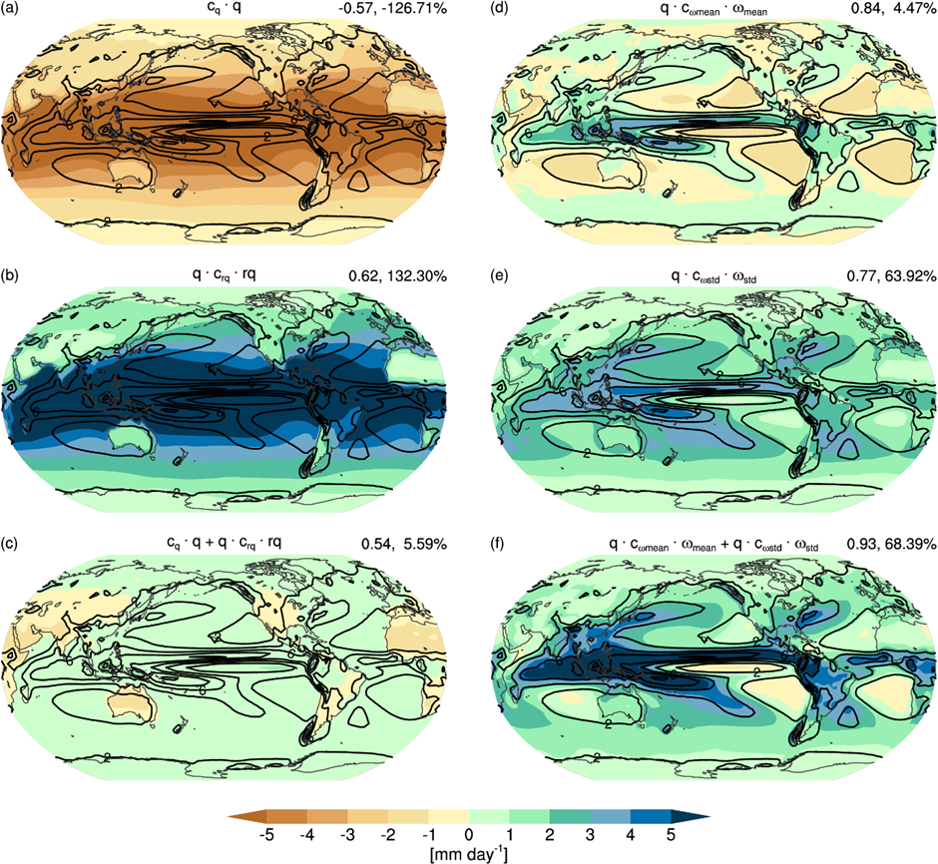
Figure S2: Same as in Fig. 3, but for CMIP6 multimodel mean.

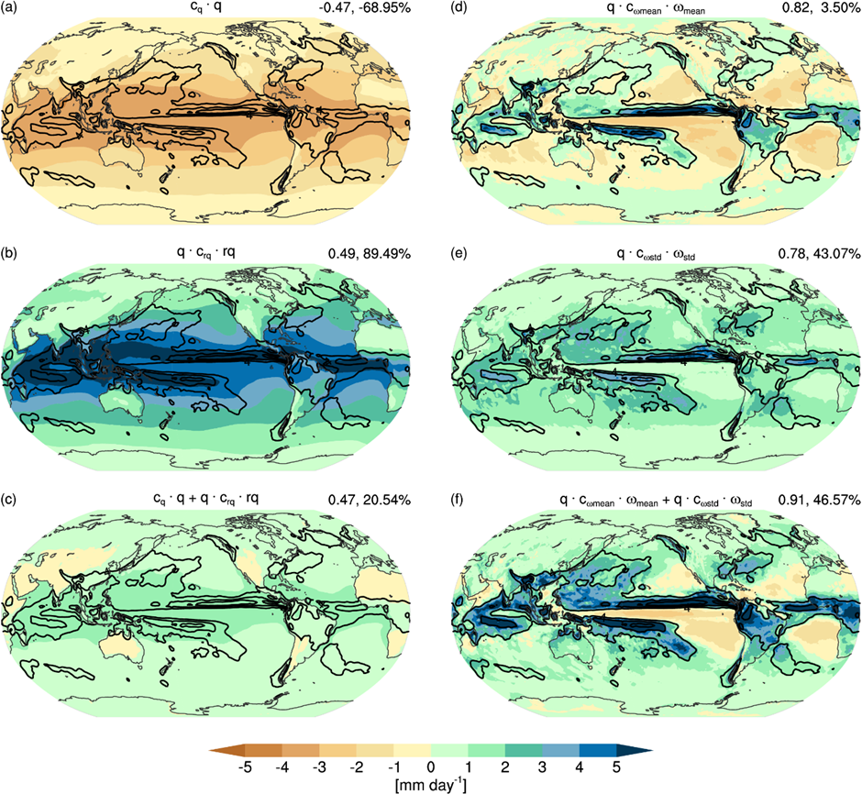
Figure S3: Same as in Fig. 3, but for ICON-Sapphire.

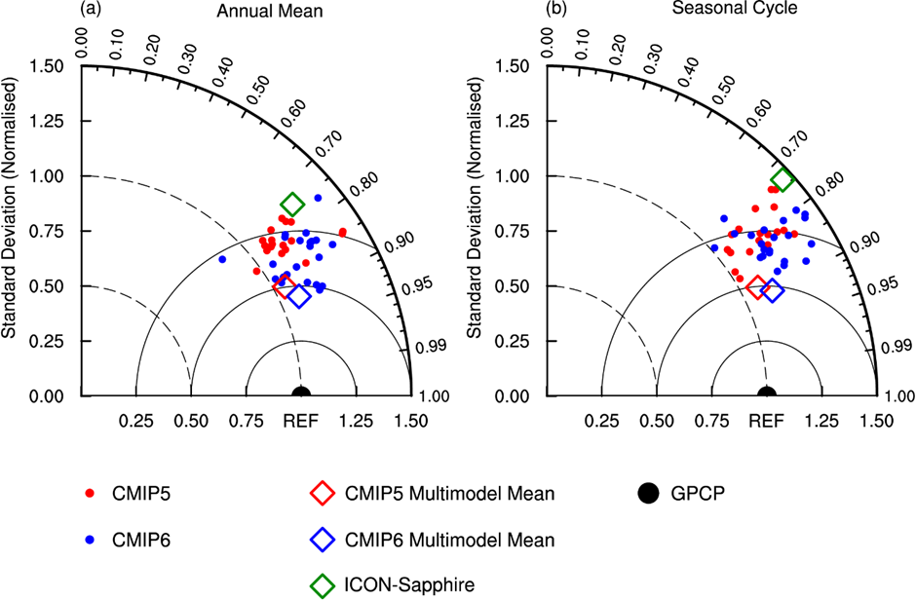
Figure S4: Taylor diagrams of (a) annual mean and (b) seasonal cycle of tropical precipitation in the individual CMIP5 (red dots) and CMIP6 (blue dots) models, the CMIP5 (red diamond) and CMIP6 (blue diamond) multimodel means, and ICON-Sapphire (green diamond) against the observed precipitation from GPCP (black dot).

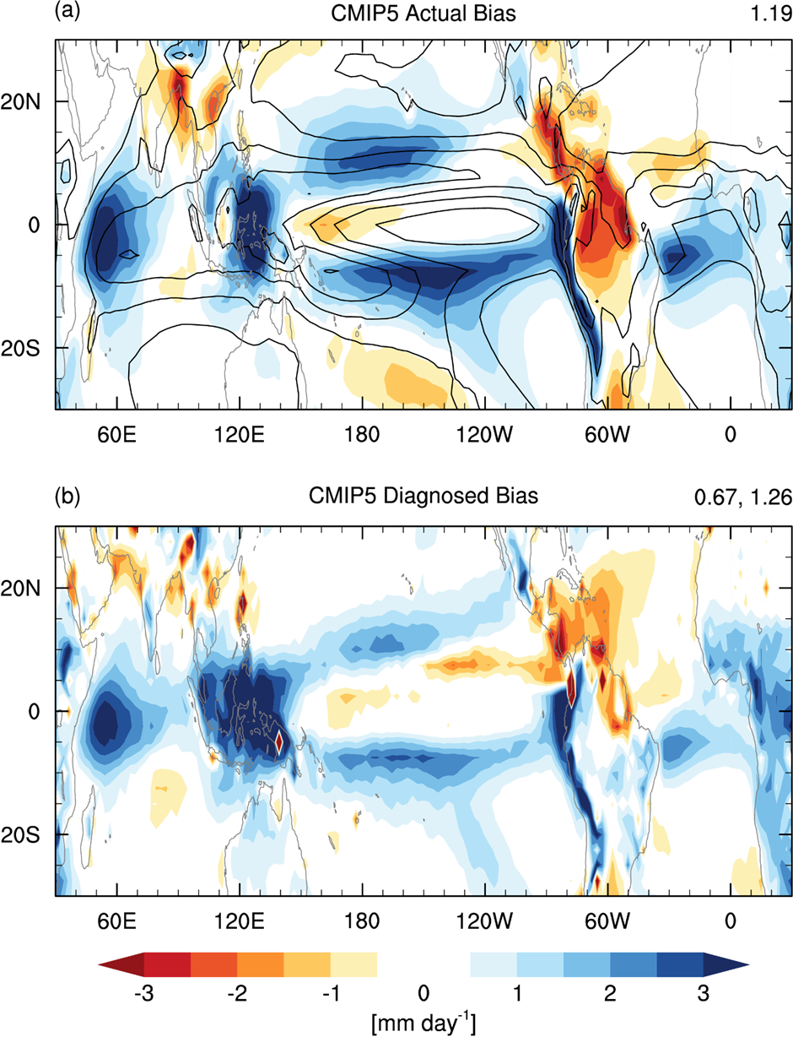
Figure S5: Same as in Figs. 4a,c, but for CMIP5 multimodel mean.

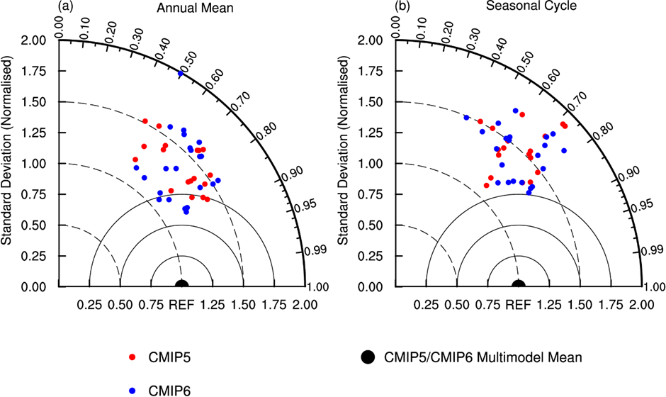
Figure S6: Taylor diagrams of tropical precipitation bias in (a) annual mean and (b) seasonal cycle in the individual CMIP5 (red dots) and CMIP6 (blue dots) models, with the bias in CMIP5/CMIP6 multimodel mean precipitation as reference (black dot).

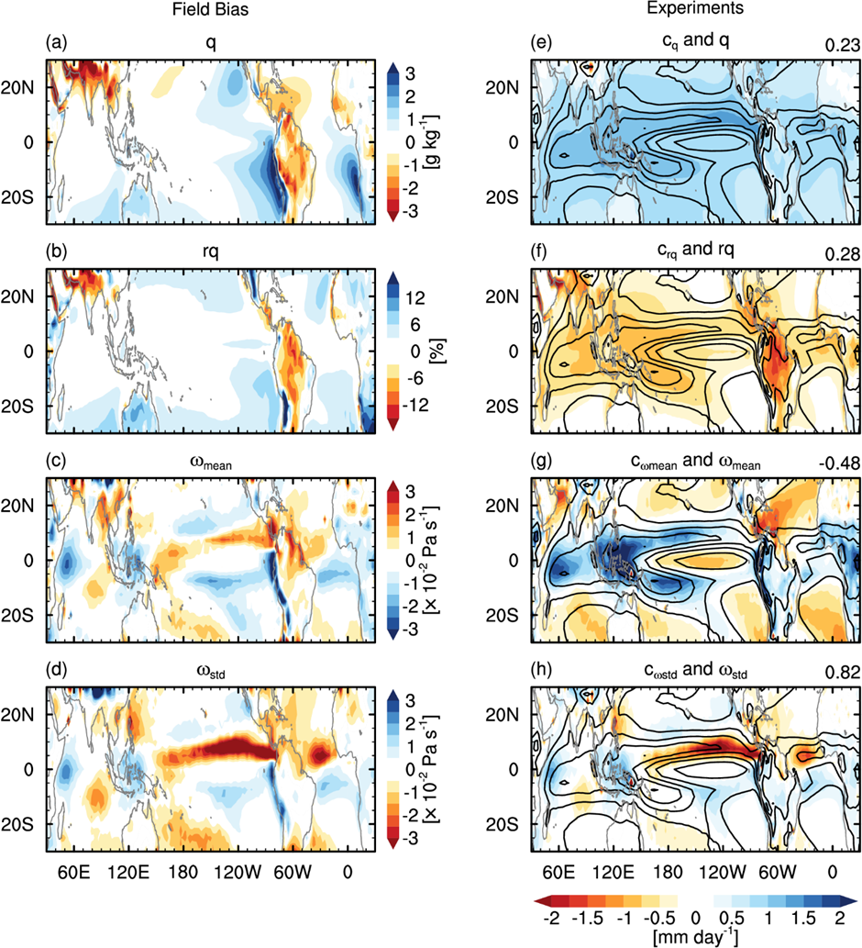
Figure S7: Same as in Fig. 7, but for CMIP5 multimodel mean.

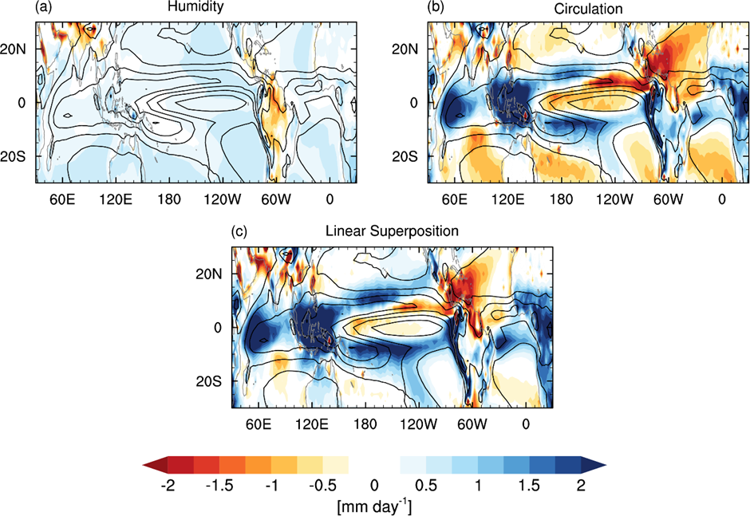
Figure S8: Same as in Fig. 8, but for CMIP5 multimodel mean.

Text S1. Approaches to Calculate Humidity Fields of ICON-Sapphire at Surface Level

As stated in the main text, humidity fields ($q$ and $rq$) of ICON-Sapphire are only available at its lowest model level, about 25 m above the surface. Here we outline several approaches to estimate the field values at the surface.

- Global Mean Multiplication
To estimate the field values at surface level, we scale the original field values using a scaling factor. This scaling factor is defined as the ratio between ERA5’s global mean value of the field and that of ICON-Sapphire’s. In this approach, the ICON-Sapphire’s original field value at each grid point is multiplied by the scaling factor. For example, ICON-Sapphire’s specific humidity at surface level ($q_{ICON-Sapphire}$) is estimated from its original specific humidity ($q_{ori,ICON-Sapphire}$; i.e., at 25 m level) as
$$q_{ICON-Sapphire}=q_{ori,ICON-Sapphire}×\frac{{\overline{q}}_{ERA5}}{{\overset{̿}{q}}_{ori,ICON-Sapphire}}$$
where the bar denotes global mean value (i.e., averaged over the whole global domain). This is the approach we choose to use in pre-processing ICON-Sapphire’s data for the analyses.
- Global Mean Addition
In this approach, we use addition instead of multiplication to adjust the field value at each grid point. For example,
$$q_{ICON-Sapphire}=q_{ori,ICON-Sapphire}+\left({\overline{q}}_{ERA5}-{\overline{q}}_{ori,ICON-Sapphire}\right)$$
- Tropical Mean Multiplication
This approach is similar to the first approach, but we use tropical mean values (i.e., averaged over 30°S-30°N) for the scaling factor, instead of the global mean.
- Tropical Mean Addition
This approach is similar to the second approach, but, as in the third approach, we use tropical mean values for the scaling factor.

Different approaches produce slightly different values of the humidity fields, and therefore, slightly different $q$ and $rq$ mean bias fields (see Figs. 9a-b). However, the main results of the analyses (e.g., Fig. 10 and Fig. 11) do not show any significant changes when we use different approaches. The main conclusions, such as that most biases in ICON-Sapphire precipitation are associated with mean circulation biases, remain the same and are not too sensitive to the choice of estimation approaches presented here. We do this estimation only to be consistently using the surface humidity fields when compared to ERA5 and CMIP models.

