Supporting Information for
Interplay of Anthropogenic and Natural Drivers of Observed Coupled Sea Surface Temperature - Arctic Sea Ice Variability
Petru Vaideanu^{1,2,5}, Mihai Dima^{1,2}, Denis Nichita^{1,3}, Christian Stepanek ², Paul Gierz², Norel Rimbu², Monica Ionita^{2,4,5} and Gerrit Lohmann^{2,6}

1 - University of Bucharest, Faculty of Physics, Bucharest-Măgurele, Romania
2 - Alfred Wegener Institute Helmholtz Centre for Polar and Marine Research, Bremerhaven, Germany
3 - “Horia Hulubei” National Institute of Physics and Nuclear Engineering, Bucharest-Măgurele, Romania
4 - Emil Racovita Institute of Speleology, Romanian Academy, Cluj-Napoca, Romania
5 - Faculty of Forestry, Stefan cel Mare University, Suceava, Romania
6- University of Bremen, MARUM & Department of Environmental Physics, Bremen, Germany

Corresponding author:
Petru Vaideanu
Email: petru.cosmin.vaideanu@awi.de

Supp. Fig. 1
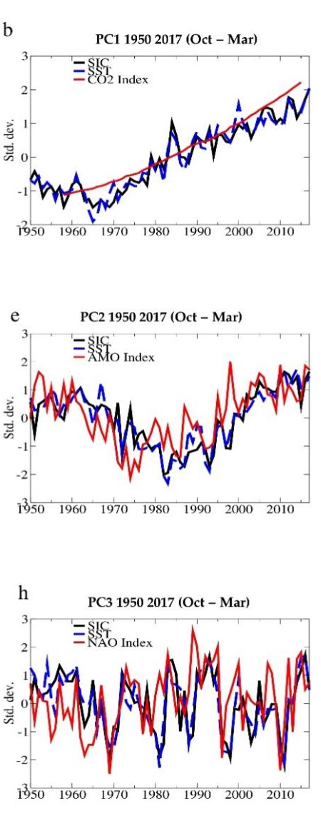
a
b
c

Supp. Fig. 1 | The temporal evolution of the first (a), second (b) and third (c) coupled SST-SIC patterns identified through CCA between the corresponding October to March (O2M) fields over the period from 1950-2017.

Supp. Fig. 2

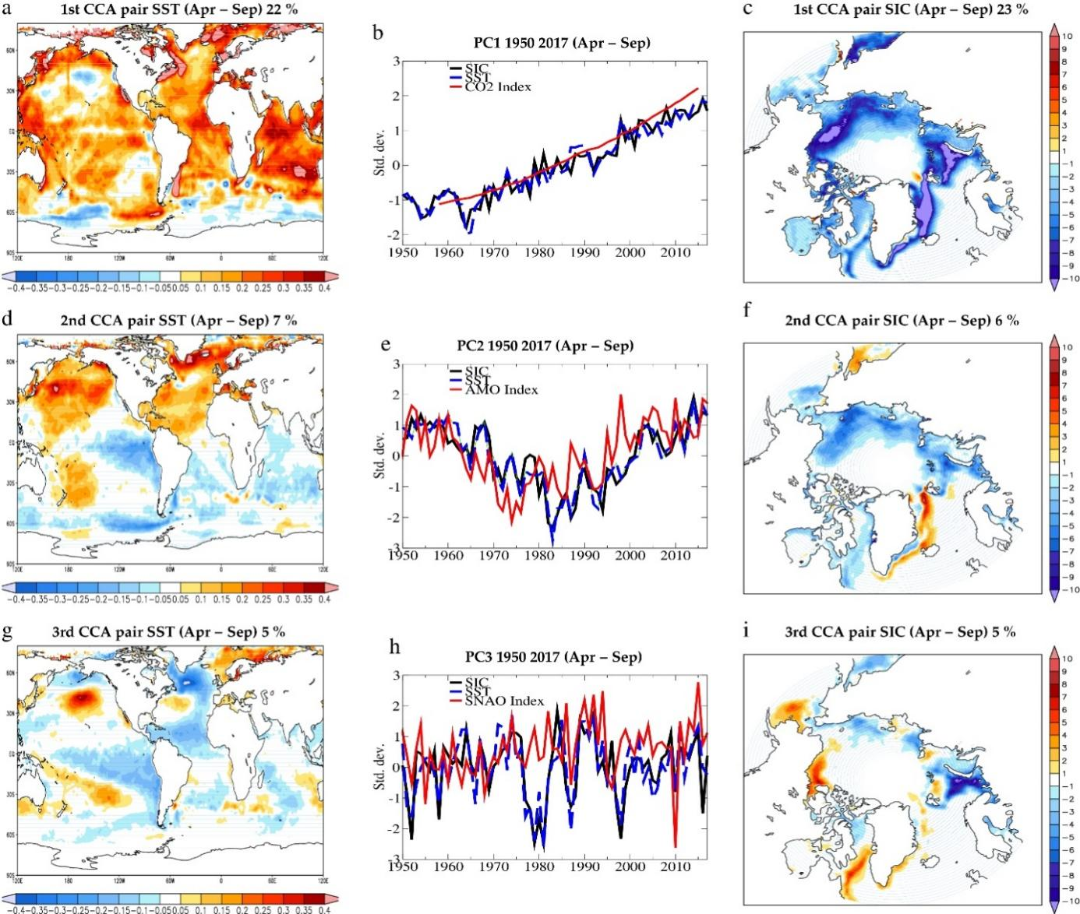
b
a
c

Supp. Fig. 2 | The temporal evolution of the first (a), second (b) and third (c) coupled SST-SIC patterns identified through CCA between the corresponding April to September (A2S) fields over the period from 1950-2017.

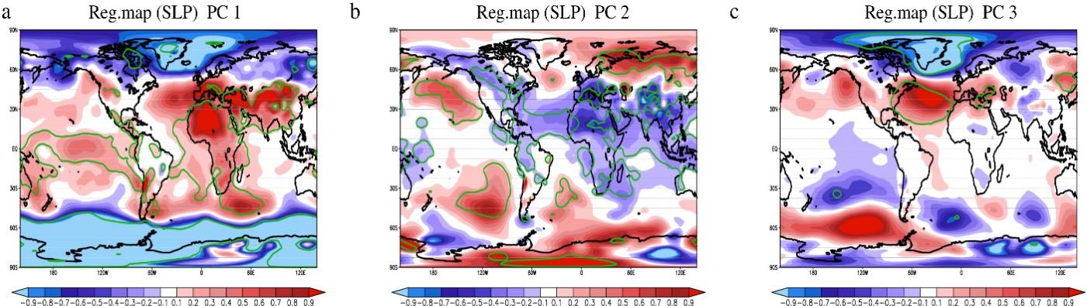

Supp. Fig. 3 | October – March (OM) regression maps of NCEP/NCAR sea level pressure (SLP) global fields (hPa) on the time series of the SST/SIC pair associated to increasing atmospheric CO₂ (a), AMO (b) and NAO (c).

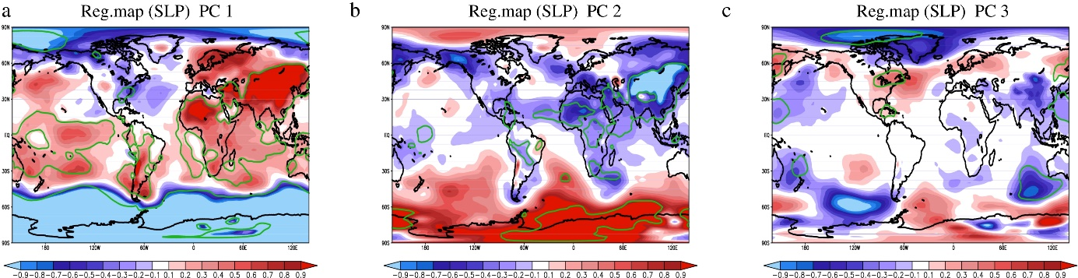

Supp. Fig. 4 | April – September (AS) regression maps of NCEP/NCAR sea level pressure (SLP) global fields (hPa) on the time series of the SST/SIC pair associated to increasing atmospheric CO₂ (a), AMO (b) and NAO (c).

Supp. Fig. 5
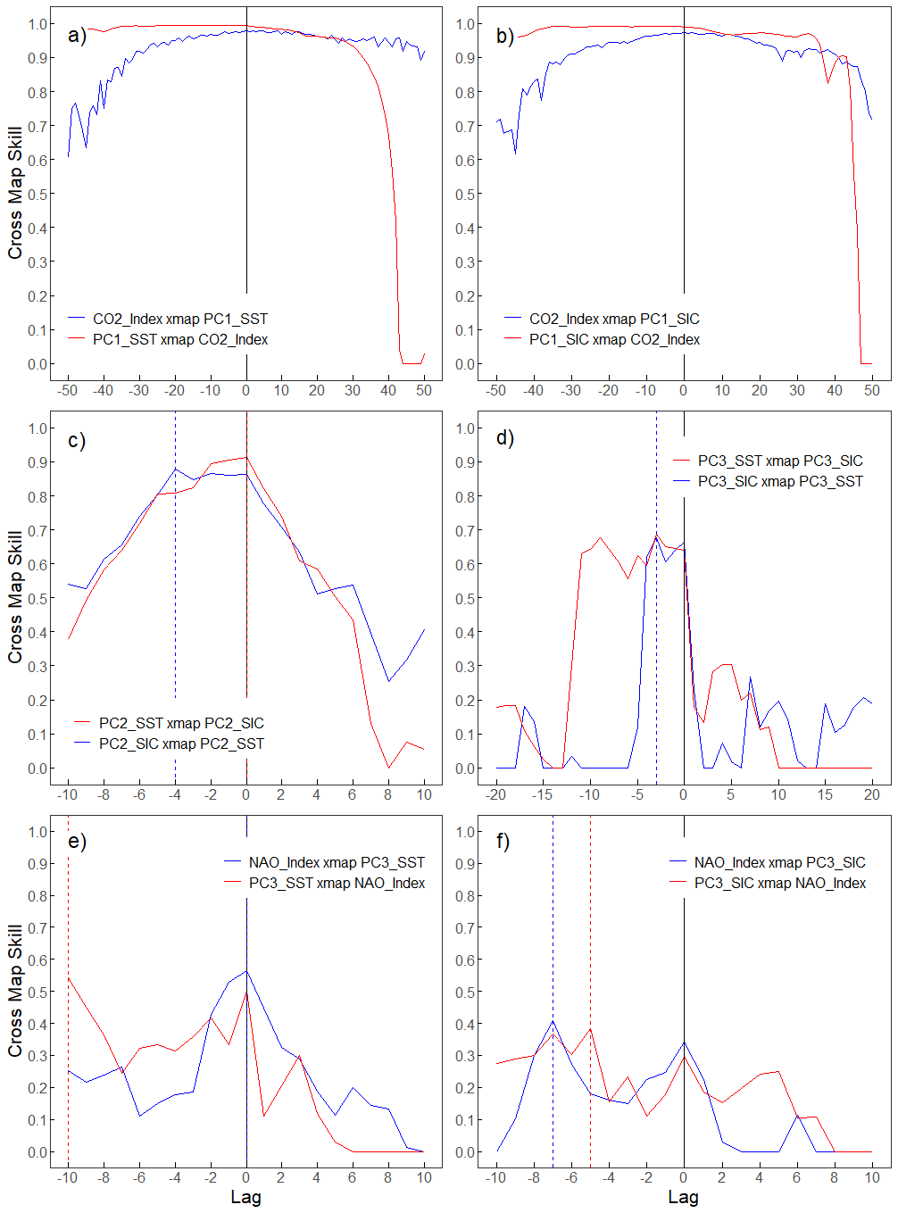
Supp. Fig. 5 | Time Delay CCM (TDCCM) analysis analogous to Fig 4 in the main text. Maxima in each panel are identified by dashed vertical lines, with the color corresponding to the direction of the cross map. Panels a) and b) show TDCCM representation between CO₂ (CO₂_Index) and PC1_SST. No specific maximum is identified here. Panel c) shows TDCCM between PC2_SST and PC2_SIC with lags at -4 (blue dashed line) and 0 (red dashed line) in the PC2_SIC xmap PC2_SST direction and PC2_SST xmap PC2_SIC respectively. Panel d) depicts TDCCM between PC3_SST and PC3_SIC with both lags at -3. Panel e) and f) show causality from the NAO_Index to the PC3_SST and PC3_SIC and in the reverse direction. We see a feedback in both directions with contemporaneous causality in the case of NAO_Index xmap PC3_SST and lag -10 for PC3_SST xmap NAO_Index. Panel f) displays a signal from PC3_SIC to NAO_Index (blue line) at lag -7, and a signal from NAO_Index to PC3_SIC at lag -5.
Supp. Fig. 5 includes the Time Delay CCM (TDCCM) analysis as follows. Panels a) and b) show the cross maps vs lags for CO₂_Index and the PC1_SST and PC1_SIC time series. One can see a sudden decrease in cross map for positive lags in the direction PC1_SST/PC1_SIC xmap CO₂_Index (red lines in Fig a) and b)). No such drop can be noticed in the opposite direction CO₂_Index xmap PC1_SST/PC1_SIC (blue line in Fig a) and b)). Instead, a moderate decrease for negative lags can be noticed in this direction, which can indicate that this direction of causality is not physical since a true direction of causality should manifest at negative lags and decrease for positive lags. The CO2_Index time series has a strong trend which dominates its variation. As a consequence, it is not expected to find a clear maximum in the TDCCM representation. However, the asymmetric decrease at positive lags can help indicate that this is the right direction of causality (PC1_SST/PC1_SIC xmap CO₂_Index). This is also consistent with physical intuition. We use lag 0 for the CCMs in the main article.
In panels c)-f) we notice bidirectional causal signals with clear maxima at negative lags:
c) PC2_SST xmap PC2_SIC (lag _{l} = 0)
PC2_SIC xmap PC2_SST (lag _{l} = -4)
d) PC3_SST xmap PC3_SIC (lag _{l} = -3)
PC3_SIC xmap PC3_SST (lag _{l} = -3)
e) NAO_Index xmap PC3_SST (lag _{l} = 0)
PC3_SST xmap NAO_Index (lag _{l} = -10)
f) NAO_Index xmap PC3_SIC (lag _{l} = -7)
PC3_SIC xmap NAO_Index (lag _{l} = -5)
If the lag l is in the interval -(E-1)*τ ≤ l ≤ 0 (where E is the embedding dimension, and τ=1 is the embedding lag) we deem that lag to be effectively 0. Any lag can be chosen in this interval, and the interaction is consistent with a no-delay causality (Ye et al., 2015).
Embedding dimension
In order to find the embedding dimension for each cross-mapping direction, we use a method similar to TDCCM, with the modification, that we keep the library length and the time delay constant and vary the embedding dimension. We obtain a cross map skill for each dimension and choose the embedding dimension for which cross mapping is maximum (M. Dima et. al 2020 npj). The embedding dimensions for each direction are:
a) CO₂_Index xmap PC1_SST (E = 1)
PC1_SST xmap CO₂_Index (E = 9)
b) CO₂_Index xmap PC1_SIC (E = 3)
PC1_SIC xmap CO₂_Index (E = 17)
c) PC2_SST xmap PC2_SIC (E = 5)
PC2_SIC xmap PC2_SST (E = 3)
d) PC3_SST xmap PC3_SIC (E = 12)
PC3_SIC xmap PC3_SST (E = 5)
e) NAO_Index xmap PC3_SST (E = 11)
PC3_SST xmap NAO_Index (E = 11)
f) NAO_Index xmap PC3_SIC (E = 17)
PC3_SIC xmap NAO_Index (E = 12)
All embedding lags are taken to be τ = 1.

Supp. Fig. 6
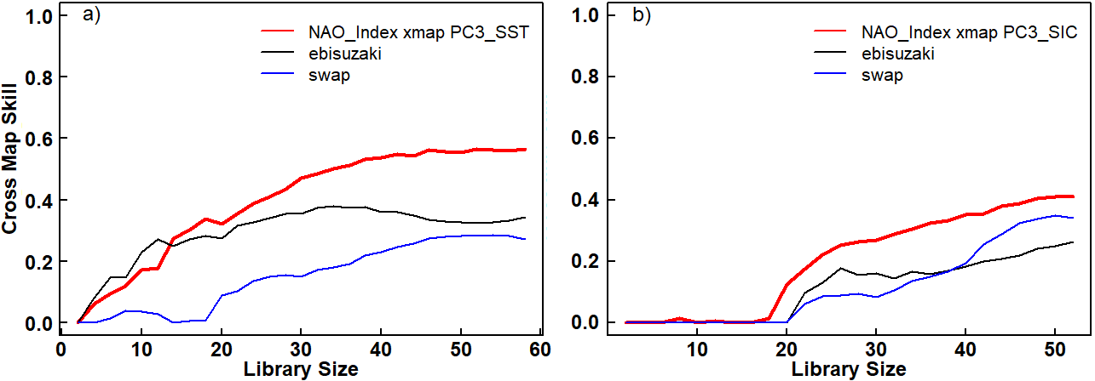

Supp. Fig. 6 | The cross maps showing causality are represented by the red line in all panels, the black lines represent the 95th surrogate under the Ebisuzaki phase-shift model, and the blue lines show the 95th surrogate under the swap model. Panels a) and b) display the in-phase statistically significant cross-map from the NAO Index to PC3_SST (a) and to PC3_SIC (b).

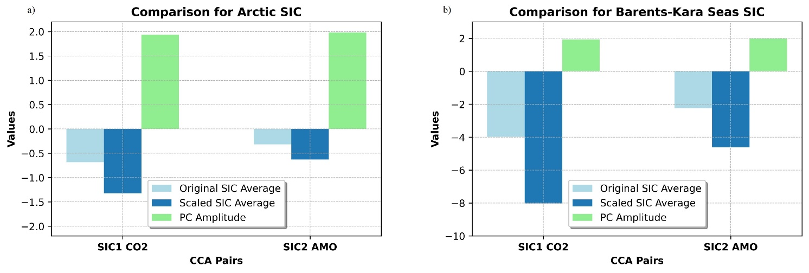
Supp. Fig. 7
Supp. Fig. 7 | Comparative Analysis of Sea Ice Concentration (SIC) Variations in the Arctic and Barents-Kara Seas. Left panel: SIC variations in the Arctic Region, showing the original average (light blue), scaled average (blue), and Principal Component (PC) amplitude (light green). Right panel: SIC variations in the Barents-Kara Seas Region, using the same color scheme. The original averages represent mean SIC values, while scaled averages are calculated by multiplying the original averages with respective PC amplitude, reflecting the influence of CO₂ and AMO climate factors. The amplitude bars denote the magnitude of SIC change over time, highlighting the differences in SIC variability between the two regions.

In order to obtain this figure, we first selected relevant SIC data, ensuring that the geographical boundaries for both regions were accurately defined. During data processing, we replaced zero values in areas without data with NaNs to ensure the analysis was not skewed, followed by calculating the mean SIC values for each region. To determine the amplitude of SIC changes, we calculated the difference between the start and end values over a specific period. Finally, these mean SIC values were scaled by their respective amplitudes and plotted.

Ye, H., Deyle, E. R., Gilarranz, L. J., & Sugihara, G. (2015). Distinguishing time-delayed causal interactions using convergent cross mapping. Scientific Reports, 5. https://doi.org/10.1038/srep14750

