Supplementary Material for

Comparison of Two Distinct Leading Modes in the Variability of Summer Humidex and Temperature Heatwaves over North America

Dae Il Jeong¹, Bin Yu¹, Alex J. Cannon²

¹ Climate Research Division, Environment and Climate Change Canada, Toronto, Ontario, M3H 5T4, Canada
² Climate Research Division, Environment and Climate Change Canada, Victoria, British Columbia, V8W 2Y2, Canada

Contents of this file
Figure S1
Figure S2
Figure S3
Figure S4
Figure S5
Figure S6
Figure S7
Figure S8
Figure S9
Figure S10
Figure S11
Figure S12

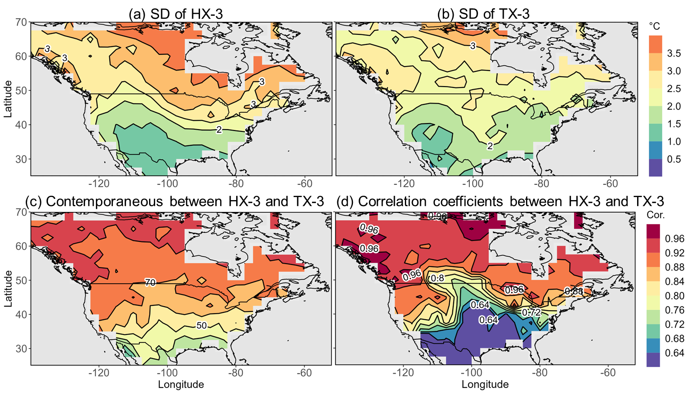
Figure S1. (a and b) Standard deviation (SD) of HX-3 and TX-3 over North America (NA) for the extended summer months (June-September) from 1951 to 2022. (c) Percentages of contemporaneous days between monthly HX-3 and TX-3, which are 33.3%, 66.7%, and 100% when 1-, 2-, and 3-day overlap, respectively. (d) Correlation coefficients between monthly HX-3 and TX-3.
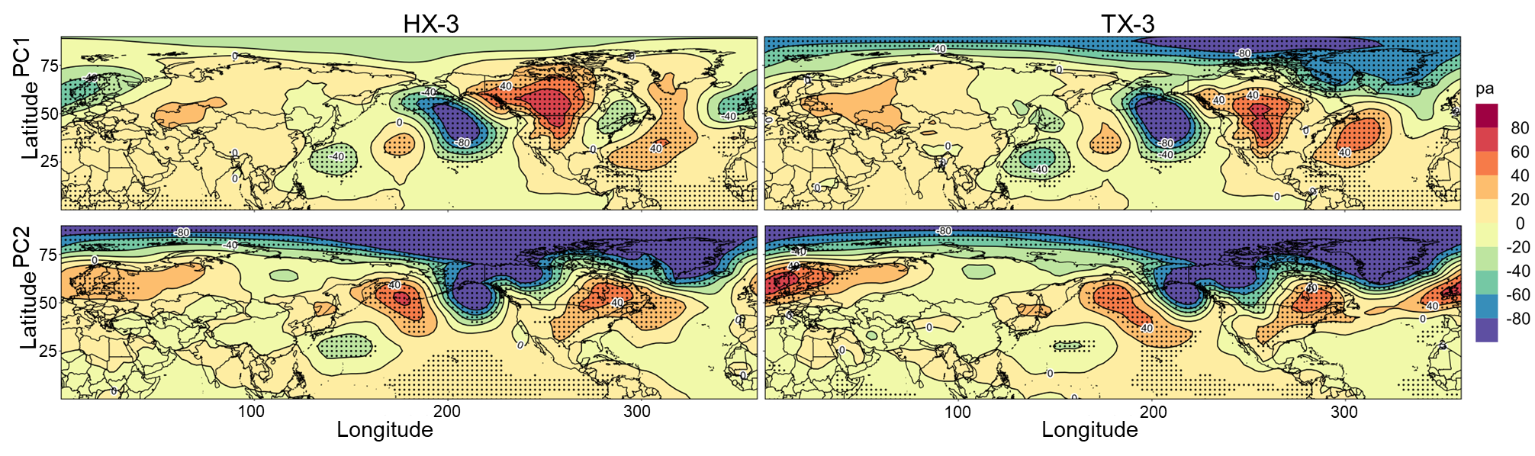
Figure S2. Regression anomalies (per one-unit of PCs) of mean sea level pressure (MSLP) onto the PC indices of HX-3 (left column) and TX-3 (right column). Black dots indicate anomalies that as significantly correlated with the PC indices at the 95% confidence level.

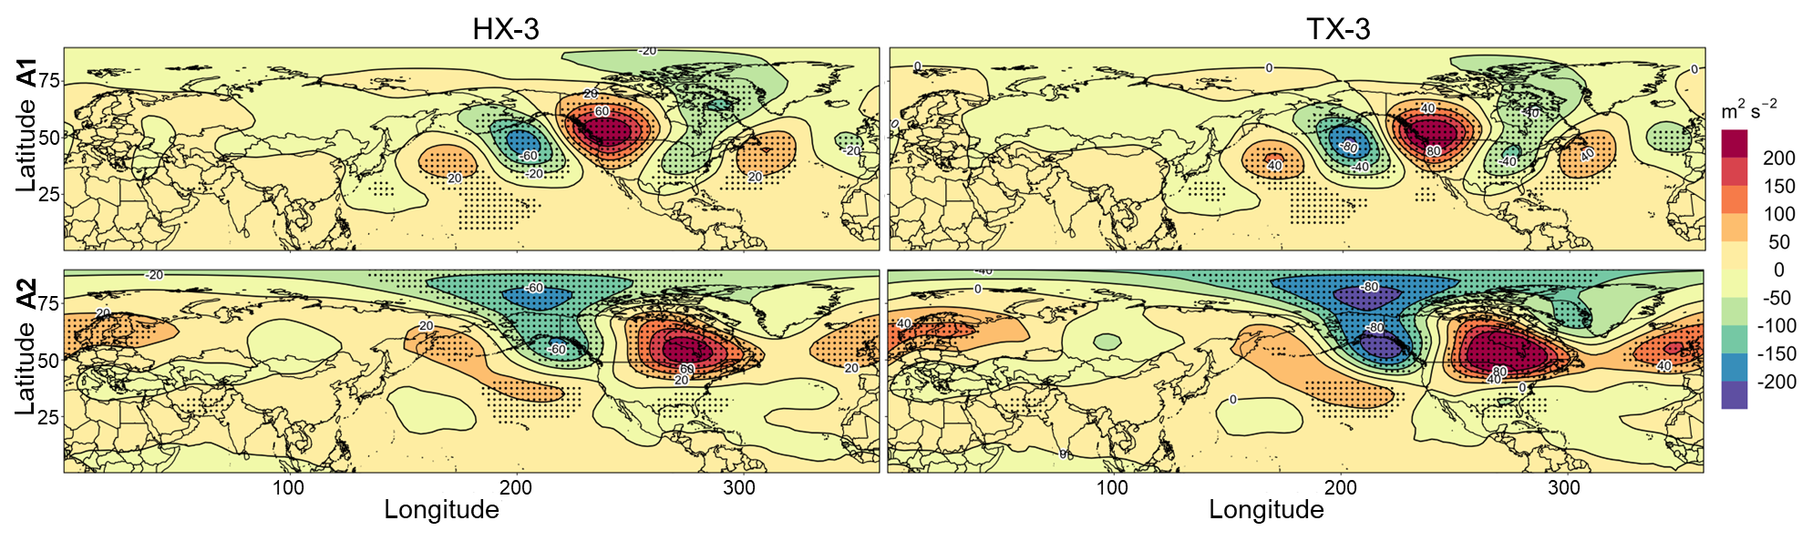
Figure S3. Regression anomalies of Φ₅₀₀ onto the area-averaged HX-3 (left column) and TX-3 (right column) anomalies at A1 and A2, respectively. Black dots indicate anomalies that as significantly correlated with the PC indices at the 95% confidence level.

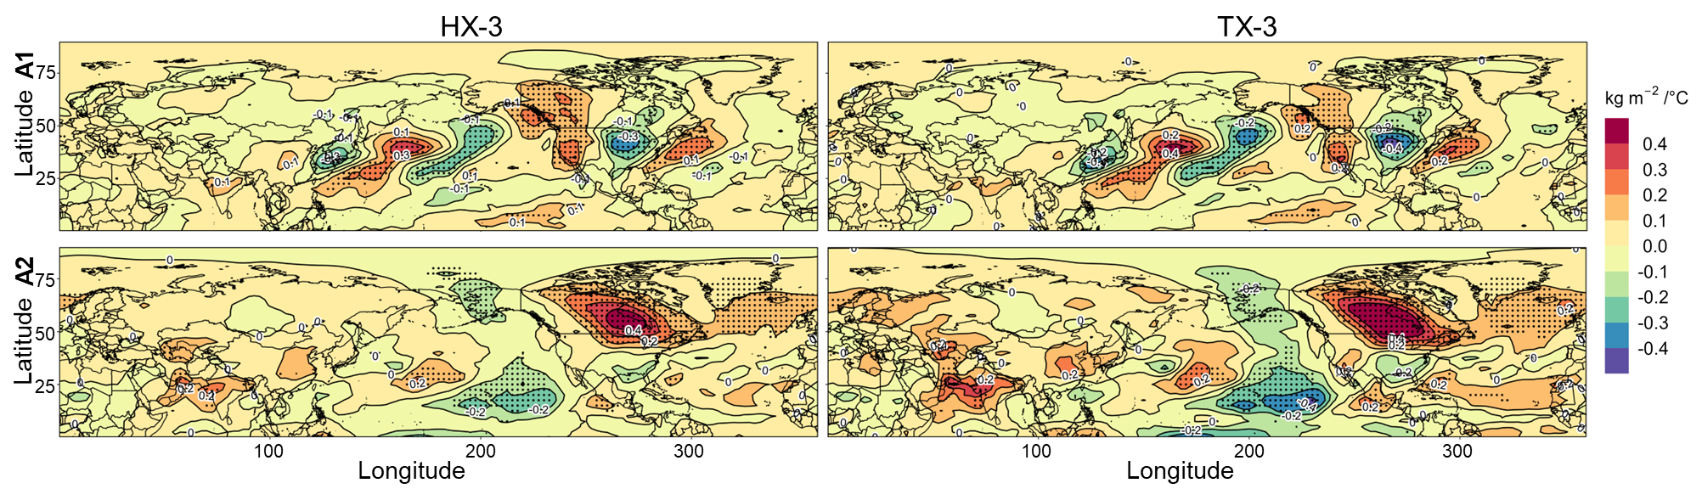
Figure S4. Regression Anomalies of total column vertically-integrated water vapour TCWV (Similar to Figure S3).

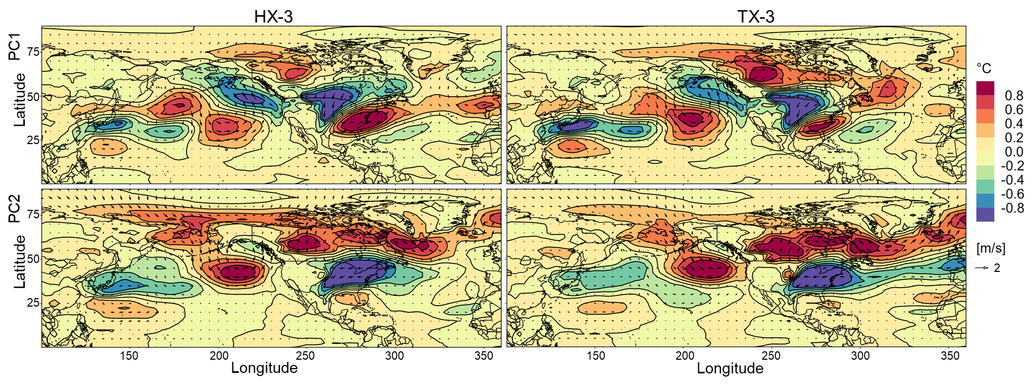
Figure S5. Anomalies of horizontal temperature advection and wind vectors at 850-hPa regressed on the two PC indices of HX-3 (left column) and TX-3 (right column).

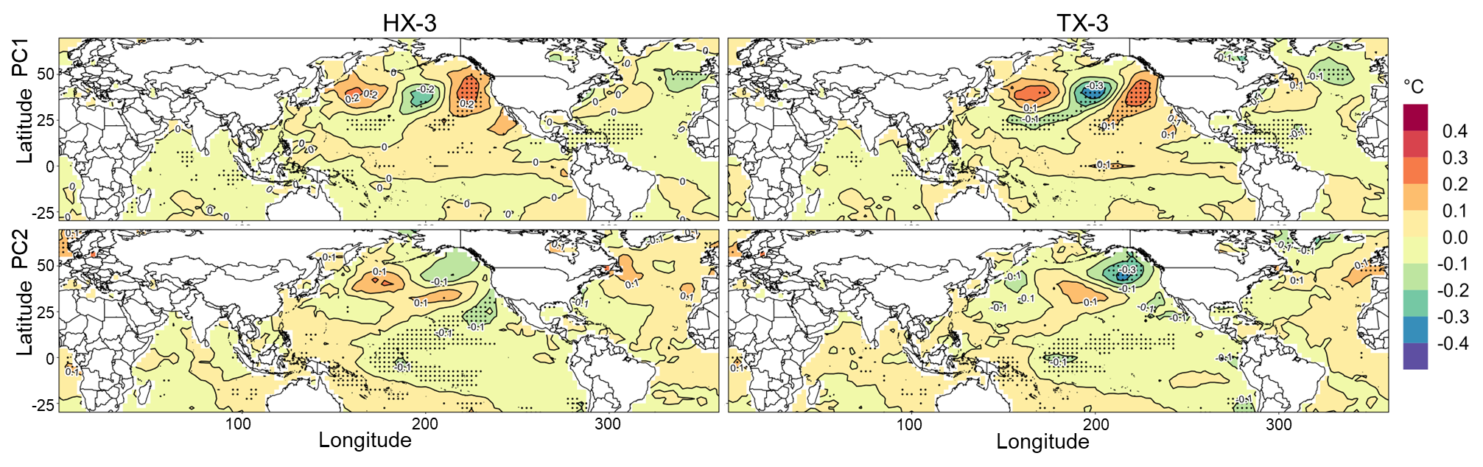
Figure S6. Regression anomalies of sea surface temperature (SST) onto the PC indices of HX-3 (left column) and TX-3 (right column). Black dots indicate anomalies that as significantly correlated with the PC indices at the 95% confidence level.
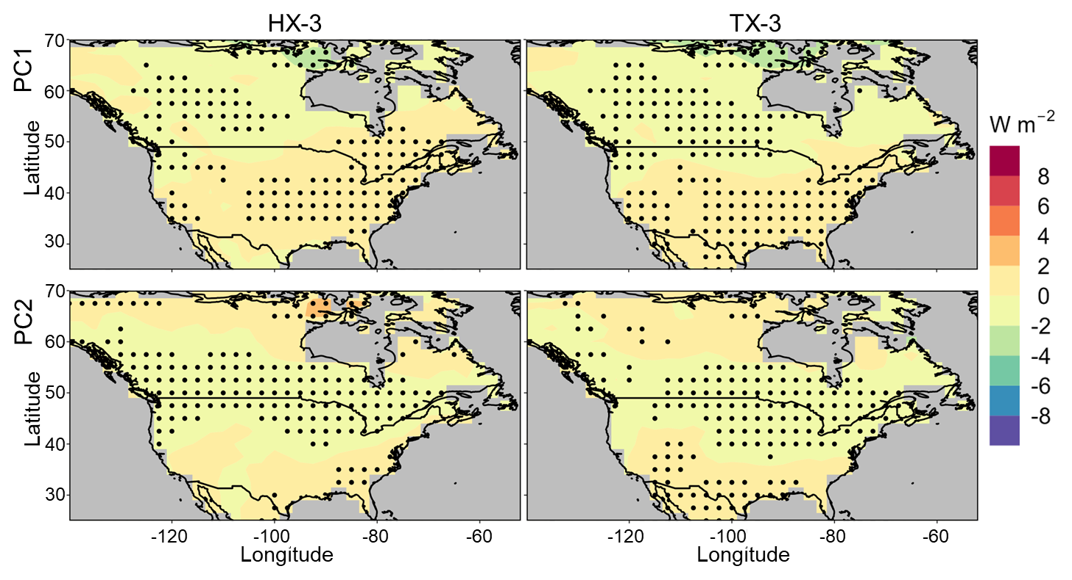
Figure S7. Regression anomalies of surface upward shortwave radiation ($R_{s}^{u}$) onto the PC indices of HX-3 (left column) and TX-3 (right column) over NA. Black dots indicate anomalies that as significantly correlated with the PC indices at the 95% confidence level.
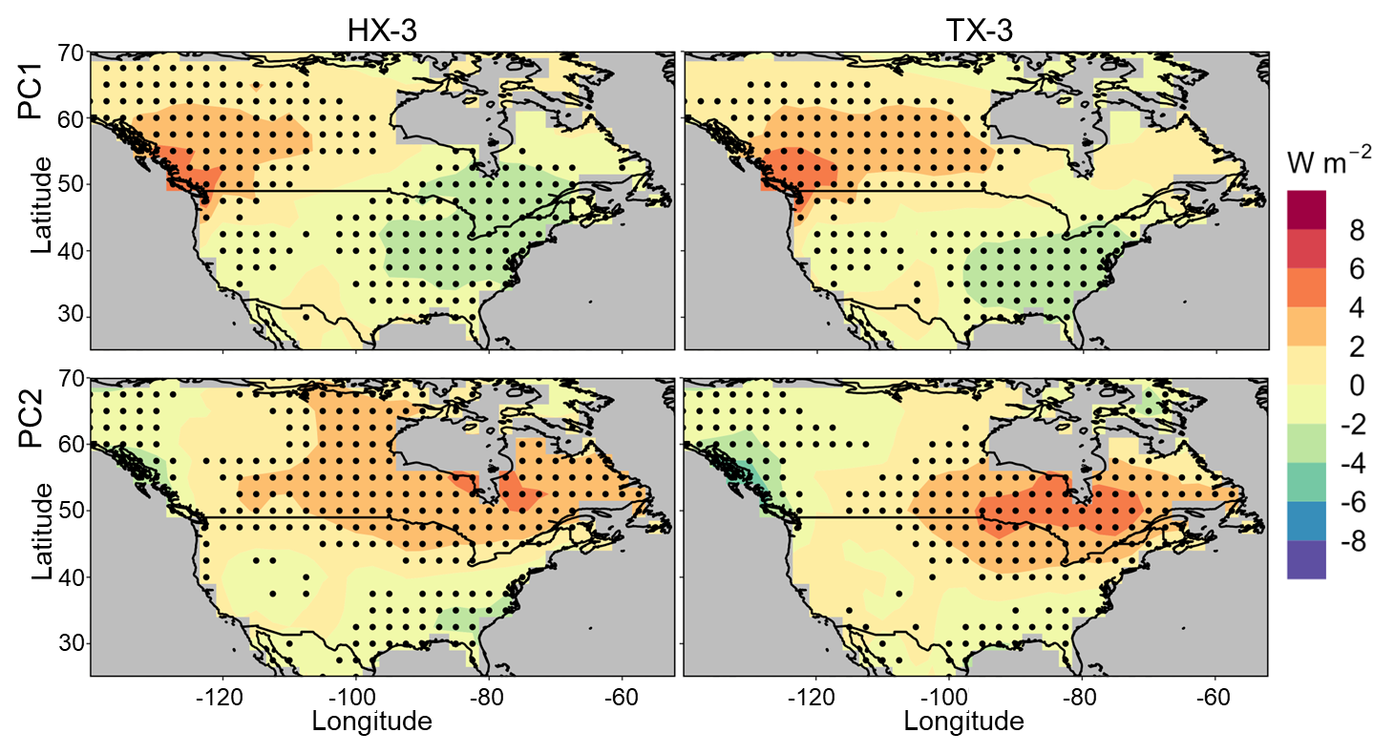
Figure S8. Regression anomalies of surface net radiation (R) onto the PC indices of HX-3 (left column) and TX-3 (right column) over NA. Black dots indicate anomalies that as significantly correlated with the PC indices at the 95% confidence level.

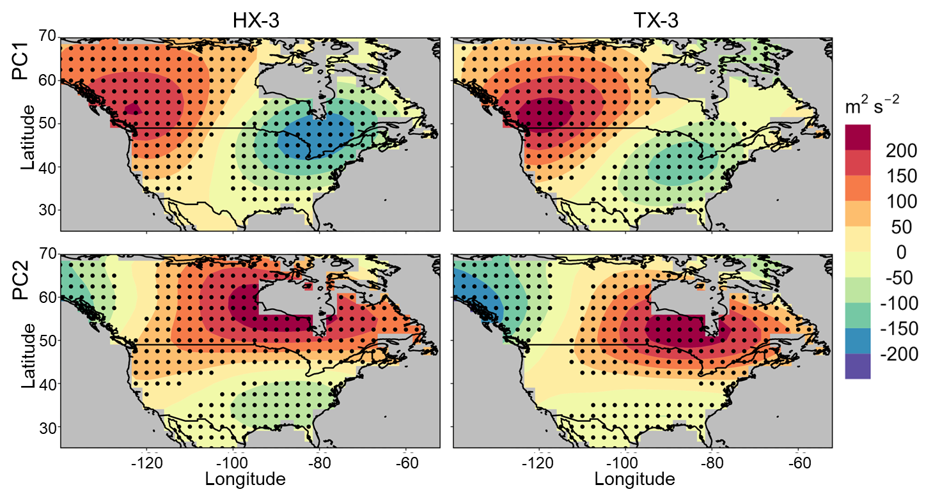
Figure S9. Regression anomalies of Φ₅₀₀ onto the PC indices of HX-3 (left column) and TX-3 (right column) over NA. Black dots indicate anomalies that as significantly correlated with the PC indices at the 95% confidence level.

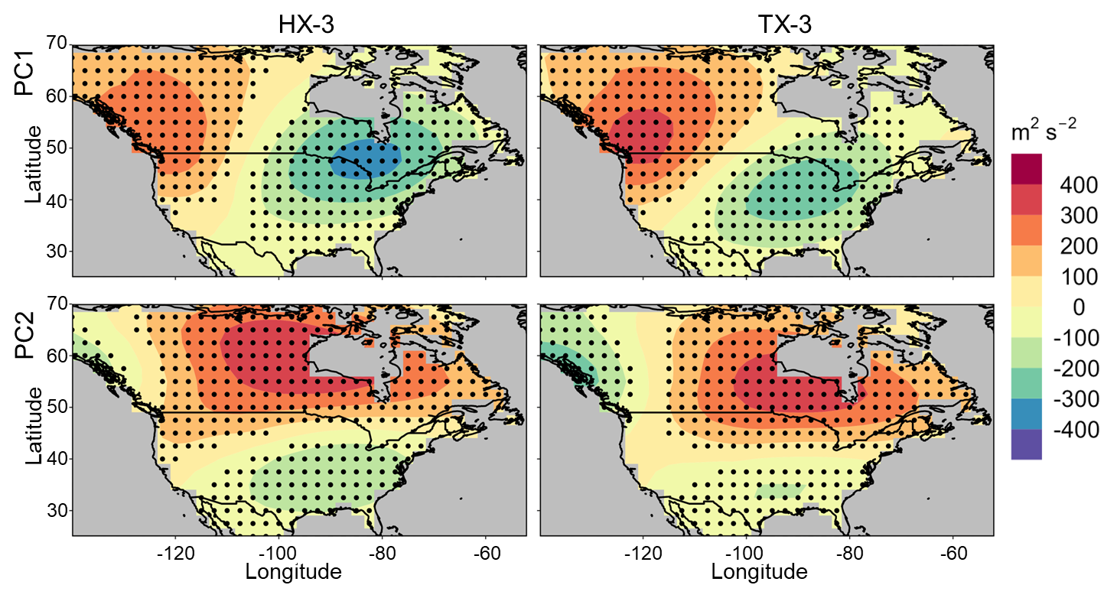
Figure S10. Regression anomalies of Φ₂₅₀ - Φ₁₀₀₀ onto the PC indices of HX-3 (left column) and TX-3 (right column) over NA. Black dots indicate anomalies that as significantly correlated with the PC indices at the 95% confidence level.

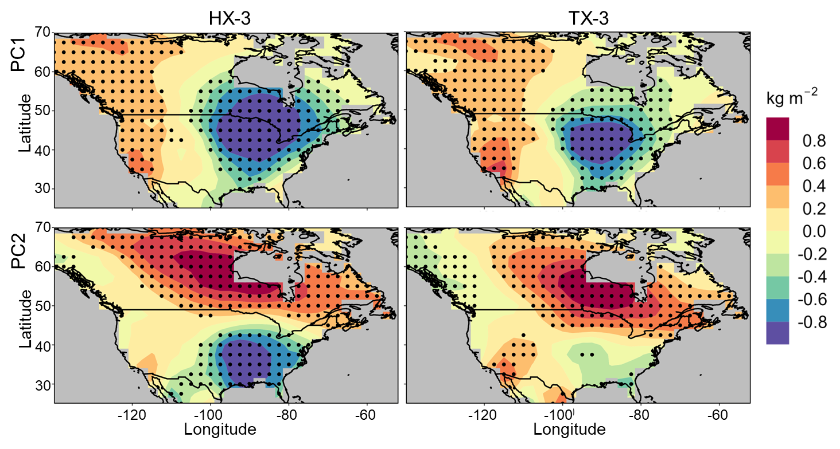
Figure S11. Regression anomalies of total column vertically-integrated water vapour (TCWV) onto the PC indices of HX-3 (left column) and TX-3 (right column) over NA. Black dots indicate anomalies that as significantly correlated with the PC indices at the 95% confidence level.

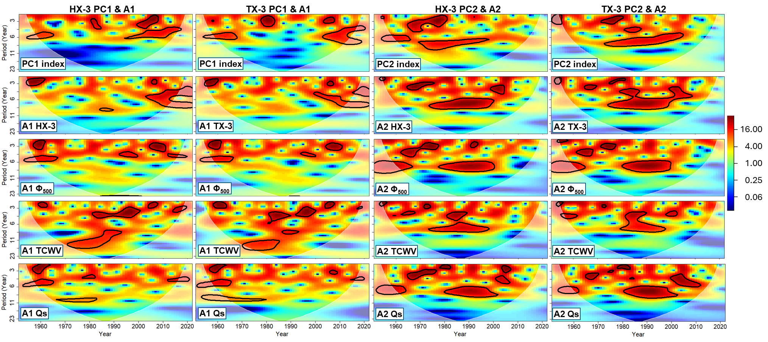
Fig. S12. Continuous wavelet transforms of PC1 and PC2 indices for both HX-3 and TX-3 (first row) and area-averaged anomalies of HX-3, TX-3, Φ₅₀₀, TCWV, and $Q_{S}$ at A1 and A2 (second to fifth rows). Annually averaged values of the extended summer months from 1951 to 2022 are used. The black contours indicate significant areas at the 90% confidence level against a red noise background spectrum. The white translucent region shows where edge effects influence the spectrum, indicating unreliable results in this area. The color bar represents the range of wavelet power in the wavelet power spectrum.

