SUPPLEMENTARY MATERIAL

Here we present supplementary results that support and enhance the main findings of the current study.
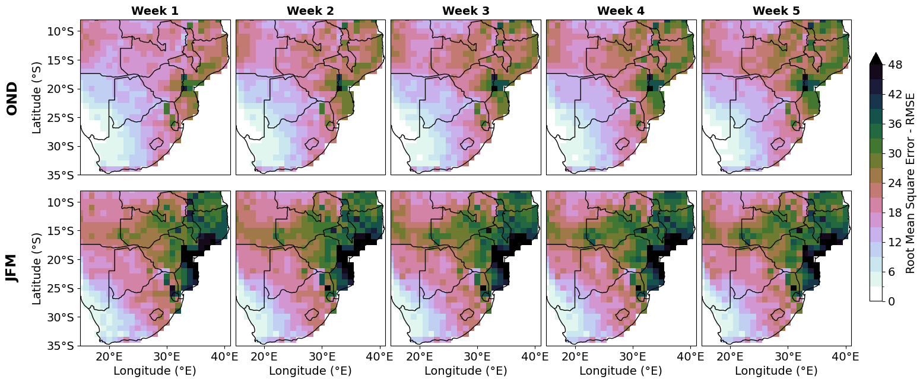

Figure S1: Root Mean Squared error (RMSE) between the bias-corrected hindcast ensemble mean and the observed precipitation totals for lead weeks 1-6 for hindcast initialisations within (a) OND (top row) and (b) JFM (bottom row).
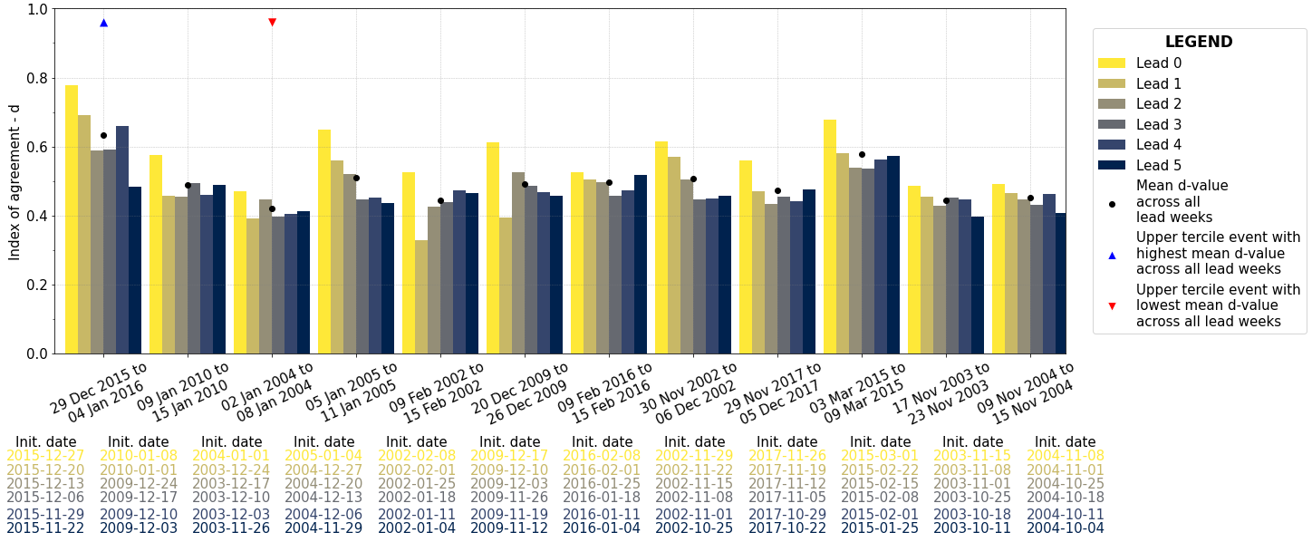

Figure S2: Index of Agreement (d) values for the ZW2 region across all LARDS events (event numbers 1 to 12, ordered from left to right). The variation in d values is shown with increasing lead times, ranging from Lead 0 to Lead 5, represented by a gradient of colors from light to dark.

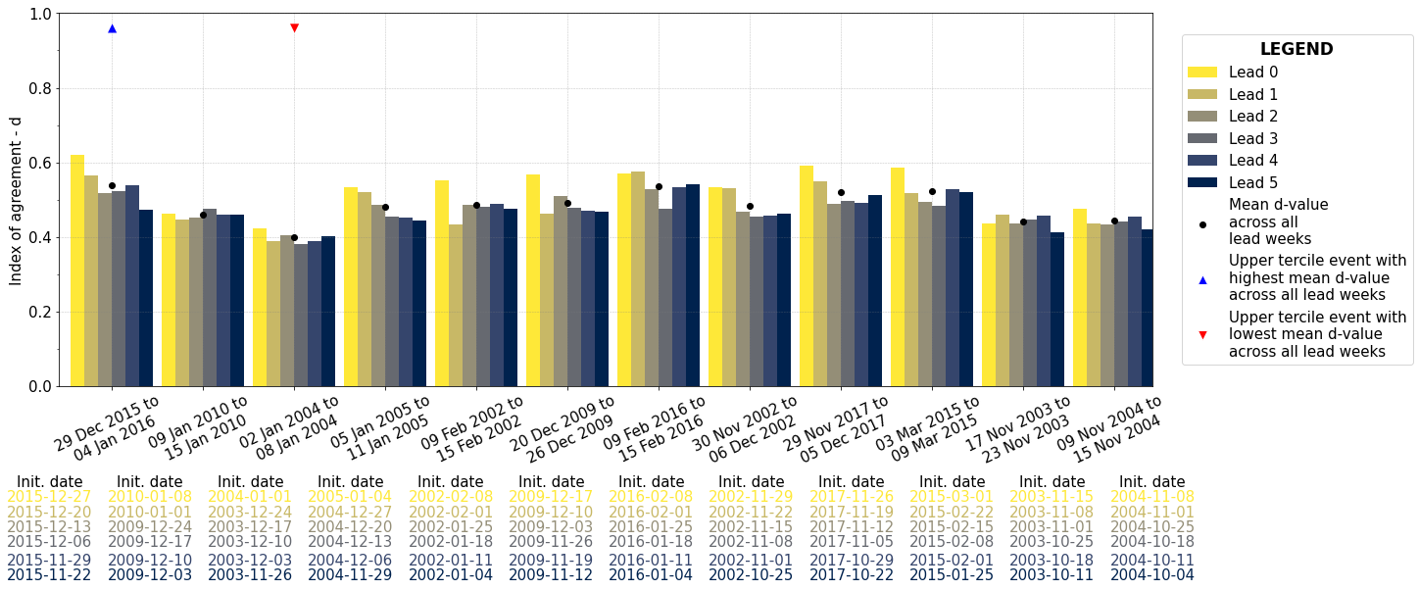

Figure S3: Same as Figure S2 but for the Southern Africa domain.
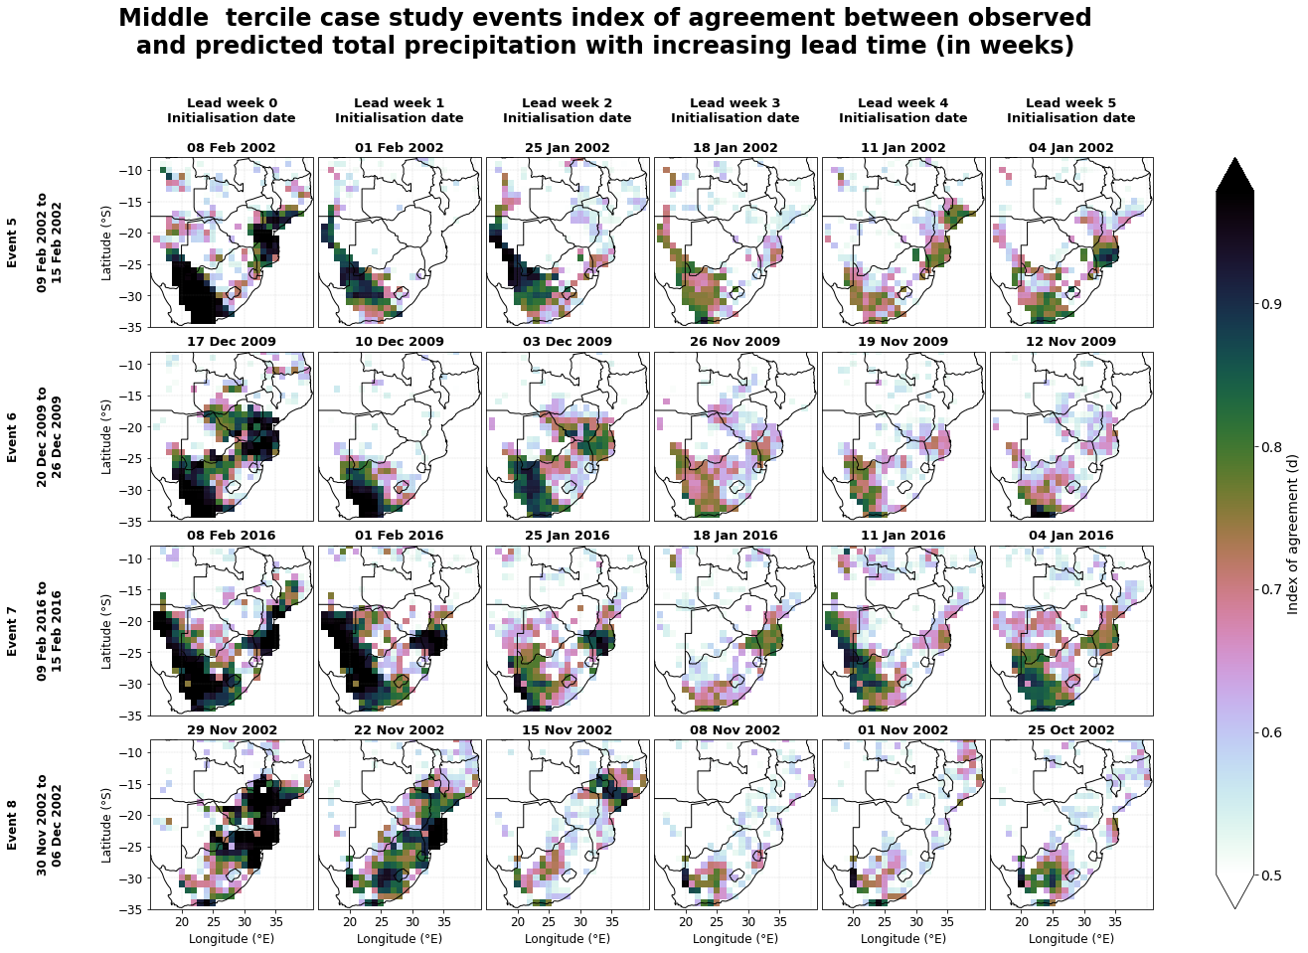

Figure S4: Spatial distribution of the agreement index (d) between the precipitation hindcast ensemble mean and observed total accumulated precipitation for middle tercile LARDS case study events. The event numbers, start and end dates of the LARDS case study events are listed from top to bottom on the left, with each column representing the hindcast initialization date at increasing lead times for each event.

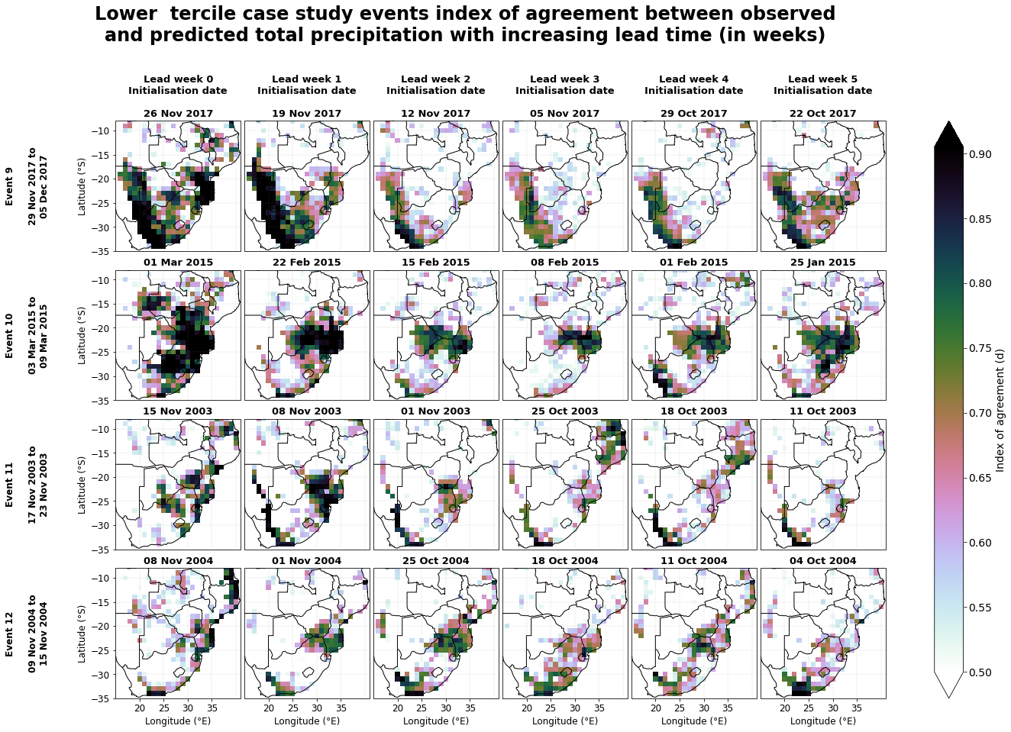

Figure S5: Same as Figure S4 but for lower tercile LARDS case study event.

