Supplementary Information for “Characterization of Western US Hydrologic Processes Linked to Atmospheric Rivers in Two Sets of Global Retrospective Forecasts."

Breanna Zavadoff^{1*} and Ben Kirtman^{1,2,3}

^{1*}Cooperative Institute for Marine and Atmospheric Studies, University of Miami, 4600 Rickenbacker Causeway, Miami, Florida, 33149, USA
²Rosenstiel School for Marine, Atmospheric, and Earth Science, University of Miami, 4600 Rickenbacker Causeway, Miami, Florida, 33149, USA
³Frost Institute for Data Science and Computing, University of Miami, 1552 Brescia Avenue, Miami, Florida, 33146, USA

*Corresponding author(s). E-mail(s): bzavadoff@earth.miami.edu

Contents of this file

- Figures S1 to S4

Fig. S1. Maps depicting the latitude-longitude grids used in (a) MERRA-2, (b) HR retrospective forecasts, and (c) LR retrospective forecasts. Circles denote the grid points along a transect of the western US coastline (black line) where the maximum IVT was recorded for both IVT threshold and AR detection calculations. Color coding indicates which latitude bin each grid point was grouped into for latitude-dependent IVT threshold calculations. Green, red, blue, and purple colored grid points were used to calculate IVT thresholds from 32.5° to 36.5°N, 36.5° to 40.5°N, 40.5° to 44.5°N, and 44.5° to 49°N, respectively.

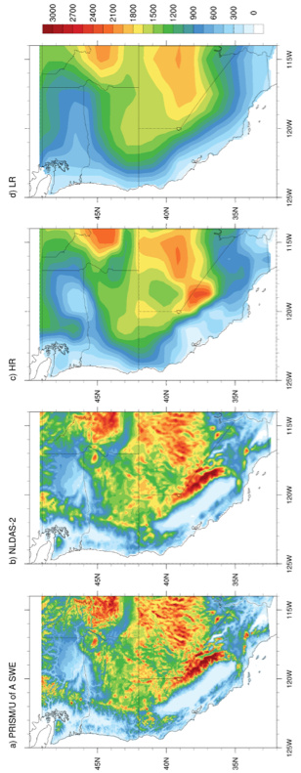

Fig. S2. Topographical representation (m; shaded according to color bar) in (a) PRISM/U of A SWE, (b) NLDAS-2, (c) HR retrospective forecasts, and (d) LR retrospective forecasts.

Fig. S3. Average climatological JFM surface temperature (°C; shaded according to left-most color bar) in (a) PRISM. Differences in average climatological JFM surface temperature (°C; shaded according to right-most color bar) between (b) CCSM4-HR, (c) CCSM4-LR, (d) CESM1-HR, (e) CESM1-LR and PRISM.

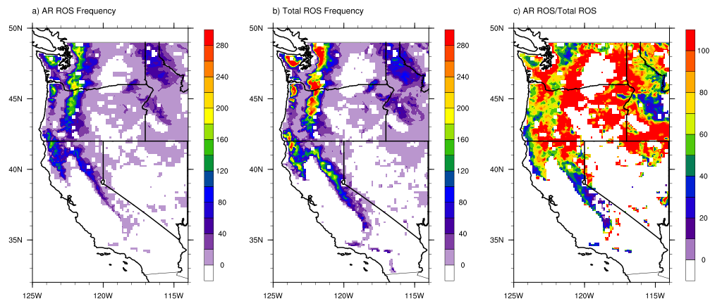

Fig. S4: Number of days (shaded according to colobar) in which (a) AR-related ROS and (b) all ROS events were recorded at each grid point throughout the 1982-2014 study period. (c) Fraction of all ROS events attributable to ARs (%; shaded according to colorbar).

