Supplementary Information (SI)

Are stratospheric polar vortex disruptions what they seem?
An alternative metric excludes tropospheric influences

Jennifer A. Francis¹, Natasa Skific¹, and Judah Cohen²

- Woodwell Climate Research Center, Falmouth MA USA
- Atmospheric and Environmental Research, Lexington MA USA

Corresponding author: J. Francis, jfrancis@woodwellclimate.org, ORCID: 0000-0002-7358-9296

Acknowledgements: JF and NS were funded by Woodwell Climate’s Fund for Climate Solutions. JC was supported by NSF grant AGS-2140909.

Submitted to Climate Dynamics 21 April 2025

b
a
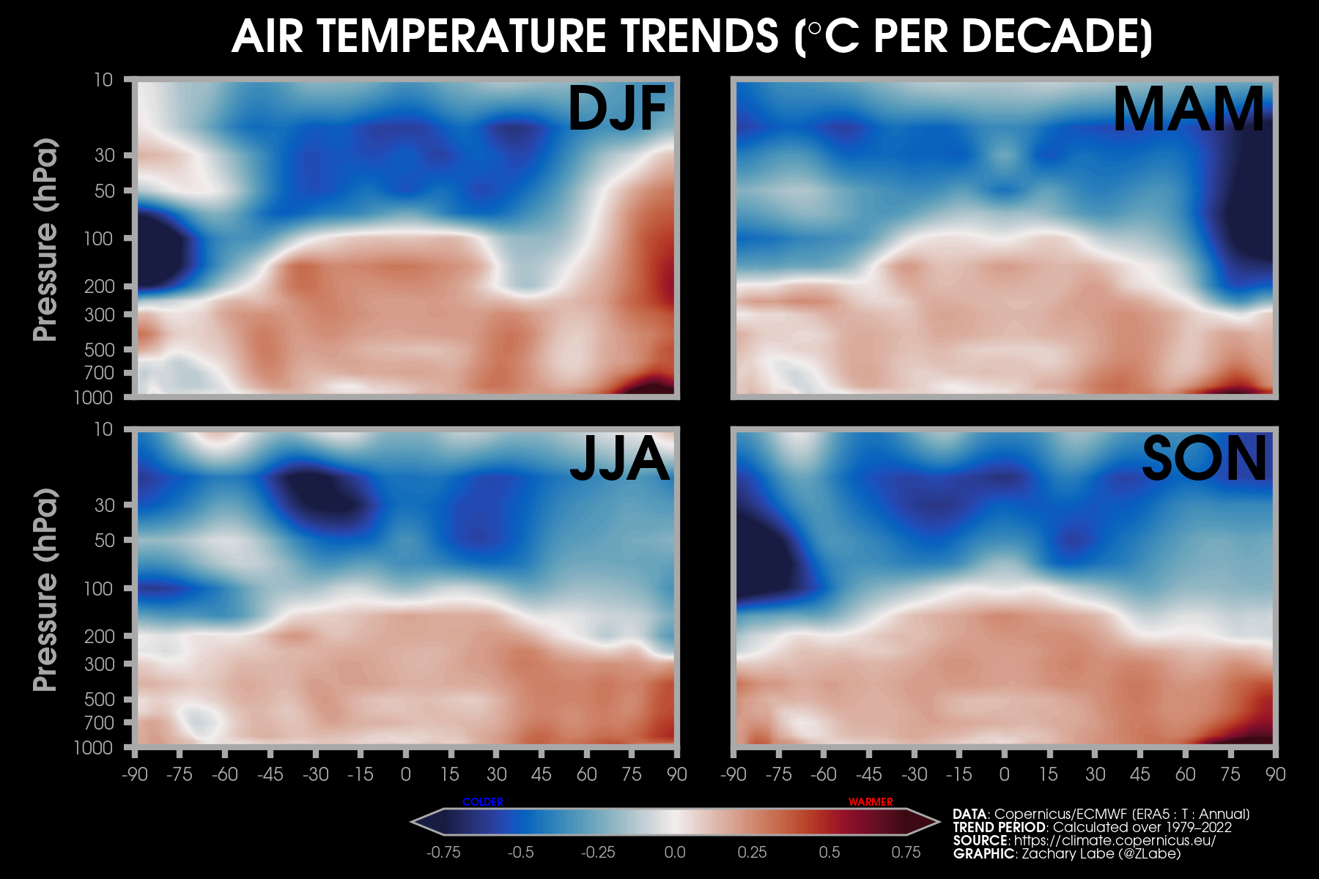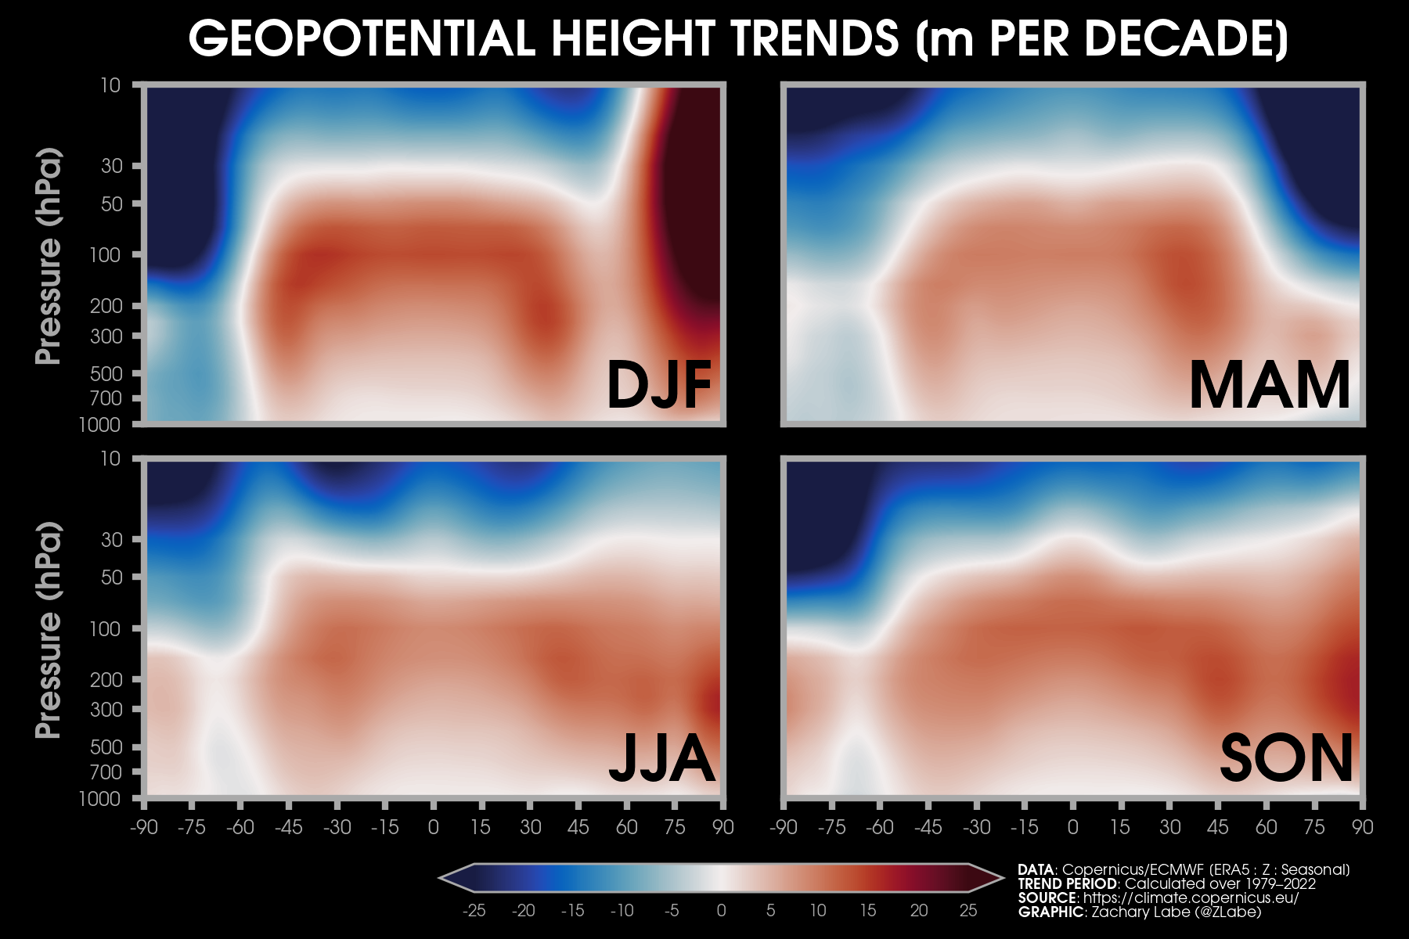
-0.75 0 0.75 -25 0 25
-90 -45 0 45 90 -90 -45 0 45 90
Figure S1: Decadal trends in zonal-mean (a) air temperature (K dec⁻¹) and (b) geopotential heights (m dec⁻¹) from 1000 to 10 hPa, 90ºS to 90ºN, and 1979 to 2022 for winter (DJF). Plot obtained from https://zacklabe.com/climate-change-indicators/ based on ERA5 output.

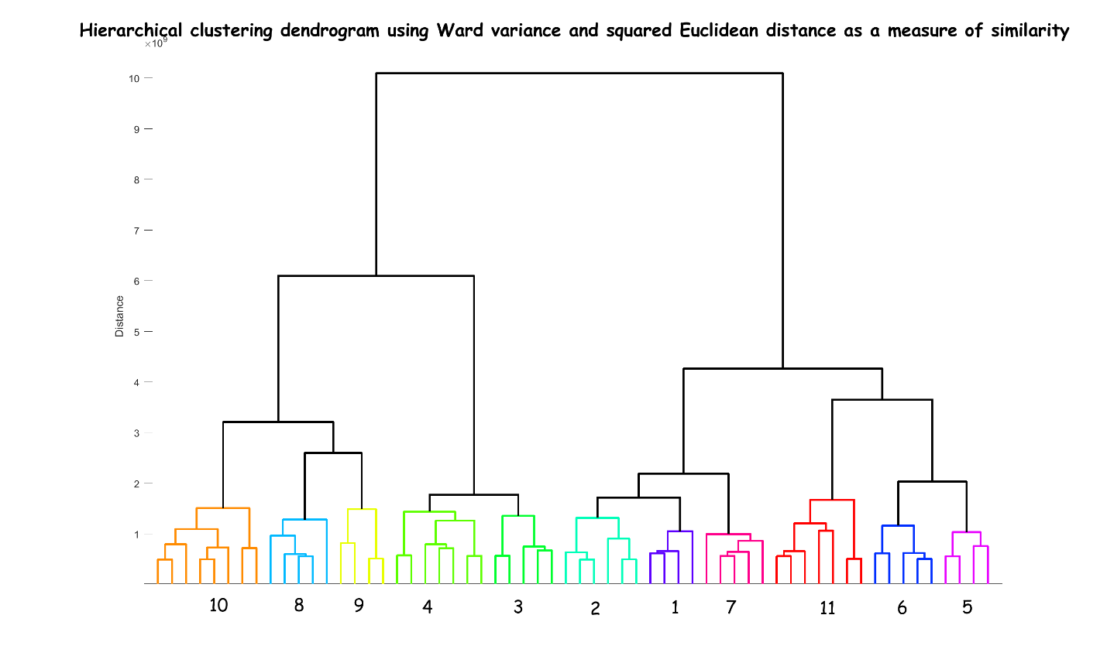
Distance
10
8
6
4
2
0
Figure S2: Hierarchical clustering dendrogram is a visual representation of the process to create a cluster tree. Ward variance and squared Euclidean distance provide a measure of similarity. Ward’s minimum variance uses the distances between “objects” (groups of two or more similar daily fields) to link pairs that are close together into a binary cluster. These objects are then linked to other samples to create bigger clusters until all the daily fields in the original data set are linked together in a hierarchical tree. Numbers along the horizontal axis identify each cluster that includes branches of the same color. The height of the upside-down Us are proportional to the distance between objects. For further details on hierarchical clustering, see Straus (2019).

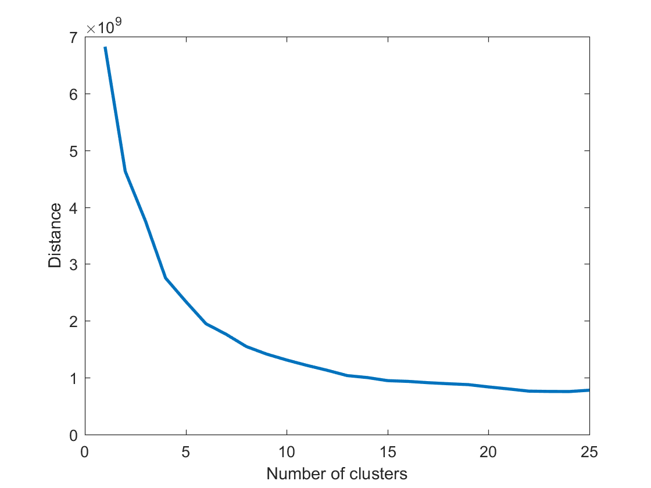
Figure S3: Mean Euclidean distance between clusters versus number of clusters.

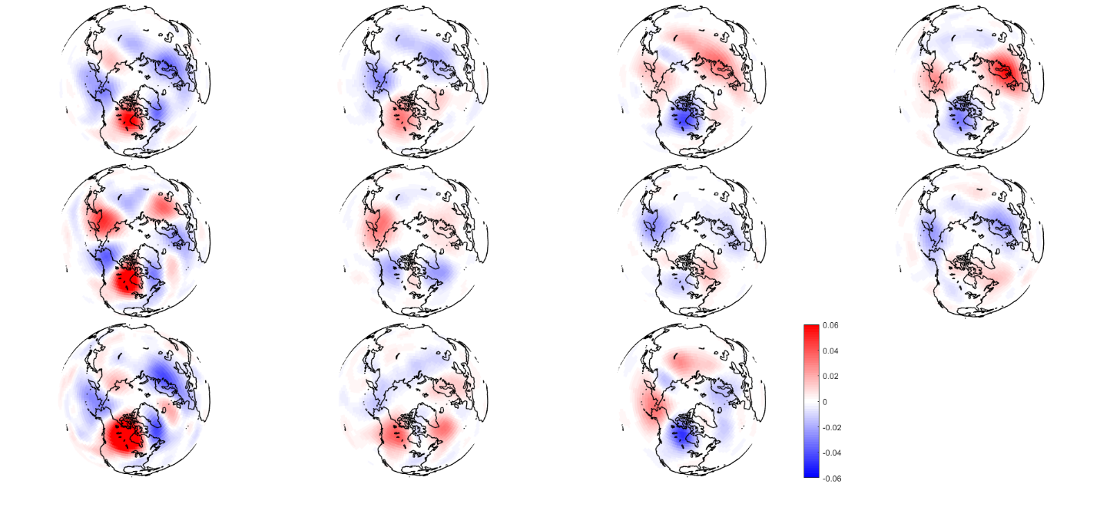
0.06
0.04
0.02
0
-0.02
-0.04
-0.06
0.06
0.04
0.02
0
-0.02
-0.04
-0.06
9 10 11
5 6 7 8
1 2 3 4
Figure S4: Anomalies in wave activity flux (WAFz, m² s⁻²) at the 100 hPa level during JF. Mean values over all days were subtracted from cluster-mean composites (presented in Fig. 9). Red (blue) shading connotes anomalous upward (downward) fluxes.

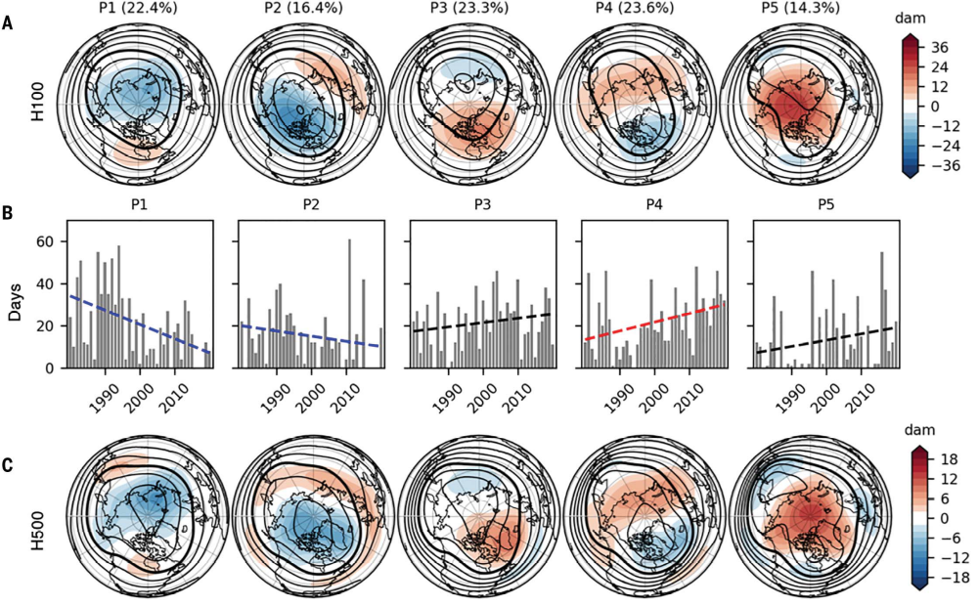
Figure S5: From Cohen et al. 2021, Fig. 1. (A) 100-hPa geopotential height composites [contours in 20-decameter (dam) intervals, anomalies shaded, and 1580-dam contour bolded] for pattern days P1 to P5. Percentage of days assigned to the pattern is indicated in parentheses. (B) Yearly frequency of (left to right) P1–P5 pattern days (gray bars), with dashed lines showing linear trend (blue if statistically significant negative trend, red if significant positive trend, and black otherwise). Statistical significance is at the 0.05 level, as determined by the Wald test with t-distribution of the test statistic. Composites for (left to right) P1–P5 pattern days of (C) 500-hPa geopotential heights (in decameters, with anomalies shaded and 540-dam contour bolded).

1
0.5
0
-0.5
-1
1
0.5
0
-0.5
-1
3
2
1
0
-1
-2
-3
QBO Index, JF 1979-2022
c
b
a
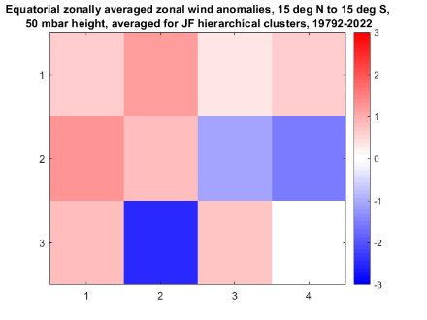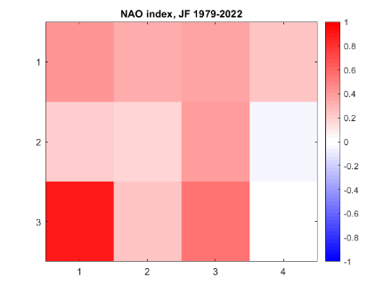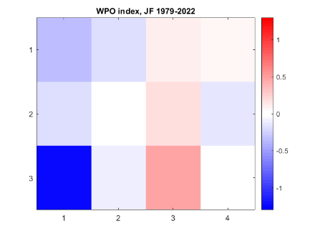
Figure S6: Phases of (a) QBO, (b) NAO, and (c) WPO associated with each node. Red indicates positive phases, blue are negative phases. Unitless.

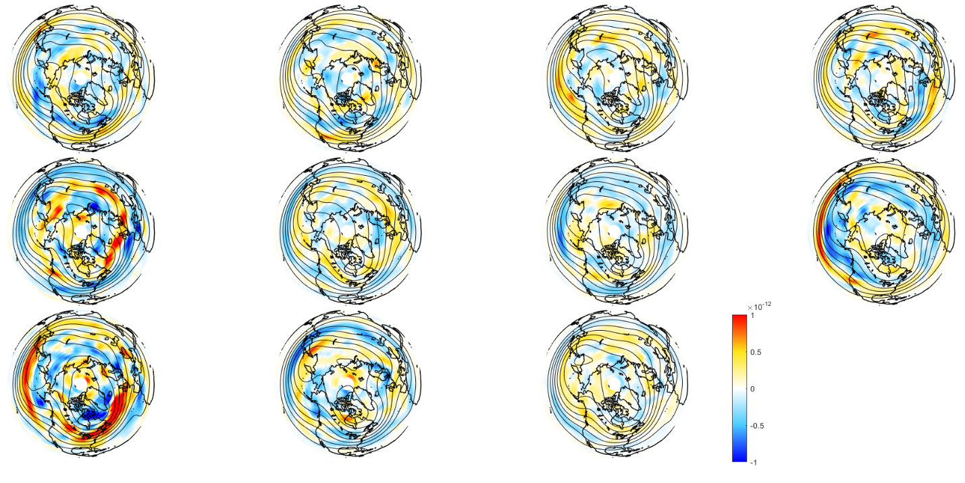
X10⁻⁶
1

0.5

0

-0.5

-1
Figure S7: Anomalies in PVy (K m kg⁻¹ s⁻¹) on the 330K isentropic surface relative to mean over all JF days from 1981-2022 (shading). Black contours indicate composited 500 hPa heights (m).

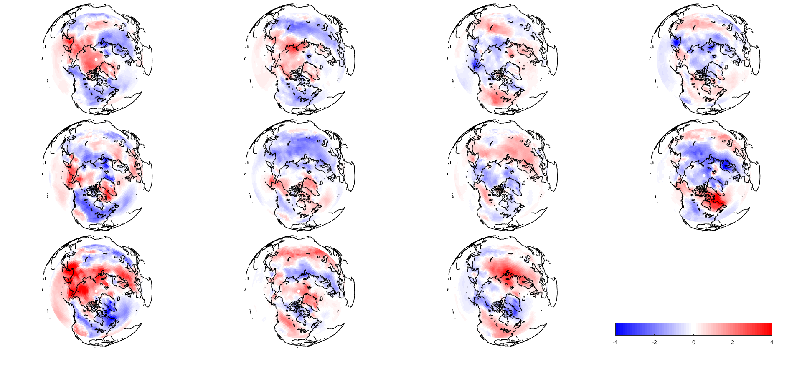
-4 -2 0 2 4
1 2 3 4
9 10 11
5 6 7 8
Figure S8: Two-meter temperature anomalies (ºC) composited for each cluster for JF from 1979 to 2022.

