A storyline approach to select the CMIP6 model ensemble to be downscaled for the South America domain

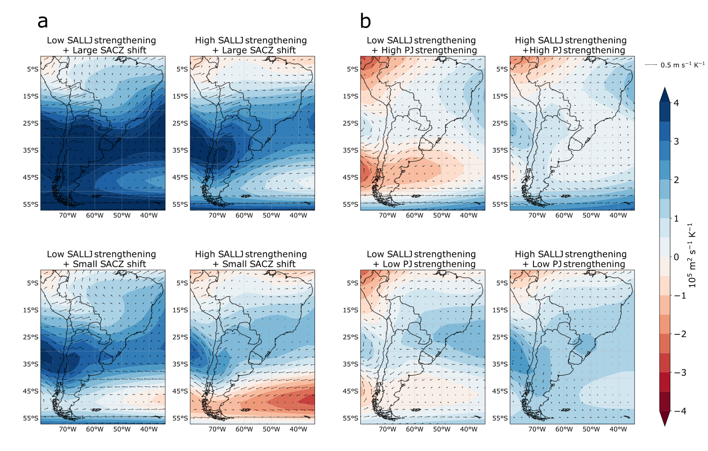

Figure S1. Wind (vectors) and stream function (shaded) response per degree of warming (10⁵ m² s⁻¹ K⁻¹) at 850 hPa are associated with the plausible storylines of climate change related to extreme values of South American Monsoon System changes in DJF in panel a) and extratropical cyclone changes in JJA in panel b).

