HighResMIP models improve detection of intense cyclones over southeast South America
(Supplementary Material)

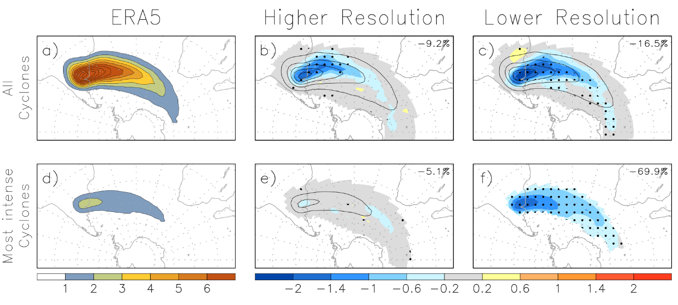
Fig. S1 Cyclone track density based on 850-hPa relative vorticity for (a, d) ERA5 and for multi-model means without ECMWF-IFS of (b, e) higher resolution models and (c, f) lower resolution models. The analysis includes (a, b, c) all cyclones and (d, e, f) the most intense cyclones (90th percentile) based on the maximum T42 850-hPa relative vorticity. Contours represent track density (contour intervals of 1), while shading indicates model bias in panels (b, c, e, f), where biases are calculated relative to ERA5 (multi-model mean minus reanalysis). Dotted areas represent regions where at least 80% of the models agree on the signal. The numbers in panels (b, c, e, f) indicate the percentage change in the track density, with p-values in parentheses. Units represent the number per season per unit area ($≅{10}^{6}{km}^{2}$) for track density.

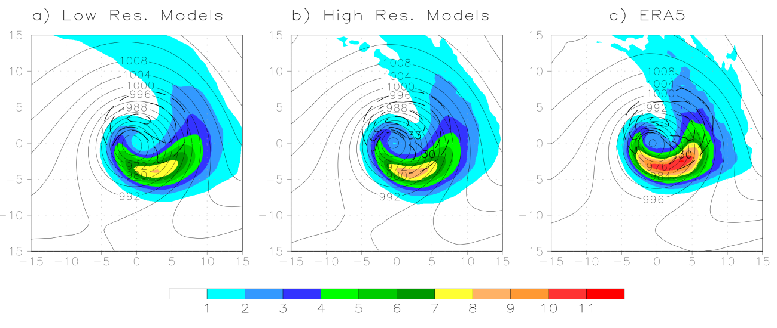
Fig. S2 Composite cyclone of the 90th percentile most intense systems at the time of maximum vorticity for (a) low-resolution models (excluding ECMWF-IFS-LR), (b) high-resolution models (excluding ECMWF-IFS-HR), and (c) ERA5 reanalysis. The mean fields include mean sea level pressure (MSLP, solid contours, hPa), total precipitation (shading, mm 6h⁻¹), and 850-hPa wind speed (dashed contours, m s⁻¹). Contour intervals are 4 hPa for MSLP and 3 m s⁻¹ for wind speed.

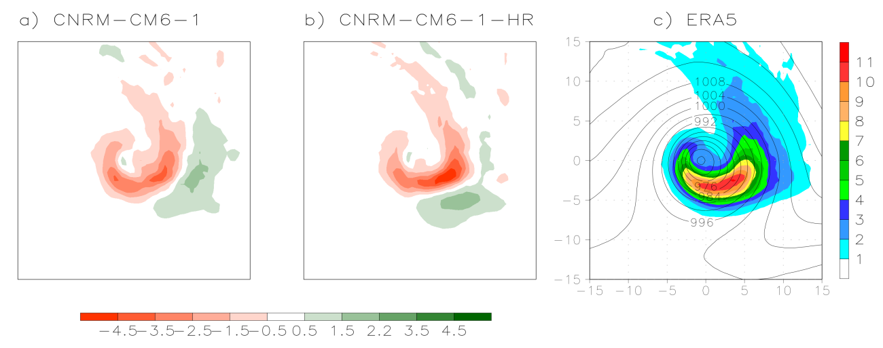
Fig. S3 Composite cyclone of the 90th percentile most intense systems at the time of maximum vorticity for (a) CNRM-CM6-1 (low-resolution), (b) CNRM-CM6-1-HR (high-resolution), and (c) ERA5 reanalysis. The mean fields include total precipitation (shading, mm 6h⁻¹) and 850-hPa wind speed (dashed contours, m s⁻¹). Contour intervals are 3 m s⁻¹ for wind speed.
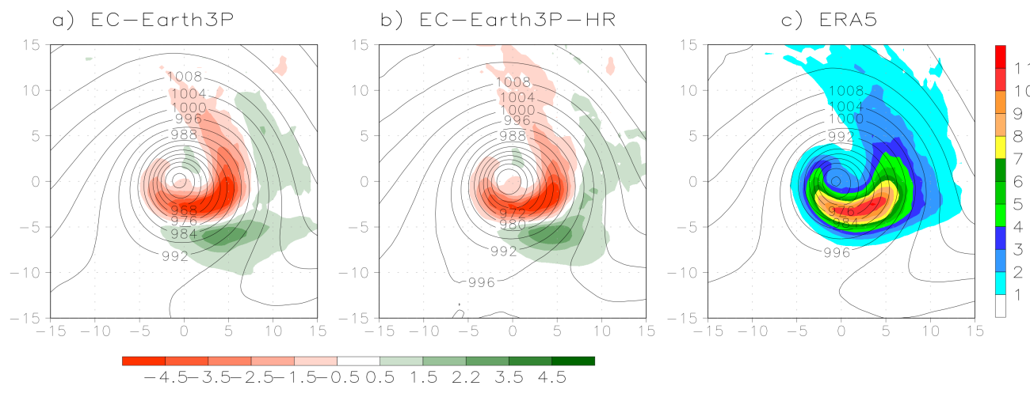
Fig. S4 Composite cyclone of the 90th percentile most intense systems at the time of maximum vorticity for (a) EC-Earth3P (low-resolution), (b) EC-Earth3P-HR (high-resolution), and (c) ERA5 reanalysis. The mean fields include mean sea level pressure (MSLP, solid contours, hPa), total precipitation (shading, mm 6h⁻¹), and 850-hPa wind speed (dashed contours, m s⁻¹). Contour intervals are 4 hPa for MSLP and 3 m s⁻¹ for wind speed.

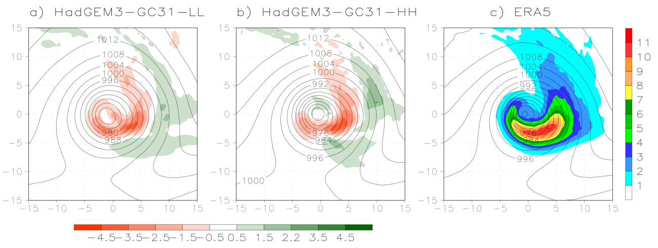
Fig. S5 Composite cyclone of the 90th percentile most intense systems at the time of maximum vorticity for (a) HadGEM3-GC3-LL (low-resolution), (b) HadGEM3-GC3-HH (high-resolution), and (c) ERA5 reanalysis. The mean fields include mean sea level pressure (MSLP, solid contours, hPa), total precipitation (shading, mm 6h⁻¹), and 850-hPa wind speed (dashed contours, m s⁻¹). Contour intervals are 4 hPa for MSLP and 3 m s⁻¹ for wind speed.

Table S1 Number of tracks, mean and standard deviation of cyclone intensity metrics for ERA5, individual models, and multi-model ensembles.
Model | Tracks | Vor mean | Vor SD | MSLP mean | MSLP SD
CMCC-CM2-VHR4 | 1382 | 81.62 | 28.29 | – | –
CMCC-CM2-HR4 | 1068 | 22.92 | 8.62 | – | –
CNRM-CM6-1-HR | 1490 | 48.20 | 14.87 | – | –
CNRM-CM6-1 | 1242 | 19.88 | 6.53 | – | –
EC-Earth3P-HR | 1421 | 59.33 | 23.11 | 1012.11 | 6.03
EC-Earth3P | 1424 | 33.61 | 13.47 | 1012.37 | 6.29
ECMWF-IFS-HR | 1363 | 63.23 | 21.50 | 1011.50 | 6.54
ECMWF-IFS-LR | 1330 | 38.57 | 13.79 | 1011.44 | 6.27
FGOALS-f3-H | 1284 | 85.20 | 25.76 | 1011.07 | 5.63
FGOALS-f3-L | 1228 | 26.66 | 8.33 | 1011.38 | 5.48
HadGEM3-GC31-HH | 1349 | 58.07 | 22.29 | 1011.16 | 6.74
HadGEM3-GC31-LL | 1221 | 19.41 | 7.50 | 1012.80 | 6.56
MPI-ESM1-2-XR | 1311 | 37.87 | 14.41 | 1012.10 | 6.56
MPI-ESM1-2-LR | 1108 | 14.14 | 5.97 | 1013.16 | 6.81
ERA5 | 1439 | 73.09 | 27.24 | 1012.49 | 5.96
High-resolution ensemble | 1371 | 61.93 | 21.46 | 1011.59 | 6.30
Low-resolution ensemble | 1232 | 25.03 | 9.17 | 1012.23 | 6.28

